**T4 Form – Qualitest International Inc.**

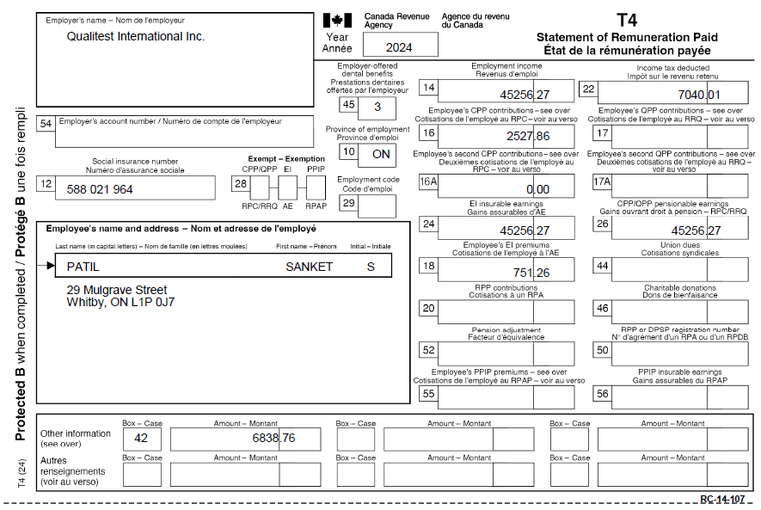

**Payslip  
#1**  
  
#2

