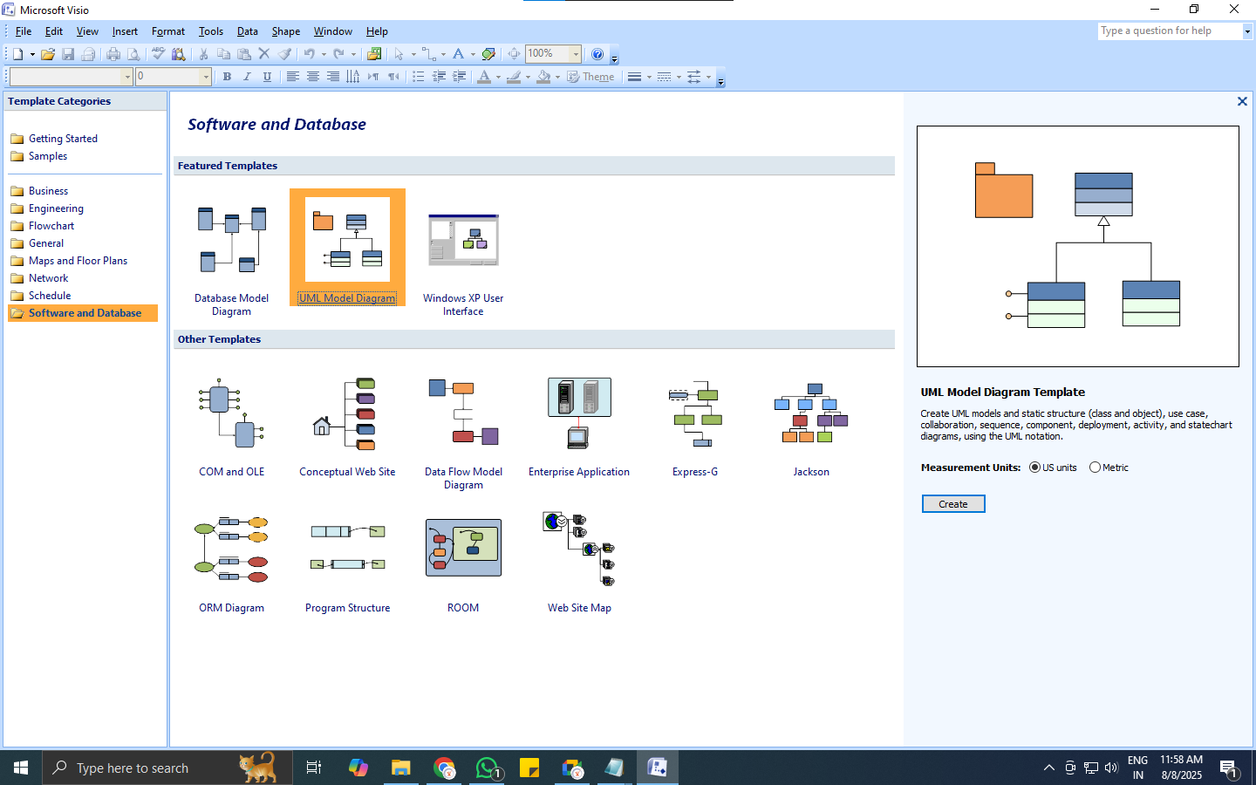
Step:3
Select create
Step:2
Select UML Model Diagram
Step:1
Select Software and Database option
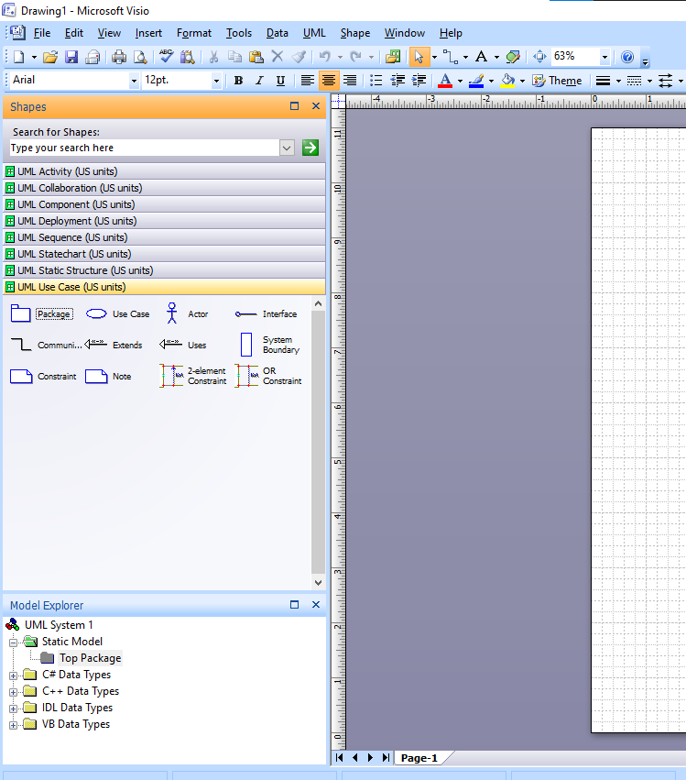
Use Case Diagram Components
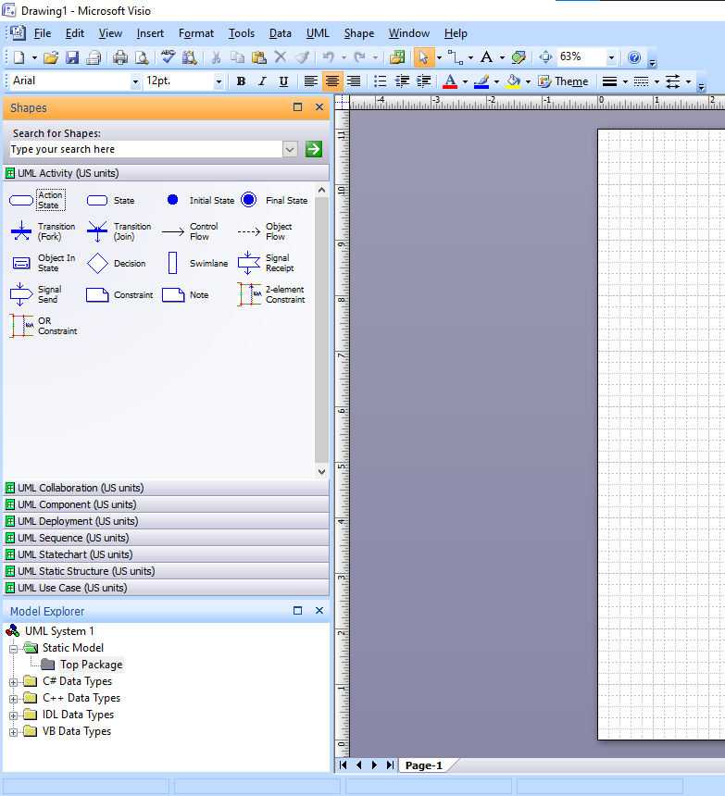
Activity Diagram Components

