Nurturing Process - Capstone Project1 – Part -1/3 V2D1- Mar2024
Online Agriculture Products Store
Question 1 – Audits - 5 Marks
4 Quarterly Audits are planned Q1 , Q2, Q3, Q4 for this Project What is your knowledge on how these Audits will happen for a BA ?
Answer
Quarterly Audit Plan for a Business Analyst (BA)
Quarterly Audit Report 01 – Requirement Gathering Phase 10 Weeks (Week 1 to Week 10)
Purpose: To ensure the initial phase of gathering business needs and user expectations is properly documented and validated.
Key Checklist for BA:
BRD Template | Completed and filled correctly with all business needs.
Elicitation Report | Summary of stakeholder interviews, workshops, and questionnaires.
Grouping of Functionalities | Categorization of functionalities (Fertilizers, Seeds, Pesticides).
Client Sign-off | Approval received on requirement gathering.
Email Communications | Clear communication documentation to stakeholders with proper use of CC and BCC for transparency.

Quarterly Audit Report 02 – Requirement Analysis Phase 7 Weeks (Week 16 to Week 21)
Purpose: To validate how raw business requirements are translated into actionable technical insights.
Key Checklist for BA:
UML Diagrams | Use Case Diagrams, Activity Diagrams, etc., clearly represent system behaviour.
Business to Functional Mapping | Linking each business requirement to its corresponding functional requirement.
Client Sign-off on Analysis | Confirmation that all analyzed requirements are accurate and approved.
RTM (Requirements Traceability Matrix) | Mapping of requirements to design/test cases for tracking.
Email Communications | Records showing communication trail with stakeholders (with CC and BCC).

Quarterly Audit Report 03 – Design Phase 7 Weeks (Week 30 to Week 37)
Purpose: To ensure BA has supported the design team with correct information and captured inputs from stakeholders accurately.
Key Checklist for BA:
Utilization of Tools | Tools like Draw.io, or similar, for modelling/UML.
Documented Communication | Design clarifications and requirement discussions are properly archived.
Stakeholder MoM (Minutes of Meeting) | Regular meetings are documented with action items.
Email Communications | Continued traceability of communication with relevant people in the loop (CC/BCC).

Quarterly Audit Report 04 – Development and Testing Phase 20 Weeks (Week 40 to Week 60)
Purpose: To evaluate the BA’s support during build and to ensure requirement clarity continues during development.
Key Checklist for BA:
JAD (Joint Application Development) Session Reports | Participation in discussions with dev/test teams.
End User Manual Preparation | User-friendly guides and usage instructions drafted by the BA.
BA & Developer MoMs | Meetings on clarifications, design tweaks, or requirement revisions.
Email Communications | Email trail showing real-time support to the dev team with proper documentation (CC/BCC).
Test Case Accuracy | Validation of whether test cases align with the original requirements.
Testing Reports Shared with End Users | UAT reports and feedback logs.
Email Communication | Especially with testers and UAT stakeholders, in CC/BCC.

Question 2 – BA Approach Strategy - 6 Marks
Before the Project is going to Kick Start, The Committee asked Mr Karthik to submit BA Approach Strategy
Answer
Business Analyst Approach Strategy
Project: Online Agriculture Product Store (Initiative by SOONY)
BA: Ms. Manju
Company: APT IT SOLUTIONS
Duration: 18 Months | Budget: ₹2 Crores
1. Elicitation Techniques to Apply
To gather clear and complete requirements from all stakeholders:
Technique | Purpose
Brainstorming | With stakeholders (Peter, Kevin, Ben) to explore farmer problems and solutions.
Document Analysis | Review any existing documentation or government farming policies.
Observation | Understand how farmers currently operate (tools, buying habits).
Interviews | One-on-one sessions with stakeholders for deep understanding.
Focus Groups | Group discussions with manufacturers (fertilizer, seed, pesticide companies).
Workshops | Collaborative sessions with technical and user-side teams for requirement validation.
Prototyping | To visualize UI for non-technical users and gather feedback early.

2. Stakeholder Analysis & RACI Matrix
Steps to perform stakeholder analysis:
- Identify all internal/external stakeholders
- Define their influence, expectations, and involvement
- Assign roles/responsibilities using RACI

 | Requirement Gathering | BRD/FRD Review & Signoff | Functional Mapping | UAT Coordination
Responsible | Ms. Manju (BA) | Ms. Manju (BA) | Ms. Manju (BA) | Ms. Manju (BA), Mr Jason and Ms Alekya (Testers)
Accountable | Mr Vandanam Senior (PM) | Mr Vandanam Senior (PM), Client | Mr Vandanam Senior (PM), Mr Mike (Network Admin), Client | Mr Vandanam Senior (PM), Client
Consulted | Client | Mr Teyson, Ms Lucie, Mr Tucker, Mr Bravo (Java Developers) | Client, Mr Teyson, Ms Lucie, Mr Tucker, Mr Bravo (Java Developers) | Mr Teyson, Ms Lucie, Mr Tucker, Mr Bravo (Java Developers)
Informed | Mr Teyson, Ms Lucie, Mr Tucker, Mr Bravo (Java Developers) | Mr Jason and Ms Alekya (Testers), Mr John (DB Admin) | Mr Mike (Network Admin), Mr Jason and Ms Alekya (Testers)

3. Documents to Prepare
Document | Description
BRD (Business Requirements Document) | High-level business needs, goals, and problems to solve.
FRD (Functional Requirements Document) | System behavior, functional details, features.
Use Case Document | User interactions and flows.
SRS (Software Requirements Specification) | Combined final version for sign-off.
RTM (Requirements Traceability Matrix) | Track coverage from requirement to implementation/testing.
UML Diagrams | Class, activity, sequence diagrams.
Change Request Register | Maintain change logs and approvals.
UAT Document & Acceptance Form | Track test results and collect final client approval.

4. Document Sign-Off Process
- Review document with stakeholders (online/in-person).
- Share via email with proper CC & BCC lists.
- Incorporate feedback.
- Use email confirmation or a digital signature to obtain final sign-off (especially on SRS).

5. Client Approval Process
- Set up formal review meetings (milestone-based).
- Walk the client through documents or deliverables.
- Obtain continuous feedback.
- Approval captured through: 1. Email confirmation
- Document signature
- Meeting MoM (Minutes of Meeting)

6. Communication Channels to Establish
Channel | Purpose
Email | Formal documentation, sign-offs, approvals.
Microsoft Teams/Zoom | Meetings, demos, discussions.
Jira/Confluence | Task tracking, document sharing.
WhatsApp Group (if informal) | Quick communication with the internal team.
Weekly Status Meetings | Progress updates
Bi-Weekly Sprint Reviews | Agile feedback loop
Monthly Stakeholder Update | Formal summary of progress

7. Change Request Handling Process
- Create Change Request Form (CRF).
- Perform impact analysis (timeline, cost, scope).
- Discuss in the Change Control Board (CCB)
- Obtain client approval.
- Update documentation (BRD, FRD, RTM).
- Communicate with the team and implement change.

8. Progress Reporting to Stakeholders
- Weekly Status Reports to PM and internal team.
- Monthly Dashboard Reports to Committee (Henry, Pandu, Dooku).
- Use Jira/Confluence for transparent tracking.
- Include completed tasks, pending actions, risks, and mitigations.

9. UAT – Client Project Acceptance Process
- Prepare UAT Plan and Test Scenarios.
- Coordinate with testers and the client.
- Conduct UAT in a controlled environment.
- Log all feedback/bugs.
- Fix issues and retest.
- Arrange Final Review Meeting.
- Get formal sign-off on: 1. UAT Report
2. Client Acceptance Form
3. Email Confirmation
Note
This structured BA approach ensures that:
- All stakeholders' needs are captured clearly
- Communication is consistent and transparent
- Deliverables are signed off on formally
- Changes are controlled and approved
- Client satisfaction is ensured through rigorous UAT and documentation

Question 3 – 3-Tier Architecture - 5 Marks
Answer
3-Tier Architecture Overview
The 3-Tier Architecture is a well-structured and organized design used in software projects. It splits the application into three separate layers:

1. Presentation Layer (User Interface Layer)
Who uses it? → Farmers & Manufacturers
What does it do? → This is the application's front-end — the part that users see and interact with.
How it helps:
- Farmers can search and view products (seeds, fertilizers, pesticides)
- Manufacturers can upload product details
- It is designed to be simple, easy, and mobile-friendly
Ex: Mobile App or Website with buttons like “Buy Seeds”, “Order Pesticides”, etc.

2. Application Layer (Business Logic Layer)
Who uses it? → Works behind the scenes
What does it do? → This is the brain of the system. It processes user requests and follows business rules.
How it helps:
- Handles operations like:
- User login/registration
- Product search
- Order placement
- Notifications and messages
Communicates between UI and database
Ex: When a farmer clicks "Buy Fertilizer", this layer processes the request and decides what to do next.

3. Data Layer (Database Layer)
Who uses it? → Only the system
What does it do? → This is where all the data is stored securely.

How it helps:
- Stores product details (seeds, fertilizers, pesticides)
- Stores farmer profiles, orders, manufacturer info, and delivery data
- Ensures data safety, backup, and fast access
Ex: When Peter orders seeds, the system saves this order in the database for tracking.

Users (Farmers/Manufacturers)

[1. Presentation Layer]
(Mobile App / Web Portal)

[2. Application Layer]
(Java Backend, Business Rules)

[3. Data Layer]
(Database - Orders, Products, Users)

Benefits of Using 3-Tier Architecture:
Scalable – Easy to add new features later (like payment, language support)
Secure – Sensitive data stays safe in the backend
Maintainable – Developers can fix bugs or update a layer without affecting others
User-Friendly – Smooth experience for farmers and manufacturers

Question 4 – BA Approach Strategy for Framing Questions – 10 Marks
Answer
- Start with the Foundation – Use 5W1H to Frame Clear Questions
5W1H is a question-based strategy that Business Analysts use to gather complete and clear information from stakeholders.
It stands for:
Tools | Guiding Question Type | Questions to be asked in this Project
What | What are the problems you're facing? | What difficulties do you face in ordering pesticides?
Why | Why do you think this feature is important? | Why do you need real-time tracking of deliveries?
Who | Who are the users of this feature? | Who will manage the product uploads?
When | When do you expect to use this system? | When do you mostly order seeds – in which season?
Where | Where will this be used – mobile or web? | Where do you usually get updates (SMS or email)?
How | How would you like the product to work? | How do you prefer to place orders – by name or category?

Purpose of 5H1W
- Helps gather complete requirements
- Avoids missing key information
- Encourages clear and structured conversations
- Works well during interviews, workshops, or surveys

- Apply SMART Criteria to Your Questions
SMART is a technique used in projects to define clear and achievable goals.
Each letter stands for a specific quality a goal should have:
Specific- The goal should be clear and well-defined (What exactly do we want?)
Measurable- The goal should be trackable (How will we measure success?)
Achievable- The goal should be realistic (Can we do it?)
Relevant- The goal should align with business needs (Is it meaningful?)
Time-bound- The goal should have a deadline (By when should it be done?)
Make sure each question covered in this project is:

Specific Targeted to a clear need
Measurable Can be validated or tested
Achievable Realistic in the project scope
Relevant Aligned with business goals (ex: helping farmers)
Time-bound Considering project timelines

How is SMART used in Projects?
- Helps Business Analysts and Project Managers set realistic objectives
- Used during requirement gathering, project planning, and reviews
- Ensures that tasks/goals are clear, trackable, and deadline-driven
- Keeps teams focused and aligned on project deliverables

4. Consider the 3-Tier Architecture
Frame questions that target each layer:
Presentation Layer
“What kind of interface do you find easiest – dropdowns, icons, search bar?”
Business Logic Layer
“What rules should apply while approving a manufacturer’s product listing?”
Data Layer
“What details do you want to save for each order?”
“Do you want access to the previous season’s order history?”

5. Use Case-Oriented Questions
Think from the perspective of user actions:
- “What should a farmer see after logging in?”
- “What steps should a manufacturer follow to list a product?”
- “What should happen when a farmer clicks 'Order Now'?”
You can also prepare:
- Use Case Specifications
- Activity Diagrams
- Page Design Mockups
Tip: Show visual flows to the stakeholders to prompt more questions and refine answers.

Sample Framed Questions for This Project:
- What information should a manufacturer provide to upload a product?
- How should a farmer track the status of their order?
- What modes of delivery do you expect — courier, local transport, etc.?
- Do you prefer product names in local language or English?
- How do you want to be notified — SMS, email, WhatsApp?
- What types of reports would help in reviewing past orders or stock?

Tool | Purpose
5W1H | Ask complete and targeted questions
SMART | Ensure question clarity and scope
RACI | Role-based requirements and clarity
3-Tier | Ask for UI, logic, and data needs
Use Cases | Understand specific user actions

Question 5 – Elicitation Techniques - 6 Marks
As a Business Analyst, What Elicitation Techniques you are aware of? ( BDRFOWJIPQU)
Answer
1. Brainstorming
Purpose: To generate a wide variety of ideas in a short time.
Who’s Involved: Stakeholders, team members, end-users.
Use Case: Useful during the initial phase of the project when defining features or solving complex problems.
Example: Ask farmers, "What problems do you face while buying farming products?" Let everyone share freely.

2. Document Analysis
Purpose: To understand existing systems, processes, or policies.
What You Analyze: Business process documents, legacy system manuals, reports.
Use Case: Helps in understanding the current workflow or system before proposing a new one.
Example: Analyzing procurement logs, vendor contracts, and supply chain flow for agricultural products.

3. Reverse Engineering
Purpose: To figure out how an existing system or product works by analyzing it
Use Case: When documentation is missing or outdated.
Example: Review a basic mobile app already used by some farmers and identify its functionalities.

4. Focus Groups
Purpose: To collect opinions and feedback from a selected group of users
Who’s Involved: A small group of real users (e.g., 5-8 farmers, vendors).
Use Case: Ideal when you want to understand preferences, behaviours, and reactions.
Example: Ask them what features they’d want in the online store and what challenges they currently face.

5. Observation
Purpose: To observe how stakeholders perform their tasks in real-time.
Use Case: Useful when users can't explain their process clearly or you want to validate what they say
Example: Observe how Peter currently buys fertilizers and what steps are involved.

6. Workshops
Purpose: Collaborative sessions where stakeholders and the project team work together to gather requirements.
Use Case: Encourages consensus building, idea sharing, and conflict resolution.
Example: A joint workshop with farmers and product manufacturers to define product categories, filters, and delivery models.

7. JAD (Joint Application Development)
Purpose: A highly structured session where users and developers work together to define requirements.
Use Case: Best when you need quick decisions and approvals.
Example: Sitting with Java Developers and farmers to design how the "Order and Delivery Tracking" feature should work.

8. Interview
Purpose: To gather detailed, personalized insights from stakeholders.
Types: Structured, unstructured, or semi-structured.
Use Case: One-on-one discussions with key stakeholders like Mr. Henry, Peter, or manufacturers.
Example: Ask Mr. Pandu what reports or analytics he expects from the admin dashboard.

9. Prototyping
Purpose: To present a mock-up of the application to users and get their feedback.
Use Case: When requirements are unclear or users need visual guidance.
Example: Creating a clickable prototype showing how a farmer would add seeds to the cart and check out.

10. Questionnaire / Survey
Purpose: To gather responses from a large group of users.
Use Case: When users are distributed or it's not feasible to meet everyone.
Example: Share a simple Google Form to 100 farmers asking what products they use most and which brands they prefer.

11. Use Case Specification
Purpose: Documenting how a user interacts with the system to achieve a specific goal.
Includes: Actors, preconditions, main flow, alternate flow, exceptions.
Use Case: Helps developers, testers, and stakeholders understand the system behaviour.
Example: A Use Case Spec for "Place Order" showing steps from product selection to payment and delivery confirmation.

Question 6 – This project Elicitation Techniques - 5 Marks
Which Elicitation Techniques can be used in this Project and Justify your selection of Elicitation Techniques?
Prototyping
Use case Specs
Document Analysis
Brainstorming
Answer
Elicitation Techniques to Be Used & Justification
1. Prototyping
Why:
- Farmers and even some stakeholders might not be able to visualize how the application should work just from words.
- Prototyping allows you to show low-fidelity mockups or wireframes to demonstrate login screens, product catalogues, cart functionality, and payment flows.
Justification:
Helps non-technical stakeholders like Peter, Kevin, and Ben understand and validate features like:
- Login/Sign-up screens
- Product catalogue and search filters
- Cart and checkout
- Delivery tracking UI

2. Use Case Specifications
Why:
- Use Cases help describe the step-by-step interaction between the user (Farmer/Manufacturer) and the system.
- Useful for developers, testers, and other technical stakeholders.
Justification:
For a clear definition of system behaviour, such as:
- “Search for product”
- “Register/Login”
- “Place order”
- “Upload product (Manufacturer)”
- “Track delivery”
Helps build test cases and development tasks.

3. Document Analysis
Why:
Helps you study existing documents related to farming supply chains, procurement processes, or any previous software that may exist (even spreadsheets or offline records).
Justification:
To understand: 1. Types of products currently used by farmers
- Existing offline purchasing methods
- Payment processes that manufacturers currently offer
Saves time and ensures no important functionality is missed.

4. Brainstorming
Why:
- Engages multiple stakeholders at once to get a broad range of ideas quickly.
- Effective when you need input on what features to include in MVP (Minimum Viable Product).
Justification: Helpful during initial meetings with Mr. Henry and stakeholders like Kevin, Peter, and Ben.
Helps in generating:
- Ideas on future modules (crop advisory, weather info, etc.)
- Enhancements like voice search for farmers or regional language support

Prototype (Low-Fidelity - Suggested)
- Home Page
- Welcome Banner
- Search bar
- Login / Register buttons
- Product Categories (Fertilizers, Seeds, Pesticides)

- Login/Sign-Up Page
- Email ID
- Password
- Forgot password / New account options

- Product Catalogue Page
- Filters (by category, price, brand)
- Product cards

- Product Detail Page
- Product description
- Add to Cart / Buy Now

- Payment Page
- Select Payment Method (COD, UPI, Cards)
- Confirm order

- Order Confirmation & Tracking Page
- Confirmation message with order ID
- Track delivery status

Identified Business Requirements (including Stakeholder Requirements)
ID | Requirement Description
BR001 | Farmers should be able to search for available products in fertilizers, seeds, and pesticides
BR002 | Manufacturers should be able to upload and display their products in the application
BR003 | Farmers should be able to create a new account using their email and a secure password
BR004 | Farmers should be able to log in to access product browsing and ordering features
BR005 | Farmers should be able to add products to a buy-later list/cart
BR006 | The system should provide a secure and user-friendly payment gateway (COD, UPI, Cards)
BR007 | Farmers should receive email confirmation for order placement and updates
BR008 | Farmers should be able to track their order status in real-time

Question 7 – 10 Business Requirements- 10 Marks
Make suitable Assumptions and identify at least 10 Business Requirements.
Answer
Suitable Assumptions
- Internet Connectivity is Available
Farmers in remote areas have at least basic internet access to use the web or a mobile application.

- Basic Mobile Literacy
Target users (farmers and manufacturers) have basic knowledge of using smartphones or computers to navigate apps/websites.
- Unique User Roles Exist
There are two main user types: Farmers (Buyers) and Manufacturers (Sellers). Additionally, there's an Admin role for managing backend operations.
- Secure Authentication is Required
The system should ensure secure login/registration through email and password.
- Product Categories are Predefined
All agricultural products fall under three major categories: Fertilizers, Seeds, and Pesticides.
- Products Have Standard Details
Each product will include: Name, Description, Category, Price, Manufacturer Name, Availability (Stock), and Product Image.
- Orders Require Shipping Info
Farmers will provide a valid delivery address while placing an order.
- Manufacturers Handle Inventory
Manufacturers will be responsible for updating stock and handling delivery logistics.
- Multilingual Support May Be Added Later
Initially, the app is in English, but based on user feedback, support for local languages can be added in future phases.
- Payment Gateway is Secure and Compliant
The app will integrate with certified payment gateways for safe transactions (e.g., Razorpay, Paytm, etc.).
Business Requirements (BR)
BR ID | Business Requirement
BR001 | The user should be able to search products (fertilizers, seeds, pesticides) by name or category.
BR002 | New users (Farmers and Manufacturers) should be able to register using their email and a secure password.
BR003 | Registered users should be able to securely log in using their credentials.
BR005 | Manufacturers should be able to upload, edit, and manage product listings (including name, description, price, and stock).
BR005 | Farmers should be able to browse the product catalogue and filter by price, type, and rating.
BR006 | Users should be able to add products to a cart and a “Buy Later” or Wishlist section.
BR007 | The application should provide multiple payment options – Credit/Debit Card, UPI, and Cash-on-Delivery (COD).
BR008 | Farmers should receive order confirmation and delivery status updates via email.
BR009 | A delivery tracking feature should allow users to check the current status of their orders.
BR010 | The admin panel should be available for internal users to manage users, orders, and product categories and resolve disputes.

Question 8 –Assumptions- 5 Marks
List your assumptions
Answer
Detailed Explanation of Assumptions
1. A user can log in using a Facebook or Google account
Explanation:
- To simplify the login process, we assume that users (especially farmers and manufacturers) should be able to log in using their existing Google or Facebook accounts. This reduces friction and saves time during registration.
- It also helps users avoid the need to remember new passwords and offers a secure authentication method (OAuth 2.0), which improves the user experience.
- Social login increases user adoption rates, especially among rural users who may already be using these platforms.

2. A user has knowledge on online shopping
Explanation:
- It’s assumed that the target users (farmers and manufacturers) have a basic understanding of how to navigate e-commerce platforms — such as browsing products, adding items to cart, making payments, etc.
- This is crucial because it allows the development team to design a more standard and modern interface without needing to overly simplify or train users.
- If this assumption proves false during user testing, a tutorial or help guide can be integrated into the app later.

3. Buying products online is trending. The customer prefers buying products online
Explanation:
- With the growing availability of mobile phones and internet access even in remote areas, online shopping is becoming increasingly popular — even among rural populations.
- Government efforts in promoting digital inclusion (Digital India, PM-WANI, etc.) support this trend.
- Hence, it's assumed that farmers are willing to shift from traditional offline purchasing to a convenient online platform, especially when it saves them travel time and effort.

4. The manufacturers have a variety of pesticides, fertilizers and seeds to display in the application. The need for the application is ever-growing
Explanation:
- It's assumed that manufacturers are ready and equipped to list a wide range of agricultural products (fertilizers, seeds, pesticides) on the platform.
- This diversity in product offerings will ensure that farmers have enough options and will encourage repeat usage.
- Also, the demand for such a centralized agricultural marketplace is constantly growing, which means this platform can be scaled or upgraded in future phases.

5. The customers have online accounts for secured payment gateways, or it should also have the facility of cash on delivery
Explanation:
- It's assumed that farmers have access to bank accounts linked to UPI, credit/debit cards, or other digital payment systems for online transactions.
- However, to address those who might still prefer traditional methods, Cash on Delivery (COD) will be an important alternative.
- Providing both options ensures inclusivity and flexibility, allowing users of different tech literacy levels to make purchases.

Question 9 – This project Requirements Priority - 8 Marks
Give Priority 1 to 10 numbers (1 being low priority – 10 being high priority) to these Requirements after discussions with the stakeholders
Once the requirements are finalized, as a business analyst, one of the major roles is to act as a liaison between the client and the project team. To gather the requirements correctly from the client side and then to deliver those requirements to the project team in a way they understand. To make the project team understand the requirements, you need to convert those requirements into UML diagrams and screen mock-ups.
Answer
Req ID | Req Name | Req Description | Priority
BR001 | Farmer Search for Products | Farmers should be able to search for available products in fertilizers, seeds, and pesticides. | 10
BR002 | Manufacturers upload their Products | Manufacturers should be able to upload and display their products in the application | 9
BR003 | User Registration & Login | Users (Farmers and Manufacturers) should be able to register and log in using email, Google, or Facebook. | 10
BR004 | Product Catalogue Display | The application should display categorized lists of fertilizers, seeds, and pesticides with product details. | 9
BR005 | Add to Cart / Wishlist | Farmers should be able to add products to a shopping cart or a buy-later Wishlist. | 7
BR006 | Payment Gateway Integration | The system should allow online payment via UPI, credit/debit card, and also support Cash on Delivery (COD). | 10
BR007 | Order Confirmation Email | The system should send an email confirmation upon successful order placement. | 8
BR008 | Order Delivery Tracking | Users should be able to track the status and location of their orders from the application. | 9
BR009 | Multilingual Support | The application should support multiple Indian languages for better accessibility. | 6
BR010 | Manufacturer Dashboard | Manufacturers should have a dashboard to manage their products, track orders, and see performance reports. | 7

Specification/ Priority Order
- High Priority Requirements (9-10) like Search, Login, Payment, Product Upload, and Order Tracking are essential for MVP (Minimum Viable Product).
- Mid-Level Requirements (6-8) enhance usability and business value but may follow after core functionalities.
- Lower Priority (1-5) items (not included above for brevity) might involve advanced analytics, seasonal offers, etc., and can be considered in future releases.
Use Case Diagram
This will show the major interactions between users (Farmers, Manufacturers) and the system.
Actors
Farmer
Manufacturer
System (Online Agri Store Platform)
- Key Use Cases:
- Register/Login
- Browse/Search Products
- Add to Cart / Wishlist
- Place Order
- Make Payment
- Track Order
- Receive Email Confirmation
- Upload Products (Manufacturer)
- Manage Orders (Manufacturer)

Wireframes / Mockups
We’ll prepare basic screen layouts (mockups) for the following key pages:
- Login / Register Page
- Home Page with Product Categories
- Search & Filter Page
- Product Detail Page
- Cart / Wishlist Page
- Payment Gateway Page
- Order Tracking Page
- Manufacturer Dashboard

Question 10 – Use Case Diagram - 10 Marks
Draw a use case diagram
Answer
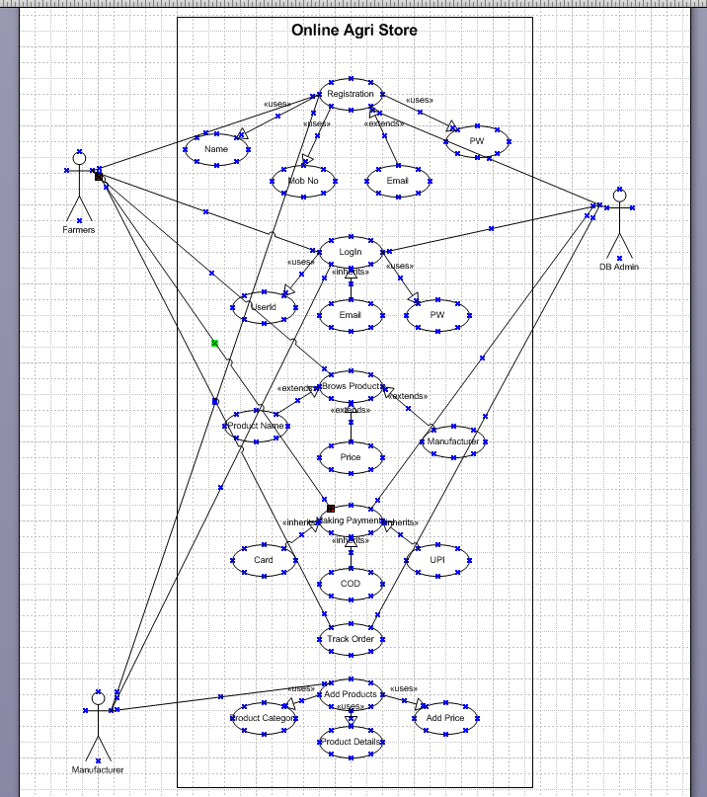

Question 11 – (minimum 5) Use Case Specs - 15 Marks
Prepare use case specs for all use cases
Answer
Use Case ID | UC001
Use case name | User Registration
Created by | Ms. Manju Last Updated by Apil 4 2024
Date Created | March 25 2023 Last Revision Date April 1 2024
Actor | Farmer, Manufacturer
Description | This use case allows a new user (farmer or manufacturer) to register for the platform.
Pre Condition | The user must have a valid email ID and mobile number.
Post Condition | The user account is successfully created and stored in the system.
Normal Flow/ Main Flow | Step 1. The user opens the application and selects “Register.”  Step 2. The system prompts the user to fill in details such as Name, Email, Mobile Number, Password, and Role (Farmer/Manufacturer).  Step 3. The user submits the registration form.  Step 4. The system validates the input data.  Step 5. If valid, the system sends a verification link or OTP.  Step 6. The user verifies using the link or OTP.  Step 7. The system confirms the registration and redirects to the login screen.
Alternative Flow | A1: Invalid Data Entry  If the user leaves any required field blank or enters invalid data (e.g., wrong mobile number format),  → The system displays an appropriate error message.  → The user must correct the input before proceeding.  Alternate Flow – A2: Email or Phone Already Registered  If the system finds that the email/phone number is already used,  → It alerts the user and suggests logging in or using another email.
Basic Flow | Step 1. The user opens the application (web or mobile).  Step 2. Clicks on "Register".  Step 3. Enter required details (name, mobile, email, password, type of user: Farmer or Manufacturer).  Step 4. The system validates inputs.  Step 5. If valid, the user receives a confirmation (OTP/email verification).  Step 6. User completes verification.  Step 7. The account is created, and a confirmation message is shown.

Use Case ID | UC002
Use case name | Login
Created by | Ms. Manju
Date Created
Actor | Farmer, Manufacturer
Description | This use case allows an existing user to log in to the system.
Pre Condition | The user must already be registered.
Post Condition | User is successfully logged in and redirected to the dashboard.
Normal Flow/ Main Flow | Step 1. The user clicks on “Login” from the homepage.  Step 2. The system prompts the user to enter their email/username and password.  Step 3. The user enters credentials and clicks “Submit.”  Step 4. The system verifies the credentials.  Step 5. Upon successful authentication, the user is directed to the dashboard/homepage.
Alternative Flow | Incorrect credentials: “Invalid email or password” is shown.
Basic Flow | Step 1. The user launches the application.  Step 2. Clicks on "Login".  Step 3. Enter username/email and password.  Step 4. System checks credentials.  Step 5. If valid, the user is authenticated and redirected to the dashboard.  Step 6. If invalid, an error message is shown, and the user is redirected.

Use Case ID | UC003
Use case name | Browse Product Catalogue
Created by | Ms. Manju
Date Created
Actor | Farmer
Description | Enables the farmer to view and search through available products (fertilizers, seeds, pesticides).
Pre Condition | The user must be logged in.
Post Condition | Products are displayed and accessible for further actions.
Normal Flow/ Main Flow | Step 1. The farmer logs into the platform.  Step 2. The system shows the home screen with product categories: Seeds, Fertilizers, and Pesticides.  Step 3. The farmer selects a category or enters a keyword in the search bar.  Step 4. The system fetches and displays a list of products matching the criteria.  Step 5. The farmer clicks on a product to see its details.  Step 6. The farmer can then choose to add the product to the cart or continue browsing.
Alternative Flow | No products found: “No results match your criteria” message is shown.
Basic Flow | Step 1. Farmer logs in to the platform.  Step 2. Clicks on "Browse Products" or "Search".  Step 3. Select category (Seeds, Fertilizers, Pesticides).  Step 4. Products are displayed based on filters or keywords.  Step 5. Farmer clicks on any product to view details.  Step 6. A farmer can add the product to the cart or wishlist.

Use Case ID | UC004
Use case name | Add Product (Manufacturer)
Created by | Ms. Manju
Date Created
Actor | Manufacturer
Description | Allows a manufacturer to add product details to the platform.
Pre Condition | The manufacturer must be logged in.
Post Condition | The product is added and shown in the catalogue.
Normal Flow/ Main Flow | Step 1. The manufacturer logs into the system.  Step 2. From the dashboard, the manufacturer clicks on “Add Product.”  Step 3. A form appears where the manufacturer enters product details such as Name, Type, Price, Description, and Uploads an Image.  Step 4. The manufacturer submits the form.  Step 5. The system validates the entries and saves the product.  Step 6. A success message is shown, and the product becomes visible to all farmers.
Alternative Flow | Missing or invalid data: The system highlights fields needing correction.
Basic Flow | Step 1. The manufacturer logs into their account.  Step 2. Navigates to the "Add New Product" section.  Step 3. Fills in product details (name, category, price, description, quantity, image).  Step 4. Clicks "Submit".  Step 5. The system validates the information.  Step 6. The product is added and visible in the public catalogue for farmers.

Use Case ID | UC005
Use case name | Purchase Product
Created by | Ms. Manju
Date Created
Actor | Farmer
Description | Allows the farmer to purchase a product from the platform.
Pre Condition | The user is logged in and has selected a product.
Post Condition | The order is placed, and payment is processed.
Normal Flow/ Main Flow | Step 1. The farmer logs into the system.  Step 2. Browses or searches for a desired product.  Step 3. Selects the product and clicks “Buy Now” or adds it to the cart.  Step 4. Proceeds to checkout and reviews the order.  Step 5. Enters shipping address and selects the payment method (Online or Cash on Delivery).  Step 6. Submits the order.  Step 7. The system processes the order, confirms the purchase, and provides an order ID with delivery estimate.
Alternative Flow | Payment failure: User is informed and asked to retry.
Basic Flow | Step 1. Farmer logs in and browses products.  Step 2. Selects a product and clicks "Buy Now" or "Add to Cart".  Step 3. Proceeds to checkout.  Step 4. Enter shipping address and select delivery option.  Step 5. Choose payment method (UPI, Debit/Credit Card, COD).  Step 6. Makes payment or confirms order.  Step 7. The system generates an order confirmation and estimated delivery date.

Question 12 – (minimum 5) Activity Diagrams - 15 Marks

Activity diagrams
Answer
Activity 1 – User Registration
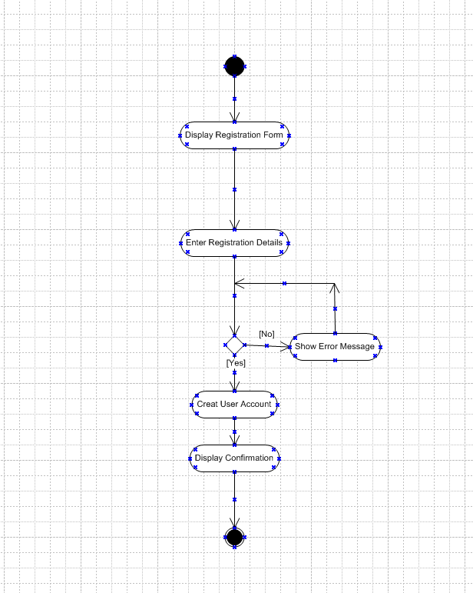

Activity 2 - Log in
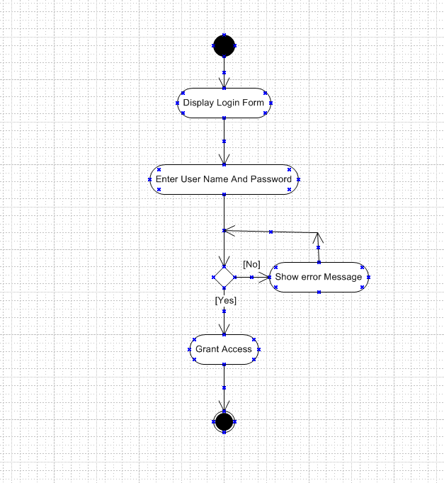

Activity 3 - Browse Product Catalogue
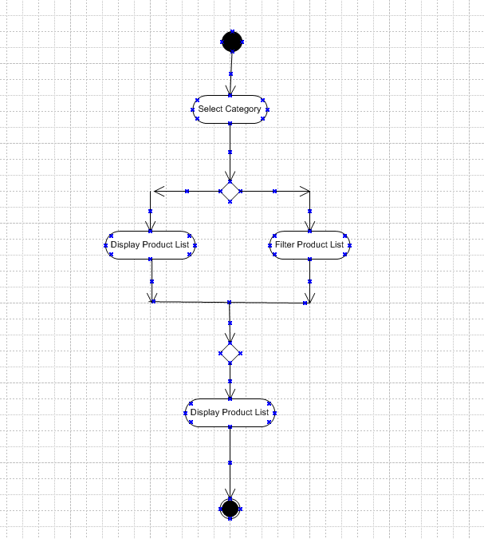

Activity – 4 Add Product by manufacturer
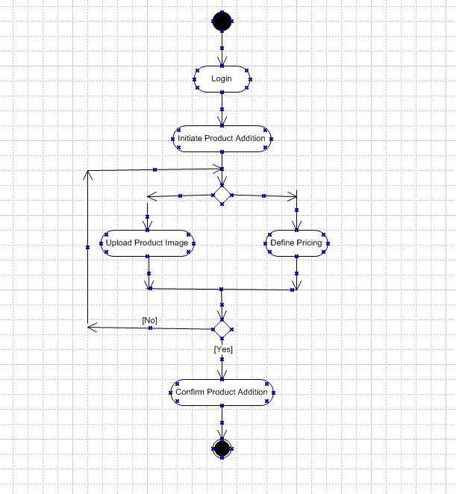

Activity 5 – Purchase Product
