CAPSTONE PROJECT 1 part 2

Online Agriculture Products Store Mr. Henry, after being successful as a businessman and has become one of the wealthiest persons in the city. Now, Mr. Henry wants to help others to fulfil their dreams. One day, Mr. Henry went to meet his childhood friends Peter, Kevin and Ben. They live in a remote village and do farming. Mr. Henry asked his friends if they are facing any difficulties in their day-to-day work. Peter told Mr. Henry that he is facing difficulties in procuring fertilizers which are very important for farm. Kevin said that he is also facing the same problem in-case of buying seeds for farming certain crops. Ben raised his concern on lack of pesticides which could help in greatly reducing pests in crops. After listening to all his friends’ problems, Mr. Henry thought that this is a crucial problem faced not only by his friends but also by so many other farmers. So, Mr. Henry decided to make an online agriculture product store to facilitate remote area farmers to buy agriculture products. Through this Online Web / mobile Application, Farmers and Companies (Fertilizers, seeds and pesticides manufacturing Companies) can communicate directly with each other. The main purpose to build this online store is to facilitate farmers to buy seeds, pesticides, and fertilizers from anywhere through internet connectivity. Since new users are involved, Application should be user friendly.

This new application should be able to accept the product (fertilizers, seeds, pesticides) details from the manufacturers and should be able to display them to the Farmers. Farmers will browse through these products and select the products what they need and request to buy them and deliver them to farmers location. Mr. Henry has given this project through his Company SOONY. In SOONY Company, Mr Pandu is Financial Head and Mr Dooku is Project Coordinator. Mr. Henry , Mr Pandu , and Mr Dooku formed one Committee and gave this project to APT IT SOLUTIONS company for Budget 2 Crores INR and 18 months Duration under CSR initiative. Peter, Kevin and Ben are helping the Committee and can be considered as Stakeholders share requirements for the Project. Mr Karthik is the Delivery Head in APT IT SOLUTIONS company and he reached out to Mr Henry through his connects and Bagged this project. APT IT SOLUTIONS company have Talent pool Available for this Project. Mr Vandanam is project Manager, Ms. Juhi is Senior Java Developer, Mr Teyson, Ms Lucie, Mr Tucker, Mr Bravo are Java Developers. Network Admin is Mr Mike and DB Admin is John. Mr Jason and Ms Alekya are the Tester. And you joined this team as a BA.

Question 1 – Audits - 5 Marks 4 Quarterly Audits are planned Q1 , Q2, Q3, Q4 for this Project What is your knowledge on how these Audits will happen for a BA ?

STAGE:-AUDIT REPORT (REQUIRMENT GATHERING PHASE)
Completed | 10 weeks (1 to 10 weeks)
Checklist | BRD Template,Elicitation results report
 | Duplicate reuirments report ,grouping of functionalities
 | Client sign off
 | Email communication:To,cc,bcc

STAGE:-AUDIT REPORT (REQUIRMENT ANALYSIS PHASE)
Completed | 7 weeks (16 to 23 weeks)
Checklist | UML DIAGRAMS,Business to functional requirments mapping
 | Client sign off documents
 | RTM document version control
 | Email communication:To,cc,bcc

STAGE:-AUDIT REPORT (DESIGN PHASE)
Completed | 7 weeks (31 to37 weeks)
Checklist | Utilization of tools
 | Document evidence on client communication
 | Stakeholder MOM
 | Email communication:To,cc,bcc

STAGE:-AUDIT REPORT (DEVELOPMENT PHASE)
Completed | 20 weeks (37to 60 weeks)
Checklist | JAD Session report
 | End user manual preaparation document
 | BA and developer MOM
 | Email communication:To,cc,bcc

STAGE:-AUDIT REPORT (TESTING PHASE)
Completed | 20weeks (58to 80 weeks)
Checklist | Test case summary
 | Training report to end users
 | Lesson learnt document
 | Email communication:To,cc,bcc

Question 2 – BA Approach Strategy - 6 Marks

What elicitation Techniques to apply:-
To effectively elicit information, consider using a combination of techniques like interviews, brainstorming, observation, document analysis, and prototyping, adapting your approach based on the project's complexity and stakeholder availability.
Some of the elicitation techniques are as follows:-
Common Elicitation Techniques:
- Brainstorming:
A group technique where participants generate ideas and solutions collaboratively, often used to discover a wide range of potential requirements.
- Observation:
Observing how people interact with systems or perform tasks to identify potential problems and hidden requirements.
- Prototyping:
Creating a working model or design of a solution to test with stakeholders and gather feedback, helping to validate requirements and refine the design.
- Document Analysis:
Reviewing existing documentation (e.g., reports, policies, procedures) to understand current processes and identify potential requirements.
- Surveys and Questionnaires:
Distributing surveys or questionnaires to a wider audience to gather opinions and gather data on requirements.
- Stakeholder Analysis:
Identifying and understanding the different stakeholders involved in a project, their roles, interests, and expectations, to ensure their needs are met.
- Interviews:
Conducting structured or unstructured interviews with stakeholders to gather information and clarify requirements.
- Joint Application Development (JAD):
A collaborative workshop involving stakeholders, business analysts, and developers to elicit and refine requirements in a structured and interactive environment.
- Reverse Engineering:
Analyzing existing systems or processes to understand their functionality and identify potential requirements, particularly useful in migration projects.
- Document Research:
Researching existing documents to understand the current market scenario and business needs.
- Use Case:
A technique used to elicit, specify, and refine solution requirements.

How to do stakeholder analysis:RACI Matrix
To perform stakeholder analysis using a RACI matrix, first identify all stakeholders and project tasks, then create a RACI matrix table, assigning roles (Responsible, Accountable, Consulted, Informed) for each task and stakeholder to clarify responsibilities and communication needs.

What documents to write:-
BRD ,FRD,Use case documentation,Test case documentation

What process to follow to sign off on the documents:-
Sign off to be taken on SRS.Sign off can be taken by using email confirmation from client.
To sign off on documents, identify the required signatories, ensure the document is complete and accurate, and then follow the designated process for electronic or physical signatures, often involving review and approval steps.

How to take approvals from the client:-
To effectively obtain client approvals, clearly present your work, solicit feedback early, establish a streamlined process, and maintain open communication throughout the process.
Establish a formal meeting with client and inform about continuos feedback.

What communication channels to establish and implement:-

To effectively communicate, establish and implement a mix of channels including email, instant messaging (like Slack or Microsoft Teams), video conferencing (like Zoom or Google Meet), social media (if relevant), and potentially live chat for customer service, ensuring each is used strategically for different purposes.
Bi weekly Sprint review meetings,weekly status meetings,monthly stakeholder updates.

How to handle change requests:-
To effectively handle change requests, establish a clear process, involve relevant stakeholders, assess the impact, and communicate decisions transparently.
Change request form,Do impact Analysis,approval process,documentation

How to update the progress of project to stakeholders

To effectively update project progress to stakeholders, establish a clear communication plan, use project management tools, provide regular updates, and be proactive in addressing concerns and managing expectations.
Weekly status reports,monthly Review meetings.

How to take sign off on UAT (Client project acceptance form)

To take sign-off on UAT, ensure all testing is complete, issues are resolved, and then formally document the client's acceptance with a project acceptance form, including details like project name, recipient, and a summary of results.
Conduct UAT
Fix Issues
Acceptance form
Final review meeting
Obtain sign off

Q3)3 Tier architecture:-

Application layer:- Presentation tier. This tier, which is built with HTML5, cascading style sheets and JavaScript, is deployed to a computing device through a web browser or a web-based application. The presentation tier communicates with the other tiers through application programming interface calls.
Screen,pages
Ecommerce site
Business logic layer:- referred to as the logic tier, is written in a programming language such as Java and contains the business logic that supports the application's core functions. The underlying application tier can either be hosted on distributed servers in the cloud or on a dedicated in-house server, depending on how much processing power the application requires.
Payment gateways,printer
Intermediary between two layers.

Database layer:-
Data tier. The data tier consists of a database and a program for managing read and write access to a database. This tier may also be referred to as the storage tier and can be hosted on-premises or in the cloud. Popular database systems for managing read/write access include MySQL, PostgreSQL, Microsoft SQL Server and MongoDB.
Storing and retrieving data.
Q4)Write about approach strategy for framing questions:-

5WH1 Framework
The 5W1H framework is a problem-solving and information-gathering tool that uses the questions "Who, What, Where, When, Why, and How" to gain a comprehensive understanding of a situation or problem.
Here's a breakdown of the 5W1H framework:
- Who: Identifies the individuals or groups involved in the situation or event.
- What: Describes the actions, events, or objects involved.
- Where: Specifies the location or place where the situation or event occurred.
- When: Indicates the time or date of the situation or event.
- Why: Explains the reasons or motivations behind the situation or event.
- How: Describes the method or process by which the situation or event occurred.

SMART Technique
The "SMART technique" refers to a method for setting goals that are Specific, Measurable, Achievable, Related, and Time-bound, ensuring they are clear, attainable, and focused.

RACI Matrix
A RACI matrix is a tool that helps define roles and responsibilities for a project. It's also known as a Responsibility Assignment Matrix.

UML Diagrams:-
A UML class diagram is important for object-oriented design, visually representing the static structure of a system. It shows classes, their attributes, operations, and relationships using rectangles.
To aid design ,development and communication between team members.

Q5)Elicitation Techniques - 6 Marks
Elicitation techniques are methods used to extract information, ideas, or requirements from stakeholders, often employed in business analysis, software development, and other fields, to understand needs and expectations. Common techniques include brainstorming, observation, prototyping, document analysis, surveys, and stakeholder analysis.,reverse engineering,JAD,Focus groups,Interview,questionare,use case specs,workshops.
Common Elicitation Techniques:

Brainstorming:-
Brainstorming is a group-oriented elicitation technique used to generate a wide range of ideas quickly, fostering creativity and problem-solving by encouraging participants to freely share their thoughts without immediate judgment.
Here's a breakdown of brainstorming as an elicitation technique:
What it is:
- Group-based:
Brainstorming involves a group of people (ideally 5-12) working together to generate ideas.
- Idea Generation:
The primary goal is to come up with as many ideas as possible within a set timeframe, focusing on quantity over quality initially.
- Free Flow of Ideas:
Participants are encouraged to share their thoughts without being judged or censored, allowing for a free flow of ideas.
- Facilitated:
A facilitator guides the brainstorming session, ensuring everyone participates and the discussion stays on track.

Document analysis:-
Document analysis, a valuable elicitation technique, involves reviewing existing documentation to extract information and identify requirements, particularly when subject matter experts are unavailable or to gain background knowledge before collaborative elicitation.
Here's a more detailed explanation:
What it is:
- Document analysis is a method of gathering information and eliciting requirements by examining existing documents related to a project, business, or system.
- It's a core technique in business analysis, helping to understand the current state, identify gaps, and verify assumptions.
- It can be used to discover implicit and hidden requirements that might not be explicitly stated

Reverse engineering:-
Reverse engineering as an elicitation technique involves analyzing an existing system or product to understand its functionality and requirements, especially when documentation is lacking or outdated, to extract implemented requirements.
Here's a breakdown of the technique:
What it is:
- Analyzing existing systems:
Reverse engineering focuses on understanding how a system or product works by examining its components, processes, and interactions.
- Extracting requirements:
The goal is to uncover hidden or implicit requirements that might not be explicitly documented, by deconstructing the system and identifying its underlying functionality.
- Migration projects:
It's particularly useful in migration projects where understanding the current system's functionality is crucial for building a new one.

Focus groups:-
A focus group elicitation technique involves gathering information and insights from a small group of people (typically 6-10) through a guided, interactive discussion, focusing on a specific topic or issue.
Here's a breakdown of the process:
1. Purpose and Scope:
- Define the research question: Clearly identify the topic or issue you want to explore.
- Set objectives: Determine what you hope to learn from the focus group.
- Determine the scope: Define the boundaries of the discussion to ensure it stays focused.
2. Participant Selection:
- Identify target audience:
Determine the characteristics of the people who would provide the most relevant insights.
- Recruit participants:
Ensure participants are representative of the target audience and willing to participate.
3. Facilitation and Discussion:
- Choose a skilled moderator:
Select someone who can guide the discussion, encourage participation, and keep the session on track.
- Develop a discussion guide:
Create a structured guide with open-ended questions to elicit detailed responses.

Observation:-

Requirement workshops:-
A requirements workshop is a structured, collaborative meeting where stakeholders and business analysts gather to elicit and refine project requirements, often using techniques like brainstorming, prototyping, and role-playing.
Here's a more detailed explanation:
What is a Requirements Workshop?
- Purpose:
To facilitate the gathering, discussion, and agreement on project requirements from multiple stakeholders.
- Structure:
A facilitated session, typically involving a group of stakeholders, including end-users, subject matter experts, and project team members.
- Goal:
To identify and document the needs, expectations, and functionalities required for a successful project outcome.
- Format:
Workshops can be structured as a series of exercises, discussions, and activities designed to elicit requirements.

JAD:-

Joint Application Development (JAD), a technique for gathering requirements, involves bringing together users, developers, and other stakeholders in a facilitated workshop to collaboratively define and refine system requirements, often speeding up the development process.
Here's a more detailed explanation:
What is JAD?
- Definition:
JAD is a structured approach to requirements gathering that emphasizes collaboration and interaction between users and developers.
- Purpose:
The primary goal of JAD is to identify and clarify system requirements in a timely and efficient manner, ensuring that the final product meets the needs of the users.
- How it works:
JAD sessions are typically facilitated by a trained facilitator, who guides the group through a series of discussions and activities to elicit and refine requirements.
- Benefits:
JAD can help to improve communication, reduce misunderstandings, and ensure that the final product meets the needs of the users.
Key Aspects of JAD:
- Facilitation:
A skilled facilitator plays a crucial role in guiding the JAD session, ensuring that all participants have a chance to contribute and that the discussions stay focused.
- Collaboration:
JAD emphasizes teamwork and collaboration between users, developers, and other stakeholders.
- Structured Approach:
JAD sessions follow a structured agenda and methodology to ensure that all aspects of the requirements are covered.
- Documentation:
The outcomes of JAD sessions are documented, providing a clear record of the agreed-upon requirements.

Interviews:-
Interviews are an effective technique for eliciting requirements by directly communicating with stakeholders. They help to build trust and collaboration, and can help to uncover hidden requirements.
How to conduct interviews for elicitation
- Identify key stakeholders: Understand the opportunities, risks, and benefits of change
- Ask clarifying questions: Ensure you get detailed information and avoid misunderstandings
- Observe body language: Gauge stakeholder interest and concerns
- Ask probing questions: Uncover hidden requirements and expectations

Prototyping:-
Prototyping can be a powerful requirement elicitation technique, allowing developers to create a tangible representation of a product or feature, enabling stakeholders to provide feedback and refine requirements early in the development process.
Here's a breakdown of how prototyping aids in requirement elicitation:
1. What is Prototyping?
- Prototyping involves creating a simplified or early version of a product or system to demonstrate its features and functionality.
- It can be done using various methods, including paper sketches, wireframes, mockups, or even interactive models.
- The goal is to allow stakeholders to visualize and interact with the product, leading to better understanding and feedback.
2. How Prototyping Facilitates Requirement Elicitation:
- Early Feedback:
Prototyping allows stakeholders to see and interact with a potential solution early in the development cycle, enabling them to provide feedback and suggest improvements.
- Identifying Unmet Needs:
By interacting with a prototype, stakeholders can identify areas where their needs are not being met or where the product is not functioning as intended.
- Clarifying Ambiguous Requirements:
Prototyping can help clarify ambiguous or unclear requirements by allowing stakeholders to see how the product is intended to work in practice.
- Facilitating Collaboration:
Prototyping can foster collaboration among stakeholders by providing a common ground for discussion and feedback.
- Reducing Development Costs:
By identifying and addressing issues early through prototyping, developers can reduce the risk of costly rework later in the development process.
3. Types of Prototyping:
- Low-Fidelity Prototyping:
Quick and inexpensive prototypes that focus on the overall structure and functionality of the product.
- High-Fidelity Prototyping:
More detailed and realistic prototypes that simulate the final product's appearance and behavior.
4. Steps for Using Prototyping in Requirement Elicitation:
- Define the Purpose and Scope:
Clearly define the goals, features, and target users of the prototype.
- Choose the Right Approach:
Select the appropriate prototyping method (low-fidelity or high-fidelity) based on the project's needs and resources.
- Involve Stakeholders:
Engage stakeholders in the prototyping process to gather their input and feedback.
- Iterate and Refine:
Continuously iterate and refine the prototype based on stakeholder feedback until the requirements are well-defined.

Questionare:-
Questionnaires can be a valuable tool in elicitation, allowing for efficient data collection from a large group of stakeholders by presenting structured questions and collecting responses.
Here's a breakdown of how questionnaires can be used for elicitation:
1. What is Questionnaire Elicitation?
- Structured Data Collection:
Questionnaires, also known as surveys, are a structured method for gathering information from stakeholders through a set of predefined questions.
- Efficiency:
They are particularly useful for collecting insights from a large number of people, making them efficient for gathering diverse perspectives.
- Focus on Needs and Expectations:
Questionnaires can help uncover user needs, expectations, and potential system requirements.
2. How to Design an Effective Questionnaire
- Clear Purpose:
Define the purpose of the survey and ensure it aligns with the project's objectives.
- Target Audience:
Identify the specific stakeholders who will be surveyed and ensure the questionnaire is relevant to their roles and responsibilities.
- Clear Instructions:
Provide clear and concise instructions on how to complete the questionnaire, including any specific formats or response options.
- Avoid Ambiguity:
Ensure questions are clear, concise, and avoid leading questions or double-barreled questions (questions that ask two things at once).
- Keep it Brief:
Aim for a questionnaire that is user-friendly and can be completed relatively quickly to encourage participation.
- Pilot Test:
Before deploying the questionnaire, conduct a pilot test to identify any potential issues or areas for improvement.
3. Types of Questions to Include
- Open-ended Questions:
Allow for detailed responses and insights, but can be more challenging to analyze.
- Closed-ended Questions:
Provide structured response options (e.g., multiple choice, rating scales) and are easier to analyze.
- Demographic Questions:
Gather information about the respondents (e.g., role, experience) to understand the context of their responses.
- Questions about Needs and Expectations:
Focus on understanding the stakeholders' needs, pain points, and expectations for the system or project.
- Questions about Processes and Procedures:
Explore how stakeholders currently work and identify areas for improvement.
- Questions about Goals and Objectives:
Understand the stakeholders' goals and objectives for the project.
4. Conducting the Questionnaire Process
- Distribution: Choose an appropriate method for distributing the questionnaire (e.g., email, online survey platform).
- Follow-up: Consider sending reminders or follow-up emails to encourage participation.
- Data Analysis: Analyze the responses to identify trends, patterns, and key findings.
- Documentation: Document the findings and use them to inform the development process.

Use cases:-
Use case elicitation is a technique to discover and document how users interact with a system to achieve specific goals, focusing on the user's perspective and system interactions. It's a powerful tool for understanding and documenting requirements, ensuring the system meets user expectations.
Here's a more detailed explanation:
What are Use Cases?
- Focus on user goals:
Use cases describe how users interact with a system to achieve a specific goal, rather than focusing on the system's internal workings.
- User-centric perspective:
They capture the interactions from the user's perspective, ensuring the system's functionality aligns with user needs.
- Describe "what," not "how":
Use cases outline what the system should do, not how it should do it.
- Components:
  - Actors: External entities (e.g., users, machines) that interact with the system.
  - Use Cases: Sequences of interactions between actors and the system to achieve a specific goal.
  - Use Case Diagram: A visual representation of actors, use cases, and their relationships.
How to Elicit Use Cases:
- Identify Actors:
Determine who interacts with the system (e.g., customer, administrator, technician).
- Identify Use Cases:
  - Brainstorming: Gather stakeholders and brainstorm possible user goals and interactions.
  - Scenario Analysis: Analyze typical user workflows and identify potential use cases.
  - Event Decomposition: Identify events that trigger system responses and map them to use cases.
  - Use Case Templates: Use structured templates to capture use case information (e.g., preconditions, main success scenario, alternative paths, postconditions).
- Document Use Cases:
  - Use Case Diagram: Visually represent actors, use cases, and their relationships.
  - Use Case Description: Provide a detailed narrative of each use case, including steps, preconditions, and postconditions.
- Iterate and Refine:
Continuously review and refine use cases based on feedback and evolving requirements.
Benefits of Using Use Cases:
- Improved communication:
Use cases facilitate clear communication between stakeholders, developers, and testers.
- Better requirement understanding:
They provide a clear and structured view of the system's functionality and user interactions.
- Reduced development risks:
By focusing on user goals, use cases help ensure that the developed system meets user needs and expectations.
- Enhanced testability:
Use cases provide a basis for creating test cases and verifying system functionality.

Question 6 – This project Elicitation Techniques - 5 Marks
Which Elicitation Techniques can be used in this Project and Justify your selection of Elicitation Techniques? Prototyping Use case Specs Document Analysis Brainstorming
Effective business analysis relies heavily on gathering accurate and relevant information from stakeholders. Here are some of the best elicitation techniques:
1. Interviews
- Description: One-on-one discussions with stakeholders to gather detailed insights.
- Best Practices: Prepare open-ended questions, listen actively, and follow up on interesting points.
2. Surveys and Questionnaires
- Description: Structured forms to collect quantitative and qualitative data from a larger audience.
- Best Practices: Keep questions clear and concise, use a mix of question types, and ensure anonymity if needed.
3. Workshops
- Description: Collaborative sessions with multiple stakeholders to brainstorm and discuss requirements.
- Best Practices: Use a facilitator to guide discussions, set clear objectives, and encourage participation from all attendees.
4. Focus Groups
- Description: Guided discussions with a selected group of stakeholders to gather diverse perspectives.
- Best Practices: Choose participants from different backgrounds, encourage interaction, and keep the discussion focused.
5. Observation
- Description: Directly observing users in their environment to understand workflows and challenges.
- Best Practices: Take detailed notes, avoid interrupting users, and look for non-verbal cues.
6. Document Analysis
- Description: Reviewing existing documentation such as reports, manuals, and previous project artifacts.
- Best Practices: Identify gaps in documentation, cross-reference with stakeholder inputs, and ensure relevance to current needs.
7. Prototyping
- Description: Creating preliminary versions of products or systems to gather feedback.
- Best Practices: Involve stakeholders early, iterate based on feedback, and focus on key functionalities.
8. Use Cases and User Stories
- Description: Defining specific scenarios in which users interact with a system to understand requirements.
- Best Practices: Collaborate with users to write realistic scenarios, prioritize them, and ensure they align with business goals.
9. Mind Mapping
- Description: Visual tool to organize thoughts and ideas around a central concept.
- Best Practices: Use it to explore different facets of a problem or requirement, encourage group contributions, and keep it clear.
10. Brainstorming
- Description: Generating a large number of ideas in a short period to explore potential solutions.
- Best Practices: Foster a non-judgmental environment, encourage wild ideas, and build on each other’s suggestions.
JUSTIFICATION :-

The two techniques which can be useful for this process are:-

Brainstorming and proto typing.The main stakeholders are the farmers,manafacturers and Project Team and others.
It will be better to do brainstorming to get new ideas and make a prototype for it.A model based on how the software should look and and meet end user requirements.

Brainstorming –
Designed to: Uncover new, innovative ideas and solutions.
How to: Assemble a mix of key stakeholders for an open conversation on innovative ideas and solutions. As facilitator, the business analyst ensures that the conversation stays on topic and records ideas discussed.
Prototyping –
Use case: When stakeholders do not understand written technical requirements and would benefit from seeing a version of the product.
Designed to: Collect feedback from non-technical stakeholders by showing them an example with which they can physically interact.
How to: At first prototyping can be executed via storyboard, interactive screen, virtual mock-up, navigation flow, etc. The exact method depends on the project, but it is usually an iterative process that is improved based on input. As more requirements come forward, more detailed prototypes are created to ensure they meet the expectations as recorded.

Q7)Write 10 business requirments:-
Identify Business Requirements (which includes Stakeholder Requirements)
BR001 – Farmers should be able to search for available products in fertilizers, seeds, pesticides BR002 – Manufacturers should be able to upload and display their products in the application
BR003:-User should be able to search for available products
BR004:-User should be able to login with username and password
BR005:-User should get a email confirmation for their order
BR006:-User should be able to make payment in COD,Credit card,debit card
BR007:-:-Manufacturer should be able to add products and display products on menu
BR008:-User should be able to browse for available products
BR009:-User should be able to add products to wish list
BR010:-User should be able to track delivery of product
BR11:-User should get details of the products.

Q8)Assumptions:-
Assumption 1:- User should be able to login to the online store through facebook ,google.
Assumption 2:-User has knowledge of agricultural products.
Assumption 3:-online shopping trend is increasing.
Assumption 4:-designers can make new designs of portal
Assumption 5:-User have online accounts for secure payment processing.

Q9)Project requirments Priority:-

Req ID | Req Name | Req description | Priority
BR001 | User search for products | User should be able to search for available products | 3
BR002 | User browse products | User should be able to browse for available products | 2
BR003 | User create login | User should be able to login with username and password | 1
BR004 | Email confirmation | User should get a email confirmation for their order | 4
BR005 | Payment gateway | User should be able to make payment in COD,Credit card,debit card | 5
BR006 | Manufacturer can add product in catalog | Manufacturer should be able to add products and display products on menu | 8

BR007 | Add to cart option | User should be able to add products to wish list | 7
BR008 | Product delivery tracking | User should be able to track delivery of product | 9
BR009 | Product information | User should get details of the products. | 6

Q10)Preapare a Use case Diagram:-

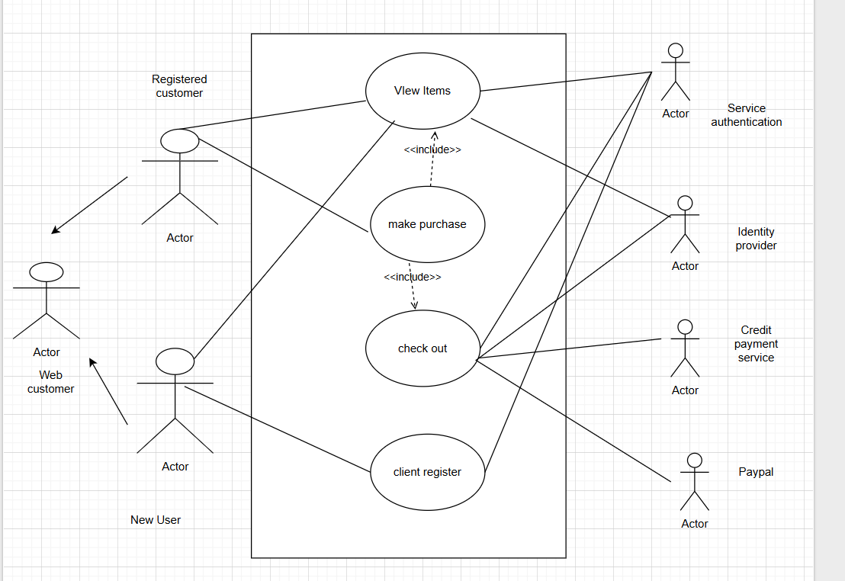

Q11)Preapare 5 Use case specific Document:-
Login to online agricultural store:-

Use case ID | UC001
Use case Name
  Verify successful login with valid credentials
Created by | Ritika Last updated by 20march 2025
Date created | 19march Last revision Date 20 march 2025
Actor | Farmer,supplier
Description | This use case describes how user can login to the website
Pre conditions | User should be able to register on the portal
Post conditions | User should receive confirmation for login
Normal flow /Basic flow | Step1:User visits the online agricultural store website  Step 2:-User is asked to sign in  Step3:User clicks on create account  Step4:-User is asked to enter details such as name,dob,shopping preferences  Mobile number  Step 4:-User is asked to create an new password  Step 5:-User is successfully registered  Step 6:-User is redirected to home page  Step7:-User enters username and password  Step 8:-User enters CAPTCHA  Step 9:-User is successfully logged in
Alternative flow | At step 4:-User enters wrong details  User will be redirected to fill in details again  At Step 7:-User enters wrong user name and password  User will be redirected to forgot username and password  At step 8:-If user enters wrong CAPTCHA  User will be redirected to home page  At step 2:User clicks on sign and enters wrong username and password  User will be redirected to create new account
Exceptions | If internet connectivity is lost while visiting the site  The user will be redirected to check your internet connectivity
Frequency of use | High
Assumptions | It is assumed customer is registered  It is assumed customer has online shopping knowledge

Use case ID | UC002
Use case Name
  Verify password reset functionality
Created by | Ritika Last updated by 20march 2025
Date created | 19march Last revision Date 20 march 2025
Actor | Farmer,supplier
Description | To verify password reset functionality of the agricultural store
Pre conditions | User is successfully registered on the website
Post conditions | User is able to reset the password
Normal flow /Basic flow | Step 1:User visits the home page  Step2:-User is asked to sign in  Step 3:-User sign in with username and password  Step4:-User click on change password  Step 5:User is asked to enter a new password meeting specifications such as use special character,1 upper case and lowercase character ,1 numeric and 8 words length  Step 6:User enters captcha  And should be a strong password  Step 7:User enters successfully resets the password  Step 8:User is redirected to home page  Step 9:User successfully login with username and new password
Alternative flow | At step 5:If user enters a wrong password  User is redirected to password does not meet guidelines  At step 5:If user enters all lowercase letters  User is redirected to password does not meet guidelines  At step 6:IF user enters wrong CAPTCHA  User is prompt with invalid captcha  At step 9:If user enters wrong login id and password  User is prompt with invalid user name and password
Exceptions | If internet connectivity is lost during login  User will be prompt with check your Internet connenctivity
Frequency of use | Low
Assumptions | User is successfully registered  User has knowledge of online shopping

Use case ID | UC003
Use case Name
  Make online purchase of product
Created by | Ritika Last updated by 20march 2025
Date created | 19march Last revision Date 20 march 2025
Actor | Farmer,supplier
Description | To make an online purchase of product
Pre conditions | User is successfully registered on the website
Post conditions | User is able to make online purchase of products
Normal flow /Basic flow | At step 1:-User enters username and password  Step 2:-User is successfully logged in  Step 3:User searches for a product  Step4:User is able to browse and search for products  Step 5:-user is able to add products to cart  Step 6:-User is able to add products to wish list  Step 7:-User is able to make payment with COD,debit card and credit card  Step 8:-User is able to get confirmation email of purchase  Step 9:user reviews the product  Step 9:User is able to success fully log out
Alternative flow | At step 1:If user is not able to login  It prompts invalid username and password  At step 1:-User enters username and prompted to get OTP  User enters OTP and is logged in  At step 3-If user is unable to browse or search products  User dials customer care  At step 7:if user is unable to make payment  User dials customer care  At step 8:-If user is unable to get confirmation mail  Users dials customer care  At step9:If user unable to add add review user contact customer care
Exceptions | If internet connectivity is slow user is prompted with check your Internet connectivity
Frequency of use | High
Assumptions | User is successfully logged in  User has knowledge of online shopping

Use case ID | UC004
Use case Name
  Verify product delivery and purchase
Created by | Ritika Last updated by 20march 2025
Date created | 19march Last revision Date 20 march 2025
Actor | Farmer,supplier
Description | To Verify delivery of product and purchase a new product
Pre conditions | User is successfully registered on the website
Post conditions | User is able to make payments and product is delivered and purchased .
Normal flow /Basic flow | At step 1:User is able to make payment through credit,debit card,COD  Step 2:-user is asked to fill in shipping address  Step 3:-User is asked to enter delivery date  Step 4:-User is able to apply for discounts and check out while making payment  Step 5:-User is able to confirmation message with OTP regarding estimated delivery date  Step 6:-User is able to track payment with shipment id received on email  Step 6:-User is able to get message when product is out for delivery  Step 7:-User receives the product.
Alternative flow | At step 1:-If user is not able to make payment  User is prompted with invalid banking details  At step 2:if user enters wrong pin code  User is prompted with enter correct delivery code  At step 4:if user is unable to apply discounts  User contacts customer care  At step 6:-if user is not able to track shipment  User contacts customer care  At step 7:if user does not get confirmation mail  User dials customer care  At step 7:-if product is delivered on estimated delivery date  User calls customer care
Exceptions | If internet connectivity is poor user is prompted with please check your internet connectivity
Frequency of use | Medium
Assumptions | User is able to successfully login  User has online shopping knowledge

Use case ID | UC005
Use case Name | Verify contact Us functionality
Created by | Ritika Last updated by 20march 2025
Date created | 19march Last revision Date 20 march 2025
Actor | Farmer,supplier
Description | This describes the contact Us functionality of website
Pre conditions | User is able to successfully register
Post conditions | User is able to contact customer care
Normal flow /Basic flow | Step 1:-user clicks on contact us  Step 2:-user is able to see email id and customer care number  Step 3:-user dials customer care  Step 4:-user is directed to menu of customer support  To purchase a new product ,to register complain  Step 5:-user enters the number  Step 6:-User is able to connect with agent  Step 8:-user mentions his concern  Step 9:-user is guided by agent  Step 10:-user logs in again and makes purchase
Alternative flow | At step 2 if user is unable to see the email id  User dials customer care  At step 3:-if user is unable to make payment user dials customer care  At step 4:-user is un able to review product  User dials customer care and registers complain  At step 9:if agent does not answer user’s request user requests to escalate and talk to manager  At step 10:if request is not escalated  User talks to senior manager  And user gets incident logged and confirmation mail from user
Exceptions | If internet is slow user is prompted to check internet connectivity of user
Frequency of use | High
Assumptions | User is able to successfully register  User has knowledge of online shopping

Q12)Preapare 5 Activity Diagrams:-

User registration
Search for products
Add products
Making a payment
Make delivery

1)User registration

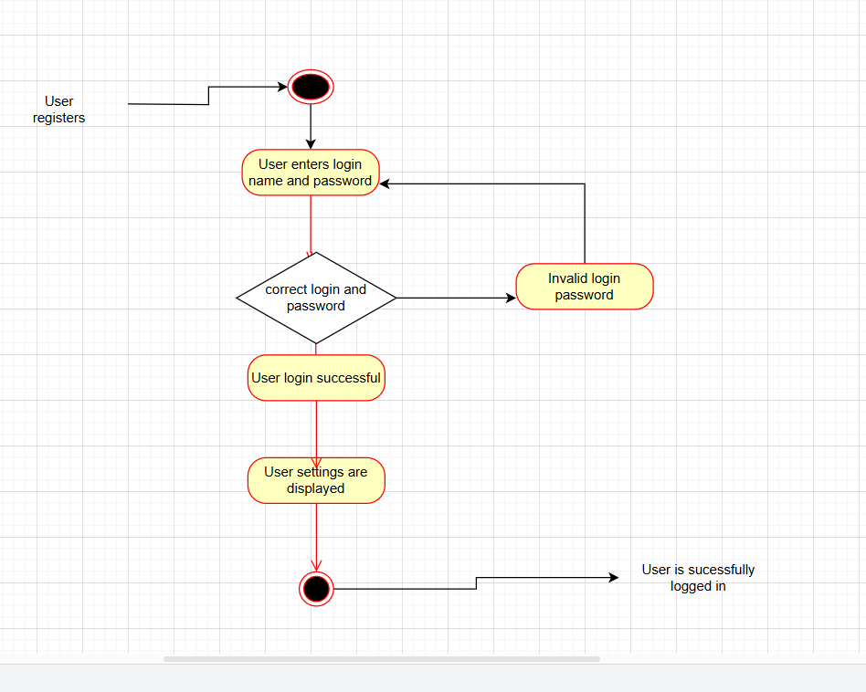

2)search for products:-
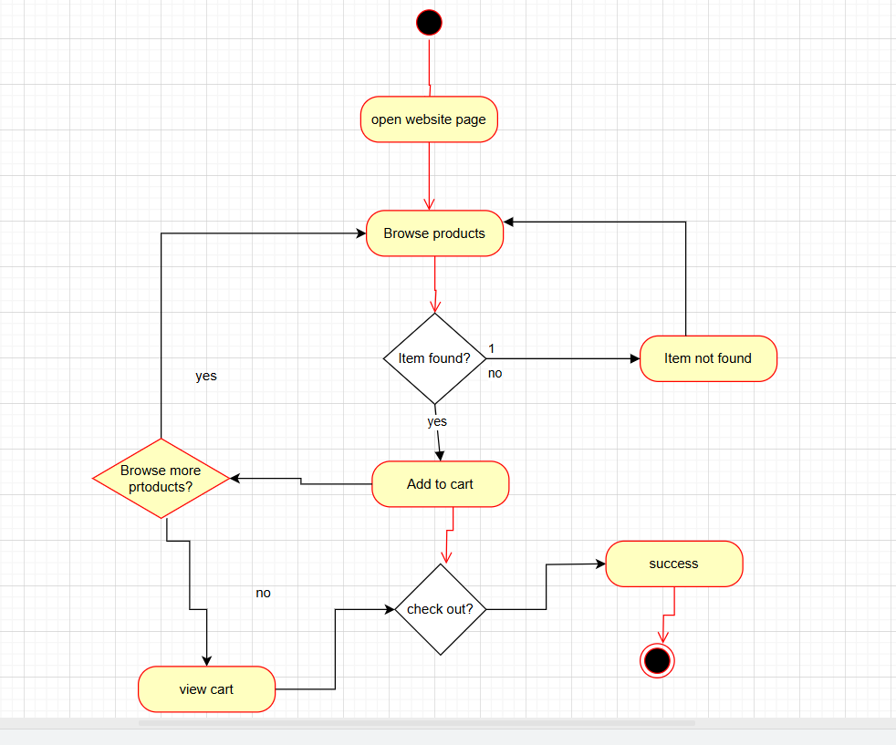

3)Add products to the cart

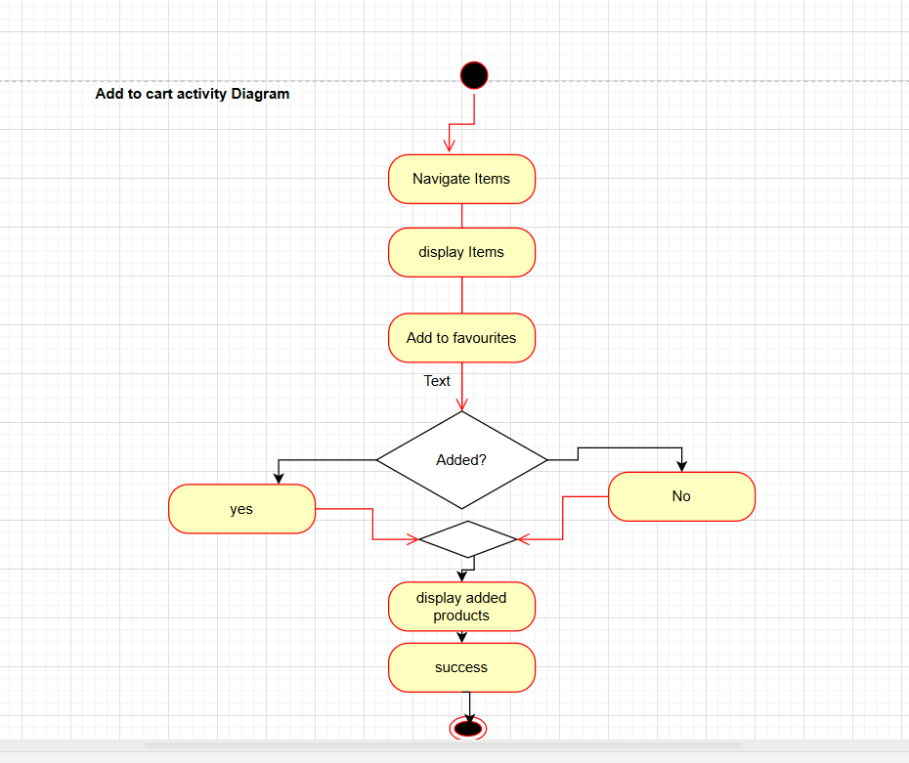

4)Making a payment
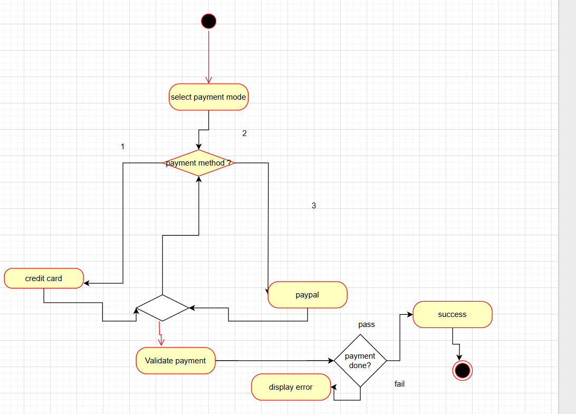

5)Delivery

