- Identify Business Process Model for Online Agriculture Store – (Goal, Inputs, Resources, Outputs, Activities, Value created to the end Customer)
Ans:
1. Goal
To provide a convenient, efficient, and reliable platform for farmers, agri-businesses, and consumers to purchase agricultural products and services online.

2. Inputs
- Product Information: Names, descriptions, images, prices, stock status, and specifications of seeds, fertilizers, equipment, etc.
- Customer Information: Customer profiles, contact details, purchase history, preferences.
- Order Information: Product selected, quantity, payment method, shipping address, delivery instructions.

3. Resources
- Digital Platform: Responsive website or mobile application for browsing, ordering, and tracking.
- Inventory Management System: Real-time tracking of stock levels, product availability.
- Secure Payment Gateway: Integration with UPI, credit/debit cards, net banking, wallets, etc.
- Logistics & Delivery Partners: Network of couriers or in-house delivery teams.
- Human Resources: Customer support agents, warehouse staff, marketing team, and IT personnel.

4. Outputs
- Fulfilled Orders: Products delivered successfully to customers.
- Transaction Records: Invoices, receipts, order history.
- Delivery Notifications: Real-time order tracking and shipment status.
- Customer Feedback and Reviews: Insights for service improvement.
- Analytics Reports: Sales trends, product performance, and customer behavior.

5. Activities
- Product Onboarding: Adding and updating agricultural products on the platform.
- Order Processing: Verifying payments, confirming stock, and initiating delivery.
- Inventory Monitoring: Replenishing stock, preventing overselling or shortages.
- Customer Engagement: Handling queries, resolving complaints, post-sale support.
- Marketing & Promotions: Running ad campaigns, discount offers, and loyalty rewards.
- Data Analysis: Studying customer patterns to improve services and recommendations.

6. Value Created to the End Customer
- Convenience: Anytime, anywhere access to agricultural products.
- Variety and Comparison: Ability to compare prices, brands, and specifications easily.
- Transparency: Clear product details, user reviews, and return policies.
- Efficiency: Saves time and effort with doorstep delivery and online payments.
- Support: Access to agricultural guidance and after-sales service.

2. Mr Karthik is doing SWOT analysis before he accepts this project. What Aspects he Should consider as Strengths, as Weaknesses, as Opportunity and as Threats.
Ans:
SWOT Analysis of an Online Agricultural Store
Strengths (Internal Positive Factors)
- Wide Product Range: Offers a diverse selection of seeds, fertilizers, equipment, and agri-accessories catering to different farming needs.
- Convenience for Customers: Enables farmers and rural buyers to shop 24/7 from their homes or farms, saving time and travel costs.
- Lower Operational Costs: Reduces expenses related to rent, physical maintenance, and in-store staffing compared to a traditional retail outlet.
- Wider Market Reach: Can serve customers in remote and underserved rural regions, increasing accessibility to quality agri-products.

Weaknesses (Internal Negative Factors)
- Lack of Physical Interaction: Customers can't inspect, feel, or test the quality of products before purchasing, possibly leading to mistrust or dissatisfaction.
- Technical Dependence: Website downtime, slow loading, or payment failures can negatively impact user experience and sales.
- Limited Human Touch: Absence of in-person customer service may reduce personalized recommendations and relationship-building.
- Logistics Complexity: Difficulties in shipping perishable or bulky products, especially to remote areas, can lead to delays or increased costs.

Opportunities (External Positive Factors)
- Market Expansion: Scope to tap into new geographical regions and customer segments, including small-scale farmers and agri-entrepreneurs.
- Service Diversification: Potential to add related services like soil testing, crop consultancy, agri-finance, or e-learning modules on modern farming.
- Strategic Collaborations: Partnering with NGOs, agri-influencers, farmer co-operatives, or government schemes to increase brand reach and trust.
- Data Analytics: Utilizing purchase patterns, location trends, and feedback to enhance product offerings and run effective targeted marketing campaigns.

Threats (External Negative Factors)
- Rising Competition: Presence of established e-commerce platforms and specialized agri-retailers can lead to pricing pressures and customer loss.
- Cybersecurity Concerns: Threats like hacking, data breaches, or payment frauds may compromise customer trust and store integrity.
- Consumer Behavior Shifts: Economic uncertainties or seasonal buying patterns can disrupt sales; customers may return to offline purchasing.
- Regulatory and Legal Barriers: Must comply with agri-product safety standards, environmental norms, packaging regulations, and e-commerce taxation rules—failure can result in penalties or loss of credibility.

3. Mr Karthik is trying to do feasibility study on doing this project in Technology (Java), Please help him with points (HW SW Trained Resources Budget Time frame) to consider in feasibility Study.
Ans:
1. Hardware Requirements
- Servers:
  - Identify required server specifications (CPU, RAM, storage) based on projected website traffic and data load.
  - Consider cloud-based hosting options (e.g., AWS, Azure) for scalability and reliability.
- Networking Infrastructure:
  - Set up secure, high-speed internet connectivity with firewalls, VPN access, and SSL certificates to ensure safe transactions.
  - Ensure uptime and redundancy through load balancers and backup systems.
- Devices and Compatibility:
  - Ensure compatibility with user devices—PCs, laptops, tablets, and smartphones.
  - Conduct responsive design testing for varied screen sizes and browsers.

2. Software Requirements
- E-commerce Platform:
  - Select a Java-compatible platform (e.g., Spring Boot + Thymeleaf, or Java-based CMS like OpenCMS or Broadleaf Commerce).
  - Key features: product listings, inventory control, shopping cart, secure checkout, and user authentication.
- Content Management System (CMS):
  - Integrate a CMS for easy content updates, such as adding product descriptions, photos, blogs, or news articles.
- Security Measures:
  - Implement SSL encryption, firewalls, user role permissions, and secure payment gateways.
  - Use OWASP security practices to protect against common vulnerabilities like SQL injection or cross-site scripting (XSS).

3. Trained Resources
- Technical Expertise:
  - Recruit or train developers skilled in Java, Spring framework, REST APIs, HTML/CSS, JavaScript, and database technologies (MySQL, PostgreSQL).
  - Need UI/UX designers and QA testers for front-end and functionality testing.
- Marketing and Sales Team:
  - Employ professionals with experience in:
    - SEO and digital marketing
    - Social media management
    - Email marketing tools and CRM platforms
    - Agricultural domain knowledge for effective customer communication

4. Budget Estimation
- Development Costs:
  - Web development tools, licenses, domain registration, and cloud hosting fees.
  - Hiring freelance or full-time developers, designers, and QA testers if in-house resources are insufficient.
- Maintenance and Support:
  - Allocate for bug fixes, feature enhancements, server upgrades, and ongoing security patches.
- Marketing and Promotions:
  - Paid ad campaigns (Google Ads, Facebook/Instagram), content marketing, influencer partnerships, and loyalty programs.
  - Branding, logo design, and offline marketing (flyers, agriculture exhibitions).

5. Time Frame
- Development Timeline:
  - Planning and Design: 2–3 weeks
  - Development Phase: 6–10 weeks (depending on scope and team size)
  - Testing & Quality Assurance: 2–3 weeks
  - Final Deployment: 1 week
- Launch and Growth Phase:
  - Initial Market Launch: First 2 months after deployment
  - Customer Acquisition & Supplier Onboarding: Ongoing
  - Platform Optimization (based on feedback and analytics): First 6 months

4. Mr Karthik must submit Gap Analysis to Mr Henry to convince to initiate this project. What points (compare AS-IS existing process with TO-BE future Process) to showcase in the GAP Analysis.
Ans:
Gap Analysis for an Online Agricultural Store
1. Website Design and User Experience
- AS-IS:
  - Basic or outdated design
  - Limited mobile responsiveness
  - Complicated navigation
- TO-BE:
  - Modern, responsive UI/UX optimized for all devices
  - Intuitive layout with easy navigation
  - Faster load times and interactive features
- Gap Identified:
  - Lack of mobile compatibility
  - Poor navigation affecting user retention
  - Unoptimized design for rural/low-bandwidth users

2. Product Catalog and Inventory Management
- AS-IS:
  - Limited product categories and inconsistent listings
  - Manual inventory tracking
- TO-BE:
  - Categorized, searchable, and filterable product listings
  - Real-time inventory management with supplier integration
- Gap Identified:
  - No automation in stock updates
  - Lack of searchable taxonomy or filters

3. Order Processing and Fulfillment
- AS-IS:
  - Manual order entry and confirmation
  - No real-time tracking for users
- TO-BE:
  - Automated order processing, digital payment, order status updates, and delivery tracking
- Gap Identified:
  - No logistics integration
  - Delay in order confirmations and lack of transparency

4. Customer Relationship Management (CRM)
- AS-IS:
  - Basic or no centralized CRM system
  - Limited understanding of customer behavior
- TO-BE:
  - Fully integrated CRM with user profiles, support tickets, and feedback analytics
- Gap Identified:
  - No personalization or communication tracking
  - Poor customer follow-up and engagement

5. Marketing and Promotion
- AS-IS:
  - Minimal online presence
  - Little to no digital advertising or content strategy
- TO-BE:
  - Active digital marketing across platforms (SEO, ads, email, social media)
  - Targeted campaigns using customer data
- Gap Identified:
  - Poor brand visibility online
  - No ongoing customer engagement strategy

6. Analytics and Reporting
- AS-IS:
  - Manual or no analytics
  - No insights into sales, traffic, or user behavior
- TO-BE:
  - Automated dashboard for real-time analytics and decision-making
  - Reporting tools for sales trends, inventory, customer behavior
- Gap Identified:
  - No data-driven decision-making
  - Missed opportunities due to lack of performance insights

7. Security and Privacy
- AS-IS:
  - Basic login security and minimal encryption
  - No formal data protection policy
- TO-BE:
  - SSL certificates, encrypted transactions, user data privacy compliance (e.g., GDPR)
  - Regular security audits and multi-factor authentication
- Gap Identified:
  - Vulnerable to data breaches and trust issues
  - Lack of compliance with global data standards

8. Integration and Scalability
- AS-IS:
  - Standalone system with no external integrations
  - Limited scalability for future growth
- TO-BE:
  - API integrations with logistics, suppliers, payment gateways
  - Scalable architecture to support traffic spikes and expansion
- Gap Identified:
  - System cannot handle large-scale operations
  - No integration with third-party services or partners

9. Training and Support
- AS-IS:
  - No formal training for staff or users
  - Basic support via email or phone
- TO-BE:
  - User manuals, video tutorials, chatbots, and 24/7 support system
  - Regular training and onboarding for employees
- Gap Identified:
  - Users lack confidence in using the platform
  - High dependency on manual support

5. List down different risk factors that may be involved (BA Risks And process/Project Risks)
Ans: Business and Project Risks for the Online Agricultural Store
Business Risks:
- Market Demand: There’s a possibility that farmers and rural customers may not show enough interest in buying agricultural products online, which can affect sales.
- Competition: Other well-established online platforms selling similar products might make it difficult to build our customer base.
- Supplier Reliability: If suppliers delay deliveries or run out of stock, it can directly affect customer satisfaction.
- Pricing Strategy: If prices are set too high, customers may not buy. If they’re too low, we may not make enough profit.
- Customer Adoption: Many customers, especially in rural areas, may still prefer traditional buying methods. They might be hesitant to use online platforms due to trust or convenience issues.
Project Risks:
- Technology Infrastructure: If the website is slow or faces technical issues, it could lead to a poor user experience and loss of trust.
- Data Security: Online platforms are always at risk of cyber-attacks. We must ensure customer data and payment details are secure.
- Payment Processing: If payments fail or transactions are not smooth, customers may lose trust and avoid repeat purchases.
- Logistics and Delivery: Managing deliveries in remote or rural areas can be difficult and may lead to delays.
- Regulatory Compliance: The platform must follow all legal guidelines related to agricultural products and e-commerce, or else we could face penalties.
To reduce these risks, we’ll need proper planning, regular monitoring, and backup plans wherever necessary.
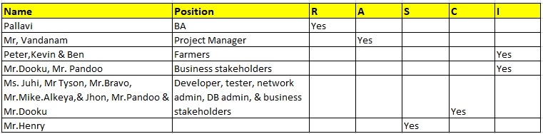

7. Help Mr Karthik to prepare a business case document
Ans:

Business Case Summary for the Online Agricultural Store Project
1. Why is this project initiated?
Mr. Henry has started this project to support his farmer friends and other farmers, especially those living in remote areas. These farmers often struggle to get timely access to essential agricultural inputs like fertilizers, pesticides, and seeds, which directly affects their daily farming activities and productivity.
2. What are the current problems?
- Farmers in remote areas are not able to purchase agricultural products on time.
- There is a lack of accessibility to quality inputs.
- Delays in procurement are affecting farming cycles and crop output.
- Limited or no digital options currently exist for easy ordering and delivery.
3. What are the resources required?
To complete this project, the following resources will be needed:
- Project Manager (PM) – to oversee the entire project.
- Business Analyst (BA) – to gather requirements and bridge the business-technical gap.
- Software Developers – to build the mobile application and backend.
- Testers – to ensure the application is bug-free and functions well.
- Technical Support Team – including network engineers and IT support.
- Database Administrator (DBA) – to manage and maintain the data securely.
4. How much organizational change is required?
Some amount of organizational change will be needed:
- Staff training to manage the online platform.
- New roles or responsibilities may be added for inventory, order processing, and customer support.
- Adoption of digital systems by teams that were previously working manually or offline.
5. With this project, how many problems could be solved?
- Timely access to farming inputs for farmers, especially in remote areas.
- Better supply chain management for agro-products.
- Improved communication between farmers and suppliers.
- Easier and faster order placement, tracking, and delivery.
- Overall increase in farming efficiency and productivity.
6. Time frame to recover ROI (Return on Investment)?
The estimated time frame to recover the investment made in this project is 4 to 5 years, depending on adoption, reach, and operational effectiveness.
7. How to identify stakeholders?
Stakeholders can be identified by analyzing:
- Who is affected by the current problems (e.g., farmers in remote areas).
- Who will benefit from the solution (e.g., farmers, fertilizer/pesticide companies, delivery partners).
- Who will be involved in building and running the system (e.g., project team, business sponsors, vendors).
This includes:
- Primary Users: Farmers
- Business Beneficiaries: Agro-product companies
- Internal Team: PM, BA, Developers, Testers, DBAs
- Sponsors and Decision-makers: Mr. Henry and other investors or supporters

8. The Committee of Mr. Henry , Mr Pandu , and Mr Dooku and Mr Karthik are having a discussion on project development approach.
Mr Karthik explained to Mr. Henry about SDLC. And four methodologies like Sequential Iterative Evolutionary and Agile. Please share your thoughts and clarity on Methodologies

Ans: -
1. Sequential Model (Waterfall Model)
This is a classic and simple linear model, often called the waterfall model. It follows a step-by-step process where each phase must be completed and reviewed before moving to the next. If the project doesn’t meet requirements at any stage, it can be stopped or discarded. The typical stages in the waterfall model are:
- Requirement Gathering
- Requirement Analysis
- Design
- Development (Coding)
- Testing
- User Acceptance Testing (UAT)
- Configuration Management
- Deployment
2. Iterative Model (Rational Unified Process - RUP)
RUP is an iterative software development approach where the project is developed through repeated cycles (iterations). It focuses on clearly defining what needs to be built, the skills required, and step-by-step guidance to reach the goal. It has four main phases:
- Inception: Define what will be built
- Elaboration: Design and plan the system
- Construction: Implement and develop the software
- Transition: Deliver the software, fix defects, and complete UAT
3. Evolutionary Model (Spiral Model)
This model puts strong emphasis on risk analysis and management, making it suitable for large and critical projects. It follows four phases in a spiral, repeated as needed:
- Planning
- Risk Analysis
- Engineering (development and testing)
- Evaluation
4. Agile Model (Scrum)
Agile Scrum is best for projects that require fast delivery and flexibility to accept changes late in the process. It promotes close collaboration between business and development teams, daily communication, and face-to-face conversations. Unlike traditional models, it requires minimal documentation and follows 12 key principles such as welcoming changing requirements and delivering working software frequently.
.
9. They discussed models in SDLC like waterfall RUP Spiral and Scrum . You put forth your understanding on these models. When the APT IT SOLUTIONS company got the project to make this online agriculture product store, there is a difference of opinion between a couple of SMEs and the project team regarding which methodology would be more suitable for this project. SMEs are stressing on using the V model and the project team is leaning more onto the side of waterfall model. As a business analyst, which methodology do you think would be better for this project.
Ans-
Waterfall: This is a linear and sequential approach where each phase (like requirements, design, development, testing) must be fully completed before moving to the next. After each phase, a formal review is conducted to decide if the project should proceed or be stopped. It’s simple and works well when requirements are clear and unlikely to change.
- Rational Unified Process (RUP): RUP is an iterative framework that breaks the project into phases with clear goals and deliverables. It defines what needs to be done, the skills required, and step-by-step instructions to reach development objectives. The phases include inception, elaboration, construction, and transition.
- Spiral Model: This model emphasizes risk management. It cycles through four key activities repeatedly: planning, risk analysis, engineering (development), and evaluation. It’s especially suitable for large and complex projects where risks need constant assessment.
- Agile Scrum: Agile Scrum allows flexible and fast development with frequent deliveries and continuous feedback. It can be adopted at any time during the project, especially if progress is behind schedule. It values collaboration, adaptability, and minimal documentation.
For this specific project, the V Model is recommended because it is well-suited for smaller projects with clear, stable requirements. The V Model pairs each development phase with a corresponding testing phase, allowing early detection of defects and ensuring that the project stays on the right track throughout its lifecycle.

10. Write down the differences between waterfall model and V mode.
Ans
Waterfall Model | V-Model
1. The Waterfall model is simple. | 1. The V-model is intermediate in complexity.
2. The Waterfall model is rigid. | 2. The V-model is somewhat flexible.
3. Re-usability of the Waterfall model is limited. | 3. The V-model can be reused to some extent.
4. Waterfall model’s steps move in a linear sequence. | 4. V-model’s steps don’t follow a strictly linear flow.
5. The cost of Waterfall model is low. | 5. V-model is more expensive.
6. Waterfall model is a continuous process. | 6. V-model is a simultaneous process.
7. Testing in Waterfall starts after development is complete. | 7. Testing in V-model starts from the very first stage.
8. Guarantee of success with Waterfall model is low. | 8. Guarantee of success with V-model is high.
9. Software made using Waterfall model has fewer defects compared to V-model. | 9. Software made using V-model has more defects compared to Waterfall.
10. Waterfall model is less commonly used nowadays. | 10. V-model is widely used in software engineering.

Q.11.Justify your choice- As a BA, state your reason for choosing one model for this project.
Ans-
As a BA, I would like to choose V model for this project as this is a small project. Also the V model is very flexible and in each phase testing and review process done.

Q.12. The Committee of Mr. Henry, Mr Pandu, and Mr Dooku discussed with Mr Karthik and finalised on the V Model approach (RG, RA, Design, D1, T1, D2, T2, D3, T3, D4, T4 and UAT) Mr Vandanam is mapped as a PM to this project. He studies this Project and Prepares a Gantt chart with V Model (RG, RA, Design, D1, T1, D2, T2, D3, T3, D4, T4 and UAT) as development process and the Resources are PM, BA, Java Developers, testers, DB Admin, NW Admin.

Ans- Gantt Chart
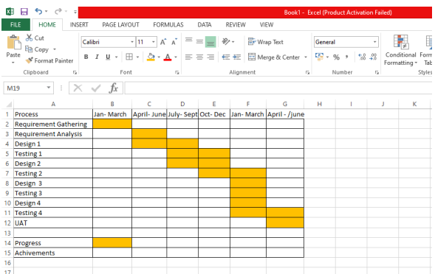

13. Explain the difference between Fixed Bid and Billing projects
Ans :
In simple terms, a Fixed Bid project means the client pays a fixed, agreed-upon amount upfront, no matter how much time or resources the project actually takes. On the other hand, a Billing project—also called Time and Materials (T&M)—means the client pays based on the actual hours worked and materials used during the project.
Fixed Bid (Fixed Price):
- Price: A set price is agreed before the project begins.
- Scope: The project scope is clearly defined and mostly stable.
- Time: Has a fixed start and end date.
- Flexibility: Less flexible; changes usually require renegotiation and possibly a new contract.
- Risk: The vendor (service provider) takes most of the financial risk by managing costs within the fixed budget.
- Suitable for: Projects with well-defined requirements and a stable scope.
Billing (Time and Materials):
- Price: Client is charged based on actual time spent and materials used.
- Scope: More flexible; changes can be accommodated during the project and billed accordingly.
- Time: Duration can be open-ended, depending on evolving project needs.
- Flexibility: Allows adjustments in budget according to the actual work done.
- Risk: The client assumes most of the financial risk, paying for whatever time and resources are used.
- Suitable for: Projects with unclear or evolving scope, or longer-term projects where requirements may change.

Question 14 – Preparer Timesheets of a BA in various stages of SDLC
➢ Design Timesheet of a BA, Development Timesheet of a BA, Testing Timesheet of a BA, UAT Timesheet of a BA, Deployment n Implementation Timesheet of a BA
Ans: Design Time sheet of BA

Development Timesheet:
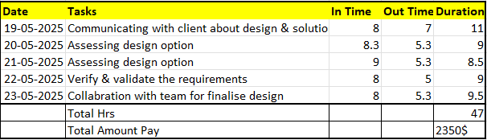
Testing Timesheet:
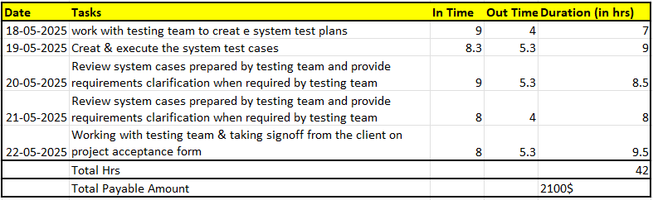
UAT Timesheet: 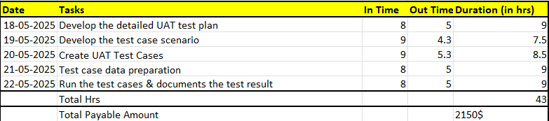
Deployment & Implementation timesheet:
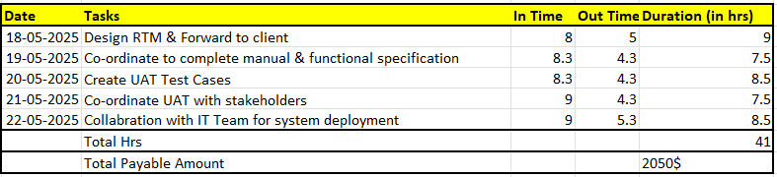
RA Timesheet of a BA : After gathering requirement we will do analysis through techniques . Design Timesheet of a BA: Once the analysis completed we will design the product, Development
Timesheet of a BA : Developer team will design the product.
Testing Timesheet of a BA : Testing team will do testing of the developed product.
UAT Timesheet of a BA : This UAT testing will be done by BA. Deployment n Implementation Timesheet of a BA: after user acceptance test done, then deployment and implementation will be done.

