Question 1 – Audits - 5 Marks

4 Quarterly Audits are planned Q1, Q2, Q3, Q4 for this Project What is your knowledge on how these Audits will happen for a BA?

Stage | Quarterly 1 Audit Report (Requirement gathering phase) | Quarterly 2 Audit Report (Requiremen t Analysis phase) | Quarterly 3 Audit Report (Design) | Quarter 4 Audit Report (Developme nt)
Completed | 10 Weeks (week  1 - 10) | 7 weeks  (week 16- 23) | 7 weeks (week  30 - 37) | 20 weeks  (week 40-60)
Check list | BRD template | UML diagram | Utilization of tools | JAD session report
 | Elicitation result report | Business to functional requirement mapping | Document evidence on client communication | End user manual preparation document
 | Duplicate requirements report | Client signs off document | Stakeholder MOM | BA and Developer MOM
 | Grouping of functionalities  /features client sign off | RTM  document version control | Email communication  -To, CC BCC | Email communicati on -To, CC BCC
 | Email communication - To, CC BCC | Email communicati on -To, CC BCC

Question 2 – BA Approach Strategy - 6 Marks

What Elicitation Techniques to apply: We have many elicitation techniques to apply used to gather requirements. Some of them are Brainstorming, Document Analysis, Reverse engineering, Focus Groups, Observation, etc...
How to do Stakeholder Analysis RACI: Stakeholder analysis can be done by using the
RACI matrix involves identifying stakeholders and defining their roles and responsibilities within a project. - Identify Stakeholders, Define Roles and Responsibilities, Create the RACI Matrix, Assign RACI Roles.
What Documents to Write: BRD, FRD, Use Case Documentation, Test Case Documents
What process to follow to Sign off on the Documents: Sign Off to be taken on SRS as this is the primary and important document. Sign off can be taken by using E-mail confirmation from Client.
How to take Approvals from the Client: Establish a formal meeting with the clients to keep them informed and get continuous feedback.
What Communication Channels to establish n implement: Regular Meetings - Weekly status meetings, bi-weekly sprint reviews, and monthly stakeholder updates.
How to Handle Change Requests: Change Request Form, Do Impact Analysis, Approval Process, Documentation.
How to update the progress of the project to the Stakeholders: Weekly Status Reports, Monthly Review Meetings.
How to take signoff on the UAT- Client Project Acceptance Form) : UAT Preparation, Conduct UAT, Fix Issues, Acceptance Form, Final Review Meeting, Obtain Sign-off.
Question 3 – 3-Tier Architecture - 5 Marks

Explain and illustrate 3-tier architecture?

This divides the application into 3 logical layers -

- Application Layer - topmost layer of the architecture - also known as "Presentation Layer - It handles user interface (UI) components such as screens, pages.

Ex: E-commerce Website.

- Business Logic Layer - middle layer of the architecture - acts as an intermediary between the presentation layer and the data storage layer - layer contains the core logic of the application.
Ex: Printer, payment gateways.

- Database Layer - bottom-most layer of the architecture - responsible for storing and retrieving data.
Ex: MySQL, Oracle database.

Question 4 – BA Approach Strategy for Framing Questions – 10 Marks

Business Analyst should keep What points in his/her mind before he frames a Question to ask to the Stakeholder (5W 1H – SMART – RACI – 3 Tier Architecture – Use Cases, Use case Specs, Activity Diagrams, Models, Page designs)

  - The 5W1H framework is a useful tool for gathering information and understanding a situation by answering questions about who, what, when, where, why, and how.
  - The SMART technique can help in creating questions: (Specific, Measurable, Attainable, Relevant & Time Bound)
  - RACI charts help define and clarify roles and responsibilities within a team by outlining who is responsible, accountable, consulted, and informed for each task.
  - UMI., or Unified Modelling Language, is a standardized way of diagramming and modelling software systems to aid in design, development, and communication between team members.
Question 5 – Elicitation Techniques - 6 Marks As a Business Analyst, What Elicitation Techniques you are aware of? ( BDRFOWJIPQU)
- Brainstorming: A group activity aimed at generating a wide range of ideas or solutions related to system requirements.
- Document Analysis: Reviewing existing documentation (like manuals or reports) to extract relevant information about current systems or processes.

- Reverse Engineering: Analysing an existing system to identify its components and functionalities, especially when documentation is lacking.
- Focus Groups: Facilitated discussions with selected users or stakeholders to gather diverse perspectives on requirements.
- Observation: Watching users interact with a system or perform tasks to understand their workflows and identify needs.
- Workshops: Structured collaborative sessions with stakeholders to define and prioritise requirements collectively.
- Joint Application Design (JAD): Intensive workshops involving users and developers to collaboratively define system requirements.
- Interviews: One-on-one or group sessions where stakeholders are asked targeted questions to elicit detailed information about their needs.
- Prototyping: Creating preliminary versions of a system to visualise requirements and gather feedback for refinement.
- Questionnaires: Distributing structured forms with specific questions to a broad audience to collect data efficiently.
- Use Case Specifications: Detailed descriptions of system interactions from a user's perspective, outlining steps to achieve specific goals.
Question 6 – This project Elicitation Techniques - 5 Marks

  - Prototyping: creating visual mock up to clarify and validate the requirement
  - Document Analysis: Reviewing existing document for relevant information
Brainstorming : Group idea generation for to get information or requirement
  - Interview: One on One or group meeting to extract the information
  - JAD: Intensive workshop between users and developers to finalise system requirements.
  - Use Case Specifications: Document interaction between user and system to achieve specific goal.

Question 7 – 10 Business Requirements- 10 Marks

- BR001 – Farmers should be able to search for available products in fertilizers, seeds, and pesticides.
- BR002 – Manufacturers should be able to upload and display their products in the application.
- BR003 – Farmers must be able to create a new user account by submitting their email and password.
- BR004 – Registered farmers should be able to log in using their user ID and password.
- BR005 – Farmers should have the ability to add products to a "Buy Later" list for future reference.

- BR006 – Farmers should be able to view detailed product descriptions, including price, quantity, and manufacturer details.
- BR007 – Farmers should be able to add selected products to a shopping cart for review before purchase.
- BR008 – The application should support secure payments via cash on delivery, debit/credit card, and UPI.
- BR009 – Farmers should receive an order Email & Normal phone number message confirmation with an estimated delivery date and invoice at a time.
- BR010 – Farmers should be able to track the delivery status of their orders.
Question 8 –Assumptions- 5 Marks List your assumptions

- Farmers have access to the internet.
- Farmers have a valid email address
- Farmers know the product names or categories they are searching for.
- Farmers have valid payment methods
- Delivery tracking system is integrated and operational.
- Payment gateways are secure and operational.

Question 9 – This project Requirements Priority - 8 Marks Give Priority 1 to 10 numbers (1 being low priority – 10 being high priority) to these Requirements after discussions with the stakeholders

Req ID | Req Name | Req Description | Priority
BR001 | User search for products. | - Farmers should be able to search for available products in fertilizers, seeds, and pesticides | 3
BR002 | Users browse through products. | - Manufacturers should be able to upload and display their products in the application. | 2
BR003 | Users create Login | - Farmers must be able to create a new user account by submitting their email and password | 1
BR004 | Email Confirmation | - Registered farmers should be able to log in using their user ID and password. | 4

BR005 | Buy later list | - Farmers should have the ability to add products to a "Buy Later" list for future reference | 5
BR006 | Payment Gateway | - The application should support secure payments via cash on delivery, debit/credit card, and UPI | 8
BR007 | Manufacturer can add products in the product catlog | - Farmers should be able to view detailed product descriptions, including price, quantity, and manufacturer details. | 7
BR008 | Add to cart option | - Farmers should be able to add selected products to a shopping cart for review before purchase | 9
BR009 | Product Delivery tracking | - Farmers should be able to track the delivery status of their orders | 6
BR010 | Product Information | - Farmers should receive an order Email confirmation with an estimated delivery date and invoice | 10

Question 10 – Use Case Diagram - 10 Marks

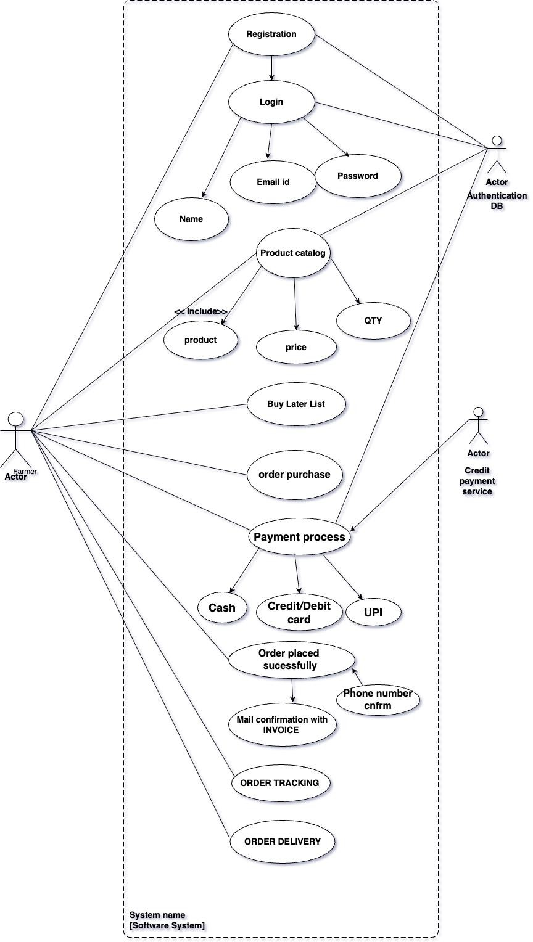

Question 11 – (minimum 5) Use Case Specs - 15 Marks Prepare use case specs for all use cases
Use Case Specification:

- User Registration

Field | Description
Use Case ID | UC001
Use Case Name | User Registration
Created By | Business Analyst
Created Date | May 29, 2025
Actor | Farmer
Description | This use case allows a new farmer to register on the agriculture  online application by providing necessary details.
Pre-Condition | The farmer is not already registered in the system.
Post-Condition | The farmer's account is created and stored in the system.
Basic flow | - Farmer navigates to the registration page.  - Farmer enters required details (e.g., name, email, password).  - Farmer submits the form.  - System validates the information.  - System creates a new user account.  - System confirms successful registration.
Alternative Flow | - Email Already Registered.  - System detects the email is already in use.  - System prompts the farmer to use a different email or recover the existing account.
Exceptions  Flow | - System encounters a server error during registration.- Required  fields are left blank.
Key scenario | As needed when new farmers want to join the platform.
Assumptions | - Farmers have access to the internet.- Farmers have a valid email  address.

- Search product

Field | Description
Use Case ID | UC002
Use Case Name | Search Product
Created By | Business Analyst
Created Date | May 29, 2025
Actor | Farmer

Description | This use case allows a farmer to search for products like seeds,  fertilizers, and pesticides in the application.
Pre-Condition | The farmer is logged into the system.
Post-Condition | The system displays search results matching the farmer's query.
Basic flow | - Farmer accesses the search bar.  - Farmer enters a product name or category.  - System processes the query.  - System displays relevant products.
Alternative Flow | - No Matching Products  - System finds no products matching the query.  - System displays a message indicating no results found.
Exceptions  Flow | - System experiences a delay in retrieving search results.- Search  input is invalid or contains prohibited characters.
Key scenario | Frequently, as farmers browse for products.
Assumptions | - The product catalog is up-to-date.- Farmers know the product  names or categories they are searching for.

- Add Product to Cart

Field | Description
Use Case ID | UC003
Use Case Name | Add Product to Cart
Created By | Business Analyst
Created Date | May 29, 2025
Actor | Farmer
Description | This use case allows a farmer to add selected products to their  shopping cart for future purchase.
Pre-Condition | The farmer is logged into the system and has searched for  products.
Post-Condition | The selected product is added to the farmer's shopping cart.
Basic flow | - Farmer selects a product from the search results.  - Farmer specifies the quantity.  - Farmer clicks "Add to Cart”.  - System adds the product to the cart.  - System confirms the addition.
Alternative Flow | - Product Out of Stock.  - System detects the product is out of stock.  - System notifies the farmer and prevents adding to cart.
Exceptions Flow | - System fails to update the cart due to a server error.- Farmer's  session has expired.

Key scenario | Frequently, as farmers build their shopping carts.
Assumptions | - Product availability is accurately reflected in the system.-  Farmers have a clear intent to purchase the selected products.
- Make Payment

Field | Description
Use Case ID | UC004
Use Case Name | Make Payment
Created By | Business Analyst
Created Date | May 29, 2025
Actor | Farmer
Description | This use case allows a farmer to make a payment for the products  in their shopping cart using various payment methods.
Pre-Condition | The farmer has items in the shopping cart and is ready to checkout.
Post-Condition | The payment is processed, and the order is confirmed.
Basic flow | - Farmer proceeds to checkout.  - System displays payment options (Cash on Delivery, Debit/Credit Card, UPI).  - Farmer selects a payment method.  - Farmer enters necessary payment details.  - System processes the payment.  - System confirms the payment and generates an order confirmation.
Alternative Flow | - Payment Failure  - Payment is declined.  - System notifies the farmer.  - Farmer is prompted to retry or choose a different payment method.
Exceptions Flow | - Payment gateway is unavailable.- Network issues interrupt the  payment process.
Key scenario | As needed, when farmers complete purchases.
Assumptions | - Payment gateways are secure and operational.- Farmers have  valid payment methods.
- PLACE ORDER

Field | Description
Use Case ID | UC005
Use Case Name | Place Order
Created By | Business Analyst

Created Date | May 29, 2025
Actor | Farmer
Description | This use case allows a farmer to place an order for the products in  their shopping cart after successful payment.
Pre-Condition | The farmer has successfully made a payment for the products in  the cart.
Post-Condition | The order is recorded in the system, and the farmer receives an  order confirmation.
Basic flow | - System confirms payment.  - System generates an order ID.  - System records order details.  - System sends an order confirmation to the farmer.  - System initiates the delivery process.
Alternative Flow | - Order Processing Delay  - System experiences a delay in processing the order.  - System notifies the farmer of the delay.
Exceptions  Flow | - System fails to record the order due to a server error.- Order  confirmation fails to send.
Key scenario | As needed, following successful payments.
Assumptions | - System has high availability to process orders.- Farmers receive  timely notifications.
- ORDER DELIVERY

Field | Description
Use Case ID | UC006
Use Case  Name | Track Delivery
Created By | Business Analyst
Created Date | May 29, 2025
Actor | Farmer
Description | This use case allows a farmer to track the delivery status of their  placed orders.
Pre-Condition | The farmer has placed an order, and the delivery process has been  initiated.
Post-Condition | The farmer views the current status and estimated delivery time of  their order.
Basic flow | - Farmer logs into the application.  - Farmer navigates to the "My Orders" section.  - Farmer selects an order to track.

 | 4. System displays the current delivery status and estimated delivery time.
Alternative Flow | - Delivery Status Unavailable.  - System cannot retrieve the delivery status.  - System notifies the farmer and suggests trying again later.
Exceptions  Flow | - System experiences a delay in updating delivery status. - Network  issues prevent status retrieval.
Key scenario | Frequently, as farmers monitor their order deliveries.
Assumptions | - Delivery tracking system is integrated and operational.- Farmers  have access to the internet.

Question 12 – (minimum 5) Activity Diagrams - 15 Marks Activity diagrams

