**ONLINE AGRICULTURE PROJECT : SECTION II**

Question 1 – Audits - 5 Marks

4 Quarterly Audits are planned Q1 , Q2, Q3, Q4 for this Project. What is your knowledge on how these Audits will happen for a BA ?

* There will be internal as well as external audits conducted during the project progress as a part of quality assurance procedure that may belong to any standards that the IT company may follow.
* During a quarterly audit the committee may review the BA performance and progression of the project, as well as the quality of their deliverables.
* The audit may involve review of the BA timesheets, project documents and communication logs to ensure that the BA is meeting project timelines and deliverables.
* The committee may also assess the BA adherence to the projects SDLC process, including their participation in project meetings, their documentations of requirements and specifications and their collaborations with other members of the development team.
* The audit may also include a review of the BA communication with stakeholders and their ability to manage and resolves stakeholder issues.
* As the audits are divided in 4 quarters, the audits will happen based on the phases which are spread across the first year.
* Below are the audit details in detail:

|  |  |
| --- | --- |
| **Stage** | Requirements gathering phase |
| **Status** | Completed |
| **Checklist** | BRD template and the document |
|  | Stakeholder analysis document |
|  | Elicitation results report |
|  | Duplicate requirements report |
|  | Grouping of functionalities/features- Client sign off |
|  | Requirement prioritisation document |
|  |  |
|  |  |
| **Stage** | Requirement analysis & design phase |
| **Status** | Completed |
| **Checklist** | Checking UML diagrams |
|  | Checking Use case documents |
|  | Business to functional document mapping |
|  | Client signoff |
|  | RTM version control list |
|  | End user manual check |
|  | Utilisation of tools |
|  | Documented evidence on client communication |
|  | Stakeholder MOM |
|  |  |
|  |  |
| **Stage** | Development phase |
| **Status** | Completed |
| **Checklist** | Creating a detailed checklist of requirement |
|  | Creating timeline and tasks with list of deliverables and deadlines |
|  | JAD session documents |
|  | Meeting with project development team |
|  | Change request documents |
|  |  |
|  |  |
| **Stage** | Testing and Deployment phase |
| **Status** | Completed |
| **Checklist** | Test case documents |
|  | Meeting with testers to check on possible outcomes |
|  | Discussions with the QA team regarding quality checks to be performed before and after the testing phase |
|  | Client signoff documents |
|  | RTM and End user manual document |
|  | Training session documents |
|  | Deployment documents |

Q2) Question 2 – BA Approach Strategy - 6 Marks

Before the Project is going to Kick Start, The Committee asked Mr Karthik to submit BA Approach

Strategy

Write BA Approach strategy (As a business analyst, what are the steps that you would need to

follow to complete a project – What Elicitation Techniques to apply, how to do Stakeholder Analysis

RACI/ILS, What Documents to Write, What process to follow to Sign off on the Documents, How to

take Approvals from the Client, What Communication Channels to establish n implement, How to

Handle Change Requests, How to update the progress of the project to the Stakeholders, How to

take signoff on the UAT- Client Project Acceptance Form )

* **What elicitation techniques will you apply:** Being a BA for this project I will be using the brainstorming technique.

Brainstorming can either be done individually or in groups. A particular problem/issue is chosen, and the group discusses about their particular inputs. The ideas discussed can then be assessed and then implemented where required. These ideas can come from what users have seen in the past or their experiences.

Brainstorming can serve as an exceptional elicitation technique to generate ideas. Brainstorming should be performed in a quiet and a relaxed environment.

As a BA, I would conduct **JAD sessions** to clarify any doubts between the developers and the business team so a flawless application can be built.

JAD sessions are extended, facilitated workshops. It involves collaboration between stakeholders and system developers to identify the needs and requirements in a concentrated and focused effort.

This technique allows for simultaneous gathering and consolidating of large amount of information. Discrepancies are resolved immediately with the aid of the facilitator.

**Interviews** can also be a good elicitation technique to understand requirements of individual stakeholders.

Interviews are basically a one-to-one conversations/discussions with the stakeholders where the interviewer asks questions to the interviewee in a formal setup. Without understanding the needs of the stakeholder we are unlikely to make an awesome application .

It can clarify the viewpoint of individual stakeholders in detail.

* **Stakeholder analysis RACI/ILS:**

**Project stakeholders:**

* Business Analyst: Rushabh Thakkar
* PM: Mr. Vandanam
* Delivery head: Mr. Kartik
* Development team: Ms. Juhi, Mr. Teyson, Tucker, Bravo & Ms. Lucy
* Testing team: Mr. Jason & Ms. Alkeya
* Network Admin: Mr. Mike
* DB Admin: Mr. John

**Business Stakeholders:**

* Project Sponsor: Mr. Henry
* Influencers: Kevin, Ben and Peter
* Project head: Mr. Dooku
* Financial head: Mr. Pandu
* **Documents to write:**

1. BRD: Business requirement document
2. In-scope features/services
3. Out of scope features/Services
4. Business case document
5. Solution architect diagram
6. RTM (Requirement traceability matrix)
7. SRS (Software requirements specification)
8. FRD: Functional Requirements documents
9. Product backlog
10. Project timeline,
11. Change tracker,
12. Change request log,
13. User manuals
14. Project closure document
15. Client acceptance form

Process to follow to Sign off on the Documents –

Project sign-off is typically executed during the contract closure phase – the company presents the

results of the work done to the client and then, after getting the necessary acceptance from them,

should get a client statement to verify that the job was completed.

Process to follow to Sign off on the Documents –

Project sign-off is typically executed during the contract closure phase – the company presents the

results of the work done to the client and then, after getting the necessary acceptance from them,

should get a client statement to verify that the job was completed.

Process to follow to Sign off on the Documents –

Project sign-off is typically executed during the contract closure phase – the company presents the

results of the work done to the client and then, after getting the necessary acceptance from them,

should get a client statement to verify that the job was completed.

* **Process to follow to sign off on documents:**

Project signoff is typically executed during the contract closure phase. The company presents the results of the work done to the client and then after getting the necessary acceptance should get a client statement to verify that the job was completed.

The process will go through Requirements gathering, requirements management , design, coding, testing and post the testing phase we will update the project closure document . Post this, the RTM and end user manuals will be updated and forwarded to the client for a sign off before the deployment and implementation phase.

1. Project Details,
2. Relevant Delivery dates
3. Detail budget status,
4. Goals
5. Project deliverables
6. Create a comment section
7. Make signature and date sections.

* **How to take approvals from the client:**
* Whenever we need to take approval from the client we need to draft an approval letter.
* This approval letter request is sent over an email, keeping in copy all the relevant stakeholders.
* Write an email addressing the relevant signatory and reviewers as per the below format.

*Dear Henry,*

*I am sending this request to seek your approval for the recent project proposal that I discussed earlier in the meeting today.*

*The team and I together have put a detailed plan that is attached to this email. After receiving your approval, we will commence with the project immediately. You will find this plan beneficial for several reasons for your Online Agriculture Product Store.*

*The project will be achieving the following milestones:*

1. *Farmers will be able to login and view multiple options for fertilizers, seeds and pesticides.*
2. *They can get the product delivered to their location &*
3. *The application will facilitate returns, refunds and inventory management.*

*I anticipate this project to be completed successfully. Our entire team looks forward to working on the project.*

* **What communication channels to establish and implement?**
* Face to face communication
* Video conferencing
* Phone calls
* Emails
* Online messaging platforms (Teams & Skype)

Q3) Explain 3 tier application and visualise it:

Answer) 3 tier architecture is a well-established software application architecture that organizes applications into three logical and physical computing layers:

1. **Application layer:** GUI, screen, pages, validations on the pages and business specific logic are displayed here. It is the presentation of the application
2. **Business logic layer:** This includesreusable and frequently changing components like payment gateways, printer, email servers, etc.
3. **Database layer:** Database components connecting to the database.

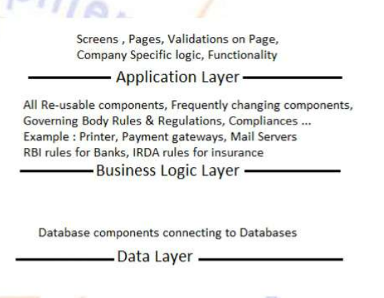

**Question 4** – BA Approach Strategy for Framing Questions – 10 Marks Business Analyst should keep What points in his/her mind before he frames a Question to ask to the Stakeholder ( 5W 1H – SMART – RACI – 3 Tier Architecture – Use Cases, Use case Specs, Activity Diagrams, Models, Page designs)

Answer) For gathering information from the stakeholder we should use the 5W1H i.e,

* What is this product?
* Why was this project initiated?
* Who are benefited from this project?
* Where were the requirements spotted?
* When will the project get initiated.
* How we should be doing the project.

Next, we should check whether the requirement that are gathered are SMART.

SMART- Specific, Measurable, Attainable, Realistic & Timebound.

A well formed requirement should comply with SMART. This helps us tackle any defect in the early stages which could otherwise have an impact later on.

Then while preparing questions we need to figure out who comes under which category so we use the RACI matrix i.e, responsible, accountable, consultant and informed.

* **Then we will prepare 3tier architecture under which we will be categorizing in 3 different stages : -**

**Application layer:**

1. How many logins will you require?
2. How many users will be using the application?
3. Home page features and functionalities?
4. What reports will you require?
5. Business rules and organisation specific logic

**Business logic layer**

1. Reusable components
2. Frequently changing components
3. Governing body rules and regulations,
4. 3rd Party plugins like payment gateways, printer and email servers.

**Data layer :**

1. Database components

* **Use case diagram, use case description document & use case specifications:**
* Use case diagram is a high-level diagram also known as mother of all diagrams. The primary focus of use case diagram is to show how external interfaces like (users, special databases, supporting systems and internet connectivity) interact with the proposed IT system.
* UCD represents the system as a whole i.e database, architecture, business logic and GUI all is included in the UCD.
* UCD are different from other diagrams but do not emphasize how many times was the action performed or in which order.
* UCDs are used to display only the positive flow.
* Use case description document outlines the following:
* Use case name
* Use case description
* Actors: Primary & secondary
* Primary flow
* Alternate flows
* Exceptional flows
* Pre conditions
* Post conditions
* Assumptions
* Constraints
* Dependencies
* Input & output
* Business Rules
* Miscellaneous information
* **Test cases:**

From the use case description document we can understand the basic, alternate and exceptional flows. From these flows we can identify the scenarios. For each scenario, identify at least 3-5 sets of valid test data. This data is sufficient form a test case.

* **Activity Diagrams:**

Activity diagrams are one of the 5 dynamic diagrams used to model the dynamic aspects of a system.

Activity diagrams are a flowchart representing flow from once activity to another activity , happening within the system from a system point of view and not user point of view.

Activity diagrams are drawn to show how a system should function to achieve the business objectives, business functionalities and application goals.

These activities are operations happening within the system hence activity diagram is flow from one operation to other operation.

Activity diagrams are not only used to model the dynamic aspects of a system but also to create a executable system using forward and reverse engineering.

Question 5) As a business analyst what type of elicitation techniques do you know about?

A. Document Analysis- Document analysis is done through reading a document and understanding the product, process and project.

B. Reverse Engineering is also called back engineering, is the process of extracting knowledge or design information from anything man-made and reproducing anything based on the extracted information.

C. Focus group- A focus group is a mean to elicit ideas and attitudes about a specific product, service or opportunity in an interactive group environment.

D. Observations- Observing, shadowing users or doing a part of their job, can provide information of existing processes, inputs and outputs.

E. Workshop- A requirement workshop is a structured approach to capture requirement. A workshop may be used to scope, discover, define, prioritize and reach closure on requirements for the target system.

F. JAD (Joint Application Development)- Application developed through JAD has higher customer satisfaction and less number of errors as user is directly involved in the development process.

G. Interview- An interview is a systematic approach where interviewee is going to ask relevant questions related to the software and documenting the responses.

H. Prototyping- Prototyping is an attractive idea for complicated and large systems for which there is no manual process or existing system to help determining the requirements.

I. Survey/ Ques琀椀onnaire- Ques琀椀onnaire can be useful for obtaining limited systems requirement details form the users/stakeholders, which have minor input or are geographically remote.

J. Brainstorming- Brainstorming is an effective way to generate lots of ideas on a specific issue and then determine which idea is the best solution. Brainstorming can either be done individually or in group. The discussed ideas can then be assessed and included in the system requirements wherever relevant. The ideas can come from what the users have seen in trade fairs/exibitions or experiences in their pervious organisation.

Question 6) Which Elicitation Techniques can be used in this Project and Justify your selection of Elicitation Techniques?

Brainstorming can be an effective elicitation technique for the development of an online agriculture store application. Thus technique involves bringing together a group of stakeholders such as farmers, company representatives, developers and project managers to generate new ideas and solutions to the problem at hand. Brainstorming session help to identify and prioritize the features and functionalities that the online agriculture store application should have.

Question 7) Make suitable Assumptions and identify at least 10 Business Requirements.

ASSUMPTIONS-

1.The project for an e-commerce platform for fertilizers, seeds and pesticides targeted towards farmers,

2.The platform will have a product catalogue and will allow users to search fertilizers, seeds and pesticides.

3.This platform will have login feature for farmers, Manufacturers and vendors and allow new users to create account by submitting their E-mail id and creating a secure password.

4.The platform will have a payment gateway that includes COD, credit/debit card and UPI options.

5.The platform will send E-mail confirmations regarding order status and delivery tracker to track product.

6.The platform will have user friendly interfaces and easy navigation for a better user experience.

7. A user can return/replace order if it does not meet the expectations.

BUSINESS REQUIREMENTS-

BR001- The platform should have a product catalogue that includes all fertilizers ,seeds and pesticides from different manufacturers and vendors.

BR002- The platform should allow farmers to search for products by name, category and brand.

BR003- The platform should have a login feature for all users including farmers, manufacturers and vendors.

BR004- the platform should allow new users to create an account by submitting their E- mail id and creating a secure Password.

BR005- The platform should have a user friendly interfaces and easy navigation for a better user experience.

BR006- The platform should have a payment gateway that includes COD,credit/debit cards and UPI options.

BR007- The platform should send E-mail confirmation regarding order status to users.

BR008- The platform should have a delivery tracker to track the whereabouts of the order

BR009- The platform should have scalable to accommodate future growth and expansion.

BR010- The platform should have a secure infrastructure to protect user data and prevent data breaches.

BR011: The farmers can return/replace their orders if it does not meet expectations.

BR012: The farmers can rate the products and manufacturers.

Question 8) List down your assumptions:

ASSUMPTIONS:-

1. Application built for the project will deliver the product to farmers in quick time.

2. The manufactures would be able to look at mostly ordered items and can able to maintain stocks by knowing it.

3. The website would require very less maintenance.

4 .The platform will have a product catalogue and will allow users to search fertilizers, seeds and pesticides.

5 .This platform will have login feature for farmers, Manufacturers and vendors and allow new users to create account by submitting their E-mail id and creating a secure password.

6 .The platform will have user friendly interfaces and easy navigation for a better user experience.

7.The platform should have a secure infrastructure to protect user data and prevent data breaches.

8. The farmers have a working internet/ are in a network area.

9. The manufacturers list their items timely, and all the items are available to order at all times.

10. The manufacturers accept returns and replace the items if defective.

Question 9) Give Priority 1 to 10 numbers ( 1 being low priority – 10 being high priority) to these Requirements after discussions with the stakeholders

There are various techniques used for prioritization of requreiements. Prioritization means to prepare the requirements for queuing them for development. We can use techniques like MOSCOW, 100 dollar test & top 10 requirements to prioritise the requirements.

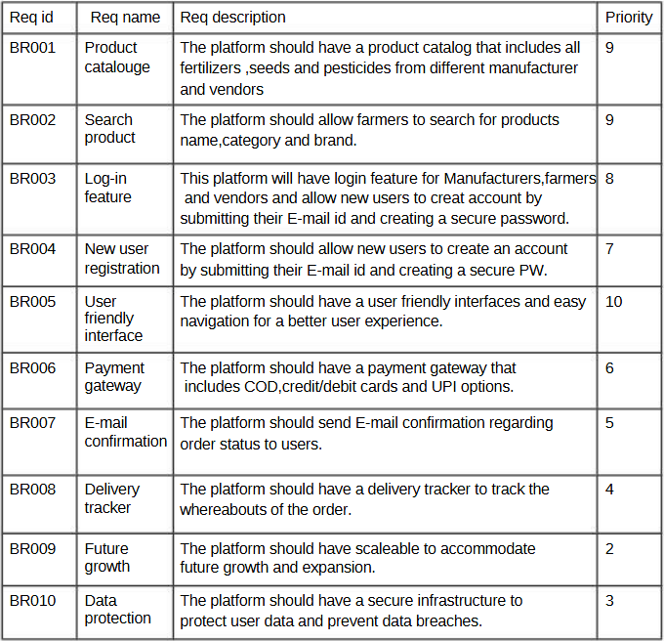

Question 10) Draw use case diagram

Answer)

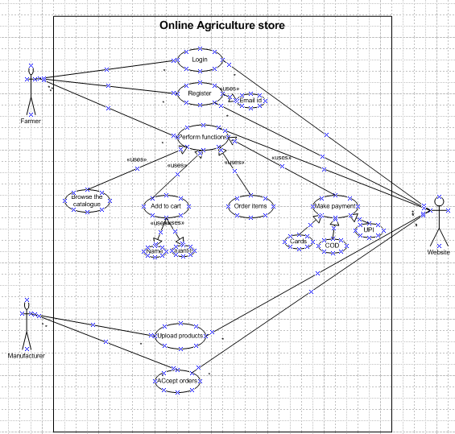

Question 11) Prepare use case specs:

Answer)

* **Use case spec- login**
* Description:- This use case specifies the essential steps to login
* Actors- Farmers, Website
* Preconditions – active internet condition, browser compatible
* Post condition- home page should be displayed
* Basic flows:

1. The use case begins when the user opens the application/software application.
2. Customer gets the multiple options like login/register
3. Customer selects the login option
4. Customer enters the username and password
5. The user enters username and password
6. The system accepts the username and password
7. The home page is displayed to the customer
8. The use case ends here

* Alternate flow:
* password is wrong
* Username is wrong
* username and password are wrong
* Customer logs on to register user
* Exceptional Flow:

Forget password, forget username

* Assumptions: users have basic computer knowledge & a working internet.
* Constraints: username cannot be special character, Password needs to have at least 1 special character, 1 small character, 1 big character and should be of 8 characters at least.
* Inputs: username and password
* Output: Login to homepage or error code.
* Business rules- username should use valid mail id password should use special character
* MIS information- interactive design and browser compatible.
* **Use case spec**- Order items
* Description- This use case describes how a customer can place order.
* Actor- farmer, website
* Preconditions: Active internet connection, browse through different products
* Postcondition: able to add items to cart and directed to payment page.
* Basic flow-

1. Customer logs into his account
2. Customer browses through the application
3. Then selects the product he wants
4. Then he selects the quantity of items to be added.
5. Customer then adds the product to cart,
6. Items selected are correctly captured while adding to cart.
7. Customer selects the delivery address,
8. Customer selects the payment method
9. The order is placed, and the use case is completed.

* Alternate flow:
* Product out of stock,
* Issue with the payment gateway,
* Product not deliverable to the pin code,
* The selected quantity is above the permitted value &
* Payment failure
* Exceptional Flow: while adding to cart different page pops out not directing to payment page.
* Assumptions:

Working internet,

user can login with his username and password,

users should know how to add product to cart &

User is using the payment method supported by the application

* Constraint : at least 1 product to be added to cart to checkout & the payment method to be supported by the application.
* Dependencies- the product should be available in stock.
* Output- the order gets through to the payment site.
* Miscellaneous info- good looking payment page.
* **Use case spec: New user**
* Description-This use case describes how a user can register with the application.
* Actor- farmer and website
* Precondition- Active internet and the customer has a mail account.
* Post condition- able to register and login to website.
* Basic flow-

1. Customer opens the app/software application,
2. Enters his email id for registration,
3. An OTP is shared with the customer on his email id,
4. The user enters the OTP and verifys the email id,
5. Customer enters his mobile phone number,
6. An OTP is shared with the customer,
7. Customer enters the OTP
8. The new user is registered, and the use case ends here.

* Alternate flow-
* Customer has entered a wrong email id,
* OTP is not being shared with the customer on his email,
* Customer enters the wrong OTP.
* Assumption- Users have basic knowledge & have an email account. Customer has network on his device
* Constraint- both mobile and Gmail need to be verified to do the registration.
* Output- Registration done and able to login the website
* MIS information- interactive design and browser compatible.
* **Upload products & accept orders- use case spec**-
* Description: This use case describes how a manufacturer can add a product to the catalogue.
* Actor : manufacturer, website
* Precondition- Manufacturer is registered with the application and stock replenishment data to be generated, easy controlling of website.
* Postcondition- stock is available all the time for demanded products .
* Basic flow-

1. The manufacturer logs into the account,
2. The manufacturer can upload his catalogue,
3. He gets stock information and the SKU data accurately,
4. The manufacturer lists the products
5. Upon the customer ordering this, the manufacturer gets a notification ,
6. The manufacturer can accept the order,
7. Then ship the product,
8. The use case is completed here.

* Alternate flow-
* Stock information is not provided correctly,
* Assumptions:- Manufacturer knows how to list products & manufacturer gets notified about stock of products.
* Constraint- stock cannot be refilled for n number of product quantities
* Input- Refill signal goes to manufacturer.
* Output- product available all the time.
* Miscellaneous information– interactive design and browser compatible.
* **Use case spec- Return/Replace**
* Description-This use case describes how a customer can return/replace orders
* Actors- farmer, website.
* Precondition- An item is ordered,
* Post condition- Return/replacement is placed successfully
* Basic Flow-
* Customer selects a product from ‘Your orders’
* Customer selects return/replace option,
* Customer elects the appropriate option and places a request for return/replacement,
* The request is completed and accepted,
* The use case is completed here
* Alternate flows: The selected product has no replacement available , the farmer has already used half of the product portion.
* Assumption: Farmer has placed an order already and wishes to replace/ return, the farmer has a working internet and can login to account
* Constraints: The farmer needs to place an order to be using this option.

Question 12) Activity diagrams:

An activity diagram is one of the 5 UML diagrams that describes the dynamic aspects of the system. An activity diagram is a flowchart that describes the flow from one activity to another. Activity diagrams describe how a system should function in order to achieve Business objectives, functionalities and goals.

Also, Activity Diagram describes activities happening within the system via system perspective and not use perspective.

An activity diagram not only describes the dynamic aspects of a system but also is useful for constructing executable systems using forward and reverse engineering.

1. Registered customer login:

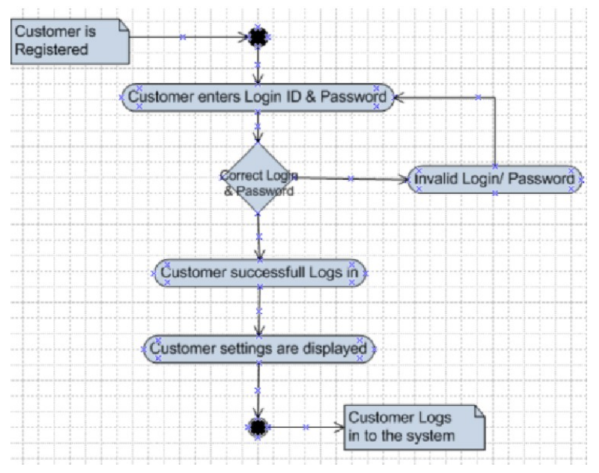

1. Add to cart:

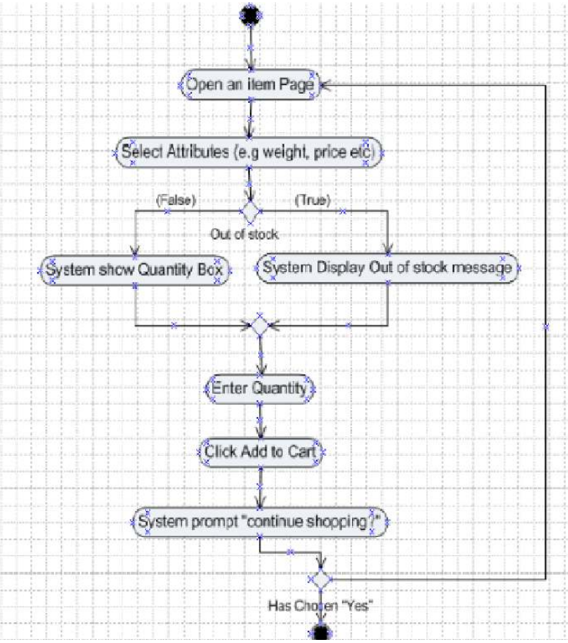

1. Make payment:

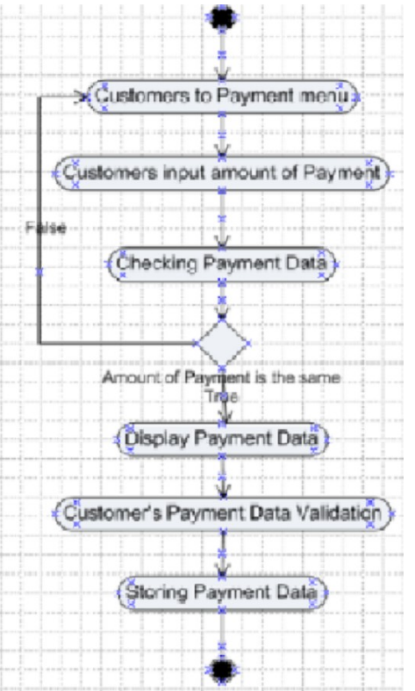

1. Order delivery:

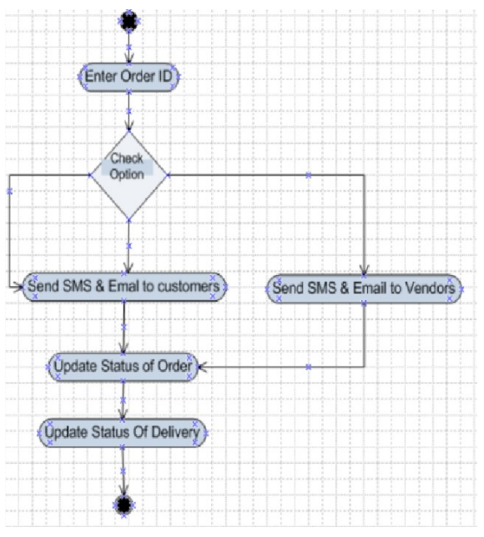

1. Return and refund tab:

