### Document 1: Definition of Done

### The Definition of Done (DoD) for the Kisan Credit Loan (KCL) project is intended to outline the criteria required for the successful processing, approval, and disbursement of a loan to eligible farmers or agricultural workers. This ensures that all necessary steps are followed and that the process is completed with due diligence, meeting regulatory, operational, and customer satisfaction standards.

### Eligibility Criteria Met:

### Customer is a farmer or agricultural worker (with valid proof of activity

### Customer meets minimum age requirement (typically 18 years or older).

### Customer has a verified landholding or agricultural income.

**Required Documents Collected:**

* Aadhar card (for identity verification).
* Land records (e.g., title deed, cultivation records).
* Proof of agricultural income (e.g., income tax return, crop yield report).
* Bank account details.
* Any other relevant documents (e.g., farmer's certificate, government subsidy forms).

**Loan Application Form Completed:**

* All sections of the loan application form are filled out completely and accurately.
* Customer has acknowledged and signed the loan application form.

**Document Verification:**

* All submitted documents have been verified for authenticity and completeness.
* Verification includes both physical and electronic checks as per regulatory requirements.

**On-Site/Field Verification:**

* Site visit (if applicable) or third-party verification of the farm or agricultural activities is completed.
* If required, the customer’s landholdings and assets have been inspected and confirmed.

**Credit Assessment Completed:**

* Creditworthiness of the customer has been assessed, including financial history and repayment capacity.
* Evaluation of the customer’s ability to repay based on income, expenses, and the requested loan amount.

**Loan Terms Finalized:**

* Loan amount, interest rates, tenure, and repayment schedule have been agreed upon.
* Government subsidies or support schemes (if applicable) are incorporated into the loan agreement.

**Approval Workflow:**

* Loan proposal has been reviewed by the designated loan officer or approval committee.
* All relevant checks (e.g., credit score, document verification, field visit report) have been approved.

**Compliance with Regulatory Guidelines:**

* The loan offering adheres to all relevant regulations, such as RBI guidelines, KYC (Know Your Customer) norms, and other government policies related to Kisan Credit Loans.

**Loan Approval Confirmed:**

* Loan approval has been granted by the authorized committee/manager.
* Customer has been notified of loan approval, including the approved loan amount, terms, and repayment details.

**Customer Agreement Signed:**

* The customer has signed the loan agreement, agreeing to all terms, conditions, and repayment schedules.

**Loan Terms Explained to Customer:**

* Customer has been provided a clear explanation of the loan terms, including interest rates, repayment terms, collateral (if any), and penalties for non-repayment.

**Loan Disbursement**

* Loan amount has been disbursed to the customer’s account or as per the agreed method (e.g., bank transfer, cash).
* Acknowledgment of receipt of funds has been obtained from the customer.

**Documentation and Record Keeping**

* All loan documentation (loan agreement, approval forms, disbursement receipts) has been filed properly in both physical and digital formats.
* The loan record has been updated in the loan management system, including all relevant details about the loan amount, repayment schedule, customer details, and any collateral.

**Reporting and Feedback**

* Loan performance, including repayment rates and customer feedback, is tracked and reported periodically.
* A feedback process is in place for customers to provide input on their loan experience, which is reviewed to improve future loan offerings.

**Compliance and Legal Closure**

* The entire loan process complies with applicable laws, including KYC requirements, the Reserve Bank of India (RBI) guidelines, and any other government-mandated rules for agricultural loans.
* Once the loan has been repaid or settled, all records are updated, and the loan is officially closed.

**Document 2- Product Vision**

|  |  |  |  |
| --- | --- | --- | --- |
| Scrum Project Name: | Bob Kisan credit loan |  |  |
| Venue: |  |  |  |
| Date | Start time: 1-1-2023 | End time: 1-11-2023 | Duration: 11 Months |
| Client | BOB |  |  |
| Stakeholder list: | |  | | --- | | Project Sponsor |  |  | | --- | |  | | |  | | --- | | Project Manager |  |  | | --- | |  | | |  | | --- | | Product Owner |  |  | | --- | |  | |
|  | |  | | --- | | Development Team |  |  | | --- | |  | | Quality Assurance (QA) Team | Customers |
| Scrum Master: | Suresh |  |  |
| Product owner: | Prjakta |  |  |
| Scrum Developer 1: | Ramesh |  |  |
| Scrum Developer 2: | Kalyani |  |  |
| Scrum Developer 3: | Praful |  |  |
| Scrum Developer 4: | Snehal |  |  |

|  |  |  |  |
| --- | --- | --- | --- |
| **Vision:** **empower farmers with financial resources** that enable them to grow their businesses, improve crop yields, invest in modern farming techniques, and weather financial challenges | | | |
| **Target group** | **Needs** | **Product** | **Value** |
| The **Bob Kissan Credit Loan** product addresses the **agricultural market segment,** specifically targeting **smallholder farmers, emerging farmers, and rural agricultural communities**.  The **target users and customers** are **farmers** who need financial assistance for agricultural activities, including purchasing seeds, equipment, and covering operational costs | solves the problem of **limited access to affordable credit for farmers,** especially smallholders and those in rural areas, who struggle to finance essential farming inputs or cope with seasonal income fluctuations.  It provides the benefit of **financial stability and growth** byoffering **low-interest loans,** flexible repayment terms, and access to resources that enable farmers to invest in their crops, improve productivity, and build a sustainable farming business. | The **Bob Kissan Credit Loan** is a **financial product designed specifically for farmers**, offering affordable loans to help them fund agricultural activities, purchase equipment, and manage cash flow.  What makes it desirable and special is its **tailored approach** for the agricultural sector, with **flexible repayment terms** aligned with farming cycles and **low-interest rates,** making it accessible and supportive for farmers in rural areas who typically lack access to traditional financial services.  Yes, it is feasible to develop the **Bob Kissan Credit Loan** product, especially with the growing adoption of **digital financial solutions** and mobile banking in rural areas. Partnering with **local banks, agricultural organizations, and technology platforms** can help streamline loan distribution, improve accessibility, and ensure the product meets the specific needs of farmers. | The **Bob Kissan Credit Loan** product will benefit the company by tapping into the **agriculture financing market,** attracting a large, underserved customer base and generating **steady revenue through interest on loans.**  The business goals include **expanding financial inclusion for farmers,** increasing **brand loyalty**, and establishing a **sustainable revenue stream** through long-term relationships with agricultural communities. The business model is based on **lending services,** with a focus on **low-interest loans,** repayment flexibility, and potentially offering value-added services like financial education or agricultural advisory. |

**Document 3: User stories**

|  |  |  |
| --- | --- | --- |
| User story No: 1 | Tasks:1 | Priority: High |
| Value statement:  **As a farmer**,  I want to apply for a loan through an easy-to-use mobile application  so that I can receive financial assistance for my farming activities. | | |
| BV:300 | CP: 05 | |
| Acceptance criteria: The form should capture basic details (e.g., farm size, crop type, loan amount required), and there should be a submit button to send the application. | | |

|  |  |  |
| --- | --- | --- |
| User story No:2 | Tasks: 2 | Priority: High |
| Value statement:  **As a farmer,**  I want to know if I am eligible for a loan before I apply,  so I don’t waste time filling out an application if I don’t qualify. | | |
| BV:250 | CP:4 | |
| Acceptance criteria: The system should display eligibility based on predefined criteria (e.g., credit score, crop type). | | |

|  |  |  |
| --- | --- | --- |
| User story No:3 | Tasks:3 | Priority: |
| Value statement:  **As a farmer,**  I want to receive the loan amount in my bank account or digital wallet as soon as my loan is approved so that I can use it immediately for farming needs. | | |
| BV:500 | CP:6 | |
| Acceptance criteria: Once approved, the loan amount should be transferred to the farmer’s account within 24 hours. | | |

|  |  |  |
| --- | --- | --- |
| User story No: 4 | Tasks: 4 | Priority: medium |
| Value statement:  **As a farmer,**  I want to upload documents (e.g., proof of income, farm registration) to support my loan application, so that my application can be processed. | | |
| BV:450 | CP:03 | |
| Acceptance criteria: The app allows uploading of required documents with clear instructions on acceptable file types (e.g., PDF, JPG). | | |

|  |  |  |
| --- | --- | --- |
| User story No:5 | Tasks:5 | Priority: Medium |
| Value statement:  **As a business stakeholder,**  I want to review the financial performance of the loan portfolio to ensure we are meeting business goals and making sustainable decisions. | | |
| BV:100 | CP:04 | |
| Acceptance criteria: Stakeholders can access real-time data on loan disbursements, repayments, and interest rates.  They can view trends in loan applications and understand the financial impact of the project. | | |

|  |  |  |
| --- | --- | --- |
| User story No: 6 | Tasks: 6 | Priority: High |
| Value statement:  **As a loan officer,**  I want to approve or reject loan applications directly through the system  so that I can efficiently manage my workload and inform farmers of their application status. | | |
| BV:300 | CP:03 | |
| The system allows loan officers to approve or reject applications with the option to add comments or reasons.  An approval/rejection notification is automatically sent to the farmer. | | |

|  |  |  |
| --- | --- | --- |
| User story No: 7 | Tasks: 7 | Priority: High |
| Value statement:  **As a loan officer**, I want to review the loan repayment status for each farmer so that I can track overdue loans and send reminders for payments. | | |
| BV:500 | CP: -04 | |
| Loan officers can view loan repayment schedules, including due dates and overdue payments.  They can send reminders or escalate overdue loans for further action. | | |

**Document 4: Agile PO Experience**

* I start by **defining and communicating the product vision** for the Bob Kissan Credit Loan project, ensuring that it addresses farmers’ financial needs and enhances their economic stability.
* I clarify the overarching goal of helping farmers access easy, affordable loans and foster financial inclusion.
* I collaborate with stakeholders (e.g., agricultural experts, farmers, business leaders) to **create a product backlog.** This backlog will include user stories like loan application, loan disbursement, repayment tracking, and financial literacy resources.
* I prioritize these stories based on business value, customer needs, and technical feasibility, making sure the most important features (like loan approval workflows or mobile notifications) are tackled first.
* I **participate in sprint planning** sessions with the development team, clarifying each user story, setting clear **acceptance criteria,** and ensuring that each sprint delivers value to the farmers.
* I work closely with the team during the sprint to ensure that the features being developed meet the defined goals and acceptance criteria.
* After each sprint, I **review the product with stakeholders** and gather feedback to ensure the solution is solving the right problems. This feedback loop will help refine the backlog and drive improvements in the next iteration.
* I work with the team to ensure that the **product is ready for release**, coordinating any final testing and approvals. You may also plan a phased rollout if needed, ensuring that features are released in stages
* I track the **success metrics** for the product, such as loan uptake, repayment rates, and user engagement. Based on this data, you will refine the product to better meet the needs of the target market.
* From the **Bob Kissan Credit Loan** project as a Product Owner, I learned the importance of **deeply understanding customer needs**, particularly in underserved markets like agriculture, to create products that truly solve their problems. I also honed my skills in **prioritizing features** based on business impact and user value while maintaining flexibility to adapt to new feedback or market changes. Effective **stakeholder communication** and **clear acceptance criteria** became essential for aligning the team and ensuring successful product delivery. Ultimately, I learned to balance **business objectives**   **user experience** to drive impactful and sustainable solutions.

**Document 5: Product and sprint backlog and product and sprint burndown charts**

**Product backlog:**

|  |  |  |  |  |  |  |
| --- | --- | --- | --- | --- | --- | --- |
| User story ID | User story | Tasks | Priority | BV | CP | Sprint |
| 1 | **As a farmer**,  I want to apply for a loan through an easy-to-use mobile application  so that I can receive financial assistance for my farming activities | 1 | High | 300 | 04 | Sprint 1 |
| 2 | **As a farmer,**  I want to know if I am eligible for a loan before I apply,  so I don’t waste time filling out an application if I don’t qualify. | 2 | High | 250 | 04 |  |
| 3 | **As a farmer,**  I want to receive the loan amount in my bank account or digital wallet as soon as my loan is approved so that I can use it immediately for farming needs. | 3 | Medium | 500 | 06 | Sprint 1 |
| 4 | **As a farmer,**  I want to upload documents (e.g., proof of income, farm registration) to support my loan application, so that my application can be processed. | 4 | Medium | 450 | 03 | Sprint 2 |
| 5 | **As a business stakeholder,**  I want to review the financial performance of the loan portfolio to ensure we are meeting business goals and making sustainable decisions. | 5 | High | 100 | 04 | Sprint 2 |
| 6 | **As a loan officer,**  I want to approve or reject loan applications directly through the system  so that I can efficiently manage my workload and inform farmers of their application status. | 6 | High | 300 | 03 | Sprint2 |

**Sprint backlog:**

|  |  |  |  |  |  |
| --- | --- | --- | --- | --- | --- |
| User story ID | User story | Tasks | Owner | Status | Estimated effort |
| 1 | **As a farmer**,  I want to apply for a loan through an easy-to-use mobile application  so that I can receive financial assistance for my farming activities | 1 | High | 300 | 4hr |
| 2 | **As a farmer,**  I want to know if I am eligible for a loan before I apply,  so I don’t waste time filling out an application if I don’t qualify. | 2 | High | 250 | 3hr |
| 3 | **As a farmer,**  I want to receive the loan amount in my bank account or digital wallet as soon as my loan is approved so that I can use it immediately for farming needs. | 3 | Medium | 500 | 2hr |
| 4 | **As a farmer,**  I want to upload documents (e.g., proof of income, farm registration) to support my loan application, so that my application can be processed. | 4 | Medium | 450 | 5hr |
| 5 | **As a business stakeholder,**  I want to review the financial performance of the loan portfolio to ensure we are meeting business goals and making sustainable decisions. | 5 | High | 100 | 5hr |
| 6 | **As a loan officer,**  I want to approve or reject loan applications directly through the system  so that I can efficiently manage my workload and inform farmers of their application status. | 6 | High | 300 | 6hr |

**Sprint burndown charts** 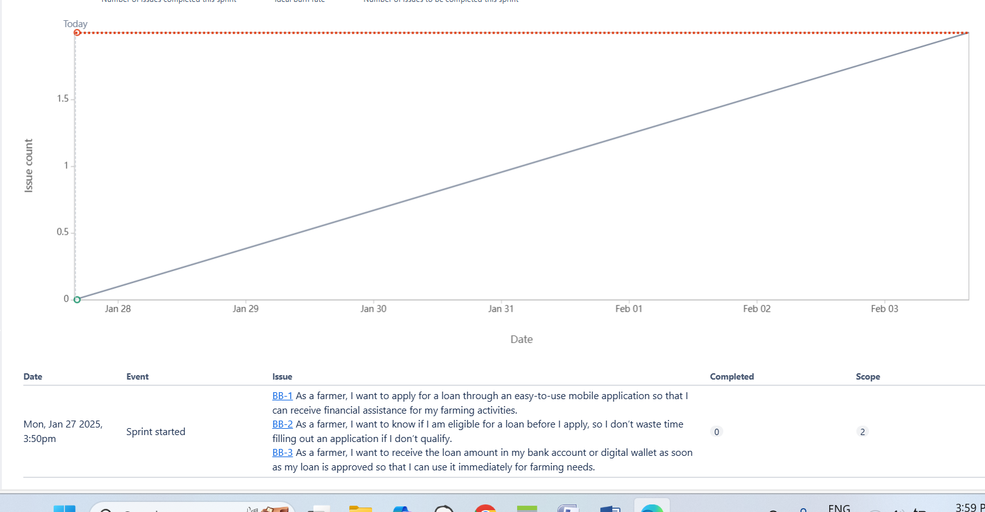

**sprint burnup charts**

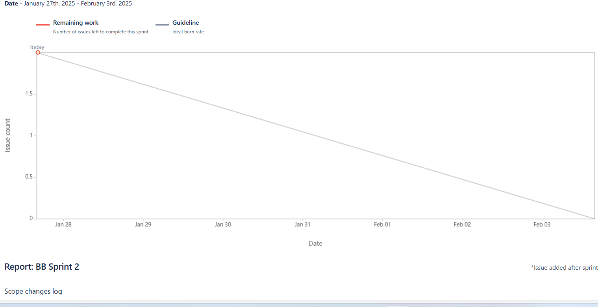

**Document 6: Sprint meetings**

**Meeting Type 1: Sprint planning meeting**

|  |  |
| --- | --- |
| Date | 1-27-2024 |
| Time | 10.AM |
| Location | Zoom |
| Prepared BY | Kalyani |
| Attendees | Suresh, Ramesh, Priya, snehal,Praful |

**Agenda Topics**

|  |  |  |
| --- | --- | --- |
| Topic | Presenter | Time Allocated |
| Clarify the main objectives for the sprint based on business goals and user needs. | Kalyani | 20 min |
| Review high-priority user stories (e.g., loan application, repayment tracking) and adjust based on feedback from stakeholders. | Kalyani | 15 min |

**Other Information**

|  |  |
| --- | --- |
| Observers | Stakeholder |
| Resources | Sprint backlog document  Product roadmap  Relevant user stories and acceptance criteria |
| Special Notes | Ensure that all team members are aware of any **regulatory changes** or new requirements that might impact the sprint (e.g., changes in loan eligibility criteria). |

**Meeting Type 2: Sprint review meeting**

|  |  |
| --- | --- |
| Date | 27-1-2025 |
| Time | 11 am |
| Location | Zoom |
| Prepared BY | Kalyani |
| Attendees | Suresh, Ramesh, Priya, snehal,Praful |

|  |  |  |  |
| --- | --- | --- | --- |
| **Sprint status** | **Things to demo** | **Quick updates** | **What’s next** |
| We’ve completed 80% of the features planned for this sprint, with some delays in loan status updates due to integration issues." | Demo of the: **Loan Application Form** | QA is currently working on testing the loan eligibility checker, and it’s almost ready for review. The backend team is still addressing some integration bugs with third-party loan data. | Next sprint, we will start implementing the loan repayment scheduling feature and integrate mobile notifications for overdue loans." |

**Meeting Type 3: Sprint retrospective meeting**

|  |  |
| --- | --- |
| Date | 27-1-205 |
| Time | 11 am |
| Location | Zoom |
| Prepared BY | Kalyani |
| Attendees | Suresh, Ramesh, Priya, snehal,Praful |

|  |  |  |  |  |
| --- | --- | --- | --- | --- |
| **Agenda** | **What went well** | **What didn’t go well** | **Questions** | **Reference** |
| Bob Kissan Credit Loan Project | The loan application feature was implemented with ease and was well-received by users, making the application process smoother for far | Some features faced delays due to unforeseen technical challenges with backend integration. | How can we improve loan status feature | Feedback gathered from farmers on the loan application form and loan tracking system for improvements. |

**Meeting Type 4: Daily Stand-up meeting**

|  |  |  |  |  |  |  |
| --- | --- | --- | --- | --- | --- | --- |
| **Question** | **Name/Role** | **27-1-2025 to 2-feb-2025** | | | | |
| **Monday** | **Tuesday** | **Wednesday** | **Thursday** | **Friday** |
| **What did you do yesterday?** | Developer 1 | |  | | --- | | Work login feature | | Completed login feature | Fixed login page bugs | Integrated loan application form | Integrated loan application form |
| Developer 2 | Developed loan application UI | Fixed frontend issues | Implemented backend for loan approval | Reviewed pull requests | Conducted final testing |
| **What will you do today?** | Developer 1 | Completed login feature | Fixed login page bugs | Fixed login page bugs | Integrated loan application form | Testing of loan application form |
| Developer 2 | Fixed frontend issues | Implemented backend for loan approval | Reviewed pull requests | Conducted final testing | Fix bug after testing |
| **What (if any) is blocking your progress?** | Developer 1 | Waiting on API specs | API delay | Blocked by testing environment | response from QA | Need review approval |
| Developer 2 | Need review approval | No blocker | Delay in approval for UI changes | Blocked by merge conflicts | No blocker |