**Doc 6:**

**Use case diagram:**

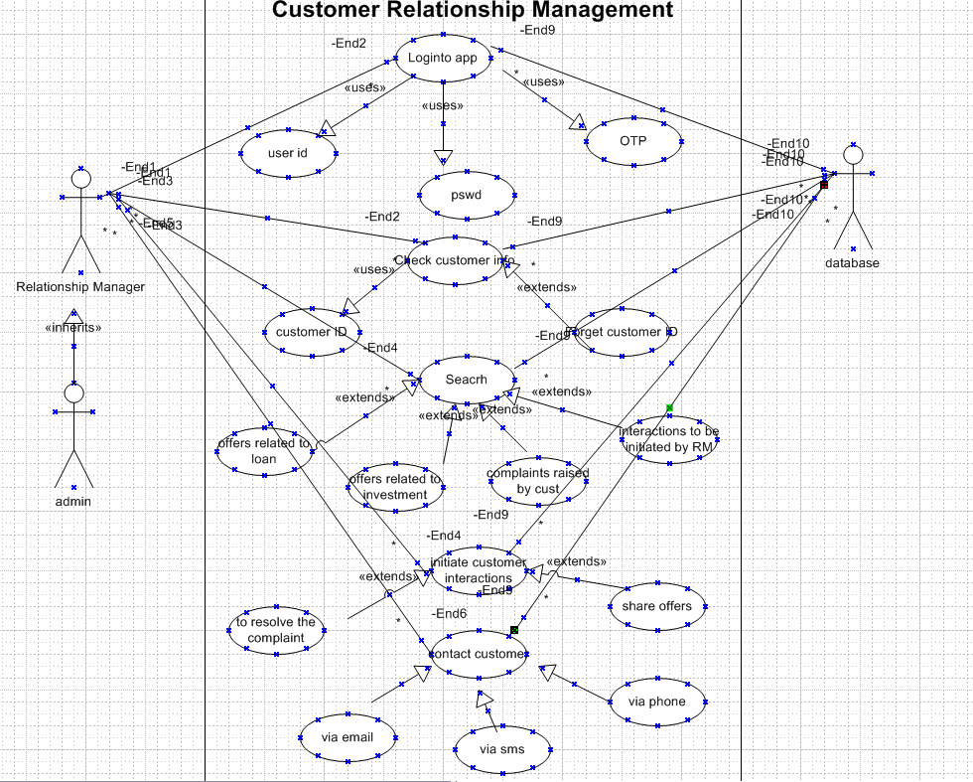

**Activity diagram:**

1. **RM logging into CRM**

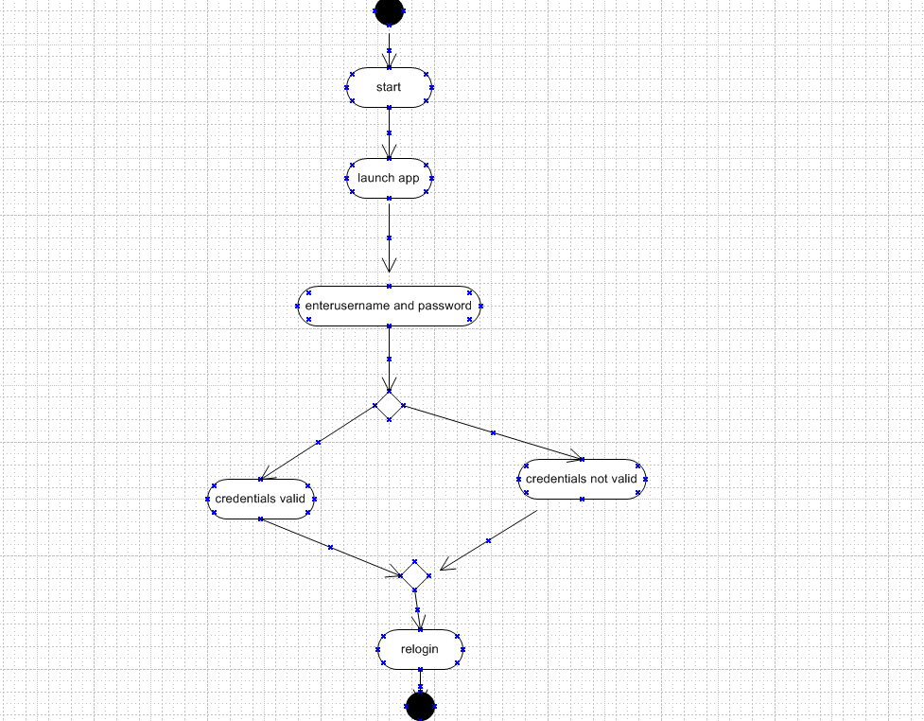

**2)**

**Checking customer information**

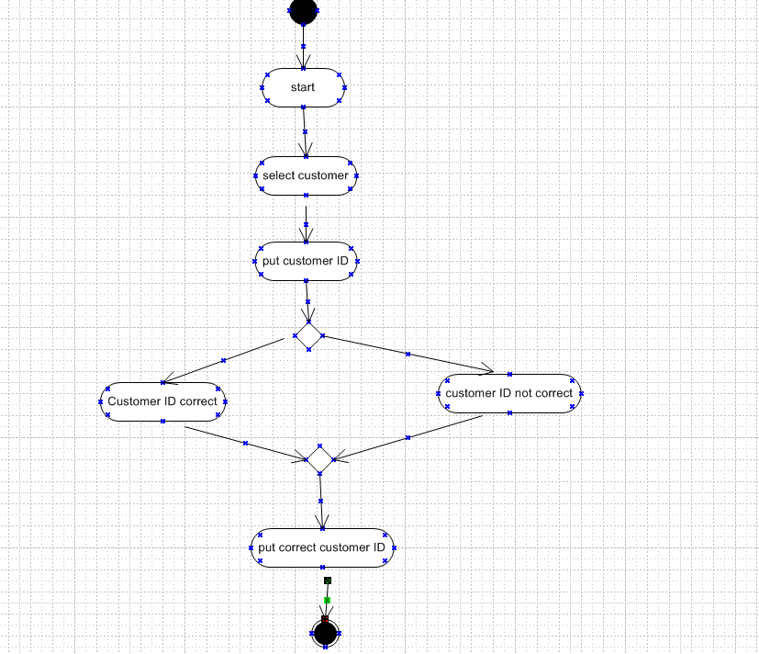

**3) searching details**

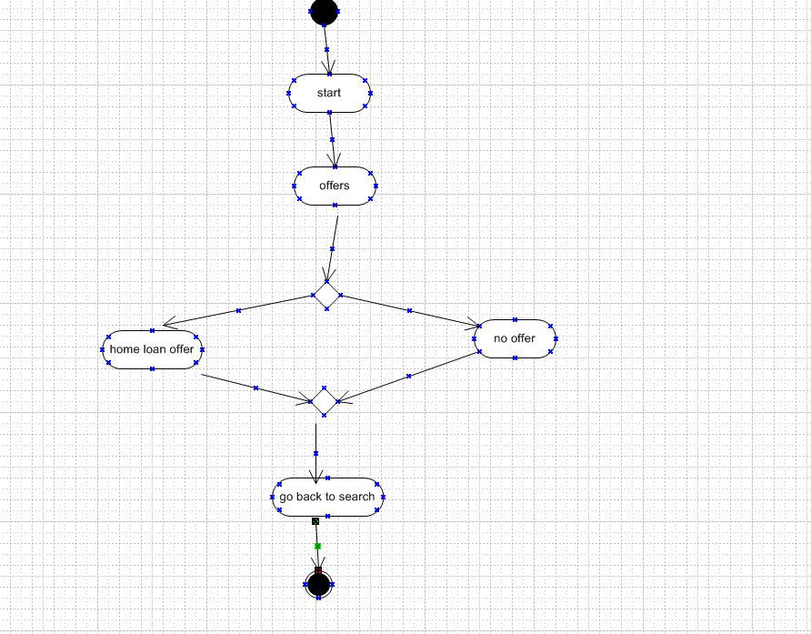

4) Initiating customer interactions.

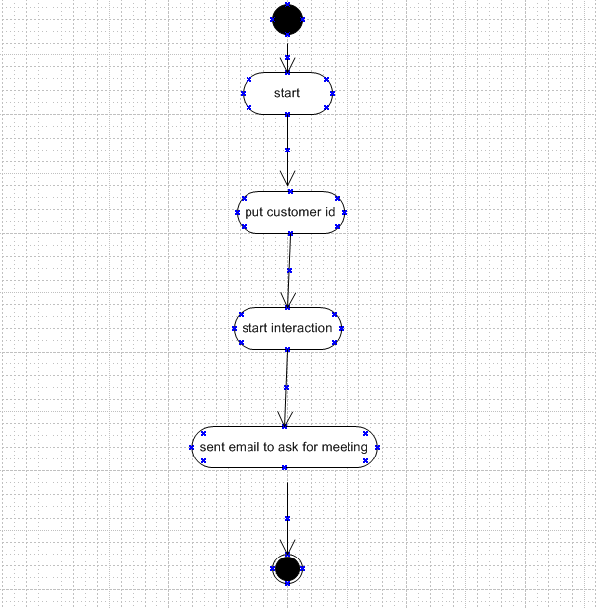

5) contacting customer.

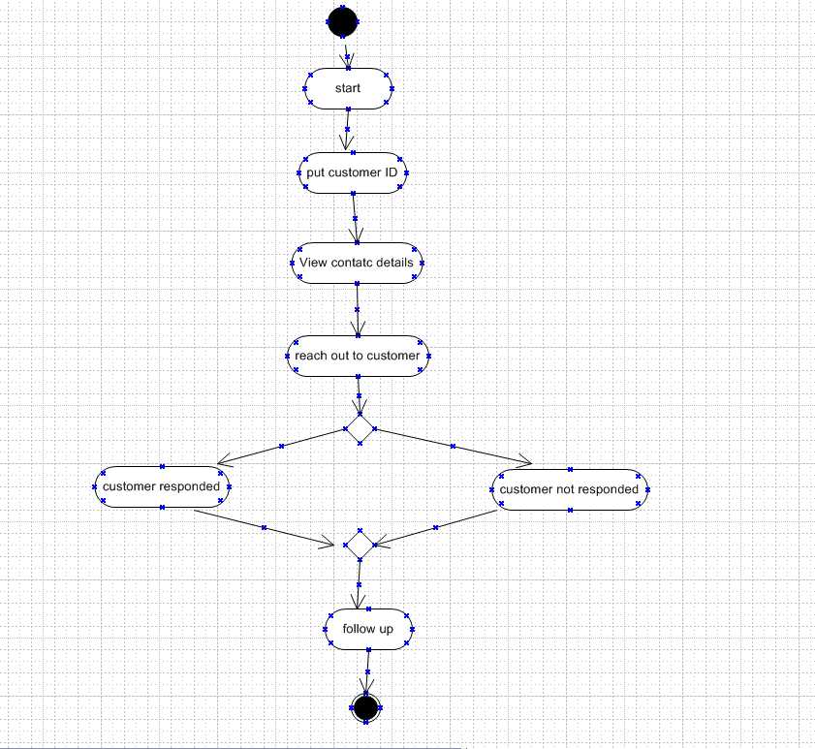

6) Customer raised complaint

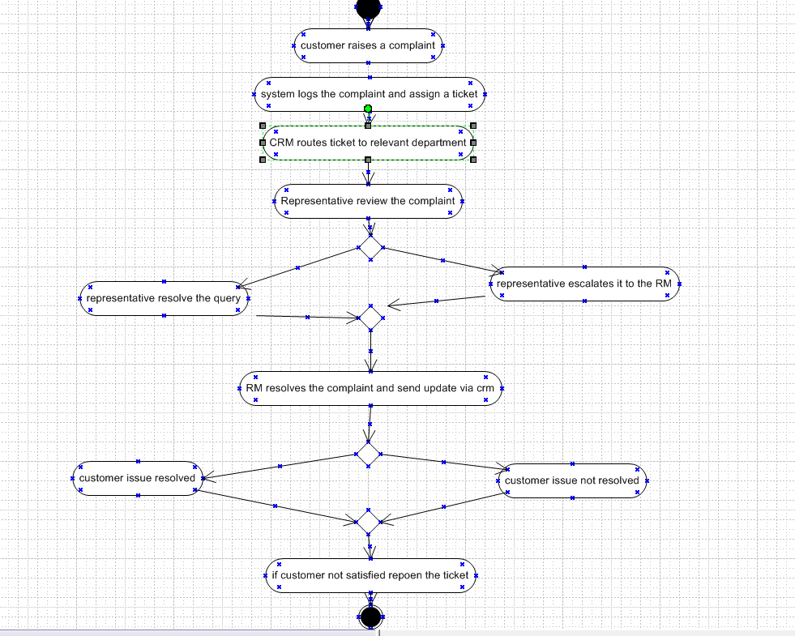

**Use case specification document:**

**Use Case Name: Login to App**

**1. Description:  
Allows RM to securely access the app via credentials.**

**2. Actors:**

* **Primary: RM**
* **Secondary: Authentication Service**

**3. Basic Flow:**

1. **RM opens app**
2. **Enters credentials**
3. **System authenticates**
4. **Grants access**

**4. Alternate Flow:**

* **Login via biometrics if enabled**

**5. Exceptional Flows:**

* **Invalid credentials**
* **Account locked after 5 attempts**
* **Server down**

**6. Pre-Conditions:**

* **RM account created**
* **Internet connection**

**7. Post-Conditions:**

* **Session started**

**8. Assumptions:**

* **Credentials are active**

**9. Constraints:**

* **2FA required for new devices**

**10. Dependencies:**

* **Auth server**
* **Device token**

**11. Inputs/Outputs:**

* **Input: Username, password**
* **Output: Login success/fail**

**12. Business Rules:**

* **Max 5 login attempts**
* **Session timeout: 15 mins**

**13. Misc:**

* **Login timestamp logged**

**Use Case Name: Check Customer Information**

**1. Description:  
RM views detailed profile of a customer.**

**2. Actors:**

* **Primary: RM**
* **Secondary: CRM system**

**3. Basic Flow:**

1. **RM selects customer**
2. **CRM fetches data**
3. **Displays profile**

**4. Alternate Flow:**

* **Show summary view on low bandwidth**

**5. Exceptional Flows:**

* **Customer ID not found**
* **Data fetch timeout**

**6. Pre-Conditions:**

* **RM logged in**
* **Customer exists**

**7. Post-Conditions:**

* **Customer profile viewed**

**8. Assumptions:**

* **Data is updated**

**9. Constraints:**

* **Read-only access**

**10. Dependencies:**

* **CRM API**

**11. Inputs/Outputs:**

* **Input: Customer ID**
* **Output: Profile data**

**12. Business Rules:**

* **Mask sensitive data**

**13. Misc:**

* **View count may be logged**

**Use Case Name: Search Customers**

**1. Description:  
RM searches customers by name, ID, mobile, etc.**

**2. Actors:**

* **Primary: RM**
* **Secondary: CRM system**

**3. Basic Flow:**

1. **RM enters search query**
2. **System returns matched customers**

**4. Alternate Flow:**

* **Auto-suggestions on typing**

**5. Exceptional Flows:**

* **No match found**
* **Invalid query format**

**6. Pre-Conditions:**

* **RM logged in**

**7. Post-Conditions:**

* **Results shown or error**

**8. Assumptions:**

* **Indexing in place**

**9. Constraints:**

* **Max 100 results**

**10. Dependencies:**

* **CRM search service**

**11. Inputs/Outputs:**

* **Input: Search filters**
* **Output: Results list**

**12. Business Rules:**

* **Search fields configurable**

**13. Misc:**

* **Support fuzzy search**

**Use Case Name:  
 RM Interaction Automation**

**1. Description:  
Automate timely prompts to Relationship Managers (RMs) for scheduled customer engagements and ensure those interactions are recorded and monitored to maintain accountability and improve customer experience.**

**2. Actors:**

* **Primary Actor: Relationship Manager (RM)**
* **Secondary Actors: CRM System, Customer**

**3. Basic Flow:**

1. **CRM System identifies accounts due for interaction**
2. **CRM generates prompt to RM**
3. **RM views pending interactions**
4. **RM initiates customer communication**
5. **RM records outcome in CRM**
6. **CRM updates interaction history**

**4. Alternate Flow:**

* **RM reschedules interaction with a valid reason**
* **CRM updates the new interaction date**

**5. Exception Flows:**

* **RM does not respond to prompt within defined SLA**
* **Escalation triggered to Team Lead**
* **CRM logs interaction as "missed" after time expiry**

**6. Pre-Conditions:**

* **RM is logged into the CRM**
* **Customer account is active and flagged for interaction**

**7. Post-Conditions:**

* **Interaction is logged**
* **Status is updated in customer timeline**
* **RM performance log is updated**

**8. Assumptions:**

* **RM checks CRM dashboard daily**
* **Customer contact details are up-to-date**

**9. Constraints:**

* **Prompt frequency limited to once per week per customer**
* **SLA for RM response is 48 hours**

**10. Dependencies:**

* **Accurate customer segmentation**
* **Up-to-date interaction schedule engine**

**11. Inputs and Outputs:**

* **Input: Customer ID, Scheduled interaction date**
* **Output: Interaction log, Status update, RM performance update**

**12. Business Rules:**

* **Each high-net-worth customer must receive an RM call at least once per quarter**
* **Missed interactions trigger escalation workflow**

**13. Miscellaneous Information:**

* **RM feedback on automation usefulness to be collected quarterly**
* **Future enhancement: voice call logging and sentiment analysis**

**Use Case Name: Contact Customers**

**1. Description:  
RM makes contact via system-triggered call, email, or chat.**

**2. Actors:**

* **Primary: RM**
* **Secondary: Notification/Telephony System**

**3. Basic Flow:**

1. **RM selects contact method**
2. **System sends communication**
3. **Status updated (sent, delivered)**

**4. Alternate Flow:**

* **Retry if failed**

**5. Exceptional Flows:**

* **Number/email blocked**
* **DND violations**

**6. Pre-Conditions:**

* **Interaction initiated**
* **Valid contact info**

**7. Post-Conditions:**

* **Contact made or logged as failed**

**8. Assumptions:**

* **Customer reachable**

**9. Constraints:**

* **No contact post 8 PM**
* **DND compliance**

**10. Dependencies:**

* **Email/Call APIs**
* **Contact DB**

**11. Inputs/Outputs:**

* **Input: Customer ID, method, message**
* **Output: Delivery status**

**12. Business Rules:**

* **Customer consent required**

**13. Misc:**

* **Call recordings may be stored**

**Doc 7:**

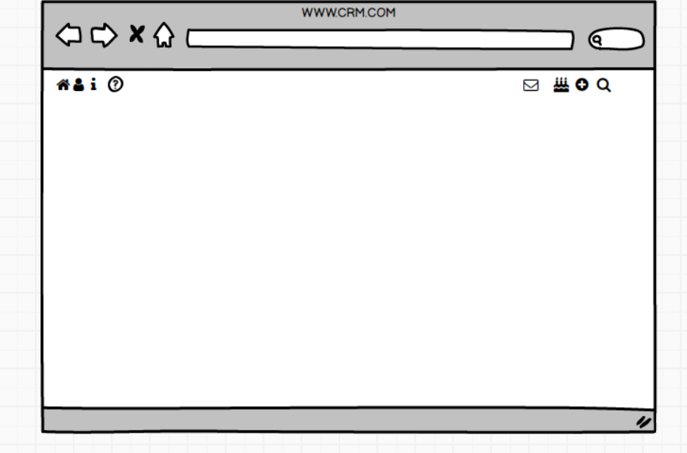

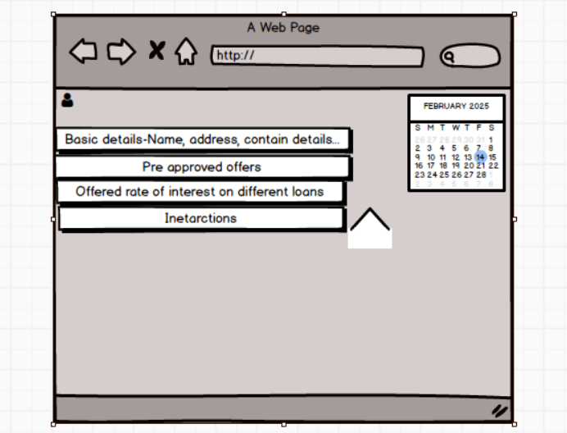

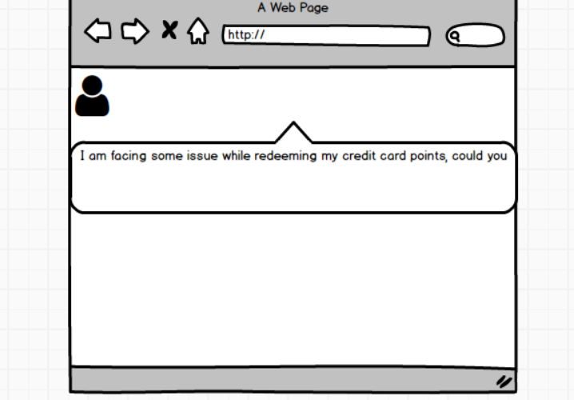

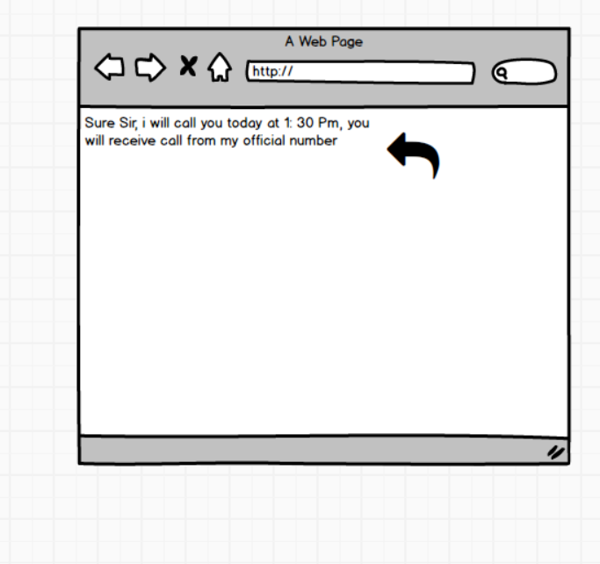

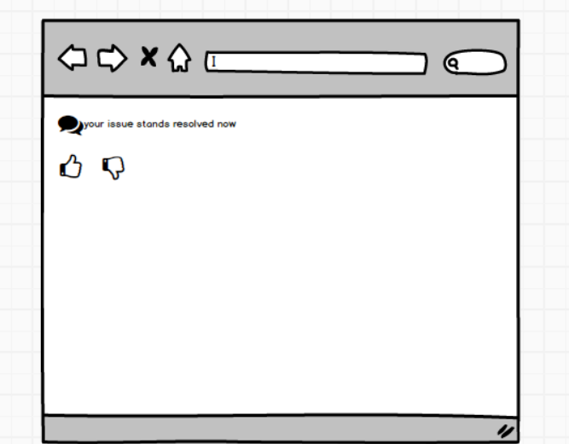

**Doc 8:**

**In my role as a Business Analyst on a strategic Customer Relationship Management (CRM) project, I utilized Microsoft Visio and Axure RP as core tools to analyze, design, and deliver solutions that directly addressed several pressing business challenges. These included departmental silos, absence of RM tracking, unmonitored customer interactions, and operational inefficiencies.**

**Use of Microsoft Visio**

**Microsoft Visio was instrumental in visualizing complex business processes and uncovering inefficiencies. My work involved the following:**

* **Process Mapping Across Departments:  
  I created detailed process maps to represent the existing workflows ("As-Is") and future-state workflows ("To-Be") for multiple teams such as Sales, Customer Service, and Relationship Management. These maps made it easier to pinpoint where communication breakdowns and hand-off delays occurred due to siloed operations.**
* **Identifying Integration Points:  
  Through swimlane diagrams, I highlighted dependencies and responsibilities across departments. These visual representations helped in identifying key areas where automation or system integration could reduce redundancy and improve coordination.**
* **RM Interaction Flows:  
  I used flowcharts to define the ideal flow of RM-customer interactions, from initiation to closure, incorporating automated prompts and follow-ups. These diagrams served as a blueprint for designing a new RM tracking module.**
* **Error and Delay Analysis:  
  I collaborated with operations and IT teams to document recurring issues in customer service, such as missed follow-ups or duplicate entries. Visio helped model the root causes in a clear and structured way, which supported decision-making on necessary system changes.**
* **Stakeholder Communication Tool:  
  The visual clarity provided by Visio made it easier to facilitate discussions with non-technical stakeholders. It became a key tool during workshops, steering meetings, and requirement validation sessions.**

**Use of Axure RP**

**Axure RP was critical in transforming abstract business needs into tangible, interactive user experiences. My work with Axure included:**

* **Designing Prototypes for CRM Modules:  
  I developed interactive wireframes for key CRM components, such as dashboards for Relationship Managers, customer profiles, interaction logging tools, and case resolution timelines. These prototypes included user interactions like dropdowns, filters, and alerts.**
* **Simulating RM Tracking Functionality:  
  One of the main pain points—lack of RM tracking—was addressed through a prototype that showcased how RMs could receive reminders, log meetings, and view customer engagement history in real-time. Axure allowed me to demonstrate this flow convincingly to stakeholders before development began.**
* **User-Centered Design Reviews:  
  I organized usability sessions with end users (e.g., RMs, service reps) using the Axure prototypes. Their feedback was incorporated iteratively to refine screen layouts, navigation, and data visibility, ensuring the final design met both business goals and user needs.**
* **Bridging Requirements and Development:  
  Axure helped bridge the gap between business requirements and technical implementation. Developers used the annotated wireframes as reference points for building out CRM features, reducing ambiguity and rework.**
* **Documenting UI/UX Requirements:  
  Alongside the prototypes, I delivered comprehensive documentation that outlined each screen’s purpose, field-level behavior, business rules, and conditional logic. This ensured traceability and consistency throughout the project lifecycle.**

**Overall Impact**

**The combined use of Visio and Axure allowed me to drive a structured and collaborative approach to problem-solving. These tools helped:**

* **Break down functional silos by showing clear, integrated workflows.**
* **Translate business problems into interactive design solutions.**
* **Increase stakeholder buy-in through early visual validation.**
* **Lay a strong foundation for a scalable, user-friendly CRM system.**

**Through these efforts, I contributed directly to reducing inefficiencies, improving relationship manager productivity, and enabling a more personalized customer service experience.**

**Doc 9:**

Throughout my CRM project, I was actively involved in each phase of the Software Development Life Cycle, following the Waterfall methodology. Below is a detailed account of my responsibilities, the hurdles I encountered, and how I overcame them.

**1. Requirement Gathering**

To gather requirements effectively, I applied the **MOSCOW prioritization technique** (Must, Should, Could, Won’t) to categorize and focus on what truly mattered. One major challenge was that the client was **not consistently available**, which delayed input. I proactively **identified alternative contacts from the client’s side** to keep the process moving and ensure minimal downtime.

Additionally, I used the **FURPS model** (Functionality, Usability, Reliability, Performance, Supportability) to validate the quality of requirements. Many requirements were **redundant or overlapping**, so I carefully reviewed and **eliminated duplicates** to maintain clarity. To make ambiguous requirements more specific, I leveraged **prototyping tools** to help stakeholders visualize the expected outcomes.

**2. Requirement Analysis**

In this phase, I created **UML diagrams**, such as use case and class diagrams, to visualize system requirements. **Activity diagrams** were especially useful in mapping out business processes step-by-step.

Sharing these diagrams with the team sometimes led to **conflicting interpretations** or pushback. I handled these situations by encouraging open discussions, listening to feedback, and **making necessary adjustments** to the diagrams to ensure alignment. I also prepared detailed **BRS (Business Requirement Specification)** and **SRS (Software Requirement Specification)** documents to formally capture and communicate the finalized requirements.

**3. Design**

From the use cases, I **developed test cases**, including both positive and **negative scenarios**, ensuring full coverage of potential outcomes. I maintained close communication with the client during the design stage to validate the solution approach and address any concerns early.

A critical task was ensuring **no test cases were missed**, as even small gaps can impact the quality of development later. I also created **test data** for upcoming testing phases and continuously updated the **Requirements Traceability Matrix (RTM)** to verify that every requirement was addressed in the design.

**4. Development**

During development, I organized and facilitated **Joint Application Development (JAD) sessions** to align the technical and functional teams. At times, certain team members were either uncooperative or disagreed with proposed solutions. I addressed this by having **one-on-one discussions** to understand their perspective, explain the business impact, and maintain a **positive team environment**.

I also supported the developers by **clarifying requirements** and referring them to relevant diagrams and documentation. Regular meetings with the client and tech team were crucial but sometimes difficult to coordinate. When participants were unavailable, I recorded the sessions and followed up with **individual briefings** to keep everyone in the loop.

**5. Testing**

In the testing phase, I took the lead in **creating test cases from use cases** and conducting **high-level testing** to ensure the system was functioning as expected. I coordinated with the client to get the required **test data** and updated the RTM to track coverage.

Once testing was complete, I arranged for **client sign-off** and helped prepare the client team for **User Acceptance Testing (UAT)** by walking them through the process and what to expect.

**6. Deployment**

During deployment, I forwarded the **final RTM** to the client, ensuring it was attached to the **project closure documentation**. I also managed the creation and distribution of **end-user manuals**, coordinated **training sessions**, and ensured **maximum participation** from the client team to support a smooth transition into live operations.

This experience helped me grow as a Business Analyst by developing a problem-solving mindset, strong communication skills, and the ability to manage multiple stakeholders effectively. Each phase had its own set of challenges, but by staying organized, proactive, and adaptable, I was able to deliver quality outcomes throughout the project lifecycle.