**CAPSTONE PREP – 3**

1. **A customer can make a payment either by Card or by Wallet or by Cash or by Net banking.**

**Draw a Use Case Diagram**

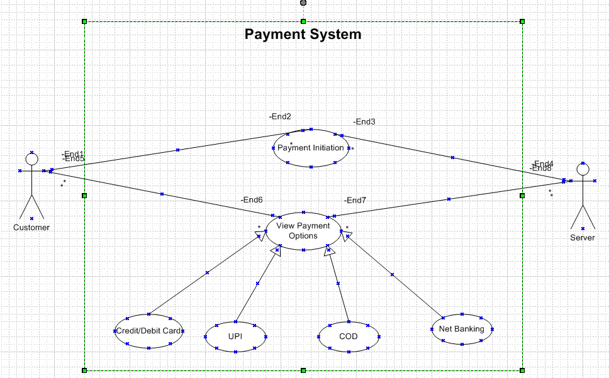

1. **Derive Boundary Classes, Controller classes, Entity Classes.**

Boundary Classes (UI/Interface Layer)

Boundary classes handle user interactions and act as interfaces between the external world and the system.

* Payment - Handles customer interactions related to payments.
* CardPayment - Handles card-specific interactions (like entering card details).
* Wallet Payment - Handles wallet-related transactions.
* Cash Payment - Handles cash payments.
* Net Banking Payment - Manages net banking payment interactions.

Controller Classes (Business Logic layer)

Controller classes process user requests, coordinate business logic, and interact with entity classes.

* Payment - Controls the payment flow.
* Card Payment - Handles payment logic for cards.
* Wallet Payment - Manages wallet payments.
* Cash Payment - Validates and confirms cash payments.
* Net Banking - Manages net banking transactions.

Entity Classes (Data Layer)

Entity classes represent the core business objects that store data.

* Payment - Stores common payment details (amount, status, method).
* Card Payment - Extends Payment, includes card number, expiry, CVV.
* Wallet Payment - Extends Payment, includes wallet ID, balance.
* Cash Payment - Extends Payment, includes cash receipt details.
* Net Banking - Extends Payment, includes bank details and transaction ID.
* Customer - Represents the user making the payment.
* Transaction - Logs payment transactions.

1. **Place these classes on a three tier Architecture.**

|  |  |  |  |
| --- | --- | --- | --- |
| **Layer** | **Class Type** | **Class Name** | **Description** |
| **Database layer** | Entity Class | Payment | Represents payment entity in database |
|  | Entity Class | Card Payment | Represents payments made via Card. |
|  | Entity Class | Wallet Payment | |  | | --- | |  |  |  | | --- | | Represents payments made via Wallet. | |
|  | Entity Class | CashPayment | Represents payments made via Cash. |
|  | Entity Class | NetBankingPayment | Represents payments made via Net Banking. |
| **Application Layer** | Boundary Class | PaymentService | Provides services for processing payments. |
|  | Boundary Class | PaymentRepository | Handles database operations for payments. |
| **Business Logic Layer** | Controller Class | PaymentController | Handles API requests related to payments. |
|  | Controller Class | CardPayment | Handles Card Payment processing. |
|  | Controller Class | WalletPayment | |  | | --- | |  |  |  | | --- | | Handles Wallet Payment processing. | |
|  | Controller Class | CashPayment | Handles Cash Payment processing. |
|  | Controller Class | NetBankingPayment | Handles Net Banking Payment processing. |

1. **Explain Domain Model for Customer making payment through Net Banking**

The domain model will represent the structure and behaviour of the system related to this specific use case.

Key Entities:

1. Customer
2. Payment
3. NetBankingPayment
4. Bank

Attributes:

* Customer
* Customer ID
* Name
* Email
* Phone Number
* Payment
* Payment ID
* Amount
* Payment Date
* Payment Status
* NetBankingPayment
* Bank Name
* Account Number
* Transaction ID
* Net Banking Details
* Bank
* Bank ID
* Bank Code
* Bank Name
* IFSC Code

**Relationships:**

* Customer makes a Payment.
* A Customer can make multiple payments
* A payment is associated with one customer.
* Payment is specialized into NetBankingPayment.
* Net Banking is a type of payment
* Net banking inherits attributes from payment and adds specific attributes related to net banking
* NetBankingPayment is associated with a Bank
* A Net banking payment is linked to a specific bank
* A bank can have multiple net banking payments

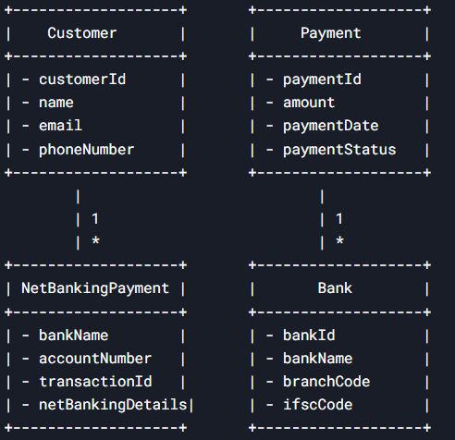

1. **Draw a sequence diagram for payment done by Customer Net Banking**

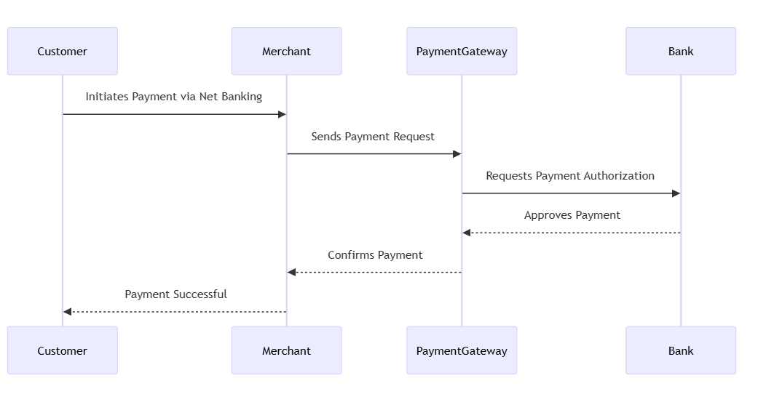

1. **Explain Conceptual Model for this Case**

A conceptual model represents the high-level structure of the system, focusing on key entities and their relationships without delving into implementation details.

Entities and Relationships

* Customer
* A customer initiates a payment.
* Can have multiple payment options available.
* Payment
* Represents a transaction initiated by the customer.
* Linked to exactly one payment method.
* Payment Method
* A payment can be made using one of the following methods:

Card (Credit/Debit)

Wallet (Digital wallets like Paytm, Google Pay, etc.)

Cash

Net Banking

Each payment method has unique attributes (e.g., card number for Card, wallet provider for Wallet).

Example Conceptual Schema

* Customer (CustomerID, Name, Email, Phone)
* Payment (PaymentID, CustomerID, Amount, Date, Status, Payment MethodID)
* PaymentMethod (Payment MethodID, Type)
* Card (Payment MethodID, Card Number, Expiry Date, CVV, Card Holder Name)
* Wallet (Payment MethodID, Wallet Provider, Wallet ID)
* Cash (Payment MethodID)
* Net Banking (Payment MethodID, BankName, AccountNumber)
* A Customer makes a Payment.
* A Payment is processed using one Payment Method.
* The Payment Method is a generalization that includes Card, Wallet, Cash,or Net Banking.
* Each payment method has specific attributes relevant to its type.

1. **What is MVC architecture? Explain MVC rules to derive classes from use case diagram and guidelines to place classes in 3-tier architecture**

MVC (Model-View-Controller) is a software design pattern used to separate concerns in an application, making it more maintainable and scalable. It divides the application into three main components:

* Model: Represents the data and business logic.
* View: Handles the user interface and presentation.
* Controller: Manages user input, interacts with the model, and updates the view.

MVC Rules to Derive Classes from a Use Case Diagram

To derive classes from a use case diagram, follow these rules:

* Identify the Actors and Use Cases
* Actors represent external entities (e.g., Customer, Payment System).
* Use cases represent functionalities (e.g., Make Payment).
* Extract the Key Entities
* Identify nouns from the use case description (e.g., Payment, Customer, Wallet, Card, Cash, Net Banking).
* These entities become model classes.
* Determine the Controller Classes
* Identify verbs that represent actions (e.g., process payment, validate transaction).
* These actions become methods in controller classes.
* Define View Components
* Identify screens/UI elements required for user interaction (e.g., Payment Page, Confirmation Page).

Guidelines to Place Classes in a 3-Tier Architecture

A 3-tier architecture consists of:

* Presentation Layer (UI Layer)
* Contains views that interact with the user (e.g., HTML pages, Mobile UI).
* Example: Payment Page, Transaction Confirmation Page.
* Business Logic Layer (Service Layer)
* Contains business rules, validations, and service classes.
* Example: Payment Service (handles processing logic), Transaction Validator.
* Data Access Layer (Persistence Layer)
* Manages database operations.
* Example: Payment DAO, Transaction Repository.

1. **Explain BA contributions in project (Waterfall Model – all Stages)**

|  |  |  |
| --- | --- | --- |
| **Stage** | **Activities** | **Artifact and Resources** |
| Pre-Project | - Identify business need for payment options - Conduct feasibility study - Prepare business case | - Business Case Document - Feasibility Study Report - Stakeholder Identification |
| Planning | - Define project scope, objectives, and deliverables - Identify stakeholders and dependencies - Create high-level project plan | - Project Charter - Stakeholder Register - High-Level Project Plan |
| Project Initiation | - Conduct stakeholder meetings to gather initial expectations - Define roles and responsibilities of team | - Project Scope Statement - RACI Matrix - Initial Risk Assessment |
| Requirement Gathering | - Conduct workshops, interviews, and surveys to gather payment requirements - Define functional and non-functional requirements - Identify regulatory compliance requirements | - Business Requirement Document (BRD) - Stakeholder Requirements Document (SRD) - Meeting Notes |
| Requirement Analysis | - Analyze payment options (Card, Wallet, Cash, Net Banking) - Prioritize requirements based on business needs and feasibility - Identify integration needs with banking/payment gateways | - Requirement Traceability Matrix (RTM) - Process Flow Diagrams - Gap Analysis Report |
| Design | - Collaborate with technical teams to design payment system architecture - Define user workflows for each payment method - Document UI/UX wireframes and API specifications | - Functional Specification Document (FSD) - System Design Document (SDD) - Wireframes & Prototypes |
| Development | - Clarify business logic and handle requirement changes - Assist developers in understanding payment flows - Ensure compliance requirements are implemented | - Updated RTM - Change Request Document (if any) - Payment Processing Logic |
| Testing | - Validate test cases for payment transactions - Support SIT (System Integration Testing) and verify compliance - Perform defect analysis and requirement validation | - Test Cases & Test Scenarios - Defect Logs - Test Execution Reports |
| UAT | - Conduct UAT sessions with business users - Ensure all payment methods function as expected | - UAT Test Cases & Results - UAT Sign-off Document - User Feedback Report |

1. **What is conflict management? Explain using Thomas – Kilmann technique**

Conflict management is the process of identifying, addressing, and resolving conflicts in a constructive manner to maintain a healthy work or personal environment. It involves strategies that help minimize the negative impact of conflicts while fostering collaboration and understanding.

The Thomas-Kilmann technique is a widely used framework for conflict resolution, developed by Kenneth Thomas and Ralph Kilmann. It categorizes conflict-handling behavior based on two dimensions:

Assertiveness - The extent to which a person tries to satisfy their own concerns.

Cooperativeness - The extent to which a person tries to satisfy the concerns of others.

Based on these dimensions, the model identifies five conflict-handling styles:

* Identify the Conflict
* Observe the situation and recognize the signs of conflict.
* Understand the emotions and concerns involved.
* Identify the people affected by the issue.
* Discuss the details
* Allow both parties to express their viewpoints.
* Encourage open communication and active listening.
* Avoid blame and focus on facts.
* Agree on the root problem
* Analyze the underlying cause of the conflict.
* Ensure both parties agree on what the real issue is.
* Differentiate between personal issues and professional disagreements.
* Check for every possible solution
* Brainstorm multiple resolutions.
* Evaluate the pros and cons of each option.
* Consider compromises or new alternatives.
* Negotiate the solution to avoid Future conflicts
* Agree on a mutually beneficial solution.
* Set clear guidelines for future similar issues.
* Document the decision to prevent recurrence.

1. **List down the reasons for project failure**

* Poor Planning and Requirements Management
* Unclear project scope (scope creep)
* Vague or incomplete requirements
* Lack of proper project documentation
* Inadequate Leadership and Stakeholder Engagement
* Weak project management
* Lack of executive support
* Poor communication among stakeholders
* Poor Resource Management
* Insufficient budget allocation
* Inadequate human resources or skill gaps
* Poor time management and unrealistic deadlines
* Ineffective Risk Management
* Failure to identify potential risks
* No contingency plans
* Ignoring early warning signs
* Technical Challenges
* Use of outdated or incompatible technology
* Poor system integration
* Insufficient testing and quality assurance
* Unrealistic Expectations
* Overpromising results to stakeholders
* Underestimating complexity and effort required
* Lack of alignment between business goals and project objectives
* Lack of User or Customer Involvement
* Not gathering feedback from end-users
* Delivering a solution that does not meet business needs
* Ignoring user experience (UX) considerations

1. **List the Challenges faced in projects for BA**

* Requirement-Related Challenges
* Unclear or Changing Requirements: Stakeholders often struggle to define their needs, leading to scope creep.
* Conflicting Stakeholder Expectations: Different departments may have opposing priorities.
* Incomplete Requirements Gathering: Missing critical details can cause issues later.
* Stakeholder Management Challenges
* Unavailability of Stakeholders: Key stakeholders may not be accessible for input.
* Resistance to Change: Users may resist new processes or technologies.
* Miscommunication: Business and technical teams often have different terminologies.
* Technical and Process Challenges
* Lack of Technical Knowledge: A BA may struggle to bridge the gap between business and IT.
* Poor Documentation Standards: Unclear documentation can lead to misunderstandings.
* Integration with Legacy Systems: Compatibility issues can arise with old software.
* Project Management Challenges
* Tight Deadlines & Resource Constraints**:** Limited time and budget can impact quality.
* Scope Creep: Constantly changing requirements can affect timelines and costs.
* Poor Risk Management: Lack of anticipation for risks can lead to project failure.
* Communication and Collaboration Issues
* Lack of Stakeholder Engagement: Some stakeholders may not actively participate.
* Difficulty in Translating Business Needs to Technical Teams: Ensuring alignment is challenging.
* Cultural and Geographical Barriers: Distributed teams may face collaboration challenges.

1. **Write about Document Naming Standards**

Document Naming Standards are a set of guidelines that help organizations maintain consistency, clarity, and efficiency in naming files and documents. A well-defined naming convention ensures that documents are easy to locate, understand, and manage, reducing confusion and errors in collaborative environments.

Example:

Project ID: PRJ123

Document Type: REQ

Version: v1.0

Date: 13-02-2025

Document Identifier: PRJ123-REQ-v1.0-20250210

This format ensures that all stakeholders can quickly identify the document's purpose, version, and relevance.

1. **What are the Do’s and Don’ts of a Business analyst**

Do’s for a Business Analyst:

* Understand Business Needs Clearly
* Conduct thorough stakeholder interviews.
* Analyze business processes to identify pain points and areas for improvement.
* Communicate Effectively
* Use clear, concise, and structured communication.
* Actively listen to stakeholders and clarify requirements.
* Document Everything
* Maintain detailed documentation (BRD, FRD, Use Cases, User Stories, etc.).
* Ensure all requirements are traceable and well-organized.
* Collaborate with Stakeholder
* Engage with business users, developers, testers, and project managers.
* Facilitate workshops and brainstorming sessions.
* Think Critically and Analytically
* Break down complex problems into smaller, manageable parts.
* Use data-driven decision-making.

Don’ts for a Business Analyst

* Don’t Assume Requirements Without Validation
* Don’t Neglect End Users
* Don’t Overcomplicate Solutions
* Don’t Ignore Documentation
* Don’t Work in Isolation
* Don’t Delay Stakeholder Engagement
* Don’t Disregard Risks
* Don’t Ignore Feedback

1. **Write the difference between packages and sub-systems**

|  |  |  |
| --- | --- | --- |
| **Aspect** | **Package** | **Subsystem** |
| Definition | |  | | --- | |  |  |  | | --- | | A logical grouping of related classes, interfaces, and sub-packages within a software system. | | A larger, self-contained module within a system that provides a distinct functionality, often comprising multiple packages. |
| Scope | Typically smaller in scope, used to organize code efficiently within a system. | Broader in scope, representing a major functional component of a system. |
| Encapsulation | Helps in organizing classes to avoid name conflicts and improve code maintainability. | Encapsulates a set of related functionalities, services, or components. |
| Implementation | Found in programming languages like Java | Implemented as a part of system architecture, often involving multiple packages |
| Example | A networking package in a software application. | A "Payment Processing" sub-system in an e-commerce application |

1. **What is camel-casing and explain where it will be used**

Camel casing is a naming convention used in programming language. It is used for naming variables, functions and identifiers

There are two main types of camel casing:

Lower Camel Case: The first letter is lowercase, and each subsequent word starts with an uppercase letter.

Example: userLogin, fetchData, calculateTotal

Upper Camel Case: Every word starts with an uppercase letter, including the first one.

Example: UserLogin, FetchData, CalculateTotal

Uses of Camel casing:

✔ Improves readability and consistency.  
✔ Reduces the need for underscores, making code cleaner.  
✔ Aligns with standard conventions in popular programming languages.

1. **Illustrate Development server and what are the accesses does business analyst has**

A development server refers to a dedicated environment or server that is used during the software development process.

It provides a platform for developers and testers to build, test and debug applications before they are deployed to a production environment

A Business Analystgenerally has limited access to development environments since their role is focused on gathering and analyzing requirements rather than development.

Depending on the organization, they may have access to:

* Read-Only Access to Project Management Tools
* Read-Only Access to Code Repository
* Access to Testing & QA Environment
* Limited Access to Development Server Logs
* Access to Reporting and Dashboarding Tools

1. **What is Data Mapping**

Data mapping is the process of connecting data from one source to another. Its like creating a guide or map that shows how data in one place corresponds to data in another place. This is especially important when you’re moving data between different systems or databases to ensure that the data stays consistent and accurate.

Types of Data Mapping:

* Manual Data Mapping – Performed manually by developers or analysts using spreadsheets or scripts.
* Automated Data Mapping – Uses tools like Talend, Informatica, or Apache NiFi to automate the process.
* Schema Mapping – Maps data structures between databases, ensuring compatibility between different schemas.

Common Use Cases:

* ETL (Extract, Transform, Load) Pipelines
* API Data Exchange
* Cloud Migrations

1. **What is API. Explain how you would use API integration in the case of your application Date format is dd-mm-yyyy and it is accepting some data from Other Application from US whose Date Format is mm-dd-yyyy**

An API or Application Programming Interface is a set of rules and tools that allows different software applications to communicate with each other.

It defines the methods and data formats that applications can use to request and exchange information

If our application expects dates in dd-mm-yyyy format but receives data from a US-based application where the format is mm-dd-yyyy, we need to integrate the APIproperly and handle the date conversion.

Steps for API Integration:

* Consume the API:
* Make a request to the external API using HTTP methods
* Receive a response in JSON/XML format.
* Extract the Date Field:
* Identify the date field in the response payload.
* Convert the Date Format:
* Since the incoming date is in mm-dd-yyyy, we need to transform it into dd-mm-yyyy.
* Example conversion:

Received: 02-15-2025 (mm-dd-yyyy)

Converted: 15-02-2025 (dd-mm-yyyy)

* Store/Use the Converted Date:
* Save it in the database or display it in the UI in the correct format.

Implementation in a Real-World API Integration:

If we are developing a microservice that integrates with the US-based system, we would:

* Call the API to fetch data.
* Process the response, convert dates.
* Store or send the formatted date forward.

Use Cases:

* APIs enable communication between applications.
* When integrating with an API, we must ensure data format compatibility.
* Date conversion is necessary when working with different regional formats.
* Python's datetime module helps in handling such transformations easily.