**COEPD – Traditional Development**

Capstone Project 1 – Part -3/3 – 100 Marks

**Ques 1:** Functional Requirements:

Identify minimum 20 functional requirements

Example:

Functional requirement: When an order is fulfilled, the local printer shall print a packing slip.

Non-Functional Requirement: Packing slips shall be printed on both sides of 4”x 6” white paper, the standard size for packing slips used by local printers.

|  |  |  |  |
| --- | --- | --- | --- |
| Req. ID | Req. Name | Req. Description | Priority |
| FR0001 | Farmer Registration | Farmers should be able to register with the application | 8 |
| FR0002 | Farmer Search for Products | Farmers should be able to search for available products in fertilizers, seeds, pesticides | 8 |
| NFR0101 | Page Loading Time | Each Page should load within 2 seconds time | 9 |
| NFR0102 | WCAG 2.1. | The system must meet Web Content Accessibility Guidelines WCAG 2.1. | 8 |

**Ans:** Following are the Functional and Non-Functional Requirements:

Priority 1 to 10 where **10** is for **Highest Priority** and **01** is **Lowest Priority**:

**Users = Farmers and Manufacturer**

|  |  |  |  |
| --- | --- | --- | --- |
| **Req. ID** | **Req. Name** | **Req. Description** | **Priority (1 – 10)** |
| FR0001 | User Registration | User should be able to register with the application | 10 |
| FR0002 | User Search for Products | Users should be able to search for available products in fertilizers, seeds, pesticides | 10 |
| FR0003 | User Login | User should login using email ID and password. | 10 |
| FR0004 | Password Reset | User should reset password via registered email | 9 |
| FR0005 | Browse Product | User can browse product catalogue without login | 9 |
| FR0006 | Filter Product | User can filter products by category (fertilizers, seeds, pesticides) | 9 |
| FR0007 | Product Listing | User can add Product List with details | 10 |
| FR0008 | Edit Product | User can edit product details | 7 |
| FR0009 | Delete Product | User can delete the products | 7 |
| FR0010 | Add to Cart | User adds product to shopping cart to buy | 10 |
| FR0011 | Save Product | User can save the product in buy-later list | 6 |
| FR0012 | Remove Product | User can delete/remove the saved product from buy-later list/cart | 9 |
| FR0013 | Place Order | User can Place Order after adding products to cart | 10 |
| FR0014 | Payment Gateways | User can choose Payment Gateway as per their choice like UPI, cards, COD | 10 |
| FR0015 | Order Confirmation | After user place order successfully, user should get order confirmation email or message | 9 |
| FR0016 | Delivery Address | User can add/edit/manage delivery addresses | 8 |
| FR0017 | Order Tracking | User can track the delivery for placed Order | 9 |
| FR0018 | Order History | User can view their Order History for their purchases | 7 |
| FR0019 | Manage Users | Managing Users role as per the login like Farmers, Manufacturer or Admin | 9 |
| FR0020 | Customer Care | User can contact customer support | 6 |
| NFR0101 | Page Loading Time | Each Page should load within 2 seconds time | 9 |
| NFR0102 | WCAG 2.1. | The system must meet Web Content Accessibility Guidelines WCAG 2.1. | 8 |

**Ques 2:** Make wireframe and prototypes.

**Ans:** Following are the Wireframes and Prototypes for 5 different pages:

* **WIREFRAMES:**

1. **Login Page Wireframe:**

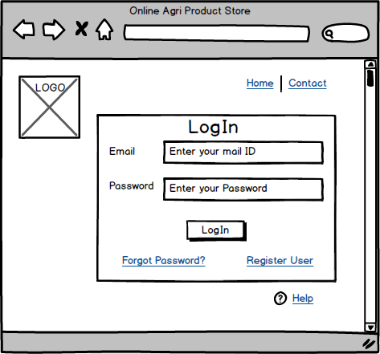

1. **User Registration Wireframe:**

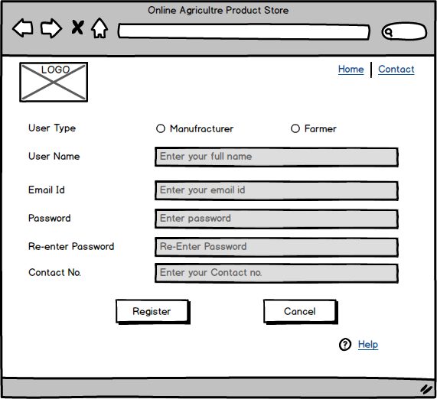

1. **Product Catalogue:**

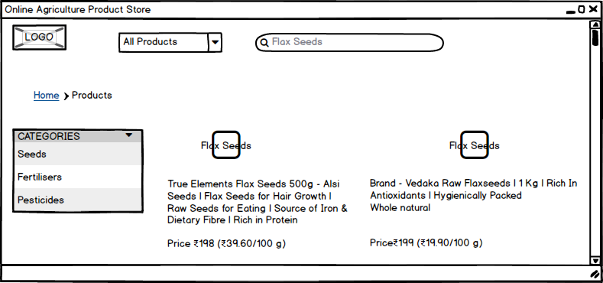

1. **Product Detail:**

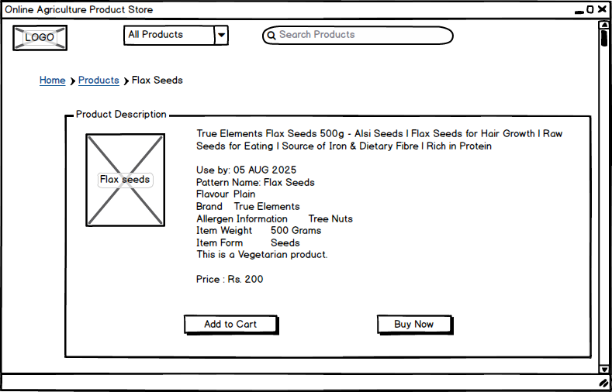

1. **Order Summary:**

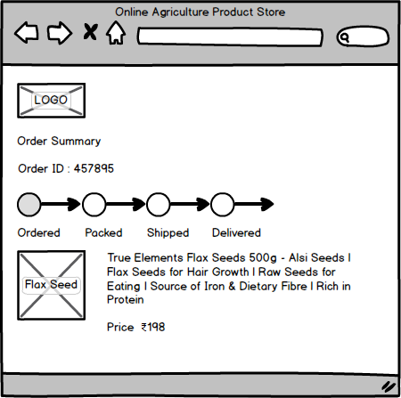

* **PROTOTYPES:**

# **Login Page Prototype:**

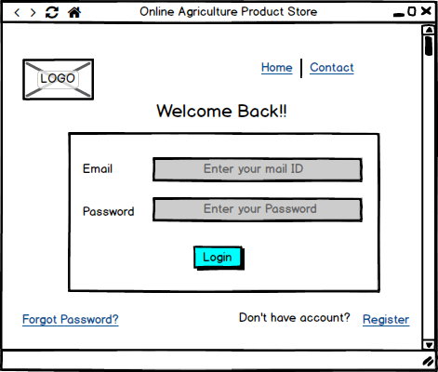

# **User Registration Prototype:**

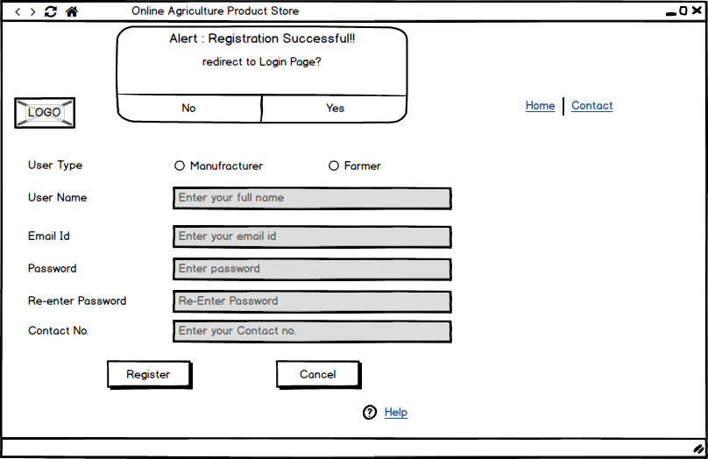

# **Product Catalogue:**

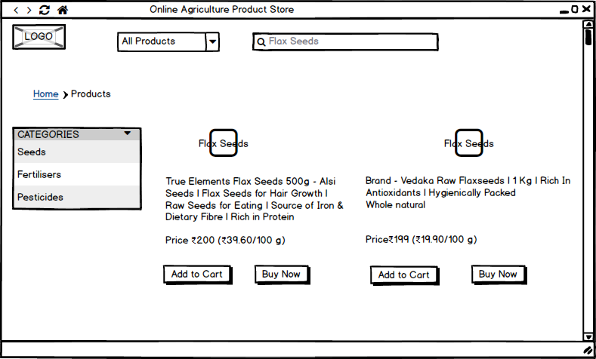

# **Product Detail:**

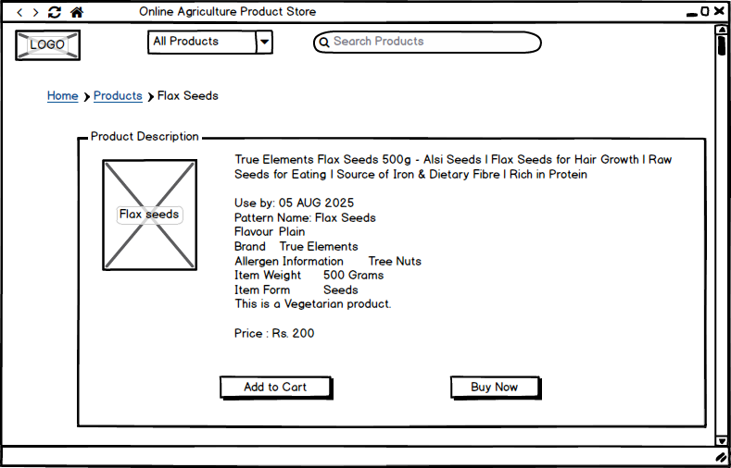

# **Order Summary:**

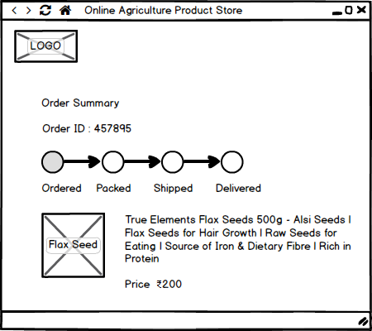

**Ques 3:** Make a note of the Tools, which you are using for above concepts.

**Ans: Balsamiq Mockups** is a widely used wireframing and prototyping tool that helps Business Analysts and Designers to create quick, low-fidelity mockups of web and mobile applications. It is especially useful in the early stages of software development when the focus is on gathering requirements, discussing ideas with stakeholders, and finalizing the layout and structure of the application.

It is a powerful, intuitive tool used by Business Analysts to visually communicate user requirements, plan UI/UX layouts, and create clickable prototypes during early project phases. Its simplicity and fast workflow make it an ideal choice for stakeholder presentations and requirement documentation.

Also, it improves collaboration, speeds up the design process, and ensures that user interface expectations are well-understood before development begins. It played a crucial role in building the UI concepts for the Online Agriculture Product Store project.

**Purpose:**

* Used to create **wireframes and clickable prototypes** for the **Online Agriculture Product Store** project.
* Helps visualize the user interface and layout of key screens like:
  + Login Page
  + Registration
  + Product Catalogue
  + Product Detail Page
  + Order Summary & Tracking Page

**Key Features of Balsamiq:**

* **Sketch-style design:** Makes it clear that these are drafts, inviting feedback.
* **Drag-and-drop UI elements:** Includes buttons, text fields, headers, icons, etc.
* **Clickable Prototypes:** Ability to add navigation between screens to simulate basic user flow.
* **Annotations and Notes:** Allows BAs to explain functionality and layout easily.
* **Export Options:** Easily export wireframes/prototypes as PNG or PDF for documentation and presentations.

**Advantages for Business Analysts:**

* Extremely **user-friendly**, no design or coding skills required.
* Helps in **communicating ideas** clearly to developers and stakeholders.
* Encourages quick **iteration based on feedback**.
* Saves time by creating reusable elements and templates.

**Why Chosen Over Other Tools:**

* Compared to tools like MS Visio (used mainly for use case and activity diagrams), Balsamiq is:
  + More focused on **UI/UX wireframes**
  + Faster for **early-stage design**
  + Ideal for client/stakeholder presentations

**Ques 4:** A business analyst’s key responsibilities are to keep track of the requirements and make sure that no requirement is missed.

Mr. Henry and peter have approached you regarding the current status of the project. How will you tackle this situation?

|  |  |  |  |  |  |  |  |  |
| --- | --- | --- | --- | --- | --- | --- | --- | --- |
| Prepare RTM Req. ID | Req. Name | Req. Description | Design | D1 | T1 | …… | T4 | UAT |
| FR0001 | Farmer Registration | Farmers should be able to register with the application |  |  |  |  |  |  |
| FR0002 | Farmer Search for Products | Farmers should be able to search for available products in fertilizers, seeds, pesticides |  |  |  |  |  |  |
|  |  |  |  |  |  |  |  |  |
| NFR0101 | Page Loading Time | Each Page should load within 2 seconds time |  |  |  |  |  |  |
| NFR0102 | WCAG 2.1. | The system must meet Web Content Accessibility Guidelines WCAG 2.1. |  |  |  |  |  |  |

**Ans:** Requirement Traceability Matrix (RTM) that can be presented to Mr. Henry and Peter to clearly show the tracking of Functional and Non-Functional Requirements, ensuring none are missed and each has a traceable path across design, development, testing, and UAT stages are as follows:

|  |  |  |  |  |  |  |  |  |
| --- | --- | --- | --- | --- | --- | --- | --- | --- |
| **Prepare RTM Req. ID** | **Req. Name** | **Req. Description** | **Design** | **T1** | **T2** | **T3** | **T4** | **UAT** |
| FR0001 | User Login | Users (farmers/manufacturers) must login with email & password | D1 | ☑ | ☑ |  |  | ☑ |
| FR0002 | User Registration | Users should register with the application | D2 | ☑ | ☑ |  |  | ☑ |
| FR0003 | User search for products | Farmer should be able to search for products (fertilizers, seeds, pesticides) | D3 | ☑ | ☑ | ☑ |  | ☑ |
| FR0004 | Product Catlog | Farmers can browse categorized product lists | D3 | ☑ | ☑ | ☑ |  | ☑ |
| FR0005 | Add to Cart | Farmers should be able to add products to the cart | D3 | ☑ | ☑ | ☑ |  | ☑ |
| FR0006 | Place Order | Farmers can confirm and place an order from the cart | D4 | ☑ | ☑ | ☑ |  | ☑ |
| FR0007 | Order Tracking | Users should be able to track order status (Ordered → Delivered) | D5 | ☑ | ☑ | ☑ | ☑ | ☑ |
| FR0008 | Order Confirmation | Users receive confirmation and updates on email | D5 | ☑ | ☑ | ☑ |  | ☑ |
| NFR0101 | Page Loading Time | Each Page should load within 2 seconds time | D-All | ☑ | ☑ | ☑ | ☑ | ☑ |
| NFR0102 | WCAG 2.1. | The system must meet Web Content Accessibility Guidelines WCAG 2.1. | D-All | ☑ | ☑ | ☑ | ☑ | ☑ |

where,

* **Design (D1–D5):** Refers to prototypes designed in Balsamiq.
* **T1–T4:** Different phases of testing (unit, integration, system, regression).
* **UAT:** User Acceptance Testing with real-world scenarios by stakeholders.
* ☑ **Indicates:** Requirement is implemented and/or verified in that phase.

**Ques 5:** Prepare 10 Test Case Documents.

**Ans:** Following are the some TC’s for Online Agriculture Product Store:

|  |  |  |  |  |  |  |
| --- | --- | --- | --- | --- | --- | --- |
| **Test case ID** | **Test Scenario** | **Test Steps** | **Expected Result** | **Actual Result** | **Status (Pass / Fail)** | **Remarks** |
| TC001 | User Login | * 1. Enter valid email and password   2. Click on “Login” button | User should be successfully logged in |  |  |  |
| TC002 | User Registration | 1. Go to Registration Page 2. Enter the details 3. Click on “Register” button | New user account should be created and confirmation message to be displayed |  |  |  |
| TC003 | Invalid Login | 1. Enter wrong credential 2. Click on “Login” button | Error message should pop-up |  |  |  |
| TC004 | Forgot Password | 1. Click on “Forgot Password” button 2. Enter registered mail id 3. Click on “Reset” button | Password link should be sent to registered mail id |  |  |  |
| TC005 | Product Catalogue | 1. Navigate to Product Catalogue 2. View different types of products like fertilisers, pesticides, seeds etc. | Products should be displayed with name, thumbnails & basic details |  |  |  |
| TC006 | Search Product | 1. Enter the keyword in Search bar 2. Click on “Search” icon | Relevant product lists should be displayed |  |  |  |
| TC007 | Filter Product | 1. Select the category for the product to apply filter 2. Click on “Filter” icon/button | Only filtered product should be displayed |  |  |  |
| TC008 | Add to Cart | 1. Click on “Add to Cart” button for selected product 2. Go to Cart | Product should appear in Cart |  |  |  |
| TC009 | Remove Product from Cart | 1. Go to Cart 2. Click on “Remove” button | Product should be deleted from Cart |  |  |  |
| TC010 | Save for Later | 1. Select the product 2. Click on “Save to Wishlist” | Product should be saved in Wishlist |  |  |  |
| TC011 | Place Order | 1. Go to Cart 2. Choose the address 3. Confirm Payment method 4. Click on “Place Order” button | Order should be placed successfully |  |  |  |
| TC012 | Email Confirmation | 1. Place Order 2. Check registered mail | Order confirmation mail should be received |  |  |  |
| TC013 | Payment method | 1. Choose payment method (UPI) 2. Enter UPI ID 3. Confirm payment | Payment should be completed and order to be placed |  |  |  |
| TC014 | Order tracking | 1. Select the ordered product 2. Click on “Track Order” link 3. View order status | Order status should be shown as "Ordered 🡪Packed 🡪 Shipped 🡪Delivered" |  |  |  |

**Ques 6:** After the requirements are thoroughly explained to the entire project team by business analyst, the Database architects have decided to do the database design and also to represent the in-flow and out-flow of data.

Draw database schema and ER diagram.

**Ans:** As the Business Analyst, once the functional and non-functional requirements are explained, the Database Architects begin designing the system's database. The core goal is to organize the data efficiently, ensure data integrity, and support seamless data flow across modules.

* **Key Entities Identified:**

Based on system requirements, the primary entities include:

* User (Farmer, Manufacturer)
* Product
* Category
* Cart
* Cart_Item
* Order
* Payment
* Delivery
* Support Request
* **Database Schema:**

Below is a tabular representation of the database schema as per the key entities identified:

* **User:**

|  |  |  |
| --- | --- | --- |
| **Field** | **Data Type** | **Description** |
| user_id | INT | Unique User ID |
| user_name | VARCHAR | User’s full name |
| email | VARCHAR | Email ID (Unique) |
| password | VARCHAR | Encrypted Password |
| role | VARCHAR | Farmer/Manufacturer |

* **Product:**

|  |  |  |
| --- | --- | --- |
| **Field** | **Data Type** | **Description** |
| product_id | INT | Unique product ID |
| product_name | VARCHAR | Product Name |
| category_id | INT | Reference to Category |
| user_id | INT | Refer to Manufacturer |
| price | DECIMAL | Product Price |
| quantity | INT | Number of product available |

* **Category:**

|  |  |  |
| --- | --- | --- |
| **Field** | **Data Type** | **Description** |
| category_id | INT | Unique category ID |
| product_name | VARCHAR | Fertilisers, Seeds, Pesticides |

* **Cart:**

|  |  |  |
| --- | --- | --- |
| **Field** | **Data Type** | **Description** |
| cart_id | INT | Unique cart ID |
| user_id | INT | Reference to user |

* **Cart_Item:**

|  |  |  |
| --- | --- | --- |
| **Field** | **Data Type** | **Description** |
| cart_product _id | INT | Unique product ID |
| cart_id | INT | Refer to cart |
| product_id | INT | Number of Product in cart |
| quantity | INT | Number of units |

* **Order:**

|  |  |  |
| --- | --- | --- |
| **Field** | **Data Type** | **Description** |
| order_id | INT | Unique order ID |
| user_id | INT | Buyer |
| order_price | DECIMAL | Total bill |
| order_status | VARCHAR | Ordered, packed, etc |
| order_date | DATETIME | When order placed |

* **Payment:**

|  |  |  |
| --- | --- | --- |
| **Field** | **Data Type** | **Description** |
| payment_id | INT | Payment reference |
| order_id | INT | Related to Order |
| amount | DECIMAL | Amount status |
| payment_method | VARCHAR | UPI, Card, COD |
| payment_status | VARCHAR | Success, Fail |

* **Delivery:**

|  |  |  |
| --- | --- | --- |
| **Field** | **Data Type** | **Description** |
| delivery_id | INT | Unique delivery ID |
| order_id | INT | ID of ordered product |
| tracking_link | VARCHAR | Link to track order status |
| delivery_status | VARCHAR | Shipped, delivered, etc |

* **Support Request:**

|  |  |  |
| --- | --- | --- |
| **Field** | **Data Type** | **Description** |
| request_id | INT | Unique request ID |
| user_id | INT | Registered By |
| message | VARCHAR | User Issue |
| created_at | DATETIME | Timestamp |

* **ER Diagram:**



**Ques 7:** What is a data flow diagram? Draw a data flow diagram to represent the in-flow and out-flow of data when a Farmer is placing an order for the product.

**Ans:**

Data Flow Diagram (DFD) represents the flow of data within information systems. Data Flow Diagrams (DFD) provide a graphical representation of the data flow of a system that can be understood by both technical and non-technical users. The models enable software engineers, customers, and users to work together effectively during the analysis and specification of requirements.

A Data Flow Diagram (DFD) is a graphical representation that illustrates how data moves through a system. It shows:

* Processes (what the system does)
* Data stores (where data is held)
* External entities (who/what interacts with the system)
* Data flows (how data moves between these elements)



**Ques 8:** Due to change in the Government Taxation structure. we should change the Tax structure How do you handle change requests in a project?

**Ans:** Change Request Handling Process have following steps:

1. **Initiate Change Request:**

* Document the request formally (using a Change Request Form).
* Include the reason: e.g., "Due to change in government taxation policy".

1. **Impact Analysis:**

* Evaluate how this change affects:
* Functional Requirements (e.g., billing, checkout, invoices).
* Non-Functional Requirements (e.g., system response time).
* Stakeholders (e.g., Finance, Legal, Developers, Customers).
* Data Models and Reports.
* Estimate time, cost, and resource impacts with the help of the technical team.

1. **Change Review Meeting:**

* Organize a review with stakeholders: Product Owner, Project Manager, Finance, Development Team.
* Present impact analysis, pros/cons, and alternatives.

1. Approval or Rejection:

* Get formal approval from decision-makers (e.g., Product Owner, Sponsor).
* If approved, update the scope, timeline, and budget.

1. Update Project Artifacts:

* Modify:
* Business Requirement Document (BRD)
* Functional Specification Document (FSD)
* User Stories / Use Cases
* Test Cases
* UI/UX if needed

1. Communicate the Change:

* Inform all stakeholders including QA team, developers, and end users (if needed).
* Conduct walkthroughs if it significantly changes user workflows.

1. Implement and Test:

* Ensure proper development and testing of the tax structure.
* Include regression testing to validate there’s no side effect.

1. Track and Monitor:

* Monitor the change after implementation to ensure it’s working as intended.
* Collect feedback and address any issues.

Example for change request due to tax updating:

|  |  |
| --- | --- |
| **Section** | **Details** |
| Change Request ID | CR-2025-003 |
| Project Name | Online Agriculture Product Store |
| Requested By | Mr. Henry (Project Sponsor) |
| Date of Request | 26/04/2025 |
| Change Title | Update in Taxation Structure as per New Government Policy |
| Change Description | The current tax logic must be updated to align with the latest government tax regulations announced in April 2025. This includes adjustments in GST slabs for agricultural products and exemptions for certain organic items. |
| Reason for Change | Compliance with new taxation laws announced by the government. |
| Impact Analysis | - Update to billing and invoice logic  - UI changes to reflect tax breakdowns  - Changes to financial reports  - Regression testing required |
| Affected Modules | Checkout Page, Invoice Generator, Order Summary, Admin Tax Settings |
| Priority | High |
| Risk Level | Medium – as it could affect financially only if no implemented correctly |
| Proposed By | Business Analyst |
| Approval Status | [] Approved [] Rejected |
| Approved By / Rejected By | Product Owner / Sponsor |
| Planned Implementation | 09/05/2025 |
| Remarks | Notify Finance and Customer Support teams post-implementation. |

**Ques 9:** As the project is in process, Ben and Kevin have contacted you. The reason is to inform you that they want the Farmers to sell their crop yields through this application i.e. Farmers should be able to add their crop yields or products and display to general public and should be able to sell them. They also want to introduce Auction system for their Crop yields. As a BA, what will be your response?

**Ans:** As a Business Analyst, I’d allow Farmers to sell their crop yields directly and will try to introduce a new model named Auction System so that it’ll easy for farmer to sell their crop yield.

* Following is the difference between Change Request and Enhancement:

|  |  |  |
| --- | --- | --- |
| **Aspect** | **Change Request** | **Enhancement** |
| **Definition** | Modification to existing functionality or process. | Addition of new functionality beyond original scope. |
| **Scope Impact** | Alters current agreed features or processes. | Extends the scope with new features or modules. |
| **Example** | Update tax calculations as per new government rule. | Add Farmer Crop Selling and Auction feature. |
| **Timeline** | May cause delay but tries to stay within project frame. | Generally, increases project size, timeline, and cost. |
| **Risk Factor** | Medium risk if change is small. | High risk if enhancement is large and affects architecture. |
| **Approval Needed** | Project Sponsor or Change Control Board. | Full business case approval needed with sponsor consent. |

**Handling the Situation as a BA will:**

1. Understand the Requirement Thoroughly
2. Classify the Request
3. Initiate Formal Change Control Process
4. Stakeholder Discussion
5. Update Project Documentation
6. Communication Plan
7. Acceptance Criteria for the Enhancement

**Ques 10.** Come up with estimations – How many Manhours required

**Ans:** To provide estimation of manhours for the Online Agriculture Product Store project, we break the work into phases and team roles. Here's a realistic estimation based on a medium-complexity application and feature list are like registration, catalog, product details, order, payments, user roles, tracking, etc.

**Example of Estimation of Manhours – Project Work Breakdown:**

|  |  |  |
| --- | --- | --- |
| **Phase** | **Activity** | **Estimated Manhours** |
| Requirement Gathering & Analysis | BA activities: stakeholder meetings, documentation | 80 hrs |
| Design | UI/UX mockups, wireframes, prototypes | 100 hrs |
| Database Design | Schema, ER diagrams, tuning | 60 hrs |
| Frontend Development | HTML/CSS, JS, responsiveness | 180 hrs |
| Backend Development | APIs, DB integration, logic | 250 hrs |
| Integration | Payment gateway, SMS/email APIs | 60 hrs |
| Testing | Test case design, unit, UAT, bug fixes | 100 hrs |
| Deployment | Environment setup, cloud hosting | 30 hrs |
| Documentation | User manuals, training docs | 20 hrs |
| Change Management | Handling CRs like taxation, auction | 40 hrs |

Total Estimated Manhours: 920 Hours

**Ques 11:** Project has finally completed all the stages i.e., design, development, testing etc. Now, it is the role of a business analyst to contact the client for testing of the final product and have to successfully complete it. How are you going to handle this situation? And once it is done, what will be the process to close the project?

Explain UAT Acceptance process.

**Ans:** Asproject has finally completed all stages i.e. Initiation, Planning, Design, Development and Testing, so Client will do testing for final phase.

UAT Phases as Business Analyst are:

1. Prepare UAT Strategy & Plan
2. Create UAT Test Scenarios & Test Cases
3. Conduct UAT Kick-off Meeting
4. Facilitate Test Execution
5. Track & Report Progress
6. Ensure Sign-off

UAT Acceptance Process Flow are:

1. **Entry Criteria:**

* All system testing completed.
* Environment and data ready.
* UAT plan and test cases approved.

1. **UAT Execution:**

* Client executes test cases.
* Bugs are reported, tracked, and resolved.
* Regression is done on fixes.

1. **Review Results:**

* Ensure all business requirements are met.
* Validate all acceptance criteria.

1. **UAT Sign-off:**

* UAT Closure Report is shared.
* Formal acceptance sign-off is obtained from the client.

Project Closure Process are as follows:

1. **Handover Documentation:**

Provide user manuals, training material, and technical handover documents.

1. **Conduct Training:**

Deliver end-user training and administrative training if required.

1. **Deployment to Production:**

Move codebase from staging to live environment post-approval.

1. **Support Transition:**

Move project to support/maintenance phase.

1. **Retrospective & Lessons Learned:**

Conduct internal review to discuss what went well and what could improve.

1. **Formal Project Closure:**

Archive documents, release resources, and officially close the project.

**Ques 12:** Explain Project closure document

**Ans:** A Project Closure Document is a formal report that signals the completion of a project. It ensures that all project activities are wrapped up, deliverables are handed over, stakeholders are satisfied, and the project is officially closed.

**Components included in a Project Closure Document:**

1. **Project Overview:**

* Summary of the project goals, scope, duration, and budget.
* High-level overview of the outcome compared to initial objectives.

1. **Deliverables Summary:**

* List of all completed deliverables and confirmation of acceptance by the client or stakeholders.

1. **Performance Analysis:**

* Comparison of planned vs. actual timelines, costs, and scope.
* Successes and areas of deviation are highlighted.

1. **Lessons Learned:**

* Document what went well, what challenges were faced, and how they were overcome.
* Helpful for future projects and organizational knowledge.

1. **Stakeholder Feedback:**

* Includes feedback from clients and end-users regarding satisfaction with the project outcomes.

1. **Handover Details:**

* Information on documentation, user manuals, system access, training provided, and support contacts.

1. **Open Issues (if any):**

* Any pending items that will be transitioned to support or another team post-project.

1. **Support & Maintenance Plan:**

* Description of ongoing support responsibilities, SLAs, and contacts.

1. **Formal Sign-Off:**

* Signature of key stakeholders or clients to officially accept the final product and close the project.

1. **Approval & Archival:**

* Project documents, reports, and artifacts are stored for future reference.

**Importance of a Project Closure Document:**

* Ensures transparency and accountability.
* Provides closure and clarity to all involved stakeholders.
* Serves as a record of project outcomes and learning.
* Confirms client satisfaction and formal acceptance.
* Frees up project resources for future work.