Assignment -1

1. Please make a BRD which can be presented to the client along with a complete development and resource plan.

Document Name: Ice-Cream and Milk Product Inventory & Delivery Management System
Version: 1.0
Date: 01-03-2025
Prepared by: Tushar
Reviewed by: Prashant
Approved by: Suresh

Revision History
Version | Date | Description | Author
1.0 | 01-03-2025 | Initial Draft | Tushar Musale

Approvals
Role | Name | Signature | Date
Project Sponsor | Rohit Varma
Business Owner | Abhishek Pande
IT Lead | Ketan Kumbhar
Business Analyst | Tushar Musale

RACI Chart
Task | Responsible | Accountable | Consulted | Informed
Requirement Gathering | Business Analyst | Project Sponsor | SMEs, Stakeholders | IT Team
Software Development | Development Team | IT Lead | Business Analyst | Business Owner
Testing | QA Team | IT Lead | Business Analyst | Business Owner
Deployment | DevOps | IT Lead | Business Analyst | Stakeholders

1. Business Goals
- Efficiently manage inventory across multiple manufacturing plants and warehouses.
- Ensure the quickest possible delivery of ice-cream and milk products to customers.
- Reduce inventory wastage by tracking expiry dates and storage conditions.
- Optimize route planning for faster deliveries.

2. Business Objectives
- Implement an automated inventory tracking system.
- Develop an intelligent order management system to fulfill orders quickly.
- Integrate a route optimization system for delivery efficiency.
- Generate real-time reports on stock levels, demand trends, and logistics performance.

3. Business Rules
- Inventory should be updated in real-time whenever stock is added, removed, or transferred.
- Orders must be fulfilled based on proximity and product availability.
- Expiry tracking should trigger alerts for near-expiry products.
- Delivery routes should be optimized using GPS tracking and shortest-path algorithms.

4. Background
The company operates multiple manufacturing plants and warehouses across the country. With increasing demand, they are facing challenges in inventory management and timely deliveries. An advanced system is required to optimize these processes and improve efficiency.

5. Project Objective
Develop a centralized software solution that integrates inventory management with an intelligent delivery system to ensure optimal stock levels and the fastest possible order fulfillment.

6. Project Scope
In-Scope Functionality
- Inventory tracking (stock levels, expiry dates, storage conditions).
- Automated order processing and fulfillment.
- Route optimization and delivery tracking.
- Integration with existing ERP systems.
- Role-based access control.
Out of Scope Functionality
- Manufacturing process management.
- Customer relationship management (CRM).
- Payment processing system.

7. Assumptions
- The company has the necessary infrastructure to support the new system.
- Employees will be trained on the new software.
- The system will integrate with existing logistics providers.
8. Constraints
- Budget limitations for software development and implementation.
- Existing infrastructure compatibility with the new system.
- Data security and compliance with regulatory requirements.

9. Risks
- Resistance to change from employees.
- Data migration challenges from legacy systems.
- Potential downtime during implementation.

10. Business Process Overview
AS-IS Process (Current State)
- Inventory is managed manually at each warehouse.
- Orders are processed based on phone calls or emails.
- Delivery routes are determined manually.
TO-BE Process (Future State)
- Inventory is updated in real-time through the system.
- Orders are automatically assigned to the nearest warehouse with available stock.
- Delivery routes are optimized using AI-based logistics management.

11.Development Plan
Resource Allocation
Role | Responsibilities | No. of Resources
Business Analyst | Requirement gathering, documentation | 1
Project Manager | Project execution, timeline tracking | 1
Backend Developer | Database, APIs | 2
Frontend Developer | UI/UX implementation | 2
QA Engineer | Testing and quality assurance | 2
DevOps Engineer | Deployment and server maintenance | 1

Development Timeline
Phase | Duration
Requirement Gathering & BRD Finalization | 2 Weeks
System Design & Architecture | 3 Weeks
Development (Frontend & Backend) | 12 Weeks
Testing & QA | 4 Weeks
UAT & Deployment | 3 Weeks
Go-Live & Support | Ongoing

2. Prepare a process flow diagram using your imagination.

Business Process Flow

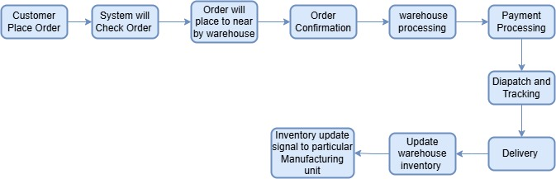

Assignment 2

1. Write an introduction letter to a client introducing yourself as a business analyst in charge of working with the client and his team to start the business understanding process.

Hi team,

I hope this message finds you well. My name is Tushar Musale, and I am delighted to
introduce myself as the Business Analyst assigned to collaborate with you and your team on this exciting project.
Understanding the challenges and opportunities within the manufacturing and logistics sectors,
particularly in delivering exceptional customer service, is a domain I am passionate about. With
your vision of managing inventory and ensuring the quickest delivery of your ice-cream and milk products, my role will be to work closely with you to transform these goals into a robust, tailor-made software solution.
To begin, I aim to thoroughly understand your current processes, challenges, and aspirations.
Together, we will explore your operational workflows, identify key requirements, and map out a strategic plan that aligns with your business objectives. Your insights will be invaluable in
ensuring the solution we design is practical, scalable, and optimized for your unique needs.
I look forward to discussing your expectations and gathering inputs from your team during our
initial meetings. In the meantime, please feel free to share any documents, current processes, or initial thoughts that could help us hit the ground running.
Thank you for the opportunity to collaborate on this project. I am confident that, together, we
will develop a solution that adds significant value to your business operations. Please let me
know a convenient time for us to connect further.
Looking forward to working with you.
Warm regards,
Tushar Musale
Business Analyst

2. Prepare a brief BRD and SRS for a project- online store.

Document Name- Mahafeed Online fertilizer Business
Version: 1.0
Date: 01-03-2025
Prepared By: Tushar Musale
Reviewed By: Akash Kale
Approved By: Ashish Joshi

Document Revision History
Version | Date | Author | Description
1.0 | 01-03-2025 | Tushar Musale | Initial Draft

Approvals
Name | Role | Approval Date
[Approver Name] | [Role] | [Date]

RACI Chart
Activity | Responsible | Accountable | Consulted | Informed
Requirement Gathering | Business Analyst | Product Owner | Stakeholders | Project Team
Development | Developers | Tech Lead | Business Analyst | Project Manager
Testing | QA Team | QA Lead | Developers | Project Manager
Deployment | DevOps | IT Head | Business Analyst | Stakeholders

1. Business Goal
To develop an e-commerce platform for Maha feed to enable direct sales of fertilizers, expand market reach, and improve customer engagement.

2. Business Objective
- Enable online purchasing and payment.
- Improve customer convenience and satisfaction.
- Optimize supply chain and inventory management.
- Enhance brand presence in the digital market.

3. Business Rules
- Customers must register to make a purchase.
- Orders above a certain value qualify for free shipping.
- Payments are processed through secure payment gateways.
- Discounts and promotions are applied based on predefined criteria.

4. Background
Mahafeed has traditionally used offline sales channels. The company aims to leverage digital transformation by launching an e-commerce platform to enhance customer experience and increase revenue.

5. Project Objective
To design and implement an online platform for Mahafeed that facilitates easy product browsing, ordering, and payment processing while integrating with existing inventory and logistics systems.

6. Project Scope
In-Scope Functionality
- User Registration & Login
- Product Catalog & Search
- Shopping Cart & Checkout
- Payment Gateway Integration
- Order Tracking
- Customer Support & FAQs
- Marketing & Promotions (Discounts, Coupons)
- Reports & Analytics

Out-of-Scope Functionality
- International Shipping
- Offline Order Processing
- Third-party Logistics Integration (Phase 2)
- Advanced AI-based Recommendations (Future Scope)

7. Assumptions
- Internet access is available to target customers.
- Users are familiar with e-commerce platforms.
- Payment gateway integration is feasible.

8. Constraints
- Budget limitations for initial development.
- Integration with existing ERP system.
- Compliance with agricultural product regulations.

9. Risks
- Platform adoption by traditional customers.
- Security vulnerabilities in payment processing.
- Technical challenges in integrating with logistics partners.

10. Business Process Overview
AS-IS Process
- Customers place orders through distributors or physical stores.
- Payments are made via cash or bank transfers.
- Orders are manually processed and delivered.
TO-BE Process
- Customers browse and order fertilizers online.
- Payments are processed through secure digital methods.
- Automated order fulfillment and delivery tracking.

11. Business Requirements
ID | Requirement | Priority
BR-01 | Customers must be able to register and log in. | High
BR-02 | Users should be able to browse and search for products. | High
BR-03 | Secure payment processing must be integrated. | High
BR-04 | Customers should receive order confirmation and tracking details. | Medium
BR-05 | The platform should support promotional offers and discounts. | Medium

Software Requirements Specification (SRS) Document for Mahafeed Online Fertilizer Store
1. Introduction
1.1 Purpose
The purpose of this document is to define the software requirements for the Mahafeed online fertilizer store. This system will enable Mahafeed to transition from traditional sales to an e-commerce platform, allowing customers to browse, purchase, and track fertilizer products online.

1.2 Document Scope
This document outlines the functional, non-functional, and system requirements for the development of Mahafeed’s e-commerce website. It provides detailed insights into user interactions, business rules, and constraints.

1.3 Stakeholders
- Business Analysts
- Project Managers
- Developers (Frontend, Backend, UI/UX)
- Testers
- Product Owners

1.4 Product Scope
Mahafeed’s online store will provide a user-friendly interface for customers to explore and purchase fertilizers. It will include user authentication, product management, order processing, payment integration, and customer support.

2. Executive Summary
2.1 Project Overview
The online fertilizer store will enhance Mahafeed’s business by providing a scalable and efficient e-commerce platform. Customers will have access to a seamless buying experience, while Mahafeed can automate order processing and stock management.

2.2 Key Benefits
- Expands market reach beyond physical stores.
- Reduces manual processing errors in order fulfillment.
- Enhances customer engagement through digital marketing and analytics.

2.3 Key Stakeholders
- Business Owners: Oversee operations and decision-making.
- IT Team: Developers, testers, and system admins.
- Customers: End users purchasing fertilizers.
- Third-party Providers: Payment gateways, shipping providers.

3. System Architecture
3.1 Technology Stack
- Frontend: React.js, Tailwind CSS.
- Backend: Node.js, Express.js.
- Database: MySQL/PostgreSQL.
- Hosting: AWS, Docker, Kubernetes.
- Third-party Integrations: Razorpay, Stripe, ShipRocket.

3. User Roles & Permissions
- Admin: Manage users, products, orders, payments.
- Customer: Browse products, add to cart, purchase, track orders.
- Supplier: Manage inventory and supply chain.
- Customer Support: Handle queries and complaints.

4. External Interfaces
- Payment Gateway: Razorpay, PayPal, Stripe.
- Shipping API: FedEx, Delhivery, BlueDart.
- SMS/Email Notifications: Twilio, SendGrid for order alerts.

5. Functional Requirements
Requirement ID | Requirement Name | Description | Priority
FR-01 | User Registration & Login | Users should be able to register, log in, and reset passwords. | High
FR-02 | Product Management | Admins should be able to add, update, and remove products. | High
FR-03 | Search & Filter Products | Users should be able to search and filter products. | High
FR-04 | Shopping Cart | Users should be able to add/remove items and update quantities in the cart. | High
FR-05 | Secure Checkout & Payment | Users should be able to checkout securely and make payments. | High
FR-06 | Order Management | Users should be able to place, track, and cancel orders. | High
FR-07 | Wishlist | Users should be able to add products to a wishlist. | Medium
FR-08 | Discount & Coupon System | Admins should be able to create promotional codes and discounts. | Medium
FR-09 | Customer Support | Users should be able to raise queries or complaints. | Medium
FR-10 | Reports & Analytics | Admins should have access to sales trends and user behavior insights. | Low

6.Non-Functional Requirements
Requirement ID | Requirement Name | Description | Priority
NFR-01 | Performance | The website should load within 3 seconds. | High
NFR-02 | Scalability | The system should handle 50,000 concurrent users. | High
NFR-03 | Security | User data and payments should be encrypted and follow PCI DSS compliance. | High
NFR-04 | Availability | The system should have 99.99% uptime. | High
NFR-05 | Usability | The UI should be intuitive and mobile-friendly. | Medium

7. Assumptions and Constraints
7.1 Assumptions
- Users have access to stable internet connections.
- Payment gateways will be integrated via third-party APIs.
7.2 Constraints
- Initial launch will support only domestic orders.
- The website should comply with local e-commerce regulations.

8. Risks
- Cybersecurity threats (e.g., DDoS attacks, data breaches).
- Payment gateway failures.
- Inventory mismatch due to incorrect stock updates.

9. Business Process Overview (AS-IS & TO-BE)
9.1 AS-IS Process
- Currently, Mahafeed sells fertilizers via offline distributors and retailers.
- Customers have to visit stores or place orders manually.
9.2 TO-BE Process
- Customers will browse fertilizers online, add products to their carts, and complete purchases digitally.
- The system will automatically process orders and update inventory.

10. Compliance & Legal Requirements
- GDPR & Data Protection: Ensuring user data privacy.
- E-commerce Regulations: Compliance with tax and invoicing laws.
- Accessibility Standards: WCAG 2.0 for users with disabilities.

11. Disaster Recovery Plan
- Data Backup Strategy: Hourly/daily backups in cloud storage.
- Failover Mechanism: Automatic server switch in case of failure.

12. System Features
- User-friendly dashboard for customers and admins.
- Real-time order tracking and notifications.
- AI-driven product recommendations.

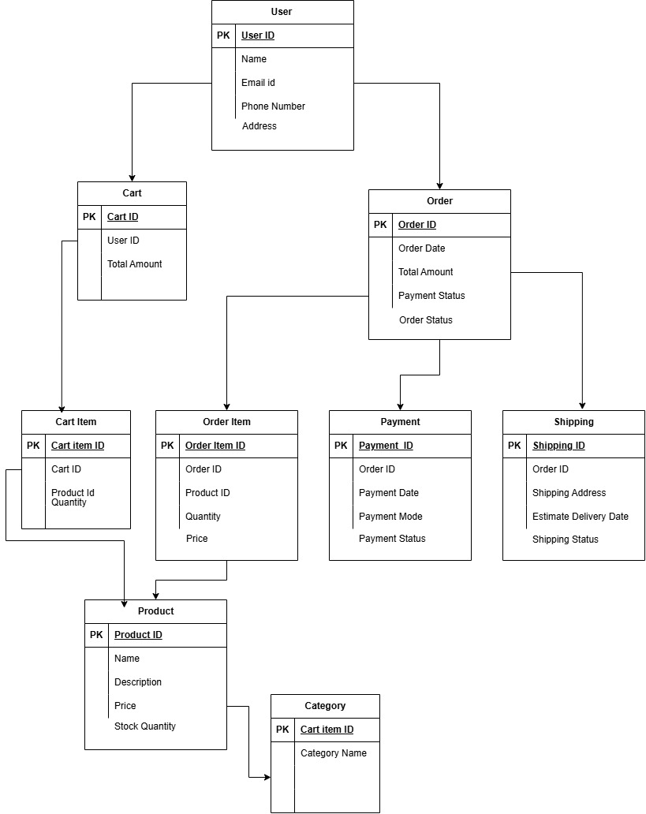

Make an ERD of creating a Ticketing life cycle.

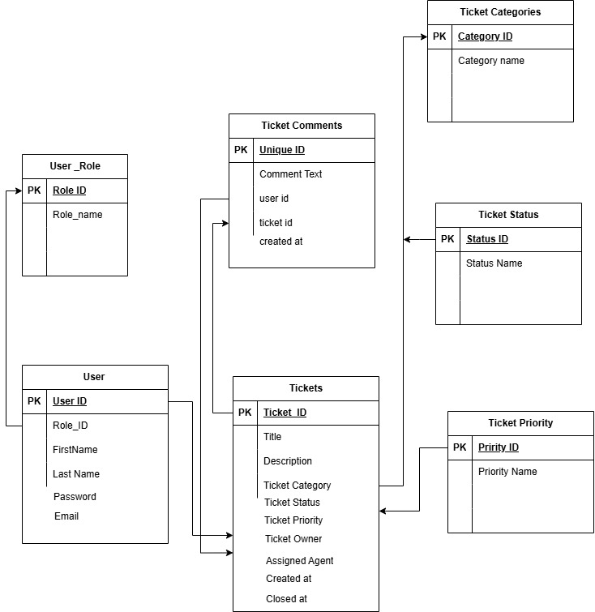

User Stories ( Mahafeed Online Fertilizer Application)

User Story No: 1 | Task: 2 |  | Priority: HIGH
As a customer, I want to create an account so that I can place orders.
BV: 500 |  | CP: 1
Acceptance Criteria:
Users can register with email, phone, and password.
Users receive an OTP for verification.
Users get a confirmation email upon successful registration.

User Story No: 2 | Task: 2 |  | Priority: HIGH
As a customer, I want to browse fertilizers by category so that I can find suitable products
BV: 500 |  | CP: 1
Acceptance Criteria:
Users can view product categories.
Users can apply filters (brand, price, type).
Users can search by keyword.

User Story No: 3 | Task: 2 |  | Priority: HIGH
As a customer, I want to view product details so that I can make an informed purchase
BV: 500 |  | CP: 3
Acceptance Criteria:
Users see product images, descriptions, specifications, and price.
Users can check stock availability.
Users can view customer ratings and reviews.

User Story No: 4 | Task: 2 |  | Priority: HIGH
As a customer, I want to add products to the cart so that I can purchase them later.
BV: 500 |  | CP: 1
Acceptance Criteria:
Users can add products to the cart.
Users can remove or update quantities.
Users see a summary of items before checkout.

User Story No: 5 | Task: 2 |  | Priority: HIGH
As a customer, I want to checkout securely so that I can place an order.
BV: 500 |  | CP: 1
Acceptance Criteria:
Users can enter a shipping address.
Users can select a payment method.
Users get order confirmation and estimated delivery date.

User Story No: 6 | Task: 2 |  | Priority: Medium
As a customer, I want to track my order so that I know the delivery status.

BV: 200 |  | CP: 1
Acceptance Criteria:
Users can view the real-time order status.
Users get tracking details via email/SMS.
Users receive notifications for shipment updates..

User Story No: 7 | Task: 2 |  | Priority: HIGH
As a customer, I want to receive order confirmation and updates via email/SMS.
BV: 500 |  | CP: 5
Acceptance Criteria:
Users receive order confirmation via email/SMS.
Users get notifications for shipment and delivery.
Users can opt out of SMS/email notifications.

User Story No: 8 | Task: 2 |  | Priority: MEDIUM
As an admin, I want to manage customer inquiries so that I can provide support.
BV: 500 |  | CP: 1
Acceptance Criteria:
Admins can view and respond to customer queries.
Admins can categorize queries by type.
Customers receive replies via email/SMS.

User Story No: 9 | Task: 2 |  | Priority: MEDIUM
As an admin, I want to generate sales reports so that I can analyze performance.
BV: 500 |  | CP: 1
Acceptance Criteria:
Admins can generate reports for sales, revenue, and top-selling products.
Reports can be exported in CSV/PDF format.
Reports can be filtered by date range.

User Story No: 10 | Task: 2 |  | Priority: MEDIUM
As a logistics partner, I want to receive order shipping details so that I can schedule deliveries.
BV: 200 |  | CP: 1
Acceptance Criteria:
Logistics partners receive order details via the system.
They can access customer addresses and contact details.
Delivery agents can mark orders as dispatched.

User Story No: 11 | Task: 2 |  | Priority: MEDIUM
As a customer, I want to select my preferred delivery date so that I can receive orders conveniently.
BV: 500 |  | CP: 1
Acceptance Criteria:
Users can choose available delivery slots.
Only valid delivery dates are shown.
Users get a confirmation email with the selected date..

User Story No: 12 | Task: 2 |  | Priority: HIGH
As an admin, I want to manage user roles so that I can control platform access.
BV: 500 |  | CP: 3
Acceptance Criteria:
Admins can assign roles (Customer, Manager, Delivery Partner).
Different roles have different access levels.
Unauthorized users cannot access restricted features.

User Story No: 13 | Task: 2 |  | Priority: HIGH
As a customer, I want to pay via multiple payment options so that I can use my preferred method.
BV: 500 |  | CP: 5
Acceptance Criteria:
Payment options include credit/debit cards, UPI, net banking.
Payments are processed securely via a payment gateway.
Users receive an invoice after successful payment.

User Story No: 14 | Task: 2 |  | Priority: LOW
As a customer, I want to subscribe to newsletters so that I receive offers and updates
BV: 100 |  | CP: 3
Acceptance Criteria:
Users can enter their email to subscribe.
Users receive periodic newsletters about offers and new products.
Users can unsubscribe at any time.

User Story No: 15 | Task: 2 |  | Priority: LOW
As an admin, I want to manage blog content so that I can share agricultural tips.
BV: 100 |  | CP: 2
Acceptance Criteria:
Admins can create, edit, publish, and delete blog posts. Blogs can include images and videos. Blogs appear in a dedicated section of the website.

