Online Agriculture Products Store

**Capstone Project1 – Part -1/3 – 100 Marks - Pass 60 %**

**Decode the Case Study**

**Project Idea -** to make an online agriculture product store to facilitate remote area farmers to buy agriculture products.

**Current Needs** - to facilitate farmers to buy seeds, pesticides, and fertilizers from anywhere through internet connectivity.

**Current Problems -** facing difficulties in procuring fertilizers which are very important for farm. problem in-case of buying seeds for farming certain crops. lack of pesticides which could help in greatly reducing pests in crops.

**Question 1 – BPM - 5 Marks**

Identify Business Process Model for Online Agriculture Store – (Goal, Inputs, Resources, Outputs, Activities, Value created to the end Customer)

**Answer**

**Goal** – To facilitate farmers with the website that will help to buy seeds, pesticides, and fertilizers from anywhere through internet connectivity.

**Inputs** - The farmers requirements and their needs, Budget allocation for the project(2crores), best team resources for the project, Time and efforts given towards the project.

**Resources** - The project Team which includes (project manager, BA, developers, coders, Testers), Financial resources (Funds), research team, Time.

**Outputs** - Website for Farmers for purchasing of products.

**Activities** - Planning for the project, requirements gathering, budget allocating, coding, testing, Implementing of the project.

**Value created to the end Customer** - User friendly and easily accessible.

**Question 2 – SWOT - 5 Marks**

Mr Karthik is doing SWOT analysis before he accepts this project. What Aspects he Should consider as Strengths, as Weaknesses, as Opportunity and as Threats.

**Answer**

**Strengths** - Getting a project from the SOONY company due to his previous project success.

**Weaknesses** - Lack of existing efficient resources for doing such project.

**Opportunity** - This kind of project they are launching for the first time this is the opportunity to capture the whole markets.

**Threats** - Budget constraints (less allocated budget).

**Question 3 – Feasibility study - 5 Marks**

Mr Karthik is trying to do feasibility study on doing this project in Technology (Java), Please help him with points (HW SW Trained Resources Budget Time frame) to consider in feasibility Study.

**Answer**

**HW developers**: Not required because we are building websites, we don’t require any feasibility study

**SW developers**: We can go with 7 software developers will be software developers which include testers, Java developers and network admin

Trained Resources our java is having expertise but need to some training for the testers.

**Timeframe**: we have got 18 months Duration but we can complete it on 15 months and keep 3 months extra in case of any problem or change request.

**Budget**: we have got 2cr budget we can complete with this budget.

**Question 4 – Gap Analysis - 5 Marks**Mr Karthik must submit Gap Analysis to Mr Henry to convince to initiate this project. What points (compare AS-IS existing process with TO-BE future Process) to showcase in the GAP Analysis

**Answer**

**AS-IS existing process**

- We don’t have any existing process or web application at present for ordering things. - Traditional way to purchase products. i.e. just from market

**TO-BE future process**

- To build web application where the farmers can easily order the pesticides.

- will provide quick and easy way to purchase item.

**Question 5 – Risk Analysis - 10 Marks**

List down different risk factors that may be involved (BA Risks And process/Project Risks)

**Answer**

**BA Risks**: Improper requirement gathering from the farmers, Improper planning for the project, Process Risk: lack of team support, continuous change requirement.

**Project Risks**: website not working properly, farmers not able to put details in website, Unrealistic expectation from the client

**Question 6 – Stakeholder Analysis (RACI Matrix) - 8 Marks**

Perform stakeholder analysis (RACI Matrix) to find out the key stakeholders who can take Decisions and Who are the influencers

**Answer**

**Responsible** - I will be responsible (BA).

**Accountable** - Mr. Vandanam project Manager will be accountable

**Consultant** - Teyson, Ms. Lucie, Mr. Tucker, Mr. Bravo, Mr. Mike, John Mr. Jason and Ms. Alekya this pe

**Informed** - Mr. Henry, Mr. Pandu, Mr. Dooku

**Supportable** - Mr. Henry

**Question 7 – Business Case Document - 8 Marks**

Help Mr Karthik to prepare a business case document

**Answer**

- The project is initiated because there was demand for pesticides in the farmers and there was no availability. So, this website will act as a felicitate role between the company and farmers.

-The current problem is that farmers are facing pest problem because of unavailability of pesticides in the market. The crops get destroyed due to unavailability of pests.

-with this project the problems could be solved are

a. The pesticides will be available in quick time to farmers.

b. There will be no middlemen in between so they can get the products at cheaper rates.

c. No need for the farmers to go the market in search of pesticides it will deliver to their house.

-The resources required are

a. We need a good set of technical teams (developers, testers, designers) for the project.

b. we need 2crore of funds for the project.

c. high speed internet facility.

-organizational changes required to adopt this technology are:

There will be no such organizational changes for adopting this technology.

-Time frame to recover ROI will be of 3 years as we are expecting good number of farmers and companies will enrol.

**Question 8 – Four SDLC Methodologies - 8 Marks**

The Committee of Mr. Henry, Mr Pandu, and Mr Dooku and Mr Karthik are having a discussion on Project Development Approach.

Mr Karthik explained to Mr. Henry about SDLC. And four methodologies like Sequential Iterative Evolutionary and Agile. Please share your thoughts and clarity on Methodologies

**Answer**

The four methodologies like Sequential Iterative Evolutionary and Agile are:

**1.Sequential**

The entire project is delivered at the end of developing life cycle.

**2.Iteractive**

With frequency some modules are delivered. In this model, the total software development is divided into iterations and each interaction has design, development, testing and review.

**3.Evolutionary**

With in the scope, they will continuously evolve they will try and fail and then they will start adding function.

**4.Agile**

Continuous delivery in every stage of the project.

**Question 9 – Waterfall RUP Spiral and Scrum Models – 8 Marks**

They discussed models in SDLC like waterfall RUP Spiral and Scrum. You put forth your understanding on these models

When the APT IT SOLUTIONS company got the project to make this online agriculture product store, there is a difference of opinion between a couple of SMEs and the project team regarding which methodology would be more suitable for this project. SMEs are stressing on using the V model and the project team is leaning more onto the side of waterfall model. As a business analyst, which methodology do you think would be better for this project?

**Answer**

**Waterfall model**

It is a traditional model and it follows a structured approach with each phase having specific deliverables.

**V Model**

It is a verification and validation model in which each phase must be completed so that next phase begins. Testing of the product is planned in parallel with a corresponding phase of development in V-model.

**RUP Model**

RUP stands for Rational Unified Process, where phase /module wise (long term project) application is developed. Hence, we can track the defects at early stages. This avoids the downward of the defects.

**Spiral Model**

The spiral model is a risk-driven process model generator for software projects. The spiral model has four phases: Planning, Risk Analysis, Engineering and Evaluation.

**Scrum Model**

scrum is a process framework used to manage product development. Scrum is empirical in that it provides a means for teams to establish a hypothesis of how they think something works, try it out, reflect on the experience, and make the appropriate adjustments.

**Question 10 – Waterfall Vs V-Model - 5 Marks**

Write down the differences between waterfall model and V model.

**Answer**

A

**waterfall model-**

we work in phase wise once the phase is complete, we will take review -once the completion of the 1st phase only 2nd phase will start.

 -It’s not flexible as changes in between cannot be initiated in between

-It’s cheaper than the V Model.

**In V model -**

In V model after one phase is completed then we will do design and testing and then only we can start with the next phase.

-Its more flexible we can update changes in between.

-Its more costly compare to waterfall model.

**Question 11 – Justify your choice - 3 Marks**

As a BA, state your reason for choosing one model for this project

- we will use V model because this type of project is quite new for the company and it require more time on design and testing .so In V model after one phase is completed then we will do design and testing and then only we can start with the next phase.

**Question 12 – Gantt Chart - 5 Marks**

The Committee of Mr. Henry, Mr Pandu, and Mr Dooku discussed with Mr Karthik and finalised on the V Model approach (RG, RA, Design, D1, T1, D2, T2, D3, T3, D4, T4 and UAT) Mr Vandanam is mapped as a PM to this project. He studies this Project and Prepares a Gantt chart with V Model (RG, RA, Design, D1, T1, D2, T2, D3, T3, D4, T4 and UAT) as development process and the Resources are PM, BA, Java Developers, testers, DB Admin, NW Admin

**Question 13 – Fixed Bid Vs Billing - 5 Marks**

Explain the difference between Fixed Bid and Billing projects

Answer

**Fixed bid Project**

-In Fixed bid, based on the milestones the funds are being released.

for ex-1st part documentation completed 20,000$ then after design phase completed 25,000$ and soon.

-Time and budget are fixed in this process.

**Billing Project**

-In billing projects, the funds are being released on the amount of work the team have been worked.

EX-Suppose 8hour working day MR. A, MR. B, MR.C and MR. D are working then it will be (8x4=32)

-Bill the client as per the resources and paid according to hours worked by the employees.

**Question 14 – Preparer Timesheets of a BA in various stages of SDLC - 20 marks**

➢ Design Timesheet of a BA

➢ Development Timesheet of a BA

➢ Testing Timesheet of a BA

➢ UAT Timesheet of a BA

➢ Deployment n Implementation Timesheet of a BA

|  |  |  |  |  |  |
| --- | --- | --- | --- | --- | --- |
| Design Timesheet of BA | |  |  |  |  |
|  |  | **Time Sheet** |  |  |  |
| Employee Name | Rajan |  |  | Date | 20-08-2024 |
| Role | BA |  |  |  |  |
| Project No: | 2216 |  |  |  |  |
|  | Type | **Design Stage** |  |  |  |

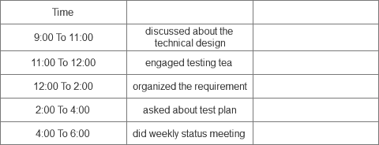

|  |  |  |  |  |  |
| --- | --- | --- | --- | --- | --- |
| Development Timesheet of a BA | | |  |  |  |
|  |  | **Time Sheet** |  |  |  |
| Employee Name | Rajan |  |  | Date | 24-08-2024 |
| Role | BA |  |  |  |  |
| Project No: | 2216 |  |  |  |  |
|  | Type | **Development Stage** |  |  |  |

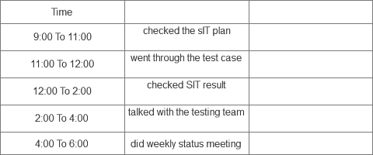

|  |  |  |  |  |  |
| --- | --- | --- | --- | --- | --- |
| Testing Timesheet of a BA | |  |  |  |  |
|  |  | **Time Sheet** |  |  |  |
|  |  |  |  |  |  |
| Employee Name | Rajan |  |  | Date | 24-08-2024 |
| Role | BA |  |  |  |  |
| Project No: | 2216 |  |  |  |  |
|  |  |  |  |  |  |
|  | Type | **Testing Stage** |  |  |  |

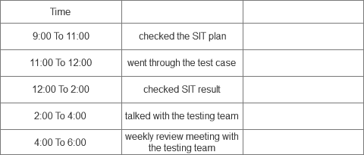

|  |  |  |  |  |  |
| --- | --- | --- | --- | --- | --- |
| UAT Timesheet of a BA | |  |  |  |  |
|  |  | **Time Sheet** |  |  |  |
| Employee Name | Rajan |  |  | Date | 25-08-2024 |
| Role | BA |  |  |  |  |
| Project No: | 2216 |  |  |  |  |
|  |  |  |  |  |  |
|  | Type | **UAT Stage** |  |  |  |

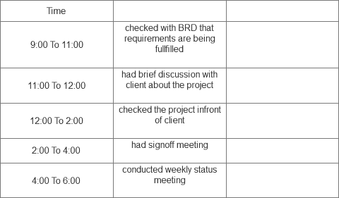

|  |  |  |  |  |  |
| --- | --- | --- | --- | --- | --- |
| Deployment n Implementation Timesheet of a BA | | |  |  |  |
|  |  | **Time Sheet** |  |  |  |
| Employee Name | Rajan |  |  | Date | 26-08-2024 |
| Role | BA |  |  |  |  |
| Project No: | 2216 |  |  |  |  |
|  |  |  |  |  |  |
|  | Type | **Deployment and implementing** |  |  |  |

