Document 1: Definition of Done
Answer: - The Definition of Done is a shared understanding within the Agile team that specifies the completion criteria for a product backlog item (PBI). It ensures that all deliverables meet quality standards and are potentially shippable at the end of a sprint.

A good DoD should be:
- Well-defined: Clear expectations of what "done" means.
- Unambiguous: No room for differing interpretations.
- Measurable: Can be objectively evaluated.
- Agreed-upon: Consensus across the entire Scrum Team (Dev, QA, BA, PO).
- Visible: Typically displayed in a shared location (e.g., Confluence, Jira, task board).

DOD for the mortgage project: -
- Code is written and reviewed.
- Unit and functional testing passed.
- Business rules for credit approval applied.
- Integrated with Credit Bureau API.
- User story acceptance criteria met and validated by PO.
- Documentation (SOP or screen help) updated.
- Deployed to UAT environment.
- No critical bugs open.

Document 2- Product Vision

Venue | Teams meeting online
Date | 03-06-2025
Client | IDFC first bank
Stakeholder List |  | BH - Rajbeer Singh, Retails assets head - shikha Malviya, Credit head - Ramesh t , Operations- John Fernandes , RCU-Ganesh, Legal head - Rajesh shrimali, Technical - Vishal Tiwari , National Sales Head - Ashish Kabra ,
 |  | Scrum Team
Scrum master |  | Rajesh Maliwal
Product owner |  | Rakesh kumar
Scrum Developer 1 |  | Rishi pandit
Scrum Developer 2 |  | Jayanthi k
Scrum Developer 3 |  | Rupa Umesh
Scrum Developer 4 |  | Lokesh gami
Scrum Developer 5 |  | Poonam R
Vision: | To build a centralized, intelligent, and fully automated mortgage processing system using Salesforce that transforms the traditional, manual loan journey into a seamless digital experience—empowering IDFC First Bank to reduce turnaround time, enhance transparency, ensure compliance, and deliver superior customer satisfaction across all mortgage products.
Target Group | Needs | Product | Value
Salaried Home buyer : - Age 21-60 , Self Employed - 23-60 ,  First Time Home Loan buyer , or Takeover and Top up .  Co applicant - parents or spouse.  Also Person who is looking for loan against existing property. | End to End Automation.  Faster Loan Processing.  Centralised Tracking and visibility.  Improved Accuracy  Enhanced compliance  Scalable and future ready. | A Salesforce-Based Mortgage Automation Platform  A customized, cloud-based application built on Salesforce (SFDC) to manage the end-to-end mortgage loan lifecycle at IDFC First Bank — from sales login, documentation, credit review, legal checks, all the way to disbursement.  Desirable – Solves Real User Pain Points  Speed – Reduces loan processing time by automating handoffs.  Convenience – Enables digital documentation, e-KYC , e-sign — no need for multiple physical visits.  Transparency – Real-time status updates and centralized tracking for customers and internal teams.  Customer Experience – Faster decisions lead to better service and higher satisfaction.  Role-Based Dashboards  End-to-End Integration  Tailored for Mortgage | How is the product going to benefit the company?  1.Faster Turnaround Time (TAT)  2. Increased Operational Efficiency  3. Improved Compliance & Audit Readiness  4.Better Cross-Team Collaboration  5.Higher Loan Book & Revenue Growth  6.Scalability for Future Products.  What are the business goals?  Reduce loan processing TAT  By 25–30% compared to baseline  Improve First-Time-Right (FTR) submissions >95% FTR cases  What Is the Business Model?  This is an internal enterprise efficiency model, where the product does not directly generate revenue, but instead:  Enables Cost Savings and Revenue Growth by:  • Reducing operational costs through automation (fewer manual errors, less manpower hours).  • Increasing processing capacity without proportionally increasing headcount.  • Accelerating customer onboarding → more loan disbursals → more interest income.  • Improving service quality → better customer retention and referral rates  Technology Cost Center Justification  • Although the SFDC platform and licenses require investment,  • ROI is achieved via increased efficiency, reduced delays, and higher output.
  Enhance customer satisfaction ,Higher Net Promoter Score (NPS)
  Increase system adoption , 100% usage across all verticals within 60 days
  Ensure regulatory compliance, Zero audit flags due to missing documentation
  Grow disbursal volume, Monthly disbursal value increases post-automation

Document 3: User stories
SPRINT-1 | TASK 2 | PRIORITY : HIGHEST
USER STORY- 1 | Login into the application using Emp ID and Password.
As a user( including sales , credit , Operations, CPA) I should be able to login using there Emp ID and password so that we can perform are respective actions.
BV - 10 | CP -1
ACCEPTANCE CRITERIA:- User is registered for the application . User ID is active.
SPRINT-1 | TASK 2 | PRIORITY : HIGHEST
USER STORY- 2 | Check the application ID and upload documents as per checklist.
As a Sales manager I should be able to check the application and upload the documents So that I can send to CPA
BV - 200 | CP -2
ACCEPTANCE CRITERIA:- All the documets uploaded as per checklist . Upload options available for KYC, income proof, and property documents
- System validates file types and sizes
- Successful upload stores files in the DMS
- Uploaded documents are linked to the specific Application ID
- Upload completion triggers system status: 'Documents Uploaded'
SPRINT-1 | TASK 2 | PRIORITY : HIGHEST
USER STORY- 3 | CPA check the documets and complete appliation.
As a CPA will check the coming files from the aspect of documentation and details so that only complete files flows thorugh the system.
BV - 100 | CP -3
ACCEPTANCE CRITERIA:- CPA sees document checklist with uploaded files
- CPA can mark each document as 'Verified' or 'Incomplete'
- Only verified applications can proceed to Credit
- System records CPA name, time, and verification status
SPRINT-1 | TASK 2 | PRIORITY : HIGHEST
USER STORY- 4 | Assign the application to credit and initiate the verifications.
As a CPA can only assign the completed application to credit team so that only correct/complete files are sent for decision.
BV - 50 | CP -2
ACCEPTANCE CRITERIA:- CPA can only forward complete and correct appliations. Verifications will be initiated by the system.
SPRINT-1 | TASK 2 | PRIORITY : HIGHEST
USER STORY- 5 | Credit checks the reports and get it updated from the respective vendor.
As a Credit I should be able to check and get the reports updated from the respective vendor so that verification is completed.
BV - 200 | CP -5
ACCEPTANCE CRITERIA:- Vendors use there API to update the reports . Vendors send the report first and once credit confirms then update the reports in system.
SPRINT-1 | TASK 2 | PRIORITY : HIGHEST
USER STORY- 6 | Credit updates the personal discussion
As a Credit I should be able to update the PD details so that we can make decesion.
BV - 100 | CP - 8
ACCEPTANCE CRITERIA:- All the cases credit discussion and remarks are mandatory . Update income ,obligation and other details as per discussion
SPRINT-1 | TASK 2 | PRIORITY : HIGHEST
USER STORY- 7 | Credit assesment and decision
As a credit I should be able to do assesment based on prop value and income assesment so that perticular amount can be sanction.
BV - 500 | CP - 5
ACCEPTANCE CRITERIA:- All the verifications are positive and reports are updated in system. Confirmed with customer All the sanction condition to be met at the time of disbursement.
SPRINT-1 | TASK 2 | PRIORITY : HIGHEST
USER STORY- 8 | Credit can check the out of TAT .
As a users I should be able view and assign/ approve or reject their assigned cases so that TAT can be tracked casewise.
BV - 200 | CP - 5
ACCEPTANCE CRITERIA:- All the stages are being time stamp and complete audit trail in the system.
SPRINT-1 | TASK 2 | PRIORITY : HIGHEST
USER STORY- 9 | Sales can download sanction letter.
As a sales I should be able to download sanction letter so that customer can be confirmed on saction.
BV - 100 | CP - 3
ACCEPTANCE CRITERIA:-Case should be final approved by the respective authority. All the verifications and decision is +ve.
SPRINT-1 | TASK 2 | PRIORITY : HIGHEST
USER STORY- 9 | Sales can calcuate the charges and confirm the customer before disbursement.
As a sales I should be able to calculate the charges so that customer can be informed .
BV - 500 | CP - 8
ACCEPTANCE CRITERIA:- Case is approved . Calculation will be based on age (Insurance ) , property valuatio etc .

Document 4: Agile PO Experience
Answer :-
Project Name: - SFDC Mortgage Loan project
Role – Product Owner
Tools used: - JIRA, SFDC environment, Excel, VISIO, Balsamiq, Power BI
As a product owner I had a vision of the product keeping industry/ domain experience.
I had an idea what basic challenges are faced by the various departments and stakeholders in the entire journey of the secured Loan process. What are the roles and responsibility of each and every member of the team.
Responsibilities & Contributions:
- Defined Product Vision & Roadmap
  - Collaborated with stakeholders (Credit, Legal, Sales, Compliance teams) to define the product vision, aligning it with business goals of reducing manual processing and improving TAT (Turnaround Time).
  - Created and maintained a high-level roadmap and prioritized product backlog using MoSCoW technique.
- Requirement Gathering & User Stories
  - Conducted User story workshops cross-functional teams to gather business and technical requirements.
  - Wrote clear, testable user stories and acceptance criteria in JIRA, focusing on modules like:
    - Property Legal & Technical Checks
    - Income Assessment (Salaried/Self-employed)
    - Credit Decision Module
    - Sanction Conditions
    - Document Management Module
- Backlog Prioritization & Sprint Planning
- Product Grooming workshops and prioritized the product backlog in collaboration with Scrum Master and Developers.
- Ensured each Sprint had well-defined, valuable deliverables through regular Sprint Planning sessions.

- Managing Overall Iteration Progress
- Sprint progress review
- Reprioritization of sprints and epics if needed
- Sprint retrospectives with Business Analyst
- Stakeholder Management
- Acted as a bridge between business users and development team.
- Conducted Product Demos after each Sprint on the Shippable product increment.
- Gathered feedback to refine future backlog items.
- Testing & Acceptance
- Participated in UAT (User Acceptance Testing) and signed off on features once business criteria were met.
- Logged defects and enhancement requests in JIRA.
- Progress Monitoring
- Monitored sprint progress via Burndown Charts and JIRA dashboards.
- Reported key metrics like velocity, completion ratio, and Shippable product increment.
➢ Market Analysis - Analysis of market need/demand, Availability and shortfall of similar products in the market
➢ Enterprise Analysis - Due diligence on the market opportunity, enterprise requirement and policies and guidelines on enterprise level.
From this project I have learned to handle different sprint meetings such as
- Sprint planning meeting
- Daily scrum meeting
- Sprint review meeting
- Sprint retrospective meeting
- Backlog refinement meeting

Document 5: Product and sprint backlog and product and sprint burndown charts
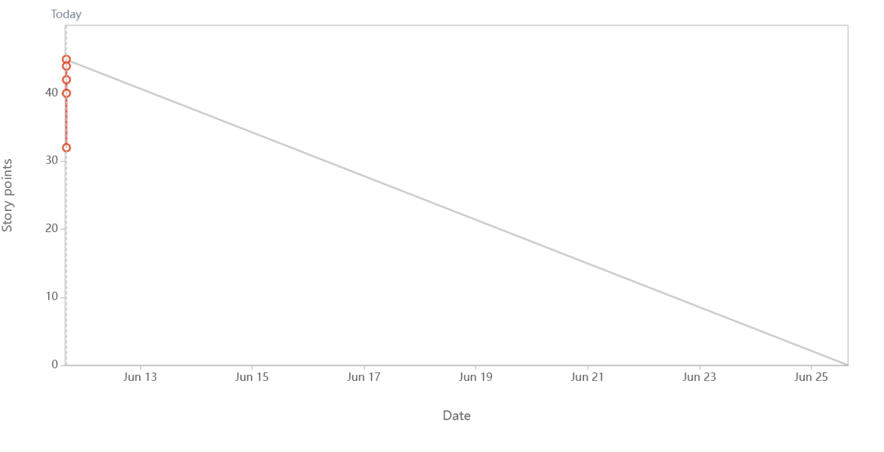

Sprint burn down chart

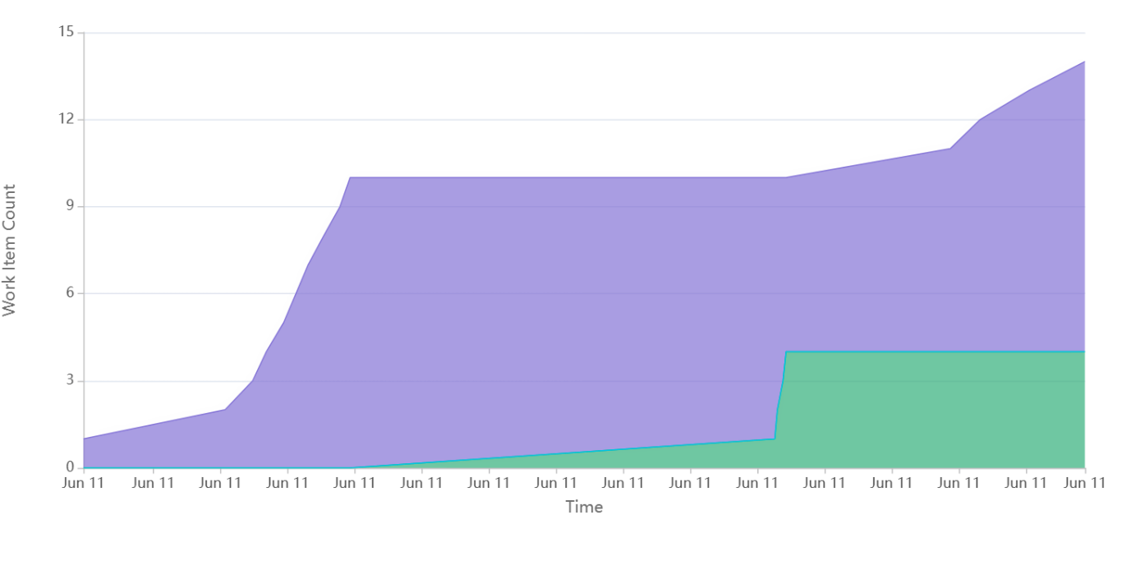
Cumulative flow diagram

Document 6: Sprint meetings

Meeting Type 1: Sprint Planning meeting

Sprint Planning meeting
Date | 12-05-2025
time | 14:00
Location | Online
Prepared by | Chetan Kapre
Attendees | Scrum team, Scrum master, PO

Agenda :- | To finalise the Sprint backlog, Duration of sprint , Prioritisation

Observers
Resources
Special Notes

Meeting type 2 : Sprint Review meeting
Sprint Review meeting
Date | 12-05-2025
time | 14:00
Location | Online
Prepared by | Chetan Kapre
Attendees | Scrum team, Scrum master , PO

Sprint status | Things to demo | Quick updates | What’s next
Status to be updated by the scrum team | What is the ready module, present it and check for any bugs or errors, | update on the pendencies and completed. | What is the plan to complete the pending tasks and if require any help.

Meeting Type 3: Sprint retrospective meeting

Sprint Review meeting
Date | 15-05-2025
time | 16:00
Location | Online
Prepared by | Scrum master
Attendees | Scrum master, scrum team

Agenda | What went well | What didn’t go well | Questions | Reference

Meeting Type 4: Daily Stand-up meeting

 |  | Week 19/05/2025 to 25/05/2025
Question | Name Role | Monday | Tuesday | Wednesday | Thursday | Friday | Saturday | Sunday
What did you do yesterday? | Rohit
What did you do yesterday? | Kunal
What did you do yesterday? | Saumya
What will you do today? | Rohit
What will you do today? | Kunal
What will you do today? | Saumya
What (if any) is blocking your progress | Rohit
What (if any) is blocking your progress | Kunal
What (if any) is blocking your progress | Saumya

