Document -1

As the Business Analyst for the SFDC enhancement initiative, I collaborated with stakeholders, product owners, and the development team to define a **clear and consistent Definition of Done (DoD)**. This was essential to ensure each backlog item delivered **tangible business value**, met **quality standards**, and aligned with **project objectives** such as automation, improved search capabilities, and streamlined RM engagement.

The **DoD checklist** was customized to reflect the unique needs of our Salesforce (SFDC) enhancement project. It ensured that every user story—such as enhancing customer search, automating RM assignments, or creating structured NTB follow-ups—was **truly complete** before being marked “done.”

The checklist included the following:

1. **Functional Completion**
   * Code delivered for requested features (e.g., search by name/number, RM auto-assignment)
   * All user story assumptions validated and covered
2. **Build & Technical Validations**
   * No build errors during integration with SFDC sandbox and production environments
   * Changes deployed and verified on test environments mirroring production
3. **Testing & Quality Assurance**
   * Unit tests written and passed for all enhancements
   * QA testing completed, covering devices and browsers as per business requirements
   * Acceptance criteria validated with Product Owner (e.g., RM details correctly visible, NTB leads re-engagement working)
4. **Review & Approval**
   * Reviewed and approved by UX designer where UI changes were involved
   * Product Owner provided formal sign-off
5. **Documentation & Peer Review**
   * Updated user documentation and training materials (e.g., updated CRM usage guides for RMs)
   * Peer code review completed to maintain code quality and alignment with standards
6. **Refactoring & Knowledge Sharing**
   * Code refactored to remove redundancies
   * Functional and configuration changes shared with all relevant team member

**Example Use in the Project:**

For the “Enhanced Customer Search” user story, the DoD ensured that the search functionality worked on all supported devices, was able to retrieve records by multiple fields (name, mobile, email), was tested against edge cases, and was approved by the PO. Only after passing all checklist items was the fea

By institutionalizing this Definition of Done, we ensured **predictable delivery**, **reduced rework**, and **clear visibility of progress** across the Scrum team and stakeholders. It became a key control point for maintaining delivery discipline throughout the project.

Document- 2

**Scrum Project**  
**Name:** SFDC Enhancement for Improved Customer Engagement  
**Venue:** Client Mumbai Office (as per sprint planning)  
**Date:** 25-April-2025  
**Start time:** 10:00 AM  
**End time:** 5:00 PM  
**Client:** IDFC FIRST BANK  
**Duration:** 3 Months (Initial Sprints)

**Stakeholder list:**

* Project Sponsor-Mr Henry Dsouza
* IT Head- Mr ABC
* Sales Head- Mr DEF
* Relationship Managers (RMs)-Mr GHI
* SFDC Admin- Mr JKL
* Business Analyst (myself)
* Product Owner- Mr MNO
* Scrum Team

**Scrum Team**  
**Scrum Master:** Mr Prashant  
**Product Owner:** Mr Nishant  
**Scrum Developer 1:** Developer – SFDC Backend  
**Scrum Developer 2:** Developer – SFDC Frontend  
**Scrum Developer 3:** QA Engineer  
**Scrum Developer 4:** UI/UX Designer  
**Scrum Developer 5:** DevOps / Deployment Lead

**Vision**

To enhance the SFDC system for improved RM productivity and customer satisfaction through automation, better data visibility, and streamlined communication.

**Target Group**

* **Market Segment:** Retail and Priority Banking
* **Target Users:** Relationship Managers, Sales Teams, Customer Support
* **Problem Solved:**
  + Limited customer search functionality
  + Manual RM communication
  + No structured NTB lead follow-up
  + Poor RM-customer engagement
* **Benefits Provided:**
  + Faster customer access
  + Automated lead tracking
  + Structured RM follow-ups
  + Efficient communication and engagement

**Product**

* **What is it?**  
  An enhanced SFDC solution tailored to streamline RM operations and lead handling.
* **What makes it desirable and special?**
  + User-friendly interfaces
  + Smart search and filters
  + Automation of RM tasks
  + Centralized communication tools

**Value**

* **Company Benefits:**
  + Increased sales conversion
  + Better lead nurturing
  + Reduced manual work
  + Higher RM efficiency
* **Business Goals:**
  + Improve NTB lead conversion by 30%
  + Automate 80% of RM-customer communication tasks
  + Reduce average response time by 50%
* **Feasibility:**  
  Yes, feasible with phased agile delivery using SFDC capabilities
* **Business Model:**
  + Improved customer lifecycle value
  + Cost savings through automation
  + Better RM performance metrics

Document 3-

User story-1

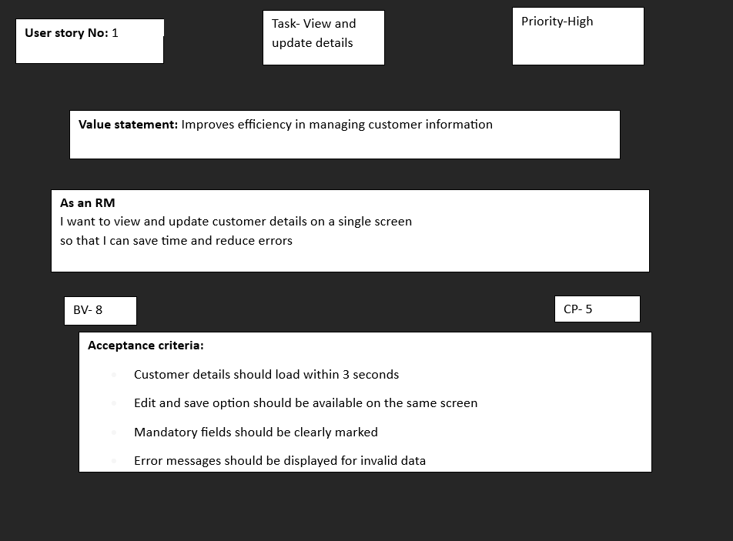

User story- 2

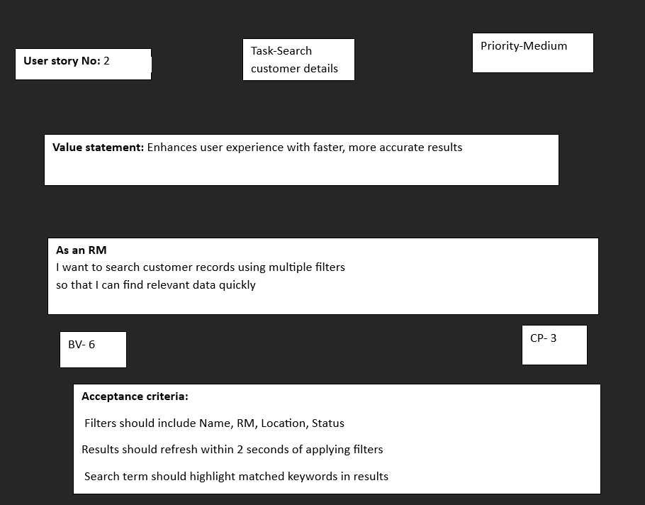

User story- 3

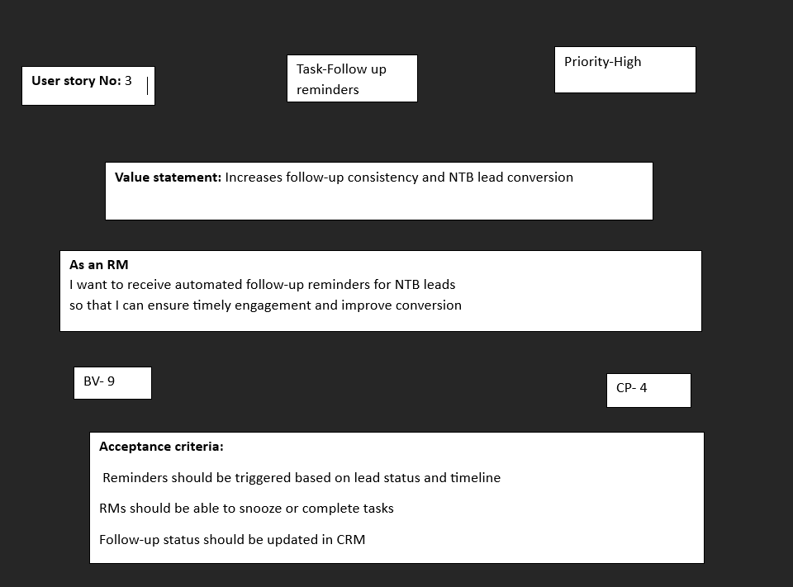

User story-4

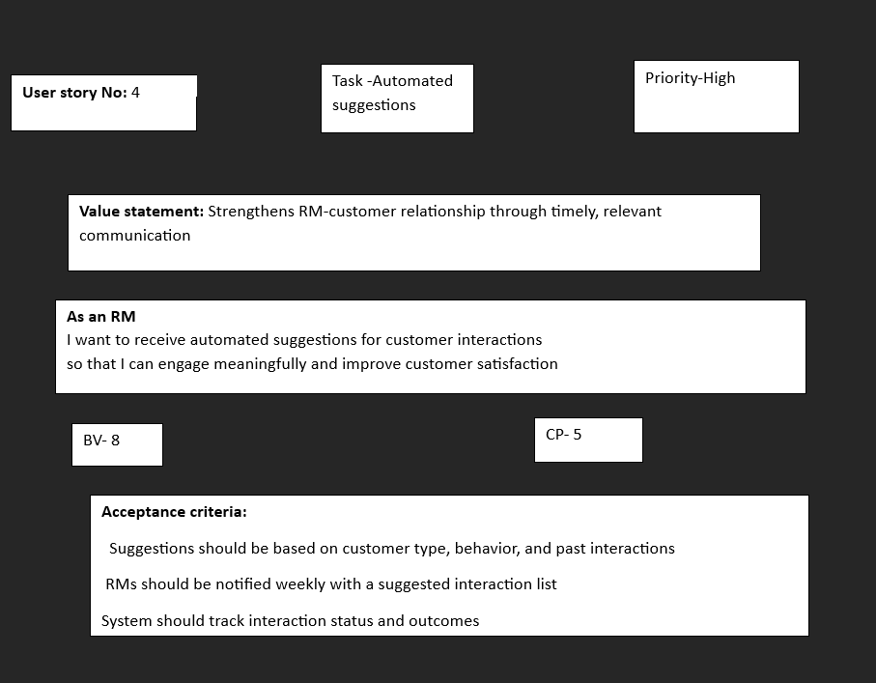

User story-5

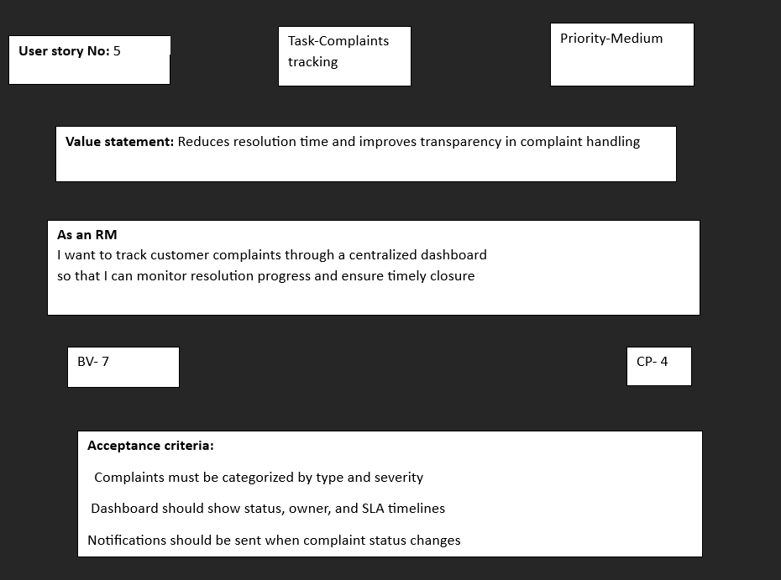

Document 4-

**Agile Product Owner Experience – Detailed Document**

As a Product Owner in an Agile project, my primary responsibility was to represent the voice of the customer and ensure that the product being developed aligned with both business objectives and market needs. I worked closely with stakeholders, Scrum Teams, and Business Analysts to turn business needs into actionable user stories, and guided the product through its development journey.

**1. Market Analysis**

I started by analyzing the current market landscape to understand where the demand lies and what gaps exist in the available products. This included:

* Studying customer pain points
* Benchmarking competitors’ products and features
* Analyzing trends and opportunities that could make our product stand out

This research helped form a solid foundation for the product vision and ensured that what we were building had real market relevance.

**2. Enterprise Analysis**

Before moving forward with the product roadmap, I conducted a feasibility study to validate:

* Whether the product idea was aligned with business strategy
* If it would provide a good return on investment
* What risks or dependencies needed to be considered

I collaborated with stakeholders from different departments (sales, operations, compliance, etc.) to gather insights and align the product plan with organizational goals.

**3. Product Vision & Roadmap**

Using the insights from market and enterprise analysis, I defined a **clear product vision**—what we wanted to achieve and how the product would solve real customer problems.

I then created a **high-level roadmap** that included:

* Key product milestones
* Release timelines
* Major features and epics planned over sprints

This roadmap was shared with both stakeholders and the Scrum team to maintain transparency and alignment.

**4. Managing Product Features**

One of the key roles I played was to manage product features and ensure that the team built what mattered most. This involved:

* Meeting regularly with stakeholders to gather feedback and evolving needs
* Prioritizing features based on criticality, impact, and business value
* Managing trade-offs between scope, time, and cost

For example, if a particular feature would help RMs engage customers better and generate leads faster, I would prioritize it in the upcoming sprint.

**5. Managing Product Backlog**

I took ownership of the **Product Backlog**, which is the heart of Agile development. My tasks here included:

* Writing clear, detailed, and testable user stories
* Prioritizing stories based on stakeholder needs, timelines, and technical readiness
* Breaking down epics into manageable stories and tasks
* Continuously refining the backlog with the team during refinement sessions

The backlog was a living document that evolved with each sprint based on feedback, performance, and market response.

**6. Managing Sprint Progress & Iteration**

Throughout each sprint, I worked closely with the Scrum Master and team to ensure smooth execution:

* Participated in **Sprint Planning** to finalize what could be delivered
* Joined **Daily Standups** to stay updated on progress and blockers
* Attended **Sprint Reviews** to demonstrate features to stakeholders and gather feedback
* Took part in **Sprint Retrospectives** to discuss what went well and what needed improvement

I also reviewed the velocity and adjusted the backlog or priorities when necessary.

**7. Agile Ceremony Experience**

I became well-versed in all key Agile ceremonies:

* **Sprint Planning:** Collaborated with the team to define sprint goals and select prioritized backlog items.
* **Daily Scrum:** Stayed aligned with the team, clarified user stories, and resolved queries in real-time.
* **Sprint Review:** Presented finished stories to stakeholders and captured their inputs.
* **Sprint Retrospective:** Discussed what worked and what didn’t, ensuring continuous improvement.
* **Backlog Refinement:** Maintained a ready pipeline of user stories for upcoming sprints.

**8. User Story Writing**

I created user stories that were clear, concise, and actionable. Each story typically included:

* **Story Number / ID** for tracking
* **Tasks/Subtasks** for breakdown of work
* **Priority** based on business urgency
* **Acceptance Criteria** for validating completion
* **BV (Business Value)** and **CP (Complexity Points)** to help the team estimate effort and ROI

Example:  
**User Story:** As an RM, I want to search for customers by mobile number, so I can access profiles quickly during calls.  
**Acceptance Criteria:** Search returns correct customer when valid mobile number is entered.

**9. Role as a Liaison in Scrum Team**

As the Product Owner, I acted as a **bridge between business and development**:

* Communicated regularly with stakeholders to keep them informed and aligned
* Worked with the development team to clarify requirements and resolve blockers
* Ensured that the team understood the **why** behind each feature, not just the **what**

This cross-functional collaboration helped deliver a product that was both technically sound and business-relevant.

**10. Final Learning & Value Addition**

Through this experience, I learned how to:

* Balance technical constraints with business priorities
* Continuously deliver value in short sprints
* Adapt to changing requirements with minimal disruption
* Keep the team motivated and stakeholders engaged

My work as a Product Owner contributed to delivering a more automated, efficient SFDC solution, improving customer engagement and operational efficiency.

Doc-5

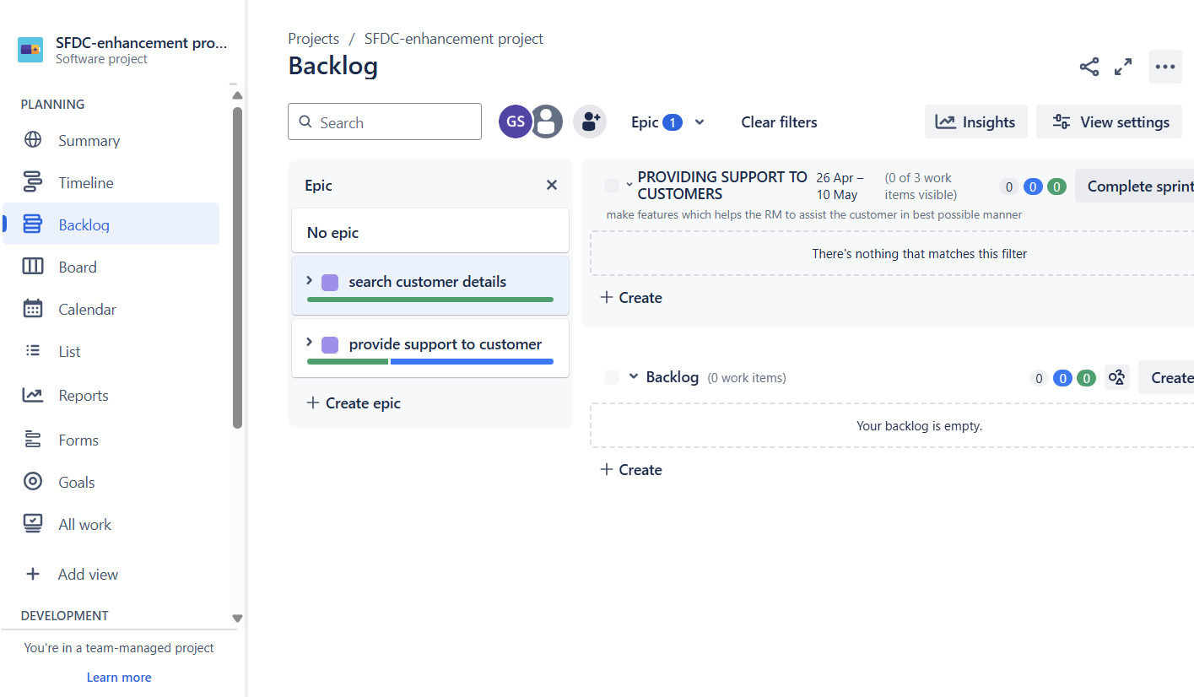

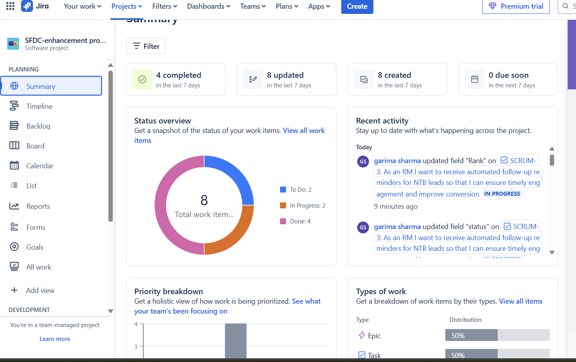

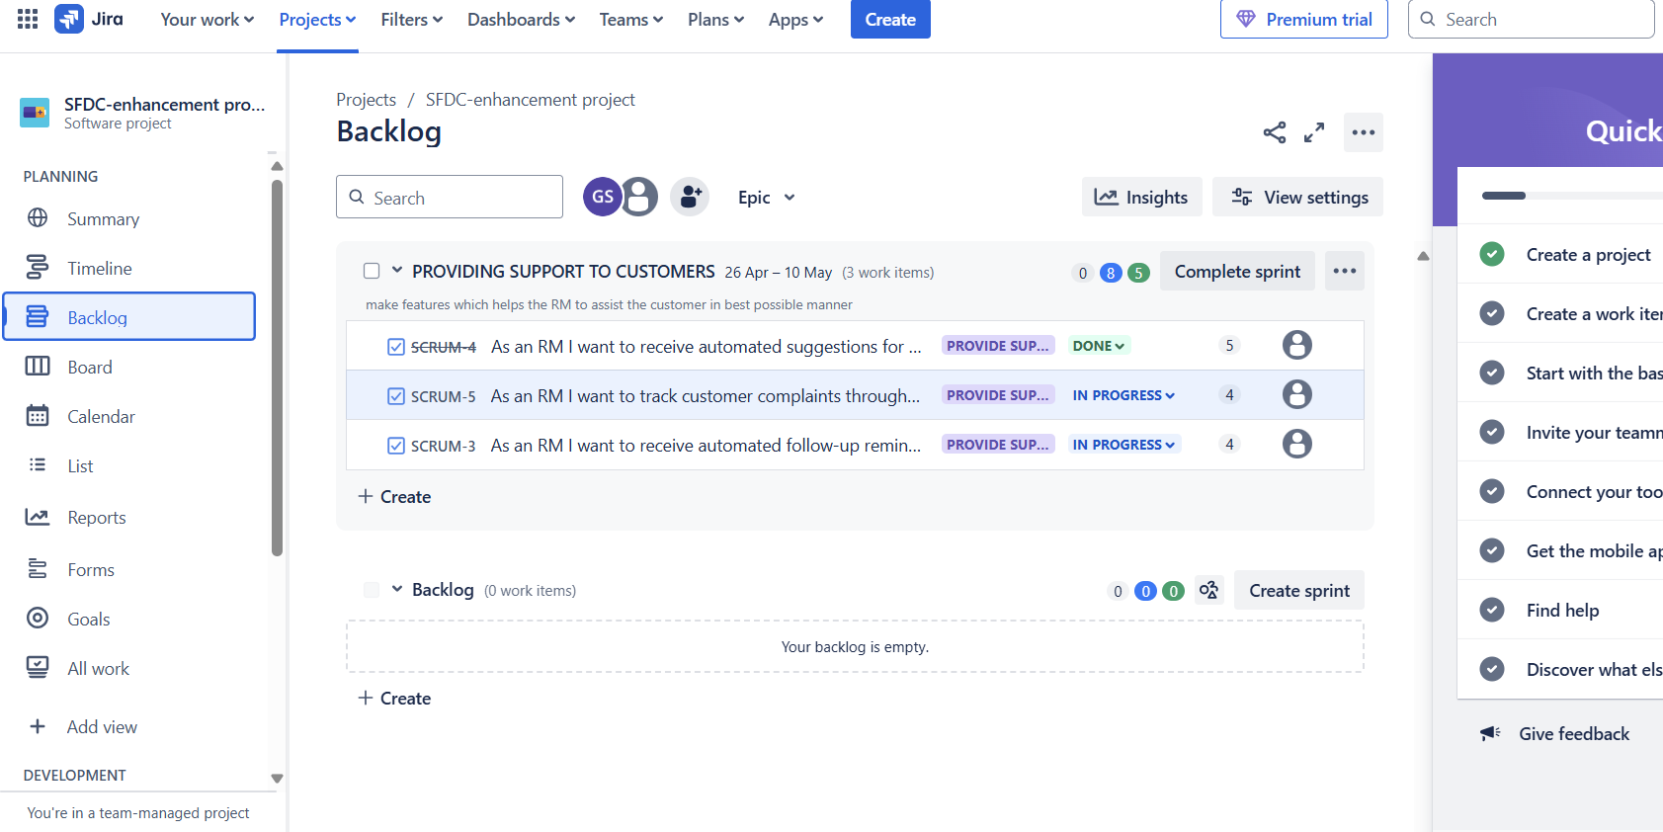

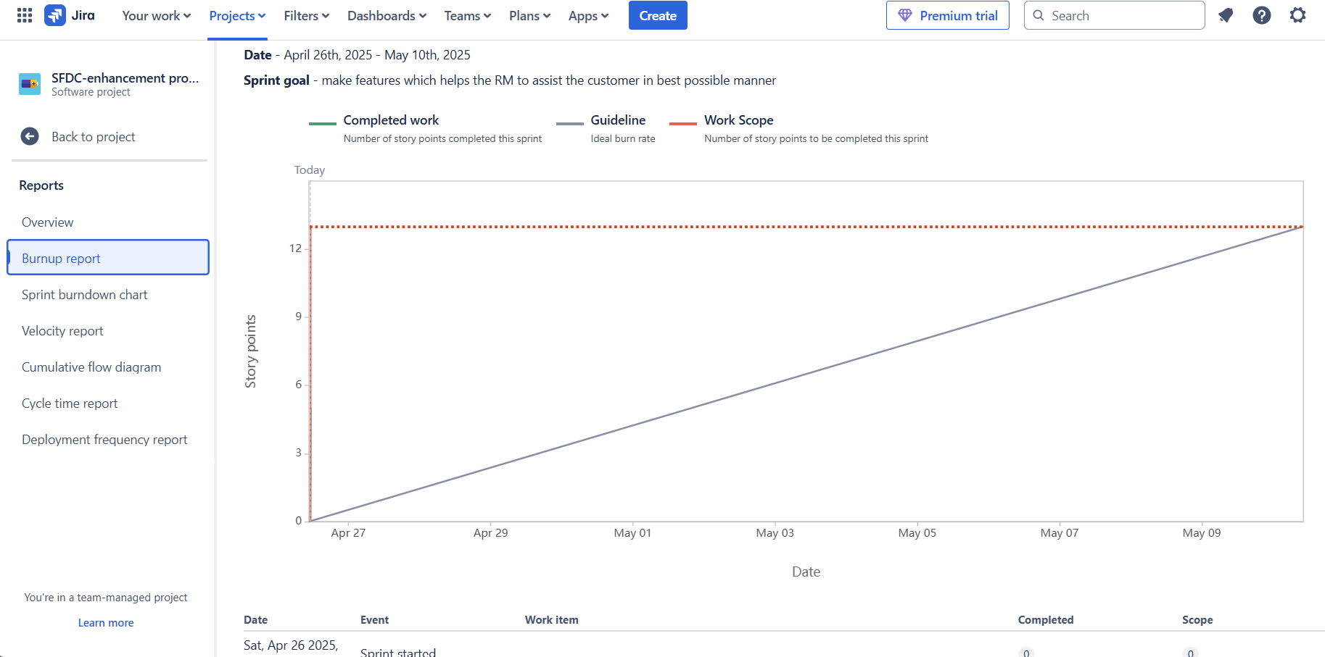

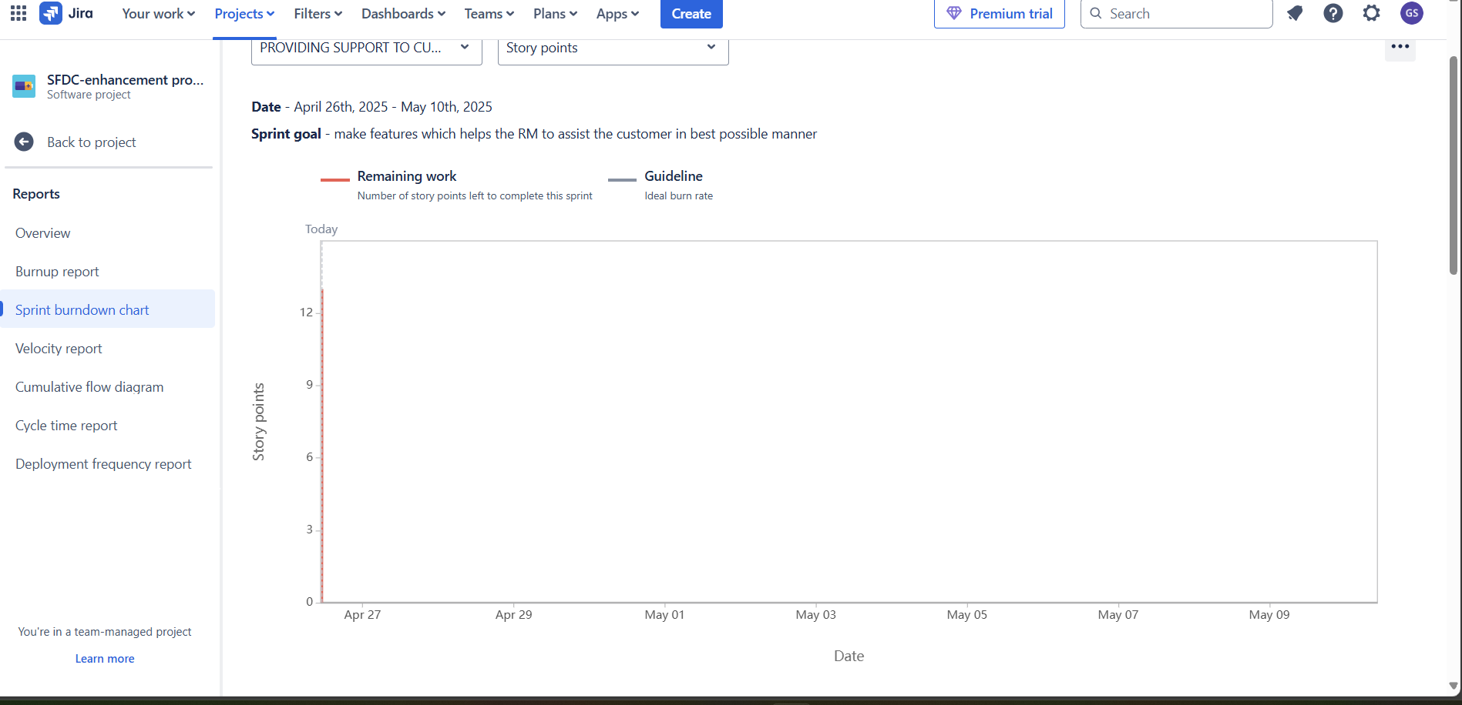

Doc-6

**Meeting Type 1: Sprint Planning Meeting**

**Date:** [Insert Date]  
**Time:** [Insert Time]  
**Location:** [Physical/Virtual Location]  
**Prepared By:** [Your Name or Role]  
**Attendees:**

* Product Owner
* Scrum Master
* Development Team
* Business Analyst
* QA Team

**Agenda Topics:**

| **Topic** | **Presenter** | **Time Allotted** |
| --- | --- | --- |
| Sprint goal overview | Product Owner | 10 mins |
| Review prioritized backlog | Scrum Master | 15 mins |
| Story breakdown & estimation | Dev Team/BA | 25 mins |
| Task assignment | Scrum Master | 10 mins |

**Other Information:**

* Sprint duration: [e.g., 2 weeks]
* Capacity planning and holidays discussed

**Observers:** [Optional roles like stakeholders, interns]  
**Resources:**

* JIRA Board / Sprint Backlog
* Previous sprint velocity chart

**Special Notes:**

* Ensure dependencies are addressed before sprint starts
* Carry over only validated stories

**Meeting Type 2: Sprint Review Meeting**

**Date:** [Insert Date]  
**Time:** [Insert Time]  
**Location:** [Physical/Virtual Location]  
**Prepared By:** [Your Name or Role]  
**Attendees:**

* Product Owner
* Scrum Master
* Development Team
* QA Team
* Stakeholders

**Sprint Status:**

* Sprint Goal: Achieved / Partially achieved / Not achieved
* Completed Stories: [List of story titles]
* Carryover: [List of uncompleted stories with reasons]

**Things to Demo:**

* Enhanced customer detail UI
* NTB lead auto follow-up tracker
* RM interaction automation feature

**Quick Updates:**

* Bugs fixed
* Customer feedback incorporated
* Story point velocity comparison

**What’s Next:**

* Backlog grooming
* Sprint Retrospective
* Plan for next sprint’s high-priority stories

DOR and DOD

Top of Form

Bottom of Form