Doc 6:

Use case diagram:

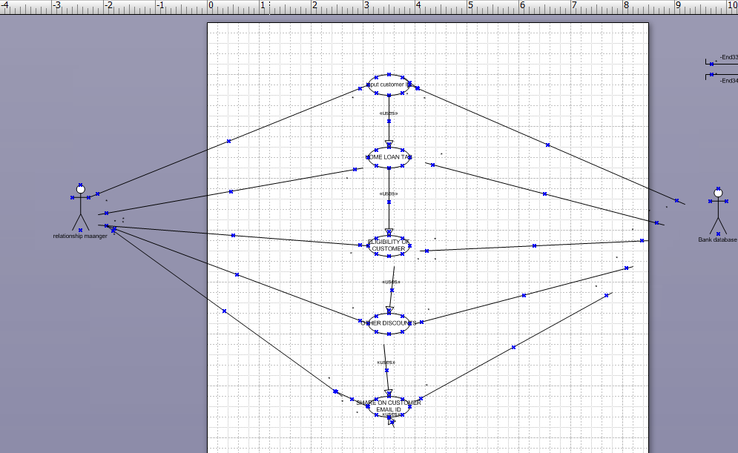

**Activity diagram:**

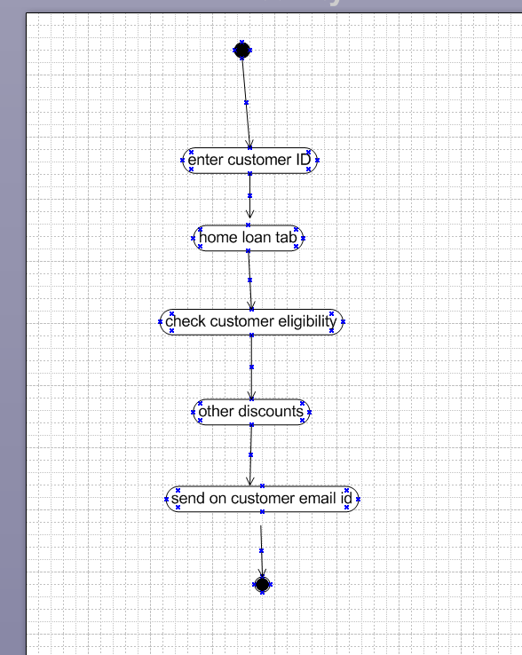

**Use case specification document:**

**Use Case ID: UC-001**

**Use Case Name: Unified Customer Interaction Management**

**Actors:**

* **Employee (Sales, Support, Billing, Complaints)**
* **Customer**
* **CRM System**

**Description: This use case describes a system that consolidates customer data, reduces repetitive data entry, and provides a unified customer view to improve query resolution.**

**Preconditions:**

* **Employee is logged into the CRM system.**
* **Customer details are partially available in individual department records.**

**Main Flow:**

1. **Employee logs into the CRM system.**
2. **System fetches customer data from sales, support, billing, and complaints databases.**
3. **Consolidated customer profile is displayed.**
4. **Employee views and updates customer information in a single interface.**
5. **System updates data across all departments in real time.**

**Alternative Flows:**

* **Data Not Found:**
  + **If no customer data is found, system prompts employee to create a new profile.**

**Exception Flows:**

* **System Error:**
  + **If data retrieval fails, system displays an error message and logs the issue.**

**Postconditions:**

* **Customer data is updated and synchronized across departments.**
* **Employee resolves customer query without switching between multiple tabs.**

**Business Rules:**

* **Only authorized employees can access and edit customer data.**
* **Customer data must comply with data protection regulations.**

**Dependencies:**

* **Integration with existing sales, support, billing, and complaint management systems.**

**Doc 7:**

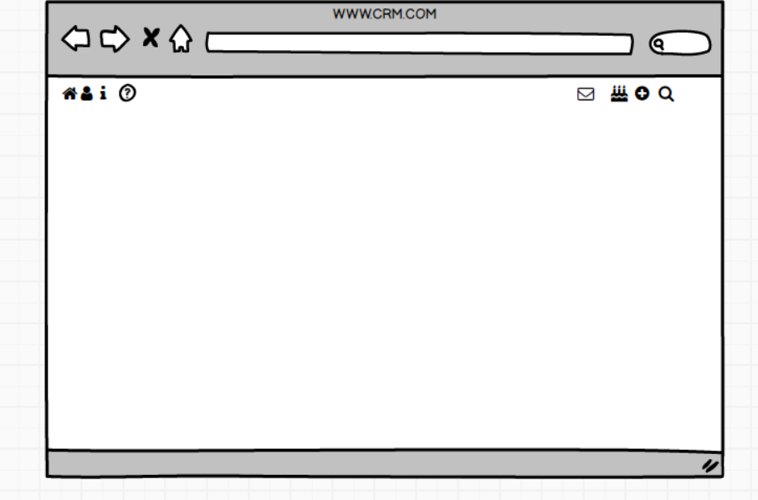

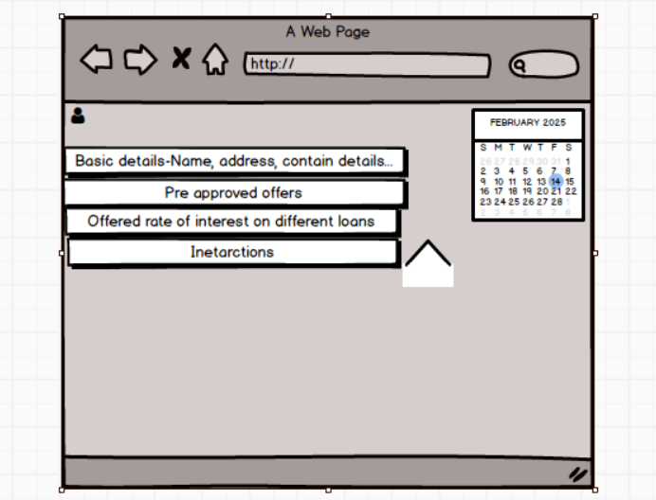

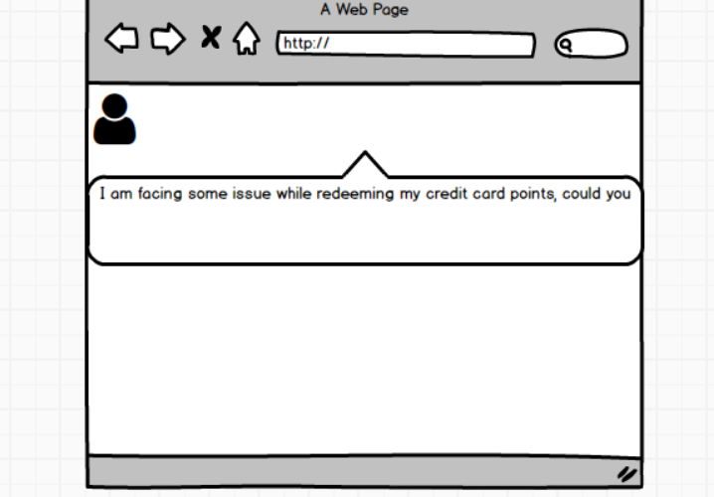

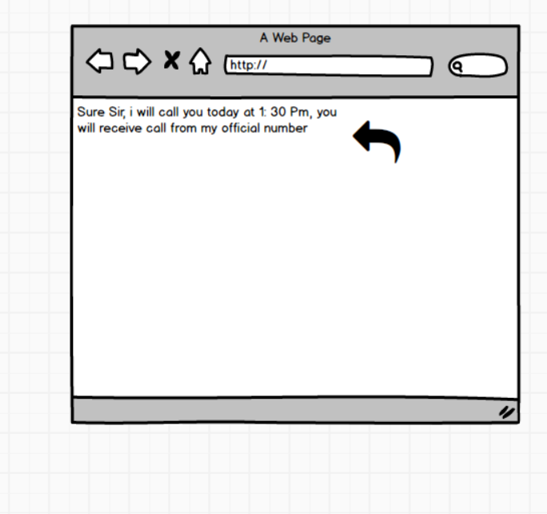

**Doc 8:**

**. MS Visio:**

* **Created detailed and professional use case diagrams and activity diagrams.**
* **Visualized system workflows and stakeholder interactions effectively.**
* **Used a variety of diagram shapes and templates for efficient process modeling.**
* **Communicated visual diagrams to the team for better understanding of requirements.**

**2. Axure:**

* **Designed interactive mock-ups for application screens.**
* **Created high-fidelity wireframes to simulate user interactions and navigation flows.**
* **Ensured user-friendly layouts and feature-specific wireframes.**
* **Provided a realistic visualization of the final product for stakeholder feedback.**

**Doc 9:**

**1. Requirement Gathering:**

* Used **MoSCoW technique** to prioritize requirements.
* Managed stakeholder unavailability by sourcing point-of-contact replacements.
* Validated requirements using **FURPS** technique.
* Removed duplicate and repetitive requirements promptly.
* Employed **prototyping** for more specific requirement collection.

**2. Requirement Analysis:**

* Created **UML diagrams** and **activity diagrams** for process visualization.
* Communicated diagrams to the team, incorporated feedback, and made changes as necessary.
* Prepared **BRS** and **SRS** documents.

**3. Design:**

* Prepared test cases from use case diagrams, including both positive and negative scenarios.
* Communicated design and solution documents to the client.
* Ensured no test cases were missed to prevent development issues.
* Created test data and updated **RTM** to verify requirement coverage.

**4. Development:**

* Conducted **JAD sessions** to gather inputs from stakeholders.
* Clarified technical queries during coding.
* Resolved conflicts with team members through one-on-one discussions.
* Referred diagrams to guide development tasks.
* Conducted regular meetings with the technical team and client, recorded sessions for absent members, and followed up with one-on-one discussions.

**5. Testing:**

* Prepared test cases based on use cases.
* Performed high-level testing.
* Requested test data from the client.
* Updated **RTM** and obtained client sign-off.
* Prepared the client for **UAT**.

**6. Deployment:**

* Shared **RTM** as part of the project closure document.
* Coordinated the preparation and delivery of **end-user manuals**.
* Planned and organized training sessions for end users.
* Ensured full participation in training sessions.

My ability to adapt to challenges, foster collaboration, and maintain meticulous documentation has been pivotal to successful project delivery.