Business RequirementDocument

Kunal Khadse (BA)



Inventory Management & Delivery Optimization System

Contents

1. Document Revisions 03

2. Approvals 03

3. RACI Chart for This Document 03

Codes Used in RACI Chart 04

RACI Chart 04

4. Introduction 04

4.1. Business Goals 04

4.2. Business Objectives 04

4.3. Business Rules 05

4.4. Background 05

4.5. Project Objective 05

4.6. Project Scope 05

4.6.1. In Scope Functionality 05

4.6.2. Out Scope Functionality 05

5. Assumptions 05

6. Constraints 06

7. Risks 06

Technological Risks 06

Skills Risks 06

Business Risks 06

Requirements Risks 06

Other Risks 06

8. Business Process Overview 07

8.1. Legacy System (AS-IS) 07

8.2. Proposed Recommendations (TO-BE) 07

9. Business Requirements 08

10. Appendices 08

10.1. List of Acronyms 09

**1.** **Document Revisions**

|  |  |  |
| --- | --- | --- |
| **Date** | **Version Number** | **Document Changes** |
| 07/04/2025 | 0.1 | Initial Draft |
| 15/04/2025 | 1.1 | Updated targeted dates |
|  |  |  |
|  |  |  |
|  |  |  |
|  |  |  |

1. **Approvals**

|  |  |  |  |  |
| --- | --- | --- | --- | --- |
| **Role** | **Name** | **Title** | **Signature** | **Date** |
| Project Sponsor | Mr. Jack | Executive Stakeholder |  |  |
| Business Owner | Mr. Amo | Strategic Business Lead |  |  |
| Project Manager | Miss. Emily | Delivery & Operations Manager |  |  |
| System Architect | Mr. Mario | Technical Architecture Lead |  |  |
| Development Lead | Mr. Lucky | Software Engineering Manager |  |  |
| User Experience Lead | Miss. Lucy | UX/UI Design Head |  |  |
| Quality Lead | Mr. Benoit | QA & Testing Manager |  |  |
| Content Lead | Mr. Nicolas | Content Strategy Manager |  |  |

1. **RACI Chart for This Document**

The RACI chart identifies the persons who need to be contacted whenever changes are made to this document. RACI stands for responsible, accountable, consulted, and informed. These are the main codes that appear in a RACI chart, used here to describe the roles played by team members and stakeholders in the production of the BRD. They are adapted from charts used to assign roles and responsibilities during a project.( RACI Can be made for IT side[Project stakeholder] as mentioned above, apart from that Can also Be made for Client side[Business Stakeholder]).

The following describes the full list of codes used in the table:

### **Codes Used in RACI Chart**

|  |  |
| --- | --- |
| * Authorize document. | Has ultimate signing authority for any changes to the |
| R Responsible | Responsible for creating this document. |
| A Accountable | Accountable for accuracy of this document  (for example, the project manager) |
| S Supports  document | Provides supporting services in the production of this |
| C Consulted | Provides input (such as an interviewee). |
| I Informed | Must be informed of any changes. |

**RACI Chart**

|  |  |  |  |  |  |  |  |
| --- | --- | --- | --- | --- | --- | --- | --- |
| **Name** | **Position** | **\*** | **R** | **A** | **S** | **C** | **I** |
| Miss. Emily | Project Manager |  | * | * |  |  | * |
| Mr. Kunal | Business Analyst |  | * |  | * | * | * |
| Miss. Mindy | Senior Developer |  |  | * | * |  | * |
| Mr. Jack | Sponsor |  |  | * |  |  | * |

**4. Introduction**

**4.1 Business Goals**

* Develop a comprehensive inventory management system for ice-cream and milk products.
* Ensure the quickest delivery to customers by optimizing logistics and supply chain processes.
* Enhance customer satisfaction through efficient order fulfillment.

**4.2 Business Objectives**

* Enable real-time tracking of inventory across multiple warehouses and manufacturing plants.
* Optimize delivery routes to minimize transit times and costs.
* Provide a user-friendly interface for inventory management and order tracking.

**4.3 Business Rules**

* Inventory levels must be updated in real-time as products are manufactured, stored, and shipped.
* Delivery routes must be dynamically optimized based on current traffic and weather conditions.
* Users must have role-based access to the system, with different permissions for administrators, warehouse managers, and delivery personnel.

**4.4 Background**

* The current inventory management system is manual and prone to errors, leading to inefficiencies in stock management and order fulfillment.
* Delivery processes are not optimized, resulting in longer transit times and higher costs.
* There is a need for a centralized system to manage inventory and streamline delivery operations.

**4.5 Project Objective**

* Develop an integrated software solution for inventory management and delivery optimization.
* Implement real-time tracking and analytic to improve inventory accuracy and delivery efficiency.
* Provide a scalable platform that can accommodate future growth and expansion.

**4.6 Project Scope**

**4.6.1 In Scope Functionality**

* Real-time inventory tracking and management across multiple locations.
* Dynamic route optimization for quickest delivery.
* Role-based access control for different user roles.
* Integration with existing ERP and logistics systems.
* Real-time analytics and reporting for inventory and delivery performance.

**4.6.2 Out Scope Functionality**

* Integration with third-party e-commerce platforms.
* Automated drone delivery systems.
* Block-chain-based supply chain tracking.

**5. Assumptions**

* The system will support multiple product categories, including ice-cream and milk products.
* The platform will primarily serve B2B customers but may expand to B2C in future phases.
* Users will have internet access to use the platform.
* The system will comply with relevant regulations and standards for inventory management and logistics.

**6. Constraints**

* The system must handle inventory and delivery operations for at least 50 warehouses and manufacturing plants.
* Implementation should be completed within nine months.

**7. Risks**

**7.1 Technological Risks**

* Potential compatibility issues with existing ERP and logistics systems.
* Challenges in integrating real-time tracking and route optimization algorithms.

**7.2 Skills Risks**

* Lack of experienced developers proficient in required technologies.
* Insufficient training for support and maintenance teams.
* Difficulty in hiring UX/UI designers with expertise in e-commerce platforms.
* Potential delays due to dependency on specialized skills for integration.

**7.3 Business Risks**

* Competitive pressure from existing inventory management and logistics solutions.
* Potential delays due to dependency on specialized skills for integration.

**7.4 Requirements Risks**

* Scope creep leading to delays.
* Potential difficulties in handling high user traffic.

**7.5 Other Risks**

* Potential difficulties in handling high user traffic.
* Users may take time to adapt to the new platform.
* Issues in order fulfillment, payment processing, and logistics.

**8. Business Process Overview**

**8.1 Legacy System (AS-IS)**

* Manual inventory tracking and management leading to inefficiencies and errors.
* Delivery routes are not optimized, resulting in longer transit times.
* Lack of real-time visibility into inventory levels and delivery status.

**8.2 Proposed Recommendations (TO-BE)**

* Implement a centralized system to manage inventory across all warehouses and manufacturing plants in real-time.
* Enable automated tracking of stock levels, with alerts for low inventory to ensure timely restocking.
* Utilize advanced algorithms to dynamically optimize delivery routes based on real-time traffic, weather conditions, and delivery priorities.
* Integrate with GPS systems for precise route planning and real-time adjustments.
* Develop a role-based access system to ensure that different users (e.g., administrators, warehouse managers, delivery personnel) have appropriate permissions and access levels.
* Enhance security by restricting access to sensitive data and operations.

**9. Business Requirements**

| **BR ID** | **Requirement Name** | **Business Requirement Description** | **Priority** |
| --- | --- | --- | --- |
| **BR0001** | **Real-Time Inventory Tracking** | **The system must track inventory levels in real-time across all warehouses and manufacturing plants.** | **High** |
| **BR0002** | **Dynamic Route Optimization** | **The system must optimize delivery routes dynamically to ensure the quickest delivery times.** | **High** |
| **BR0003** | **Role-Based Access Control** | **The system must provide role-based access control for different user roles.** | **High** |
| **BR0004** | **Integration with ERP Systems** | **The system must integrate with existing ERP systems for seamless data exchange.** | **High** |
| **BR0005** | **Real-Time Analytics and Reporting** | **The system must provide real-time analytics and reporting for inventory and delivery performance.** | **Medium** |
| **BR0006** | **User-Friendly Interface** | **The system must have a user-friendly interface for inventory management and order tracking.** | **High** |
| **BR0007** | **Alerts and Notifications** | **The system must send alerts and notifications for low stock levels and delivery updates.** | **Medium** |
| **BR0008** | **Customer Feedback Collection** | **The system must collect and analyze customer feedback post-delivery.** | **Medium** |
| **BR0009** | **Scalability and Performance** | **The system must be scalable to accommodate future growth and handle increased load efficiently.** | **High** |
| **BR0010** | **Compliance and Security** | **The system must comply with relevant regulations and implement robust security measures.** | **High** |
| **BR0011** | **Training and Support Resources** | **The system must provide training resources and support for users to adapt to the new system.** | **Medium** |
| **BR0012** | **Predictive Analytics** | **The system must use predictive analytics to forecast inventory needs and optimize stock levels.** | **Medium** |
| **BR0013** | **Multi-Channel Communication** | **The system must support multi-channel communication for notifications (email, SMS, in-app).** | **Medium** |
| **BR0014** | **Automated Inventory Replenishment** | **The system must automate inventory replenishment based on predefined thresholds and lead times.** | **High** |
| **BR0015** | **Vendor and Supplier Management** | **The system must manage vendor relationships and automate purchase orders for inventory restocking.** | **Medium** |
| **BR0016** | **Real-Time Delivery Tracking** | **The system must provide real-time tracking of deliveries for both customers and internal stakeholders.** | **High** |
| **BR0017** | **Customer Support Integration** | **The system must integrate with customer support platforms for real-time issue resolution.** | **Medium** |
| **BR0018** | **Continuous Improvement Mechanism** | **The system must include a feedback loop for continuous improvement based on performance metrics.** | **Medium** |
| **BR0019** | **Disaster Recovery and Backup** | **The system must have a disaster recovery plan and regular data backups to ensure data integrity.** | **High** |
| **BR0020** | **Mobile Accessibility** | **The system must be accessible via mobile devices for inventory management and order tracking.** | **Medium** |

**10. Appendices**

**10.1 List of Acronyms**

* **BRD** - Business Requirements Document
* **RTM** - Requirement Trace ability Matrix

FlowChart -



**Assignment 2 -**

1. **Introduction Letter**

**Kunal Khadse**   
**Business Analyst**  
**ABC Pvt.Ltd**  
**07/04/2025**

Dear Jack,

I am **Kunal Khadse**, a Business Analyst at **ABC Pvt.Ltd**, and I’m excited to lead the collaboration between our teams to develop your Inventory and Delivery Optimization System. My role is to ensure we fully understand your business needs, translate them into actionable requirements, and deliver a solution aligned with your goals.

Over the next two weeks, I’ll work closely with your stakeholders to map processes, identify pain points, and define success metrics. Let’s schedule a kickoff meeting to discuss your priorities and time-lines.

Looking forward to partnering with you!

Best regards,  
**Kunal Khadse**  
kunalkhadse@abc.com

**2. Brief BRD and SRS for a Project**

**Project: Online Store**

**Business Requirements Document (BRD)**

**1. Introduction**

The goal of this project is to develop an online store that provides a seamless shopping experience for customers. The store will offer a wide range of products, easy navigation, secure payment options, and efficient order management.

**2. Business Goals**

* Increase online sales and customer base.
* Provide a user-friendly interface for shopping.
* Ensure secure and efficient transaction processing.

**3. Business Objectives**

* Develop a responsive and intuitive user interface.
* Implement secure payment gateways.
* Provide real-time order tracking and management.

**4. Business Rules**

* All transactions must be secured using SSL encryption.
* Inventory levels must be updated in real-time.
* Customer support must be available 24/7.

**5. Project Scope**

**In Scope:**

* Product catalog management.
* Shopping cart and checkout process.
* Secure payment processing.
* Order tracking and management.
* Customer reviews and ratings.

**Out of Scope:**

* Integration with third-party e-commerce platforms.
* Automated drone delivery systems.

**6. Assumptions**

* The system will support multiple product categories.
* Users will have internet access to use the platform.
* The system will comply with relevant regulations and standards.

**7. Constraints**

* The system must handle at least 10,000 concurrent users.
* Implementation should be completed within six months.

**8. Risks**

* Potential compatibility issues with payment gateways.
* Challenges in integrating real-time inventory tracking.

**9. Business Requirements**

| BR ID | Requirement Name | Description | Priority |
| --- | --- | --- | --- |
| BR001 | User Registration | Users must be able to register and create accounts. | High |
| BR002 | Product Catalog | The system must display a catalog of products with search and filter options. | High |
| BR003 | Shopping Cart | Users must be able to add/remove items from their shopping cart. | High |
| BR004 | Secure Payment | The system must support secure payment processing. | High |
| BR005 | Order Tracking | Users must be able to track their orders in real-time. | High |
| BR006 | Customer Reviews | Users must be able to leave reviews and ratings for products. | Medium |

**System Requirements Specification (SRS)**

**1. Introduction**

This SRS document outlines the functional and non-functional requirements for the online store project.

**2. Functional Requirements**

* User Registration and Authentication
* Product Catalog Management
* Shopping Cart and Checkout Process
* Secure Payment Processing
* Order Tracking and Management
* Customer Reviews and Ratings

**3. Non-Functional Requirements**

* Performance: The system must handle at least 10,000 concurrent users.
* Security: All transactions must be secured using SSL encryption.
* Usability: The interface must be intuitive and user-friendly.
* Scalability: The system must be scalable to accommodate future growth.

**3.ER Diagram of creating a support ticket/Ticketing life cycle.**

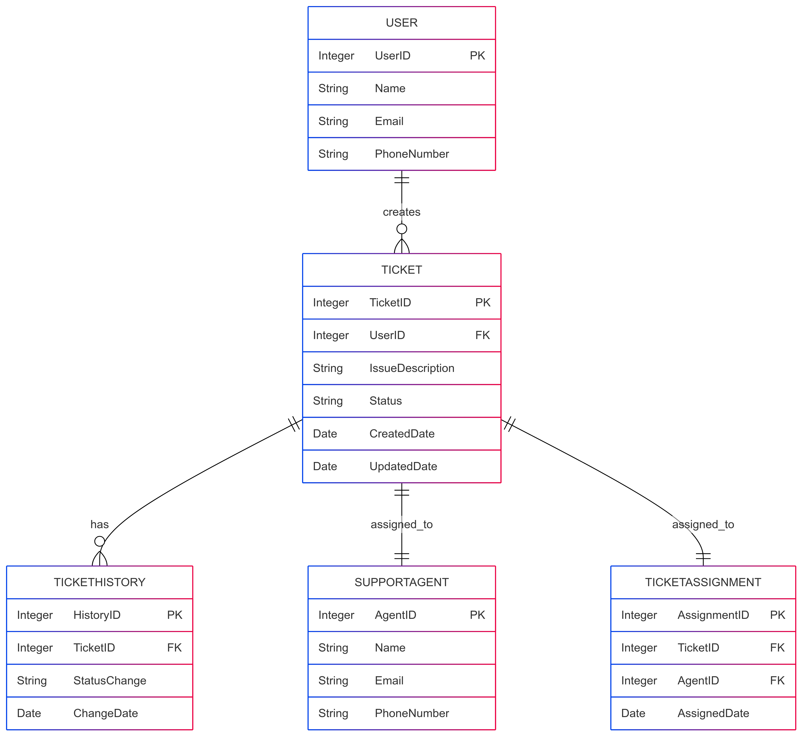

**4.User stories of shopping from e commerce.**

**User Story 1: Browsing Products**

As a customer, I want to browse through different product categories, so that I can explore various items available on the e-commerce platform.

Acceptance Criteria:

1. The platform displays a list of product categories on the homepage.
2. I can click on a category to view products within that category.
3. I can use filters (e.g., price, brand, rating) to refine my search.

**User Story 2: Searching for a Product**

As a customer, I want to search for specific products using keywords, so that I can quickly find the items I am looking for.

Acceptance Criteria:

1. There is a search bar prominently displayed on the homepage.
2. The search function returns relevant results based on my keywords.

**User Story 3: Viewing Product Details**

As a customer, I want to view detailed information about a product, so that I can make an informed decision before purchasing.

Acceptance Criteria:

1. Each product has a detailed page with images, descriptions, specifications, and reviews.
2. I can view customer reviews and ratings for the product.
3. The page displays pricing information and any available discounts.

**User Story 4: Adding Items to the Cart**

As a customer, I want to add items to my shopping cart, so that I can purchase multiple products in a single transaction.

Acceptance Criteria:

1. I can add items to the cart from the product details page.
2. The cart updates to show the number of items added.
3. I can view and edit the items in my cart before proceeding to checkout.

**User Story 5: Checkout Process**

As a customer, I want a seamless checkout process, so that I can complete my purchase quickly and securely.

Acceptance Criteria:

1. The checkout process includes steps for shipping, payment, and order review.
2. I can choose from multiple payment options (e.g., credit card, COD,UPI).
3. I receive a confirmation email with order details after completing the purchase.

**User Story 6: Tracking Order Status**

As a customer, I want to track the status of my order, so that I know when to expect delivery.

Acceptance Criteria:

1. I can view the status of my order in my account dashboard.
2. I receive updates via email or SMS as the order progresses (e.g., shipped, out for delivery).

**User Story 7: Returning a Product**

As a customer, I want an easy process for returning a product, so that I can get a refund or exchange if needed.

Acceptance Criteria:

1. The return policy is clearly stated on the website.
2. I can initiate a return through my account or by contacting customer support.
3. I receive instructions on how to return the product and the expected refund timeline.