Assignment 01-Q1-Answer
1. Executive Summary
This document outlines the requirements for developing software for Colliers India, a manufacturer of ice-cream and milk products with a network of manufacturing plants and warehouses across the country. The proposed system will focus on two primary objectives: effective inventory management and enabling the quickest delivery to customers. By achieving these goals, the company aims to enhance operational efficiency, minimize waste, and improve customer satisfaction.
2. Business Goals
- Streamlined Inventory Management:
  - Ensure real-time monitoring of inventory levels across all warehouses and plants to reduce spoilage and optimize stock levels.
- Enhanced Delivery Efficiency:
  - Implement a system to identify the fastest delivery routes and automate order allocation based on proximity and inventory availability.
- Improved Customer Satisfaction:
  - Minimize order fulfillment time and ensure product freshness at delivery.
3. Business Objectives
- Develop a Centralized System:
  - Track and manage inventory across all locations (plants and warehouses).
- Automate Order Processing:
  - Automate order allocation and dispatch based on inventory levels, proximity to the warehouse, and order urgency.
- Integrate Delivery Route Optimization:
  - Incorporate real-time traffic, weather data, and GPS systems for optimal route planning and timely deliveries.
- Reduce Inventory Wastage:
  - Implement a system to track product expiration dates to ensure inventory is rotated and managed effectively.

- Reporting and Analytics:
  - Create dashboards for managers to review inventory levels, orders, delivery performance, and forecasts.
4. Business Rules
- Real-Time Inventory Updates:
  - Inventory must be updated in real-time upon receipt, dispatch, or adjustment to ensure accurate tracking.
- Order Fulfillment:
  - Orders should only be fulfilled if the inventory is available and meets the required shelf-life criteria.
- Delivery Prioritization:
  - Delivery routes must prioritize product freshness while minimizing transportation costs and travel time.
- Priority Orders:
  - Customer priority orders (e.g., bulk orders) must be flagged for immediate action and processing.
- Warehouse Reordering:
  - Automated reorder thresholds should trigger purchase orders to suppliers based on inventory levels.
5. Scope of the System
In-Scope:
- Real-time inventory tracking at manufacturing plants and warehouses.
- Automated order management and allocation.
- Integration of delivery route optimization and scheduling.
- Analytics and reporting dashboards to track inventory trends, order patterns, and delivery performance.

Out-of-Scope:
- Manufacturing process management (production scheduling, machine management, etc.).
- Customer relationship management (CRM) features such as customer feedback and support tickets.

6. Assumptions
- Connectivity:
  - All warehouses and plants have internet connectivity for real-time updates.
- GPS-Enabled Vehicles:
  - Delivery vehicles are equipped with GPS systems to support route optimization.
- External Data Availability:
  - Data from external sources (e.g., traffic, weather) will be available through APIs for dynamic route optimization.

7. Constraints
- Budget Constraints:
  - The budget may limit the number of features or integrations that can be included in the first phase of the project.
- Integration Challenges:
  - Integration with legacy systems and third-party logistics providers could present technical challenges.
- Project Timeline:
  - The timeline must align with the company’s peak season, so delivery must be ready before high demand periods.

8. Risk Analysis
Technical Risks:
- Integration issues with existing systems (e.g., legacy software or third-party logistics).
- The scalability of the system to manage increasing inventory, orders, and customer base.
Political Risks:
- Resistance from employees due to new processes, technologies, and workflows.
- Vendor lock-in due to third-party tool dependencies.
Requirement Risks:
- Incomplete or evolving requirements from stakeholders could cause delays or rework.
Business Risks:
- System downtime during deployment could disrupt operations.
- Potential customer dissatisfaction if the system rollout takes longer than expected.

9. Business Process Overview
AS-IS:
- Inventory Management: Currently managed manually or through isolated systems across different warehouses.
- Order Allocation: Manual order allocation leads to inefficiencies.
- Delivery Routes: Routes are planned based on experience and not optimized.
TO-BE:
- Centralized System: A unified system for real-time inventory management and automation.
- Automated Order Processing: An intelligent algorithm for order allocation based on inventory, proximity, and urgency.
- Optimized Delivery Routes: Real-time delivery route optimization using GPS, weather, and traffic data.

10. Business Requirements
- Inventory Management Module:
  - Real-time tracking of inventory across all locations.
  - Expiry-date tracking and alerts for perishable products.
- Order Management Module:
  - Automated order allocation based on product availability, location, and proximity to the customer.
  - Prioritization of bulk or customer-priority orders.
- Delivery Optimization Module:
  - Integration with GPS and real-time traffic/weather data for optimal route planning.
  - Dynamic rerouting in case of delays or unforeseen conditions.
- Reporting Module:
  - Real-time analytics on inventory levels, sales trends, and delivery performance.
11. Development and Resource Plan
Development Plan:
- Phase 1: Requirement Gathering (4 weeks)
  - Conduct workshops with stakeholders.
  - Finalize system architecture and design.
- Phase 2: Development of Core Modules (12 weeks)
  - Develop the Inventory, Order, and Delivery modules.
- Phase 3: Integration with External and Legacy Systems (6 weeks)
  - Integrate with GPS, weather data APIs, and any existing company systems.
- Phase 4: Testing & Quality Assurance (4 weeks)
  - Perform unit, integration, and user acceptance testing (UAT).
- Phase 5: Deployment, Training, and Support (4 weeks)
  - Deploy the system.
  - Train the internal team on the new processes and software.
  - Provide post-launch support.
Resource Plan:
- Project Manager: 1 Full-Time Equivalent (FTE)
- Developers: 3 FTE (Backend Developer, Frontend Developer, Integration Specialist)
- QA Engineers: 2 FTE
- Business Analyst: 1 FTE
- Support Team: 2 FTE (for post-launch support)
12. Appendices
- Glossary of Terms:
  - FTE: Full-Time Equivalent
  - API: Application Programming Interface
  - UAT: User Acceptance Testing
- Abbreviations Used:
  - ERP: Enterprise Resource Planning
  - GPS: Global Positioning System
  - IMS: Inventory Management System
13. Related Documents
- Feasibility Study Report:
  - Overview of the feasibility of implementing the proposed system.
- Market Analysis for Inventory and Delivery Optimization Software:
  - Market trends and competitive landscape for similar software solutions.
- Stakeholder Requirements Document:
  - A document detailing the specific needs and expectations of various stakeholders involved in the project.
Assignment 01-Q2-Answer

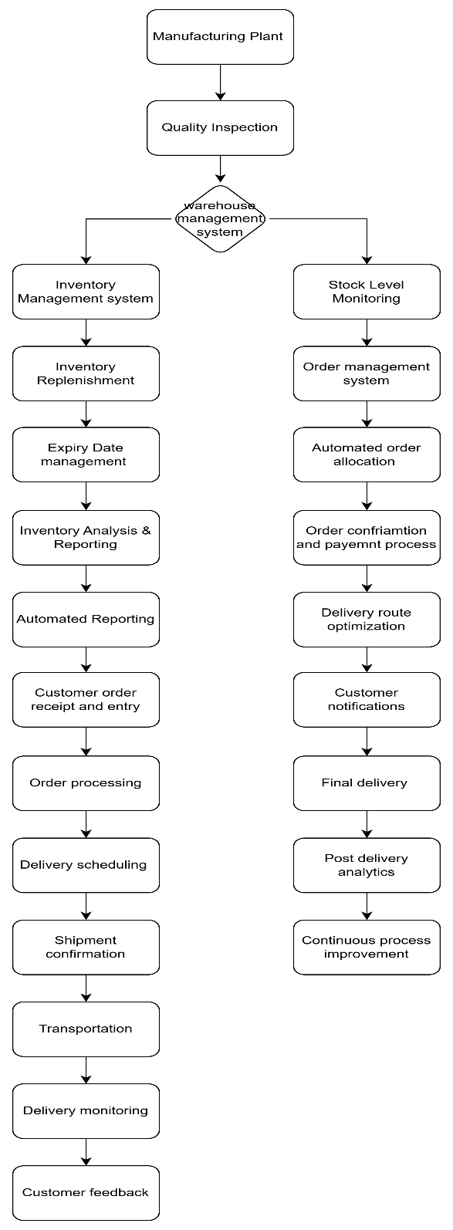

Assignment 02-Q1-Answer
Subject: Introduction to your Business Analyst Expert
Dear Client,
I hope this message finds you well. My name is Ashay Pillewan, and I am truly delighted to introduce myself as the Business Analyst assigned to collaborate with you and your team on this exciting project.
With a deep interest in the challenges and opportunities within the manufacturing and logistics sectors, particularly in providing exceptional customer service, I am eager to support your efforts in managing inventory and ensuring the prompt delivery of your ice cream and milk products. It will be my privilege to collaborate with you in turning these objectives into a well-structured, tailor-made software solution as per the business requirement.
To begin, I would like to gain a comprehensive understanding of your current processes, challenges, and aspirations. Through close collaboration, we will examine your operational workflows, identify key requirements, and develop a strategic plan that aligns seamlessly with your business goals. Your insights and feedback will be invaluable in helping us craft a solution that is not only effective and scalable but also perfectly suited to your unique needs.
I am looking forward to the opportunity to discuss your expectations and to gather input from your team during our upcoming meetings. In the meantime, should you have any relevant documents, processes, or initial thoughts you would like to share, please do not hesitate to send them my way—this will help us get started on the right foot.
Thank you for the opportunity to work together on this project. I am confident that, with our combined efforts, we will create a solution that brings meaningful value to your operations.
I look forward to collaborating with you and your team.

Warm regards,
Ashay Pillewan
Business Analyst
ABC Company

Assignment 02-Q2-Answer
Prepare a brief BRD and SRS for a project- Ticketing system.

Business Requirements Document (BRD)
Project Name: Ticketing System
Prepared By: Ashay Pillewan
Date: 6th March 2025

Executive Summary
The objective of the Ticketing System project is to develop a comprehensive solution for managing customer support tickets efficiently. The system aims to streamline ticket creation, tracking, resolution, and closure, ensuring seamless communication between users, support agents, and managers. This will enhance the overall efficiency of customer support operations. Additionally, advanced features will be incorporated to monitor Service, improve reporting, and integrate with a knowledge base for quicker problem resolution.

1. Document Revision History

Date | Version Number | Document Changes
23/02/2025 | 1 | Initial draft of Requirement Gathering
26/02/2025 | 2 | Changes in the requirement gathering
28/02/2025 | 3 | Updated BRD
30/02/2025 | 4 | Changed the use case diagram
04/10/2024 | 5 | Updated RACI

2. Approval
Role | Name | Title | Signature | Date
Project Sponsor | Arnab Ghosh Girish Roy | Requirements | Arnab Ghosh Girish Roy | 23/02/2025
Business Owner | Vrushali Sawant | Requirements | Vrushali Sawant | 23/02/2025
Project Manager | Parth Sondagar | BRD | Parth Sondagar | 23/02/2025
System Architect | Sujata Khobragade | Architecture | Sujata Khobragade | 23/02/2025
Development Lead | Rutuja Kadlag | Requirement | Rutuja Kadlag | 23/02/2025
UX Lead | Tejaswini Waghmare | Design | Tejaswini Waghmare | 23/02/2025
Quality Lead | Anuja Malke | Quality | Anuja Malke | 23/02/2025

3. RACI Matrix
Name | Position | R | A | S | C | I
Divya Rao | Hiring Manager |  |  |  | Yes
Manohar | Recruiter |  |  |  | Yes
Arnab Ghosh, Girish Roy | Project Sponsor | Yes |  | Yes | Yes
Vrushali Sawant | Business Owner | Yes | Yes |  | Yes

4. Introduction
4.1 Business Goals
- Streamline Issue Resolution: Enable users to easily raise and track tickets while ensuring efficient resolution.
- Enhance Transparency: Provide stakeholders with real-time updates on ticket status and resolution timelines.
- Improve Accountability: Introduce automated ticket assignments, ensuring clear ownership of tickets.
- Boost Operational Efficiency: Automate processes such as ticket routing and SLA monitoring to reduce errors.
- Enable Data-Driven Decisions: Generate actionable insights to improve service quality and optimize resources.
4.2 Business Objectives
- Enhanced Customer Satisfaction: By reducing resolution time and ensuring timely support through SLA compliance.
- Optimized Support Team Performance: By improving ticket assignment and workload management.
- Better Decision-Making: By providing reports on ticket trends and agent efficiency.
- Cost Efficiency: Automating processes to reduce manual work and errors.
4.3 Business Rules
- Tickets must be assigned within 15 minutes of creation.
- Tickets cannot be closed until all required information is provided and the issue is resolved.
- Support agents must comply with SLAs for each ticket type.
- A ticket must be reopened if a customer reports the issue again within 30 days of closure.
4.4 Background
The company’s existing ticketing system is inefficient, with slow response times, missed SLAs, and manual processing. This new system will automate ticket management, track SLAs, integrate with a knowledge base, and provide detailed reporting, enhancing overall efficiency and customer satisfaction.
4.5 Scope of the System
- In-Scope: User portal for raising tickets, Admin/Support team portal, automated ticket assignment, SLA tracking, performance dashboards.
- Out-of-Scope: Third-party tool integrations (planned for future phases), hardware procurement and setup.

5. Assumptions
- All users will have access to a computer or mobile device with internet connectivity.
- Support teams will adhere to SLA policies.
6. Constraints
- The system must be developed within 8 months.
- It should support up to 12,000 tickets per day without performance degradation.
- It must comply with data privacy regulations.

7. Risk Management
Technical Risk
- Risk: Integration issues with existing systems.
- Mitigation: Conduct thorough technical assessments and testing for system compatibility.
Political Risk
- Risk: Organizational changes may affect project support.
- Mitigation: Maintain regular communication and keep stakeholders informed.
Requirement Risk
- Risk: Misunderstood requirements leading to a misaligned solution.
- Mitigation: Engage stakeholders early and use iterative feedback to refine requirements.
Business Risk
- Risk: The system may not achieve the expected improvements in customer satisfaction.
- Mitigation: Define clear, measurable business objectives and assess system performance regularly.

8. Business Process Overview
1. Legacy System (AS-IS)
- Ticket Creation: Customers submit tickets manually via email or phone, leading to errors and delays.
- Ticket Assignment: Manual assignment without prioritization.
- SLA Management: Monitored through spreadsheets, prone to errors.
- Reporting: Done manually, which makes tracking key metrics difficult.
2. Proposed Recommendations (TO-BE)
- Ticket Creation: Multiple channels for ticket submission, with automated data capture.
- Ticket Assignment: Automated assignment based on predefined criteria.
- SLA Management: Automated SLA tracking with real-time alerts.
- Reporting: Built-in reporting tools to track KPIs.

9. Business Requirements
- Ticket Creation and Submission: The system must allow ticket submission through email, web portal, and chat.
- Automated Ticket Categorization and Prioritization: Categorize and prioritize tickets based on predefined criteria.
- SLA Management and Alerts: Real-time SLA tracking and escalation alerts.
- Ticket Assignment and Routing: Automatic assignment to the appropriate agent based on workload and expertise.
- Knowledge Base Integration: A searchable knowledge base for agents.
- Ticket Resolution Workflow: Automated workflows guiding agents through resolution.
- Ticket History and Audit Trail: Complete history of all actions taken on each ticket.
- Reporting and Dashboards: Customizable real-time dashboards for performance monitoring.
- User Roles and Permissions: Configurable access controls for agents and managers.
- Mobile Access for Support Agents: Mobile access to manage tickets remotely.
- Security and Data Privacy Compliance: Compliance with GDPR and other privacy regulations.

10. Appendices
10.1 List of Acronyms
- AI: Artificial Intelligence
- GDPR: General Data Protection Regulation
- SLA: Service Level Agreement
- API: Application Programming Interface
- KPI: Key Performance Indicator
10.2 Glossary of Terms
- Ticket: A support request or issue raised by a customer.
- SLA: The agreed-upon timeframes for responding and resolving tickets.
- Knowledge Base: A centralized repository for solutions and troubleshooting guides.
- Ticket Lifecycle: Stages a ticket goes through from creation to closure.
10.3 Related Documents
- Business Case Document
- Requirement Traceability Matrix (RTM)

SRS Document
1. Purpose
The purpose of the Ticketing Life Cycle System is to streamline the process of issue reporting, tracking, and resolution within an organization, particularly for businesses operating in India. The system aims to provide a platform where users can raise tickets for their concerns or inquiries, which are then tracked and managed until resolution. The platform will assign tickets to appropriate agents based on the issue's category, facilitate real-time updates, and ensure timely resolution. This improves communication between users and the support team, boosts customer satisfaction, and enhances overall operational efficiency.
2. Scope
The Ticketing Life Cycle System is intended for organizations across industries in India, with the flexibility to support varied sizes, ranging from startups to large enterprises. The system will cater to multiple roles including end-users, agents, and administrators. The primary functionalities of the system include:
- Ticket Creation and Management: Allows users to create and manage tickets by providing necessary details like title, description, category, and priority.
- Agent Assignment and Resolution: Tickets are automatically assigned to available agents based on predefined rules and categories.
- Role-Based Dashboards: Custom dashboards are available for users, agents, and administrators to manage their tasks efficiently.
- Real-Time Tracking and Notifications: Users and agents receive instant notifications and updates on the status of their tickets.
- Analytics and Reporting: Administrators can analyze trends, monitor performance, and generate various reports to improve operational efficiency.
The system will support scalability, data security, and comply with Indian industry standards, making it ideal for customer support, technical support, and other issue resolution activities.
3. Overview
The Ticketing Life Cycle System is a web-based solution accessible across devices in India, supporting both on-premises and cloud-based deployments. It includes several modules to optimize the ticket management process:
- User Management: Facilitates user registration, login, and profile management.
- Ticket Management: Covers the entire ticket lifecycle from creation to resolution.
- Agent Management: Admins assign roles, monitor workloads, and assess agent performance.
- Notification System: Users and agents will be notified about updates, comments, and escalations in real-time.
- Integration and Extensibility: The system supports third-party integrations such as Slack, Microsoft Teams, and APIs for additional customization.
1. Software Interfaces
- Operating Systems: The system shall support Windows, macOS, and Linux for on-premises deployments and be accessible via any modern browser for cloud-based deployments.
- Web Browsers: The system shall support modern browsers such as Google Chrome, Mozilla Firefox, Microsoft Edge, and Safari (latest versions).
- Database Management System: The system shall support relational databases like MySQL, PostgreSQL, and cloud-based solutions such as AWS RDS or Azure SQL Database.
- Notification Services: The system shall integrate with email systems (e.g., SMTP) and SMS gateways (e.g., Twilio) for notifications.
2. Hardware Interfaces
- User Devices: Users and agents shall access the system using devices such as desktops, laptops, tablets, or smartphones with internet connectivity.
- Network Infrastructure: A reliable internet connection with a minimum bandwidth of 10 Mbps is required for smooth operation.

4. Functional Requirements
Req ID | Requirement Name | Requirement Description | Priority
FR-001 | User Registration | The system allows users to register by providing their name, email, and password. | High
FR-002 | User Login | The system shall allow registered users to log in using their email and password. | High
FR-003 | Ticket Creation | Users shall be able to create new tickets by entering a title, description, category, and priority. | High
FR-004 | Ticket Assignment | The system shall automatically assign a ticket to an available agent based on the category. | High
FR-005 | Ticket Status Update | Agents shall update the status of tickets to Open, In Progress, or Closed. | High
FR-006 | Ticket Priority Update | The system shall allow users or agents to update the ticket's priority. | Medium
FR-007 | View Ticket Details | Users and agents shall be able to view all ticket details, including status, category, and assigned agent. | High
FR-008 | User Dashboard | Users shall have a dashboard displaying their open and closed tickets. | Medium
FR-009 | Agent Dashboard | Agents shall have a dashboard displaying assigned tickets with filters for status and priority. | Medium
FR-010 | Ticket Search | Users and agents shall be able to search for tickets using keywords or filters like status and priority. | High
FR-011 | Add Ticket Comments | Users and agents shall add comments to tickets for better collaboration. | Medium
FR-012 | Email Notifications | The system should send email notifications for ticket updates such as status changes or the latest comments. | Medium
FR-013 | Auto-assigned Ticket to Agent | The system shall use predefined rules to automatically assign tickets to agents based on availability and category. | High
FR-014 | Ticket Escalation | Tickets not resolved within a specific timeframe shall be escalated to higher authority. | Medium
FR-015 | Role-Based Access Control | The system should provide role-based access control, restricting features for users, agents, and admins. | Medium
FR-016 | View Ticket History | Users and agents shall be able to view the history of changes made to a ticket. | High
FR-017 | Add Attachments to Tickets | Users and agents shall be able to attach files to tickets for additional context or support. | Medium
FR-018 | View Agent Performance | Admins should view performance metrics for agents, such as the number of resolved tickets. | Medium
FR-019 | Define Ticket Categories | Admins should create and manage ticket categories such as Technical, Billing, or General Support. | Low
FR-020 | Filter Tickets | Users and agents shall be able to filter tickets by status, priority, or category in their dashboards. | Medium

5. Non-Functional Requirements
Req ID | Requirement Name | Requirement Description
NFR001 | System Availability | The system shall maintain an uptime of 99.9% to ensure uninterrupted access to users and agents.
NFR002 | Performance | The system shall handle up to 1,000 concurrent users without performance degradation.
NFR003 | Scalability | The system shall scale horizontally to accommodate up to 10,000 users and 50,000 tickets per month.
NFR004 | Security | The system shall comply with industry security standards (e.g., OWASP) to prevent unauthorized access.
NFR005 | Data Encryption | All sensitive data, including passwords and ticket information, shall be encrypted at rest and in transit.
NFR006 | Response Time | The system shall provide responses to user actions (e.g., ticket creation) within 2 seconds under normal load.
NFR007 | Browser Compatibility | The system should support all major browsers (e.g., Chrome, Firefox, Safari, and Edge).
NFR008 | Mobile Compatibility | The system should provide a responsive design for seamless operation on mobile devices.
NFR009 | Accessibility Compliance | The system shall adhere to WCAG 2.1 Level AA standards to ensure accessibility for users with disabilities.
NFR010 | Maintainability | The system shall allow developers to update or extend features with minimal impact on existing functionality.
NFR011 | Backup and Recovery | The system shall perform daily backups and provide data recovery within 2 hours in case of failure.
NFR012 | Logging and Monitoring | The system shall log all critical events and provide real-time monitoring for troubleshooting.
NFR013 | Usability | The system should provide an intuitive user interface, requiring no more than 30 minutes of training for basic operations.
NFR014 | Localization | The system shall support localization for at least 5 languages, including Hindi, English, Marathi, Tamil, and Telugu.
NFR015 | Data Retention | Closed tickets and related data shall be retained for a minimum of 5 years.
NFR016 | Integration | The system shall integrate with third-party tools like Slack, Microsoft Teams, and email systems.
NFR017 | Fault Tolerance | The system shall automatically recover from a single point of failure within 30 seconds.

Assignment 02- Q3-Ans
Entities and Relationships

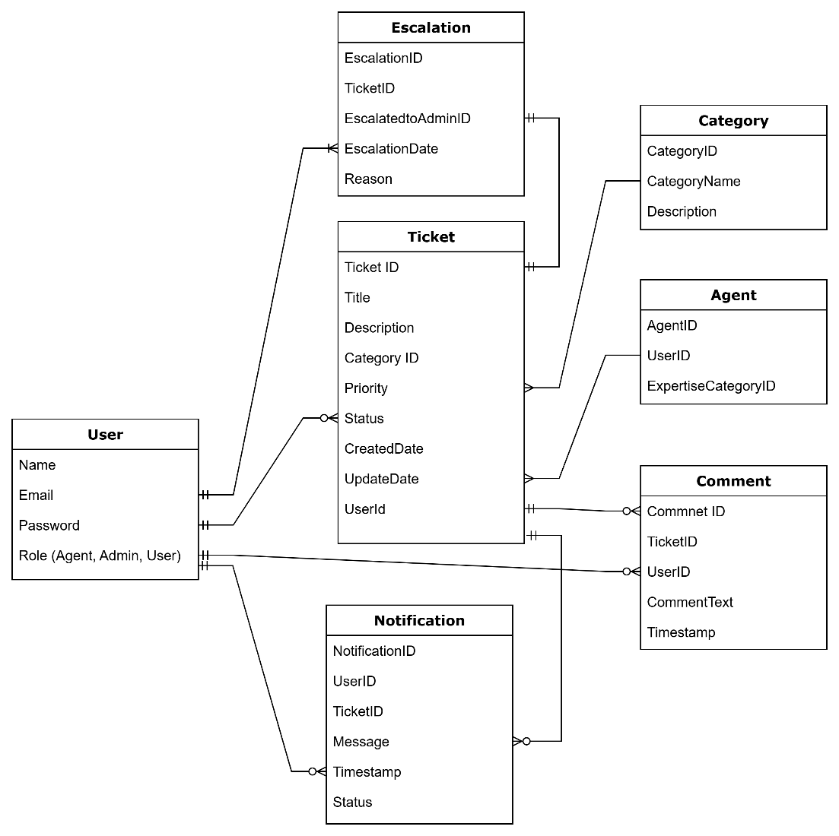
Assignment 02- Q4-Ans
User Story 1
Story No: 1
Task: Allow users to browse products by category.
Priority: High
Value Statement:
AS A CUSTOMER
I WANT TO BROWSE PRODUCTS BY CATEGORY
SO THAT I CAN QUICKLY FIND ITEMS OF INTEREST
BV: 900
CP: 5
Acceptance Criteria:
- Categories are displayed on the homepage and the product listing page.
- Users can filter products within a selected category.

User Story 2
Story No: 2
Task: Enable a product search bar on the homepage.
Priority: High
Value Statement:
AS A CUSTOMER
I WANT TO SEARCH FOR PRODUCTS USING A SEARCH BAR
SO THAT I CAN FIND SPECIFIC ITEMS QUICKLY
BV: 1000
CP: 5
Acceptance Criteria:
- The search bar is visible and functional on the homepage.
- Search results are displayed within 2 seconds after submission.

User Story 3
Story No: 3
Task: Provide product sorting options (e.g., price, popularity).
Priority: High
Value Statement:
AS A CUSTOMER
I WANT TO SORT PRODUCTS BASED ON PRICE OR POPULARITY
SO THAT I CAN MAKE AN INFORMED CHOICE
BV: 800
CP: 5
Acceptance Criteria:
- Sorting options are available on product listing pages.
- Products are sorted correctly based on the selected criteria.
User Story 4
Story No: 4
Task: Implement a user-friendly product details page.
Priority: High
Value Statement:
AS A CUSTOMER
I WANT TO SEE DETAILED INFORMATION ABOUT A PRODUCT
SO THAT I CAN DECIDE WHETHER TO BUY IT
BV: 1000
CP: 8
Acceptance Criteria:
- The product page includes images, price, description, and reviews.
- "Add to Cart" and "Buy Now" buttons are visible and functional.

User Story 5
Story No: 5
Task: Add a feature for customers to leave reviews and ratings.
Priority: Medium
Value Statement:
AS A CUSTOMER
I WANT TO LEAVE A REVIEW FOR A PRODUCT
SO THAT I CAN SHARE MY FEEDBACK WITH OTHER USERS
BV: 700
CP: 3
Acceptance Criteria:
- Customers can submit reviews and ratings after purchasing a product.
- Reviews are displayed on the product details page.
User Story 6
Story No: 6
Task: Enable customers to add items to a shopping cart.
Priority: High
Value Statement:
AS A CUSTOMER
I WANT TO ADD PRODUCTS TO MY SHOPPING CART
SO THAT I CAN PURCHASE MULTIPLE ITEMS AT ONCE
BV: 1000
CP: 5
Acceptance Criteria:
- Items are added to the cart with correct quantity and pricing.
- Users can view, update, or remove items from the cart.
User Story 7
Story No: 7
Task: Create a secure user authentication system.
Priority: High
Value Statement:
AS A CUSTOMER
I WANT TO LOG IN SECURELY
SO THAT MY PERSONAL INFORMATION IS PROTECTED
BV: 1000
CP: 8
Acceptance Criteria:
- Users can sign up, log in, and reset passwords securely.
- Passwords are encrypted, and two-factor authentication is available.
User Story 8
Story No: 8
Task: Develop a Wishlist feature for saving favorite products.
Priority: Medium
Value Statement:
AS A CUSTOMER
I WANT TO SAVE ITEMS TO A WISHLIST
SO THAT I CAN PURCHASE THEM LATER
BV: 700
CP: 3
Acceptance Criteria:
- Users can add, view, and remove items from the wish list.
- Wishlist items persist even after logout.
User Story 9
Story No: 9
Task: Implement a secure checkout process.
Priority: High
Value Statement:
AS A CUSTOMER
I WANT A SECURE AND EASY CHECKOUT PROCESS
SO THAT I CAN COMPLETE MY PURCHASE CONFIDENTLY
BV: 1000
CP: 8
Acceptance Criteria:
- Users can enter billing and shipping details securely.
- Payment is processed securely using industry standards.

User Story 10
Story No: 10
Task: Offer multiple payment methods (credit card, PayPal, etc.).
Priority: High
Value Statement:
AS A CUSTOMER
I WANT TO CHOOSE MY PREFERRED PAYMENT METHOD
SO THAT I CAN COMPLETE MY PURCHASE CONVENIENTLY
BV: 900
CP: 5
Acceptance Criteria:
- Payment gateway supports credit cards, PayPal, and digital wallets.
- Transactions are processed within 5 seconds.
User Story 11
Story No: 11
Task: Provide a product comparison feature.
Priority: Medium
Value Statement:
AS A CUSTOMER
I WANT TO COMPARE PRODUCTS SIDE-BY-SIDE
SO THAT I CAN CHOOSE THE BEST OPTION
BV: 700
CP: 3
Acceptance Criteria:
- Users can select up to three products to compare.
- Key attributes are displayed for easy comparison.

User Story 12
Story No: 12
Task: Enable guest checkout without account creation.
Priority: High
Value Statement:
AS A CUSTOMER
I WANT TO CHECK OUT AS A GUEST
SO THAT I CAN MAKE A QUICK PURCHASE WITHOUT CREATING AN ACCOUNT
BV: 800
CP: 5
Acceptance Criteria:
- Users can complete the checkout process without signing in.
- Guest users can track orders using email and order ID.

User Story 13
Story No: 13
Task: Develop an order tracking feature.
Priority: High
Value Statement:
AS A CUSTOMER
I WANT TO TRACK MY ORDERS
SO THAT I CAN KNOW WHEN THEY WILL ARRIVE
BV: 900
CP: 5
Acceptance Criteria:
- Users can view the status of their orders in real-time.
- Notifications are sent for key updates (e.g., shipped out for delivery).

User Story 14
Story No: 14
Task: Display related products on product pages.
Priority: Medium
Value Statement:
AS A CUSTOMER
I WANT TO SEE RELATED PRODUCTS
SO THAT I CAN DISCOVER COMPLEMENTARY ITEMS
BV: 700
CP: 3
Acceptance Criteria:
- Related products are displayed dynamically based on user behavior.
- Clicking on a related product redirects to its details page.

User Story 15
Story No: 15
Task: Add an email and SMS notification system for orders.
Priority: Medium
Value Statement:
AS A CUSTOMER
I WANT TO RECEIVE NOTIFICATIONS ABOUT MY ORDER STATUS
SO THAT I STAY INFORMED
BV: 800
CP: 5
Acceptance Criteria:
- Notifications are sent for order confirmation, shipping, and delivery.
- Users can opt-in or opt-out of notifications.

User Story 16
Story No: 16
Task: Implement advanced search with filters (e.g., price range, brand).
Priority: Medium
Value Statement:
AS A CUSTOMER
I WANT TO FILTER MY SEARCH RESULTS
SO THAT I CAN REFINE MY PRODUCT SEARCH EFFICIENTLY
BV: 800
CP: 5
Acceptance Criteria:
- Filters for price range, brand, and ratings are available.
- Results update dynamically based on selected filters.

User Story 17
Story No: 17
Task: Allow users to view their order history.
Priority: Medium
Value Statement:
AS A CUSTOMER
I WANT TO VIEW MY PAST ORDERS
SO THAT I CAN REORDER ITEMS EASILY
BV: 700
CP: 3
Acceptance Criteria:
- Users can view a list of their completed orders.
- Clicking on an order shows detailed information, including items and total cost.

User Story 18
Story No: 18
Task: Develop a loyalty rewards program.
Priority: Medium
Value Statement:
AS A CUSTOMER
I WANT TO EARN REWARDS FOR MY PURCHASES
SO THAT I FEEL VALUED
BV: 700
CP: 3
Acceptance Criteria:
- Users earn points for each purchase.
- Points can be redeemed for discounts during checkout.

User Story 19
Story No: 19
Task: Support multi-language functionality.
Priority: Low
Value Statement:
AS A GLOBAL CUSTOMER
I WANT TO VIEW THE SITE IN MY PREFERRED LANGUAGE
SO THAT I CAN SHOP COMFORTABLY
BV: 600
CP: 2
Acceptance Criteria:
- Users can select their preferred language from a dropdown menu.
- All text content updates dynamically based on the selected language.

User Story 20
Story No: 20
Task: Implement a discount and promo code feature.
Priority: High
Value Statement:
AS A CUSTOMER
I WANT TO APPLY PROMO CODES DURING CHECKOUT
SO THAT I CAN SAVE MONEY
BV: 900
CP: 5
Acceptance Criteria:
- Users can enter promo codes at checkout.
- Discounts are applied correctly, and the updated total is displayed.

User Story 21
Story No: 21
Task: Add a "frequently bought together" section on product pages.
Priority: Medium
Value Statement:
AS A CUSTOMER
I WANT TO SEE RELATED ITEMS FREQUENTLY PURCHASED WITH THE PRODUCT
SO THAT I CAN BUNDLE MY PURCHASE
BV: 700
CP: 3
Acceptance Criteria:
- Frequently bought together items are displayed dynamically on the product page.
- Users can add all items to the cart with one click.

User Story 22
Story No: 22
Task: Allow customers to schedule delivery times.
Priority: Medium
Value Statement:
AS A CUSTOMER
I WANT TO SCHEDULE A DELIVERY TIME
SO THAT I CAN RECEIVE MY ORDER AT A CONVENIENT TIME
BV: 700
CP: 3
Acceptance Criteria:
- Users can select preferred delivery dates and time slots during checkout.
- Delivery preferences are confirmed in the order summary.

User Story 23
Story No: 23
Task: Enable product availability notifications.
Priority: Medium
Value Statement:
AS A CUSTOMER
I WANT TO RECEIVE NOTIFICATIONS WHEN A PRODUCT IS BACK IN STOCK
SO THAT I DON’T MISS OUT
BV: 800
CP: 5
Acceptance Criteria:
- Users can subscribe to back-in-stock alerts.
- Notifications are sent via email or SMS when the product becomes available.

User Story 24
Story No: 24
Task: Create a user profile page with editable details.
Priority: Medium
Value Statement:
AS A CUSTOMER
I WANT TO UPDATE MY PERSONAL INFORMATION
SO THAT MY PROFILE IS ACCURATE
BV: 700
CP: 3
Acceptance Criteria:
- Users can update their name, address, and contact details.
- Changes are saved and reflected immediately.
User Story 25
Story No: 25
Task: Add a feature for users to track shipping costs.
Priority: Medium
Value Statement:
AS A CUSTOMER
I WANT TO SEE THE SHIPPING COST BEFORE COMPLETING MY PURCHASE
SO THAT I KNOW THE TOTAL EXPENSE
BV: 800
CP: 5
Acceptance Criteria:
- Shipping costs are calculated dynamically based on the delivery location.
- The total cost, including shipping, is displayed in the cart.

User Story 26
Story No: 26
Task: Implement a user review system for products.
Priority: High
Value Statement:
AS A CUSTOMER
I WANT TO READ REVIEWS FOR PRODUCTS
SO THAT I CAN MAKE AN INFORMED DECISION
BV: 900
CP: 5
Acceptance Criteria:
- Customers can leave reviews with a rating system (1-5 stars).
- Reviews can be filtered by the most recent or highest rating.

User Story 27
Story No: 27
Task: Integrate social media sharing options for products.
Priority: Low
Value Statement:
AS A CUSTOMER
I WANT TO SHARE PRODUCTS ON SOCIAL MEDIA
SO THAT I CAN SHOW MY FRIENDS WHAT I'M INTERESTED IN
BV: 600
CP: 2
Acceptance Criteria:
- Users can share product links on popular social media platforms (Facebook, Instagram, etc.).
- Social media share buttons are easily accessible on product pages.

User Story 28
Story No: 28
Task: Allow customers to save items to a Wishlist.
Priority: Medium
Value Statement:
AS A CUSTOMER
I WANT TO SAVE ITEMS TO A WISHLIST
SO THAT I CAN PURCHASE THEM LATER
BV: 800
CP: 5
Acceptance Criteria:
- Users can add products to their Wishlist.
- Wishlist items remain saved across sessions and can be added to the cart for purchase.

User Story 29
Story No: 29
Task: Add a product recommendation engine.
Priority: Medium
Value Statement:
AS A CUSTOMER
I WANT TO RECEIVE PRODUCT RECOMMENDATIONS BASED ON MY PAST PURCHASES
SO THAT I CAN DISCOVER NEW PRODUCTS
BV: 800
CP: 5
Acceptance Criteria:
- Product recommendations are shown on the homepage and product pages based on customer history.
- Recommendations are updated dynamically based on customer behavior.

User Story 30
Story No: 30
Task: Implement an automated email system for abandoned carts.
Priority: High
Value Statement:
AS A CUSTOMER
I WANT TO RECEIVE EMAIL REMINDERS ABOUT ABANDONED CARTS
SO THAT I CAN COMPLETE MY PURCHASE
BV: 900
CP: 5
Acceptance Criteria:
- Users receive an email reminder if they leave items in the cart without completing the purchase.
- Emails contain a clear call to action and a link back to the cart.

User Story 31
Story No: 31
Task: Integrate a payment gateway for easy transactions.
Priority: High
Value Statement:
AS A CUSTOMER
I WANT TO PAY SECURELY USING MY PREFERRED PAYMENT METHOD
SO THAT I CAN COMPLETE MY PURCHASE EASILY
BV: 900
CP: 5
Acceptance Criteria:
- Users can select their payment method from multiple options (credit card, PayPal, etc.).
- Payment transactions are processed securely, and users receive confirmation.

User Story 32
Story No: 32
Task: Enable users to track their points in the loyalty program.
Priority: Medium
Value Statement:
AS A CUSTOMER
I WANT TO SEE MY REWARD POINT BALANCE
SO THAT I KNOW WHEN TO REDEEM THEM
BV: 700
CP: 3
Acceptance Criteria:
- Users can view their accumulated points in their account dashboard.
- Points can be used for discounts during checkout.

User Story 33
Story No: 33
Task: Add an order cancellation feature.
Priority: Low
Value Statement:
AS A CUSTOMER
I WANT TO CANCEL MY ORDER BEFORE IT SHIPS
SO THAT I CAN CHANGE MY MIND IF I MAKE A MISTAKE
BV: 600
CP: 2
Acceptance Criteria:
- Users can cancel an order before it enters the shipping process.
- Users receive confirmation of the cancellation.

User Story 34
Story No: 34
Task: Implement an order modification system (change address, items).
Priority: Low
Value Statement:
AS A CUSTOMER
I WANT TO MODIFY MY ORDER AFTER PLACING IT
SO THAT I CAN MAKE CHANGES BEFORE IT SHIPS
BV: 600
CP: 2
Acceptance Criteria:
- Users can modify order details like shipping address or items before shipment.
- Modifications are reflected in the order summary and confirmed via email.

User Story 35
Story No: 35
Task: Enable a gift card to purchase and redemption system.
Priority: Low
Value Statement:
AS A CUSTOMER
I WANT TO PURCHASE AND REDEEM GIFT CARDS
SO THAT I CAN GIFT A STORE CREDIT TO OTHERS
BV: 600
CP: 2
Acceptance Criteria:
- Users can buy gift cards of varying amounts.
- Gift cards can be redeemed at checkout for purchases.

User Story 36
Story No: 36
Task: Display stock availability for each product.
Priority: Medium
Value Statement:
AS A CUSTOMER
I WANT TO SEE IF A PRODUCT IS IN STOCK
SO THAT I CAN DECIDE IF I WANT TO PURCHASE IT
BV: 800
CP: 5
Acceptance Criteria:
- Stock availability is clearly displayed on the product page.
- Users are notified if the product is out of stock or low in stock.
User Story 37
Story No: 37
Task: Implement a shipping cost estimator on the checkout page.
Priority: Medium
Value Statement:
AS A CUSTOMER
I WANT TO ESTIMATE MY SHIPPING COSTS
SO THAT I CAN SEE THE TOTAL BEFORE CHECKING OUT
BV: 800
CP: 5
Acceptance Criteria:
- Users can enter their delivery zip code to estimate shipping costs.
- The estimated shipping cost is updated dynamically.

User Story 38
Story No: 38
Task: Implement a product return and refund system.
Priority: High
Value Statement:
AS A CUSTOMER
I WANT TO RETURN A PRODUCT EASILY IF IT’S NOT WHAT I EXPECTED
SO THAT I CAN GET A REFUND OR EXCHANGE
BV: 900
CP: 5
Acceptance Criteria:
- Users can initiate returns and select a refund or exchange option.
- Return and refund policies are clearly displayed on the website.

User Story 39
Story No: 39
Task: Add a feature to display products on sale.
Priority: Medium
Value Statement:
AS A CUSTOMER
I WANT TO SEE PRODUCTS THAT ARE ON SALE
SO THAT I CAN SAVE MONEY ON MY PURCHASES
BV: 700
CP: 3
Acceptance Criteria:
- Sale items are displayed prominently on the homepage and product pages.
- Sale prices are clearly marked, and discounts are applied at checkout.

User Story 40
Story No: 40
Task: Integrate a real-time inventory system.
Priority: High
Value Statement:
AS A CUSTOMER
I WANT TO SEE IF THE PRODUCT I WANT IS AVAILABLE IN REAL-TIME
SO THAT I DON’T PLACE AN ORDER FOR OUT-OF-STOCK ITEMS
BV: 900
CP: 5
Acceptance Criteria:
- Product availability is updated in real-time across all channels.
- Users can see if an item is in stock or not.

