**Question 1 – write Agile Manifesto – 8 M**

**Answer:**

The Agile Manifesto, created in 2001 by 17 software development professionals, outlines the core values and principles of Agile development. It emphasizes flexibility, collaboration, and customer satisfaction over rigid processes.

The Four Core Values of the Agile Manifesto:

1. **Individuals and interactions over processes and tools**: Agile prioritizes people and teamwork over strict adherence to tools and methodologies. Effective communication leads to better outcomes.
2. **Working software over comprehensive documentation**: While documentation is necessary, Agile focuses on delivering functional software that meets user needs rather than excessive paperwork.
3. **Customer collaboration over contract negotiation:** Agile encourages continuous engagement with customers to ensure the product aligns with their evolving needs, rather than sticking to rigid contractual terms.
4. **Responding to change over following a plan:** Agile embraces change as an opportunity for improvement instead of treating it as a disruption to a fixed project plan.

The 12 Agile principles are:

1. Our highest priority is to satisfy the customer through the early and continuous delivery of valuable software.
2. Welcome changing requirements, even late in development. Agile processes harness change for the customer’s competitive advantage.
3. Deliver working software frequently, from a couple of weeks to a couple of months, with a preference to the shorter timescale.
4. Business people and developers must work together daily throughout the project.
5. Build projects around motivated individuals. Give them the environment and support they need, and trust them to get the job done.
6. The most efficient and effective method of conveying information to and within a development team is face-to-face conversation.
7. Working software is the primary measure of progress.
8. Agile processes promote sustainable development. The sponsors, developers, and users should be able to maintain a constant pace indefinitely.
9. Continuous attention to technical excellence and good design enhances agility.
10. Simplicity–the art of maximizing the amount of work not done–is essential.
11. The best architectures, requirements, and designs emerge from self-organizing teams.
12. At regular intervals, the team reflects on how to become more effective, then tunes and adjusts its behaviour accordingly.

**Question 2 – User Stories- Acceptance Criteria-BV-CP – 40 M**

**Write minimum 40 User stories and their Acceptance Criteria along with their BV and CP**

**BV – Business Value**

This is not the cost of Development or the complexity of the feature. Business Value is how important is this feature (user Story) to the Business. This is estimated by Scrum Currency Notes. We provide Rs 1000. Rs 500, Rs 100, Rs 50, Rs 20 and Rs 10 Denominations. These estimations are done by the Stakeholders (Clients). If different values are selected by the stakeholders, then discussions will happen, and they agree to one BV value to that user story.

**CP – Complexity Value**

CP is also known as Story Points (SP). CP is the effort required by the Scrum Developers to develop this feature (user story) using technology. Efforts include time taken to solve the complexity and write the code. CP is estimated by the Scrum Developers by using Poker cards. We provide pokers with values “?”, 1, 2, 3, 5, 8, 13, 20, 40, 100 and BIG. If the entire Project development takes 200 points, then this user story coding effort will be… how many points? … Thinking in this way, Scrum Developers will give CP to the User story. ). If different values are selected by the Scrum Developers, then discussions will happen, and they agree to one CP value to that user story.

**Answer:**

|  |  |  |  |
| --- | --- | --- | --- |
| User story no. 1 | Tasks: 2 | | Priority: Highest |
| AS A DELIVERY BOY  I WANT TO REGISTER IN SCRUM FOODS SO THAT I CAN DELIVER ORDERS | | | |
| BV: 500 | | CP: 02 | |
| ACCEPTANCE CRITERIA  Registration Screen  Text Boxes for User Name, Password, Nation ID, Mobile No, Email, Address, Phone Number  Click on Register Button.  Send Successful Notification to the user | | | |

|  |  |  |  |
| --- | --- | --- | --- |
| User story no. 2 | Tasks: 2 | | Priority: Highest |
| AS A RESTAURANT OWNER  I WANT TO VIEW ORDERS SO THAT I CAN VIEW THE LIST OF ORDERS | | | |
| BV: 500 | | CP: 02 | |
| ACCEPTANCE CRITERIA  View Order, Display List of orders in the tabular Form | | | |

|  |  |  |  |
| --- | --- | --- | --- |
| User story no. 3 | Tasks: 2 | | Priority: Highest |
| AS A CUSTOMER  I WANT TO ADD THE ADDRESS SO THAT I CAN GET THE ORDER TO MY ADDRESS | | | |
| BV: 500 | | CP: 02 | |
| ACCEPTANCE CRITERIA  Text Box to enter.  Business Rules: Within the radius of 5 km | | | |

|  |  |  |  |
| --- | --- | --- | --- |
| User story no. 4 | Tasks: 2 | | Priority: Highest |
| AS A CUSTOMER  I WANT TO SELECT THE PAYMENT MODE SO THAT I CAN MAKE PAYMENT OF MY CHOICE | | | |
| BV: 500 | | CP: 03 | |
| ACCEPTANCE CRITERIA  Display payment modes, radio buttons to select payment modes, payments button.  Business Rule. Can select only one payment mode | | | |

|  |  |  |  |
| --- | --- | --- | --- |
| User story no. 5 | Tasks: 2 | | Priority: Highest |
| AS AN ADMIN  I WANT TO VIEW THE RESTAURANTS SO THAT I CAN APPROVE THEIR REGISTRATION | | | |
| BV: 500 | | CP: 02 | |
| ACCEPTANCE CRITERIA  List of restaurant, select Restaurants, verify restaurant details, approve button, reject button, notification to the restaurant. | | | |

|  |  |  |  |
| --- | --- | --- | --- |
| User story no. 6 | Tasks: 2 | | Priority: Low |
| AS A CUSTOMER  I WANT TO VIEW THE PRICE SO THAT I CAN ORDER THE FOOD | | | |
| BV: 50 | | CP: 01 | |
| ACCEPTANCE CRITERIA  Display price in the list of menu items | | | |

|  |  |  |  |
| --- | --- | --- | --- |
| User story no. 7 | Tasks: 2 | | Priority: Low |
| AS A CUSTOMER  I WANT TO VIEW THE CONTACT NUMBER OF DELIVERY BOY SO THAT I CAN CONTACT DELIVERY BOY FOR THE STATUS | | | |
| BV: 50 | | CP: 01 | |
| ACCEPTANCE CRITERIA  Display delivery boy mobile number  Display delivery boy name in tracking field  Display delivery boy picture | | | |

|  |  |  |  |
| --- | --- | --- | --- |
| User story no. 8 | Tasks: 2 | | Priority: Medium |
| AS A RESTAURANT OWNER  I WANT TO PROVIDE TIME SLOTS SO THAT CUSTOMER CAN CHECK OPENING AND CLOSING HOURS | | | |
| BV: 100 | | CP: 02 | |
| ACCEPTANCE CRITERIA  Click on restaurant dashboard  Add from time to time  Click on submit  Display updated successfully | | | |

|  |  |  |  |
| --- | --- | --- | --- |
| User story no. 9 | Tasks: 2 | | Priority: Highest |
| AS A Business OWNER  I WANT TO VIEW RESTAURANT REVENUE REPORT SO THAT I CAN VIEW THE RESTAURANT’S REVENUE | | | |
| BV: 200 | | CP: 03 | |
| ACCEPTANCE CRITERIA  Select Reports  Select Revenue Reports  Select to and from date Select Region (can select all)  Generate Report  Download Report in EXCEL | | | |

|  |  |  |  |
| --- | --- | --- | --- |
| User story no. 10 | Tasks: 3 | | Priority: Highest |
| AS A REG ADMIN  I WANT TO MANAGE REGIONAL RESTAURANTS, SO THAT, I CAN TRACK THE PERFORMANCE OF REGIONAL RESTAURANTS. | | | |
| BV: 200 | | CP: 03 | |
| ACCEPTANCE CRITERIA  CLICK ON PERFORMANCE OF RESTAURANTS  SELECT FROM DATE TO DATE  CLICK ON GENERATE REPORT WHICH INCLUSES RESTAURANTS ID, NAME, REVENUE  CLICK ON DOWNLOAD REPORT SHOULD BE IN EXCEL | | | |

|  |  |  |  |
| --- | --- | --- | --- |
| User story no. 11 | Tasks: 2 | | Priority: Medium |
| AS ADMIN  I WANT TO SEE THE REGIONAL REVENUE REPORTS, SO THAT I CAN VIEW THE REGIONAL PERFORMANCE | | | |
| BV: 100 | | CP: 03 | |
| ACCEPTANCE CRITERIA  Select regional dropdown  View performance of each rest of that region in tabular form which includes rest name, revenue, generated  Download in excel or PDF | | | |

|  |  |  |  |
| --- | --- | --- | --- |
| User story no. 12 | Tasks: 2 | | Priority: High |
| AS A CUSTOMER  I WANT TO CHAT WITH REG ADMIN SO THAT I CAN REQUEST FOR REFUND | | | |
| BV: 200 | | CP: 02 | |
| ACCEPTANCE CRITERIA  Br-all mandatory  Text box fields  Display order id  Text box,for description  Submit button  Generate issue id  Display successful | | | |

|  |  |  |  |
| --- | --- | --- | --- |
| User story no. 13 | Tasks: 2 | | Priority: High |
| AS A USER  I WANT TO BROWSE NEARBY RESTRAUNT SO THAT I CAN ORDER THE FOOD | | | |
| BV: 200 | | CP: 02 | |
| ACCEPTANCE CRITERIA  Each restraint entry displays tis name, cuisine type and rating  This list can be sorted by distance or rating | | | |

|  |  |  |  |
| --- | --- | --- | --- |
| User story no. 14 | Tasks: 2 | | Priority: High |
| AS A CUSTOMER  I WANT TO BROWSE DIFFERENT RESTRAUNTS AND MENUS SO THAT I CAN FIND A PLACE TO ORDER FOOD | | | |
| BV: 200 | | CP: 02 | |
| ACCEPTANCE CRITERIA  The menu includes dishes, prices and descriptions  Shows the restraint is open or closed | | | |

|  |  |  |  |
| --- | --- | --- | --- |
| User story no. 15 | Tasks: 1 | | Priority: High |
| AS A CUSTOMER  I WANT TO BROWSE FOR SPECIFIC DISHES AND CUISINES SO THAT I CAN FIND A PLACE TO ORDER FOOD | | | |
| BV: 200 | | CP: 02 | |
| ACCEPTANCE CRITERIA  App displays relevant restraint and dishes matching the query | | | |

|  |  |  |  |
| --- | --- | --- | --- |
| User story no. 16 | Tasks: 1 | | Priority: High |
| AS A CUSTOMER  I WANT TO FILTER RESTRAUNTS SO THAT I CAN FIND A PLACE TO ORDER FOOD | | | |
| BV: 200 | | CP: 02 | |
| ACCEPTANCE CRITERIA  Filter restaurants by cuisine type and dietary options | | | |

|  |  |  |  |
| --- | --- | --- | --- |
| User story no. 17 | Tasks: 2 | | Priority: High |
| AS A CUSTOMER  I WANT TO TRACK MY ORDER SO THAT I KNOW THE TIME OF DELIVERY | | | |
| BV: 200 | | CP: 02 | |
| ACCEPTANCE CRITERIA  App shows real time update on the order status  Display estimated delivery time | | | |

|  |  |  |  |
| --- | --- | --- | --- |
| User story no. 18 | Tasks: 1 | | Priority: High |
| AS A USER  I WANT TO RATE AND REVIEW RESTRAUNTS SO THAT I CAN RATE AND REVIEW THE RESTRAUNTS I HAVE VISITED | | | |
| BV: 200 | | CP: 02 | |
| ACCEPTANCE CRITERIA  Can see reviews from other users to help me make dining decisions | | | |

|  |  |  |  |
| --- | --- | --- | --- |
| User story no. 19 | Tasks: 1 | | Priority: High |
| AS A USER  I WANT TO VIEW PAST ORDER HISTORY SO THAT I CAN ORDER AGAIN | | | |
| BV: 200 | | CP: 02 | |
| ACCEPTANCE CRITERIA  Can see the details such as order items, total cost, order date | | | |

|  |  |  |  |
| --- | --- | --- | --- |
| User story no. 20 | Tasks: 3 | | Priority: High |
| AS A USER  I WANT TO RECEIVE NOTIFICATIONS SO THAT I CAN RECEIVE UPDATES | | | |
| BV: 200 | | CP: 02 | |
| ACCEPTANCE CRITERIA  Notification for order confirmation  Notification for dispatch  Notification for delivery | | | |

|  |  |  |  |
| --- | --- | --- | --- |
| User story no. 21 | Tasks: 1 | | Priority: Medium |
| AS A USER  I WANT TO CONTACT CUSTOMER SUPPORT SO THAT I CAN SUBMIT QUERIES OR ISSUES | | | |
| BV: 200 | | CP: 02 | |
| ACCEPTANCE CRITERIA  Customer support section with contact information | | | |

|  |  |  |  |
| --- | --- | --- | --- |
| User story no. 22 | Tasks: 2 | | Priority: High |
| AS A RESTRAUNT OWNER  I WANT TO RECEIVE AND MANAGE ORDERS SO THAT I CAN UPDATE ORDER STATUS | | | |
| BV: 200 | | CP: 02 | |
| ACCEPTANCE CRITERIA  Manage order status  Notify restaurants about incoming orders | | | |

|  |  |  |  |
| --- | --- | --- | --- |
| User story no. 23 | Tasks: 2 | | Priority: High |
| AS A RESTRAUNT OWNER  I WANT TO ACCESS TO CUSTOMER REVIEWS SO THAT I CAN VIEW AND RESPOND TO CUSTOMER REVIEWS | | | |
| BV: 200 | | CP: 02 | |
| ACCEPTANCE CRITERIA  Owners can address feedback  Owners can improve their services | | | |

|  |  |  |  |
| --- | --- | --- | --- |
| User story no. 24 | Tasks: 1 | | Priority: Medium |
| AS A CUSTOMER  I WANT TO VIEW PROMO CODES AND DISCOUNTS SO THAT I CAN ORDER AT A LOWER PRICE | | | |
| BV: 100 | | CP: 04 | |
| ACCEPTANCE CRITERIA  Active promo code | | | |

|  |  |  |  |
| --- | --- | --- | --- |
| User story no. 25 | Tasks: 7 | | Priority: HIGH |
| AS A DELIVERY BOY  I WANT TO VIEW THE ORDERS SO THAT I CAN ACCEPT THE ORDERS | | | |
| BV: 200 | | CP: 04 | |
| ACCEPTANCE CRITERIA  Order visibility  Real time updates  Order details  Order filtering and sorting  Order map view  Order navigation  Order completion and confirmation | | | |

|  |  |  |  |
| --- | --- | --- | --- |
| User story no. 26 | Tasks: 1 | | Priority: Medium |
| AS A CUSTOMER  I WANT TO APPLY PROMO CODES AND DISCOUNTS SO THAT I CAN ORDER AT A LOWER PRICE | | | |
| BV: 100 | | CP: 04 | |
| ACCEPTANCE CRITERIA  Active promo code | | | |

|  |  |  |  |
| --- | --- | --- | --- |
| User story no. 27 | Tasks: 5 | | Priority: High |
| AS A DELIVERY BOY  I WANT TO LOGIN SO THAT I CAN ACCEPT THE ORDER | | | |
| BV: 200 | | CP: 04 | |
| ACCEPTANCE CRITERIA  User authentication  Error handling  Passowrd security  Multi factor authentication  Compatibility and usability | | | |

|  |  |  |  |
| --- | --- | --- | --- |
| User story no. 28 | Tasks: 5 | | Priority: Medium |
| AS A DELIVERY BOY  I WANT TO VIEW THE FEEDBACK SO THA I CAN IMPROVE | | | |
| BV: 200 | | CP: 04 | |
| ACCEPTANCE CRITERIA  Access to feedback system  Feedback visibility  Feedback sorting and filtering  Response mechanism  User support | | | |

|  |  |  |  |
| --- | --- | --- | --- |
| User story no. 29 | Tasks: 5 | | Priority: Medium |
| AS A ADMIN  I WANT TO VIEW FEEDBACK SO THAT I CAN KNOW THE CUSTOMER FEEDBACK | | | |
| BV: 200 | | CP: 04 | |
| ACCEPTANCE CRITERIA  Access to feedback system  Feedback visibility  Feedback sorting and filtering  Response mechanism  User support | | | |

|  |  |  |  |
| --- | --- | --- | --- |
| User story no. 30 | Tasks: 5 | | Priority: Medium |
| AS A RESTRAUNT OWNER  I WANT TO VIEW FEEDBACK SO THAT I CAN KNOW THE CUSTOMER FEEDBACK | | | |
| BV: 200 | | CP: 04 | |
| ACCEPTANCE CRITERIA  Access to feedback system  Feedback visibility  Feedback sorting and filtering  Response mechanism  User support | | | |

|  |  |  |  |
| --- | --- | --- | --- |
| User story no. 31 | Tasks: 3 | | Priority: HIGH |
| AS A ADMIN  I WANT TO KNOW THE ISSUES SO THAT I CAN RESOLVE THEM | | | |
| BV: 100 | | CP: 03 | |
| ACCEPTANCE CRITERIA  Display issue section  Sorting and filtering issue list  Editing and modifying the issues | | | |

|  |  |  |  |
| --- | --- | --- | --- |
| User story no. 32 | Tasks: 3 | | Priority: HIGH |
| AS A REGIONAL ADMIN  I WANT TO KNOW THE ISSUES SO THAT I CAN RESOLVE THEM | | | |
| BV: 200 | | CP: 04 | |
| ACCEPTANCE CRITERIA  Display issue section  Sorting and filtering issue list  Editing and modifying the issues | | | |

|  |  |  |  |
| --- | --- | --- | --- |
| User story no. 33 | Tasks: 6 | | Priority: HIGH |
| AS A RESGTRAUNT OWNER  I WANT TO VIEW REVENUE GENERATED SO THAT I CAN VIEW RESTRAUNTS REVENUE | | | |
| BV: 200 | | CP: 04 | |
| ACCEPTANCE CRITERIA  Select reports  Select renvenue reports select  Range for the date selection  Generate reports  Download report | | | |

|  |  |  |  |
| --- | --- | --- | --- |
| User story no. 34 | Tasks: 2 | | Priority: HIGH |
| AS A RESTRAUNT OWNER  I WANT TO KNOW INFORMATION ABOUT THE DELIVERY BOY FORE VERIFICATION | | | |
| BV: 200 | | CP: 04 | |
| ACCEPTANCE CRITERIA  ID proof  Reliability | | | |

|  |  |  |  |
| --- | --- | --- | --- |
| User story no. 35 | Tasks: 2 | | Priority: LOW |
| AS A CUSTOMER  I WANT TO VIEW THE CONTACT NUMBER OF THE DELIVERY BOY SO THAT CAN CONTACT HIM FOR THE STATUS | | | |
| BV: 50 | | CP: 01 | |
| ACCEPTANCE CRITERIA  Display delivery boys mobile no.  Display delivery boys name  Display delivery boys picture | | | |

|  |  |  |  |
| --- | --- | --- | --- |
| User story no. 36 | Tasks: 2 | | Priority: Medium |
| AS A RESTRAUNT OWNER  I WANT TO PROVIDE TIME SLOTS SO THAT CUSTOMER CAN CHECK OPENING AND CLOSING HOURS | | | |
| BV: 100 | | CP: 02 | |
| ACCEPTANCE CRITERIA  Click on restraunt dashboard  Choose the time accordingly  Click on submit  Display updated successfully | | | |

|  |  |  |  |
| --- | --- | --- | --- |
| User story no. 37 | Tasks: 3 | | Priority: HIGH |
| AS A USER  I WANT TO RECEIVE NOTIFICATIONS SO THAT I CAN RECEIVE UPDATE | | | |
| BV: 200 | | CP: 02 | |
| ACCEPTANCE CRITERIA  Notification for order confirmation  Notification for dispatch  Notification for delivery | | | |

|  |  |  |  |
| --- | --- | --- | --- |
| User story no. 38 | Tasks: 1 | | Priority: Medium |
| AS A USER  I WANT TO CONTACT CUSTOMER SUPPORT SO THAT I CAN SUBMIT QUERIES OR ISSUES | | | |
| BV: 200 | | CP: 02 | |
| ACCEPTANCE CRITERIA  Customer support section with contact information | | | |

|  |  |  |  |
| --- | --- | --- | --- |
| User story no. 39 | Tasks: 4 | | Priority: Medium |
| AS A CUSTOMER  I WANT TO VIEW THE ORDER SO THAT I CAN CANCEL IT | | | |
| BV: 100 | | CP: 03 | |
| ACCEPTANCE CRITERIA  Order status  Method od cancellation  Refund policy  Time frame | | | |

|  |  |  |  |
| --- | --- | --- | --- |
| User story no. 40 | Tasks: 4 | | Priority: HIGH |
| AS A REGIONAL ADMIN  I WANT TO TRACK THE DELIVERY SO THAT I CAN VIEW THE STATUS OF THE DELIVERY | | | |
| BV: 100 | | CP: 03 | |
| ACCEPTANCE CRITERIA  Real time tracking  Security and data privacy  User friendly interface | | | |

**Question 3– What is epic? Write 2 epics – 5 M**

**Answer:**

An Epic is a large user story that cannot be completed within a single sprint and needs to be broken down into smaller user stories. It represents a high-level business requirement that provides significant value to the product but needs to be divided into smaller, manageable tasks for development. Epics typically span multiple sprints and involve multiple teams.

**Epic No. 1: Order Management System:** As a customer, I want a seamless order management system so that I can browse restaurants, add food to the cart, place orders, and track deliveries.

User story: As a customer, I want to browse restaurant menus so that I can choose my desired food items.

Acceptance criteria:

* User must be logged in to browse the restaurant menu.
* The system should display a list of available restaurants based on the user's location.
* Each restaurant should have a menu with food items, descriptions, and prices.
* Customers should be able to filter restaurants by cuisine, ratings, and delivery time.

User story: As a customer, I want to add food items to my cart so that I can place my order conveniently.

Acceptance criteria:

* Customers should be able to add multiple items to their cart.
* Cart should display item name, quantity, price, and total cost.
* Customers should be able to modify item quantity or remove items before checkout.
* System should display a warning if an item is out of stock.

User story: As a customer, I want to track my order in real-time so that I know when my food will arrive.

Acceptance criteria:

* Order tracking should display order status (e.g., "Order Placed," "Preparing," "Out for Delivery," "Delivered").
* Customers should receive live updates on estimated delivery time.
* The system should provide the delivery boy’s name, contact number, and live location.
* Customers should get notifications (SMS, app alerts) about order status changes.

User story: As a customer, I want to cancel my order within a specific time frame so that I can modify my selection if needed.

Acceptance criteria:

* Order can only be cancelled within 5 minutes after placing it.
* If order preparation has started, cancellation should not be allowed.
* Refund policies should be displayed before confirming cancellation.
* The system should notify the customer about cancellation status via SMS and email.

**Epic No. 2: Delivery Boy Management System:** As a delivery boy, I want an efficient system to manage my orders so that I can deliver food on time and track my earnings.

User story: As a delivery boy, I want to view my assigned orders so that I can plan my delivery route.

Acceptance criteria:

* Only logged-in delivery boys should be able to access assigned orders.
* The system should display new and pending orders assigned to the delivery boy.
* Delivery address, restaurant name, and customer contact details should be visible.
* The system should provide an optimized route suggestion for delivery.

User story: As a delivery boy, I want to view my earnings report so that I can track my income.

Acceptance criteria:

* The system should display earnings per order and total earnings for the day, week, and month.
* Delivery boys should be able to filter earnings based on time duration.
* The system should show pending payments and expected payout date.
* Earnings should be downloadable as a report

User story: As a delivery boy, I want to update the delivery status so that customers can track their orders in real time

Acceptance criteria:

* Delivery boys should be able to update status as "Picked Up," "On the Way," or "Delivered."
* Customers should get live tracking updates once the order is picked up.
* System should send notifications to customers on each status update.
* If delivery fails, a reason must be entered before marking the order as undelivered.

User story: As a delivery boy, I want to raise an issue if I face difficulties in delivering an order so that customer support can assist me

Acceptance criteria:

* Delivery boys should have an option to raise an issue from the order details page.
* Issue categories should include "Incorrect Address," "Customer Not Available," and "Other."
* The system should allow delivery boys to add comments and attach images (if needed).
* The support team should receive real-time notifications when an issue is raised.

By satisfying the acceptance criteria, the food delivery app can successfully implement real-time order tracking, providing the users a transparent and convenient megthod to monitor the orders.

**Question 4 –What is the difference between BV and CP – 2 M**

**Answer:**

**Business Value (BV):**

* It refers to the perceived or benefit a particular task, feature might bring to the business or project
* It is typically determined based on the factors such as revenue generation, cost savings, customer satisfaction, strategic alignment and other business related criteria
* It helps in prioritizing tasks or features based on their importance to yhe overall project goals and objectives
* Examples of Business value are: Focus on increased revuenue, improved iser experience, compliance with industry regulations, etc.
* Commonly used techniques are MoSCoW

**Complexity Points (CP):**

* Complexity points, are also known as story points or function points, are a measure of relative complexity or effort required to complete a task, feature or requirement
* They are used to estimate the effort, time and resources needed to complete the task
* They are often assigned based on factors such as technical difficulty, development effort, integration challenges, and other development related criteria
* It helps in accessing the workload and resource allocation for different tasks
* Examples of complexity points are: Integration with legacy system, technical dependencies, data migration, algorithmic complexity, etc.
* Commonly used techniques are Planning poker

In short we can define BV as a method to measures the importance of a feature to the business. And CP determines the efforts required to develop a feature.

**Question 5 –Explain about Sprint– 5 M**

**Answer:** A Sprint is a time-boxed iterative development period during which a specific set of tasks and goals are worked on by a development team. It is a short, fixed-length cycle that enables teams to develop, test, and release features quickly and iteratively.

Here are the key characteristics of sprint:

* **Time Frame:** A sprint has a fixed duration, often ranging from 1 to 4 weeks.
* **Goals and objectives:** At the beginning of each sprint, the dev team, along with he stakeholders, selects a set of userstories, features or tasks to work during the sprint. These item are know as sprint backlog.
* **Planning:** During this phase the development team breaks down the selected items from the product backlog into smaller tasks and estimates the effort required for each task.
* **Daily Stand-up:** Throughout the sprint, the team holds daily meetings known as “daily scrum” to discuss the progress, obstacles and plans. Each member shares what they’ve accomplished, what they are working on, and if they are facing any challenges.
* **Development:** The development team works on the tasks identified in the sprint backlog. They collaborate together to ensure high-quaity work.
* **Continuous integration:** Developer integrate their code changes into the main code regularly, ensuring the software remains functional and stable
* **Testing:** It is an integral part of sprint. Automated tests are run to validate the changes in the code and manual testing is conducted for the quality testing
* **Review and Demo:** At this stage, the development team conducts a sprint review and demo. They show the completed work to the stakeholder, gathering feedback.

Sprints allow development teams to iteratively deliver value to the customer and stakeholder in a controlled and predictable manner. By breaking down the work into small manageable work and applying continuous changes through feedback.

**Question 6 – Explain Product backlog and sprint back log– 5 M**

**Answer:**

**Product Backlog**

* The Product Backlog is a dynamic, prioritized list of all the work that might be needed for a product.
* It includes features, enhancements, bug fixes, and other requirements. This backlog is maintained by the Product Owner, who ensures its alignment with the product's vision and goals.
* Items in the Product Backlog are often referred to as Product Backlog Items (**PBIs**) and are ordered based on factors like business value, risk, and necessity.
* The Product Backlog evolves as new information emerges, making it a living artifact throughout the product's lifecycle.

**Sprint Backlog**

* The Sprint Backlog is a subset of the Product Backlog.
* It consists of items selected by the development team during the Sprint Planning meeting that they commit to completing in the upcoming Sprint.
* The Sprint Backlog includes the selected **PBIs** and a plan for delivering them, often broken down into tasks.
* Unlike the Product Backlog, which can evolve, the Sprint Backlog is fixed during the Sprint to maintain focus on the agreed-upon work.

|  |  |  |
| --- | --- | --- |
| **Details** | **Product Backlog** | **Sprint Backlog** |
| Definition | A prioritized list of all features, enhancements, bug fixes, and technical improvements for the product. | A subset of the Product Backlog that consists of selected items committed for completion in a Sprint. |
| Scope | Covers the entire product lifecycle. | Covers only the current Sprint (typically 1-4 weeks). |
| Owner | Product Owner is responsible for managing and prioritizing. | Development Team is responsible for selecting and completing the tasks. |
| Prioritization | Prioritized based on business value, customer needs, and strategic goals. | Prioritized based on the Sprint Goal and team capacity. |
| Flexibility | Continuously updated with new requirements, priorities, and insights. | Fixed for the duration of the Sprint (changes only in exceptional cases). |
| Timeframe | Exists throughout the entire project. | Exists only during the current Sprint. |
| Purpose | Defines the long-term roadmap of the product. | Defines the short-term deliverables for a Sprint. |
| Examples | "As a customer, I want to track my food order in real time."  "As a restaurant owner, I want to receive notifications for new orders." | Implement the order tracking system.  Develop real-time order notification feature for restaurants. |

**Question 7 – What is impediments log? write 2 impediments – 5 M**

**Answer:** Impediments Log is a tool used to document, track, and manage obstacles that hinder the Scrum Team's progress toward their goals. These impediments can range from technical issues and resource constraints to organizational challenges and external dependencies.

Examples of two impediments are:

* Delivery partner shortage in a specific region
* Technical issue causing intermittent order processing failure

Delivery partner shortage in a specific region

|  |  |
| --- | --- |
| Login | 1 |
| Description | Delivery partner storage in specific region |
| Impact | Delays in order deliveries and increases customer dissatisfaction |
| Priority | High (due to its impact on customer experience) |
| Assigned to | Ops team and HR team |
| Status | Open |
| Action taken | The Ops and HR team are working on recruitment of the delivery partners |
| Resolution | The process of hiring new delivery partners |

Technical issue causing intermittent order processing failure

|  |  |
| --- | --- |
| Login | 2 |
| Description | Technical issue causing intermittent order processing failure |
| Impact | Delays in order processing and potential revenue loss |
| Priority | High (due to impact on revenue and customer exp) |
| Assigned to | Tech team and QA team |
| Status | In progress |
| Action taken | The tech and QA team are conducting extensive testing to ensure the issue is resolved |
| Resolution | The tech team has implemented a fix and conducted through testing. The issue will be resolved |

**Question 8 – Explain Velocity of the Team – 1 M**

**Answer:**

**Definition:** Velocity is a key metric in Agile Scrum that measures the amount of work a team completes during a sprint, measured in story points. It’s calculated by summing the story points of all fully completed user stories in a sprint.

**Purpose:** It is used to forecasr how much work the team can complete in future sprints, setting realistic sprint goals, and track improvements in the teams performance over time.

**Calculation:** At the end of each sprint, the total story points (or another work unit) associated with user stories are summed. This sum is the sprint’s velocity. Over several sprints, an average velocity is calculated to guide planning.

**Example:** If Sprint 1 yields 20 points, Sprint 2 yields 25 points, and Sprint 3 yields 22 points, then Average Velocity = (20 + 25 + 22) / 3 ≈ 22.3 points.

**Factors influencing Velocity:** Team experience, complexity of work, external dependencies, sprint length, team collaboration, etc.

**Question 9 – Draw Sprint Burn Charts and Product Burn Down Charts– 3 M**

**Sprint Burndown Chart:**

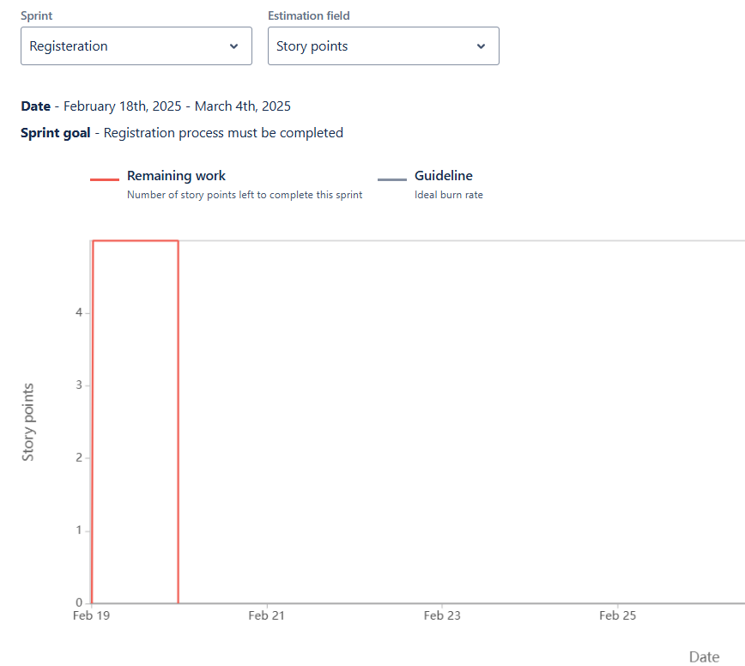

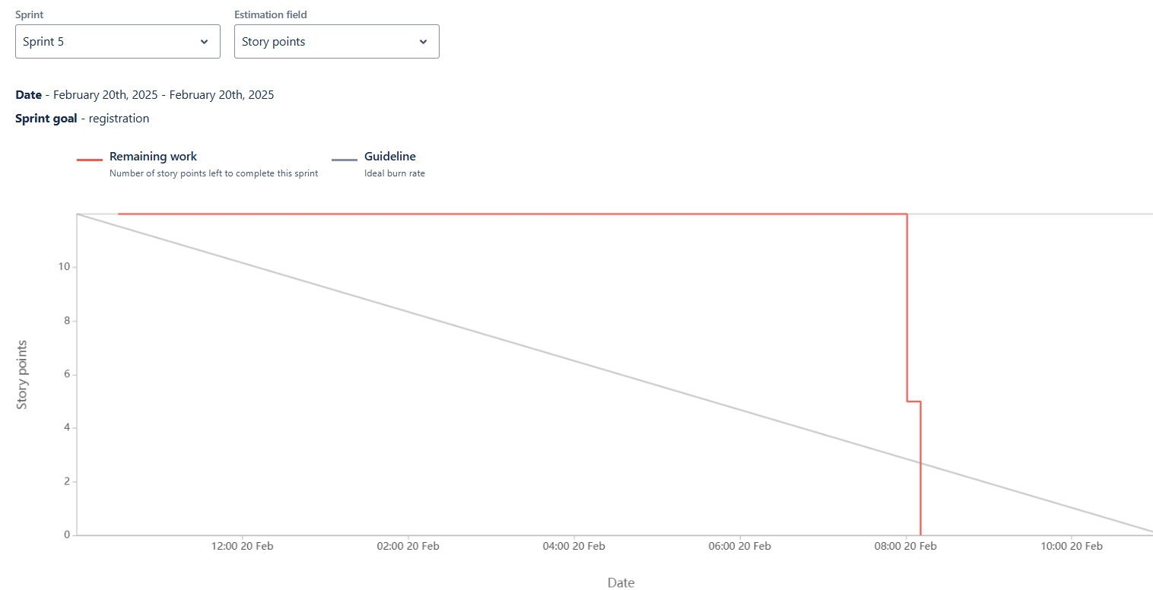

**Product Burn Down Chart**

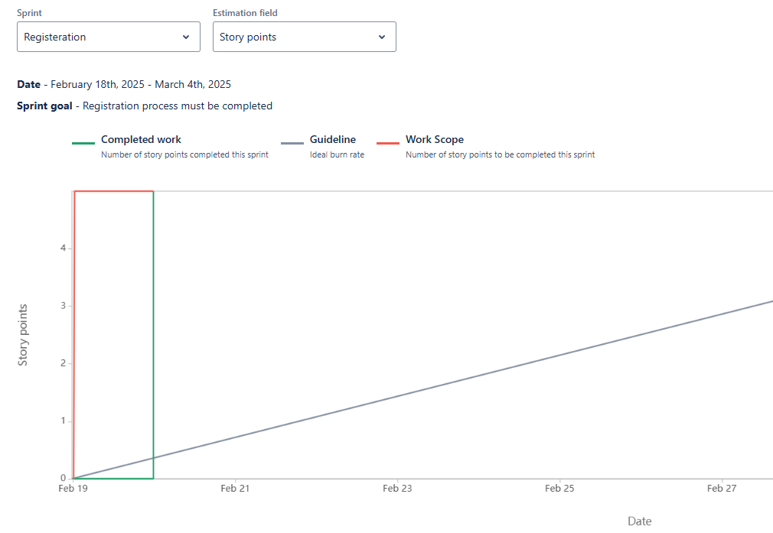

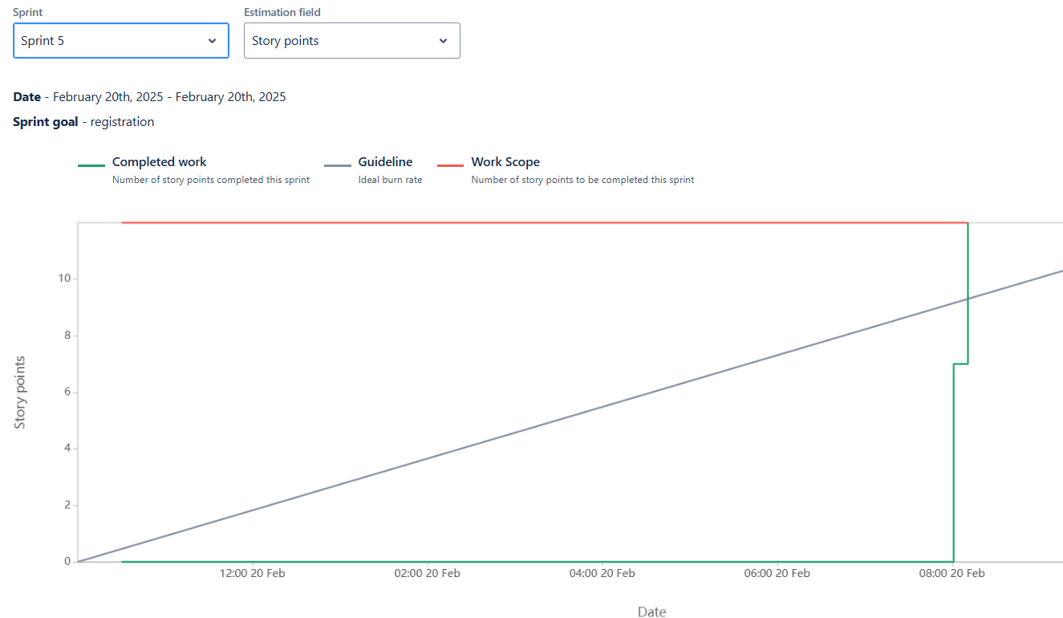

**Question 10 – Explain about Product Grooming – 2 M**

**Answer:** Product Grooming, also known as Backlog Refinement, is a crucial activity in Agile development that involves preparing and refining items in the product backlog to ensure they are well-understood, prioritized and ready for development.

* **Setting the Context:** At the beginning of the backlog grooming process, the team and relevant stakeholders come together to understand the overall goals and objectives of the project. This helps set the context for the work to be done and aligns everyone's understanding.
* **Backlog Review:** The product owner and the development team review the items in the product backlog. This involves assessing the user stories, tasks, and other items to ensure they are accurate, up-to-date, and still relevant to the project's goals.
* **Prioritization**: During backlog grooming, the team collaboratively prioritizes the backlog items based on their value to the product and the needs of the users or customers. This helps ensure that the most important and valuable work is addressed first.
* **Refinement and Estimation:** In this step, the backlog items are refined to provide clear and detailed descriptions. The team breaks down user stories into smaller tasks and discusses the technical requirements. Estimation involves assigning story points or other sizing metrics to each item, indicating the relative effort needed for implementation.
* **Dependency Analysis:** The team examines potential dependencies between backlog items. Identifying and understanding dependencies helps in planning the order of implementation and managing potential bottlenecks.
* **Acceptance Criteria:** Well-defined acceptance criteria are established for each backlog item. These criteria outline the conditions that must be met for the item to be considered complete and ready for delivery. Clear acceptance criteria help prevent misunderstandings and ensure a shared understanding of what is expected.
* **Backlog Grooming Meetings**: These are recurring meetings where the product owner and the development team come together to perform the activities mentioned above. These meetings often occur before sprint planning sessions to ensure that the upcoming sprint backlog is well-prepared.

Backlog grooming is an iterative process that helps maintain a well-organized product backlog. It ensures that the development team always has a prioritized list of well-defined, estimated, and ready-to-develop items. This supports the efficient planning and execution of sprints and helps the team deliver value to customers in a more predictable and effective manner.

**Question 11 – Explain the roles of Scrum Master and Product Owner – 3 M**

**Answer:**

|  |  |  |
| --- | --- | --- |
| **Criteria** | **Product Owner** | **Scrum Master** |
| **Nature of work** | Collaborates with all the stakeholders and brings the vision of a product into the product backlog | Acts as a team coach and is  responsible for maintaining  the quality of the product |
| **Responsibilities** | Responsible for completing  the project on time. Acts as an intermediary between  development team and the  customers | Ensures the scrum  framework is followed and  helps the development team  create a quality product |
| **Accountability** | Responsible for project  backlog and the timely  completion of the product  and for providing updates to  the clients and stakeholders | Accountable for the quality of  the entire project and for  giving updates to the  management about the  completion of the product |
| **Reporting** | Reports to top management  and clients | Reports to top management  about the efficiency of the  team and the quality of the  product |
| **Qualities** | Communication and the  leadership skills, creativity, critical thinking and a sharp  mind are key assets for any  product owner | Thorough knowledge of  scrum theory and practices.  Being able to lead the team  but without the sense of  authority |

**Question 12 – Explain all Meetings Conducted in Scrum Project – 8 M**

**Answer:**

* **Sprint Planning:** This meeting kicks off each sprint, which is a time-boxed iteration of work, usually spanning 2-4 weeks. During this meeting, the Scrum team, including the Product Owner, Scrum Master, and Development Team, collaborates to determine which backlog items (user stories, features, etc.) will be worked on in the upcoming sprint. The team also breaks down these items into tasks and estimates the effort required.
* **Daily Stand-up (Daily Scrum):** Held daily during the sprint, this short meeting aims to facilitate quick and focused communication among team members. Each team member answers three key questions: What did I accomplish since the last stand-up? What will I work on until the next stand-up? Are there any obstacles or impediments in my way? This meeting helps keep everyone aligned and informed about the progress and challenges.
* **Sprint Review**: At the end of each sprint, the team holds a review meeting to showcase the work completed during the sprint to stakeholders, customers, and the Product Owner. The team demonstrates the potentially shippable product increment and gathers feedback. Based on this feedback, the Product Owner can update the backlog.
* **Sprint Retrospective**: Also held at the end of each sprint, the retrospective is a dedicated time for the team to reflect on their processes and practices. The team discusses what went well, what could be improved, and any potential changes they'd like to make in the next sprint to enhance their efficiency and effectiveness.
* **Backlog Refinement (Grooming):** While not officially part of the Scrum events, backlog refinement is an important ongoing activity. During these sessions, the team and the Product Owner review and refine backlog items, adding details, clarifications, and estimates to make them ready for inclusion in future sprints.
* **Product Backlog Refinement:** This meeting focuses on refining the product backlog items. The team and the Product Owner discuss and clarify requirements, priorities, and any changes needed in the backlog items. This ensures that the backlog is well- prepared for upcoming sprints.
* **Release planning**: This meeting occurs at the start of the project or major release and involves the product owner, development team, and stakeholders. It aims to discuss and plan the high-level scope, timeline, and goals for the project.
* **Ad hoc meetings:** These meetings may be schedules as needed to address specific topics or issues, such as resolving impediments, discuss technical challenges, or conducting additional planning or collaboration sessions

**Question 13 - Explain Sprint Size and Scrum Size- 2 M**

**Answer:**

**Sprint Size:**

In Scrum, a "sprint" is a time-boxed iteration during which the development team works to deliver a potentially shippable product increment. The length of a sprint is referred to as the "sprint duration" and is usually fixed throughout the project. Common sprint durations are 1 to 4 weeks. The choice of sprint duration depends on factors such as team velocity, project complexity, and business needs. A shorter sprint encourages more frequent opportunities for feedback and adaptation, while a longer sprint provides more time for development.

**Scrum Team Size:**

The Scrum team size refers to the number of individuals who collectively contribute to the development of the product. A Scrum team consists of three key roles: the Product Owner, the Scrum Master, and the Development Team. The Development Team, in particular, is responsible for creating the product increment. Scrum recommends that the Development Team size be kept small, typically between 3 to 9 members, to facilitate effective communication, collaboration, and decision-making.

**Question 14 – Explain DOR and DOD – 2 M**

**Answer:**

**Definition of Ready (DOR):**

The Definition of Ready outlines the criteria that a product backlog item (user story, feature, task, etc.) should meet before it is considered ready to be taken into a sprint for development. The DOR ensures that the item is well-defined, understood, and prepared for efficient development. The specific criteria in the DOR can vary from team to team, but commonly include elements such as:

* Clear description and acceptance criteria: The item's requirements are clearly stated, and the conditions for its successful completion are well-defined.
* Dependencies identified: Any dependencies on external factors, teams, or resources are identified and addressed.
* Estimable: The team has enough information to provide a reasonable estimate of the effort required.
* Testable: It's possible to determine whether the item has been successfully implemented through testing.
* Minimal ambiguity: The item's details are clear, and any uncertainties are resolved

**Definition of Done (DOD):**

The Definition of Done outlines the criteria that must be met for a product increment or backlog item to be considered complete and potentially shippable. The DOD ensures that the team maintains a consistent level of quality and completeness in their work. The specific criteria in the DOD can vary based on the team's standards, the nature of the project, and the industry, but commonly include elements such as:

* Code complete: All development work is finished, including coding, testing, and integration.
* Peer-reviewed: Code has been reviewed by other team members for quality and adherence to coding standards.
* Automated tests passed: Automated tests (unit tests, integration tests, etc.) have been successfully executed and passed.
* Functional requirements met: The item meets all specified acceptance criteria and functional requirements.
* Document updating: Any necessary documents, user guides, or technical documentation has been updated.

DoR focuses on the **pre-implementation phase,** ensuring that work items are well-prepared and the team is ready to start development.

DoD pertains to the **post-implementation phase,** confirming that all necessary steps have been completed to consider a work item finished

**Question 15 - Explain Prioritization Techniques and MVP - 3 M**

**Answer:**

**Prioritization Techniques:**

Prioritization techniques are methods used to determine the order in which tasks, features, or items should be addressed in a project. These techniques help teams allocate resources effectively and focus on delivering the most valuable work first. Some common prioritization techniques include:

* **MOSCOW:** This technique categorizes items into Must have, should have, Could have, and Won't have categories. It helps clarify essential features from those that are optional or lower priority.
* **Weighted Shortest Job First (WSJF):** WSJF assigns a priority score to each item based on factors like business value, time sensitivity, and risk. Items with higher scores are considered more important to work on.
* **Kano Model:** This model categorizes features into Basic Needs, Performance Needs, and Delighters. It helps prioritize based on how features impact user satisfaction.
* **Value vs. Effort Matrix:** Items are plotted on a matrix based on their potential value and effort required. This helps identify quick wins and high-value tasks.
* **Relative Prioritization:** Teams compare items pairwise to determine which is more important. This helps create a relative ranking of items.
* **Buy a Feature:** Stakeholders are given a budget to 'buy' features, which helps prioritize features based on how much value they see in them.

**Minimum Viable Product (MVP):**

An MVP is the smallest version of a product that includes just enough features to provide value to early adopters and gather feedback. The MVP approach helps validate assumptions, learn from users, and iteratively build upon a product's foundation. It involves:

* **Core Functionality:** An MVP focuses on delivering the core functionalities that address the primary needs or pain points of the target users.
* **Minimal Features:** The MVP omits non-essential features to avoid unnecessary complexity and expedite development.
* **Testing Hypotheses:** The MVP tests assumptions and hypotheses about user behavior, market demand, and product viability.
* **Iterative Development:** Based on user feedback, the product is refined and expanded in subsequent iterations, gradually adding more features.
* **Early Value:** The MVP allows the product to be released faster, gaining valuable insights and attracting early adopters.

**Question 16 – Difference between Business Analyst n Product Owner – 3 M**

**Answer:**

|  |  |  |
| --- | --- | --- |
| **Aspect** | **Business analyst** | **Product owner** |
| **Role focus** | Understand business needs, processes, and requirements. | Define, prioritize, and convey requirements for the product. |
| **Requirement gathering** | Gathers and documents  detailed business requirements. | Creates user stories and  defines product features. |
| **Problem solving** | Identifies problems, inefficiencies, and suggests improvements. | Drives the product vision,  strategy, and value  proposition. |
| **Communication** | Acts as a liaison between business stakeholders and  development teams. | Collaborates with  stakeholders, customers, and the development team. |
| **Documentation** | Creates documentation of business rules, workflows,  and requirements. | Manages the product backlog and maintains clear user stories. |
| **Scope definition** | Helps define the scope of  projects based on business  needs. | Defines the scope of  product features and  enhancements. |
| **Vision and strategy** | Focuses on specific project or process improvements. | Has a holistic vision for the  product and its strategic  direction. |
| **Backlog management** | Not typically responsible for  managing a product backlog. | Manages and prioritizes the  product backlog items. |
| **Prioritization** | Does not have a primary role  in prioritizing features. | Prioritizes features based on  business value, user needs,  and market trends. |
| **Decision making** | Provides input but not responsible for final product  decisions. | Makes final decisions on  product features,  enhancements, and priorities. |
| **Iterative development** | May or may not be involved in iterative development cycles | Actively participates in  sprint planning, reviews, and  retrospectives. |
| **Collaboration** | Collaborates with business  stakeholders and development teams. | Collaborates closely with  stakeholders, customers, and  the development team. |
| **Acceptance** | Ensures business requirements are met. | Ensures user stories meet  acceptance criteria and align  with product vision. |
| **Leadership and strategy** | Focuses on tactical solutions and improvements. | Focuses on strategic  leadership and product  direction. |
| **Continuous improvement** | Contributes to process improvements and business  efficiency. | Incorporates user feedback for  ongoing product enhancement. |

**Question 17 – Prepare a sample Resume of 3yrs exp Product Owner – 3 M**

**Answer:**

**Abhishek Bagul**

**Worli, Mumbai. Phone- 8459866832**

**Experience:**

**Accenture, Mumbai – Jun 2021 to Aug 2023**

* Assisted in developing product strategies and feature prioritization, contributing to a 20% increase in market share.
* Translated client requirements into detailed user stories and acceptance criteria, ensuring clear communication with the development team.
* Monitored product performance metrics post-launch, identifying areas for improvement and facilitating iterative enhancements.
* Supported the Product Owner in backlog grooming and release planning, maintaining alignment with project timelines.
* Engaged with customers to gather feedback, informing data-driven decisions for future product iterations.

**Aspect ratio, Pune – Sept 2023 to present**

* Collaborated with stakeholders to define product vision and roadmap, ensuring alignment with business objectives.
* Managed and prioritized a product backlog of over 150 user stories, leading to a 25% increase in development efficiency.
* Facilitated sprint planning, daily stand-ups, and retrospectives, fostering a cohesive and productive Agile team environment.
* Conducted market research and user feedback analysis, resulting in a 15% boost in customer satisfaction scores.
* Coordinated with UX/UI designers to implement user-centric designs, enhancing the overall user experience.

**Education:**

* **PICT, Pune**
  + **BE in EnTc**
* **IIM Visakhapatnam**
  + **MBA in Marketing and Analytics**

**Skills**

* Agile & Scrum Methodologies
* User Story Creation
* Stakeholder Engagement
* Market Research & Analysis
* Cross-functional Team Leadership
* Data-Driven Decision Making
* Excellent Communication Skills
* Problem-Solving Abilities