Capstone Project Prep. 1 Part 3
Q.1 Identify minimum 20 functional requirements.
Answer- Functional Requirements:
Definition- System tasks, operations, and behaviours (user actions, system responses)
Example-
- Users must register and log in with email/password
- Users can search for products using keyboards
- The system calculates tax and processes orders.
Non-Functional Requirements:
Definition- Quality attributes and constraints – performance, usability, security, scalability etc- that determine how well functions work.
Example-
- Page loads must happen in under 2 seconds
- The app must support up to 10,000 concurrent users
- All sensitive data must be encrypted.
- System uptime must be at least 99.9%

Functional Requirments:
Req ID | Req Name | Req Description | Priority
FR0001 | Farmer Registration | Farmer should be able to register with the application | 9
FR0002 | Farmer Login | Registered farmers should be able to log in to the system | 9
FR0003 | Manufacturer Registration | Manufacturer should be able to register and manage their profile | 8
FR0004 | Manufacturer Login | manufacturer should be able to login to the system | 8
FR0005 | Farmer Search for Products | Farmer should be able to search for available products in fertilizers, seeds & pestisides | 8
FR0006 | Manufacturer product listing | Manufacturer should be able to list their product in the catalogue | 7
FR0007 | View product catalogue | Farmers should be able to browse through the catalogue of available products | 9
FR0008 | Product Search | Farmers should be able to search products by their name, category & brand. | 8
FR0009 | Add to Cart | Farmers should be able to add products to their shopping cart | 9
FR0010 | Buy Later List | Farmers sholud be able to save products in a "Buy Later" or Wishlist. | 7
FR0011 | Place Order | Farmers should be able to place an order for selected products | 9
FR0012 | Payment Gateway | System should allow payments by UPI, debit/credit card, and cash-on-delivery. | 10
FR0013 | Order Confirmation Notification | Farmer should receive email confirmation once the order is placed. | 9
FR0014 | Delivery Tracking | Farmer should be able to track the delivery status of their orders. | 9
FR0015 | Order History | farmers should be able to view their previous orders & statuses. | 8
FR0016 | Manufacturer Dashboard | Manufacturers should see a dashboard with product listings & order summaries. | 7
FR0017 | Manage Delivery Address | Farmers should be able to add/edit delivery address during checkout. | 8
FR0018 | Logout Functionality | Users should be able to securely log out of the application. | 10
FR0019 | Product Rating & Feedback | Farmers should be able to rate and give feedback on products they've bought. | 6
FR0020 | Help/FAQ Access | Users should be able to access help documents or contact support. | 5

Non-Functional Requirements:

Req ID | Req Name | Req Description | Priority
NFR001 | Usability | The application should be intuitive & user friendly | 9
NFR002 | Page Loading Time | Each page should load within 2 seconds under normal network conditions. | 9
NFR003 | WCAG2.1 Compliance | The system must meet Web Content Accessibility Guidelines for accessibility. | 8
NFR004 | Security | The application must ensure secure user authentication. | 8
NFR005 | Compatibility | The application must be usable across desktop, tablet & mobile devices. | 9
NFR006 | Multiple Language | The application must provide multiple language support to users from different regions | 7
NFR007 | Auto Readable | OTP must be auto readable by the application. | 7
NFR008 | Accuracy | Location must be accurate up to 50 meters. | 8
NFR009 | Refresh | Pages must be refreshed after every 30 seconds. | 6
NFR010 | Backup & Recovery | The system should back up data daily & support recovery if data is lost. | 9

Q.2 Make wireframes and prototypes.
Answer-
Wireframes: A wireframes is a simple, low-fidelity blueprint of a website or app interface. It focuses on layout and structure using boxes, lines, and particular placeholder text to show where content, buttons, navigation, and features will go, without any visual styling like colours and images.
Example-
- Balsamiq- Fast, low fidelity wireframes with a sketchy, hand drawn feel to focus on structure.
- MS Visio- It is an excellent app for flowcharts and diagramming. It created medium fidelity mock-ups, focusing on structure and layout rather than design polish.

Prototypes: A prototypes is an early, often interactive model of a product. It allows you to click through screens or perform basic tasks, as if it a working app- to test usability, user flow, and behaviour before coding begins.
Example:
Axure RP- Ideal for advanced prototypes with logic, conditional interactions and detailed documentation.

.

Application Dashboard

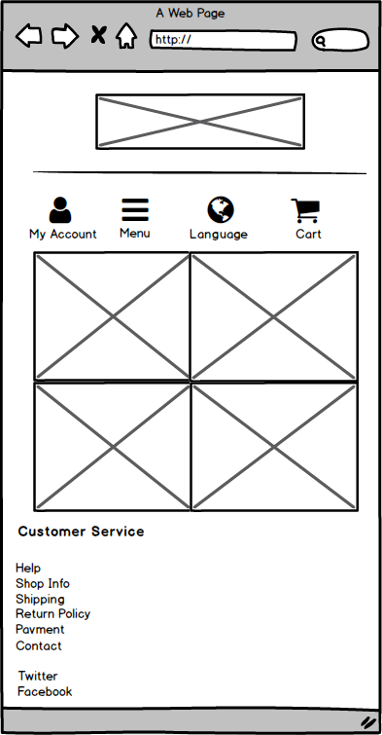

Category Page
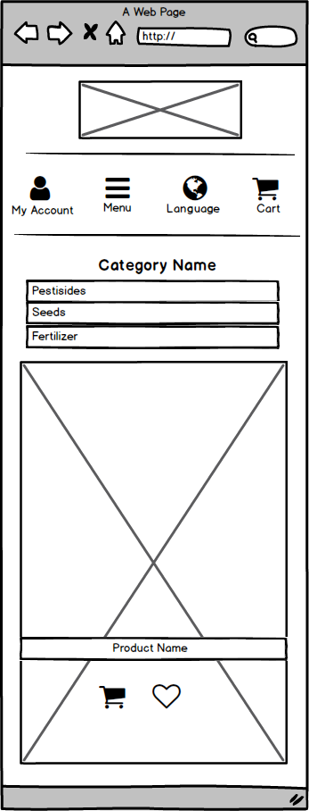

Login Page

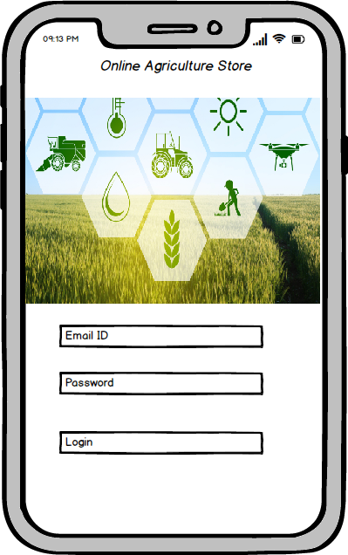

Registration Page

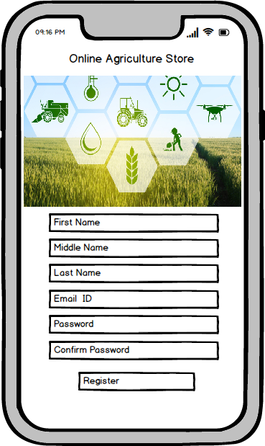

Payment Page

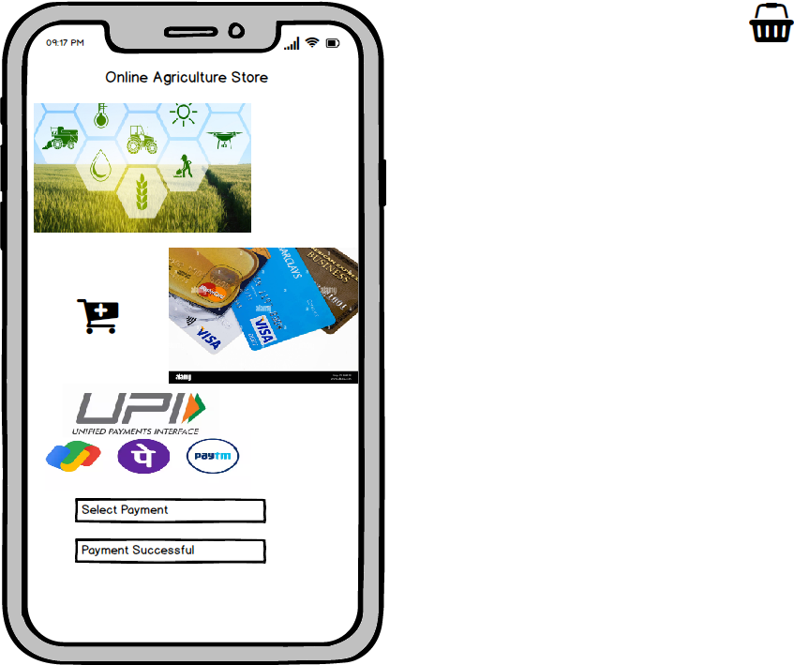

Q.3 Make a note of the tools, which you are using for above concepts (Visio, Balsamic)
Answer:
Tools used for Requirements & Design:
1. Microsoft Visio
Purpose- Used to create process flows, use case diagrams, & system architecture diagrams.
Usage:
- Visually represent login flows, order processing flows, & data flow diagrams.
- Helps communicate technical understanding to developers & stakeholders.
Benefit:
- Clear professional diagram, easy for presentation & documentation.

2. Balsamic wireframes
Purpose:
- Used for designing low-fidelity wireframes of the application UI.
- Usage- Designed wireframes for key pages like Home, Login, Product CatLog, and Order Tracking.
- Emphasis on layout & structure without detailed styling.
Benefit:
- Fast & intuitive UI planning tool for early -stage design discussions with stakeholders.

3. Axure RP
Purpose:
- Used to create high fidelity wireframes, interactive prototypes, & simulate dynamic content & user flows.
- Usage- Designed interactive prototypes of the application where buttons (e.g., "Login", "Add to cart") actually simulate navigation.
- Created conditional logic, form validations & page transitions to mirror actual app behaviour.

Benefit:
- Ideal for presenting realistic mock-ups to stakeholders or clients.
- Allows business analyst & designers visually communicate functional logic without writing code.

Q.4 what is Requirement Traceability Matrix?
A business analyst’s key responsibilities are to keep track of the requirements and make sure that no requirement has missed.
Answer: Requirement Traceability Matrix (RTM) is a document used in project management and software development to ensure that all requirements are accounted for throughout the project lifecycle. It serves as a tool to track the relationship between requirements and various project artefacts, such as design documents, test cases, and implementation.

Req ID | Req Name | Req Description | Design | D1 | T1 | D2 | T2 | D3 | T3 | D4 | T4 | UAT
FR0001 | Farmer Registration | Farmer should be able to register with the application | comp. | comp. | comp. | comp. | comp. | comp. | comp. | comp. | comp. | comp.
FR0002 | Farmer search for products | Farmer should be able to search for available products in fertilizers,seeds,pesticides | comp. | comp. | comp. | comp. | comp. | comp. | comp. | comp. | comp. | WIP.
FR0003 | Manufacturer's Registration | Manufacturer should be able register with the application | comp. | comp. | comp. | comp. | comp. | comp. | comp. | comp. | comp. | comp.
FR0004 | Manufacturer product listing | Manufacturer should be able to list their products in the catalogue | comp. | WIP | comp. | comp. | comp. | comp. | comp. | comp. | comp. | WIP.
FR0005 | Product details | The application should display detailed information about each product including descriptions, specification & pricing | comp. | comp. | comp. | comp. | comp. | comp. | comp. | comp. | comp. | comp.
FR0006 | Add to cart | Users should be able to add products to their shopping cart for purchase | comp. | comp. | comp. | comp. | WIP | comp. | comp. | comp. | comp. | WIP.
FR0007 | Cart Mgmt | Users should be able to view & manage the contents of their shopping cart , adding & removing products | comp. | comp. | comp. | comp. | comp. | comp. | comp. | comp. | comp. | comp.
FR0008 | Wishlist Mgmt | Users should be able to manage their wishlist or buy-later list, including adding or removing products | comp. | comp. | comp. | WIP | comp. | comp. | comp. | comp. | comp. | WIP.
FR0009 | Multiple payment gateway | The platform should integrate with multiple payment gateways to facilitate secure and convenient transaction | comp. | comp. | comp. | comp. | comp. | comp. | comp. | comp. | comp. | comp.
FR0010 | Order placement | Users should be able to place orders for selected products specifying quantity & delivery address | comp. | comp. | comp. | comp. | comp. | WIP | comp. | comp. | comp. | WIP.
FR0011 | Order confirmation | Users shuld receive an order confirmation with details such as order no., product quantity,total amount, estimated delivety date | comp. | comp. | comp. | comp. | comp. | comp. | comp. | comp. | comp. | comp.
FR0012 | Order Tracking | Users should be able to track the status and location of their orders in real-time | comp. | WIP | comp. | comp. | comp. | comp. | comp. | comp. | comp. | WIP.
FR0013 | Order history | Users should be able to view their history including past orders, order details and statuses | comp. | comp. | comp. | comp. | comp. | comp. | comp. | comp. | comp. | comp.
FR0014 | Customer support | Users should have access to customer support, either through live chat, email, or phone for assistance | comp. | comp. | comp. | comp. | WIP | comp. | comp. | comp. | comp. | WIP.
FR0015 | Users Ratings and Reviews | Users should be able to provide ratings and reviews for products they have ordered | comp. | comp. | comp. | comp. | comp. | comp. | comp. | comp. | comp. | comp.
FR0016 | Product Recommendation | The platform should offer personalized product recommendations based on user preferences and browsing history. | comp. | WIP | comp. | comp. | comp. | comp. | comp. | comp. | comp. | WIP.
FR0017 | Social sharing | Users should have the option to share products or their purchase experience on social media plattforms | comp. | comp. | comp. | comp. | comp. | comp. | comp. | comp. | comp. | comp.
FR0018 | Secure Transactions | The platform should ensure secure transactions by implementing appropriate encryption and security measures |  | comp. | comp. | comp. | comp. | comp. | comp. | WIP | comp. | WIP.
FR0019 | Product Filtering | Users should be able to filterproducts based on various criteria such as price range, branch or product type | comp. | comp. | comp. | comp. | comp. | comp. | comp. | comp. | comp. | comp.
FR0020 | Account Mgmt | Users should be able to manage their account settings including profile information, password changes and email preferences | comp. | comp. | comp. | comp. | WIP | comp. | comp. | comp. | comp. | WIP.

To address Mr. Henry and Peter’s query, I will use this Requirement Traceability Matrix to explain the project’s status. This matrix tracks each requirement and its development stage, showing how many are completed, in progress, and how much time is left to finish. With this information, I can create a summary report for Mr. Henry and Peter that includes the development status, testing status, completion dates, critical areas, risks, and dependencies.

Q.5 Prepare 10 Test Case Documents.
Answer:
Test Case Document- A test case document is a detailed outline used by testers to ensure that a software application or system is working as expected.

1. User Registration
Test Case ID | TC001 | Test Case Name | User Registration
Project ID | PI001 | Project Name | Online Agriculture Store Project
PM ID | 98562 | PM Name | Mr Vandanam
Tester ID | TID-001 | Tester Name | Mr Jason
Date of Test | DD-MM-YYYY
Test Description | To register new user using email id / phone no. And creating password.
Page Link | www.onlineagristore.com
Pre Condition | Internet connectivity should be available
Input Data | Email id, Mobile no., Username, Location, Create Password.
Expected behaviour | Once user succesfully registered using email/mobile and password. System shows user created successfully.
Actual behaviour | [To be filled by tester]
Tester comment | [To be filled by tester]
Result(Pass/Fail) | [To be filled by tester]

2. User Login
Test Case ID | TC002 | Test Case Name | User Login
Project ID | PI001 | Project Name | Online Agriculture Store Project
PM ID | 98562 | PM Name | Mr Vandanam
Tester ID | TID-002 | Tester Name | Ms Alekya
Date of Test | [Date to be determined]
Test Description | To login registered user using username and password.
Page Link | www.onlineagristore.com/login
Pre Condition | User is already registered.
Input Data | Email id/Mobile no. and Password. Example: Emailid:-johndoe@mail.com password:-******
Expected behaviour | Once user succesfully login using email/mobile and password. System shows user login successfully.
Actual behaviour | [To be filled by tester]
Tester comment | [To be filled by tester]
Result(Pass/Fail) | [To be filled by tester]

3. Add Product Details by Manufacturer
Test Case ID | TC003 | Test Case Name | Upload Product by Manufacturer
Project ID | PI001 | Project Name | Online Agriculture Store Project
PM ID | 98562 | PM Name | Mr Vandanam
Tester ID | TID-001 | Tester Name | Mr Jason
Date of Test | [Date to be determined]
Test Description | Verify that manufacturer can upload product details.
Page Link | www.onlineagristore.com/products
Pre Condition | The manufacturer is successfully logged into the system.
Input Data | Product 1 | Product 2 | Product 3
Input Data | Fertilizer | Seeds | Urea
Input Data | Organic | Tomato seed | organic pesticide
Input Data | 500Rs/Kg | 100 Rs/100gm | 500Rs/kg
Expected behaviour | Product is successfully added and visible in the product catalog.
Actual behaviour | [To be filled by tester]
Tester comment | [To be filled by tester]
Result(Pass/Fail) | [To be filled by tester]

4. Product Search
Test Case ID | TC004 | Test Case Name | Product Search
Project ID | PI001 | Project Name | Online Agriculture Store Project
PM ID | 98562 | PM Name | Mr Vandanam
Tester ID | TID-002 | Tester Name | Ms Alekya
Date of Test | [Date to be determined]
Test Description | Verify that user can search for products.
Page Link | www.onlineagristore.com/product-search
Pre Condition | The User is successfully logged into the system.
Input Data | Keyword 1 | Keyword 2 | Keyword 3
Input Data | Fertilizer | Seeds | Pesticide
Expected behaviour | Relevant products are displayed in the search results.
Actual behaviour | [To be filled by tester]
Tester comment | [To be filled by tester]
Result(Pass/Fail) | [To be filled by tester]

5. Product Search filter
Test Case ID | TC005 | Test Case Name | Product Search Filter
Project ID | PI001 | Project Name | Online Agriculture Store Project
PM ID | 98562 | PM Name | Mr Vandanam
Tester ID | TID-001 | Tester Name | Mr Jason
Date of Test | [Date to be determined]
Test Description | Verify that users can apply filters to search results.
Page Link | www.onlineagristore.com/product-search
Pre Condition | The User has access to the product search page.
Input Data | Filter 1 | Filter 2 | Filter 3
Input Data | Price Range | Brand | Organic/Chemical
Expected behaviour | Search results shown based on applied filters.
Actual behaviour | [To be filled by tester]
Tester comment | [To be filled by tester]
Result(Pass/Fail) | [To be filled by tester]

6. Product Details
Test Case ID | TC006 | Test Case Name | Product Details
Project ID | PI001 | Project Name | Online Agriculture Store Project
PM ID | 98562 | PM Name | Mr Vandanam
Tester ID | TID-002 | Tester Name | Ms Alekya
Date of Test | [Date to be determined]
Test Description | Verify that user can view details information about a product.
Page Link | www.onlineagristore.com/product-detials
Pre Condition | The product exists and user is able to navigate to the product detail page by clicking on the product.
Expected behaviour | Verify that user can view detailed info about a product.
Actual behaviour | [To be filled by tester]
Tester comment | [To be filled by tester]
Result(Pass/Fail) | [To be filled by tester]

7. Add to cart
Test Case ID | TC007 | Test Case Name | Add to Cart
Project ID | PI001 | Project Name | Online Agriculture Store Project
PM ID | 98562 | PM Name | Mr Vandanam
Tester ID | TID-001 | Tester Name | Mr Jason
Date of Test | [Date to be determined]
Test Description | Verify that users can add products to the shopping cart.
Page Link | www.onlineagristore.com/cart
Pre Condition | Products are available in inventory and add to cart is enabled.
Post Condition | Total prices will be shown, payment option would be shown
Expected behaviour | Product is added to the cart successfully with the correct quantity.
Actual behaviour | [To be filled by tester]
Tester comment | [To be filled by tester]
Result(Pass/Fail) | [To be filled by tester]

8. Payment Options
Test Case ID | TC008 | Test Case Name | Payment Options
Project ID | PI001 | Project Name | Online Agriculture Store Project
PM ID | 98562 | PM Name | Mr Vandanam
Tester ID | TID-001 | Tester Name | Mr Jason
Date of Test | [Date to be determined]
Test Description | Verify that user can select different payment option during checkout.
Page Link | www.onlineagristore.com/payment
Pre Condition | Product added to cart and total price is calculated.
Post Condition | Redirect to 3rd party apps or COD option
Input Data(payment mode) | Card details | UPI details | COD
Expected behaviour | User can select the payment option successfully and proceed.
Actual behaviour | [To be filled by tester]
Tester comment | [To be filled by tester]
Result(Pass/Fail) | [To be filled by tester]

9. Order Confirmation
Test Case ID | TC009 | Test Case Name | Order Confirmation
Project ID | PI001 | Project Name | Online Agriculture Store Project
PM ID | 98562 | PM Name | Mr Vandanam
Tester ID | TID-002 | Tester Name | Ms Alekya
Date of Test | [Date to be determined]
Test Description | Verify that users receive an order confirmation after completing the payment.
Page Link | www.onlineagristore.com/payment
Pre Condition | Product added to cart and total price is calculated.
Post Condition | Order status, order tracking is enabled.
Input Data | Order ID 1 | Order ID 2 | Order ID 3
Input Data | Oid:20250801001 | Oid:20250801002 | Oid:20250801003
Expected behaviour | Once payment are done.Order confirmation is sent to the user via email/sms
Actual behaviour | [To be filled by tester]
Tester comment | [To be filled by tester]
Result(Pass/Fail) | [To be filled by tester]

10. Delivery Tracking
Test Case ID | TC010 | Test Case Name | Order Tracking
Project ID | PI001 | Project Name | Online Agriculture Store Project
PM ID | 98562 | PM Name | Mr Vandanam
Tester ID | TID-001 | Tester Name | Mr Jason
Date of Test | [Date to be determined]
Test Description | Verify that users receive an order confirmation after completing the payment.
Page Link | www.onlineagristore.com/order-tracking
Pre Condition | User has placed successfully order and tracking functionality is enabled.
Post Condition | The tracking details like: delivery date, shipment progress, courier details) is displayed accurately.
Input Data | Order ID 1 | Order ID 2 | Order ID 3
Input Data | Oid:20250801001 | Oid:20250801002 | Oid:20250801003
Expected behaviour | Delivery tracking info is displayed with real-time updates.
Actual behaviour | [To be filled by tester]
Tester comment | [To be filled by tester]
Result(Pass/Fail) | [To be filled by tester]

Q.6 Draw database schema and ER diagram.

Answer: DB Schema is a blueprint that outlines the structure of a database, including its tables, fields, relationships, constraints and characteristics.

An Entity-Relationship(ER) diagram is a visual representation of the relationships between entities in a database. It depicts the entities (such as tables), attributes (properties or fields), and relationship between them.

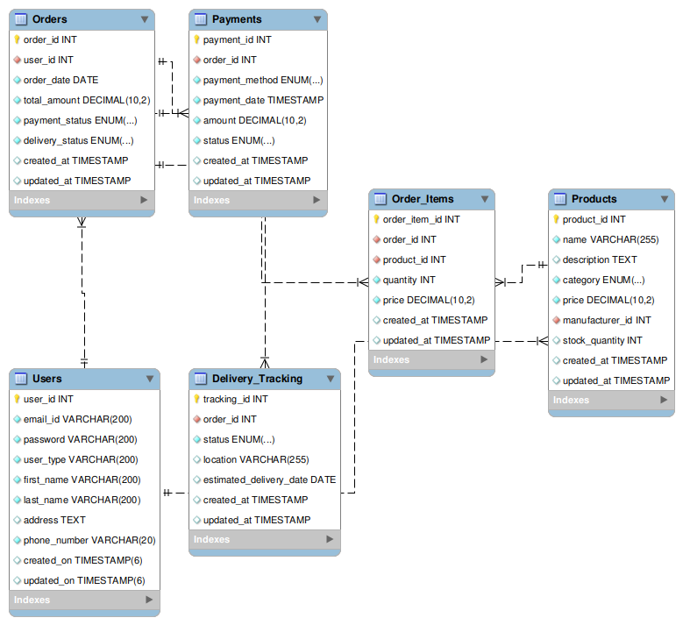

Q.7 what is a data flow diagram? Draw a data flow diagram to represent the in-flow and out-flow of data when a Farmer is placing an order for the product.
Answer:
Definition: - Data Flow Diagram (DFD) is a graphical representation of data flow in any system. The DFD depicts both incoming and outgoing data flows and provides a high-level overview of system functionality.

There are 4 main components of a DFD with symbols:
1) External entities: rectangles
2) Processes: circles (Yourdon and Coad notation) or rectangles with rounded corners (Gane and Sarson)
3) Data stores: parallel lines (Yourdon and Coad) or open-ended rectangles (Gane and Sarson)
4) Data flows: horizontal lines

Following are the rules of Data Flow Diagram (DFD):

1) Data stores cannot be connected directly to external entities.
2) External entities can transmit data to a process, but cannot transmit data directly to a data store.

1. Data can flow from
Entity → Process
Process → Entity
Process → Data Store
Data Store → Process
Process → Process

2. Data Cannot Flow From
Entity → Entity
Entity → Data Store
Data Store → Entity
Data Store → Data Store
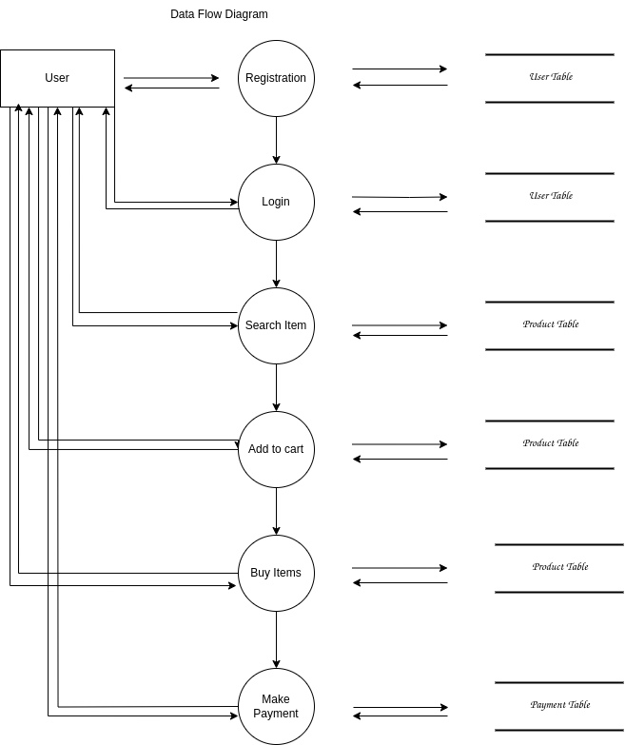

Q.8 Due change in in the Government taxation structure. We should change the tax structure how you handle change requests in a project.

Answer- Handling change request in a project involves a systematic process to ensure that changes are effectively managing while minimizing disruption to the project's scope, timeline & resources. Here are the steps typically followed to handle change request.

1. Change request identification: identify & document the change request. Including the specific details of the requested change, the reason for the change, & its potential impact on the project.

2. Change impact analysis: Access the impact of the change on various aspects of the project, such as scope, timeline, cost, resources, & risks
3. Change evaluation: Review the change request with key stakeholders, including project sponsor’s clients, and relevant team members. Discuss the potential benefits & risks associated with the change.

4. Change prioritization: prioritize the change request based on its urgency, impact & alignment with the project goals. Determine whether the change is critical and must implemented immediately or can be scheduled for a future release.

5. Change approval: obtain formal approval from the appropriate stakeholders, such as project sponsor’s, or change control boards. Ensure the all stakeholders agree regarding the change and its implications.

6. Change implementation: incorporate the approved change into the project plan, including any necessary adjustments to the scope, schedule, budget and resources. Communicate the change to the project team and other relevant stakeholders. Update project documentation such as requirements, design, and test plan, to reflect the approved change.

7. Change communication: communicate the approved change to all relevant parties, including team members, clients, and other stakeholders. Clearly explain the reason for the change, its impact on the project, and any adjustments to expectations or deliverables.

8. Change tracking and documentation: track and document all approved changes, including the rationale, approvals and implemented modifications. Maintain a change log or change register to ensure transparency and accountability throughout the project.

9. Change control & monitoring: continuously monitor the impact of implemented changes on the project's progress, risks, and quality. Maintain open lines of communication with stakeholders to address any concerns or issues related to the approved changes. Monitor the project's overall alignment with the revised scope, timeline and objectives.

By following these steps, a project can effectively manage change requests, ensuring that changes are evaluated, approved, and implemented in a controlled manner, while minimizing disruptions and maintaining project success.

Q.9 As the project is in process; Ben and Kevin have contacted you. The reason is to inform you that
They want the Farmers to sell their crop yields through this application i.e. Farmers should be able
To add their crop yields or products and display to general public and should be able to sell them.
They also want to introduce Auction system for their Crop yields. As a BA, what will be your
Response?

Answer:
change request: a change request is a formal proposal to modify a project, product, process, or system. It is typically used in project management, software development and various industries to handle modifications and improvements. A change request can arise at any point during a project's lifecycle, whether it is due to new requirement, unforeseen issues or the need for enhancements.

Enhancement: refet to improvements or addition made to the software after its initial release. These changes are aimed at increasing the software's value, performance, or functionality based on evolving business needs, user feedback or technological advances. Enhancements can be part of the regular software maintenance cycle or occur as part of a new version or update.

As a BA, my response to Ben and Kevin's request would be to classify it as an enhancements rather than a change request. a change request typically involves modifications to existing functionality or requirements, while an enhancement introduces new features or capabilities that were not initially specifies. In this case, the request to allow farmers to add their crop yields, display them to the general public, and enable selling through the application represents an enhancement because it introduces new functionality that goes beyond the initial scope of the project. Additionally the introduction of auction system for crop yields adds another layer of functionality to the application.

To address this enhancement request, I would follow the standard process for handling new requirements:

1. Requirement gathering: i will meet with Ben and Kevin to gather detailed requirements for the new functionality. This would involve understanding the specific features they envision, such as the process for farmers to add and manage their crop yields, the display of products to the public, and the implemented of the auction system.

2. Impact analysis: I would assess how these enhancements affect the project's scope, timeline, budget, and resources. This analysis will help determine if adding the requested features is feasible and what the implications might be.

3. Stakeholders analysis: I would identify and involve relevant stakeholders, such as the project sponsor, development team, and other key personnel, to assess their perspectives and gather their inputs on the potential enhancements.

4. Documentation & Communications; i would document the detailed requirements and changes in the project scope, and communicate them to the project team, stakeholders and any other parties involved. This would ensure everyone is aware of the proposed enhancements and their implications.

5. Evaluation percentage prioritization: I would collaborate with the project team and stakeholders to assess the value and priority of the requested enhancements. This evaluation would consider benefits, impact on project goals, alignment with business objectives, and available resources.

6. Planning & Execution: If the enhancements were approved, I would update the project plan, schedule, and resources. I would then work with the development team and stakeholders to add the new features, ensuring proper testing and quality assurance.

By treating this request as an enhancement, the project can manage additional requirements and deliver the desired functionality while considering its impact on the ongoing work.

Question 10- Come up with estimations – How many Manhours required

Answer: Estimation: Estimation in software development life cycle refers to the process of predicting the resources (time, cost, effort) required to complete a software development project or specific tasks within the project. Estimation is a critical part of the planning phase of SDLC, as it helps in setting realistic expectations, managing resources efficiently and determining the project's feasibility.

Man- hour’s estimation in software development refers to the process of estimating the total amount of human effort required to complete a software development task, project or feature. It is typically expressed in terms of the number of hours that a team or individual will spend working on the project. This estimation is crucial for planning, budgeting and scheduling the project. It helps determine resource requirements, assess project timelines and evaluate project feasibility.

Types of projects based on Man-Hours:
1. Small Project- Upto 500 Man-Hours
2. Medium Project- Upto 1000 Man-Hours
3. Large Project- Upto 1500 Man-Hours

Man-hours required= Total hours working per day * total number of members * total numbers of days worked over the specific period.

Number of working hours a day = 8 Hours

Number of resources = 12

Time period provided = 18 months = 547 days = 78 weeks (including weekends and Public holidays)

Assuming Weekends = 156

Assuming Public holidays = 10

Total = 166

Total working days = 547-166 = 381 working days

Hence, Estimated Manhours = 8 hours *12 resources * 381 days = 36,576 Man hours required.

Question 11. Project has finally completed all the stages i.e., design, development, testing etc. Now, it is the role of a business analyst to contact the client for testing of the final product and have to successfully complete it. How are you going to handle this situation? And once it is done, what will be the process to close the project? Explain UAT Acceptance process

Answer: To handle the situation of contacting the client for testing the final product, I would follow these steps:

1. Schedule a Meeting: Arrange a meeting with the client to discuss the User Acceptance Testing (UAT) process and set expectations.

2. Prepare Documentation: Provide the client with necessary documentation, including test cases, user guides, and any relevant information about the product.

3. Conduct UAT: Facilitate the UAT by guiding the client through the testing process, ensuring they understand how to execute the test cases and what to look for.

4. Collect Feedback: Gather feedback from the client during and after the testing to identify any issues or areas for improvement.

5. Address Issues: Work with the development team to resolve any issues identified during UAT.

6. Obtain Approval: Once the client is satisfied with the product, obtain formal approval to proceed with project closure.

Project Closure Process:

Once UAT has completed successfully, the project closure process involves:

1. Final Review: Conduct a final review meeting with the project team and stakeholders to discuss the project outcomes.

2. Documentation: Ensure all project documentation is complete and archived, including UAT results, final reports, and lessons learned.

3. Release Resources: Release project resources, including team members and budget.

4. Client Handover: Officially, hand over the final product to the client, including any necessary training or support.

5. Closure Report: Prepare a project closure report summarizing the project’s performance, outcomes, and any recommendations for future projects.

UAT Acceptance Process:
The UAT acceptance process typically includes:

1. Test Planning: Define the scope, objectives, and criteria for acceptance testing.

2. Test Execution: The client executes the test cases in a real-world environment to validate the product against requirements.

3. Issue Logging: Any defects or issues found during testing are logged for resolution.

4. Review and Sign-off: After testing, the client reviews the results and provides formal sign-off if the product meets their expectations.

5. Final Acceptance: Once the client signs off, the product is considered accepted, and the project can proceed to closure.

Q.12 Explain Project closure document.

Answer- A project closure document is a formal record that signifies the completion of a project. It serves as a comprehensive summary of the project’s performance, outcomes, and lessons learned. Here are the key components typically included in a project closure document:

1. Project Overview: A brief description of the project, including its objectives, scope, and stakeholders.

2. Project Deliverables: A list of all deliverables produced during the project, along with their status (completed, pending, etc.).

3. Performance Metrics: An evaluation of the project’s performance against key metrics, such as time, budget, and quality. This may include comparisons to the original project plan.

4. Lessons Learned: Insights gained throughout the project, including what went well and what could be improved in future projects. This section helps inform best practices for future initiatives.

5. Stakeholder Feedback: Summary of feedback received from stakeholders, including clients, team members, and other relevant parties.

6. Final Financials: A summary of the project’s financial performance, including budget utilization, any variances, and final costs.

7. Closure Activities: Documentation of activities completed during the project closure phase, such as final meetings, resource release, and handover processes.

8. Sign-off: Formal approval from key stakeholders, indicating that the project has completed to their satisfaction.

9. Archiving: Information on how project documentation and materials will be archived for future reference.

The project closure document is essential for ensuring that all aspects of the project are formally concluded and provides a reference for future projects. It helps in maintaining transparency and accountability while also capturing valuable insights for continuous improvement.

