Q1. Write Agile Manifesto

A1. Agile Manifesto has

Four main Values

1. Individuals and interactions over processes and tools
2. Working software over comprehensive documentation
3. Customer collaboration over contract negotiation.
4. Responding to change over following a plan.

Twelve Principles of Agile Software:

1. Satisfy the customer through early and continuous delivery of valuable software.
2. Welcome changing requirements, even late in development. Agile processes harness change for the customer's competitive advantage.
3. Deliver working software frequently, from a couple of weeks to a couple of months, with a preference to the shorter timescale.
4. Business people and developers must work together daily throughout the project.
5. Build projects around motivated individuals. Give them the environment and support they need, and trust them to get the job done.
6. The most efficient and effective method of conveying information to and within a development team is face-to-face conversation.
7. Working software is the primary measure of progress.
8. Agile processes promote sustainable development. The sponsors, developers, and users should be able to maintain a constant pace indefinitely.
9. Continuous attention to technical excellence and good design enhances agility.
10. Simplicity--the art of maximizing the amount of work not done--is essential.
11. The best architectures, requirements, and designs emerge from self-organizing teams.
12. At regular intervals, the team reflects on how to become more effective, then tunes and adjusts its behaviour accordingly.

Q2. Write minimum 40 User stories and their Acceptance Criteria along with their BV and CP.

A2.

|  |  |  |
| --- | --- | --- |
| User Story No: 1 | Tasks: 02 | Priority: Medium |
| As a customer,  I want to search restaurants  So that, I can view varieties of food. | | |
| BV: 100 | CP: 01 | |
| Acceptance Criteria:  Search restaurant and select.  View variety of food items available. | | |
| User Story No: 2 | Tasks: 02 | Priority: Medium |
| As a customer,  I want to select food item  So that, I can order. | | |
| BV: 200 | CP: 02 | |
| Acceptance Criteria:  Select restaurant and select food item.  Order Food. | | |

|  |  |  |
| --- | --- | --- |
| User Story No: 3 | Tasks: 02 | Priority: High |
| As a restaurant owner,  I want to display all food items  So that, I can receive orders. | | |
| BV: 200 | CP: 02 | |
| Acceptance Criteria:  Display list of food items.  Receive orders from customer. | | |

|  |  |  |
| --- | --- | --- |
| User Story No: 4 | Tasks: 02 | Priority: High |
| As a restaurant owner,  I want to view orders  So that, I can view the list of orders. | | |
| BV: 500 | CP: 02 | |
| Acceptance Criteria:  View Order, Display List of orders in the tabular Form | | |

|  |  |  |
| --- | --- | --- |
| User Story No: 5 | Tasks: 02 | Priority: High |
| As a customer,  I want to add address  So that, I can get orders to my address. | | |
| BV: 500 | CP: 02 | |
| Acceptance Criteria: Text box to enter.  Business rules: Within the radium of 5km. | | |

|  |  |  |
| --- | --- | --- |
| User Story No: 6 | Tasks: 02 | Priority: High |
| As a customer,  I want to select The Payment Mode  So that, I can make Payment Of My Choice | | |
| BV: 500 | CP: 03 | |
| Acceptance Criteria: Display payment modes, radio buttons to select payment modes, payments button  Business rules: Can select only one payment mode. | | |

|  |  |  |
| --- | --- | --- |
| User Story No: 7 | Tasks: 01 | Priority: High |
| As a admin,  I want to view the restaurants,  So that, I can approve their registration. | | |
| BV: 200 | CP: 02 | |
| Acceptance Criteria: Register in the platform with the details. | | |

|  |  |  |
| --- | --- | --- |
| User Story No: 8 | Tasks: 01 | Priority: Low |
| As a customer,  I want to view the prices,  So that, I can order the food. | | |
| BV: 50 | CP: 01 | |
| Acceptance Criteria: Display prices in the list of menu items. | | |

|  |  |  |
| --- | --- | --- |
| User Story No: 9 | Tasks: 02 | Priority: Low |
| As a customer,  I want the contact number of delivery boy,  So that, I can contact delivery boy for the status. | | |
| BV: 50 | CP: 01 | |
| Acceptance Criteria: Display delivery boy name, photo and mobile number. | | |

|  |  |  |
| --- | --- | --- |
| User Story No: 10 | Tasks: 02 | Priority: medium |
| As a restaurant owner,  I want to provide the time slots,  So that, customers able to see opening and closing hours. | | |
| BV: 50 | CP: 01 | |
| Acceptance Criteria: Click on restaurant dashboard. Add from time to time. Click on submit. Display updated successfully. | | |

|  |  |  |
| --- | --- | --- |
| User Story No: 11 | Tasks: 02 | Priority: High |
| As a business owner,  I want to view restaurant revenue report,  So that, I can view the restaurants revenue. | | |
| BV: 200 | CP: 03 | |
| Acceptance Criteria: Select reports. Select revenue reports, to and from date, region or can select all. Generate report. Download report in excel | | |

|  |  |  |
| --- | --- | --- |
| User Story No: 12 | Tasks: 03 | Priority: High |
| As a regional admin,  I want to manage regional restaurants,  So that, I can track the performance of regional restaurants. | | |
| BV: 200 | CP: 03 | |
| Acceptance Criteria: Click on performance of restaurants, select from date to date, click on generate report which includes restaurants id, name, revenue. Click on download report in excel. | | |

|  |  |  |
| --- | --- | --- |
| User Story No: 13 | Tasks: 02 | Priority: Medium |
| As admin,  I want to see the regional revenue reports,  So that, I can view the regional performance. | | |
| BV: 100 | CP: 03 | |
| Acceptance Criteria: Select regional dropdown. View performance of each rest of that region in tabular form which includes rest name, revenue, generated download in excel or PDF. | | |

|  |  |  |
| --- | --- | --- |
| User Story No: 14 | Tasks: 02 | Priority: High |
| As a customer,  I want to chat with regional admin  So that, I can request for refund. | | |
| BV: 200 | CP: 02 | |
| Acceptance Criteria: Text box fields, display order id, text box for description, submit button, generate issue id, display successful. | | |

|  |  |  |
| --- | --- | --- |
| User Story No: 15 | Tasks: 02 | Priority: High |
| As a hungry user,  I want to browse the nearest restaurants,  So that, I can order food. | | |
| BV: 200 | CP: 02 | |
| Acceptance Criteria: Each restaurant entry displays its name, cuisine type, and rating. This list can be sorted by distance or rating. | | |
| User Story No: 16 | Tasks: 02 | Priority: High |
| As a customer,  I want to browse different restaurants and menus,  So that, I can find a place to order food. | | |
| BV: 200 | CP: 02 | |
| Acceptance Criteria: The menu includes dishes, prices and descriptions. Show the restaurant is open or closed. | | |

|  |  |  |
| --- | --- | --- |
| User Story No: 17 | Tasks: 01 | Priority: High |
| As a customer,  I want to browse for specific dishes and cuisines,  So that, I can find a place to order food. | | |
| BV: 200 | CP: 02 | |
| Acceptance Criteria: App displays relevant restaurant and dishes matching the query. | | |

|  |  |  |
| --- | --- | --- |
| User Story No: 18 | Tasks: 01 | Priority: High |
| As a customer,  I want to filter restaurants,  So that, I can find a place to order food. | | |
| BV: 200 | CP: 02 | |
| Acceptance Criteria: Filter restaurants by cuisine type and dietary options(vegan, veg, nonveg, egg) | | |

|  |  |  |
| --- | --- | --- |
| User Story No: 19 | Tasks: 02 | Priority: High |
| As a customer,  I want to track my order,  So that, I know the time of delivery. | | |
| BV: 200 | CP: 02 | |
| Acceptance Criteria: App shows real time update on the order status. Display estimated delivery time. | | |

|  |  |  |
| --- | --- | --- |
| User Story No: 20 | Tasks: 02 | Priority: High |
| As a user,  I want to rate and review restaurant,  So that, I can rate and review the restaurant I have visited. | | |
| BV: 200 | CP: 02 | |
| Acceptance Criteria: Can see reviews from other users to help me make dining decisions. | | |

|  |  |  |
| --- | --- | --- |
| User Story No: 21 | Tasks: 01 | Priority: High |
| As a user,  I want to save favorite restaurants and dishes,  So that, I can order from my favorite. | | |
| BV: 200 | CP: 02 | |
| Acceptance Criteria: Access my list of favourites easily for future orders. | | |

|  |  |  |
| --- | --- | --- |
| User Story No: 22 | Tasks: 03 | Priority: High |
| As a user,  I want to view past orders history,  So that, I can order again. | | |
| BV: 200 | CP: 02 | |
| Acceptance Criteria: Can see the details such as order items, total cost and order date. | | |

|  |  |  |
| --- | --- | --- |
| User Story No: 23 | Tasks: 02 | Priority: Medium |
| As a user,  I want to receive notifications,  So that, I can receive updates. | | |
| BV: 200 | CP: 02 | |
| Acceptance Criteria: Notifications for order confirmation, dispatch, delivery. | | |

|  |  |  |
| --- | --- | --- |
| User Story No: 24 | Tasks: 02 | Priority: High |
| As a customer,  I want to contact customer support,  So that, I can submit queries or issues. | | |
| BV: 200 | CP: 02 | |
| Acceptance Criteria: Customer support section with contact information. | | |

|  |  |  |
| --- | --- | --- |
| User Story No: 25 | Tasks: 02 | Priority: High |
| As a restaurant owner,  I want to receive and manage orders,  So that, I can update order status. | | |
| BV: 200 | CP: 02 | |
| Acceptance Criteria: manage order status, notify restaurants about incoming orders. | | |

|  |  |  |
| --- | --- | --- |
| User Story No: 26 | Tasks: 01 | Priority: Medium |
| As a restaurant owner,  I want to access to customer reviews,  So that, I can view and respond to customer reviews. | | |
| BV: 100 | CP: 04 | |
| Acceptance Criteria: Owners can address feedback, improve their services. | | |

|  |  |  |
| --- | --- | --- |
| User Story No: 27 | Tasks: 04 | Priority: Medium |
| As a customer,  I want to apply promocodes and discounts,  So that, I can order at lower price. | | |
| BV: 100 | CP: 04 | |
| Acceptance Criteria: Active promo codes. | | |

|  |  |  |
| --- | --- | --- |
| User Story No: 28 | Tasks: 05 | Priority: High |
| As a delivery boy,  I want to view the orders,  So that, I can accept the orders. | | |
| BV: 200 | CP: 04 | |
| Acceptance Criteria: Order visibility, real time updates, order details, filtering and sorting, map view, navigation, completion and confirmation. | | |

|  |  |  |
| --- | --- | --- |
| User Story No: 29 | Tasks: 05 | Priority: High |
| As a delivery boy,  I want to login,  So that, I can accept the orders. | | |
| BV: 200 | CP: 04 | |
| Acceptance Criteria: user authentication, error handling, password security, multi factor authentication, compatibility and usability. | | |

|  |  |  |
| --- | --- | --- |
| User Story No: 30 | Tasks: 05 | Priority: High |
| As a delivery boy,  I want to view feedback,  So that, I can know the customer feedback. | | |
| BV: 200 | CP: 04 | |
| Acceptance Criteria: Access to system feedback, feedback visibility, feedback sorting and filtering, response mechanism, user support. | | |

|  |  |  |
| --- | --- | --- |
| User Story No: 31 | Tasks: 05 | Priority: High |
| As an admin,  I want to view feedback,  So that, I can know the customer feedback. | | |
| BV: 200 | CP: 04 | |
| Acceptance Criteria: Access to system feedback, feedback visibility, feedback sorting and filtering, response mechanism, user support. | | |

|  |  |  |
| --- | --- | --- |
| User Story No: 32 | Tasks: 03 | Priority: High |
| As a restaurant owner,  I want to view feedback,  So that, I can know the customer feedback. | | |
| BV: 100 | CP: 03 | |
| Acceptance Criteria: Access to system feedback, feedback visibility, feedback sorting and filtering, response mechanism, user support. | | |

|  |  |  |
| --- | --- | --- |
| User Story No: 33 | Tasks: 03 | Priority: High |
| As an admin,  I want to know the issues,  So that, I can resolve them. | | |
| BV: 200 | CP: 04 | |
| Acceptance Criteria: Display issue section, sorting and filtering of issues, editing and monitoring the issues. | | |

|  |  |  |
| --- | --- | --- |
| User Story No: 34 | Tasks: 06 | Priority: High |
| As a regional admin,  I want to know the issues,  So that, I can resolve them. | | |
| BV: 200 | CP: 04 | |
| Acceptance Criteria: Display issue section, sorting and filtering of issues, editing and monitoring the issues. | | |

|  |  |  |
| --- | --- | --- |
| User Story No: 35 | Tasks: 02 | Priority: High |
| As a restaurant owner,  I want to view the revenue generation,  So that, I can view the restaurant revenue. | | |
| BV: 200 | CP: 04 | |
| Acceptance Criteria: Select reports, revenue reports, select to and from date, select region, generate report and download report in excel. | | |

|  |  |  |
| --- | --- | --- |
| User Story No: 36 | Tasks: 02 | Priority: Low |
| As a restaurant owner,  I want to know the delivery boy,  So that, I can verify the delivery boy. | | |
| BV: 50 | CP: 01 | |
| Acceptance Criteria: Id proof, punctuality and reliability. | | |

|  |  |  |
| --- | --- | --- |
| User Story No: 35 | Tasks: 02 | Priority: Medium |
| As a customer,  I want to view the contact number of delivery boy,  So that, I can contact delivery boy for the status. | | |
| BV: 100 | CP: 02 | |
| Acceptance Criteria: Display delivery boy mobile no., name in tracking field and picture. | | |

|  |  |  |
| --- | --- | --- |
| User Story No: 36 | Tasks: 03 | Priority: High |
| As a restaurant owner,  I want to provide time slots,  So that, customer can check opening and closing hours. | | |
| BV: 200 | CP: 02 | |
| Acceptance Criteria: Click on restaurant dashboard, add from time to time, click on submit, display updated successfully. | | |

|  |  |  |
| --- | --- | --- |
| User Story No: 37 | Tasks: 04 | Priority: Medium |
| As a customer,  I want to view the order,  So that, I can cancel the order. | | |
| BV: 200 | CP: 03 | |
| Acceptance Criteria: Order status, method of cancellation, refund policy time frame. | | |

|  |  |  |
| --- | --- | --- |
| User Story No: 38 | Tasks: 02 | Priority: Medium |
| As a customer,  I want to contact customer support  So that, I can ask any queries or complaints. | | |
| BV: 200 | CP: 03 | |
| Acceptance Criteria: Customer support section with contact details. | | |

|  |  |  |
| --- | --- | --- |
| User Story No: 39 | Tasks: 02 | Priority: Medium |
| As a regional admin,  I want to track the delivery  So that, I can view the status of delivery. | | |
| BV: 200 | CP: 03 | |
| Acceptance Criteria: Real time tracking, security and data privacy, user friendly interface. | | |

|  |  |  |
| --- | --- | --- |
| User Story No: 40 | Tasks: 02 | Priority: High |
| As a restaurant owner,  I want to access to customer reviews  So that, I can view and respond to customer reviews. | | |
| BV: 200 | CP: 02 | |
| Acceptance Criteria: Owners can address feedback, can improve their service. | | |

Q3. What is epic? Write 2 epics.

A3. Epic is a large user story or a collection of related user stories that represents a significant feature or functionality

Epics are high level, often spanning multiples sprints or iterations, and they provide a way to organize and prioritize work in a product backlog. Below are 2 epics.

a. **Ratings and reviews:**

User stories:

1. As a user, I want to view ratings and reviews for restaurants on scrum foods, so that I can make informed decisions about where to order food from.
2. As a user, I want to provide ratings and reviews for restaurants on scrum foods, so that I can share my experiences with other users and contribute to the community.

b. **Real-Time Order Tracking for Food Delivery App:**

Description:

The real-time order tracking epic aims to provide users with a seamless and transparent

experience by allowing them to track the status and location of their food orders in

real-time. This feature enhances customer satisfaction, reduces support inquiries, and

improves overall user engagement.

User stories:

1. As a customer, I want to see the live status of my order.
   1. Display the current status of the order, such as "order confirmed," "preparing" "out for delivery," and "delivered."
   2. Provide real-time updates as the order progresses through various stages.
2. As a customer, I want to track the location of my delivery.
   1. Integrate GPS or location services to show the delivery partner's real-time location on a map.
   2. Allow customers to view the estimated time of arrival (ETA) based on the delivery partner's location
3. As a customer, I want to receive notifications for order updates.
   1. Send push notifications or SMS updates to inform customers about order confirmation, preparation, and delivery status changes.
   2. Provide delivery partner details, including name, contact information, and a profile picture.
4. As a customer, I want to contact the delivery partner directly.
   1. Enable in-app chat or call functionality to allow customers to communicate with the assigned delivery partner.
   2. Ensure privacy by using masked phone numbers or secure messaging channels.
5. As a customer, I want to view the delivery route.
   1. Allow customers to track the progress of the delivery in real-time along the route.
   2. Display the delivery route on the map, showing the path the delivery partner will take to reach the destination.
6. As a customer, I want to provide feedback on the delivery experience.
   1. Allow customers to rate the delivery partner and overall delivery experience after the order is delivered.
   2. Implement a feedback system with written comments to gather valuable insights.
7. As a customer, I want to see estimated delivery time adjustments
   1. Update the estimated delivery time accordingly and inform the customer promptly.
   2. Account for real-time traffic conditions and other factors that may affect the delivery time.
8. As a customer, I want to have a seamless tracking experience across platforms.
   1. Ensure the real-time order tracking feature is available and consistent on all supported platforms (e.g., mobile app, web).
9. As an admin, I want to monitor order tracking performance
   1. Provide analytics and reporting on order tracking metrics, such as average delivery time and customer satisfaction ratings.
   2. Use data to identify areas for improvement and optimize the delivery process.

Q4. What is the difference between BV and CP

A4.

|  |  |
| --- | --- |
| **Business Value (BV)** | **Complexity Points (CP)** |
| Business Value refers to the perceived or quantifiable worth or benefit that a specific task, feature, or requirement brings to the business or project. | Complexity Points, also known as story points or function points, are a measure of the relative complexity or effort required to complete a task, feature, or requirement. |
| It is typically determined based on factors such as revenue generation, cost savings, customer satisfaction, market competitiveness, strategic alignment, and other business-related criteria. | They are used to estimate the effort, time, and resources needed to implement a specific item. |
| Business Value helps prioritize tasks or features based on their importance to the overall project goals and objectives. | Complexity Points are often assigned based on factors such as technical difficulty, development effort, integration challenges, and other technical or development-related criteria. Complexity Points help in assessing the workload and resource allocation needed for different tasks or features |
| Examples of Business Value considerations: Increased revenue, improved user experience, compliance with industry regulations, competitive advantage | Examples of Complexity Points considerations: Integration with legacy  systems, technical dependencies, data migration, algorithmic complexity. |

Q5. Explain about Sprint

A5. In the context of software development and project management, a sprint is a time-boxed, iterative development period during which a specific set of tasks and goals are worked on by a development team. Sprint is a core concept in Agile methodologies, such as Scrum, which emphasizes flexibility, collaboration, and delivering value to the customer in shorter cycles.

Here are the key characteristics and components of a sprint:

●**Time Frame:** A sprint typically has a fixed duration, often ranging from 1 to 4 weeks. The duration is consistent across all sprints to provide a predictable cadence for development and planning.

● **Goals and Objectives**: At the beginning of each sprint, the development team, along with stakeholders, selects a set of user stories, features, or tasks to work on during that sprint. These items are collectively referred to as the sprint backlog.

**● Planning**: During sprint planning, the development team breaks down the selected items from the product backlog into smaller tasks and estimates the effort required for each task. The team commits to completing these tasks within the sprint duration.

● **Daily Stand-ups**: Throughout the sprint, the team holds daily stand-up meetings (also known as daily scrums) to discuss progress, obstacles, and plans. Each team member shares what they've accomplished, what they're working on, and any challenges they're facing. These meetings foster communication and collaboration.

● **Development:** The development team works on the tasks identified in the sprint backlog. They collaborate closely, often using techniques like pair programming and frequent code reviews to ensure high-quality work.

**● Continuous Integration**: Developers integrate their code changes into the main codebase regularly, ensuring that the software remains functional and stable throughout the sprint.

● **Testing**: Testing is an integral part of a sprint. Automated tests are run to validate code changes, and manual testing may be conducted to ensure the quality of the software.

● **Review**: At the end of the sprint, the development team conducts a sprint review and demo. They showcase the completed work to stakeholders, gathering feedback and validation. This helps ensure that the delivered features align with expectations.

● **Retrospective**: Following the review and demo, the team holds a sprint retrospective. They reflect on what went well during the sprint, what could be improved, and actions to take in the next sprint. The retrospective encourages continuous improvement.

● **Incremental Development**: Each sprint results in a potentially shippable product increment, meaning that at the end of each sprint, a new version of the software is available with additional features or improvements.

**● Adaptability**: Agile methodologies emphasize adaptability and the ability to respond to changing requirements. If new priorities or insights emerge, adjustments can be made in subsequent sprints.

Sprints allow development teams to iteratively deliver value to customers and stakeholders in a controlled and predictable manner. By breaking down the work into manageable chunks and continuously seeking feedback, Agile teams can enhance collaboration, reduce risk, and improve the overall quality of the software being developed.

Q6. Explain Product backlog and sprint back log

A6. The Product Backlog is a dynamic, prioritized list of all the features, user stories, enhancements, bug fixes, and other work items that need to be addressed over the course of a project. It represents the entire scope of the product's development and is managed by the Product Owner. The Product Backlog is continually refined and updated based on feedback, changing requirements, and new insights. The Sprint Backlog is a subset of the Product Backlog that represents the work that the development team commits to completing during a specific time period called a "Sprint."

A Sprint is a fixed-duration iteration, usually lasting two to four weeks, in which the team Works on a set of items from the Product Backlog. The Sprint Back log is created during the Sprint Planning meeting, where the development team selects a set of items to work on based on their capacity and the priorities set by the Product Owner.

|  |  |  |
| --- | --- | --- |
| **S.no** | **Product backlog** | **Sprint backlog** |
| **1** | Anything that needed to Accomplish the project vision | Anything that needed to fulfil the sprint goal |
| **2** | Product owner owns | Development team owns |
| **3** | Contains requirements, tasks, defects | A subset of product backlog items defined as a priority by the product owner |
| **4** | Product backlog refinement meeting is to refine the product backlog | Sprint planning meeting is to refine the sprint backlog items |
| **5** | Release burndown metric is used | Sprint burn down metric is used |
| **6** | Estimation is done at a user Story level | Estimation is done at activity or task level |
| **7** | Daily standup meeting does not discuss product backlog items | Daily standup meeting discusses the sprint backlog in accordance with sprint goal |

Q7. What is impediments log? write 2 impediments

A7. An impediment log, also known as an issue log or obstacle log, is a document or tool

used in Agile software development to track and manage obstacles, bottlenecks, or any

factors that impede the progress of a project or team.

2 Impediments:

● Delivery partner shortage in a specific region

● Technical issue causing intermittent order processing failure

**Delivery partner shortage in a specific region**:

|  |  |
| --- | --- |
| Login ID | 1 |
| Description | Delivery partner storage in specific region |
| Impact | Delays in order deliveries and increases customer dissatisfaction |
| Priority | High (due to its impact on customer experience) |
| Assigned to | Operations team and HR team |
| Status | Open |
| Action taken | The operations team is actively recruiting new delivery partners |
| Resolution | Delivery partner recruitment efforts are ongoing and the HR team is streamlining the onboarding process to expedite new hires. Regular updates are being provided in team meetings. |

**Technical issue causing intermittent order processing failure:**

|  |  |
| --- | --- |
| Login ID | 2 |
| Description | Technical issue causing intermittent order processing failures |
| Impact | Delays in order processing and potential revenue loss |
| Priority | High(due to its impact on revenue and customer experience ) |
| Assigned to | Tech team and QA team |
| Status | In progress |
| Action taken | The tech team has identified the root cause and is working on a fix.  The QA team is conducting extensive testing to ensure the issue is resolved |
| Resolution | The tech team has implemented a fix and conducted through testing. The issue has been resolved, and orders are now processing smoothly. |

Q8. Explain Velocity of the Team

A8. Velocity refers to the measure of the amount of work a development team can complete during a sprint. The calculation of velocity is performed by the development team itself, as they are responsible for estimating the effort required to complete each user story or backlog item. Velocity serves as an Agile metric used to estimate the amount of work a Scrum team can complete within a specific time frame, typically a single sprint.

We can express velocity in story points, which are units that measure the complexity, risk, and uncertainty of tasks. Unlike time-based metrics like hours or days, story points offer a more nuanced way to estimate work.

For example, consider a user story when developing an application login screen. The team could assign this task a story point value of 3 based on its perceived complexity and the effort to complete it. Integrating a complex payment gateway could receive a value of 8 due to higher complexity and potential risks.

Many factors affect the number of story points a team member can complete during a two-week sprint, including individual experience, task complexity, and team dynamics. New Scrum teams usually average 5–10 story points per person per two-week sprint.

Understanding the team’s velocity can help with continuous improvement. It allows teams to forecast future sprints, plan projects, and set realistic goals. This metric helps develop a stable work rhythm, predict project timelines, and manage stakeholder expectations. It is also crucial for effective sprint planning and managing stakeholder expectations.

Q9. Draw Sprint Burn Charts and Product Burn Down Charts

A9. Sprint Burndown Chart:

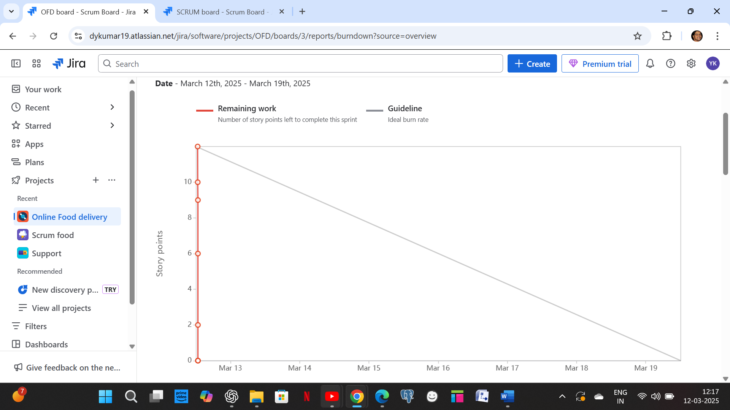

Product Burndown chart:

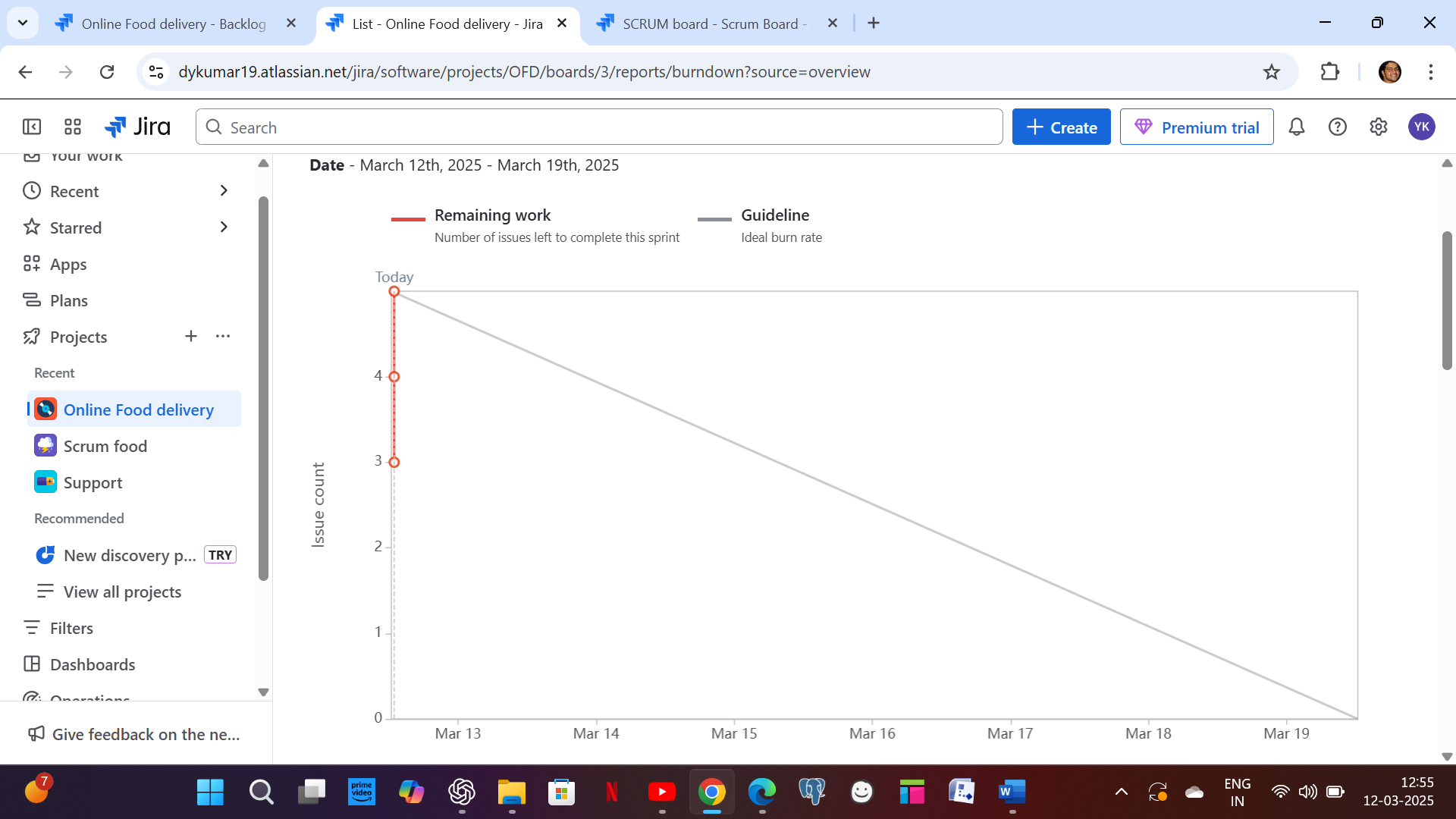

Q10. Explain about Product Grooming

A10. Product grooming, also known as backlog grooming or refinement, is a crucial activity in Agile development that involves preparing and refining items in the product backlog to ensure they are well-understood, prioritized, and ready for development.

Backlog Grooming Meetings are recurring meetings where the product owner and the development team come together to perform the activities mentioned above. These meetings often occur before sprint planning sessions to ensure that the upcoming sprint backlog is well-prepared.

Backlog grooming is an iterative process that helps maintain a healthy and well-organized product backlog. It ensures that the development team always has a prioritized list of well-defined, estimated, and ready-to-develop items. This, in turn, supports the efficient planning and execution of sprints and helps the team deliver value to customers in a more predictable and effective manner.

Q11. Explain the roles of Scrum Master and Product Owner

A11. Scrum Master: Scrum masteris the mentor coach or the leader for the agile development teams and allows the team to self-organize. It manages the process of information exchange between the team members and takes necessary steps accordingly owing to agile principles.

**Roles of Scrum Master:**

* Guides the team members working on the project. He checks whether the work is done and how much work is left out.
* Provides the goals and idea of any software which is newly going to be developed.
* Organizes meetings and supervises his teammates according to the scrum.
* Maintains a record of each staff working on the project.
* Helps scrum team to accomplish the work within the time period by clearing all the obstacles.
* It is his responsibility to keep his scrum team focused and dedicated to getting a high-level product.
* Removes the barrier between teammates and stakeholders by facilitating stakeholder collaborations.
* He is the main link between the project team and the organization.
* Ensures a good bonding between the scrum team, product owner, organization, project manager, and others.

Product Owner: A product owner is a role in an agile development who is responsible for the output or the final product ensures that it is up to date in terms of priorities with no backlog and has the items which are demanded in the current vision. The product owner represents the business and is accountable for collaborating with the customers to define what features will be in the product release.

**Roles of Product Owner:**

* Maximizes the value of the product resulting from the work of the development team.
* Manages the product backlog and the prioritized features list for the product.
* Prioritizes the work while planning a sprint in the meeting.
* Sets the goals according to customer demand and visualizes them to the scrum master, development team, business manager.
* Evaluate each and every stage of the progress of the project throughout the sprint of each event.
* Primary communicators between stakeholder and development teams.
* Takes major decisions by giving clear instructions and priorities of the sprint to the developers.
* Checks the final product and ensures whether to outreach the product to the customer.

Q12. Explain all Meetings Conducted in Scrum Project

A12. Meetings conducted in scrum project are:

**Sprint Planning**: This meeting kicks off each sprint, which is a time-boxed iteration of work, usually spanning 2-4 weeks. During this meeting, the Scrum team, including the Product Owner, Scrum Master, and Development Team, collaborates to determine which backlog items (user stories, features, etc.) will be worked on in the upcoming sprint. The team also breaks down these items into tasks and estimates the effort required.

**Daily Stand-up (Daily Scrum):**  Held daily during the sprint, this short meeting aims to facilitate quick and focused communication among team members. Each team member answers three key questions: What did I accomplish since the last stand-up? What will I work on until the next stand-up? Are there any obstacles or impediments in my way? This meeting helps keep everyone aligned and informed about the progress and challenges.

**Sprint Review:** At the end of each sprint, the team holds a review meeting to showcase the work completed during the sprint to stakeholders, customers, and the Product Owner. The team demonstrates the potentially shippable product increment and gathers feedback. Based on this feedback, the Product Owner can update the backlog.

**Sprint Retrospective: A**lso held at the end of each sprint, the retrospective is a dedicated time for the team to reflect on their processes and practices. The team discusses what went well, what could be improved, and any potential change they'd like to make in the next sprint to enhance their efficiency and effectiveness.

**Backlog Refinement (Grooming):** While not officially part of the Scrum events, backlog refinement is an important ongoing activity. During these sessions, the team and the Product Owner review and refine backlog items, adding details, clarifications, and estimates to make them ready for inclusion in future sprints.

**Product Backlog Refinement**: This meeting focuses on refining the product backlog items. The team and the Product Owner discuss and clarify requirements, priorities, and any changes needed in the backlog items. This ensures that the backlog is well-prepared for upcoming sprints.

**Release planning:** This meeting occurs at the start of the project or major release and involves the product owner, development team, and stakeholders. It aims to discuss and plan the high level scope, timeline, and goals for the project.

**Ad hoc meetings:** These meetings may be schedules as needed to address specific topics or issues, such as resolving impediments, discuss technical challenges, or conducting additional planning or collaboration sessions

Q13. Explain Sprint Size and Scrum Size

A13. **Sprint Size:**

In Scrum, a "sprint" is a time-boxed iteration during which the development team works to deliver a potentially shippable product increment. The length of a sprint is referred to as the "sprint duration" and is usually fixed throughout the project. Common sprint durations are 1 to 4 weeks. The choice of sprint duration depends on factors such as team velocity, project complexity, and business needs. A shorter sprint encourages more frequent opportunities for feedback and adaptation, while a longer sprint provides more time for development.

**Scrum size**

The Scrum team size refers to the number of individuals who collectively contribute to the development of the product. A Scrum team consists of three key roles: the Product Owner, the Scrum Master, and the Development Team. The Development Team, in particular, is responsible for creating the product increment. Scrum recommends that the Development Team size be kept small, typically between 3 to 9 members, to facilitate effective communication, collaboration, and decision-making.

Q14. Explain DOR and DOD

A14. DOR: The Definition of Ready outlines the criteria that a product backlog item (user story, feature, task, etc.) should meet before it is considered ready to be taken into a sprint for development. The DOR ensures that the item is well-defined, understood, and prepared for efficient development.

DOD: The Definition of Done outlines the criteria that must be met for a product increment or backlog item to be considered complete and potentially shippable. The DOD ensures that the team maintains a consistent level of quality and completeness in their work. A set of criteria that determines if a user story or task is complete. Ensures that the product meets customer expectations.

Q15. Explain Prioritization Techniques and MVP

A15. Prioritization techniques are methods used to determine the order in which tasks, features, or items should be addressed in a project. These techniques help teams allocate resources effectively and focus on delivering the most valuable work first. Some common prioritization techniques include:

**MOSCOW:** This technique categorizes items into Must have, should have, could have, and won't have categories. It helps clarify essential features from those that are optional or lower priority.

**Weighted Shortest Job First (WSJF):**WSJF assigns a priority score to each item based on factors like business value, time sensitivity, and risk. Items with higher scores are considered more important to work on.

**Kano Model**: This model categorizes features into Basic Needs, Performance Needs, and Delighters. It helps prioritize based on how features impact user satisfaction.

**Priority Poker**: This agile priority technique is based on similar rules as actual poker played with cards. When playing poker, prioritization is done in a calculative manner, with big wins being the ultimate goal. Similarly, in agile priority poker, items that will yield the highest results in specific target markets are given priority.

How are high priority items determined? Well, the project manager gathers all stakeholders of the project, which can also sometimes include end-users. The stakeholders are then asked to assign priority to each task or feature that is scheduled. The answers and then moderated and the list of priorities are compiled based on the rankings of the stakeholders.

**100 Dollar Test**: The stakeholders divide their 100 dollars by assigning a spending amount to each feature. Once all the 100 dollars are spent, the moderator then tallies all the points and the feature with the most dollars assigned is given the highest priority, followed by tasks with the next highest amounts. This is one of the easiest and the most effective techniques to ensure that all the stakeholders are in agreement with the priority list.

**Minimum Viable Product (MVP):** An MVP is the smallest version of a product that includes just enough features to provide value to early adopters and gather feedback. The MVP approach helps validate assumptions, learn from users, and iteratively build upon a product's foundation.

Q16. Difference between Business Analyst n Product Owner

A16.

|  |  |
| --- | --- |
| **Business analyst** | **Product owner** |
| Understanding business needs process and requirements | Define, prioritize and convey requirements for the product |
| Gathers and documented detailed business requirements | Creates user stories and define product features |
| Identifies problems, in efficiencies and suggest improvements | Drives the product vision, strategy and value proposition |
| Creates documentation of  Business rules, work flows, and requirements | Manage the product backlog and maintains clear user stories |
| Helps define scope of the project based on business needs | Define the product features and enhancement |
| Does not have primary role in prioritizing features | Prioritize features based on business needs, customer value and market trends |
| Provide inputs but not responsible for final product decisions | Make final decision on product features, enhancement and priorities |
| Contributes to process improvement and business efficiency | Incorporates feedback for ongoing product enhancement |

Q17. Prepare a sample Resume of 3yrs exp Product Owner

A17. 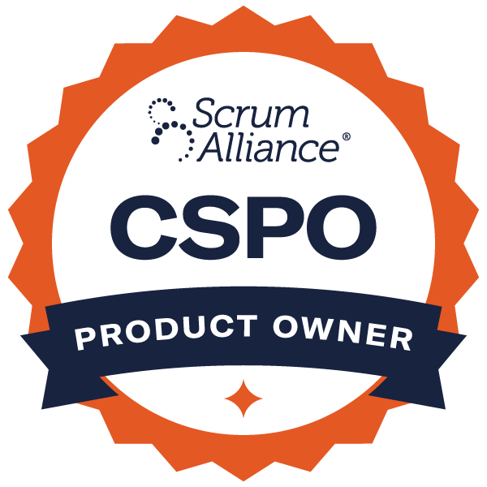

**CURRICULUM VITAE**

**D.YASHWANTH KUMAR**

Manish Reddy, Flat E2, Financial district, Hyderabad – 500032.

**Mobile**:+91-8978550079**, E-mail** :dykumar19@gmail.com.

# Professional Objective

Intend to build a career with leading corporate of hi-tech environment with committed and dedicated people that will challenge me and allow me to use my experiences in a way that is mutually beneficial to myself and my employer and allow for future growth and advancement.

# Professional Profile

* Overall experience of 9 years, including 6 years as Product owner and 3 years as Business Analyst/Functional in Retail Banking Domain with experience on Waterfall and Agile methodologies. Proven track record of leadership skills with an ability to develop high-performing team and team members.
* Possess ample experience in gathering, analysing and documenting business requirements. Also have good experience in creating and maintaining Product Backlog & User Stories. Develop gap analysis, prepare mock-ups, impact analysis, new initiatives, presentations. Strong knowledge on SDLC.
* Dedicated to meeting and exceeding expectations for product launches and sprint updates.
* Good at handling multi tasks.

# Core Skills

* Product vision, creating roadmaps for product delivery, requirement gathering, User Stories, Gap Analysis, Traceability Matrix, Process Maps, Competitive analysis.
* MS Excel, JIRA, MS visio, Power BI, SQL, Axure RP.

# 

# Certification Details

Scrum Alliance Certified Scrum Product Owner®

Digital Badge: <https://bcert.me/sypnmztyi>

Expiry date: 12/08/2026

Badge id: 2026133

# Professional Experience

Organization : **ICICI Bank**

Designation : Chief Manager

Domain : IT – Product owner

Duration : Jul 2023 – Jun 2024

**Roles & Responsibilities**:

* Coordinate projects with business users, development staff and infrastructure teams.
* Identify and prioritize application features in conjunction with business users.
* Effective communicating with technical and non-technical stakeholders across multiple initiatives.
* Oversees all aspects of system analysis, design, development, maintenance, assesses the Business Requirements, evaluates possible technical solutions and recommendations.
* Creating user stories, managing product backlog items. Ensuring the quality product deliverables continuously. Learning from feedback from client, shareholders.
* Determining work priorities and schedules work assignments.
* Ensuring the applications are developed in a way that complies with architectural standards and established methodologies, policies and practices.

# Professional Experience

Organization : **HDFC LTD**

Designation : Deputy Manager

Domain : IT **–** Product owner

Duration : Oct 2017 – Dec 2022

**Roles &Responsibilities**:

* Facilitated project meetings to capture testing and project updates within credit risk reporting processes.
* Created project plans/timelines, resolved issues to promote efficient and successful project releases across multiple teams.
* Led multiple tasks to implement best practices by documenting, tracking end-to-end life cycle review and signoff processes.
* Collaborated closely with technology, business partners to develop business requirement documents, and test scripts during multiple release phases.

# Professional Experience

Organization : **Capgemini**

Designation : Consultant

Domain : Banking

Duration : April 2016 – Sept 2017.

**Roles &Responsibilities**:

* Analysing clients' business processes and functional needs.
* Writing requirement specifications and functional specifications.
* Assisting the business owner in defining project objectives.
* Participating in the analysis of impacts on the organization and work processes.
* Supporting change management.

# Professional Experience

Organization : **HDFC Bank**

Designation : Executive trainee

Domain : Business Banking

Duration : Mar 2015 – April 2016

**Roles & Responsibilities:**

* Act as a liaison between business and technical teams to ensure requirements are met.
* Communicate findings, technical insights, and recommendations to non-technical stakeholders.
* Work closely with engineering, product management, and data teams to align objectives and ensure project success.
* Analyse existing processes and suggest improvements to enhance efficiency and effectiveness.
* Create and maintain reports and dashboards to provide data-driven insights for decision-making.
* Define and monitor key performance indicators (KPIs).

# Professional Experience

Organization : **CONVERGYS**

Designation : Associate Programming/Analysis for development.

Domain : AS400 (Synon)

Duration : Jun 2011 – Aug 2012

# Project Undertaken in CONVERGYS

Project Name : ICOMS

Roles and Responsibilities : Development followed by functional testing and bug fixing.

# Academic Record

|  |  |  |  |
| --- | --- | --- | --- |
| **Degree** | **Year** | **School/College** | **Percentage or CGPA** |
| PGDM(Finance,Analytics) | 2013-2015 | Institute of Management  Technology(IMT), Hyderabad | 7.44 CGPA |
| B.Tech (ECE) | 2007-2011 | MVGR College of Engineering, JNTU Kakinada, Vizianagaram | 73.23% |
| XII(IPE) | 2007 | Sri Chaitanya Jr. College,  Visakhapatnam | 93.40% |
| X(ICSE) | 2005 | St. Aloysius High School, Visakhapatnam | 70.66% |

**Strengths**

• Good Team Spirit, Positive Attitude, Adaptability, Multitask.

# Personal Details

|  |  |
| --- | --- |
| Father’s Name | : D.AnandaRao |
| Mother’s Name | : D.Padmaja |
| Date of birth | : 19-08-1989 |
| Languages Known : Telugu and English | Languages Known : Telugu and English |

**Declaration**

I hereby declare that all the details furnished are true up to the best of my knowledge.

Place:

Date: **(D. YASHWANTH KUMAR)**