**Online Agriculture Product Store**

1. (BPM) Business Process Model for Online Agriculture Store.

* **Goal:** To build an online store for Farmers to purchase a Agriculture Products (Like. Seeds, Fertilizers, Pesticides).

**Inputs:** Agriculture Products like, Seeds, Fertilizers, Pesticides. Customer Data, Marketing Campaigns, Customer data is used for marketing through Text messages and Emails to provide timely updates on products and offers. Trained employees to manage the website and application.

**Resources:** User friendly Software and Mobile Application that any farmer can use. A Warehouse to store products. Office space for the manage all operations.

**Output:** Verified products to provide the best products to farmer. Maximum sales revenue and operational efficiency is crucial for an online store.

**Activities:** Products listing by manufacturers. Order placement then payment processing and Deliver products and co-ordination with logistics. Excellent customer support for any queries related to products and application usage.

**Value:** A wide range of products is provided to meet the needs of farmers. Customer satisfaction is delivering quality products, reducing procurement delays, excellent service, and timely support, ensuring trust and loyalty.

1. SWOT Analysis.

* **Strength:** i) Strong Manufacturers and suppliers

ii) Building a strong reputation in an online agriculture store enhances customer satisfaction.

**Weakness:** i) Dependence on external vendors can impact business operations.

ii) Dependence on internet connectivity in rural areas is challenging due to the lack of reliable internet connections.

iii) Limited experience in agriculture supply chain.

**Opportunities:** i) Expanding into the undeserved rural agricultural market is a strategic opportunity.

ii) Building long term partnership with farmers and manufacturers enhances sustainability and reliability.

iii) Verified products come directly from the manufacturer to expand online market.

**Threats:** i)Competition from existing agricultural supply platform.

ii) The changes customer spending habits and preferences.

iii) Economic downturns can negatively impact businesses and overall economic growth.

1. Feasibility study.

Budget

Amount Assign to the project – 2 Crore

Cost Estimated – 1,60,00,000

Technology Used: Based on the database servers, Payment gateways, Security and API’s

Web Server: Apache, Nginx

Database server: MySQL

Programming Language: Javascript, Python, PHP

Content Management System: WorldPress, Drupal, Magento

10 Lakh

Hardware

Web Servers: Dell PowerEdge, HP ProLiant, IBM System X

Database Servers: Dell PowerEdge, HP ProLiant, IBM System X

Load Balancer: F5 Big-IP, Citrix NetScaler, HA Proxy

Storage Devices: Dell EqualLogic, HP3PAR, NetApp FAS

5 Lakh

Software

Content Management System: WordPress, Drupal, Magento

Ecommerce Platform: WooCommerce, Shopify, Magento

Payment Gateway: PayPal, UPI, Phonepe

Security Application: SSL Certificate, Firewall, Anti-Malware

15 Lakh

Resources

PM- 1 Lakh/Month

BA- 75000 /Month

Java Development team (5Members)- 2,50,000

Network Admin- 30,000

DB Admin- 25,000

Tester (2 Members) – 70,000

18 Months

1. GAP Analysis.

* **AS-IS:**
* An Established Online Agriculture Product store with a wide range of products and user friendly application.
* Collaborate with manufacturers and limited product suppliers.

**TO BE:**

* Digital platform for direct manufacturer and farmer interaction.
* Real time product update and delivery tracking.
* Payment gateway
* Expansion into new product manufacturing brands.
* Continue investing in enhancing software and customer experience.

1. Risk Analysis.

* **Internal Risks:**
* Dependence on external manufacturers for product supply and Inventory management.
* High operating expenses due to investment in technology and marketing campaigns.
* Technical issue and system and payment gateway downtime that can affect the customer experience.

**External Risks:**

* Intense competition from other online Agriculture store.
* Changes in government regulations and policies that affect the e-commerce industry.
* Logistics delays.

**BA Risks:**

* Incomplete requirement gathering
* Improper Documentation
* Change in requirement
* Lack of Domain Expertise
* Infrequent stakeholder involvement

**Project Based Risks:**

* Scope risk.
* Stakeholder risk.
* Timeline overrun
* Testing challenges
* Internet connectivity issues

1. Stakeholder Analysis (RACI Matrix)?

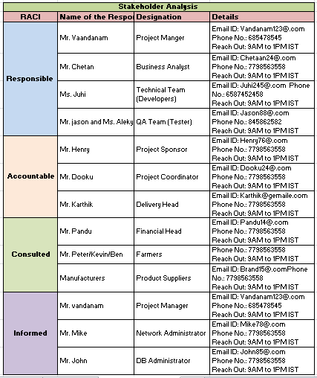

1. Business Case Document?
2. Why is this project initiated?

* This Project initiated because, there is a gap between a current state and future state. Currently farmers face difficulties such as not being provided seeds, fertilizers and pesticides on time by local vendors. To address this problem, we have established an online agriculture product store offering a wide range of products. This enables farmers to conveniently purchase items through application and receive timely delivery in any rural area.

1. What are the current problems?

* Farmers are facing difficulties in procuring seeds, fertilizers and pesticides and they have to cover long distances to purchase agriculture products.

1. With this project, how many problems could be solved?

* We solved farmer’s difficulties in procuring agriculture products by making it convenient and easy for farmers to purchase products online through our application. We also connected them with selected, trusted brands.

Real time product updates, an easy payment gateway, delivery tracking and on time delivery are provided.

Expansion into new product brands to enhance 24*7 customer service.

1. What are the resources required?

* We have 11 people.

Project Manager – Mr. Vandanam

Business Analyst – Mr. Chetan

Java Developer – Ms. Juhi, Mr. Teyson, Ms. Lucie, Mr. Tucker, Mr. Bravo

Network Admin – Mr. Mike

DB Admin – John

Tester – Mr. Jason and Mr. Alekya

1. How much organizational change is required to adopt this technology?

* **Current state:** Farmers rely on local vendors for seeds, fertilizers and pesticides, which often lead to delays and inefficiencies. There is no centralized platform for farmers and manufactures to interact directly.

**Proposed Change:** The introduction of an online agriculture product store will require significant organizational changes, including-

* **Technology adoption:** Farmers and manufacturers will need to adopt the new online platform, which may require training and support.
* **Process Changes:** Farmers will shift from traditional purchasing methods to online ordering and manufacturers will need to integrate their systems with the platform.
* **Infrastructure Upgrades:** Farmers in remote areas may need improved internet connectivity to access the platform.
* **Organizational structure:** The Project team (APT IT SOLUTIONS) will need to coordinate with stakeholders (farmers, manufacturers and Mr. Henry team) to insure smooth implementation

**Change Management:** A structured change management plan will be required to train users, address resistance, and ensure adoption.

1. What is time frame to require ROI?

* **Initial Investment:** The Project has a project of 2 Crores and a timeline 18 months

**Revenue Streams:**

Transaction fees: A small percentage of each transaction on the platform.

Subscription fees: Manufacturers may pay a subscription fees to list their product.

Advertising revenue: Companies can pay for premium advertising space on the platform

**ROI recovery time frame:** Based on projected user adoption and revenue growth, the ROI is expected to be recovered within 3-4 Years.

1. How to identify stakeholder?

Stakeholders are individual or groups who have an interest in the project or will be affected by its outcomes. They can be identified as follows:

Primary Stakeholder:

**Farmers:** Peter, Kevin, Ben and other farmers who will use the platform to purchase the products.

**Manufacturers:** Companies producing seeds, fertilizers and pesticides.

**Project Team:** APT IT SOLUTIONS team (Mr.KArthik, Mr. Vandanam, Developers and testers etc.)

**Committee:** Mr. Henry, Mr. Pandu and Mr. Dooku who oversee the project.

Secondary stakeholder:

Local vendors: May be impacted by the shift to online purchasing.

Government agencies: May have interest in the project success as it supports rural development.

Stakeholder Identification process:

**Brainstorming:** Conduct meeting with the project team to list potential stakeholder.

**Interviews:** Speak with farmers, manufacturers, and other relevant parties to understand their needs and concerns.

**Stakeholder Mapping:** Use tool like the RACI Matrix to categorize stakeholder based on their roles. (Responsible, Accountable, Consulted, Informed).

**Feedback Loop:** Continuously engage with stakeholder throughout the project to insure their needs are met.

1. Four SDLC Methodologies.

* **Sequential (Waterfall):** The waterfall is a linear and sequential approach where each phase (Requirement, Design, Development, Testing, Deployment) is completed before moving to the next. It is best for projects with well-defined requirements and minimal changes expected. However, lacks flexibility as revisiting previous phases is difficult once completed.

**Iterative:** The Iterative model involves repeating cycles of development and testing. Each iteration produces a working version of the product, which is refined over time. This approach is useful for projects where requirements evolve, as it allows for continuous improvement and feedback incorporation.

**Evolutionary:** The Evolutionary model focuses on gradual development, starting with a basic version of the product and enhancing it over time based on user feedback. It is ideal for project where the end goal is unclear, as it allows for flexibility and adaptation to changing requirements.

**Agile:** Agile is a flexible, iterative approach that emphasizes collaboration, customer feedback, and small, frequent deliverables. It is best suited for dynamic projects with changing requirements. Agile promotes adaptability and ensures that the final product aligns closely with user needs.

1. Write about the SDLC models?

* **Waterfall Model:** The Waterfall model is a linear and sequential approach where each phase (Requirement, Design, Development, Testing, Deployment) is completed before moving to the next. It is best for project with well-defined requirements and minimal changes expected. However, it lacks flexibility, as revisiting previous phases is difficult once completed. It is ideal for small, predictable projects.

**V Model:** The V-Model is an extension of Waterfall model, emphasizing verification and validation. Each development phase (e.g., requirements, design) has a corresponding testing phase (e.g, unit testing, system testing). This ensures early detection of defects and high quality output. It is suitable for projects where quality and reliability are critical, such as in healthcare and aerospace.

**Spiral Model:** The Spiral model combines iterative development with risk analysis. It involves repeated cycle (Spirals) of planning, risk analysis, development and evolution. This model is ideal for large, complex with high uncertainly, as it allows for continuous risk management and flexibility in adapting to changes.

**Srcum:** Scrum is an agile framework that focuses on delivering value in short iterations called sprints (typically 2-4 weeks). It emphasizes collaboration, adaptability and continuous improvement. Scrum team work in cross-functional roles, with regular feedback from stakeholders. It is best for dynamic projects with evolving requirements.

**RUP (Rational Unifies Process):** RUP is an iterative framework that divides the project into four phases: inception, elaboration, construction and transition. It emphasizes documentation, risk management and adaptability. RUP is suitable for large-scale projects where thorough planning and control are required, but it can be resource intensive due to its detailed process.

1. Difference between Waterfall and V Model?



|  |  |
| --- | --- |
| **Waterfall** | **V-Model** |
| 1) Linear and sequential, with each phase completed one after the other. | 1) Extends the waterfall model with a V shape where each development phase. |
| 2) Testing is performed only after the development phase is complete. | 2) Testing is integrated into each phase of development, with specific test plans created alongside design and requirement. |
| 3) Inflexible, as revisiting previous phases is difficult once completed. | 3) Slightly more flexible due to the parallel planning of development and testing, but still less adaptable than agile models. |
| 4) Require expensive documentation at each phase, but testing documentation is created only after development. | 4) Emphasizes detailed documentation for both development and testing phase, ensuring alignment between requirements and testing. |
| 5) Less Expensive | 5) More Expensive |
| 6) Less Customer interaction. | 6) More customer interaction. |

1. Justify Your Choice.

* I recommend the V-Model over the Waterfall Model. The V-Model is better suited because it integrate testing at every development stage, ensuring quality and reducing risk crucial for a user friendly application targeting farmers, many of whom new to online platforms. In this project, requirements like product browsing, ordering and delivery need to be spot on from the start and the V-Models verification and validation process ensures errors are caught early. For ex. If the fertilizer or seeds catalog display isn’t intuitive, we can fix it before coding progress too far. Waterfall, on the other hand, delays testing until the end, risking costly rework it farmer’s needs aren’t made.

1. Gantt Chart.

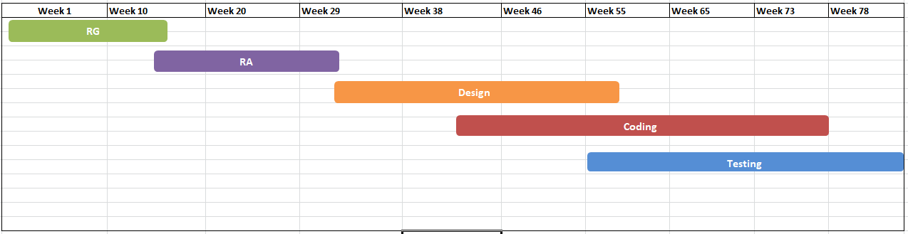

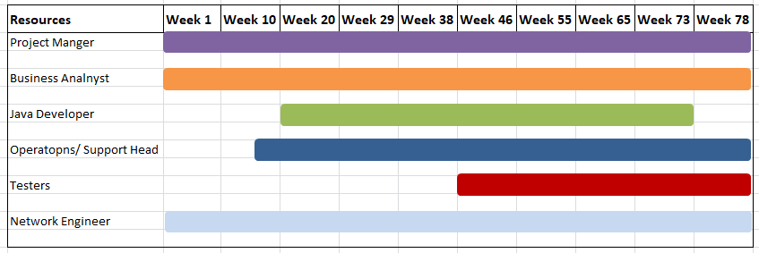

1. Explain the difference between Fixed bid and billing projects.

* **Fixed Bid:** In a Fixed Bid project, the client and service provider agree on a fixed price for the entire project, regardless of the time or resources used. This model is suitable for well-defined requirements and scope. The provider bears the risk of cost overruns, while the client has a clear budget. However, changes in scope may require renegotiation.

**Billing:** In billing (Time and Materials), the client pays based on the actual time and resources spent. This model is flexible and ideal for projects and evolving requirements. The client bears the risk of cost overruns, but it allows for adjustments during the project. It is commonly used in Agile or iterative projects.

1. Timesheets.

i) Design Timesheet of a BA

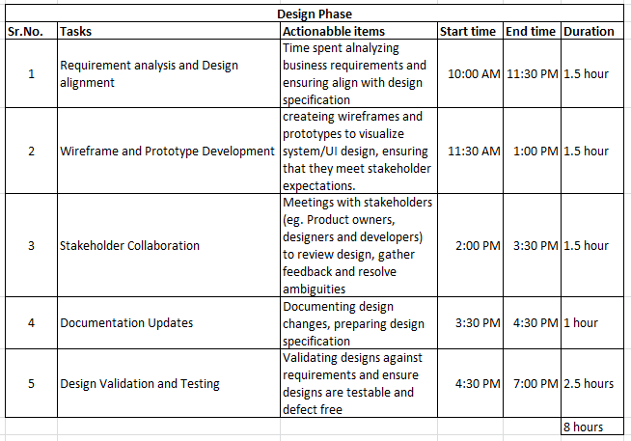

ii) Development Timesheet of a BA

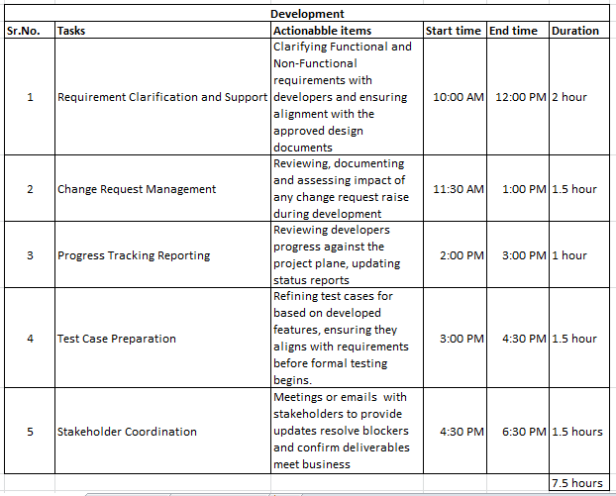

iii) Testing Timesheet of a BA

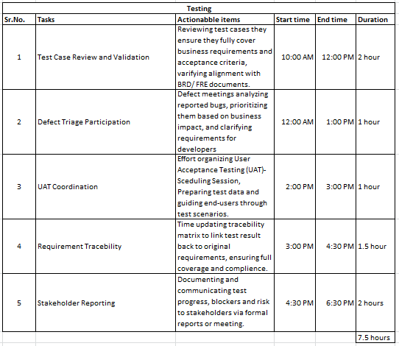

iv) UAT Timesheet of a BA

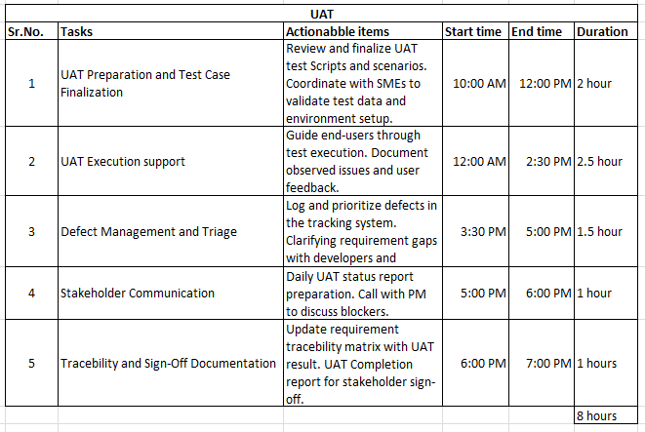

v) Deployment and Implementation Timesheet of a BA

