Waterfall Model Documents

  - Document No 6

Use Case Diagram

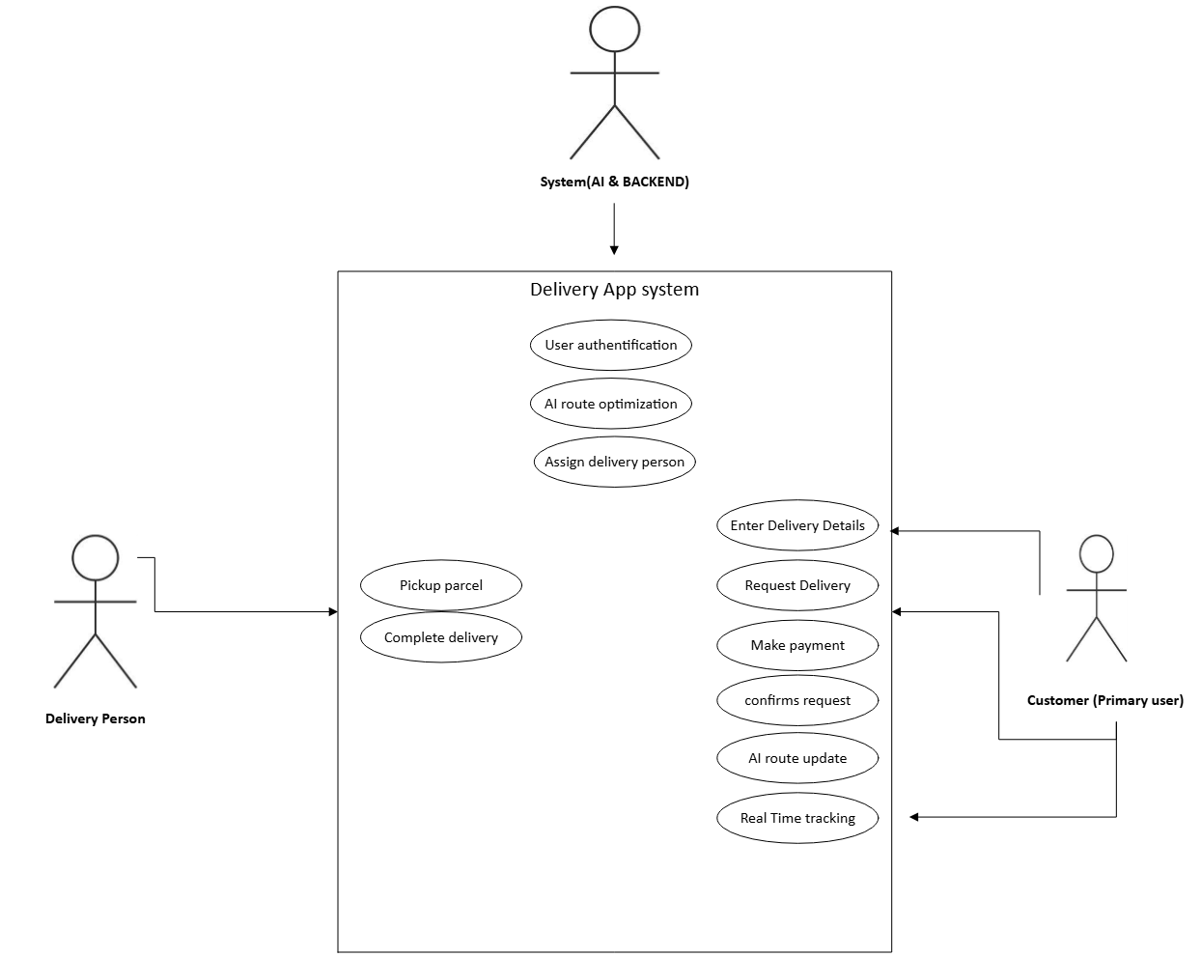

Activity Diagram

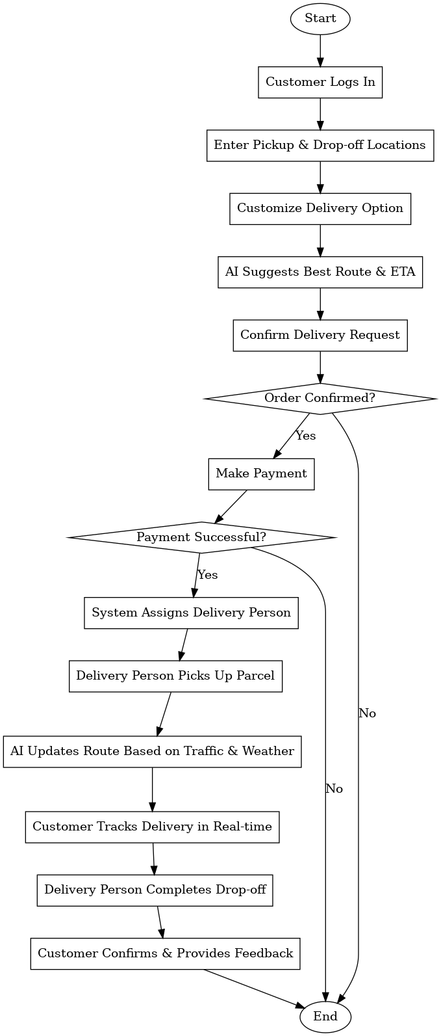

Use case Specification Document

Use case Name
Order Placement and Delivery Management

Use Case Description:
This use case details the process of placing, processing, and delivering an order through the customizable delivery app. The app allows users to place inter-city delivery requests with AI-powered route optimization and tracking. AI helps in selecting the best delivery routes, assigning delivery personnel, and estimating the fastest delivery time.

Actors:
- Primary Actors:
  - Customer
  - System (AI-enabled route optimizer, order manager)
  - Delivery Personnel
- Secondary Actors:
  - Payment Gateway
  - Customer Support

Basic Flow:
- Customer logs into the app.

- Customer enters the pickup and drop-off locations.

- AI suggests the best routes and estimated delivery times.

- Customer confirms the delivery request.

- Customer selects a payment method and completes payment.

- System assigns a delivery person based on AI optimization.

- Delivery person picks up the parcel.

- AI continuously updates the best route based on traffic and weather.

- Customer tracks delivery in real-time.

- Delivery person completes the drop-off.

- Customer confirms order completion and provides feedback.

Alternate Flow:
- If the customer cancels before pickup, the system refunds the payment.

- If the delivery person is unavailable, the system assigns another one automatically.

- If the AI suggests an unavailable route, an alternate route is selected.

Exceptional Flows:
- If payment fails, the customer is prompted to retry or select a different method.

- If the delivery person is delayed, the system notifies the customer and re-routes.

- If the item is undeliverable (damaged/lost), customer support intervenes for resolution.

Pre-Conditions:
- The customer must be a registered user.

- Pickup and drop-off locations must be serviceable.

- AI must have access to live traffic and weather data.

Post-Conditions:
- The order is successfully delivered.

- The customer receives a confirmation notification.

- The delivery history is updated in the system.

Assumptions:
- Customers provide accurate pickup/drop-off details.

- Delivery personnel follow AI-recommended routes.

- AI predictions are based on real-time data and are accurate.

Constraints:
- Delivery service is available only in predefined cities.

- AI optimization depends on internet connectivity.

- Limited delivery slots for high-demand areas.

Dependencies:
- Payment gateway for processing transactions.

- AI route optimizer for efficient delivery.

- GPS tracking system for real-time updates.

- Customer support for issue resolution.

Inputs and Outputs:
- Inputs: Pickup and drop-off locations, package details, payment details.

- Outputs: Estimated delivery time, real-time tracking, notifications.

Business Rules:
- Orders cannot be placed without payment confirmation.

- Customers can cancel an order within 2 minutes of placement.

- AI assigns delivery personnel based on proximity and availability.

- High-value deliveries require identity verification upon receipt.

- Delivery cannot exceed a weight limit of 30kg per package.

Miscellaneous Information:
- Customers receive an AI-generated estimated time of arrival (ETA).

- AI dynamically reroutes deliveries based on real-time traffic.

- AI-assisted support chat is available for customer queries.

- Customers can schedule future deliveries within a 48-hour window.

- Integration with smart assistants (Alexa, Google Assistant) for voice-based order placement.

  - Document No 7

Screens and pages

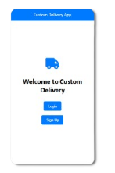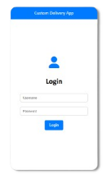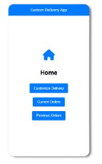

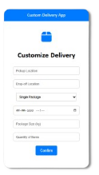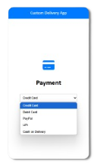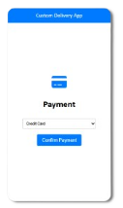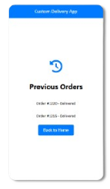

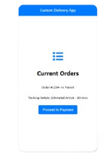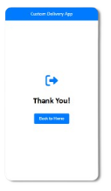

  - Document No 8

Tools-Visio and Axure
For this project, Microsoft Visio was instrumental in creating clear and structured use case diagrams and activity diagrams. Its intuitive drag-and-drop interface helped in designing UML-based representations, ensuring that workflows and interactions were well-documented. The ability to use pre-defined shapes and templates made it efficient to map out complex processes.

Axure RP was used for developing high-fidelity wireframes and interactive prototypes. It provided an excellent platform to visualize user flows and refine the UI/UX for the customizable delivery app. The ability to create clickable prototypes allowed for better demonstration and validation of the application’s functionalities before actual development. The combination of Visio for system diagrams and Axure for wireframes helped create a seamless and structured approach to designing the app.

  - Document No 09

BA experience

Requirement Gathering:

- Gathered business requirements from stakeholders through discussions.

- Documented all necessary features for the customizable delivery app.

- Ensured clarity in scope to align with the project objectives.

Requirement Analysis:

- Analyzed the gathered requirements and structured them for development.

- Created use case diagrams and workflows to represent the system behavior.

- Reviewed the feasibility of features based on business and technical constraints.

Design:

- Developed wireframes and UI layouts using Axure to visualize the app’s functionality.

- Ensured a user-friendly and intuitive design aligned with business needs.

- Reviewed the designs with stakeholders and refined them based on feedback.

Development:

- Worked closely with developers to ensure the implementation of requirements.

- Provided necessary clarifications regarding functionality and expected outcomes.

- Ensured that the development followed the structured approach of the Waterfall Model.

Testing:

- Assisted in validating the app's functionality by reviewing test cases.

- Ensured that all features worked as intended before deployment.

- Identified and addressed any usability or functionality gaps before release.

Deployment:

- Verified that the final version of the application met all requirements.

- Supported documentation and user training to ensure smooth adoption.

- Coordinated with stakeholders to facilitate a seamless launch.

