Q1. Draw a Use Case Diagram
A customer can make a payment either by Card or by Wallet or by Cash or by Net banking.
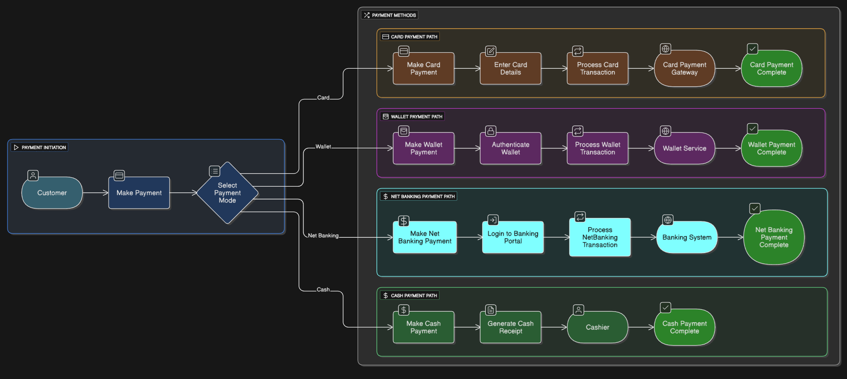

Q2. Derive Boundary Classes, Controller Classes, Entity Classes
1. Boundary Classes
Boundary classes handle the interaction between the system and external actors (e.g., UI screens, APIs).
Boundary Class Name | Purpose
PaymentUI | Interface to initiate payment and display overall status
PaymentModeSelectionUI | Presents options: Card, Wallet, Net Banking, Cash
CardPaymentForm | Form for entering card number, expiry date, CVV
WalletPaymentScreen | Interface for wallet selection and displaying balance
NetBankingLoginPage | Captures bank username/password and login flow
CashPaymentConfirmationUI | Screen to confirm and acknowledge cash payment receipt

2. Controller Classes
Controller classes handle the flow of control and coordination between UI and business logic.
Controller Class Name | Purpose
PaymentController | Orchestrates the overall “Make Payment” workflow
CardPaymentController | Validates card details and invokes card-gateway transaction logic
WalletPaymentController | Manages wallet authentication, selection, and transaction processing
NetBankingController | Handles bank portal login and processes net-banking transactions
CashPaymentController | Triggers cash-receipt generation and confirms payment completion

3. Entity Classes
Entity classes represent the persistent domain data used across payment modes.
Entity Class Name | Purpose
Customer | Stores customer profile information (ID, name, contact)
Payment (abstract) | Defines common payment attributes: paymentID, amount, date, status
CardDetails | Holds card-specific data: cardNumber, expiryDate, CVV
WalletAccount | Represents wallet account: walletID, balance
BankAccount | Contains bank account info: accountNumber, IFSC, bankName
TransactionLog | Records each transaction: logID, timestamp, details
CashReceipt | Captures receiptNumber, issuedDate, and paidAmount

Q3. Place These Classes on a Three-Tier Architecture
The three-tier architecture consists of the Presentation Tier, Business Logic Tier, and Data Tier. Below is the classification of boundary, controller, and entity classes into appropriate tiers based on their responsibilities:
Tier | Classes Placed | Purpose
1. Presentation Tier | PaymentUI, PaymentModeSelectionUI, CardPaymentForm, WalletPaymentScreen, NetBankingLoginPage, CashPaymentConfirmationUI | Handles all user interactions, input forms, and UI displays
2. Business Logic Tier | PaymentController, CardPaymentController, WalletPaymentController, NetBankingController, CashPaymentController | Processes user inputs, applies business rules, and coordinates between UI and data layers
3. Data Tier | Customer, Payment, CardDetails, WalletAccount, BankAccount, TransactionLog, CashReceipt | Stores and manages data; interacts with databases and external systems (e.g., payment APIs)

Each class has been placed logically based on its role in the application architecture.
- Presentation Tier = Boundary (UI) classes
- Business Tier = Controllers (logic handlers)
- Data Tier = Entities (persistent domain models)
Q4. Explain Domain Model for Customer Making Payment Through Net Banking
A Domain Model represents the key business entities, their attributes, and relationships within a specific context.
"Customer making a payment through Net Banking."
Key Entities & Their Attributes
Entity Name | Key Attributes | Description
Customer | customerID, name, email, contactNumber | Represents the individual making the payment
Payment | paymentID, amount, date, status, paymentMode | Abstract entity capturing the payment details
NetBankingDetails | bankName, accountNumber, loginID | Specific details used for Net Banking transaction
BankAccount | accountNumber, IFSC, accountHolderName, bankBranch | Linked bank account used to complete the payment
TransactionLog | transactionID, timestamp, responseStatus, remarks | Maintains a log of the net banking transaction for audit and status tracking

Entity Relationships
- Customer → Payment
A customer initiates one or more payments.
- Payment → NetBankingDetails
If paymentMode = NetBanking, the transaction contains net banking credentials.
- NetBankingDetails → BankAccount
The net banking session is linked to a specific bank account.
- Payment → TransactionLog
Each payment is logged with timestamp and result status for auditing.
Explanation:
- The Customer entity initiates the Payment via Net Banking.
- The NetBankingDetails hold temporary credentials and session info.
- The BankAccount entity is used to debit the amount.
- The entire activity is captured in the TransactionLog for traceability.
Q5. Draw a Sequence Diagram for Payment Done by Customer Using Net Banking
A sequence diagram illustrates the step-by-step interaction between objects or components in a time-ordered manner. Below is the sequence of events for the scenario where a Customer makes a payment using Net Banking.
Participants (Objects/Actors)
- Customer (Actor)
- PaymentUI (Boundary)
- PaymentController (Controller)
- NetBankingController (Controller)
- BankAccount (Entity)
- BankingSystem (External System)
- TransactionLog (Entity)
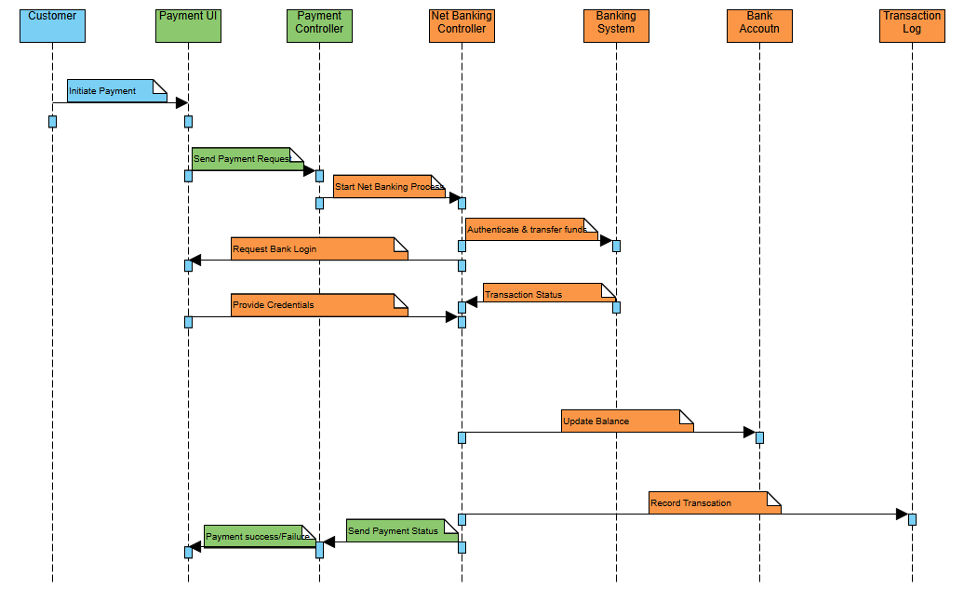
Sequence Flow

- Customer → PaymentUI: Initiates “Make Payment”
- PaymentUI → PaymentController: Sends payment request with selected mode = Net Banking
- PaymentController → NetBankingController: Delegates the net banking process
- NetBankingController → PaymentUI: Requests bank login credentials
- PaymentUI → NetBankingController: Submits credentials
- NetBankingController → BankingSystem: Authenticates and initiates fund transfer
- BankingSystem → NetBankingController: Sends transaction status (success/failure)
- NetBankingController → BankAccount: Updates account balance
- NetBankingController → TransactionLog: Logs transaction details
- NetBankingController → PaymentController: Sends final payment status
- PaymentController → PaymentUI: Displays success/failure message to Customer

Q6. Explain Conceptual Model for This Case
A Conceptual Model is a high-level representation of real-world concepts involved in the system, focusing on business understanding without involving technical or implementation-specific details. It identifies major business entities, their relationships, and behaviors in the context of the Customer making a payment through Net Banking.
Key Concepts in the Model
Concept | Description
Customer | A user who initiates the payment
Payment | A transaction initiated by the customer to transfer funds
Payment Mode | The selected method of payment (Card / Wallet / Net Banking / Cash)
Net Banking | A specific mode of payment using online bank credentials
Bank | The financial institution handling fund transfer and authentication
Bank Account | The customer’s account used for the transaction
Transaction | The result of a payment processed through the bank
Payment Status | Indicates whether the payment is successful, pending, or failed
Conceptual Relationships
- Customer initiates → Payment
- Payment is made using → Payment Mode (Net Banking)
- Net Banking is processed by → Bank
- Bank operates on → Bank Account
- Payment results in → Transaction
- Transaction has → Payment Status
Explanation:
It highlights that a Customer, using Net Banking, interacts with a Bank, through a Bank Account, to initiate a Payment, which generates a Transaction and results in a Payment Status.
Q7. What is MVC Architecture? Explain MVC Rules to Derive Classes from Use Case Diagram and Guidelines to Place Classes in 3-Tier Architecture
1. What is MVC Architecture?
MVC (Model-View-Controller) is a design pattern used to separate an application into three main interconnected components:
Component | Description
Model | Represents the data and business logic. It manages the state of the application.
View | Represents the user interface (UI). It displays the data to the user.
Controller | Handles user input, processes it, and updates the model or view accordingly.
2. MVC Rules to Derive Classes from Use Case Diagram
To derive classes from a use case diagram using MVC principles, the following rules are followed:
Component | Derivation Rule from Use Case Diagram
Boundary Classes (View) | Derive one boundary class for each actor–use case interaction. E.g., for each form or screen where user inputs/outputs are handled.
Controller Classes (Controller) | Derive one controller class for each use case. It coordinates the interaction between boundary and entity classes.
Entity Classes (Model) | Derive entity classes based on business/domain objects identified in the use case or associated domain model. These persist and manage business data.
Example:
For the use case “Make Payment”, with modes: Card, Wallet, Net Banking, Cash
- Boundary: PaymentUI, CardFormUI, etc.
- Controller: PaymentController, CardPaymentController, etc.
- Entity: Payment, Customer, Transaction, BankAccount
3. Guidelines to Place Classes in 3-Tier Architecture
The MVC components map directly to the 3-tier architecture, as shown below:
Tier | Mapped MVC Component | Types of Classes Placed
Presentation Tier (UI) | View | All Boundary Classes (e.g., forms, pages, screens that interact with users)
Business Logic Tier | Controller | All Controller Classes (e.g., classes controlling business flow and validation logic)
Data Tier | Model | All Entity Classes (e.g., domain objects like Payment, Customer, BankAccount, etc.)

Summary:
- MVC promotes separation of concerns: UI, business logic, and data management
- Classes are systematically derived from the use case diagram
- Proper placement of classes in the 3-tier architecture ensures scalability, maintainability, and modular design
Q8. Explain BA Contributions in Project (Waterfall Model – All Stages)
The Waterfall Model is a linear and sequential software development methodology where each phase must be completed before moving to the next. A Business Analyst (BA) plays a critical role in every stage of this model to ensure that business needs are understood, communicated, and fulfilled correctly.
1. Requirements Gathering & Analysis Phase
BA Contributions
- Interacts with stakeholders to gather functional and non-functional requirements
- Conducts elicitation techniques like interviews, workshops, and document analysis
- Documents requirements in BRD (Business Requirement Document) or SRS (Software Requirement Specification)
- Validates requirements through walkthroughs and reviews with stakeholders
- Ensures that all requirements are clear, complete, and testable
2. System Design Phase
BA Contributions
- Supports the design team by clarifying business requirements
- Participates in use case modeling, process flow diagrams, wireframes, and prototypes
- Ensures traceability between requirements and design elements
- Validates that the design aligns with business objectives and user expectations
3. Development Phase
BA Contributions
- Acts as a liaison between business and development teams
- Answers developer queries related to functional logic and rules
- Participates in scrum or daily meetings (if followed) to address blockers from a business standpoint
- Verifies that development is being done as per documented and approved requirements
4. Testing Phase
BA Contributions
- Prepares or reviews test cases, test scenarios, and UAT (User Acceptance Testing) scripts
- Performs Requirement Traceability Matrix (RTM) to ensure complete coverage
- Coordinates and supports UAT with end-users
- Helps identify and prioritize bugs or gaps found during testing
- Validates test results against original requirements
5. Deployment Phase
BA Contributions
- Ensures all business processes and workflows are updated to reflect the new system
- Supports the release team with documentation, FAQs, and end-user manuals
- Helps coordinate training sessions and user onboarding
- Acts as a point of contact for any last-minute clarifications
6. Maintenance Phase
BA Contributions
- Gathers feedback from users for improvements or issues
- Helps prioritize enhancement requests or change requests (CRs)
- Participates in impact analysis for proposed changes
- Maintains updated documentation for any modifications made post-deployment
Summary:
A Business Analyst is a key bridge between business and technology in all stages of the Waterfall model. Their involvement ensures the alignment of deliverables with business needs, reduces the chances of rework, and enhances overall project quality and stakeholder satisfaction.
Q9. What is Conflict Management? Explain Using Thomas–Kilmann Technique
1. What is Conflict Management?
Conflict Management is the process of identifying and handling disputes in a rational, fair, and efficient manner. In a business or project setting, especially for a Business Analyst (BA), conflicts can arise due to:
- Misaligned stakeholder expectations
- Requirement disagreements
- Resource constraints
- Miscommunication
Effective conflict management ensures that such disputes are resolved constructively without affecting project timelines or stakeholder relationships.
2. Thomas–Kilmann Conflict Management Model
The Thomas–Kilmann Conflict Mode Instrument (TKI) is a framework that identifies five conflict-handling styles, based on two dimensions:
Dimension | Definition
Assertiveness | Degree to which one tries to satisfy their own concerns
Cooperativeness | Degree to which one tries to satisfy others' concerns

3. The Five Conflict-Handling Styles
Style | When Used | BA’s Role/Example
1. Competing (High Assertiveness, Low Cooperativeness) | When quick, decisive action is needed (e.g., urgent decisions, enforcing rules) | BA may insist on critical compliance or standards even if stakeholders disagree
2. Collaborating (High Assertiveness, High Cooperativeness) | When the goal is to fully satisfy all parties (win-win) | BA facilitates workshops or JAD sessions to co-create solutions with stakeholders
3. Compromising (Medium Assertiveness, Medium Cooperativeness) | When both parties give up something to reach a middle ground | BA negotiates feature scope to meet deadline while partially fulfilling business needs
4. Avoiding (Low Assertiveness, Low Cooperativeness) | When the conflict is minor or better resolved later | BA may defer discussions on low-priority features to focus on major deliverables
5. Accommodating (Low Assertiveness, High Cooperativeness) | When maintaining relationships is more important than being right | BA may agree with a stakeholder's suggestion to build trust, even if it's not ideal
Summary:
Conflict is natural in projects. A BA must assess the situation and apply the right conflict-handling style based on urgency, stakeholder impact, and project goals.
The Thomas–Kilmann technique helps the BA choose an appropriate strategy to turn conflict into productive collaboration.
Q10. List Down the Reasons for Project Failure
Projects can fail for many reasons—sometimes due to technical issues, but often because of poor planning, unclear communication, or unmet expectations. Below are the most common reasons why projects fail, especially from a Business Analyst’s (BA) perspective:
1. Unclear or Incomplete Requirements
- Stakeholders do not clearly define what they want.
- Requirements are vague, ambiguous, or not documented properly.
- BA fails to validate requirements with all concerned parties.
2. Scope Creep (Uncontrolled Changes in Requirements)
- New features are added without evaluating their impact on time, budget, or resources.
- Lack of change control process.
- BA does not set clear boundaries of what is “in-scope” and “out-of-scope”.
3. Poor Communication
- Miscommunication between stakeholders, developers, testers, or clients.
- BA fails to act as an effective bridge between business and technical teams.
- Updates are not shared regularly, leading to misalignment.
4. Inadequate Stakeholder Involvement
- Key users or sponsors are not available for feedback or approval.
- Requirements are assumed without validation.
- Lack of buy-in affects user acceptance later.
5. Unrealistic Timelines and Budgets
- Deadlines are set without consulting the actual effort needed.
- Project teams are overburdened or under-resourced.
- BA estimates are ignored or poorly defined.
6. Lack of Risk Management
- Potential risks are not identified early.
- No contingency plans are in place.
- Unexpected problems (technical, legal, market-related) derail progress.
7. Poor Project Planning and Execution
- Weak project management practices.
- No proper schedule, milestones, or quality checks.
- BA deliverables are delayed or misaligned with the development lifecycle.
8. Frequent Team Turnover
- Changes in key team members (BA, developer, tester) mid-project.
- New members need time to understand the context.
- Loss of domain knowledge affects progress.
9. Misalignment Between Business and IT Goals
- The solution developed doesn’t solve the actual business problem.
- Technical team focuses on “how to build it” instead of “why it is needed”.
10. Inadequate Testing and Quality Assurance
- Requirements are not testable or measurable.
- BA doesn’t ensure all scenarios are covered in test cases.
- Critical bugs are found late due to poor requirement traceability.
Q11. List the Challenges Faced in Projects for a Business Analyst (BA)
A Business Analyst (BA) plays a central role in bridging business needs with technical solutions. However, in real-world projects, a BA often faces several challenges that can impact project success if not handled effectively.
Below are the key challenges a BA may face in projects:
1. Unclear or Changing Requirements
- Stakeholders may not fully understand what they need.
- Requirements change frequently without a formal change management process.
- Leads to confusion, rework, and delays.
2. Difficulty in Stakeholder Communication
- Stakeholders may be unavailable, uncooperative, or have conflicting interests.
- Technical and non-technical stakeholders may interpret information differently.
- BA has to balance conflicting needs and maintain alignment.
3. Lack of Domain Knowledge
- BA may be new to the industry or business domain.
- Understanding the processes, terminology, and regulations takes time.
- Makes requirement gathering and validation more difficult initially.
4. Limited Access to End Users
- End users are often busy and not easily available for interviews or feedback.
- Without end-user input, requirements may be incomplete or inaccurate.
5. Managing Scope Creep
- New features or changes are requested without impact analysis.
- BA must diplomatically push back and follow change control procedures.
6. Misalignment Between Business and Development Teams
- Developers may misinterpret requirements if they are not clearly defined.
- BA must ensure proper handoffs, clarifications, and follow-up throughout the SDLC.
7. Conflicts Between Stakeholders
- Departments or individuals may have opposing goals.
- BA must act as a mediator to resolve conflicts and find a common ground.
8. Making Requirements Measurable & Testable
- Vague statements like “system should be fast” are hard to implement or test.
- BA must refine such statements into measurable, actionable requirements.
9. Tool and Technology Limitations
- BA may need to use unfamiliar tools for modeling, documentation, or collaboration.
- Sometimes, there is no budget for modern tools like JIRA, Confluence, etc.
10. Tight Timelines and Resource Constraints
- Limited time to gather and validate requirements properly.
- Project schedules may not allow enough time for thorough analysis or revisions.
Summary:
Business Analysts must navigate through multiple communication gaps, stakeholder conflicts, unclear requirements, and process limitations.
Success comes from applying strong analytical skills, adaptability, active listening, and effective negotiation throughout the project.
Q12. Write About Document Naming Standards
Document Naming Standards refer to the consistent and structured way of naming files and documents throughout a project or organization. These standards ensure that documents are easily identifiable, searchable, traceable, and well-organized.
Why Are Document Naming Standards Important?
- Avoids confusion between multiple versions of the same document
- Helps teams quickly locate the correct file
- Ensures consistency across departments and stakeholders
- Makes project audits and reviews easier
- Supports version control and collaboration
Common Elements in a Document Naming Convention
Element | Description
Project Code/Name | Short name or ID to identify the project (e.g., “INVAPP” for Invoice App)
Document Type | Indicates the content (e.g., BRD, SRS, MOM, RTM, UAT, TestPlan)
Version Number | Tracks revisions (e.g., v1.0, v1.1, v2.0)
Date | Format: YYYY-MM-DD or DD-MM-YYYY for clarity and sorting
Author or Team | Optional – adds owner initials or department (e.g., BA, DEV, QA)
Recommended Best Practices
- Use hyphens or underscores instead of spaces
- Use uppercase for abbreviations (e.g., BRD, SRS, UAT)
- Stick to a consistent date format (preferably YYYY-MM-DD for sorting)
- Update the version number clearly when revisions are made
- Avoid special characters (e.g., / \ : * ? “ < > |) that cause system issues
- Maintain a version history log inside the document as well
Summary:
A well-defined document naming standard improves collaboration, version control, and document traceability. It is a simple yet powerful practice that enhances professionalism and project efficiency for a Business Analyst and the entire project team.
Q13. What Are the Do’s and Don’ts of a Business Analyst
A Business Analyst (BA) acts as the bridge between business needs and technical solutions. To be effective in this role, it’s important to follow best practices (Do’s) and avoid common pitfalls (Don’ts).
Do’s of a Business Analyst
Do | Explanation
1. Listen Actively | Pay close attention to stakeholder inputs, concerns, and expectations. Listening helps uncover hidden needs.
2. Ask the Right Questions | Use open-ended and probing questions to clarify ambiguous requirements.
3. Document Clearly and Precisely | Use standard formats like BRD, SRS, RTM. Ensure documents are easy to understand and unambiguous.
4. Validate Requirements | Always review and get approval from stakeholders before finalizing requirements.
5. Use Visual Tools | Use models like Use Case Diagrams, Flowcharts, and Wireframes to simplify complex ideas.
6. Maintain Traceability | Link every requirement to design, development, and testing using a Requirement Traceability Matrix (RTM).
7. Communicate Effectively | Keep all stakeholders informed about progress, changes, and blockers.
8. Manage Expectations | Be honest about scope, limitations, and timelines. Avoid overpromising.
9. Continuously Learn | Stay updated with new tools, domains, and business trends. BAs must evolve with the business.
10. Facilitate Collaboration | Act as a neutral facilitator between conflicting teams or departments.
Don’ts of a Business Analyst
Don’t | Explanation
1. Assume Requirements | Never guess or make assumptions—always confirm with stakeholders.
2. Ignore Stakeholder Opinions | Every stakeholder’s input matters; dismissing views can cause conflict or missed requirements.
3. Use Technical Jargon with Business Users | Speak in business-friendly language to avoid confusion.
4. Delay Documentation | Late documentation can result in missing requirements or miscommunication.
5. Overcomplicate Solutions | Recommend practical and business-feasible solutions, not overly technical or unnecessary features.
6. Work in Isolation | Avoid working without team feedback or stakeholder input. Collaboration is key.
7. Skip Requirement Reviews | Without formal review sessions, errors and misunderstandings may go unnoticed.
8. Be Biased Toward Any Department | Always remain neutral—your role is to represent the business need fairly.
9. Forget About Non-Functional Requirements | Usability, performance, and security are just as important as functional needs.
10. Resist Change | Be flexible and open to changes in requirements, scope, or priorities (with proper change control).
Summary:
A great BA is proactive, communicative, and detail-oriented. By following the Do’s and avoiding the Don’ts, a BA ensures that the solution delivered is truly aligned with business needs and expectations.
Q14. Write the Difference Between Packages and Sub-Systems
In software design and system modeling (especially using UML), Packages and Sub-systems are used to organize components or functionalities. Although they may appear similar, they serve different purposes and levels of abstraction.
Aspect | Package | Sub-system
Definition | A logical grouping of related classes, interfaces, or components | A semi-independent system that performs a specific set of functionalities
Level of Abstraction | Lower-level (more granular) organization unit | Higher-level (macro) modular unit of the system
Purpose | To organize code or UML elements for simplicity | To break down a large system into manageable, functional parts
Dependency | Classes inside a package can be dependent on each other | Sub-systems often communicate through well-defined interfaces
Used In | Primarily used in UML diagrams (e.g., Package Diagram) | Used in architecture design and system partitioning
Example | A package called PaymentModule with classes: Card, Wallet, Bank | A sub-system called UserManagementSystem handling registration, login, roles
Visual Analogy
- Package = A folder inside your computer containing files of the same type (like .docx or .pdf)
- Sub-system = An app on your phone that does a full job (like WhatsApp or Google Maps)
Summary
- A package is a structural tool for grouping related classes.
- A sub-system is a functional module that represents a self-contained part of the system.
- Sub-systems are broader and may contain multiple packages internally.
Understanding both helps a Business Analyst when working with technical teams on system architecture, modularity, and component traceability.
Q15. What is Camel-Casing and Explain Where It Will Be Used
What is Camel-Casing?
Camel-casing is a naming convention where multiple words are combined into a single word without spaces, and each word after the first starts with a capital letter. It is called "camel" casing because the capital letters in the middle look like the humps of a camel .
Types of Camel-Casing
Type | Example | Usage
lowerCamelCase | customerName, totalAmount | Used in variable names, object names
UpperCamelCase | CustomerDetails, PaymentController | Used in class names, file names
Where Is Camel-Casing Used?
Camel-casing is widely used in programming, documentation, and modeling for the following:
Context | Usage Example
Variable Naming | userEmail, orderID, netBankingFlag
Method/Function Naming | calculateTotal(), processPayment()
Class Names | Customer, BankAccount, PaymentUI
Database Column Names | accountNumber, transactionDate
UML Class Diagrams | Naming attributes or operations in class models
API Field Naming (JSON/XML) | firstName, paymentMode, cardType
Why Camel-Casing Is Important
- Makes names readable without using spaces or underscores
- Helps in standardizing code and documentation across teams
- Improves clarity and consistency in requirements, models, and programming
Best Practices for Business Analysts
- Use lowerCamelCase for attributes and variables in UML and documentation
- Use UpperCamelCase for class names, use case names, and modules
- Stay consistent with team or project naming standards
Summary:
Camel-casing is a simple but essential convention used in software development and modeling. A Business Analyst should use it correctly when naming elements in UML diagrams, requirement documents, data fields, and interface specifications.
Q16. Illustrate Development Server and What Are the Accesses a Business Analyst Has
What Is a Development Server?
A Development Server is a testing environment where developers build, test, and debug new features or code before releasing them to production (live) servers.
It is not accessible to end-users and is used internally by project teams including developers, testers, and sometimes business analysts (BAs) for early validation.
Purpose of a Development Server
Purpose | Explanation
Build and test new features | Developers push new code for internal review and testing
Integration and unit testing | Ensures code changes do not break existing functionality
Early review by QA and BA | Allows testers and BAs to validate requirements early
Bug fixing | Developers can test fixes before deploying to staging or production
Accesses a Business Analyst Has on a Development Server
A Business Analyst (BA) may not have full technical control over the server but typically has the following accesses and responsibilities:
1. Read-Only Access to UI/Web Application
- To review the implemented features in real-time.
- To validate functional behavior against documented requirements (BRD/SRS).
2. Access to Logs or Error Messages (with support)
- May view system logs or error messages (if allowed) for analysis and bug reporting.
3. Access to Test Data or Mock Data
- BA can view pre-filled test data to understand system responses and outputs.
4. Early UAT or Smoke Testing
- BA performs informal acceptance testing before it goes to QA or staging.
- Helps catch requirement gaps or misinterpretations early.
5. Bug Reporting Tools (e.g., JIRA, Bugzilla)
- BA uses integrated tools connected to the development server to log defects or issues found during review.
6. Integration Verification
- In case of API or third-party integrations, BA may validate if data is flowing correctly (e.g., payment gateway, login system).
Restrictions on BA Access
Access Area | BA Access
Source Code Repository | No direct access
Deployment Scripts | Not allowed
Database Write Access | Restricted or read-only
Summary
A Development Server is a controlled testing space for the project team.
The Business Analyst typically gets read-only or validation access to verify if the implemented solution meets the business requirements.
This early access helps the BA in identifying gaps, reducing rework, and ensuring alignment between what was requested and what is being built.
Q17. What is Data Mapping
Definition of Data Mapping
Data Mapping is the process of creating a relationship between two sets of data elements — typically from a source system to a target system. It tells the system how to transfer, transform, and align data from one structure to another during processes like data migration, system integration, or ETL (Extract, Transform, Load).
Why Is Data Mapping Important?
- Ensures accurate data transfer between systems
- Supports data consistency and integrity
- Helps in data integration, especially when systems use different formats or field names
- Crucial for system migration, API integration, and report generation
Where Is Data Mapping Used?
Scenario | Purpose
System Migration | Mapping legacy system fields to new system fields
API Integration | Mapping internal data to match third-party API field requirements
ETL Processes | Mapping source database to target data warehouse
Report Automation | Mapping data inputs to specific fields in reports
Example of a Data Mapping Table
Source Field (System A) | Target Field (System B) | Transformation Rule
Cust_ID | CustomerID | No change
First_Name | FullName | Combine with Last_Name
DOB | DateOfBirth | Format to YYYY-MM-DD
MobileNo | PhoneNumber | Remove special characters
IsActive | Status | If Yes → Active; If No → Inactive
Role of Business Analyst in Data Mapping
- Understand business rules and logic behind each data field
- Work with technical teams to define correct mappings
- Ensure field names, formats, and dependencies are accurately mapped
- Create Data Mapping Documents for development and testing reference
- Validate test results to confirm data has been correctly transformed
Summary
Data Mapping is like creating a GPS route between the old address and the new address of data — telling the system where to take each piece of information and how to format it when it arrives.
It is a critical task for BAs in projects involving data migration, system integration, or automation to ensure that the right data ends up in the right place.
Q18. What is API? Explain How You Would Use API Integration in the Case Where Your Application Uses dd-mm-yyyy Date Format but Receives Data from a US Application Using mm-dd-yyyy
What is an API?
API (Application Programming Interface) is a set of rules and protocols that allows one software application to communicate with another. It acts as a bridge between systems, enabling data exchange and functionality sharing.
Key Features of an API:
- Allows system-to-system communication
- Can send/receive data or trigger actions
- Works using protocols like HTTP, REST, or SOAP
- Typically returns data in formats like JSON or XML
Example: API in Real Life
Like a restaurant menu, the API tells you what you can order (data or functions), and when you place an order, the kitchen (server) prepares and sends it back to you.
Business Scenario: Date Format Issue in API Integration
Your application:
- Accepts dates in dd-mm-yyyy format (e.g., 07-07-2025)
US Partner Application:
- Sends dates in mm-dd-yyyy format (e.g., 07-04-2025 = July 4th)
Problem:
- Misinterpretation of dates may lead to incorrect transactions, scheduling, or data validation errors.
Solution Using API Integration
Step 1: Identify Affected Fields
- Locate all date fields coming from the US API (e.g., dateOfBirth, transactionDate).
Step 2: Add Date Format Conversion Logic
- Before storing or processing the data in your system, convert all mm-dd-yyyy dates to dd-mm-yyyy.
Step 3: Implement Transformation in Middleware or Backend Code
- Use date parsing functions in your code (e.g., in Python, Java, or JavaScript) to detect and reformat the dates.
Step 4: Validate Before Saving
- Apply input validation to confirm the correct format is stored in your system.
Step 5: Document the Mapping and Format Conversion
- Update the Data Mapping Document to include:
  - Field name
  - Source format (mm-dd-yyyy)
  - Target format (dd-mm-yyyy)
  - Transformation logic
Role of Business Analyst in API Integration with Date Format Issues
Task | BA Responsibility
Understand API Request/Response | Read API documentation, identify field formats
Clarify Business Rules | Ask stakeholders what the expected behavior should be for date fields
Define Mapping & Conversion Logic | Work with developers to ensure correct transformation
Validate with Test Cases | Check if converted dates match expected results after API calls
Document the Integration Process | Maintain integration and data flow documentation
Summary
An API allows applications to exchange data, but format mismatches like different date formats can cause serious issues.
In this case, the Business Analyst plays a key role in ensuring that data received from a US system (mm-dd-yyyy) is converted correctly to match your application’s expected format (dd-mm-yyyy), using transformation logic within the integration layer.
This prevents data corruption and ensures seamless system interoperability.

