**Q1)** 5 Quarterly Audits are planned Q1, Q2, Q3, Q4, Q5 for this Project

Q1 Audit Report:

|  |  |
| --- | --- |
| Stage | Requirement Gathering Phase (Week 1 to Week 6) |
| Completed | 6 Weeks as scheduled |
| Checklist | Documentation Review |
|  | Stakeholder Engagement |
|  | Requirement Clarity and Consistency/Requirement Sign-off |
|  | Quality Assurance |

Q2 Audit Report:

|  |  |
| --- | --- |
| Stage | Requirement Analysis Phase (Week 7 to Week 12) |
| Completed | 5 Weeks (Week 7-Week 11) |
| Checklist | Stakeholder Validation |
|  | Risk Identification and Mitigation |
|  | Requirement Prioritization and Classification |
|  | Requirement Analysis Documentation Review |

Q3 Audit Report:

|  |  |
| --- | --- |
| Stage | Design Phase (Week 13 to Week 18) |
| Completed | 6 Weeks (Week 13-Week 18) |
| Checklist | Design Documentation Review |
|  | Functional Design/Non-Functional Requirements |
|  | Technical Feasibility/Interface Design |
|  | Integration Points |

Q4 Audit Report:

|  |  |
| --- | --- |
| Stage | Development Phase (24 Weeks) |
| Completed | 24 Weeks |
| Checklist | Development Plan Review |
|  | Adherence to Requirements/Code Quality |
|  | Testing Preparation |
|  | Progress Tracking |

Q5 Audit Report:

|  |  |
| --- | --- |
| Stage | Testing Phase (24 Weeks) |
| Completed | 24 Weeks |
| Checklist | Test Plan Review |
|  | Test Cases and Scripts |
|  | Regression Testing |
|  | Testing Progress and Metrics |

**Q2)** BA Approach Strategy

**What Elicitation Techniques to apply**

* Will conduct interviews, workshops, and surveys to gather requirements.
* Use brainstorming sessions and prototyping to explore ideas and clarify requirements with stakeholders.
* Utilize observation techniques to understand user behaviour and preferences.

**How to do Stakeholder Analysis RACI/ILS**

* Identify stakeholders and their roles (Responsible, Accountable, Consulted and Informed).
* Analyze stakeholder interests, influence, and level of involvement.
* Use tools like Influence-Interest Grid or Power-Interest Grid for stakeholder prioritization.

**What Documents to Write**

* Business Requirements Document (BRD) to capture high-level business objectives and functional requirements.
* Functional Requirements Specification (FRS) to details specific functionalities and user interactions.
* Use Case Documents to describe system interactions from the perspective of end-users.

**What process to follow to Sign off on the Documents**

* Schedule review sessions with stakeholders to present and discuss the documents.
* Include feedback and revisions based on stakeholder input.
* Take formal sign-off from stakeholders indicating their approval of the documents.

**How to take Approvals from the Client**

* Present project deliverables and milestones to the client for review and approval.
* Clearly communicate project progress, risks, and any deviations from the plan.
* Take formal approval from the client at key project stages, such as after completing requirements gathering or before deployment.

**What Communication Channels to establish and implement**

* Conduct regular meetings with stakeholders.
* Utilize email, project management tools, and collaboration platforms for asynchronous communication.

**How to Handle Change Requests**

* Document change requests thoroughly, including the reason and impact analysis.
* Assess the urgency and priority of change requests in consultation with stakeholders.
* Obtain approval from the appropriate stakeholders before implementing changes.

**How to update the progress of the project to the Stakeholders**

* Provide regular status reports outlining project progress, accomplishments, and upcoming milestones.
* Use visual aids such as Gantt charts or dashboards to illustrate progress.
* Address any concerns or issues raised by stakeholders promptly and transparently.

**How to take signoff on the UAT- Client Project Acceptance Form)**

* Collaborate with the client to define UAT criteria and acceptance criteria.
* Coordinate UAT activities, including test planning, execution, and defect resolution.
* Take formal sign-off from the client upon successful completion of UAT, indicating their acceptance of the project deliverables.

**Q3) Explain and illustrate 3-tier architecture?**

In this we have 3 layers

Those are

**Application Layer**

GUI – Graphical User Interfaces like Screens and

Pages, Validations on pages, Organization specific business logic will be on the Application Layer

**Business Logic Layer**

All reusable components (logic pertaining to industry) , Frequently changing Components, Governing Body rules and regulations, Compliances should go to middle layer Ex: Printer, Payment Gateways, mail Servers, RBI rules for banks, IRDA rules for Insurance, etc.,

**Data Layer**

Database Components connecting to databases will be at the Data Layer.

**Q4) Business Analyst should keep what points in his/her mind before he frames a Question to ask to the Stakeholder**

For this particular project Models & page designs this helps in understanding how the web pages/application looks like, testing payment gateway. Use cases and Activity diagrams help developers in better understanding of the process. We can also check if all the requirements are specific, measurable, attainable, realistic and testable.

And 5W 1H framework will ensure that all aspects of the project are thoroughly explored and understood. By asking questions related to who is involved, what needs to be done, when it needs to happen, where it will take place, why it's important, and how it will be accomplished.

Each "W" (Who, What, When, Where, Why) helps to clarify different aspects of the project requirements and H will help to identify how the function will work. By following the "5W 1H" questions, will ensures alignment with stakeholder expectations and needs.

It provides a structured approach to gathering information and conducting analysis. It helps organize the inquiry process and ensures that no important aspect of the project is overlooked.

**Q5 ) As a Business Analyst, What Elicitation Techniques you are aware of? ( BDRFOWJIPQU)**

**Brainstorming:** Brainstorming can be done either individually or in groups. The ideas collected can then be reviewed / analyzed and where relevant included within the system requirements. Ideas can come from what users / stakeholders have seen (e.g. at software exhibitions), or experienced elsewhere (e.g. before they joined the present organization).

**Document Analysis:** Document analysis is a research method to gather information from various documents relevant to a project. It involves systematically reviewing and analyzing documents such as interface details, user manuals, and software vendor manuals.

**Reverse Engineering :** In situations where the software for an existing system has little or outdated documentation and it is necessary to understand what the system actually does, reverse engineering is an elicitation technique that can extract implemented requirements from the software code.

There are two general categories of reverse engineering:

• **Black Box Reverse Engineering:** The system/product is studied without examining its internal structure.

• **White Box Reverse Engineering:** The inner workings of the system/product are studied.

**Focus Groups:** A focus group is a means to elicit ideas and attitudes about a specific product, service or opportunity in an interactive group environment.

**Observation:** Observing, shadowing users or even doing part of their job, can provide information of existing processes, inputs and outputs.

**Workshop:** Workshops can comprise 6-10 or more users / stakeholders, working together to identify requirements. Workshops tend to be of a defined duration, rather than outcome and may need to be briefly repeated in order to clarify or obtain further details.

**JAD:** The Joint Application Development (JAD) technique is an extended, facilitated workshop. It involves collaboration between stakeholders and systems analysts to identify needs or requirements in a concentrated and focused effort.

**Interview:** An interview is a systematic approach to elicit information from a person or group of people in an informal or formal setting by talking to the person - the interviewee, asking relevant questions and documenting the responses.

**Prototyping:** Screen mock-ups can support the requirements gathering process when introduced at the right time, but if introduced too early they can become problematic.

**Questionnaire:** Questionnaires can be useful for obtaining limited system requirements details from users / stakeholders, who have a minor input or are geographically remote. The design of the questionnaire (whether off line or web based) and types of questions are important and can influence the answers, so care is needed.

**Use Case Specification:** Every Use case will have its own use case Description Document or Use case Specification

1. Use case Name

2. Use case Description

3. Actors

Primary Actors

Secondary actors

4. Basic Flow

5. ALTERNATE FLOW

6. Exceptional flows

7. Pre- Conditions

8. Post- conditions

9. Assumptions

10. Constraints

11. Dependencies

12. Inputs and Outputs

13. Business Rules

14. Miscellaneous Information

**Q6) Which Elicitation Techniques can be used in this Project and Justify your selection of Elicitation Techniques?**

I would like to use Prototyping, Use case Specs, Brainstorming for this project since with prototyping we can visually mock-up the screen. This is to visualize the functionality of the system. This can be a big advantage to help analysts and stakeholders identify problems.

And with the help of use case specification we can analyze the positive flow and negative flow of the functionality and there some of the parameters will have to be fulfilled.

And also since its new project Brainstorming will help to generate lots of ideas on a specific issue and then determine which idea is the best solution. The ideas collected during the brainstorming session are reviewed or analyzed.

**Q7) 10 Business Requirements**

1. The system shall provide login functionality for manufacturers and farmers to access the platform.
2. Manufacturers should be able to upload and display their products in the application.
3. Farmers should be able to browse through the products catalogue once they visit the website.
4. Farmers should be able to search for available products in fertilizers, seeds, pesticides.
5. If a farmer wants to buy any product or add them to the buy-later list, they need to login first using their email id and password.
6. If any new user, then they can create a new account by submitting their email ID and creating a secure password.
7. Farmers need to have an easy-to-use payment gateway which should include cash-on-delivery (COD), Credit/Debit card and UPI options.
8. Farmers get an email confirmation regarding their order status.
9. A delivery tracker to track the whereabouts of their order.
10. The platform shall be designed to ensure a user-friendly experience for both manufacturers and farmers.

**Q8) List your assumptions**

Assumption 1: The manufacturers will provide accurate and up-to-date information about fertilizers, seeds, and pesticides for inclusion in the product catalogue.

Assumption 2: Users (farmers) have access to internet connectivity and compatible devices to access the platform and make purchases.

Assumption 3: The payment gateway integration will comply with relevant security standards and regulations to ensure the safety of users' financial information.

Assumption 4: The delivery tracking functionality will rely on third-party logistics services to provide accurate and timely updates on order statuses.

Assumption 5: Users will adhere to the terms of service and privacy policies outlined by the platform to maintain the integrity and security of their accounts and transactions.

**Q9) Give Priority 1 to 10 numbers ( 1 being low priority – 10 being high priority) to these Requirements after discussions with the stakeholders**

|  |  |  |  |
| --- | --- | --- | --- |
| **Req ID** | **Req Name** | **Description** | **Priority** |
| BR001 | Farmer Search for Products | Farmers should be able to search for available products in fertilizers, seeds, pesticides | 6 |
| BR002 | Manufacturers upload their Products | Manufacturers should be able to upload and display their products in the application | 5 |
| BR003 | User Management | The system shall provide a login functionality for manufacturers and farmers to access the platform. | 10 |
| BR004 | Products Catalog | Farmers should be able to browse through the products catalog once they visit the website. | 7 |
| BR005 | User Authentication | If a farmer wants to buy any product or add them to the buy-later list, they need to login first using their email id and password. | 8 |
| BR006 | User Registration | If any new user, then they can create a new account by submitting their email ID and creating a secure password. | 9 |
| BR007 | Payment Processing | Farmers need to have an easy-to-use payment gateway which should include cash-on-delivery (COD), Credit/Debit card and UPI options. | 4 |
| BR008 | Feedback | Farmers Can provide feedback which will be visible to all users | 1 |
| BR009 | Delivery Tracking | A delivery tracker to track the whereabouts of their order. | 3 |
| BR0010 | User Interface | The platform shall be designed to ensure a user-friendly experience for both manufacturers and farmers. | 2 |

**Q10)** Draw use case diagram

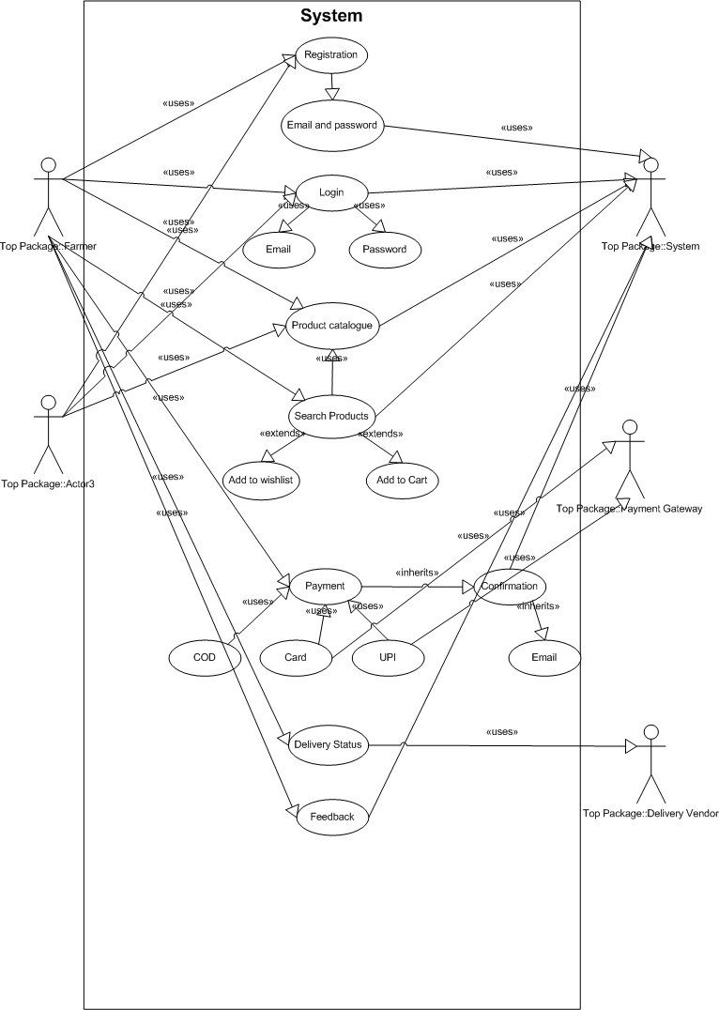

**Q11)** Prepare use case specs for all use cases

|  |  |  |  |  |
| --- | --- | --- | --- | --- |
| **Name of Use Case:** | Log in | | | |
| **Created By:** | Venkat | | **Last Updated By:** | January 21st 2025 |
| **Date Created:** | December 20th 2024 | | **Last Revision Date:** | January 10th 2025 |
|  | |  | | |
| **Description:** | | This use case allows manufacturers and farmers to manage their accounts and login to access the platform. | | |
| **Actors:** | | Manufacturer, Farmer | | |
| **Preconditions:** | | Users must have a registered account. | | |
| **Post conditions:** | | User successfully logged in to the platform. | | |
| **Flow:** | | 1. User navigates to the login page. 2. User enters their credentials (email ID and password). 3. System validates the credentials. 4. If credentials are valid, the user is redirected to the platform's homepage. | | |
| **Alternative Flows:** | | 3a. If the user enters invalid credentials then   * System displays an error message and prompts the user to re-enter their credentials. * Steps 2 and 3 are repeated. | | |
| **Exceptions:** | | 1. If the user account is suspended or banned, the system displays a message informing the user and prevents login. | | |
| **Frequency:** | | High | | |
| **Assumptions:** | | User credentials are stored securely in the system's database. | | |

|  |  |  |  |  |
| --- | --- | --- | --- | --- |
| **Name of Use Case:** | Product Catalog | | | |
| **Created By:** | Venkat | | **Last Updated By:** | January 21st 2025 |
| **Date Created:** | December 20th 2024 | | **Last Revision Date:** | January 10th 2025 |
|  | |  | | |
| **Description:** | | This use case displays a catalog of fertilizers, seeds, and pesticides available from manufacturers. | | |
| **Actors:** | | Farmer | | |
| **Preconditions:** | | User is logged in. | | |
| **Postconditions:** | | Users can browse through the product catalog. | | |
| **Flow:** | | 1. User navigates to the product catalog page. 2. System retrieves and displays the catalog of available products. | | |
| **Alternative Flows:** | | 2a. If the catalog loading time is unusually long then   * System displays a message indicating that the catalog is taking longer than usual to load. * Users are provided with options to refresh the page or wait for the catalog to load. * If the issue persists, users may contact customer support for assistance. | | |
| **Exceptions:** | | * If there are no products available in the catalog System displays a message indicating that no products are currently available. * Users are prompted to check back later or contact customer support for assistance. | | |
| **Frequency:** | | High | | |
| **Assumptions:** | | Product information is regularly updated and maintained by system administrators. | | |

|  |  |  |  |  |
| --- | --- | --- | --- | --- |
| **Name of Use Case:** | Farmer Search for Products | | | |
| **Created By:** | Venkat | | **Last Updated By:** | January 21st 2025 |
| **Date Created:** | December 20th 2024 | | **Last Revision Date:** | January 10th 2025 |
|  | |  | | |
| **Description:** | | This use care allow to search for available products in fertilizers, seeds, pesticides | | |
| **Actors:** | | Farmer | | |
| **Preconditions:** | | User is logged in and viewing the product catalog. | | |
| **Postconditions:** | | * User is presented with a list of products that match the search criteria. * User can view product details, such as name, description, and price, for each matching product. * User can navigate back to the product catalog or perform a new search if needed. | | |
| **Flow:** | | 1. User enters a search query in the search bar.  2. System retrieves and displays relevant products matching the search query. | | |
| **Alternative Flows:** | | 2a. If the search query returns too many results then   * System prompts the user to refine their search criteria to narrow down the results. * Users may adjust their search query or apply filters to refine the search. | | |
| **Exceptions:** | | If no products match the search query:   * System displays a message indicating that no products match the search criteria. * Users may refine their search criteria and try again. | | |
| **Frequency:** | | High | | |
| **Assumptions:** | | Search functionality accurately retrieves relevant products based on user queries. | | |

|  |  |  |  |  |
| --- | --- | --- | --- | --- |
| **Name of Use Case:** | Buy and Payment processing | | | |
| **Created By:** | Venkat | | **Last Updated By:** | January 21st 2025 |
| **Date Created:** | December 20th 2024 | | **Last Revision Date:** | January 10th 2025 |
|  | |  | | |
| **Description:** | | This use case processes payments for orders made by users | | |
| **Actors:** | | Farmer | | |
| **Preconditions:** | | User has confirmed their order and entered payment information. | | |
| **Postconditions:** | | Payment for the order is successfully processed. | | |
| **Flow:** | | 1. User selects the desired payment method (Cash-on-Delivery, Credit/Debit card, UPI). 2. System processes the payment securely. | | |
| **Alternative Flows:** | | 2a. If the payment processing fails:   * System displays an error message indicating the reason for failure. * Users may try again or choose an alternative payment method. | | |
| **Exceptions:** | | * If the selected payment method is unavailable or encounters technical issues then System displays an error message and prompts the user to select a different payment method. | | |
| **Frequency:** | | High | | |
| **Assumptions:** | | * Payment gateway integration is reliable and functions properly. * Users provide valid payment information. | | |

|  |  |  |  |  |
| --- | --- | --- | --- | --- |
| **Name of Use Case:** | Delivery Tracking | | | |
| **Created By:** | Venkat | | **Last Updated By:** | January 21st 2025 |
| **Date Created:** | December 20th 2024 | | **Last Revision Date:** | January 10th 2025 |
|  | |  | | |
| **Description:** | | This use case allows users to track the whereabouts of their orders in real-time. | | |
| **Actors:** | | Farmer | | |
| **Preconditions:** | | User has placed an order and received an order confirmation. | | |
| **Postconditions:** | | Users can track the status of their order in real-time. | | |
| **Flow:** | | 1. User navigates to the order tracking page. 2. User enters the order number or other relevant information. 3. System retrieves and displays the current status and location of the order. | | |
| **Alternative Flows:** | | 3a. If the order tracking information is unavailable or outdated then System prompts the user to contact customer support for assistance. | | |
| **Exceptions:** | | * If the order is lost or cannot be tracked then System displays an error message and advises the user to contact customer support for further assistance. | | |
| **Frequency:** | | Medium | | |
| **Assumptions:** | | * Delivery tracking information is updated in real-time by the logistics provider. * Users have access to accurate order tracking information. | | |

|  |  |  |  |  |
| --- | --- | --- | --- | --- |
| **Name of Use Case:** | Feedback | | | |
| **Created By:** | Venkat | | **Last Updated By:** | January 21st 2025 |
| **Date Created:** | December 20th 2024 | | **Last Revision Date:** | January 10th 2025 |
|  | |  | | |
| **Description:** | | This use case outlines the process of providing feedback within the system. | | |
| **Actors:** | | Farmers | | |
| **Preconditions:** | | * User must be logged into the system. * There must be a specific item or action for which feedback is being provided. * The feedback mechanism must be enabled and accessible. | | |
| **Postconditions:** | | * Feedback is recorded and stored in the system. * Users may receive acknowledgment or follow-up based on the feedback provided. | | |
| **Flow:** | | 1. User navigates to the feedback section within the system. 2. User selects the relevant item or action for which feedback is intended. 3. User provides feedback through a designated interface. 4. System records and stores the feedback. 5. Administrators review and analyze the feedback for actionable insights. | | |
| **Alternative Flows:** | | * If the user encounters difficulties in providing feedback, they may contact customer support directly. | | |
| **Exceptions:** | | * Technical issues preventing users from accessing the feedback feature. * Feedback containing inappropriate content or violating community guidelines. | | |
| **Frequency:** | | Low | | |
| **Assumptions:** | | * Users have sufficient knowledge and access to navigate the feedback process within the system. | | |

**Q12)** Activity diagram



