**Document 1 - Definition of Done**

**Definition of DOD - Definition of Done is crucial concepts in Agile and Scrum methodologies.**

The Definition of Done is a set of criteria that defines what it means for a piece of work to be truly finished. It goes beyond just completing the task and includes ensuring that the work meets certain standards.

**Key aspects of DOD:**

1. Quality Standards: The work should meet agreed-upon quality standards
2. Testing: All necessary tests should be passed
3. Documentation: Appropriate documentation should be in place
4. Deployment: The work should be deployable to production
5. User Acceptance: Users should accept the work
6. Regulatory Compliance: Work should comply with regulatory requirements
7. Code Review: Code review should be completed

**Importance of DOD**

DOD play critical roles in Agile and Scrum:

1. Ensuring Quality: They help maintain high-quality work throughout the development process
2. Improving Communication: They facilitate better communication between team members and stakeholders
3. Reducing Conflicts: By clearly defining what needs to be done, they reduce misunderstandings and conflicts
4. Enhancing Efficiency: They streamline the workflow by ensuring all necessary steps are taken

**Document 2- Product Vision**

|  |  |  |  |
| --- | --- | --- | --- |
| **Scrum Project Name:** | **HRM Pro** |  |  |
| **Venue:** | Mumbai |  |  |
| **Date:** | **Start time: 10:00 AM** | **End time: 06:00 PM** | **Duration:8 Hrs** |
| **Client:** | APT IT SOLUTIONS (Internal Development) |  |  |
| **Stakeholder list:** | HR Managers, Recruiters, Team Leaders, Project Managers, IT Team |  |  |
|  |  |  |  |
|  | **Scrum Team** |  |  |
|  |  |  |  |
| Scrum Master: | Deepti Rao |  |  |
| Product owner: | Deepak Kumar |  |  |
| Scrum Developer 1: | Shreyas Panse |  |  |
| Scrum Developer 2: | Kartik Sharma |  |  |
| Scrum Developer 3: | Aniket Barde |  |  |
| Scrum Developer 4: | Komal Singh |  |  |
| Scrum Developer 5: | Charan Kumar |  |  |

|  |  |  |  |
| --- | --- | --- | --- |
| **Target Group** | **Needs** | **Products** | **Value** |
| **Which market segment does the product address?** | **What problem does the product solve?** | **What product is it?** | **How is the product going to benefit the company?** |
| HR and Recruitment Industry | Manual inefficiencies in hiring processes | Agile ATS (Applicant Tracking System) software | Enhances recruitment speed by automating repetitive tasks |
| Corporates and Enterprises | Difficulty in tracking candidate progress | Named HRM Pro | Reduces hiring costs by optimizing recruiter efforts |
| Startups and Staffing Agencies | Challenges in managing job requirements and roles | - Integrated with AI-driven resume parsing and interview management | - Provides valuable insights through recruitment analytics |
| Startups and Staffing Agencies | Lack of insights into recruitment performance | |  | | --- | | - Supports parsing from multiple job portals |  |  | | --- | |  | | - Improves the candidate experience, leading to better hires |
| Talent Acquisition Teams |  |  |  |
| **Who are the target users and customers?** | **Which benefit does it provide?** | **What makes it desirable and special?** | **What are the business goals?** |
| HR Managers | - Automates resume parsing and candidate data extraction | - AI-driven resume parsing for quick candidate profiling | - Improve productivity of recruitment teams |
| - Recruiters | - Provides end-to-end candidate tracking | - Real-time tracking of candidates from sourcing to onboarding | - Provide a competitive edge in talent acquisition |
| - Team Leaders | - Facilitates easy assignment of job requirements to recruiters | - Customizable job requirement templates | - Enable data-driven decision-making |
| - Project Managers | - Centralized dashboard for job and candidate management | - Robust reporting and analytics to measure recruitment success | - Increase customer satisfaction with a smooth recruitment process |
| - Senior Management for strategic insights | - Enhances collaboration between HR teams and hiring managers | - Seamless integration with existing HR tools |  |
| - Recruitment Agencies |  |  |  |
|  |  | **Is it feasible to develop the product?** | **What is the business model?** |
|  |  | - Yes, leveraging agile methodologies for iterative development | - SaaS (Software as a Service) |
|  |  | - Utilizing AI and machine learning for enhanced resume parsing | - Subscription-based licensing (monthly/annual) |
|  |  | - Built with scalability and integration in mind | - Enterprise packages with advanced features |
|  |  |  | - Free trial period to attract potential clients |
|  |  |  | - Custom pricing for large organizations with specific needs |

**Document 3 –**

**User Stories**

|  |  |  |  |
| --- | --- | --- | --- |
| User Story No: 1 | Tasks: 1 | | Priority: HIGHEST |
| As a recruiter, I want to parse resumes automatically from job portals, so that I can save time and improve efficiency in candidate screening. | | | |
| BV – 500 | | CP - 02 | |
| Acceptance criteria:   1. The system should connect to predefined job portals seamlessly. 2. Resume parsing should accurately extract candidate details like name, skills, experience, and contact information. 3. Parsed data should auto-populate into the candidate database without manual input. 4. The system should handle various resume formats (PDF, Word, etc.). 5. Errors in parsing should generate appropriate error logs.   6. Users should be able to manually review and edit parsed data if needed. | | | |

|  |  |  |  |
| --- | --- | --- | --- |
| User Story No: 2 | Tasks: 1 | | Priority: HIGHEST |
| As a manager, I want to create detailed job requirements, so that I can assign them effectively to recruiters. | | | |
| BV – 500 | | CP - 02 | |
| Acceptance criteria:   1. Managers can create and save job requirements with all necessary details. 2. The requirement form must validate inputs and highlight missing or incorrect information. 3. Users should be able to attach job descriptions and relevant documents. 4. Recruiters receive an automated notification when assigned a requirement. 5. The system should track changes made to job requirements for audit purposes. | | | |

|  |  |  |  |
| --- | --- | --- | --- |
| User Story No: 3 | Tasks: 1 | | Priority: MEDIUM |
| As a recruiter, I want to track candidate’s status throughout the recruitment process, so that I can maintain a clear overview of progress and next steps. | | | |
| BV – 300 | | CP - 02 | |
| Acceptance criteria:   1. The dashboard should display all active candidates with a clear visual status. 2. Each candidate card should show recruitment stages such as screening, interview, offer, and onboarding. 3. Recruiters should be able to update the candidate status with a single click. 4. The system should allow filtering candidates by status, job role, and hiring manager. 5. The timeline view should be dynamic and interactive. 6. Historical data on candidate status changes should be accessible. | | | |

|  |  |  |  |
| --- | --- | --- | --- |
| User Story No: 4 | Tasks: 2 | | Priority: HIGHEST |
| As a HR manager, I want to use AI-driven interview features, so that I can ensure unbiased and efficient candidate evaluation. | | | |
| BV – 500 | | CP - 02 | |
| Acceptance criteria:   1. The AI module should generate interview questions based on the job role and candidate profile. 2. Evaluation should provide a detailed candidate performance report, including strengths and weaknesses. 3. The system should offer suggestions for candidate selection based on predefined criteria. 4. The AI-driven interview should support both video and text-based formats. 5. Recorded interviews should be stored securely and accessible for review. 6. Interview feedback should be automatically compiled and sent to relevant stakeholders. | | | |

|  |  |  |  |
| --- | --- | --- | --- |
| User Story No: 5 | Tasks: 2 | | Priority: MEDIUM |
| As a team leader, I want to receive notifications about recruitment progress, so that I can stay informed and take action if needed. | | | |
| BV – 500 | | CP - 02 | |
| Acceptance criteria:   1. Notifications should be sent for key recruitment milestones like new candidate entries, status changes, and completed interviews. 2. Users can set notification preferences (e.g., email, SMS, in-app). 3. Notifications should include actionable links to relevant modules or profiles. 4. The system should log all notifications sent, including time and type. 5. Users should be able to mark notifications as read or archive them. | | | |

|  |  |  |  |
| --- | --- | --- | --- |
| User Story No: 6 | Tasks: 2 | | Priority: MEDIUM |
| As a senior manager, I want to access recruitment analytics, so that I can make data-driven decisions to improve hiring strategies. | | | |
| BV – 500 | | CP - 02 | |
| Acceptance criteria:   1. Reports should include metrics like time-to-hire, conversion rates, and source performance. 2. The analytics dashboard should support custom filters and data visualization (charts, graphs). 3. Data export options should include Excel, PDF, and CSV formats. 4. The system should provide insights into bottlenecks in the recruitment process. 5. Reports should be shareable with external stakeholders securely. | | | |

|  |  |  |  |
| --- | --- | --- | --- |
| User Story No: 7 | Tasks: 3 | | Priority: MEDIUM |
| As a HR administrator, I want to integrate HRM Pro with existing HR systems, so that I can avoid manual data entry and reduce errors. | | | |
| BV – 300 | | CP - 02 | |
| Acceptance criteria:   1. The system should support integration with popular HR tools like SAP, Workday, and BambooHR. 2. Data synchronization should be automatic and in real-time. 3. Any integration errors should trigger alerts to the administrator. 4. The integration setup should be documented and supported through an easy-to-use interface. 5. The system should provide logs of all integration activities. | | | |

|  |  |  |  |
| --- | --- | --- | --- |
| User Story No: 8 | Tasks: 3 | | Priority: HIGHEST |
| As a system administrator, I want to manage user roles and permissions, so that I can ensure data security and proper access control. | | | |
| BV – 400 | | CP - 02 | |
| Acceptance criteria:   1. The system should support roles like Recruiter, Manager, Admin, and Candidate. 2. Each role should have specific access permissions defined. 3. Passwords should follow strong security guidelines. 4. Multi-factor authentication (MFA) should be supported. 5. Unauthorized access attempts should be logged and notified to admins. | | | |

|  |  |  |  |
| --- | --- | --- | --- |
| User Story No: 9 | Tasks: 3 | | Priority: HIGHEST |
| As a recruiter, I want to view a detailed candidate profile, so that I can make informed decisions during the hiring process. | | | |
| BV – 500 | | CP - 02 | |
| Acceptance criteria:   1. Candidate profiles should include personal info, resume, interview history, and evaluation notes. 2. The system should allow adding and editing notes on the profile. 3. Profiles should support attachments (e.g., portfolios, certificates). 4. Recruiters can mark candidates as shortlisted or rejected with a reason. 5. The profile history should be tracked for transparency. | | | |

|  |  |  |  |
| --- | --- | --- | --- |
| User Story No: 10 | Tasks: 4 | | Priority: LOWEST |
| As a candidate, I want to provide feedback on the interview process, so that the company can improve the recruitment experience. | | | |
| BV – 200 | | CP - 01 | |
| Acceptance criteria:   1. Candidates should receive an automated email with a feedback form after the interview. 2. Feedback questions should cover experience, interviewer behavior, and process clarity. 3. The system should analyze feedback and generate a report for HR managers. 4. The feedback form should be anonymous to encourage honesty. 5. Managers should have access to aggregated feedback trends and individual responses. | | | |

|  |  |  |  |
| --- | --- | --- | --- |
| User Story No: 11 | Tasks: 4 | | Priority: MEDIUM |
| As a HR executive, I want to generate and manage offer letters, so that I can streamline the offer process and reduce manual errors. | | | |
| BV – 300 | | CP - 01 | |
| Acceptance criteria:   1. The system should support customizable offer letter templates. 2. Offer letters should include details like salary, job role, start date, and benefits. 3. The approval workflow should include notifications for managers and HR heads. 4. The system should allow digital acceptance of offer letters by candidates. 5. All offer-related communications should be logged and accessible for reference. | | | |

|  |  |  |  |
| --- | --- | --- | --- |
| User Story No: 12 | Tasks: 4 | | Priority: MEDIUM |
| As a HR director, I want to analyze recruiter performance, so that I can identify top performers and areas for improvement. | | | |
| BV – 300 | | CP - 02 | |
| Acceptance criteria:   1. The system should generate performance metrics such as time-to-fill, hiring quality, and candidate satisfaction. 2. Recruiter performance analytics should be displayed on a dashboard with visual charts. 3. Managers should be able to compare recruiter performance over specific periods. 4. The system should provide suggestions to improve performance based on historical data. | | | |

|  |  |  |  |
| --- | --- | --- | --- |
| User Story No: 13 | Tasks: 5 | | Priority: LOWEST |
| As a website visitor, I want to view and apply for job openings directly on the company’s Careers page, so that I can explore opportunities without navigating external job portals. | | | |
| BV – 200 | | CP - 01 | |
| Acceptance criteria:   1. The Careers page should display live job listings from HRM Pro. 2. Applicants should be able to apply directly through the page, linking back to the ATS. 3. The page design should align with the company’s branding guidelines. 4. Job application data should sync seamlessly with the internal system. 5. Admins should be able to update the page content without coding knowledge. | | | |

|  |  |  |  |
| --- | --- | --- | --- |
| User Story No: 14 | Tasks: 5 | | Priority: LOWEST |
| As a recruiter, I want to access a simplified version of the dashboard on my mobile device, so that I can manage basic recruitment tasks while on the go. | | | |
| BV – 200 | | CP - 01 | |
| Acceptance criteria:   1. The mobile interface should provide access to job postings, candidate profiles, and application statuses. 2. Recruiters should be able to perform quick actions like shortlisting candidates or sending interview invites. 3. The UI should be responsive and work well on both Android and iOS devices. 4. Push notifications should alert recruiters of important updates (e.g., new applications, interview reminders). 5. The mobile app should ensure data security, including secure logins and encrypted communication. | | | |

|  |  |  |  |
| --- | --- | --- | --- |
| User Story No: 15 | Tasks: 5 | | Priority: LOWEST |
| As a new user, I want to access a knowledge base with guides and tutorials, so that I can quickly learn how to use the system effectively. | | | |
| BV – 200 | | CP - 01 | |
| Acceptance criteria:   1. The knowledge base should include written articles, video tutorials, and step-by-step guides. 2. Content should be searchable by keywords and categorized by topics (e.g., recruitment, onboarding, analytics). 3. The system should offer guided walkthroughs for new users upon their first login. 4. The knowledge base should be regularly updated as new features are added to HRM Pro. 5. Users should be able to provide feedback on knowledge base content for continuous improvement. | | | |

**Document 4-**

**Agile Product Owner Experience – HRM Pro Project**

As a **Product Owner** for the **HRM Pro** project, my primary responsibility was to ensure that the product aligned with market needs, business goals, and stakeholder expectations. Throughout the project, I applied my domain knowledge and industry experience to shape the product vision and roadmap while actively managing the backlog and sprint progress.

**Key Responsibilities and Contributions:**

**1. Market Analysis**

* Conducted an in-depth market need analysis to understand the demand for AI-driven ATS software.
* Researched existing HRMS and ATS solutions to identify gaps and unique selling points for HRM Pro.
* Evaluated competitive products to ensure our software provided better automation, efficiency, and AI-driven insights.

**2. Enterprise Analysis**

* Conducted due diligence on the market opportunity to assess feasibility and potential ROI.
* Analyzed how HRM Pro could streamline recruitment processes for different industries and companies.

**3. Product Vision and Roadmap**

* Defined a clear product vision based on market analysis and customer needs.
* Created a high-level product roadmap, outlining the key features and their timelines.
* Ensured that the AI-driven ATS module (Ai-tom Software) was a core differentiator, improving resume parsing, candidate tracking, and interview automation.

**4. Managing Product Features**

* Worked closely with stakeholders, recruiters, and hiring managers to understand and prioritize feature requirements.
* Prioritized epics, stories, and features based on their business value (BV), complexity points (CP), and return on investment (ROI).
* Ensured that essential features, such as resume parsing, job posting automation, and AI-based interview assistance, were developed in early sprints.

**5. Managing Product Backlog**

* Continuously refined and prioritized the product backlog based on feedback and evolving business needs.
* Planned epics and user stories, ensuring that sprint goals aligned with overall product objectives.
* Adjusted priorities as per stakeholder feedback to enhance user experience and performance.

**6. Managing Overall Iteration Progress**

* Conducted sprint progress reviews to ensure features were delivered as planned.
* Reprioritized sprints and epics when necessary to adapt to changes in business requirements.
* Participated in sprint retrospectives with the Business Analyst (BA) to improve future sprint execution.

**Scrum Meetings and Agile Practices**

During the HRM Pro project, I played a crucial role in facilitating and participating in Agile ceremonies, ensuring smooth execution and collaboration among teams.

* **Sprint Planning Meeting:**
  + Defined sprint objectives and user stories for each sprint cycle.
  + Ensured alignment between business requirements and development capacity.
* **Daily Scrum Meetings:**
  + Monitored daily progress and addressed blockers faced by the development team.
  + Provided updates on priority changes and stakeholder expectations.
* **Sprint Review Meeting:**
  + Demonstrated completed features to stakeholders and collected feedback.
  + Assessed whether the sprint met business goals and requirements.
* **Sprint Retrospective Meeting:**
  + Identified areas of improvement for upcoming sprints.
  + Discussed challenges faced and optimized workflow for better efficiency.
* **Backlog Refinement Meeting:**
  + Reviewed, updated, and prioritized the backlog for future sprints.
  + Ensured backlog items had well-defined acceptance criteria and business value assessments.

**User Story Creation and Breakdown**

I was actively involved in the creation and refinement of user stories, ensuring each story provided clear business value and followed Agile best practices.

Each user story included:

* **Story No:** Unique identifier for tracking.
* **Tasks:** Specific development and testing actions.
* **Priority:** High, Medium, or Low based on business impact.
* **Acceptance Criteria:** Defined measurable outcomes for completion.
* **BV (Business Value) & CP (Complexity Points):** Used for prioritization and effort estimation.

**Product Owner as a Liaison**

As the Product Owner, I acted as a bridge between different teams, ensuring that all stakeholders were aligned with the project’s progress. My responsibilities included:

* Communicating with business stakeholders to gather requirements and updates.
* Collaborating closely with Scrum teams to provide clarity on user stories and backlog items.
* Ensuring that HR, recruitment teams, and company leadership were informed about product development updates.

Key Learnings from this Project

* Effectively managing the product vision and aligning it with business goals.
* Leading sprint meetings and refining the backlog dynamically.
* Prioritizing features and user stories based on stakeholder needs and market trends.
* Understanding the complexities of AI-driven ATS solutions and optimizing recruitment workflows.
* Enhancing collaboration between stakeholders, business analysts, developers, and QA teams.

**Document 5 -**

**Sprint Backlog :**

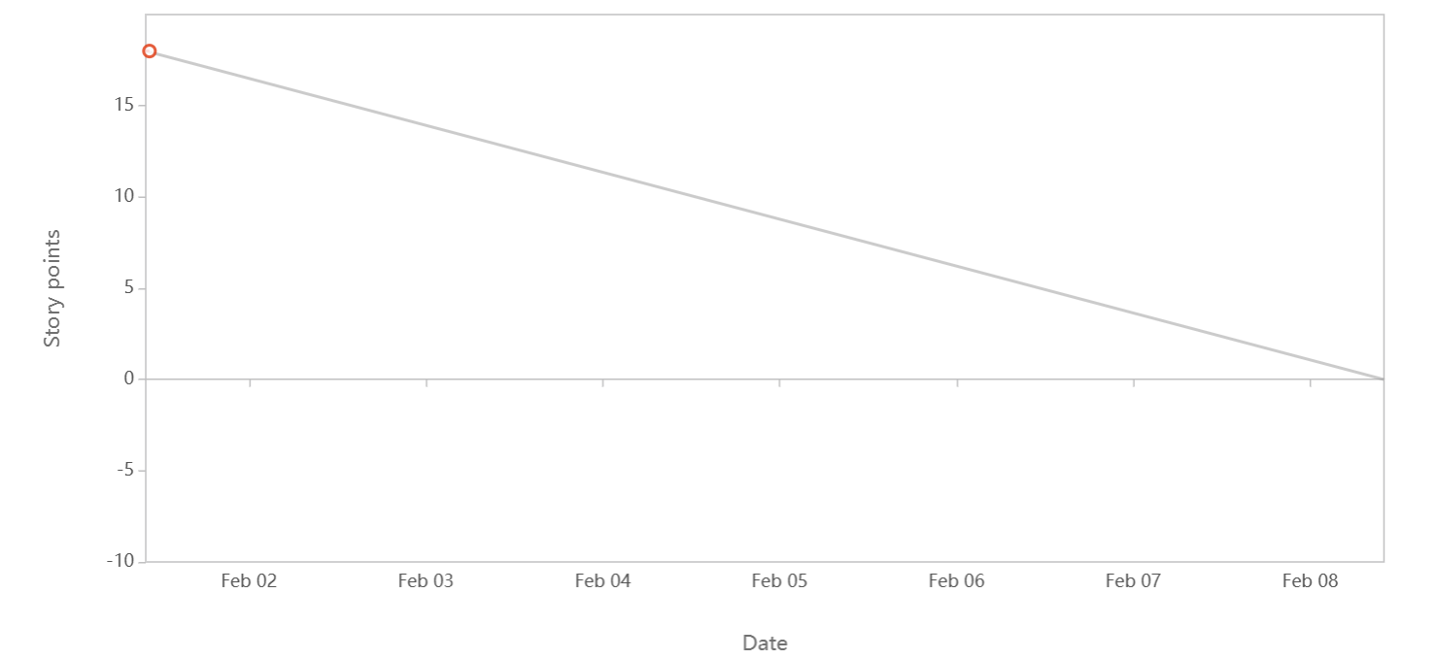

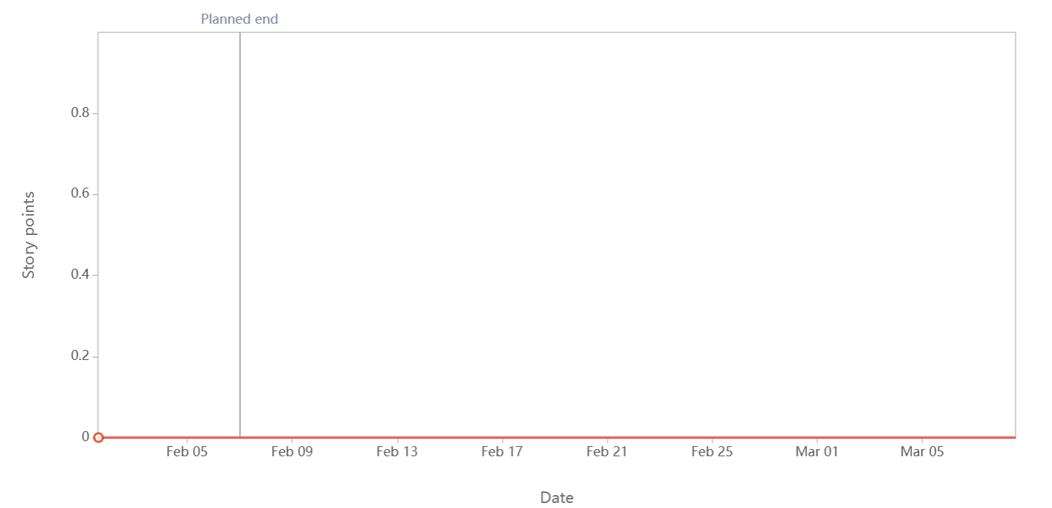

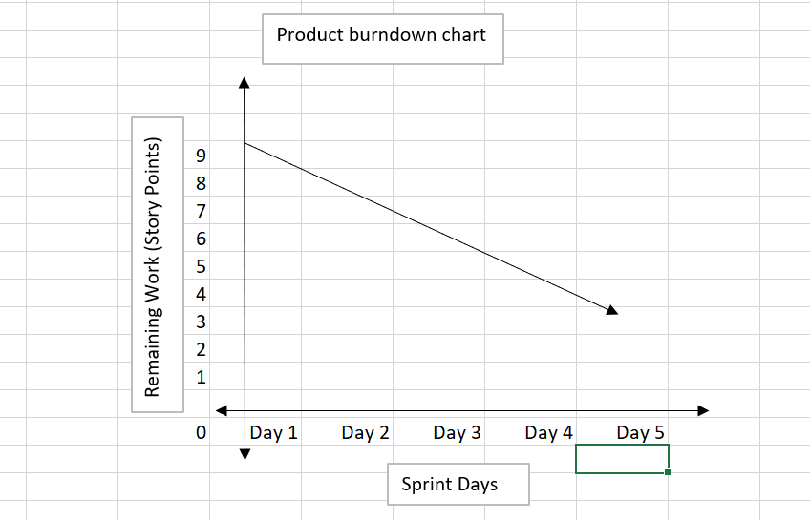

|  |  |  |  |  |  |  |
| --- | --- | --- | --- | --- | --- | --- |
| User story ID | User story | Tasks | Priority | BV | CP | Sprint |
| 1 | As a recruiter, | 1 | HIGHEST | 500 | 2 | 1 |
|  | I want to parse resumes automatically from job portals, |  |  |  |  |  |
|  | so that I can save time and improve efficiency in candidate screening. |  |  |  |  |  |
| 2 | As a manager, | 1 | HIGHEST | 500 | 2 | 1 |
|  | I want to create detailed job requirements, |  |  |  |  |  |
|  | so that I can assign them effectively to recruiters. |  |  |  |  |  |
| 3 | As a recruiter, | 1 | MEDIUM | 300 | 2 | 1 |
|  | I want to track candidate’s status throughout the recruitment process, |  |  |  |  |  |
|  | so that I can maintain a clear overview of progress and next steps. |  |  |  |  |  |
| 4 | As a HR manager, | 2 | HIGHEST | 500 | 2 | 2 |
|  | I want to use AI-driven interview features, |  |  |  |  |  |
|  | so that I can ensure unbiased and efficient candidate evaluation. |  |  |  |  |  |
| 5 | As a team leader, | 2 | HIGHEST | 500 | 2 | 2 |
|  | I want to receive notifications about recruitment progress, |  |  |  |  |  |
|  | so that I can stay informed and take action if needed. |  |  |  |  |  |
| 6 | As a senior manager, | 2 | MEDIUM | 300 | 2 | 2 |
|  | I want to access recruitment analytics, |  |  |  |  |  |
|  | so that I can make data-driven decisions to improve hiring strategies. |  |  |  |  |  |
| 7 | As a HR administrator, | 3 | MEDIUM | 300 | 2 | 3 |
|  | I want to integrate HRM Pro with existing HR systems, |  |  |  |  |  |
|  | so that I can avoid manual data entry and reduce errors. |  |  |  |  |  |
| 8 | As a system administrator, | 3 | HIGHEST | 500 | 2 | 3 |
|  | I want to manage user roles and permissions, |  |  |  |  |  |
|  | so that I can ensure data security and proper access control. |  |  |  |  |  |
| 9 | As a recruiter, | 3 | HIGHEST | 500 | 2 | 3 |
|  | I want to view a detailed candidate profile, |  |  |  |  |  |
|  | so that I can make informed decisions during the hiring process. |  |  |  |  |  |
| 10 | As a candidate, | 4 | LOWEST | 200 | 1 | 4 |
|  | I want to provide feedback on the interview process, |  |  |  |  |  |
|  | so that the company can improve the recruitment experience. |  |  |  |  |  |
| 11 | As a HR executive, | 4 | MEDIUM | 300 | 2 | 4 |
|  | I want to generate and manage offer letters, |  |  |  |  |  |
|  | so that I can streamline the offer process and reduce manual errors. |  |  |  |  |  |
| 12 | As a HR director, | 4 | MEDIUM | 300 | 2 | 4 |
|  | I want to analyze recruiter performance, |  |  |  |  |  |
|  | so that I can identify top performers and areas for improvement. |  |  |  |  |  |
| 13 | As a website visitor, | 5 | LOWEST | 200 | 1 | 5 |
|  | I want to view and apply for job openings directly on the company’s Careers  page, |  |  |  |  |  |
|  | so that I can explore opportunities without navigating external job portals. |  |  |  |  |  |
| 14 | As a recruiter, | 5 | LOWEST | 200 | 1 | 5 |
|  | I want to access a simplified version of the dashboard on my mobile device, |  |  |  |  |  |
|  | so that I can manage basic recruitment tasks while on the go. |  |  |  |  |  |
| 15 | As a new user, | 5 | LOWEST | 200 | 1 | 5 |
|  | I want to access a knowledge base with guides and tutorials, |  |  |  |  |  |
|  | so that I can quickly learn how to use the system effectively. |  |  |  |  |  |

**Sprint backlog:**

|  |  |  |  |  |  |
| --- | --- | --- | --- | --- | --- |
| **User Story ID** | **User Story** | **Tasks** | **Owner** | **Status** | **Estimated Effort** |
| 1 | As a recruiter, I want to parse resumes automatically from job portals, so that I can save time and improve efficiency in candidate screening. | 1. Integrate resume parsing API 2. Implement UI for uploading resumes 3. Test with sample resumes | Dev Team A | In Progress | 5 |
| 3 | As a manager, I want to create detailed job requirements, so that I can assign them effectively to recruiters. | 1. Design job requirement form 2. Implement database structure 3. Develop front-end UI | Dev Team B | To Do | 4 |
| 5 | As a recruiter, I want to track candidate’s status throughout the recruitment process, so that I can maintain a clear overview of progress and next steps. | 1. Create candidate status tracking module 2. Implement notifications for status updates | Dev Team A | In Progress | 3 |
| 7 | As a HR manager, I want to use AI-driven interview features, so that I can ensure unbiased and efficient candidate evaluation. | 1. Research AI models 2. Implement AI scoring system 3. Develop UI for interview feedback | Dev Team C | To Do | 6 |
| 10 | As a system administrator, I want to manage user roles and permissions, so that I can ensure data security and proper access control. | 1. Define role-based access 2. Implement role management system 3. Test role-based access control | Dev Team B | To Do | 6 |
| 12 | As a recruiter, I want to view a detailed candidate profile, so that I can make informed decisions during the hiring process. | 1. Design candidate profile layout 2. Fetch candidate data from database 3. Implement profile view UI | Dev Team A | In Progress | 4 |
| 14 | As a candidate, I want to provide feedback on the interview process, so that the company can improve the recruitment experience. | 1. Design feedback form 2. Develop backend API for feedback storage 3. Implement UI for candidate feedback | Dev Team C | To Do | 3 |
| 16 | As an HR executive, I want to generate and manage offer letters, so that I can streamline the offer process and reduce manual errors. | 1. Develop offer letter template 2. Implement offer letter automation 3. Test with sample candidates | Dev Team B | In Progress | 5 |
| 18 | As a HR director, I want to analyse recruiter performance, so that I can identify top performers and areas for improvement. | 1. Define performance metrics 2. Implement reporting dashboard 3. Generate recruiter performance reports | Dev Team A | To Do | 4 |
| 20 | As a website visitor, I want to view and apply for job openings directly on the company’s Careers page, so that I can explore opportunities without navigating external job portals. | 1. Create job listing page 2. Implement job application feature 3. Test application process | Dev Team C | To Do | 3 |

**Document 6 -**

**Meeting Type 1: Sprint Planning meeting**

|  |  |
| --- | --- |
| **Date** | **February 1, 2025** |
| **Time** | 10:00 AM - 11:30 AM |
| **Location** | Conference Room A / Virtual (Microsoft Teams) |
| **Prepared By** | Rhutik |
| **Attendees** | Product Owner, Scrum Master, Development Team, QA Team, Stakeholders |

**Agenda Topics**

|  |  |  |
| --- | --- | --- |
| **Topic** | **Presenter** | **Time Allotted** |
| **Review Product Backlog & Prioritize Items** | Product Owner | 20 mins |
| **Define Sprint Goal** | Scrum Master | 15 mins |
| **Select User Stories for Sprint** | Development Team | 30 mins |
| **Estimate Effort (Story Points)** | Development & QA Team | 20 mins |
| **Identify Dependencies & Risks** | Scrum Master | 15 mins |
| **Finalize Sprint Backlog** | Team Discussion | 10 mins |

**Other Information**

|  |  |
| --- | --- |
| **Observers** | **None (Optional: Business Analysts, Clients)** |
| **Resources** | Jira Board, Product Backlog, Sprint Metrics |
| **Special Notes** | Ensure all dependencies are identified before starting the sprint |

**Meeting Type 2: Sprint review meeting**

|  |  |
| --- | --- |
| **Date** | **February 15, 2025** |
| **Time** | 3:00 PM - 4:00 PM |
| **Location** | Conference Room A / Virtual (Microsoft Teams) |
| **Prepared By** | Rhutik |
| **Attendees** | Product Owner, Scrum Master, Development Team, QA Team, Stakeholders |

|  |  |  |  |
| --- | --- | --- | --- |
| **Sprint Status** | **Things to Demo** | **Quick Updates** | **What’s Next** |
| Sprint completed successfully with 12 user stories delivered. | New AI-driven interview features, automated resume parsing, and  candidate tracking improvements. | Bug fixes and minor UI enhancements done based on stakeholder feedback. | Plan for Sprint 2, refine backlog, prioritize pending items. |

**Meeting Type 3: Sprint retrospective meeting**

|  |  |
| --- | --- |
| **Date** | **February 16, 2025** |
| **Time** | 4:00 PM - 5:00 PM |
| **Location** | Conference Room A / Virtual (Microsoft Teams) |
| **Prepared By** | Rhutik |
| **Attendees** | Scrum Master, Product Owner, Development Team, QA Team |

|  |  |  |  |
| --- | --- | --- | --- |
| **What went well** | **What didn’t go well** | **Questions** | **Reference** |
| Timely delivery of user stories, improved team collaboration. | Some delays due to unexpected bugs, scope creep issues. | How can we improve bug identification earlier? | Sprint 5 backlog and sprint report. |

|  |  |  |  |  |  |  |  |  |
| --- | --- | --- | --- | --- | --- | --- | --- | --- |
| **Question** | **Name/Role** | **Monday** | **Tuesday** | **Wednesday** | **Thursday** | **Friday** | **Saturday** | **Sunday** |
| What did you do yesterday? | Developer 1 | Worked on AI interview module | Fixed parsing issue | - | - | - | - | - |
|  | Developer 2 | Tested candidate tracking | UI fixes | - | - | - | - | - |
|  | Developer 3 | Integrated API | Worked on dashboard | - | - | - | - | - |
| What will you do today? | Developer 1 | Continue AI module | Deploy update | - | - | - | - | - |
|  | Developer 2 | Bug fixing | Test notifications | - | - | - | - | - |
|  | Developer 3 | Review feedback | Work on report module | - | - | - | - | - |
| What (if any) is blocking your progress? | Developer 1 | No blockers | API dependency | - | - | - | - | - |
|  | Developer 2 | UI alignment issue | Waiting for backend update | - | - | - | - | - |
|  | Developer 3 | No blockers | Limited test data | - | - | - | - | - |