**Document 6- Please prepare a use case diagram, activity diagram and a use case specification document.**

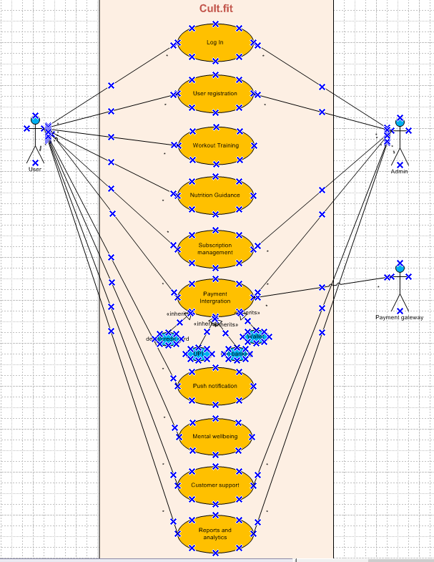

Use case specification document and activity diagram.

Use case specification: UC001- Log In

|  |  |
| --- | --- |
| Use case ID: | UC-001 |
| Use case name: | Log In |
| Description: | Allows registered users to log into the application using valid credentials. |
| Actors: | Registered user |
| Preconditions: | User must be registered and have valid login credentials. |
| Post conditions: | User is authenticated and redirected to the dashboard. |
| Normal flow: | 1. User enters login credentials 2. Clicks on login button 3. System verifies credentials 4. User is logged in |
| Alternative flow: | Invalid credentials: Show error message and retry option |
| Exceptions: | Servers/database errors |

Use case specification: UC002- User Registration

|  |  |
| --- | --- |
| Use case ID: | UC-002 |
| Use case name: | User registration |
| Description: | Allows a new user to register using email or phone. |
| Actors: | New User |
| Preconditions: | User not registered |
| Post conditions: | User is added to the system can log in. |
| Normal flow: | 1. User selects "Register"  2. System prompts for required details  3. User submits form  4. System validates and saves the data  5. Confirmation is shown |
| Alternative flow: | Duplicate email/phone number: show error. |
| Exceptions: | Network/server error |

Use case specification: UC003- Workout Training

|  |  |
| --- | --- |
| Use case ID: | UC-003 |
| Use case name: | Workout Training |
| Description: | Allows user to log workouts, track calories burned and view history. |
| Actors: | Registered user |
| Preconditions: | User must be logged in. |
| Post conditions: | Workout data is stored and analytics updated. |
| Normal flow: | 1. User navigates to Workout section 2. User logs workout data 3. System calculates calories burned 4. User views history |
| Alternative flow: | None |
| Exceptions: | Data entry error |

Use case specification: UC004- Nutrition Guidance

|  |  |
| --- | --- |
| Use case ID: | UC-004 |
| Use case name: | Nutrition Guidance |
| Description: | Provides personalized meal plans and tracks calorie intake. |
| Actors: | Registered user |
| Preconditions: | User must be logged in |
| Post conditions: | Meal plan is generated and calorie intake is recorded. |
| Normal flow: | 1. User opens Nutrition section 2. System recommends meals 3. User logs meal intake 4. Calories are tracked |
| Alternative flow: | No data for recommendation: prompt user to input preferences |
| Exceptions: | API/engine failure for recommendations |

Use case specification: UC005- Subscription Management

|  |  |
| --- | --- |
| Use case ID: | UC-005 |
| Use case name: | Subscription management |
| Description: | Allows user to purchase, renew or cancel subscriptions. |
| Actors: | Registered user |
| Preconditions: | User is logged in. |
| Post conditions: | Subscription status is updated. |
| Normal flow: | 1. User accesses Subscription section 2. Chooses an action (purchase/renew/cancel) 3. System processes request 4. Confirmation is displayed |
| Alternative flow: | Payment failure: Show error |
| Exceptions: | Server/payment system error |

Use case specification: UC006- Payment Integration

|  |  |
| --- | --- |
| Use case ID: | UC-006 |
| Use case name: | Payment integration |
| Description: | Handles secure payments via cards, UPI and wallets. |
| Actors: | Registered user |
| Preconditions: | User initiates a transaction. |
| Post conditions: | Payment is processed and acknowledged. |
| Normal flow: | 1. User selects payment method 2. Enters payment info 3. System validates and completes transaction 4. Receipt/confirmation shown |
| Alternative flow: | Invalid payment details: show error |
| Exceptions: | Payment gateway failure. |

Use case specification: UC007- Push Notification

|  |  |
| --- | --- |
| Use case ID: | UC-007 |
| Use case name: | Push notification |
| Description: | Sends alerts for classes, reminders and offers. |
| Actors: | System background and user |
| Preconditions: | User must be registered for notifications. |
| Post conditions: | Notifications are received by the user. |
| Normal flow: | 1. System checks for new events 2. Sends push notifications 3. User receives alerts |
| Alternative flow: | None |
| Exceptions: | Notification service failure. |

Use case specification: UC008 – Mental Wellbeing Section

|  |  |
| --- | --- |
| Use case ID: | UC008 |
| Use case name: | Mental wellbeing section |
| Description: | Provides guided meditation, stress relief sessions and expert content. |
| Actors: | Registered user |
| Preconditions: | User must be logged in. |
| Post conditions: | User views/accesses wellbeing resources. |
| Normal flow: | 1. User opens Mental Wellbeing section 2. Selects content (meditation/session/article) 3. System delivers selected content |
| Alternative flow: | None |
| Exceptions: | Content loading error |

Use case specification: UC009 – Customer Support

|  |  |
| --- | --- |
| Use case ID: | UC009 |
| Use case name: | Customer support |
| Description: | Users can contact support via chat, email |
| Actors: | Users and customer support agent |
| Preconditions: | User must be logged in and support team is active. |
| Post conditions: | User receives help or issue resolution. |
| Normal flow: | 1. User opens support section 2. Selects contact method 3. System connects to support 4. Support interaction occurs |
| Alternative flow: | No support available: suggest call back/email option. |
| Exceptions: | Chat/email service outage. |

Use case specification: UC010 – Reports and analytics

|  |  |
| --- | --- |
| Use case ID: | UC010 |
| Use case name: | Reports and analytics |
| Description: | Displays user progress reports and nutrition tracking data. |
| Actors: | Registered user |
| Preconditions: | User must have workout/nutrition data logged. |
| Post conditions: | Reports are shown to the user. |
| Normal flow: | 1. User opens Reports section 2. System retrieves data 3. Analytics are generated and displayed |
| Alternative flow: | No data available show message |
| Exceptions: | Data retrieval issues. |

Activity diagram





**Document 8- Tools-Visio and Axure**

In my project, I extensively used **Microsoft Visio** and **Axure RP** to design and visualize system functionalities and user interactions. Visio was instrumental in creating detailed **use case diagrams, activity diagrams**, and **process flows,** which helped in clearly communicating the system’s behaviour and structure to both stakeholders and the development team. On the other hand, Axure was my go-to tool for building **interactive wireframes and prototypes.** It allowed me to simulate user journeys, test functionality early, and gather feedback efficiently, ensuring that the final design aligned well with user expectations. Together, these tools significantly enhanced the clarity and effectiveness of our requirements documentation and UI/UX validation process.

**Document 9- BA Experience**

As a Business Analyst, I played a pivotal role throughout the entire software development lifecycle, beginning with **requirement gathering,** where I conducted stakeholder interviews, facilitated workshops, and reviewed existing documentation to elicit clear, complete, and prioritized requirements. During the **requirement analysis** phase, I translated business needs into functional and non-functional requirements, created **use case documents,** and clarified ambiguities through stakeholder collaboration. In the **design phase,** I worked closely with UI/UX designers and developers to validate wireframes, create **use case diagrams, activity diagrams,** and ensured the design aligned with the business goals. Throughout the **development phase,** I supported the team by clarifying requirements, handling scope changes, and conducting **walkthrough sessions** to ensure alignment between business needs and technical implementation. During **testing,** I was involved in preparing test scenarios, validating test cases, performing UAT (User Acceptance Testing), and ensuring that all issues were addressed. Finally, in the **deployment phase**, I coordinated with stakeholders for rollout planning, contributed to training and documentation, and ensured that the delivered solution met the intended business value. This end-to-end involvement allowed me to act as a strong bridge between business and technology teams.