Q1. What is the difference between Brainstorming and JAD Sessions? 3 Marks

**Answer:**

Brainstorming and Joint Application Development (JAD) Sessions are both elicitation techniques used to gather requirements, but they differ in approach, participants, and purpose.

1. Brainstorming

Definition: A creative group discussion technique used to generate ideas or solutions for a problem.

Purpose: To encourage free thinking and idea generation without immediate criticism.

Participants: Usually a diverse group of stakeholders, business analysts, and sometimes subject matter experts.

Approach:

Participants contribute ideas freely.

No idea is dismissed immediately; all ideas are recorded.

Ideas are refined and evaluated after the session.

Best Used For:

Generating a wide range of ideas in the initial phases of requirement gathering.

Finding innovative solutions to complex problems.

Exploring different features and functionalities for a project.

2. JAD (Joint Application Development) Sessions

Definition: A structured workshop involving key stakeholders and technical teams to collaboratively define system requirements.

Purpose: To gather, refine, and finalize business requirements with real-time feedback.

Participants: Business analysts, developers, testers, project managers, end users, and sometimes executives.

Approach:

A facilitator leads the session with a structured agenda.

Requirements are documented and reviewed in real-time.

Decisions are made based on stakeholder inputs.

Best Used For:

Detailed requirement gathering for a specific system.

Resolving conflicts between stakeholders.

Getting faster approvals and reducing back-and-forth communication.

Q2. Why Document Analysis is one of the compulsory technique we use in a Project? Justify – 3 Marks

**Answer:**

Document Analysis is one of the most fundamental elicitation techniques in business analysis because it helps gather historical, structured, and validated information about the project.

1. Provides Historical and Existing Knowledge

* Many projects are not built from scratch; they are often extensions, upgrades, or replacements of existing systems.
* Analyzing previous project documents, requirement specifications, and user manuals helps understand what has already been done.

2. Reduces Dependency on Stakeholder Memory

* Stakeholders might miss out on key details when providing requirements due to memory gaps.
* Existing documents serve as a reference point to validate and cross-check stakeholder inputs.

3. Saves Time and Effort

* Instead of conducting multiple stakeholder meetings for basic information, document analysis provides a quick starting point.
* Helps avoid redundant discussions and ensures that elicitation sessions focus on refining and validating requirements rather than collecting the same information again.

4. Ensures Compliance and Standardization

* Projects often have to comply with legal, regulatory, and industry standards.
* Document analysis ensures that compliance requirements are identified and integrated early in the project.

5. Helps Identify Gaps and Risks

* Existing documentation can reveal inconsistencies, missing requirements, and risks.
* Helps in risk mitigation by identifying areas that might lead to project failures or delays.

Justification: Why It’s Compulsory?

1. Reduces Rework – Saves time by leveraging existing information.
2. Improves Accuracy – Ensures completeness and correctness of requirements.
3. Enhances Efficiency – Provides a strong foundation for requirement gathering.
4. Ensures Compliance – Helps meet legal and industry regulations.
5. Identifies Risks Early – Prevents potential project failures.

Q3. In Which Context we will use Reverse Engineering? - 3 Marks

**Answer:**

Reverse Engineering is used in a project when there is a need to understand, analyse, or recreate an existing system or component without proper documentation. It is commonly applied in business analysis, software development, and system migration projects.

Where Reverse Engineering is Used:

* When an existing system does not have proper documentation, and the team needs to understand its functionality.
* When upgrading or replacing an old system while ensuring all features and functionalities are retained.
* When analysing a competitor’s product to understand its design and improve upon it.
* When integrating an existing system with new applications but the API or system structure is unknown.
* When assessing a system for security risks, vulnerabilities, or potential breaches.
* When fixing critical bugs or performance issues in software with no access to source code.

Q4. What is the difference between Brainstorming and Focus Groups? - 3 Marks

**Answer:**

1. Brainstorming

Definition: A creative group discussion technique used to generate ideas or solutions for a problem.

Purpose: To encourage free thinking and idea generation without immediate criticism.

Participants: Usually a diverse group of stakeholders, business analysts, and sometimes subject matter experts.

Approach:

Participants contribute ideas freely.

No idea is dismissed immediately; all ideas are recorded.

Ideas are refined and evaluated after the session.

Best Used For:

Generating a wide range of ideas in the initial phases of requirement gathering.

Finding innovative solutions to complex problems.

Exploring different features and functionalities for a project.

2. Focus Groups

Definition: A structured discussion where a selected group of participants provides feedback and opinions on a product, service, or system.

Purpose:

To gather user insights and feedback.

To validate assumptions about user needs, preferences, and expectations.

Participants:

A targeted group of end-users or stakeholders (5-12 participants).

A moderator leads the discussion.

Structure:

A moderator presents topics or questions.

Participants share opinions and experiences.

The session is recorded or documented for further analysis.

Best Used For:

Understanding user preferences and behaviours.

Testing usability of an interface or system.

Validating business assumptions before implementation.

Q5. Observation Technique – Explain both Active and Passive approaches - 3 Marks

Answer:

Observation Technique in Business Analysis

The Observation Technique is used to gather requirements by watching users perform their tasks in a real-world environment. It helps identify pain points, inefficiencies, and areas for improvement that might not be captured through interviews or discussions.

There are two main approaches to observation:

1. Active Observation (Participatory Observation)

Definition: The observer actively engages with the participants, asks questions, and interacts during the process.

Characteristics:

The business analyst (BA) participates in the process.

Observer asks real-time questions to clarify doubts.

Helps in understanding user behaviour and challenges firsthand.

Best Used For:

When processes are complex and need clarification.

When stakeholders might miss key details in interviews.

When interaction with users is necessary to understand system usage.

2. Passive Observation (Non-Participatory Observation)

Definition: The observer silently watches the participants perform their tasks without interfering.

Characteristics:

The business analyst does not interact with users.

Observer only notes down observations.

Provides a real, unbiased understanding of how users behave.

Best Used For:

When stakeholders may act differently if they know they are being observed.

When processes need to be analysed without external influence.

When you need to validate system usability and real-time interactions.

Q6. How do you conduct the Requirements Workshop- 3 Marks

Answer:

A Requirements Workshop is a structured, collaborative session where stakeholders come together to discuss, define, and refine project requirements. It helps in quickly gathering, validating, and prioritizing requirements while ensuring stakeholder alignment.

Steps to Conduct a Successful Requirements Workshop:

1. Define the Objective

Clearly outline the purpose of the workshop.

2. Identify and Invite Participants

Key stakeholders: Business sponsors, end-users, developers, testers, and project managers.

Facilitator: A Business Analyst (BA) to guide discussions.

Scribe: To document key points and decisions.

3. Prepare Agenda & Materials

Set agenda (timelines, discussion points, expected outcomes).

Prepare materials:

Existing documentation.

Use case diagrams.

Mock-ups or prototypes.

Business process flows.

4. Facilitate the Workshop

Set ground rules (e.g., respect everyone's opinion, stay on topic).

Use elicitation techniques:

* + Brainstorming for new ideas.
  + JAD Sessions for in-depth discussions.
  + Process Modelling to visualize workflows.

Keep discussions focused and time-bound.

Capture conflicts and resolutions for further analysis.

5. Document and Validate Requirements

Record: Decisions, action items, dependencies, risks.

Use tools like JIRA, Confluence, or Google Docs for tracking.

Share Meeting Minutes for validation.

6. Follow-Up and Next Steps

Get stakeholder sign-off on agreed requirements.

Assign action items and responsibilities.

Plan next steps: Prototyping, further elicitation, or feasibility study.

Q7. In which context, Interview Technique can be conducted by a BA? How may

approaches are there in conducting Interviews? (Structured – Unstructured) Explain them.

Explain the difference between Open Ended Questions and Closed ended Questions –

6Marks.

**Answer:**

The Interview Technique is used by a Business Analyst (BA) to gather detailed, specific, and qualitative information from stakeholders through direct interaction. It helps understand business needs, pain points, expectations, and system functionalities.

Approaches to Conducting Interviews:

1. Structured Interviews

Definition: A predefined set of questions is asked in a fixed order, and responses are recorded systematically.

Characteristics:

Questions are planned and consistent for all participants.

Helps in collecting quantifiable and comparable data.

Less flexible but ensures all key topics are covered.

Best Used For:

Gathering specific, measurable data.

Comparing responses across multiple stakeholders.

2. Unstructured Interviews

Definition: A free-flowing, open discussion without a strict question format.

Characteristics:

No predefined structure; questions are flexible and based on responses.

Helps in exploring deep insights, pain points, and opinions.

More time-consuming but provides rich qualitative data.

Best Used For:

When exploring new ideas or unknown challenges.

When discussing complex or sensitive topics.

Difference Between Open-Ended and Closed-Ended Questions:

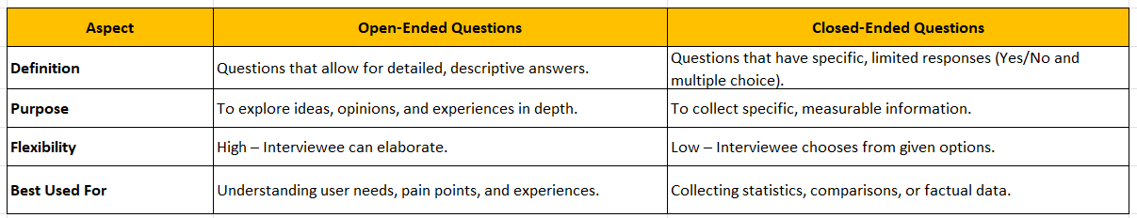

Q8. Questionnaire Technique – Where we will use? Give one example - 6 Marks

**Answer:**

Where to Use the Questionnaire Technique?

The Questionnaire Technique is used when a Business Analyst (BA) needs to collect information from multiple stakeholders efficiently and systematically. It consists of a set of structured questions that help gather quantitative and qualitative data.

Best Scenarios for Using a Questionnaire:

1. When Collecting Feedback from a Large Audience

Useful when stakeholders are geographically dispersed.

2. When Standardizing Data Collection

Ensures consistency in responses for easy analysis.

3. When Time or Budget is Limited

Helps in gathering data quickly without needing face-to-face meetings.

4. When Validating Requirements

Can be used after interviews or workshops to validate findings.

Example:

Topic: Farmers' Preferences for Buying Agricultural Products Online

How often do you purchase agricultural products online?

1. Frequently (Every month)

2. Occasionally (Few times a year)

3. Rarely (Once a year)

4. Never

Q9. How to Sort the Requirements – Where we will use? Give one example - 5 Marks

**Answer**:

Sorting requirements helps prioritize and organize them based on business needs, feasibility, and impact. This ensures that the most critical functionalities are developed first, reducing project risks and delays.

Where Do We Use Requirement Sorting?

Requirement sorting is used in requirement elicitation and documentation phase of a project.

Based on functional vs Non-functional requirements, priority sorting, user role sorting, time dependency sorting we can sort the requirements.

Example for Online Agriculture Store:

Sorting requirements for the Online Agriculture Products Store to decide which features should be included in Phase 1 (MVP) and which can be added later.

Example Categories:

Must-Have: Login, Product Catalog, Payment Gateway

Nice-to-Have: Voice Search, Multi-language Support

Q10. Prioritise the Requirements – –Where we will use? Give one example - 5 Marks

**Answer:**

Prioritizing requirements is essential to ensure that the most critical and high-impact features are developed first. It helps in effective project planning, resource allocation, and phased releases.

Where Do We Use Requirement Prioritization?

Requirement prioritization is used in:

• Project Planning & Roadmap Creation → To define what should be delivered first.

• MVP (Minimum Viable Product) Development → To focus on must-have features.

• Sprint & Release Planning (Agile) → To decide what goes into each sprint.

• Budget & Resource Allocation → To ensure high-priority features get immediate attention.

Example for Online Agriculture Products Store:

Prioritizing Login, Product Catalog, and Payment Gateway in Phase 1 (MVP).

Deferring Voice Search & AI-based Recommendations to later phases.

|  |  |
| --- | --- |
| **Requirement** | **Priority** |
| User Login (OTP-based) | Must Have |
| Product Catalog (Search, Filters) | Must Have |
| Payment Gateway (UPI, COD, Credit/Debit) | Must Have |
| Order Tracking | Should Have |
| Multi-language Support | Could Have |
| AI-based Product Recommendations | Won’t Have Now |

One of the most important method to Prioritize Requirements:

1. MoSCoW Method (Common in Agile & Waterfall)

M – Must Have (Critical for success)

S – Should Have (Important but not urgent)

C – Could Have (Enhancement, can be postponed)

W – Won’t Have (Out of scope for now)

Q11. Weekly status reporting – How we will drive? 5 Marks

**Answer:**

A Weekly Status Report is a structured update on a project’s progress, challenges, risks, and next steps. As a Business Analyst (BA), you will be responsible for collecting, analysing, and presenting key updates to stakeholders.

Steps to Drive Weekly Status Reporting

1. Define the Reporting Structure

The report should cover:

Overall Project Progress (Completed tasks, milestones)

Key Accomplishments (BA activities like requirement gathering, documentation)

Challenges/Risks (Issues impacting progress)

Next Steps & Action Items (Planned activities for next week)

2. Gather Data from Team Members

Connect with stakeholders, developers, testers, and admins to collect updates.

Example questions:

Developers: “Did you face any issues while implementing payment integration?”

Testers: “Are there any major defects in the login functionality?”

DB Admins: “Is the database schema finalized for the product catalog?”

3. Prepare the Weekly Status Report

Week Ending: 02.06.2025

Report Prepared By: Arjun Raut

Section Details

1. Overall Progress

Completed Use Case Diagram for Login and Payment

Initial API discussions with Dev Team

1. Key Accomplishments

Conducted stakeholder interview

Completed draft of BRD (Business Requirement Document)

1. Challenges/Risks

Payment gateway provider API documentation is unclear

Farmers need a voice search feature, which requires additional feasibility study

1. Next Steps

Finalize UI wireframes for product catalog

Organize a JAD session with stakeholders

Coordinate with Dev Team on API requirements

4. Share & Discuss with the Team

Send the status report via email

Conduct a weekly meeting to discuss key points.

Address any blockers and assign action items.

5. Follow Up on Action Items

Track the progress of pending tasks.

If an issue persists, escalate to the Project

Update the status of previous challenges in the next report.

Q12. Meeting Minutes Document – prepare one Sample -5 Marks

**Answer:**

A Minute of Meeting (MoM) is an official record of the discussions, decisions, and action points from a meeting. It helps track progress, assign responsibilities, and ensure accountability among team members.

MOM (Minutes of Meeting):

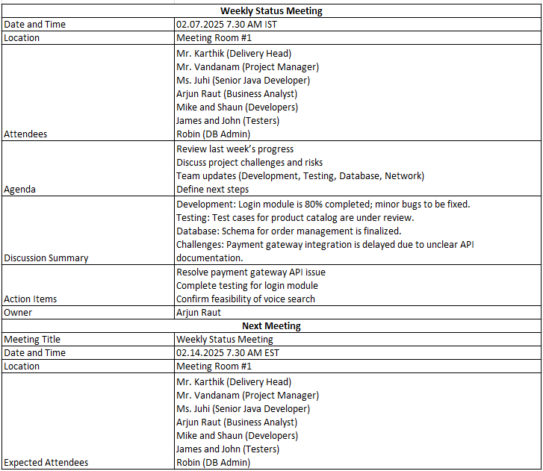

Q13. Change Tracker – Document - – prepare one Sample -4 Marks

**Answer:**

Change tracker document is used by the project team to log and track change requests made throughout the life of the project.

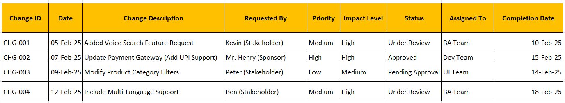

Q14. Difference between Traditional Development Model and Agile Development Models –

8 Marks

**Answer:**

Waterfall Model

The Waterfall Model is a linear and sequential approach where each phase must be completed before the next one begins. It’s structured with distinct stages like requirements gathering, design, implementation, testing, and maintenance.

Pros:

Clear structure: Each phase has specific deliverables and a review process, ensuring clarity and accountability.

Simple to manage: The linear nature makes it easier to manage, especially for projects with well-defined requirements.

Documentation: Each phase results in detailed documentation, which is useful for ongoing maintenance.

Cons:

Inflexibility: Once a phase is completed, it’s difficult to go back and make changes, which can be problematic if requirements evolve.

Late testing: Testing only happens after the development phase, which means that any bugs or issues found can be costly and time-consuming to fix.

Agile Development Model

The Agile Development Model is a flexible, iterative, and customer-focused software development approach that delivers small, functional parts of a project frequently instead of waiting until the end. It emphasizes collaboration, adaptability, and continuous improvement.

Key Features of Agile Development Model

Iterative Approach – Work is divided into small iterations (Sprints), ensuring continuous improvements.

Customer Collaboration – Frequent stakeholder feedback helps in refining the product.

Flexibility to Changes – Agile welcomes requirement changes even late in the project.

Cross-functional Teams – Developers, testers, BAs, and designers work together throughout.

Continuous Testing & Deployment – Ensures a high-quality product with fewer defects.

Working Software Delivery – Every sprint (2-4 weeks) delivers a working feature.

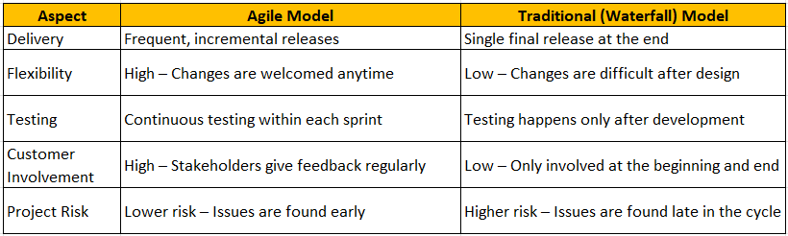

Q15. Explain Brainstorming Technique – Where to use? 5 Marks

**Answer:**

Brainstorming Technique

Brainstorming is a group discussion technique used to generate a large number of ideas, solutions, or alternatives quickly. It encourages free thinking, creativity, and collaboration among team members.

Where to Use Brainstorming

Brainstorming is useful in scenarios where:

Requirement Gathering – Identifying features for a new project.

Problem Solving – Finding solutions to a complex issue.

Process Improvement – Improving workflows or operations.

Risk Identification – Identifying potential project risks.

Decision Making – Selecting the best approach among multiple options.

How to Conduct a Brainstorming Session

Define the Objective – Clearly state the problem or topic.

Gather Participants – Include stakeholders, team members, and SMEs.

Encourage Free Thinking – Allow participants to share ideas without judgment.

Note Down Ideas – Capture all suggestions (on a whiteboard, sticky notes, or digital tools).

Categorize & Analyze – Group similar ideas and evaluate feasibility.

Select the Best Ideas – Choose the most viable solutions for further discussion.

Case study ( Q16 – Q20 ◊ 33 Marks) TTS Company is a multinational Company giving services on Software development in the BFSI Vertical. They have multiple products available. They have Research and Development Wing, which continuously try to improve the Quality of the products and innovation is their USP, this is helping TTS Company to be in Top 10 List. TTS Company came up one initiative to help their Employees with Loans based on their eligibility. To support this cause, they proposed the development of Employees Loan Management System. The Employees Loan Management System will help an organization to manage a loan for its employees online in an efficient way. Employees can request loans, which will be reviewed by the HR and Accounts departments and then loans will be approved or rejected. In case, the loan is rejected, the employee will be informed of the reason for loan rejection. However, in the case of loan approval, Loan approval terms and conditions, the loan repayment schedule will be provided to the employee. If the employee will agree with the loan offer, terms and condition, and repayment schedule, the loan will be granted to the employee and automatic deduction from employee salary will be made.

Q16. What reports Accounts Departments will generate (minimum 5 reports) – 10 Marks

**Answer:**

Accounts Department will generate the following reports:

1. Loan Applications Summary Report – Lists of all loan applications with status (Approved/Pending/Rejected).



1. Approved Loans Report – Details of all approved loans, including loan amount, interest rate, and repayment schedule.



1. Rejected Loans Report – Includes rejected applications with reasons for rejection.



1. Loan Repayment Report – Displays repayment status for each employee, including due dates and outstanding amounts.



1. Salary Deduction Report – Details monthly deductions for employees with active loans.



Q17. What is the structure of the message/mail communicated from the HR department to

the employee in case the Loan is rejected? – 5 Marks

**Answer:**

Subject: Loan Application Status – Rejected

Dear Bob Brown

We regret to inform you that your loan application Loan ID# L003 submitted on has been rejected due to the following reason(s):

Reason for Rejection: Insufficient eligibility

If you have any questions or need further clarification, please contact the HR department at

Email: [Abcd.123@gmail.com](mailto:Abcd.123@gmail.com) ; Phone: 020-789456

Best Regards,

John S

HR Department

TTS Company

Q18. What is the structure of the message/mail communicated from the HR department to the employee in case the Loan is approved? – 5 Marks

**Answer:**

Subject: Loan Application Approved – Next Steps

Dear Emma Davis,

We are pleased to inform you that your loan application Loan ID# L004 submitted on 02.11.2025 has been approved.

• Loan Amount: ₹ 2,50,000

• Interest Rate: 6.45%

• Repayment Period: 24 months

• Monthly Deduction: $11760.41

Please review the attached Loan Terms & Conditions and Repayment Schedule. To proceed, kindly confirm your acceptance by signing the attached agreement and submitting it before 02.16.2025.

For any queries, please contact HR at Email: Abcd.123@gmail.com ; Phone: 020-789456.

Best Regards,

John S

HR Department

TTS Company

Q19. Design a sample report on the Loans applications Received by the accounts

department – 8 Marks

**Answer:**

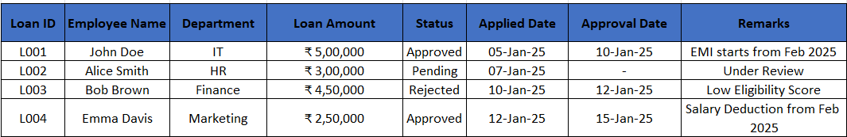

Q20. Which reporting Tools we will use for generating reports. – 5 Marks

**Answer:**

For generating reports, the following tools can be used:

1. **Microsoft Power BI** – Interactive dashboards and real-time data visualization.
2. **Tableau** – Advanced data analytics and visual representation.
3. **SAP Crystal Reports** – Detailed, printable financial reports.
4. **SQL Server Reporting Services (SSRS)** – Generates structured reports using SQL.
5. **Excel with Pivot Tables & Macros** – For quick analysis and custom reports.