AGILE DELIVERABLES

Documented by B.Vaishnavi
Date : 06-SEP-2025

Agile Documents –

Document 1: Definition of Done

Definition of Done (DoD) for the Content Integrity Initiative (Single Review Tool - SRT):
As per Agile practices, the DoD defines the conditions that must be met for a user story or feature to be marked as complete. It ensures clarity, shared understanding, and delivery of quality.
Checklist for DoD:
Governance Features – Review checklists and approval workflows are fully functional, tested, and linked to roles (Creator, Reviewer, Publisher, Compliance).
Automated Integrity Checks – Keyword, metadata, and copyright validations run automatically and block non-compliant content.
Audit Trail & Version Control – All edits, reviews, and approvals logged with timestamps; side-by-side comparison available.
Dashboards & Alerts – SLA dashboards and overdue alerts display correct metrics with no missing data.
Compliance Workflow – High-risk posts (finance, healthcare, political) are routed through compliance officers before approval.

Document 2- Product Vision
Scrum Project | Content Integrity Initiative – Single Review Tool (SRT)
Venue: | Online – Microsoft Teams
Date: | 05-September-2025
Start time: | 10:00 AM
End time: | 12:00 PM
Duration: | 2 Hours
Client: | Content Operations & Compliance Department
Stakeholder list: | Moderators, Compliance Officers, Product Managers, Legal Team, Development Team
Scrum Role | Name
Scrum Master: | Roshan
Product Owner: | Vaishnavi
Scrum Developer 1: | Kiran Reddy (Frontend – ReactJS)
Scrum Developer 2: | Srija (Backend – Node.js/Java)
Scrum Developer 3: | Vardhan (AI/ML – Python)
Scrum Developer 4: | Sreemanthi (UI/UX Designer
Scrum Developer 5: | Arun (QA Engineer)

Vision
To build a smart and scalable content moderation platform that uses AI/ML to automatically detect harmful or non-compliant content, provides a centralized dashboard for moderators, and ensures transparency, compliance, and faster decision-making.

Target group | Needs | Product | Value
Marketing teams publishing across Meta, Facebook, Instagram.  - Compliance officers ensuring regulatory adherence.  - Content creators & social media managers. | - Ensures content complies with brand guidelines, legal, and compliance rules.  - Solves delays caused by manual review bottlenecks.  - Prevents reputational risks from non-compliant or misleading posts. | A Single Review Tool (SRT) with built-in content integrity features.  - Automated checks for banned keywords, metadata completeness, and copyright usage.  - Version control, audit trails, and compliance workflows.  - Feasible using existing SRT with added features (low incremental cost). | Reduces compliance risks and potential legal penalties.  - Builds trust in the company’s digital presence.  - Improves speed-to-market by reducing approval delays.  - Business Goals: brand protection, faster publishing, cost reduction in manual reviews.  - Business Model: Internal adoption for compliance efficiency; potential SaaS offering in future.

Document 3 UserStories

User Stories - Content Integrity Initiative (SRT)

User story No: US-01 |  | Tasks: Add metadata completeness validation |  |  | Priority: High
Value statement:
As a Content Creator, I want the system to validate metadata so that
posts comply with publishing standards.
BV: 500 |  | CP: 5 |  |  | Acceptance criteria:  - Missing hashtags flagged  - Alt text required for images  - Broken or missing links detected
 | User story No: US-02 |  | Tasks: Implement review checklist functionality | Priority: High
Value statement:
As a Reviewer, I want to follow a standardized review checklist so that I can ensure content meets brand and compliance requirements.
 | BV: 500 |  | CP: 5 | Acceptance criteria:  - Checklist is mandatory before approval  - Reviewer cannot approve content without completing checklist  - Checklist includes brand, metadata, and banned keywords

User story No: US-03 | Tasks: Configure workflow for multiple reviewer approvals | Priority: High
Value statement:
As a Publisher, I want mandatory multi-level approvals before publishing so that content integrity is not compromised.
BV: 500 | CP: 8 | Acceptance criteria:  - At least 2 reviewers must approve content  - System prevents publishing until all approvals completed  - Approval sequence logged in audit trail

User story No: US-04 | Tasks: Set SLA timers for review turnaround | Priority: Medium
Value statement:
As a Marketing Manager, I want SLAs for reviews so that campaign timelines are not delayed.
BV: 200 | CP: 3 | Acceptance criteria:  - SLA values configurable (e.g., 48 hours)  - Alerts triggered when SLA is breached  - Reports show SLA compliance rates

User story No: US-05 | Tasks: Develop automated banned keyword detection | Priority: High
Value statement:
As a Reviewer, I want the system to automatically flag banned keywords so that I don’t miss policy violations.
BV: 500 | CP: 8 | Acceptance criteria:  - Banned keyword list configurable by Admin  - Keywords highlighted in content for review  - Reviewer alerted before content approval

User story No: US-06 | Tasks: Integrate copyright/media validation | Priority: Medium
Value statement:
As a Compliance Officer, I want copyright validation so that unauthorized media is not published.
BV: 200 | CP: 3 | Acceptance criteria:  - System flags duplicate/unlicensed images  - Requires proof of licensing before publishing  - Blocked content logged in audit trail

User story No: US-07 | Tasks: Enable side-by-side post comparison | Priority: Medium
Value statement:
As a Reviewer, I want to compare post versions so that I can validate changes after feedback.
BV: 200 | CP: 2 | Acceptance criteria:  - System stores all post versions  - Changes highlighted automatically  - Reviewer can approve/reject updated version

User story No: US-08 | Tasks: Create audit trail for all reviews and approvals | Priority: High
Value statement:
As an Admin, I want a complete audit trail so that accountability is maintained.
BV: 500 | CP: 5 | Acceptance criteria:  - Logs all actions (submitted, edited, approved, rejected)  - Includes timestamp and user ID  - Audit logs exportable for compliance

User story No: US-09 | Tasks: Develop review status dashboard | Priority: High
Value statement:
As a Marketing Manager, I want a dashboard showing review status so that I can track campaign readiness.
BV: 500 | CP: 5 | Acceptance criteria:  - Dashboard displays content by status (Draft, In Review, Approved, Rejected)  - Filters by platform (Meta, FB, Instagram)  - Exportable reports available

User story No: US-10 | Tasks: Configure overdue review alerts | Priority: Medium
Value statement:
As a Reviewer, I want overdue content flagged so that I can prioritize urgent reviews.
BV: 200 | CP: 3 | Acceptance criteria:  - Alerts triggered when SLA breached  - Notifications via email/in-app  - Escalation to manager if not reviewed

User story No: US-11 | Tasks: Implement escalation workflow for high-risk content | Priority: Medium
Value statement:
As a Compliance Officer, I want high-risk content auto-escalated so that I can review before publishing.
BV: 200 | CP: 3 | Acceptance criteria:  - High-risk categories configurable (finance, healthcare, political ads)  - Posts auto-routed to compliance officer  - Content blocked until compliance approval complete

User story No: US-12 | Tasks: Generate compliance performance reports | Priority: Low
Value statement:
As a Stakeholder, I want compliance reports so that I can measure integrity performance.
BV: 50 | CP: 1 | Acceptance criteria:  - Monthly report shows rejection rates and SLA compliance  - Exportable in PDF/Excel  - Comparisons available across campaigns

Document 4: Agile PO Experience
As the Product Owner, my responsibilities in the Content Integrity Initiative (SRT Project):

Responsibilities:
- Market Analysis: Researched the demand for automated content moderation tools and identified that existing solutions lacked real-time AI detection, centralized dashboards, and audit trails.
- Enterprise Analysis: Analyzed compliance risks and opportunities, especially the need for transparent decision logs to satisfy regulators.
- Product Vision & Roadmap: Created a vision to deliver an AI-powered, compliance-ready content review platform. Designed a roadmap of six sprints, each delivering usable increments like flagging, dashboards, policy tagging, and reporting.
- Managing Features: Collected stakeholder inputs from moderators, compliance officers, and legal teams. Prioritized epics and user stories based on urgency, ROI, and regulatory deadlines.
- Backlog Management: Maintained product backlog in Jira, continuously refined user stories with acceptance criteria, and adjusted priorities after sprint reviews.
- Iteration Progress: Regularly reviewed sprint burndown charts, monitored progress, and worked with Scrum Master and BA to resolve blockers quickly.

Lessons Learned:
- Actively participated in sprint planning, daily scrums, reviews, and retrospectives, gaining practical experience in Agile ceremonies.
- Learned how user stories evolve through collaboration, especially for modules like AI flagging and compliance dashboards.
- Improved skills in writing user stories with Business Value (BV) and Complexity Points (CP).
- Understood the importance of stakeholder communication to align business goals with technical implementation.
- Practiced balancing regulatory compliance vs. development capacity, ensuring critical features were prioritized early.

Document 5: Product and sprint backlog and product and sprint burndown charts

Product Backlog

User story  ID | User story | Tasks | Priority | BV | CP | Sprint
US001 | As a Reviewer, I want to follow a standardized review checklist so that I can ensure content meets brand and compliance requirements. | Implement review checklist functionality | High | 500 | 5 | 1
US002 | As a Publisher, I want mandatory multi-level approvals before publishing so that content integrity is not compromised | Configure workflow for multiple reviewer approvals | High | 500 | 8 | 1
US003 | As a Marketing Manager, I want SLAs for reviews so that campaign timelines are not delayed. | Set SLA timers for review turnaround | Medium | 200 | 3 | 1
US004 | As a Reviewer, I want the system to automatically flag banned keywords so that I don’t miss policy violations | Develop automated banned keyword detection | High | 500 | 5 | 1
US005 | As a Content Creator, I want the system to validate metadata so that posts comply with publishing standards | Add metadata completeness validation | High | 500 | 5 | 2
US006 | As a Compliance Officer, I want copyright validation so that unauthorized media is not published. | Integrate copyright/media validation | Medium | 200 | 3 | 2
US007 | As a Reviewer, I want to compare post versions so that I can validate changes after feedback. | Enable side-by-side post comparison | Medium | 200 | 3 | 2
US008 | As an Admin, I want a complete audit trail so that accountability is maintained. | Create audit trail for all reviews and approvals | High | 500 | 5 | 2
US009 | As a Marketing Manager, I want a dashboard showing review status so that I can track campaign readiness. | Develop review status dashboard | High | 500 | 5 | 3
US010 | As a Reviewer, I want overdue content flagged so that I can prioritize urgent reviews | Configure overdue review alerts | Medium | 200 | 3 | 3
US011 | As a Compliance Officer, I want high-risk content auto-escalated so that I can review before publishing. | Implement escalation workflow for high-risk content | Medium | 200 | 3 | 3
US012 | As a Stakeholder, I want compliance reports so that I can measure integrity performance | Generate compliance performance reports | Low | 50 | 1 | 3

Sprint Backlog
User story  ID | User story | Tasks | Owner | Status | Estimated effort
US001 | As a Reviewer, I want the system to automatically flag banned keywords so that I don’t miss policy violations | Develop automated banned keyword detection | Developer 1 &2 | Review | 12 hours
US002 | As a Reviewer, I want to compare post versions so that I can validate changes after feedback. | Enable side-by-side post comparison | Developer 1,2 & 3 | Done | 22 hours
US003 | As a Content Creator, I want the system to validate metadata so that posts comply with publishing standards | Add metadata completeness validation | Developer 3 & 1 | IN progress | 16 hours
US004 | As a Compliance Officer, I want copyright validation so that unauthorized media is not published. | Integrate copyright/media validation | Developer 2 & 3 | Done | 16 hours

Burnup chart

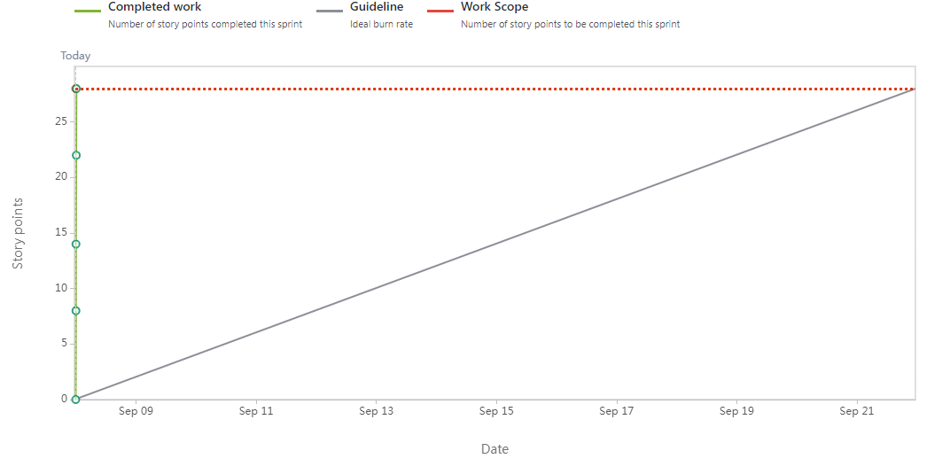

Burndown chart

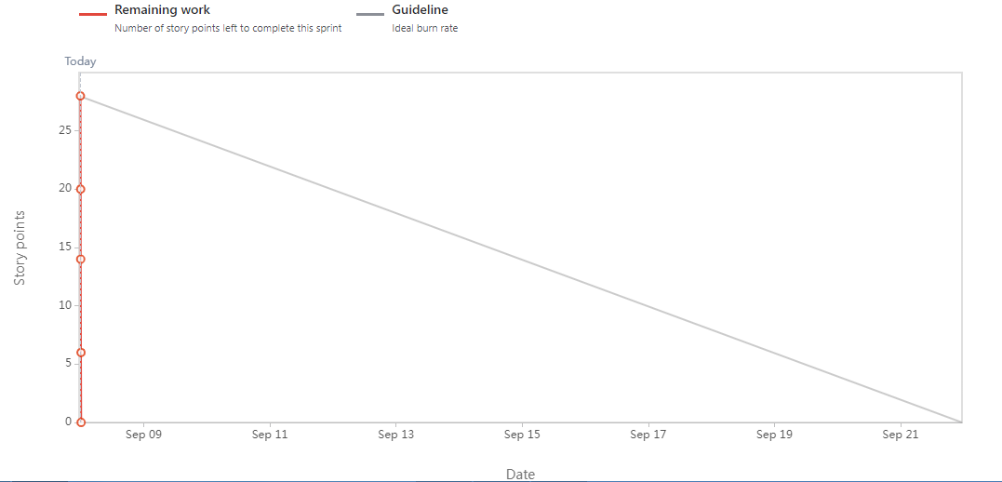

Document 6: Sprint meetings
Meeting Type 1: Sprint Planning meeting
Date | 01-July-2025
Time | 9:00 AM – 11:00 AM
Location | Online (Teams)
Prepared By | Scrum Master
Attendees | Product Owner, Scrum Master, Dev Team

Agenda Topics
Topic | Presenter | Time allotted
Discuss Sprint 1 scope | Product OWNER | 2 weeks
Story estimation & BV/CP assignment | BA | 45mins

Other Information
Observers | Stakeholders
Resources | JIIRA board , Backlog
Special Notes | Focus on content integrity features

Meeting Type 2: Sprint review meeting

Date | 10-July-2025
Time | 4:00 PM
Location | Teams
Prepared By | Scrum Master
Attendees | PO , BA , QA, SM,COMPLAINCE MANAGER

Sprint status | Things to demo | Quick updates | What’s next
100% DCS UI/Backend completed | Doubt input, mentor dashboard |  | Timesheet & Job Portal in Sprint 2
  Completed – engine flags disallowed words, tested with sample data
  Metadata validation (hashtags, alt text, captions) working. Copyright check integration pending

Meeting Type 3: Sprint retrospective meeting
Date | 23-Sep-2025
Time | 10:00 AM – 11:00 AM
Location | Online (MS Teams)
Prepared By | Scrum Master / BA
Attendees | Scrum Team (PO, SM, Dev, QA), Compliance Officer

Agenda | What went well | What didn’t go  well | Questions | Reference
Sprint Goal Review | Integrity checks completed on time | Testing delays due to lack of test data | Can compliance provide datasets earlier? | Sprint Board
Collaboration | Dev & Compliance worked closely | Daily standup attendance low | How to ensure better engagement? | Jira
Technical Setup | Keyword detection engine integrated | Metadata rules not fully configured | Should we prioritize rules configuration next sprint? | User Stories

Meeting Type 4: Daily Stand-up meeting
Question | Name/Role | Week “1” (from 01-07-2025 to 15-07-2025)
  Monday | Tuesday | Wednesday | Thursday | Friday | Saturday | Sunday
What did  you do  yesterday?
  Developer
  1
  Developer
  2
  Developer
  3
  Set up keyword rules engine | Integrated banned keyword list | Tested keyword detection with sample data | Fixed false positives in keyword detection | Prepared demo for PO | - | -
  Created metadata validation rules | Implemented alt text validation | Tested metadata completeness for 10 sample posts | Debugged hashtag validation logic | Completed unit tests | - | -
  Designed audit trail schema | Built version history storage | Implemented side-by-side comparison prototype | Integrated audit logging | Ran QA on audit logs | - | -
What will  you do  today?
  Developer
  1
  Developer
  2
  Developer
  3
  Integrate keyword rules with review workflow | Improve flagged word highlighting | Work with QA to refine validation | Update documentation | Demo in sprint review | - | -
  Enhance metadata checks with broken link detection | Add mandatory caption validation | Support QA in testing | Document metadata module | Sprint review demo | - | -
  Complete version comparison UI | Test audit trail export | Finalize API integration with dashboard | Prepare sprint review materials | Demo version control feature | - | -
What (if  any) is  blocking  your  progress?
  Developer
  1
  Developer
  2
  Developer
  3
  None |  | - | - | - | - | -
    Waiting for compliance team to finalize banned keyword list
  Delay in getting accessibility guidelines from compliance officer | - | - | - | - | - | -
  Need test data for old post versions to validate audit trail | - | - | - | - | - | -

