# -Case Study: Online Agricultural Products Store

Mr. Henry, after being successful as a businessman and has become one of the wealthiest persons in the city. Now, Mr. Henry wants to help others to fulfil their dreams. One day, Mr. Henry went to meet his childhood friends Peter, Kevin and Ben. They live in a remote village and do farming. Mr. Henry asked his friends if they are facing any difficulties in their day-to-day work.

Peter told Mr. Henry that he is facing difficulties in procuring fertilizers which are very important for farm. Kevin said that he is also facing the same problem in-case of buying seeds for farming certain crops. Ben raised his concern on lack of pesticides which could help in greatly reducing pests in crops.

After listening to all his friends’ problems, Mr. Henry thought that this is a crucial problem faced not only by his friends but also by so many other farmers. So, Mr. Henry decided to make an online agriculture product store to facilitate remote area farmers to buy agriculture products. Through this Online Web / mobile Application, Farmers and Companies (Fertilizers, seeds and pesticides manufacturing Companies) can communicate directly with each other.

The main purpose to build this online store is to facilitate farmers to buy seeds, pesticides, and fertilizers from anywhere through internet connectivity. Since new users are involved, Application should be user friendly.

This new application should be able to accept the product (fertilizers, seeds, pesticides) details from the manufacturers and should be able to display them to the Farmers. Farmers will browse through these products and select the products what they need and request to buy them and deliver them to farmers location.

Mr. Henry has given this project through **his Company SOONY**. In SOONY Company, Mr Pandu is Financial Head and Mr Dooku is Project Coordinator. Mr. Henry , Mr Pandu , and Mr Dooku formed one Committee and gave this project to **APT IT SOLUTIONS** company for **Budget 2 Crores INR and 18 months Duration** under CSR initiative**. Peter, Kevin and Ben** are helping the Committee and can be considered as **Stakeholders** share requirements for the Project.

Mr Karthik is the Delivery Head in APT IT SOLUTIONS company, and he reached out to Mr Henry through his connects and Bagged this project. APT IT SOLUTIONS company have Talent pool Available for this Project. **Mr Vandanam is project Manager, Ms. Juhi is Senior Java Developer, Mr Teyson, Ms Lucie, Mr Tucker, Mr Bravo are Java Developers. Network Admin is Mr Mike and DB Admin is John. Mr Jason and Ms Alekya are the Tester. And you joined this team as a BA.**

**Question 1 – Audits - 5 M**

4 Quarterly Audits are planned Q1 , Q2, Q3, Q4 for this Project. What is your knowledge on how these Audits will happen for a BA ?

**Answer:** Quality audits are useful as they help us analyze the progress of the project as per the business goals. As a BA we have to be informed about various types of audits. Like financial audits, operational audits, compliance audits, IT audits, etc. These audits focus on verifying requirements, tracking the project documentation and ensuring that the business objectives are achieved.

Auditors will check the following details during the audits:

|  |  |
| --- | --- |
| **Quarter 1** | **Requirement Gathering and Analysis** |
| Checklist | BRD document, UML diagrams, Review of project scope, budget and timeline, |
|  | Conducting stakeholder analysis, Client signoff- documents, and the email |
|  | Communications with client. |
|  |  |
| **Quarter 2** | **Design and Development** |
| Checklist | Preparation of use case and activity diagram, Documents signed by the client |
|  | Before start of the development stage, JAD session development, reporting |
|  | Of the timesheets, |
|  |  |
| **Quarter 3** | **Testing** |
| Checklist | Tracking for the testing of product, training reports to the end users, email |
|  | Communication to the clients, ensuring that all the requirements are addressed |
|  | Assisting the team for testing the product |
|  |  |
| **Quarter 4** | **Deployment and UAT** |
| Checklist | Preparing the end user manual, Assisting the delivery manager during |
|  | Implementation, Assisting in the UAT, organizing the training sessions, |
|  | Communicating with the client |

**Question 2 – BA Approach Strategy - 6 M**

Before the Project is going to Kick Start, The Committee asked Mr Karthik to submit BA Approach Strategy

Write BA Approach strategy (As a business analyst, what are the steps that you would need to follow to complete a project –

* What Elicitation Techniques to apply,
* how to do Stakeholder Analysis RACI/ILS,
* What Documents to Write,
* What process to follow to Sign off on the Documents,
* How to take Approvals from the Client,
* What Communication Channels to establish n implement,
* How to Handle Change Requests,
* How to update the progress of the project to the Stakeholders,
* How to take signoff on the UAT- Client Project Acceptance Form )

**Answer:** As a BA the following step can be taken to complete the project and ensure effective communication between stakeholders.

1. **Elicitation techniques to apply:** There are many such techniques which can be used namely:
   1. Brainstorming: Arranging session where all the participants provide their inputs on the projects. The goal of this process is to get as many creative ideas as possible
   2. Interviews: Interviewing all the stakeholders to understand their requirements
   3. Workshops: Arranging workshops with all the key stakeholders and SME. The purpose of this is to discuss on planning, designing, scoping and modelling
   4. Prototyping: Develop mock-ups for the validation of users expectation
   5. Surveys: Gathering inputs from the stakeholders in form of open and closed ended questions

1. **Stakeholder Analysis:**

The RACI Matrix helps to identify the key stakeholders based on their roles and responsibilities in the project:

RACI stands for

* Responsible: those who do the work to complete the task
* Accountable: the final decision-makers; ownership of the task
* Consulted: whose opinions are sought before making decisions
* Informed: who need updated about the decisions

The stakeholders in this project are

* Mr. Henry – Project Sponsor
* Mr. Pandu – Financial head
* Mr. Dooku – Project coordinator
* Peter, Kevin, Ben – Stakeholders
* Mr. Kartik – Delivery head
* Mr. Vandanam – Project Manager
* Ms. Juhi – Senior Java Developer
* Mr. John – DB Admin
* Mr. Jason and Ms. Alekya – Tester
* Abhishek Bagul – BA

|  |  |  |  |  |  |  |
| --- | --- | --- | --- | --- | --- | --- |
| Tasks | Abhishek Bagul (BA) | Mr. Henry  (Product sponsor) | Peter, Kevin, Ben (Stakeholder) | Mr. Kartik (Delivery head) | Mr. Vanadanam (Project Manager) | Ms Juhi and team |
| Requirement gathering | R |  | C | I | A |  |
| Requirement analysis | R |  |  |  | I |  |
| Development |  |  |  |  | A | R/I |
| Testing | I |  |  |  | I | R/C |
| Implementation | R |  |  | R | I |  |
| UAT | I | I |  |  | R/A |  |

* Mr. Henry & Mr. Pandu drive the high-level decisions.
* APT IT Solutions team executes the project with technical leadership
* Farmers and Manufacturers influence platform requirements but don’t take major decisions

1. **Documents to write:**
   1. Business requirements documents(BRD) – High level business need
   2. Functional requirements documents(FRD) – detailed functional requirements
   3. Use case and process flow – Visual representation of workflows
   4. User stories and acceptance criteria
   5. Requirement Traceability Matrix – Mapping business needs to functionalities
   6. Test case and UAT scripts – Criterias for the system validation from end-users
2. **Signing off on the documents:**
   1. Sending the above mentioned documents to the stakeholders to get their approvals
   2. Addressing the changes which are suggested before moving forward
3. **How to take approvals from clients:** 
   1. Present the requirements through a detailed walkthrough
   2. Demonstrate the prototypes and mock-ups for validation of the process
   3. Obtain written approval over mail and call them to explain the process
4. **Communication channels to establish and implement:**
   1. Email communication
   2. Weekly meetings (project status report)
   3. Video conference
   4. Phone calls
5. **How to Handle Change Requests:**
   1. Understanding the scope change
   2. Understanding the feasibility of the change
   3. Tsking the approvals for the change
   4. Communicating and implementating the change
6. **How to update the progress of the project to the Stakeholders:**
   1. Providing weekly updates to the stakeholders
   2. Validation at each of the SDLC stage
7. **How to take signoff on the UAT- Client Project Acceptance Form:**
   1. UAT Preparation:
      1. Creating UAT planning sessions.
      2. Defining test cases and scenarios based on business needs.
      3. Train end-users on the new system.
   2. UAT Execution:
      1. Capture feedback and resolve defects.
      2. Ensuring that all the acceptance criteria are met.
   3. Sign-Off Process:
      1. Submit the Client Project Acceptance form to key stakeholders.
      2. Obtain approval and document completion for project closure.

**Question 3 – 3-Tier Architecture - 5 M**

Explain and illustrate 3-tier architecture?

**Answer:** The 3-tier architecture model is a software design which divides and application layer into 3 logical layers: Presentation layer, Application (business) layer and data storage layer.

* **Presentation (UI) layer:** also known as the client layer, it is responsible for accepting inputs from the users and interacting with the system to generate output based on the inputs received. It includes interface which is built using HTML, CSS, Java technology
* **Application layer:** also known as Business logic layer which contains logic for the solution of the business problem. It is the middle layer and acts a bridge between both the system and the user. It converts the inputs from the user and converts it into appropriate system logic. It is developed using Java, .NET, Python, etc. technologies
* **Database layer:** This layer contains all the data or information stored. This layer manages data storage and retrieval of the stored data. It includes databases like MySQL, etc. to access and manage the databases

DATA

REQUEST

Information System

Database layer

Application Layer

Presentation layer

v

RESPONSE

**Question 4 – BA Approach Strategy for Framing Questions – 10 M**

Business Analyst should keep what points in his/her mind before he frames a Question to ask to the Stakeholder

(5W 1H – SMART – RACI – 3 Tier Architecture – Use Cases, Use case Specs, Activity Diagrams, Models, Page designs)

**Answer:** The points a BA should consider while framing questions

* **5W 1H**
  + **What** – What is the business problem or requirement?
  + **Why** – Why is this requirement important?
  + **Who** – Who are the users or stakeholders involved?
  + **When** – When should the solution be delivered or used?
  + **Where** – Where will the system be implemented or accessed?
  + **How** – How will this requirement be achieved or integrated?
* **SMART:** These questions help to clarify requirements, gather specific information, and ensure these responses are actionable and measurable.
  + **Specific** – Clearly define the requirements to get actionable inputs
  + **Measurable** – Ensure that the questions are quantified and countable
  + **Achievable** – Confirm feasibility of the questions
  + **Relevant** – Does the question identify the needs of the customer
  + **Time-bound** – Establish deadlines or constraints
* **RACI matrix:** 
  + **Responsible:** The person who do the work to complete the task
  + **Accountable:** The people responsible for the final decision and ensuring the completion of the tasks
  + **Consulted:** The people whose opinions are sought before making decisions.
  + **Informed:** The people who need to be informed about the progress of the project.
* **3 – tier Architecture:**
  + **Presentation layer:** This layer contains the user related functions
  + **Business layer:** This layer contains logic for the solution of the business problem
  + **Data layer:** This layer contains all the data or information stored
* **Use Case:**
  + What is the type of product we will deliver?
  + Who is the stakeholder?
  + Where will this product be used?
  + How will we deliver this project?
  + When should be the process be completed?
* **Use Case spec:**
  + Who are the primary and secondary actors?
  + Whar are the goals of the actors?
  + What information does the actors need from the system?
  + What is the main tasks fo the actions performed by the actors?
* **Activity Diagrams:**
  + These diagrams are the visual representation of a series of actions in a system
  + Represents the process flow step-by-step from start to finish
  + Identify the different users and how they interact with the system
* **Models:**
  + What key data elements should be captured?
  + Are there any dependencies or constraints we should consider?

**Question 5 – Elicitation Techniques - 6 M**

As a Business Analyst, What Elicitation Techniques you are aware of? (BDRFOWJIPQU)

**Answer:** Elicitation is the process of gathering requirements and insights from stakeholders to define business needs. Here are some of the commonly used techniques:

* Brainstorming: It involves gathering a group of stakeholders to generate ideas and solutions. It is useful for identifying possible features, risks, and enhancements.
* Document Analysis: Reviewing existing documents such as business plans, process flows, and user plans to understand the current processes and requirements. This technique helps in identifying gaps and deriving business rules.
* Reverse Engineering: Analysing an existing system or product to understand its components and functionalities. This technique is very helpful when certain documentation are missing or outdated.
* Focus Groups: Engaging a group of subject matter experts (SMEs) and end-users for structured discussions. This is useful for gathering qualitative feedback and insights from the stakeholders.
* Observations: Watching users perform their daily tasks, to understand the workflows and pain points. This can be done in two ways Passive where we are only observing and Active where we will be actively asking questions while observing
* Workshops: These are interactive sessions held with stakeholders to discuss about the requirements, how to prioritize features, and resolve conflicts. It helps in gaining a understanding on business needs.
* Joint Application Development (JAD) Sessions: This is a structured meeting involving business and IT teams to collaboratively define the requirements. This facilitates a faster decision-making process and helps reduces misunderstandings.
* Interviews: One-on-one or group discussions with stakeholders to gather in-depth insights. This can be carried out in two ways: Structured where there are a set of predefined questions and Unstructured where the questions generally lead to open-ended discussions
* Prototyping: Developing wireframes, mock-ups, or interactive models to visualize requirements. This is useful for validating UI/UX expectations and refining requirements iteratively.
* Questionnaires & Surveys: The process of distributing structured questions to a large audience to gather feedback efficiently. This is an effective way to collect quantitative data.
* Use Case Modelling: Defining user interactions with a system to document functional requirements. This helps in understanding the role of the actors, their interaction with the system, and related workflows.

**Question 6 – This project Elicitation Techniques - 5 M**

Which Elicitation Techniques can be used in this Project and Justify your selection of Elicitation Techniques?

* Prototyping
* Use case Specs
* Document Analysis
* Brainstorming

**Answer:**  The techniques which can be used for this project are:

* Prototyping: It is the process of creating a model representing the ideas and allowing to the testing the ideas with the users before the final product. Using this technique we can understand the stakeholder inputs to make the necessary changes for the feasibility check before rolling out the final product. It helps in identifying the missing or unclear requirements.
* Brainstorming: It is the process of gathering innovative ideas and requirements from all the stakeholder. After collecting the ideas we analyse and select the best ideas to implement. This helps in prioritizing the features which are most required and essential.
* Use case specs: This technique helps in understanding the user interactions with the system. All the functional requirements are documented and helps understand the behaviour of the system.
* Document and Analysis: This technique helps us in understanding the existing agricultural supply chain processes before building the system. Analysing reports, regulations, and existing e-commerce systems will highlight gaps and improvement areas. Ensures compliance with e-commerce, agriculture, and payment security laws.

By employing these elicitation techniques, we can gather a range of requirements, and validate them through feedback and discussions to ensure the proper working of the project.

Fertilizers, seeds, pesticides details from the manufacturers and should be able to display them to the Farmers.

To gather the business requirements from the client, you went to SOONY and met Mr. Henry. When Mr. Henry was asked about the project and what are they expecting from the project, Mr. Henry stated that he is expecting to have a login for all its users (fertilizers, seeds, pesticides manufacturers and Farmers) , a product catalog of fertilizers, seeds, pesticides, a search option to search for products, payment process, and delivery tracking.

After doing the stakeholder analysis, you have found out that Peter, Kevin, Ben are the key stakeholders and you have scheduled an appointment to meet them. After meeting with them and trying to gather the stakeholder requirements, Kevin said that, a Farmer should be able to browse through the products catalog once they visit the website and need to have a search option so that they can search for any product they need. Peter said that, if a farmer wants to buy any product or add them to buy-later list, they need to login first using their email id and password. If it is a new user, then they can create a new account by submitting their email ID and creating a secure password. Ben added saying that, Farmers needs to have an easy-to-use payment gateway which should include cash-on-delivery (COD), Credit/Debit card and UPI options so that the user’s experience should be better. Kevin mentioned that, a user gets an email confirmation regarding their order status. A delivery tracker to track the whereabouts of their order.

Identify Business Requirements (which includes Stakeholder Requirements)

BR001 – Farmers should be able to search for available products in fertilizers, seeds, pesticides BR002 – Manufacturers should be able to upload and display their products in the application

**Question 7 – 10 Business Requirements- 10 M**

Make suitable Assumptions and identify at least 10 Business Requirements.

**Answer:**

|  |  |
| --- | --- |
| **BR001** | All users (manufacturers and Farmers) should be able to sign up easily on the system. |
| **BR002** | All users (manufacturers and Farmers) should be able to log in by submitting their email ID and password. |
| **BR003** | Farmers should be able to search for available products in fertilizers, seeds, pesticides. |
| **BR004** | Manufacturers should be able to upload and display their products. |
| **BR005** | Once the user's login to the portal, they should be able to update their address details, to make sure the delivery happens to their requested address |
| **BR006** | Farmers should be able to browse through the Product catalogues once they visit the website. |
| **BR007** | Farmers should have the Buy Now option if they want to purchase the product immediately. |
| **BR008** | Farmers can have a Save for Later or Wish list option, if they want to buy any product later. |
| **BR009** | Farmers need to have an easy-to-use payment gateway which should include cash-on (COD), Credit/Debit card and UPI options so that the user's experience should be better. |
| **BR010** | Farmers should get an email confirmation regarding their order status. |
| **BR011** | Farmers should be able to track their order, once placed. |
| **BR012** | Farmers should be able to cancel or return the product, if not happy with it. |
| **BR013** | Farmers should have an option to rate the Product, Delivery and Overall experience. |
| **BR014** | The online store should be optimized for mobile devices, allowing farmers to access and use the platform seamlessly on smartphones and tablets |
| **BR015** | The platform should ensure the security of farmers' personal information, including their payment details, by implementing robust security measures and using encryption protocols. |

**Question 8 –Assumptions- 5 M**

List your assumptions

**Answer:**

* **Internet Access:** Farmers will have sufficient internet connectivity to access the platform.
* **Digital Literacy:** Farmers will have basic knowledge of using mobile and web applications.
* **Product Availability:** Manufacturers will regularly update their product listings and stock availability.
* **Secure Payments:** The platform will support secure payment gateways, including UPI, Credit/Debit Cards, and COD.
* **Logistics Support:** Delivery partners will efficiently handle the distribution of products to farmers.
* **Regulatory Compliance:** The platform will comply with government regulations related to e-commerce and agriculture
* **Authentication System:** Users will register and log in securely using email and passwords.
* **Data Privacy:** The system will safeguard user data and comply with privacy regulations.
* **Scalability:** The platform will be scalable to accommodate an increasing number of users.
* **Customer Support:** A dedicated support team will be available to assist farmers and manufacturers.
* **Multilingual Support:** The platform will support multiple languages to enhance usability for regional farmers.
* **Mobile-Friendly:** The application will be optimized for both mobile and web use.
* **Order Tracking:** Farmers will be able to track their orders in real time.
* **System Availability:** The platform will be available 24/7 for farmers and manufacturers to use.
* **Training & Awareness:** Farmers and manufacturers will be provided with training sessions to familiarize them with the platform.
* **Payment Gateway:** The payment gateway will support multiple options, like Cash on Delivery, credit/debit card, and UPI.

**Question 9 – This project Requirements Priority - 8 M**

Give Priority 1 to 10 numbers ( 1 being low priority – 10 being high priority) to these Requirements after discussions with the stakeholders

**Answer:**

|  |  |  |
| --- | --- | --- |
| **Req. ID** | **Description** | **Priority** |
| **BR001** | All users (manufacturers and Farmers) should be able to sign up easily on the system. | **9** |
| **BR002** | All users (manufacturers and Farmers) should be able to log in by submitting their email ID and password. | **9** |
| **BR003** | Farmers should be able to search for available products in fertilizers, seeds, pesticides. | **8** |
| **BR004** | Manufacturers should be able to upload and display their products. | **8** |
| **BR005** | Once the user's login to the portal, they should be able to update their address details, to make sure the delivery happens to their requested address | **7** |
| **BR006** | Farmers should be able to browse through the Product catalogues once they visit the website. | **6** |
| **BR007** | Farmers should have the Buy Now option if they want to purchase the product immediately. | **9** |
| **BR008** | Farmers can have a Save for Later or Wish list option, if they want to buy any product later. | **8** |
| **BR009** | Farmers need to have an easy-to-use payment gateway which should include cash-on (COD), Credit/Debit card and UPI options so that the user's experience should be better. | **10** |
| **BR010** | Farmers should get an email confirmation regarding their order status. | **6** |
| **BR011** | Farmers should be able to track their order, once placed. | **9** |
| **BR012** | Farmers should be able to cancel or return the product, if not happy with it. | **7** |
| **BR013** | Farmers should have an option to rate the Product, Delivery and Overall experience. | **6** |
| **BR014** | The online store should be optimized for mobile devices, allowing farmers to access and use the platform seamlessly on smartphones and tablets | **7** |
| **BR015** | The platform should ensure the security of farmers' personal information, including their payment details, by implementing robust security measures and using encryption protocols. | **8** |

**Question 10 – Use Case Diagram - 10 M**

Draw use case diagram

**Answer:**

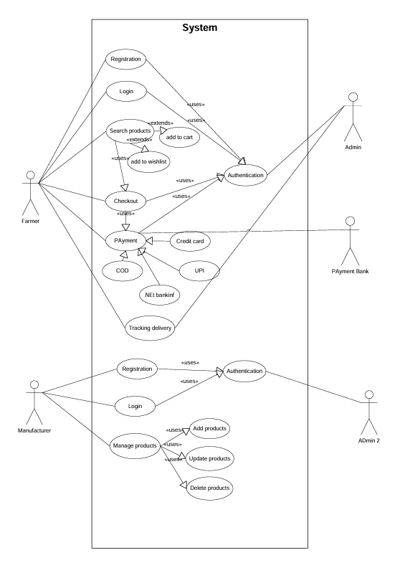

**Question 11 – (minimum 5) Use Case Specs - 15 M**

Prepare use case specs for all use cases

**Answer:**

|  |  |
| --- | --- |
| **Use Case spec 1:- User Buying fertilizers from online agriculture product store** | |
| **Brief Description** | This use case explains how a farmer uses the online agriculture store to buy products |
| **Actors** | * Farmers * Database/Admin |
| **Pre-conditions** | * There should be active internet connection * Farmers should have laptop/mobile |
| **Basic flow** | * Use case begins with user login * User validation is performed * Customer begin search for the agricultural products * Application displays multiple products for the query * User selects the product and adds it to the cart * User selects the delivery location for the product delivery * User selects the payment mode to pay * Order is placed and user receives an SMS for the order confirm * Use case ends successfully |
| **Alternate flow** | * Invalid user - This happens when the user validation fails * Product Out of Stock - If user selects the product which is out of stock * Product Out of Stock for selected location - If the product is not available for the selected location * No response from payment server - While making payments, if the server gets disconnected or there is no response from the server |
| **Post conditions** | * Successful completion - User bought the fertilizer successfully. * Failure condition – User couldn’t purchase the product due to some technical/financial reason |
| **Requirements** | * The price of all the agricultural products should be as per the government policy * The application shall keep details of all complete and incomplete transactions |

|  |  |
| --- | --- |
| **Use Case spec 2:- User registering in the application** | |
| **Brief Description** | This use case describes, how a user registers himself in the online agricultural store |
| **Actors** | * Farmers * Database/Admin |
| **Pre-conditions** | * There should be active internet connection * Farmers should have laptop/mobile * The user should have an active email address * The user should have active mobile number |
| **Basic flow** | * Use case begins – When a new user starts registering himself with the user details * User enters personal details * Application displays options to send OTP to mobile * User receives the OTP * User enters OTP * User validation approved * User created successfully |
| **Alternate flow** | * Invalid OTP – When user enter incorrect OTP * Mobile number already in use – When the user has already used the mobile no. which means he is already a registered user * Email address already in use - When the user has already used the email which means he is already a registered user * User ID not available – When the user enters an incorrect user id * Server issue – When the user is not able to login due to a servder breakdown |
| **Post conditions** | * Successful completion – The user id has been successfully created. |
| **Requirements** | * The applications shall keep a log, including date and time, of all complete and incomplete transactions. |

|  |  |
| --- | --- |
| **Use Case spec 3:- User making payment for the order placed** | |
| **Brief Description** | This use case describes, how the user goes through a payment process after the product selection |
| **Actors** | * Farmers * Admin * Bank |
| **Pre-conditions** | * There should be active internet connection * Farmers should have laptop/mobile * The user should have an active Bank account * The user should have an active mobile no. to receive Bank OTP |
| **Basic flow** | * Use case begins – When a new user starts the payment after the selection of the product * Application displays multiple options to pay by credit card, debit card, net banking, and UPI * User has options to pay by pay by credit card, debit card, net banking, and UPI * User selects the payment mode and fill in the details * Application will display payment completed * User receives email and SMS with the order completion * Use case ends successfully |
| **Alternate flow** | * Incorrect card details – when the user enters incorrect card details. User receives SMS from Bank about payment failure due to incorrect details entered * Incorrect OTP – When the user enters incorrect OTP. * Insufficient funds – Payment got declined due to insufficient funds * Server busy – Payment didn’t complete due to server is busy |
| **Post conditions** | * Successful completion – Payment is completed, and the order is placed successful |
| **Requirements** | * The applications shall keep a log, including date and time, of all complete and incomplete transactions. |

|  |  |
| --- | --- |
| **Use Case spec 4 :- Seller adding and updating the products in the portal** | |
| **Brief Description** | This use case describes, how a Seller/Manufacturers adds this products on the portal |
| **Actors** | * Seller/ Manufacturer * Database/Admin |
| **Pre-conditions** | * There should be active internet connection * Farmers should have laptop/mobile |
| **Basic flow** | * Use case begins – When a new seller wants to Add/update any new agricultural product * Seller selects the sale option before login * User validation is performed * The application displays different product and alternatives. * Seller has to choose the category of the product * Seller enters product details: Product name, type of product, price, and offers on products and approximate delivery date * Application displays the new product details updated successfully * Seller also receives a receipt by SMS or email * Use case ends successfully |
| **Alternate flow** | * Region wise product display to customer: When the seller inputs the product based on region but the app shows error * Incorrect product categories: Seller inputs the wrong category for the products. |
| **Post conditions** | * Successful completion – The product has been successfully updated |
| **Requirements** | * The applications shall keep a log, including date and time, of all complete and incomplete transactions. |

|  |  |
| --- | --- |
| **Use Case spec 5 :- User cancelling the product** | |
| **Brief Description** | This use case describes, how a user can cancel/return the products at the online store |
| **Actors** | * Farmer * Seller/ Manufacturer * Database/Admin |
| **Pre-conditions** | * There should be active internet connection * Farmers should have laptop/mobile |
| **Basic flow** | * Use case begins – When the user wants to cancel/return the products * User validation performed * Application shows the history of all the orders placed previously * User selects the order to cancel/return * User provides the reason in the application * Validation of the return/cancellation policy * Seller intimated about the queries raised of the product * Seller arranges the return/cancellation/replacement of product * Use case ends successfully |
| **Alternate flow** | * Cancellation period: The application displays the message when the user tries to cancel the cancellation/return/replacement of the product |
| **Post conditions** | * Successful cancellation/return: When the product has been cancelled and the internal records have been updated |
| **Requirements** | * The applications shall keep a log, including date and time, of all complete and incomplete transactions. |

**Question 12 – (minimum 5) Activity Diagrams - 15 M**

**Answer:**

**Login Page**

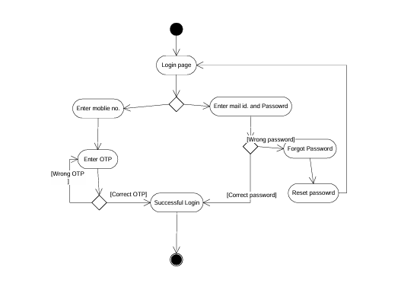

**Signup Page**

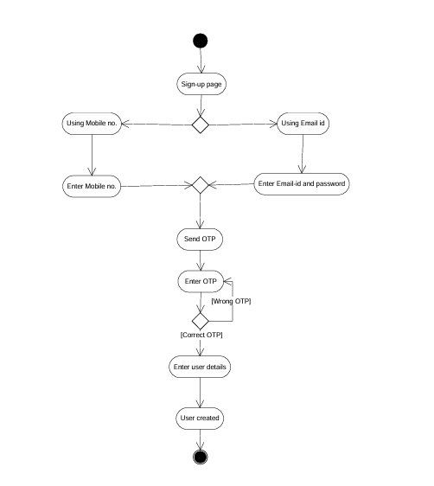

**Buying fertilizer**

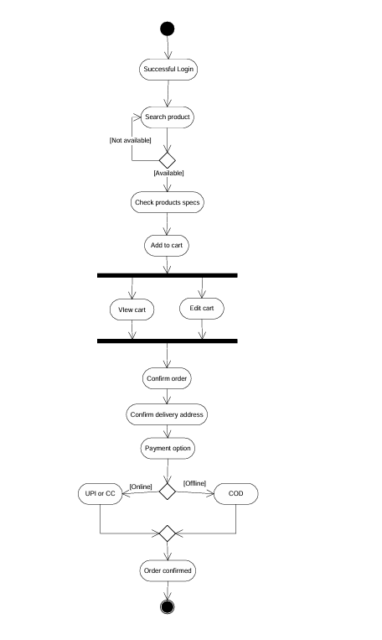

**Order cancellation**

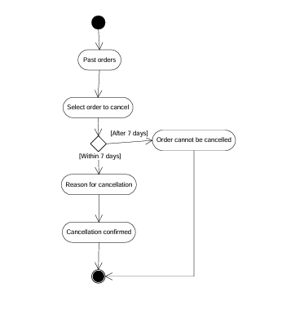

**Adding or updating the product**

