**Online Agriculture Products Store**

**Question 1 – Functional Requirements - Identify minimum 20 functional requirements**

Answer 1

|  |  |  |  |
| --- | --- | --- | --- |
| Req ID | Requirement Name | Requirement Description | Priority |
| FR0001 | Farmer Registration | Farmers should be able to register with the application | 10 |
| FR0002 | Farmer Search for  Products | Farmers should be able to search for available products in fertilizers, seeds and pesticides | 10 |
| FR0003 | Shopping Cart | Allow farmers to add product to cart and review | 7 |
| FR0004 | Payment Processing | Provide secure payment processing options to customers. | 7 |
| FR0005 | Order Management | Allow farmers to view their order history and track the status | 6 |
| FR0006 | Search | Implement a search bar to allow customers to find products. | 6 |
| FR0007 | Product reviews and  ratings | Allow customers to leave reviews and ratings for products they have purchased to help other customers make informed decisions. | 5 |
| FR0008 | Wish list | Allow customers to save products they are interested. | 5 |
| FR0009 | Shipping & Delivery | Provide customers with shipping options and estimated delivery | 8 |
| FR0010 | Return & Refund Policy | Outline the return and refund policy for customers to ensure a positive customer experience and minimize customer complaints | 5 |
| FR0011 | Availability of product | If the product is out of stock or sold out, it will be mentioned below the product. The inventory updates will, be integrated at the backend. | 8 |
| FR0012 | Search Products | After selecting a particular product category, customers will further be able to filter products based on different attributes available of product like price, newly added, Category | 9 |
| FR0013 | Availability of product | If the product is out of stock or sold out, it will be mentioned below the product.  The inventory updates will, be integrated at the backend. | 8 |
| FR0014 | New Deals and Festive  offers | Banners of all deals and offers will be showcased on homepage, so that user can view all products under that deal or offer in one click. | 7 |
| FR0015 | Company logo and name | Users will be able to view the company logo and name | 8 |
| FR0016 | Search | When three words for search are typed in the search bar, the auto suggestions give suggestions to users as they enter their search query into the search box | 8 |
| FR0017 | Buy now | On clicking on ‘buy now’, the customer will be redirected to the checkout page:- Payment Gateway | 9 |
| FR0018 | Product Comparison | Farmers can view multiple products and compare them to their liking | 7 |
| FR0019 | Product Delivery | Farmers should get real time notifications on their order progress | 6 |
| FR0020 | Product return | Farmers should be able to initiate return of products if it is of bad quality or broke while shipping | 8 |

**Question 2–Minimum 5 page designs**

**Answer 2**

|  |  |
| --- | --- |
|  |  |
|  |  |
|  |  |

**Question 3 – Tools (Visio, Balsamiq)**

Answer 3

**Visio**: Microsoft Visio is software for drawing a variety of diagrams. These include flowcharts, org charts, building plans, floor plans, data flow diagrams, process flow diagrams, business process modelling, swim lane diagrams, 3D maps, and many more.

**Balsamiq**: Balsamiq is a rapid Wireframing tool. It creates mock-ups and wireframes for websites, web apps, and desktop software. It allows us to picture ideas and concepts through a simple drag-and drop interface. The wireframes created using Balsamiq have a hand-drawn style. It focuses on the structure and content of the product rather than visual details.

**Axure**: Axure is a UX design tool used for creating wireframes and interactive prototypes. Axure is especially useful for designers of desktop and mobile applications, and it is highly regarded among enterprise companies for the high level of functionality and visual detail that can be built into its prototypes.

**Question 4 – RTM A business analyst’s key responsibilities are to keep track of the requirements and make sure that no requirement is missed.**

Answer 4

|  |  |  |  |  |  |  |  |  |  |  |
| --- | --- | --- | --- | --- | --- | --- | --- | --- | --- | --- |
| **Req ID** | **Req**  **Name** | **Req**  **Description** | **Priori**  **ty** | **Design** | **D1** | **T1** | **T2** | **T3** | **T4** | **UAT** |
| FR000  1 | Farmer  Registration | Farmers should be able to register with the application | High | Completed | Completed | Completed | Completed | Completed | Completed | Completed |
| FR000  2 | Farmer Search for Products | Farmers should  be able to search for available products in fertilizers, seeds, pesticides | High | Completed | Completed | Completed | Completed | Completed | Completed | Completed |
| FR000  3 | Page Loading Time | Each Page should load within 2 seconds time | High | Completed | Completed | Completed | Completed | Completed | Completed | Completed |
| FR000  4 | WCAG  2.1. | The system must meet Web Content Accessibility Guidelines WCAG  2.1. | High | Completed | Completed | Completed | Completed | Completed | Completed | Completed |
| FR000  5 | Bill  Printing | Bill should be printed on page on both sides  When order id  dispatched | High | Completed | Completed | Completed | Completed | Completed | Completed | Completed |

**Question 5 – 10 Test Case Documents - Prepare 10 Test Case Documents**

Answer 5

|  |  |  |  |
| --- | --- | --- | --- |
| **Test Case ID** | TC001 | **Test Case Name** |  |
| **Project ID** | OAA | **Project Name** | Online Agriculture Product  Store |
| **PM ID** |  | **PM Name** | Mr Vandanam |
| **Test Strategy ID** |  | **Tester ID** |  |
| **Test Plan ID** |  | **Tester Name** | Mr Jason |
| **Test Schedule ID** |  | **Date of Test** | 01-Oct-24 |
| **Scenario** | To authenticate a successful user login on Gmail.com | | |
| **Link to that page** |  | | |
| **Input Data** | Name, Contact number, Email ID | | |
| **Expected**  **Behaviour** | Once username and password are entered, the web page redirects to the user’s inbox, displaying and highlighting new emails at the top. | | |
| **Actual Behaviour** | It will authenticate the user and will login successfully | | |
| **Comments** | NA | | |
| **Result(Pass/Fail)** | Pass | | |

|  |  |  |  |
| --- | --- | --- | --- |
| **Test Case ID** | TC002 | **Test Case Name** |  |
| **Project ID** | OAA | **Project Name** | Online Agriculture Product  Store |
| **PM ID** |  | **PM Name** | Mr Vandanam |
| **Test Strategy ID** |  | **Tester ID** |  |
| **Test Plan ID** |  | **Tester Name** | Mr Miss Alekya |
| **Test Schedule ID** |  | **Date of Test** | 01-Oct-24 |
| **Scenario** | Seller Product Creation | | |
| **Link to that page** |  | | |
| **Input Data** | Product id, Product pictures, product prices | | |
| **Expected**  **Behaviour** | Authenticated sellers can access authorized product  creation panels under authorized categories | | |
| **Actual Behaviour** | The seller will be able to create the Product | | |
| **Comments** | NA | | |
| **Result(Pass/Fail)** | Pass | | |

|  |  |  |  |
| --- | --- | --- | --- |
| **Test Case ID** | TC003 | **Test Case Name** |  |
| **Project ID** | OAA | **Project Name** | Online Agriculture Product  Store |
| **PM ID** |  | **PM Name** | Mr Vandanam |
| **Test Strategy ID** |  | **Tester ID** |  |
| **Test Plan ID** |  | **Tester Name** | Mr Jason |
| **Test Schedule ID** |  | **Date of Test** | 01-Oct-24 |
| **Scenario** | Filter Results | | |
| **Link to that page** |  | | |
| **Input Data** | Product key names, product alternative names | | |
| **Expected**  **Behaviour** | The user should be able to see results with default search criteria when at least one of the filter parameters isn’t mandatory | | |
| **Actual Behaviour** | User will be able to filter the data while using the filter | | |
| **Comments** | NA | | |
| **Result(Pass/Fail)** | Pass | | |

|  |  |  |  |
| --- | --- | --- | --- |
| **Test Case ID** | TC004 | **Test Case Name** |  |
| **Project ID** | OAA | **Project Name** | Online Agriculture Product  Store |
| **PM ID** |  | **PM Name** | Mr Vandanam |
| **Test Strategy ID** |  | **Tester ID** |  |
| **Test Plan ID** |  | **Tester Name** | Miss Alekya |
| **Test Schedule ID** |  | **Date of Test** | 01-Oct-24 |
| **Scenario** | Product details | | |
| **Link to that page** |  | | |
| **Input Data** | Product colour alternatives, product quantity, product quality | | |
| **Expected**  **Behaviour** | Test that all the product details are displayed correctly and that no empty/invalid details are displayed. | | |
| **Actual Behaviour** | All the products enter are displayed correctly | | |
| **Comments** | NA | | |
| **Result(Pass/Fail)** | Pass | | |

|  |  |  |  |
| --- | --- | --- | --- |
| **Test Case ID** | TC005 | **Test Case Name** |  |
| **Project ID** | OAA | **Project Name** | Online Agriculture Product  Store |
| **PM ID** |  | **PM Name** | Mr Vandanam |
| **Test Strategy ID** |  | **Tester ID** |  |
| **Test Plan ID** |  | **Tester Name** | Mr Jason |
| **Test Schedule ID** |  | **Date of Test** | 01-Oct-24 |
| **Scenario** | Shopping Cart | | |
| **Link to that page** |  | | |
| **Input Data** | Item price, Item quantity | | |
| **Expected**  **Behaviour** | Test that all added items have at least a quantity, price, and  delete option associated with it | | |
| **Actual Behaviour** | The products added in the cart shows the quantity, price and delete option | | |
| **Comments** | NA | | |
| **Result(Pass/Fail)** | Pass | | |

|  |  |  |  |
| --- | --- | --- | --- |
| **Test Case ID** | TC006 | **Test Case Name** |  |
| **Project ID** | OAA | **Project Name** | Online Agriculture Product  Store |
| **PM ID** |  | **PM Name** | Mr Vandanam |
| **Test Strategy ID** |  | **Tester ID** |  |
| **Test Plan ID** |  | **Tester Name** | Mr Jason |
| **Test Schedule ID** |  | **Date of Test** | 01-Oct-24 |
| **Scenario** | Checkout Page | | |
| **Link to that page** |  | | |
| **Input Data** | Item price, coupon details, price breakup | | |
| **Expected**  **Behaviour** | User should be shown the total amount with the necessary breakup as applicable. | | |
| **Actual Behaviour** | The price break is shown of the item during the checkout page | | |
| **Comments** | NA | | |
| **Result(Pass/Fail)** | Pass | | |

|  |  |  |  |
| --- | --- | --- | --- |
| **Test Case ID** | TC007 | **Test Case Name** |  |
| **Project ID** | OAA | **Project Name** | Online Agriculture Product  Store |
| **PM ID** |  | **PM Name** | Mr Vandanam |
| **Test Strategy ID** |  | **Tester ID** |  |
| **Test Plan ID** |  | **Tester Name** | Miss Alekya |
| **Test Schedule ID** |  | **Date of Test** | 01-Oct-24 |
| **Scenario** | Payment page | | |
| **Link to that page** |  | | |
| **Input Data** | Saved payment method, card numbers, UPI, Customer ID  of net banking | | |
| **Expected**  **Behaviour** | For returning customers, they should be redirected to login for checkout | | |
| **Actual Behaviour** | For the old customer/returning customer they are redirected to login for checkout | | |
| **Comments** | NA | | |
| **Result(Pass/Fail)** | Pass | | |

|  |  |  |  |
| --- | --- | --- | --- |
| **Test Case ID** | TC008 | **Test Case Name** |  |
| **Project ID** | OAA | **Project Name** | Online Agriculture Product  Store |
| **PM ID** |  | **PM Name** | Mr Vandanam |
| **Test Strategy ID** |  | **Tester ID** |  |
| **Test Plan ID** |  | **Tester Name** | Miss Alekya |
| **Test Schedule ID** |  | **Date of Test** | 01-Oct-24 |
| **Scenario** | Session log out if page left idle for more than 10 minutes | | |
| **Link to that page** |  | | |
| **Input Data** | Timer for page loading | | |
| **Expected**  **Behaviour** | Maintain a session for each user and test verify the session  times out after a while | | |
| **Actual Behaviour** | The session is maintain for each user for 10 minutes and then the session timeout | | |
| **Comments** | NA | | |
| **Result(Pass/Fail)** | Pass | | |

|  |  |  |  |
| --- | --- | --- | --- |
| **Test Case ID** | TC009 | **Test Case Name** |  |
| **Project ID** | OAA | **Project Name** | Online Agriculture Product  Store |
| **PM ID** |  | **PM Name** | Mr Vandanam |
| **Test Strategy ID** |  | **Tester ID** |  |
| **Test Plan ID** |  | **Tester Name** | Miss Alekya |
| **Test Schedule ID** |  | **Date of Test** | 01-Oct-24 |
| **Scenario** | Calculation of shipping Cost | | |
| **Link to that page** |  | | |
| **Input Data** | Cart Details | | |
| **Expected**  **Behaviour** | Test the accurate calculation of shipping costs based on the chosen shipping method and destination. Verify that shipping cost | | |
| **Actual Behaviour** | The calculation of the shipping cost was accurate and with correct destination | | |
| **Comments** | NA | | |
| **Result(Pass/Fail)** | Pass | | |

|  |  |  |  |
| --- | --- | --- | --- |
| **Test Case ID** | TC010 | **Test Case Name** |  |
| **Project ID** | OAA | **Project Name** | Online Agriculture Product  Store |
| **PM ID** |  | **PM Name** | Mr Vandanam |
| **Test Strategy ID** |  | **Tester ID** |  |
| **Test Plan ID** |  | **Tester Name** | Miss Alekya |
| **Test Schedule ID** |  | **Date of Test** | 01-Oct-24 |
| **Scenario** | App installation/uninstallation | | |
| **Link to that page** |  | | |
| **Input Data** | Device details, auto fill up, contact number | | |
| **Expected**  **Behaviour** | The application is installed and works correctly/ The  Application is uninstalled. The app’s icon isn’t displayed on the device’s OS. | | |
| **Actual Behaviour** | The application was installed correct and words fine. The app is also uninstalled and not displayed anywhere. | | |
| **Comments** | NA | | |
| **Result(Pass/Fail)** | Pass | | |

**Question 6 – DB Design - After the requirements are thoroughly explained to the entire project team by business analyst, the Database architects have decided to do the database design and also to represent the in-flow and out-flow of data. Draw database schema and ER diagram**

Answer 6

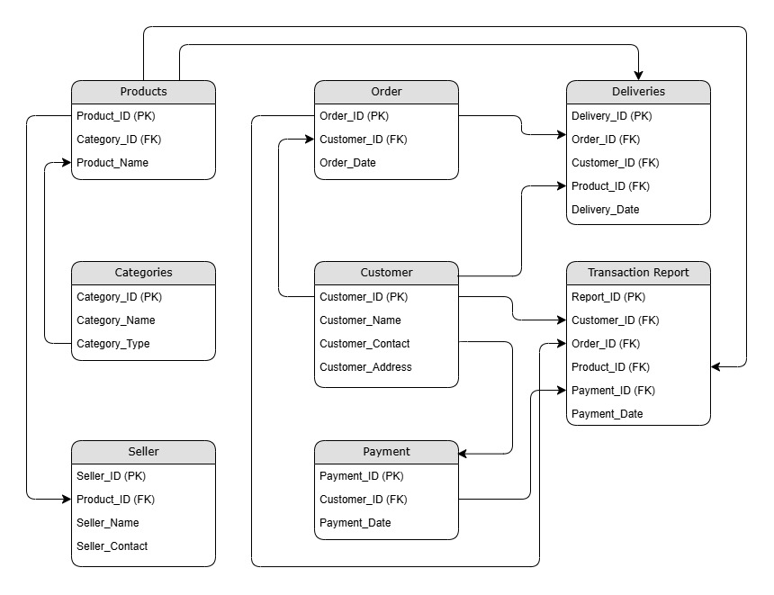

**Question 7 – Data Flow Diagram - What is a data flow diagram? Draw a data flow diagram to represent the in-flow and out-flow of data when a Farmer is placing an order for the product.**

Answer 7

A data flow diagram (DFD) maps out the flow of information for any process or system. It uses defined symbols like rectangles, circles, and arrows plus short test labels to show data inputs, outputs, storage points and the routes between each destination.

1. External entity - Rectangle

2. Data flow - arrow

3. Process or bubble – circle (process)

4. Data store –Parallel lines (Backend)

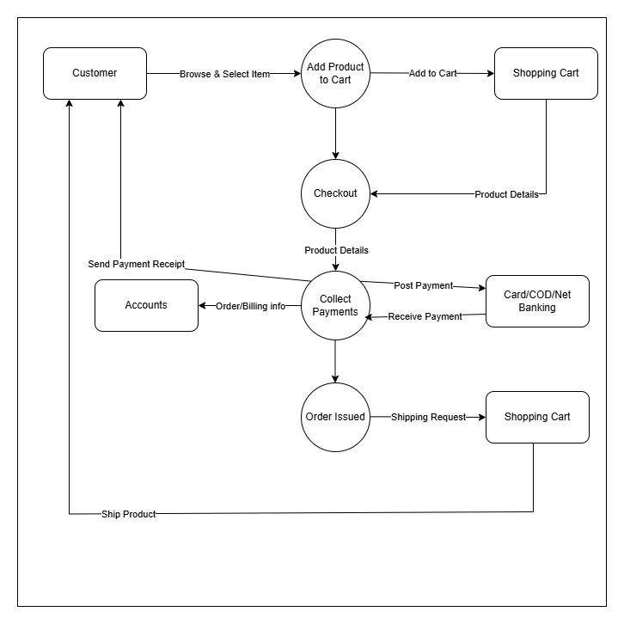

**Question 8 – Change Request Due to change in the Government Taxation structure we should change the Tax structure. How do you handle change requests in a project?**

Answer 8

Change information should include the following:

* The reason/business justification for the change
* Why the change is needed – giving detailed information on implications of not implementing the change – i.e., security risks, Government taxation, Compliances etc.
* Known risks or impact to the business of implementing the change – consideration should also be given to the risk and impact to the business of not implementing the change.
* Required resources – including people, time, and investment/costs.

The status of a change at this stage of the change process will be: NEW and then AWAITING

ASSESSMENTThe Change Manager assigns the change a priority based on the following information: Priority information (priority is based on how quickly the change needs to be implemented)

* **Emergency** – Causing loss of service or severe usability problems to a larger number of Users, a mission-critical system, or some equally serious problem. Immediate action required.
* **High** – Needs doing within 48 hours. Severely affecting some users or impacting upon many users. To be given highest priority for change building, testing, and implementation resources. (Other than emergency).
* **Medium** – No severe impact, but rectification cannot be deferred until the next scheduled release or upgrade. To be allocated medium priority for resources.
* **Low** – needs doing by the indicated date. A change is justified and necessary but can wait until the next scheduled release or upgrade. To be allocated resources accordingly.

**Question 9 – Change Request Vs an Enhancement As the project is in process, Ben and Kevin have contacted you. The reason is to inform you that they want the Farmers to sell their crop yields through this application i.e. Farmers should be able to add their crop yields or products and display to general public and should be able to sell them. They also want to introduce Auction system for their Crop yields. As a BA, what will be your response? Is this a change request or an enhancement???**

Answer 9

**Change Request** - A change request is a formal proposal for an alteration to some product or system. In project management, a change request often arises when the client wants an addition or alteration to the agreed-upon deliverables for a project. Such a change may involve an additional feature or customization or an extension of service, among other things.

**Enhancement** - An enhancement project is one in which new capabilities are added to an existing system. Enhancement projects might also involve correcting defects, adding new reports, and modifying functionality to comply with revised business rules or needs.

So, this is an enhancement in the project.

**Question 10 – Estimations - Come up with estimations – How many Man-hours required**

Answer 10

|  |  |  |  |
| --- | --- | --- | --- |
| **Best Resource Structure** | | | |
| **Type of Resource** | **Week** | **No of Resources** | **Total Weeks** |
| BA | 8 | 1 | 8 |
| Design (Web) | 8 | 1 | 8 |
| Angular Back end | 10 | 4 | 32 |
| HTML Front end | 8 | 2 | 16 |
| Testing | 4 | 2 | 8 |
| Devops | 2 | 1 | 2 |
|  |  | Total man weeks | 74 |
|  |  | Total cost in INR | 2000000 |

**Question 11 – UAT - Project has finally completed all the stages i.e., design, development, testing etc. Now, it is the role of a business analyst to contact the client for testing of the final product and have to successfully complete it. How are you going to handle this situation? And once it is done, what will be the process to close the project? Explain UAT Acceptance process?**

Answer 11

**Planning**: Blueprints are made to implement UAT testing for every feature that needs to test and minimum standards for accepting the test.

**Designing**: Test cases are designed to hide all possibilities of software packages in a real-world environment.

**UAT Testers**: A testing team consists of a end users that meet the criteria for the implementation testing. The end user must have expertise in subject matter, the ability to report all problems.

**Bug Fixing**: The development team works on whatever bugs are found during UAT testing to make the software error free.

**Sign off**: After removing all the bugs, the testing team indicates acceptance of the completion of the bugs. In this phase, all the stakeholders conclude that the software is ready to GO live and sign it off.

**Question 12 – Project Closure Document - Explain Project closure document**

Answer 12 –

|  |  |  |  |
| --- | --- | --- | --- |
| **Sr No** | **Points to include** | **Details** | **Reference link** |
| **1** | **Did the client sign off on the UAT Testing** | |  |
|  | Date of sign off | 15-Oct-24 | ABC Doc |
|  | Name of resources | Mr. Henry |
| **2** | **Objectives of the project** | |  |
|  | User friendliness | Achieved |  |
|  | Customer Satisfaction | ROI in 6 months |  |
|  | More categories | Achieved |  |
| **3** | **Functionalities worked on** | |  |
|  | Secured payment processing | Achieved |  |
|  | Categories | Achieved |  |
| **4** | **Infrastructure** | |  |
|  | Software installed |  |  |
|  | Laptops purchased |  |  |
| **5** | **Funding** | |  |
|  | Amount approved | 2 Crore | XYZ Doc |
|  | Amount used | 2 Crore |
| **6** | **Overall project information** | |  |
|  | Escalations | 25 |  |
|  | Customer Satisfaction | High |  |
| **7** | **Value to company** | |  |
|  | Positive/Negative | Positive 95%  -Company has successfully made an app to help remote farmers to get the products on doorstep.  - Upcoming projects  - Increased users |  |

Finance team - Mr Pandu Project Team - Mr DokunInfluencers - Peter, Kevin and B

Project Team - Mr Doku