# Assignment 1

# Project Title: Inventory & Delivery Management System for Dairy Manufacturing Company

**Client**: Alpha pvt ltd

**Prepared** **By**: Ketankumar Fulbandhe, Business Analyst

**Date:** 16-04-2025

# 1. Executive Summary

The customer is a local ice-cream and milk product manufacturer with plants and warehouses located in various regions of the country. The objective of this project is to develop a centralized software solution to manage inventory efficiently and facilitate the fastest possible delivery to customers (retailers, distributors, or end-customers).

# 2. Business Objectives

1. Successful real-time monitoring and management of inventory between factories and warehouses.
2. Automated stock level alerts, reorder levels, and spoiled item expiration tracking.
3. Improve delivery by locating the nearest warehouse/plant that has inventory available.
4. Integration with route optimization software for fastest delivery.
5. Provide dashboards to monitor operations, delivery time, and inventory status.

# 3. Scope of the Project

## In-Scope:

1. Inventory Management System
2. Delivery Management System
3. User Roles: Admin, Warehouse Manager, Delivery Manager, Customer Support
4. Integration with GPS / Route optimization tools

Reporting and Alerts

## Out-of-Scope:

1. Financial accounting modules
2. HR and Payroll systems

# 4. Functional Requirements

1. Inventory tracking (batch-wise, product-wise, location-wise)
2. Real-time stock updates from plants and warehouses
3. Auto-replenishment triggers
4. Delivery scheduling and tracking
5. Customer order management
6. Route optimization and delivery ETA calculation
7. User access management

# 5. Non-Functional Requirements

1. High system availability (>99%)
2. Scalable to accommodate new warehouses/plants
3. Mobile-friendly UI for delivery agents
4. Secure login with role-based access

# 6. Assumptions

1. All locations are equipped with internet connectivity
2. Barcode/RFID infrastructure is already available or will be implemented

# 7. Constraints

1. Perishable nature of products requires tight SLAs
2. Integration with third-party route optimizers must be scoped out

# 8. Development Plan

1. Methodology: Agile (Scrum Framework)
2. Sprint Duration: 2 weeks
3. Total Duration: 5 months (10 Sprints + 2 weeks buffer)

|  |  |
| --- | --- |
| **Sprint** | **Deliverables** |
| Sprint 1 | Requirement finalization, system architecture |
| Sprint 2 | Inventory management - backend logic |
| Sprint 3 | Inventory management - UI & reporting |
| Sprint 4 | Order placement module |
| Sprint 5 | Delivery allocation & scheduling |
| Sprint 6 | GPS/route optimization integration |
| Sprint 7 | Alerts, notifications, and expiry tracking |
| Sprint 8 | Dashboard & admin panel |
| Sprint 9 | UAT and feedback |
| Sprint 10 | Final fixes and deployment |

# 9. Resource Plan

|  |  |  |
| --- | --- | --- |
| **Role** | **Count** | **Responsibilities** |
| Project Manager | 1 | Overall coordination |
| Business Analyst | 1 | Requirement gathering, validation |
| UI/UX Designer | 1 | Wireframes, visual design |
| Backend Developer | 2 | API and business logic |
| Frontend Developer | 2 | UI development |
| QA Tester | 2 | Functional & regression testing |
| DevOps Engineer | 1 | Deployment, CI/CD setup |
| Data Analyst | 1 | Reporting, dashboards |

# 10. Risk Management

|  |  |
| --- | --- |
| **Risk** | **Mitigation** |
| Data synchronization delay | Real-time API architecture |
| Delivery delay due to inaccurate routing | Integrate best-in-class route optimization APIs |
| Inventory mismanagement | Automated barcode/RFID scanning at every stage |

# 11. Process Flow Diagram

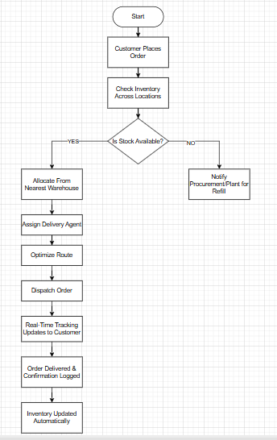

# Assignment 2

# 1. **Introduction Letter to Client**

**Subject: Introduction as Business Analyst for Inventory & Delivery Management System for Dairy Manufacturing Company**

Dear Alpha pvt ltd,

Greeting for the day !!!

My name is Ketankumar Fulbandhe, and I have been assigned as the Business Analyst for your project at Alpha pvt ltd. I will be your primary point of contact for gathering, analyzing, and translating your business needs into clear and actionable requirements for our development team.

Over the next few weeks, I will work closely with you and your team to understand your goals, current processes, challenges, and expectations. My objective is to ensure that the delivered solution aligns precisely with your vision and brings tangible value to your business.

Please feel free to reach out to me with any questions or documents you would like to share ahead of our discussions. I look forward to our collaboration and building a solution that truly meets your needs.

Warm regards,

Ketankumar Fulbandhe

Business Analyst

Ketanfulbandhe11@gmail.com

Sapiens india pvt ltd.

# Business Requirement Document (BRD) – Online Store

**Project Title**: Online Retail Shopping Platform

**Business Owner**: Alpha pvt ltd

**Prepared By**: Ketankumar Fulbandhe, Business Analyst

**Date**: 17-04-2025

# Business Objectives

1. Enable customers to browse, search, and purchase products online.
2. Provide secure checkout with multiple payment options.
3. Allow customers to track orders and manage returns.

# Business Requirements

1. Users must register and login to the platform.
2. Customers should be able to search, filter, and view product details.
3. Users must be able to add/remove products to/from cart.
4. The system should support online payment via cards, UPI, and wallets.
5. Order history and tracking features must be available in the user dashboard.

# Software Requirement Specification (SRS) – Online Store

## 1. Functional Requirements

FR1: The system shall allow user registration and login.

FR2: The system shall provide product categories and search functionality.

FR3: The system shall maintain shopping cart state per user session.

FR4: The system shall integrate with payment gateway API.

FR5: The system shall notify users via email/SMS upon successful purchase.

## 2. Non-Functional Requirements

NFR1: The system shall respond to user actions within 2 seconds.

NFR2: The system shall be available 99.5% uptime.

NFR3: The platform shall be mobile-responsive.

# ERD – Ticketing System (Support Ticket Lifecycle)

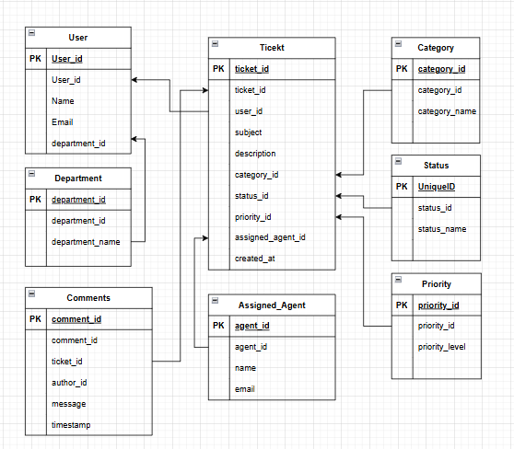

# User Story for Shopping on E-commerce Platform

## Epic: Shopping on E-commerce Website

**User Story 1:**

As a customer, I want to register and login so that I can securely access my personal shopping account.

**User Story 2:**

As a customer, I want to search and filter products so that I can find what I need quickly.

**User Story 3:**

As a customer, I want to add items to my cart so that I can review and purchase them later.

**User Story 4:**

As a customer, I want to make payments online so that I can complete my purchase conveniently.

**User Story 5:**

As a customer, I want to receive confirmation and tracking updates so that I know the status of my order.