**CAPSTONE PROJECT 3 ANSWERSHEET**

**Que 1: Identify minimum 20 functional requirements.**

**Ans**:

|  |  |  |
| --- | --- | --- |
| **Req ID** | **Req Name** | **Priority** |
| FR001 | Farmer should be able to login using username and password. | 9 |
| FR002 | Farmer should use unique username and password. | 5 |
| FR003 | Farmer should register themselves if they want to order the product. | 8 |
| FR004 | Farmer should be able to search the product in the catalog. | 8 |
| FR005 | Application should display all the products in user friendly format with product ID, details and price. | 7 |
| FR006 | Application should give an option to notify farmers if any product is back in stock. | 7 |
| FR007 | Application should allow farmers to add the products in the cart. | 7 |
| FR008 | If farmers want, they can also delete products from the cart. | 7 |
| FR009 | Application should allow farmers to select mode of payment. | 10 |
| FR010 | If farmers select UPI or Card as payment mode, application should ask for the necessary details to proceed with the payment. | 10 |
| FR011 | Application should provide safe payment option to the farmer and proceed with order if farmer selects cash on delivery. | 10 |
| FR012 | Application should allow farmer to check previous order history. | 6 |
| FR013 | Application should have a search bar where farmers can directly search for a product by the brand or company. | 6 |
| FR014 | Application should allow farmers to share their review, feedback and add images/videos if they wish. | 7 |
| FR015 | Other users of the application should have access to view the reviews and feedback. | 6 |
| FR016 | Application should display the products with higher rating first so that it will be easy for the farmers to add to cart. | 5 |
| FR017 | Farmer should be able to check the estimated delivery date for the order. | 4 |
| FR018 | Order cancellation should be easy. | 4 |
| FR019 | Farmer should be able to contact our service support in order they have any issue. | 5 |
| FR020 | Farmer should have the option to wish list the product so they can order later when they need. | 6 |

**Que 2: Make wireframe and prototypes.**

**Ans: Wireframe 1 (BALSAMIQ)**

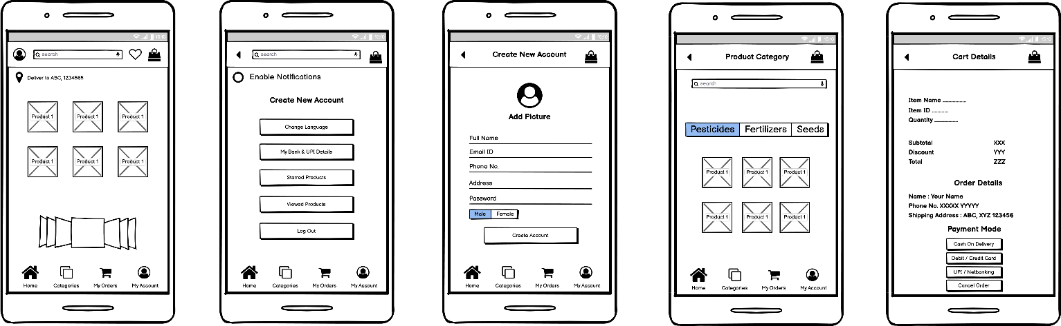

**Wireframe 2 (MS VISIO)**

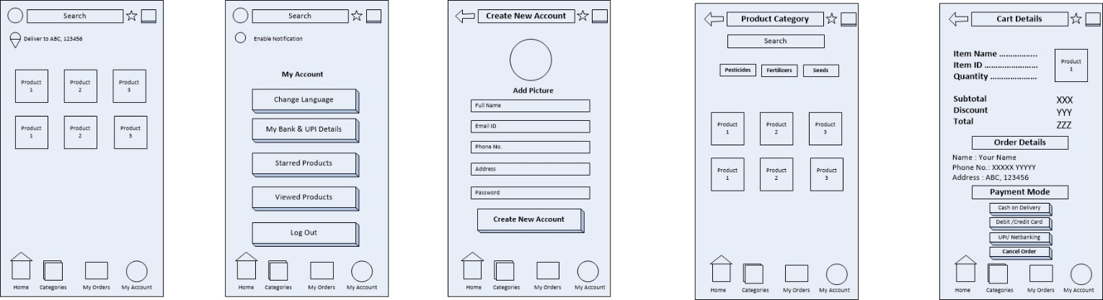

**Que 3:** **Make a note of the Tools, which you are using for above concepts.**

**Ans:**

* **Microsoft Visio:**Visio is like a digital canvas for creating all sorts of diagrams. If you need to show how a system works, how people or processes are connected, or how data flows, Visio is your go-to tool. It comes with lots of built-in shapes and symbols, which makes it easier to create diagrams like use case diagrams, flowcharts, or network maps. It's especially helpful for designers, analysts, or anyone who needs to visually communicate complex ideas.
* **Balsamiq:**  
  Balsamiq is a tool designed for quickly creating wireframes, which are like the skeleton of an app or website. Imagine sketching your app's layout on paper but with more precision. Balsamiq gives you a chance to focus on the structure of your design without worrying about fine details like colors or fonts. It's great for brainstorming ideas and getting early feedback from others before you dive into the actual design process. It's simple, fast, and has a “sketchy” look that helps you focus on functionality first.

In short:

* Visio helps map out ideas and systems visually.
* Balsamiq lets you create simple, sketch-like designs to plan your app’s layout.

Each of these tools has its own role in the design process, helping you go from brainstorming to building something that feels real.

**Que 4 :** **RTM**

**A business analyst’s key responsibilities are to keep track of the requirements and make sure that no requirement is missed. Mr. Henry and peter have approached you regarding the current status of the project. How will you tackle this situation?**

**Ans:**

|  |  |  |  |  |  |  |  |  |  |
| --- | --- | --- | --- | --- | --- | --- | --- | --- | --- |
| **Req ID** | **Req Description** | **Category** | **Sub Category** | **Design** | **Code** | **Unit Testing** | **Component Testing** | **System Testing** | **UAT** |
| FR001 | User registration and Login | Registration | Name, Email ID, Password | Done | Done | Done | Under Process | Pending | Pending |
| FR002 | Product Catalogue | Product Details | Product Type | Done | Done | Done | Under Process | Pending | Pending |
| FR003 | Add to cart | Add to cart | Product Quantity, Product ID | Done | Done | Done | Done | Under Process | Pending |
| FR004 | Pay | Pay | Product ID, Quantity, Location, Contact details, Mode of Payment | Done | Done | Under Process | Pending | Pending | Pending |
| FR005 | Manage Order Details | Manage | Track order details like status, location, Delivery Date, Previous orders | Done | Done | Done | Under Process | Pending | Pending |

**Que 5 :** **Prepare 10 Test Case Documents.**

**Ans:**

**LOGIN**

|  |  |  |  |
| --- | --- | --- | --- |
| **Test Case ID** | TC001 | **Test case name** | Login |
| **Project ID** | OPS001 | **Project Name** | Online product store |
| **PM ID** | 10123 | **PM Name** | Mr Vandanam |
| **Test Strategy ID** | 111 | **Tester ID** | 101234 |
| **Test Plan ID** | 1212 | **Tester Name** | Ms Alekya |
| **Test Schedule ID** | 123123 | **Date of Test** | 2 Nov 2024 |
| **Scenario** | Login | | |
| **Input Data** | Set1  Username: ABC Password: ABC Email: abc@gmail.com | Set2  Username: PQR Password:123 Email: abc@gmail.com | Set3  Username: ABC XYZ Password: $A1pqryz Email: ABCXYZ@gmail.com |
| **Expected Outcome** | Successful | Successful | Successful |
| **Actual Outcome** | Error: name and password cannot be same | Error: password should be min 8 characters | Successful |
| **Pass/Fail** | FAIL | FAIL | PASS |

**SEARCH**

|  |  |  |  |
| --- | --- | --- | --- |
| **Test Case ID** | TC002 | **Test case name** | Search |
| **Project ID** | OPS001 | **Project Name** | Online product store |
| **PM ID** | 10122 | **PM Name** | Mr Vandanam |
| **Test Strategy ID** | 222 | **Tester ID** | 101345 |
| **Test Plan ID** | 2323 | **Tester Name** | Ms Alekya |
| **Test Schedule ID** | 321123 | **Date of Test** | 27 Nov 2024 |
| **Scenario** | Search for Product | | |
| **Input Data** | Set1(Pesticides) Good rating pesticides Residue Level Application method Mode of action | Set2(Seeds) Seed Quality Seed Rate Seed treatment Sowing method Climate | Set3(Fertilizers) Nutrient requirements Fertilizer contribution Soil nutrient availability |
| **Expected Outcome** | 15 Products | 5 Products | 7 Products |
| **Actual Outcome** | 13 Products | 5 Products | 6 Products |
| **Pass/Fail** | FAIL | PASS | FAIL |

**ADD TO CART**

|  |  |  |  |
| --- | --- | --- | --- |
| **Test Case ID** | TC003 | **Test case name** | Add to cart |
| **Project ID** | OPS001 | **Project Name** | Online product store |
| **PM ID** | 10122 | **PM Name** | Mr Vandanam |
| **Test Strategy ID** | 222 | **Tester ID** | 101345 |
| **Test Plan ID** | 2323 | **Tester Name** | Ms Alekya |
| **Test Schedule ID** | 321123 | **Date of Test** | 27 Nov 2024 |
| **Scenario** | Add to cart | | |
| **Input Data** | Set 1  Product ID  Product quantity Product size  Product price | Set 2  Product ID  Product quantity Product size | Set 3  Product ID  Product size  Product price |
| **Expected Outcome** | Add to cart | Add to cart | Add to cart |
| **Actual Outcome** | Successfully able to add as all are fulfilled | Cannot add as price is missing | Product quantity missing |
| **Pass/Fail** | PASS | FAIL | FAIL |

**USER PROFILE**

|  |  |  |  |
| --- | --- | --- | --- |
| **Test Case ID** | TC004 | **Test case name** | User Profile |
| **Project ID** | OPS001 | **Project Name** | Online product store |
| **PM ID** | 10122 | **PM Name** | Mr Vandanam |
| **Test Strategy ID** | 444 | **Tester ID** | 101345 |
| **Test Plan ID** | 2424 | **Tester Name** | Ms Alekya |
| **Test Schedule ID** | 333333 | **Date of Test** | 27 Nov 2024 |
| **Scenario** | User should be able to create a user profile successfully | | |
| **Input Data** | Set 1  Username  Password  Email ID  Address  Contact Number | Set 2  Username  Password  Address  Contact Number | Set 3  Username  Password |
| **Expected Outcome** | Profile created | Unable to create user profile | Unable to create user profile |
| **Actual Outcome** | Profile created | Some details are missing | Some details are missing |
| **Pass/Fail** | PASS | FAIL | FAIL |

**CHECKOUT PROCESS**

|  |  |  |  |
| --- | --- | --- | --- |
| **Test Case ID** | TC005 | **Test case name** | Checkout Process |
| **Project ID** | OPS001 | **Project Name** | Online product store |
| **PM ID** | 1012 | **PM Name** | Mr Vandanam |
| **Test Strategy ID** | 555 | **Tester ID** | 101345 |
| **Test Plan ID** | 2525 | **Tester Name** | Ms Alekya |
| **Test Schedule ID** | 55555 | **Date of Test** | 27 Nov 2024 |
| **Scenario** | The user should be able to check out the items that he has selected. | | |
| **Input Data** | Set 1  Select product Quantity  Select mode of payment  Enter contact details | Set 2  Select product Quantity  Select mode of payment  Enter Shipping Address  Enter contact details | Set 3  Select product Select mode of payment  Enter shipping address Enter contact details |
| **Expected Outcome** | Order Placed Successfully | Order Placed Successfully | Order Placed Successfully |
| **Actual Outcome** | Shipping address missing | Order Placed | Quantity not provided |
| **Pass/Fail** | FAIL | PASS | FAIL |

**PAYMENT THROUGH CARD**

|  |  |  |  |
| --- | --- | --- | --- |
| **Test Case ID** | TC006 | **Test case name** | Payment Through Card |
| **Project ID** | OPS001 | **Project Name** | Online product store |
| **PM ID** | 1016 | **PM Name** | Mr Vandanam |
| **Test Strategy ID** | 666 | **Tester ID** | 101345 |
| **Test Plan ID** | 2626 | **Tester Name** | Ms Alekya |
| **Test Schedule ID** | 666666 | **Date of Test** | 27 Nov 2024 |
| **Scenario** | The user should be able to register his card in the application and make payment. | | |
| **Input Data** | Set 1  Bank Name  Card Number  Expiry date  Expiry year  Acc holder name | Set 2  Bank Name  Card Number  Expiry year  Acc holder name | Set 3  Card Number  Expiry date  Expiry year  Acc holder name |
| **Expected Outcome** | Payment Successful | Payment Successful | Payment Successful |
| **Actual Outcome** | Payment Successful | Failed As Expiry Date is missing | Failed as bank name is missing |
| **Pass/Fail** | PASS | PASS | FAIL |

**NOTIFICATION AND ALERT**

|  |  |  |  |
| --- | --- | --- | --- |
| **Test Case ID** | TC007 | **Test case name** | Notification Alert |
| **Project ID** | OPS001 | **Project Name** | Online product store |
| **PM ID** | 1017 | **PM Name** | Mr Vandanam |
| **Test Strategy ID** | 777 | **Tester ID** | 101345 |
| **Test Plan ID** | 2727 | **Tester Name** | Ms Alekya |
| **Test Schedule ID** | 777777 | **Date of Test** | 27 Nov 2024 |
| **Scenario** | The user should receive notification regarding the order placed. | | |
| **Input Data** | Set 1  Enable notification Email address Contact Number | Set 2  Email address Contact Number | Set 3  Enable notification Contact Number |
| **Expected Outcome** | Enabled | Enabled | Enabled |
| **Actual Outcome** | Notification received | Failed as user did not enable the option | Failed as farmer did not provide the email address |
| **Pass/Fail** | PASS | FAIL | FAIL |

**SECURITY**

|  |  |  |  |
| --- | --- | --- | --- |
| **Test Case ID** | TC008 | **Test case name** | Security |
| **Project ID** | OPS001 | **Project Name** | Online product store |
| **PM ID** | 1018 | **PM Name** | Mr Vandanam |
| **Test Strategy ID** | 888 | **Tester ID** | 101345 |
| **Test Plan ID** | 2828 | **Tester Name** | Ms Alekya |
| **Test Schedule ID** | 888888 | **Date of Test** | 27 Nov 2024 |
| **Scenario** | The farmer should be able to login securely in the application. | | |
| **Input Data** | Set 1  Username  Password  OTP | Set 2  Username  Password | Set 3  Username  OTP |
| **Expected Outcome** | Logged IN | Logged IN | Logged IN |
| **Actual Outcome** | Farmer Able to LogIn | Unable to Login | Unable to Login |
| **Pass/Fail** | PASS | FAIL | FAIL |

**CANCEL ORDER**

|  |  |  |  |
| --- | --- | --- | --- |
| **Test Case ID** | TC009 | **Test case name** | Cancel Order |
| **Project ID** | OPS001 | **Project Name** | Online product store |
| **PM ID** | 1019 | **PM Name** | Mr Vandanam |
| **Test Strategy ID** | 999 | **Tester ID** | 101345 |
| **Test Plan ID** | 2929 | **Tester Name** | Ms Alekya |
| **Test Schedule ID** | 999999 | **Date of Test** | 27 Nov 2024 |
| **Scenario** | The farmer can cancel the order anytime. | | |
| **Input Data** | Set 1  Log in to the account where the order is placed Req order cancel | Set 2  Log in to the account where the order is placed Reason for order cancel | Set 3  Log in to the account where the order is placed Req order cancel Reason for order cancel |
| **Expected Outcome** | Order Cancelled | Order Cancelled | Order Cancelled |
| **Actual Outcome** | Unable to cancel the order, as reason missing | Unable to cancel the order, as reason missing | Order Cancelled |
| **Pass/Fail** | FAIL | FAIL | PASS |

**REFUND**

|  |  |  |  |
| --- | --- | --- | --- |
| **Test Case ID** | TC010 | **Test case name** | Refund |
| **Project ID** | OPS001 | **Project Name** | Online product store |
| **PM ID** | 10010 | **PM Name** | Mr Vandanam |
| **Test Strategy ID** | 101010 | **Tester ID** | 101345 |
| **Test Plan ID** | 101010 | **Tester Name** | Ms Alekya |
| **Test Schedule ID** | 10101010 | **Date of Test** | 27 Nov 2024 |
| **Scenario** | The farmer should receive a refund. | | |
| **Input Data** | Set 1  Return/cancel req Register  bank details  Acc number | Set 2  Return/cancel req Register  bank details  IFSC code | Set 3  Return/cancel req Register bank details Acc number  IFSC Code |
| **Expected Outcome** | Refund Initiated | Refund Initiated | Refund Initiated |
| **Actual Outcome** | Unable to initiate as IFSC code is missing. | Unable to initiate as Acc Number Missing. | Refund Initiated |
| **Pass/Fail** | FAIL | FAIL | PASS |

**Que 6 :** **DB Design**

**Draw database schema and ER diagram.**

**Ans:**

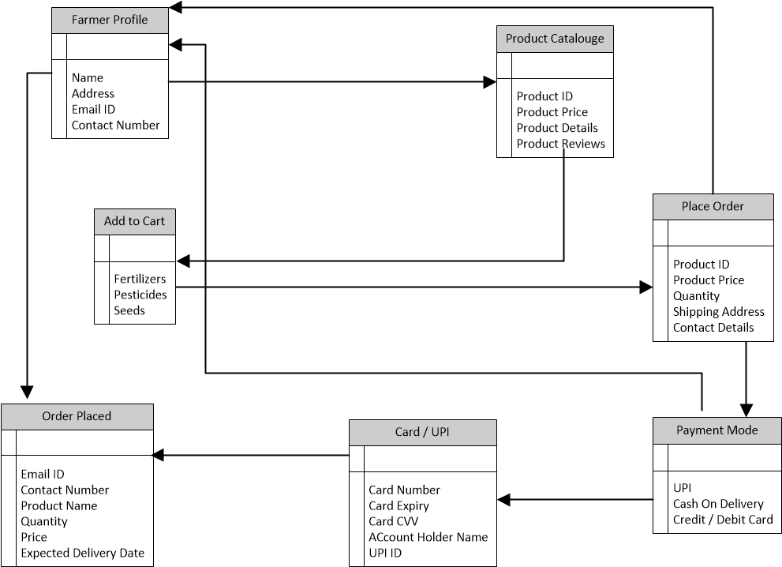

**Que 7 : Data Flow Diagram**

**Ans:**

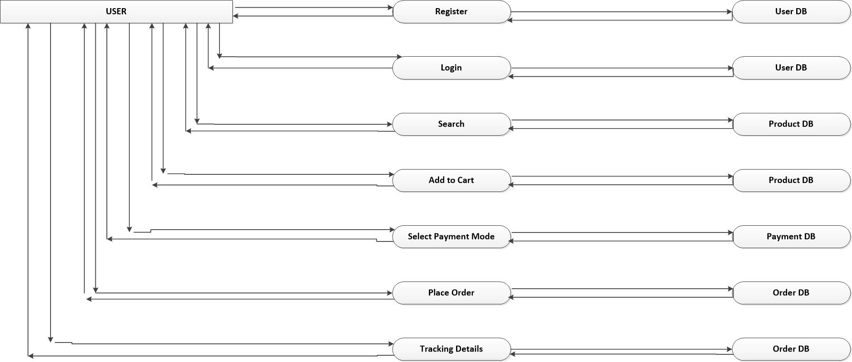

**Que 8 : Due to change in the Government Taxation structure . we should change the Tax structure How do you handle change requests in a project?**

**Ans:**

1. Understand the scope of the change request: Gather all details regarding the change request so that it becomes easier for all the stakeholders to identify whether the change request is worth.

2. Determine whether the change is inside/outside the scope: Change requests that are inside the scope are small correction to an existing requirement. Change request that are Outside scope takes lot of time to implement and affect the budget of the project.

3. Do analysis: A. Feasibility-Perform analysis on the change request and check if it is feasible that is check the strength and weakness B. Impact analysis- To determine the impact the change request will have on the project C. Effort analysis- Efforts needed to implement the change request and the budget required.

4. Approve or Reject the change request: After analyzing different factors then we can decide if the change request can be approved and implemented or rejected.

5. Communicate and implement the approved change request: If the change request is approved successfully after the complete analysis, then communicate the change request with the technical team for implementation. Also share an email with the stakeholder regarding the change request and keep project manager in CC.

**Que 9 : Change Request Vs an Enhancement**

**Ans:**

In this case study adding auction would be considered as an enhancement as this will be a new feature added to the application. Farmers adding their crop yields is somewhat like the manufacturing company adding their products. These are similar requests only actors are changing little bit. As a BA I will gather the requirements through different elicitation techniques, document the requirement. Also, I will determine the feasibility and impact of this change request on the developing application and budget for adding this feature in the application, risk analysis and benefits. Once this is done, we will have the sign off from the stakeholder and communicate with the tech team.

**Que 10 : Come up with estimations – How many Manhours required ?**

**Ans :**

Project is measured in manhours and efforts are calculated. Milestones are set week wise. Example: Requirement gathering needs to be done in 13-14 weeks (about 3 months). Basically, there are 3 types of projects: Small (up to 500 hours), Medium (up to 1000 hours), Large (up to 1500 hours)

In this case, we have a team size of about 12 and the duration is 18 months (about 1 and a half years). So, this will come under medium size of project. As we have trained resources, we do not need trainers. We save a lot of time there.

**Que 11: Explain UAT Acceptance process.**

**Ans:**

UAT is a crucial phase where the product is tested by end-users to ensure it meets business requirements and is ready for release. \

* **Planning**: In this phase blueprint is done to implement UAT testing for every feature, module, component that needs to test and minimum standard for accepting the test.
* **Designing**: Here the test cases are designed to hide all the possibilities of software packages
* **UAT tester**: A testing team consists of an end user that meets the criteria for implementing the test. The end user must have expertise in subject matter and have the ability to report the problem.
* **Bug Fixing**: If any errors are found during the UAT testing, the development team works on the error and makes software error free.
* **Sign Off**: After removing all the bugs, the testing team indicates acceptance of the completion of the errors. In this phase all stakeholders conclude that the software is ready for deployment and sign it off.

**Que 12 : Explain Project closure document.**

**Ans:**

|  |  |  |  |
| --- | --- | --- | --- |
| **Sr. No.** | **Points to Include** | **Details** | **Links** |
| **1.** | **Did the client sign off UAT Testing** | |  |
|  | Date of Sign off | 27 Nov 2024 |  |
|  | Name of the Resources | Mr. Henry |  |
|  |  |  |  |
| **2.** | **Objective of the project** | |  |
|  | User Friendliness | Achieved |  |
|  | Customer Satisfaction | ROI in 8 Months |  |
|  |  |  |  |
| **3.** | **Functionalities Worked On** | |  |
|  | Secure Payment Processing | Achieved |  |
|  | Categories | Achieved |  |
|  |  |  |  |
| **4.** | **Infrastructure** | |  |
|  | Software Installed | Achieved |  |
|  |  |  |  |
| **5.** | **Funding** | |  |
|  | Amount Approved | Rs. 2 CR |  |
|  | Amount Used | Rs. 1 Cr 75 lacs |  |
|  |  |  |  |
| **6.** | **Value of the company** | |  |
|  |  | Company has gained customers as this is has helped farmers to save their energy and time Trained employee New Project in pipeline |  |