**CAPSTONE PROJECT- Prep 2**

1. **4 Quarterly Audits are planned Q1 , Q2, Q3, Q4 for this Project What is your knowledge on how these Audits will happen for a BA ?**

**Q1 Audit: Project Initiation and Requirements Gathering**

Focus Areas:

* Review of the initial project documentation, including the business case, scope, and objectives.
* Validation of stakeholder involvement and alignment.
* Assessment of requirements-gathering processes and deliverables.

BA Responsibilities:

* Requirements Documentation**:** Ensure that all requirements (functional and non-functional) have been thoroughly documented, reviewed, and approved by stakeholders.
* Stakeholder Communication**:** Provide evidence of stakeholder engagement, including meeting minutes and requirement sign-offs.
* Traceability Matrix**:** Present a requirements traceability matrix to demonstrate alignment with project objectives.

**Q2 Audit: Design and Development**

Focus Areas:

* Verification of design deliverables against the approved requirements.
* Assessment of development progress and adherence to agreed timelines.
* Review of risk management and issue resolution practices.

BA Responsibilities:

* Requirement Alignment: Confirm that the design documentation (e.g., mockups, prototypes, and system architecture) aligns with the requirements.
* Change Management: Document and justify any changes to the requirements or scope.
* Stakeholder Feedback: Demonstrate how feedback has been incorporated into the design phase.

**Q3 Audit: Testing and Quality Assurance**

Focus Areas:

* Validation of testing processes, including test cases, plans, and defect tracking.
* Review of user acceptance testing (UAT) preparation and execution plans.
* Assessment of the system's performance against defined KPIs.

BA Responsibilities:

* Test Case Review: Collaborate with testers (Jason and Alekya) to ensure test cases are derived from requirements and are comprehensive.
* Defect Analysis: Participate in defect triaging and ensure alignment with business priorities.
* UAT Coordination: Prepare UAT documentation and guide stakeholders through the testing process.

**Q4 Audit: Delivery and Post-Implementation**

Focus Areas:

* Review of delivery readiness, including deployment plans and user training materials.
* Assessment of post-implementation support and feedback mechanisms.
* Evaluation of project success against initial objectives.

BA Responsibilities:

* Go-Live Readiness: Ensure all business requirements are met and documented as "complete."
* Training Material**:** Verify that user training materials are accurate and align with the delivered system.
* Post-Implementation Feedback: Facilitate feedback collection from stakeholders and document lessons learned for future projects.

1. **BA Approach Strategy**
2. Project Initiation and Planning

* Understand Project Objectives: Collaborate with stakeholders (Committee members, APT IT Solutions team, and farmers) to clearly define the project’s purpose and goals.
* Define Scope: Document the boundaries of the project, focusing on key deliverables like online product listing, order placement, and delivery management.
* Plan Elicitation Activities: Identify techniques and tools for gathering requirements effectively.

1. Stakeholder Analysis:

* Primary Stakeholders
* Mr. Henry (Project Sponsor)
* Mr. Henry (Project Sponsor)
* Peter, Kevin, Ben (Farmer Representatives)
* Fertilizer, seed, and pesticide companies (Vendors)
* Internal Stakeholders
* SOONY Committee (Mr. Henry, Mr. Pandu, Mr. Dooku)
* APT IT Solutions Team (Project manager, Developers, Tester, Network Admin, DB Admin)
* External Stakeholders
* Farmers as end-users
* Logistics service providers

RACI Matrix:

* Responsible: Developers, Testers, and Network/DB Admins
* Accountable: Project Manager (Mr. Vandanam)
* Consulted: Farmers, Committee, BA, Delivery Head (Mr. Karthik)
* Informed: Stakeholders during periodic updates

1. Requirements Elicitation Techniques:

* Workshop: Conduct interactive sessions with farmers and manufacturers to gather detailed requirements.
* Interviews: One-on-one discussions with stakeholders (e.g., Peter, Kevin, Ben, and manufacturers).
* Surveys/Questionnaires: Gather feedback from a larger audience of farmers
* Observation: Understand farming challenges by visiting rural areas.
* Prototyping: Create mock-ups of the application for validation.
* Document Analysis: Review existing CSR guidelines and farming regulations

1. Documentation:

* Business Requirements Documents: Captures high-level requirements.
* Functional Requirements Documents: Details specific features (e.g., product search, cart, payment gateway).
* Use case Diagrams/ User Stories: Define workflows for farmers and manufacturers.
* Wireframes/Mockups: Visual representations of the interface.
* Project Charter: Outline objectives, stakeholders, scope, and constraints.
* Traceability Matrix: Map requirements to deliverables.

Document Review and Sign Off:

* Share drafts with stakeholders for feedback.
* Organize review meetings
* Incorporate feedback and circulate revised documents.
* Obtain sign-offs from the committee and key stakeholders.

1. Approval and Communication Processes:

* Use a formal approval workflow with signatures (digital or physical)
* Maintain a record of approvals in a centralized repository

Communication Channels:

* Regular Meetings: Weekly progress meetings with stakeholders.
* Email Updates: Share updates and deliverables.
* Project Management Tools: Use tools like Jira or Trello for task tracking.
* Slack/Teams: Establish channels for quick communication.

1. Change Request Management:

Steps to handle Change Requests:

* Log Requests: Use a Change Request Form to document details.
* Impact Analysis: Assess scope, time, and cost implications.
* Approval: Present to the Committee for decision-making.
* Implementation: Update project plans and inform stakeholders.
* Track Changes: Maintain a Change Log for transparency.

1. Progress Reporting:

Reporting Mechanisms

* Status Reports: Weekly reports outlining accomplishments, risks, and next steps.
* Milestone Updates: Highlight key achievements during major phases.
* Dashboards: Provide visual progress updates through tools like Power BI.
* Stakeholder Meetings: Share insights during monthly Committee reviews.

1. User Acceptance Testing and Project Sign-Off:

UAT Process:

* Test Plan Creation: Collaborate with testers to define UAT scenarios.
* Testing: Farmers and manufacturers validate the system.
* Issue Resolution: Address defects or feedback.
* Final Approval: Obtain UAT sign-off from Committee and stakeholders.

Project Acceptance

* Prepare a Client Project Acceptance Form detailing deliverables.
* Conduct a closure meeting to confirm acceptance.
* Archive signed forms and deliverables for future reference.

1. Post-Implementation Support:

* Offer training sessions for farmers and manufacturers.
* Establish a helpdesk for issue resolution.
* Monitor system performance during the initial rollout phase.

1. **Explain and illustrate 3-tier architecture?**

Application Layer: This is the **user-facing layer** responsible for displaying data and collecting input from the user.

Purpose in this Case Study:

* Farmers and manufacturers interact with this layer via a **web or mobile application**.
* Farmers browse products like fertilizers, seeds, and pesticides.
* Manufacturers upload product details (names, prices, descriptions, etc.)
* Features like user authentication and cart management are implemented here.

Business Logic Layer: This layer processes business rules and acts as the bridge between the Presentation and Database layers.

Purpose in this Case Study:

* Handles operations like verifying user authentication, managing product availability, and processing purchase requests.
* Validates that farmers are purchasing within the allowed rules (e.g., stock availability).
* Facilitates communication between farmers and manufacturers for order fulfillment.
* Ensuring the correctness of data flow (e.g., displaying only in-stock products).
* Managing orders, including shipping logistics to remote areas.
* Integrating payment gateways for secure transactions.

Database Layer: This is the **storage layer**, responsible for managing and storing data.

* Stores data related to farmers, manufacturers, products, orders, and delivery details.
* Ensures data consistency and availability, even with multiple simultaneous requests.

Key Benefits of 3-Tier Architecture for the Case Study:

* Scalability: The architecture allows the system to grow as the user base increases (e.g., adding more manufacturers or farmers).
* Modularity: Developers can independently update or modify the layers without disrupting the entire system.
* Security: Sensitive information like payment details can be managed securely in the business logic and database layers
* Ease of maintenance: Errors or updates in one layer do not necessarily affect others.

1. **Write about the approach strategy for framing questions**

**5W 1H (Who, What, When, Where, Why, How):** This technique ensures a comprehensive understanding of the project by addressing fundamental questions:

* Who:
* Who are the end-users (farmers, manufacturers)?
* Who will manage the application post-launch?
* Who are the stakeholders for feedback and approval?
* What:
* What products (fertilizers, seeds, pesticides) need to be supported?
* What features are mandatory (user-friendly interface, order tracking)?
* When:
* When is the expected go-live date within the 18-month duration?
* When should development milestones be delivered?
* Why:
* Why is this application better than traditional methods?
* Why should it be scalable for future use cases?
* Where:
* Where will the application be hosted (cloud/on-premises)?
* Where are the primary user groups located?
* Why:
* Why is this application better than traditional methods?
* Why should it be scalable for future use cases?
* How:
* How will transactions (payment, order confirmation) occur?
* How will manufacturers onboard their products?

**SMART (Specific, Measurable, Achievable, Relevant, Time-bound)**

Specific: Define clear goals like “Facilitate farmers to order agricultural products online with minimal steps.”

Measurable: Determine metrics such as the number of orders processed daily or user registration statistics.

Achievable: Ensure all features can be implemented within the budget of 2 Crores INR and 18 months.

Relevant: Ensure the application aligns with the primary objective of enabling remote farmers to procure essential products.

Time-bund: Break the project into phases (e.g., design: 3 months, development: 9 months, testing: 4 months, deployment: 2 months).

**RACI (Responsible, Accountable, Consulted, Informed)**

|  |  |  |  |  |
| --- | --- | --- | --- | --- |
| **Role** | **Responsible** | **Accountable** | **Consulted** | **Informed** |
| Requirement Gathering | Business Analyst | Project Manager (Vandanam) | Stakeholders (Peter, Kevin, Ben) | Henry, Pandu, Dooku |
| Development | Developers | Senior Java Developer (Juhi) | BA, Tester | Henry |
| Testing | Testers (Jason, Alekya) | |  | | --- | |  |  |  | | --- | | Project Manager | | |  | | --- | |  |  |  | | --- | | Developers | | Henry |
| Deployment | Network Admin (Mike), DB Admin (John) | Project Manager | Stakeholders | Farmers, Manufacturers |

**3 -Tier Architecture**

Application Layer:

* User-friendly interface for farmers to browse products and place orders.
* Responsive design for web and mobile platforms.

Business Logic Layer:

* Core functionalities like product catalog management, order placement, and notifications.
* Role-based access for farmers and manufacturers.

Data Layer:

* Store product details, user information, order history, and payment records.

**Use Cases, Use Case Specifications, and Activity Diagrams**

**Use Cases:**

* Farmer registration and login.
* Manufacturer uploads product details.
* Farmer browses products and places orders.
* Payment processing and order confirmation.
* Delivery tracking.

**Use-Case Specifications:**

* Include actors (Farmer, Manufacturer, System), preconditions, main flow, alternate flow, and exceptions for each use case.

**Activity Diagrams:**

* Visualize workflows for key processes like order placement and product listing.

**Models and Page Designs:**

Models:

* Entity-Relationship Diagram: Show relationships between farmers, manufacturers, products, and orders.
* Class Diagram: Define objects like users, products, orders, and roles.

Page Designs:

* Farmer Dashboard: Display product categories, recommended items, and recent orders.
* Manufacturer Dashboard: Provide options to add products, track orders, and view analytics.
* Order Page: Show selected items, delivery details, and payment options.

1. **As a Business Analyst, What Elicitation Techniques you are aware of? (BDRFOWJIPQU)**
2. B- Brainstorming : It is used to generate creative ideas and gather a wide range of insights. Brainstorm with stakeholders like Peter, Kevin, and Ben to identify all the challenges faced by farmers in their daily farming activities.
3. D- Document Analysis: To study existing documents and systems to understand the current processes and gaps. Analyze any existing agricultural product supply chain documentation to identify inefficiencies and how the new platform can improve it.
4. R- Requirements Workshop: A collaborative session to gather detailed requirements. Conduct workshops with farmers and manufacturers to define the key features and user experience of the application.
5. F- Focus Groups: To gather feedback from a targeted group of stakeholders. Organize sessions with a group of farmers and manufacturers to validate the application’s concept and features.
6. O- Observation: To understand current workflows and issues by directly observing them. Visit the farmers’ fields to observe their daily activities and the challenges they face in procuring fertilizers, seeds, and pesticides.
7. J- Job Shadowing: To follow users in their work environment to gain insights into their tasks. Shadow farmers as they interact with suppliers or seek products to understand the pain points in the current system.
8. I – Interviews: To gather detailed insights from individuals. Conduct one-on-one interviews with key stakeholders like Peter, Kevin, Ben, and manufacturers to understand specific needs and expectations.
9. P- Prototyping: To create mock-ups or prototypes of the application for feedback. Present initial prototypes to farmers and companies to refine user interface and functionality.
10. Q – Questionnaires/Surveys: To collect data from a larger audience quickly. Distribute surveys to farmers in remote areas to gather data on their preferences and expectations for the online store.
11. U – User Stories: To capture user needs in a structured format. Work with stakeholders to document user stories like: "As a farmer, I want to browse available fertilizers, so I can choose the best one for my crops."
12. **Which Elicitation Techniques can be used in this Project and Justify your selection of Elicitation Techniques?**

* Prototyping: It involves creating a visual or functional representation of the system to gather feedback from stakeholders. In this case, since the application needs to be user-friendly for farmers and manufacturers, a prototype will help visualize key features like the product catalog, search functionality, login process, and payment gateway. Farmers and manufacturers can provide feedback early, ensuring the system aligns with their expectations.
* Use Case Specifications: Use case specifications detail interactions between users and the system. This technique will clarify how farmers and manufacturers interact with functionalities such as product searches, uploading products, payment, and delivery tracking. These scenarios will help developers understand system behavior and ensure no critical functionality is overlooked.
* Document Analysis: Reviewing existing documents (e.g., market research, competitor analysis, or agricultural supply chain reports) can help identify best practices and refine requirements. This is especially useful for understanding features required by manufacturers and aligning the application with regulatory standards or CSR guidelines.
* Brainstorming: A brainstorming session with stakeholders like Mr. Henry, Peter, Kevin, and Ben can generate ideas for improving the application’s usability and functionality. Involving the delivery team (e.g., developers, network admin, testers) can also surface potential technical challenges and solutions early in the project.

Business Requirements (Including Stakeholder Requirements)

**BR001**: Farmers should be able to search for available products in fertilizers, seeds, and pesticides.

Stakeholder Requirement: Kevin emphasized the need for a search option to make product browsing efficient.

**BR002:** Manufacturers should be able to upload and display their products in the application.

Stakeholder Requirement: The application should enable manufacturers to list products such as fertilizers, seeds, and pesticides.

1. **Make suitable Assumptions and identify at least 10 Business Requirements.**

Business Requirements:

* Farmer Registration and Profile management: The system must allow farmers to register, create, and manage their profiles, including details like name, contact number, location, and preferred products.
* Manufacturer registration and Profile Management:

The application must enable manufacturers to register, create, and manage their profiles, including company details, contact information, and product catalogs (fertilizers, seeds, pesticides).

* Product Catalog Browsing: Farmers must be able to browse through a well-organized product catalog with categories such as fertilizers, seeds, and pesticides, along with product details (name, price, description, and availability).
* Search and Filter Functionality: The application must provide advanced search and filter options for farmers to quickly locate products based on categories, brands, price range, and availability.
* Order Placement and Tracking: Farmers must be able to place orders for selected products and track the status of their orders, including shipment and delivery updates.
* Payment Integration: The system must support multiple payment methods such as credit/debit cards, UPI, net banking, and cash on delivery for seamless transactions.
* Delivery and Scheduling: The application must allow farmers to select a preferred delivery date and time based on their availability and convenience.
* Multilingual Support: Since the target audience includes farmers from remote areas, the application must support multiple regional languages for accessibility and ease of use.
* Feedback and Rating System: Farmers must be able to provide feedback and rate products as well as manufacturers based on their experience. Manufacturers should also have a mechanism to respond to farmer queries.
* CSS Reporting Dashboard: The system must provide SOONY's Committee with a reporting dashboard to monitor the project's progress, budget utilization, number of farmers helped, and other key performance indicators.

1. **List your assumptions**

* Farmers’ Internet Connectivity: Farmers in remote areas will have access to at least basic internet connectivity to browse the online platform and place orders.
* Device Availability: Farmers have access to smartphones or computers to use the application.
* Language and Usability: The application will support multiple local languages to cater to farmers from different regions, along with simple navigation and user-friendly features.
* Payment Infrastructure: Farmers will use online payment methods such as UPI, debit/credit cards, or net banking. Cash-on-delivery (COD) options will also be provided for areas with limited digital adoption
* Logistics and Delivery: Reliable logistics partners will be engaged to ensure products are delivered to farmers in remote areas within a reasonable timeframe.
* Product Availability: Manufacturers will upload accurate and up-to-date information about their products, including availability, pricing, and specifications.
* Platform Scalability: The platform will be designed to accommodate future growth, such as additional product categories or increased user traffic.
* Training and Support: Farmers and manufacturers will receive initial training or user manuals for navigating the application. Customer support will be available for troubleshooting.

1. **Project Requirement Priority**

|  |  |  |  |
| --- | --- | --- | --- |
| **Req ID** | **Req Name** | **Req Description** | **Priority** |
| BR001 | User Registration | Farmers and companies should be able to register and create profiles easily. | 10 |
| BR002 | Product Catalog | Display a detailed catalog of fertilizers, seeds, and pesticides with descriptions and pricing. | 9 |
| BR003 | Search & Filter | Enable farmers to search and filter products by type, price, and manufacturer. | 8 |
| BR004 | Product Submission | Allow manufacturers to add and manage their products on the platform. | 9 |
| BR005 | Order Placement | Enable farmers to select products, | 10 |
|  |  |  |  |
| BR006 | Secure Payment gateway | Provide secure and seamless payment options for transactions between farmers and manufacturers. | 8 |
| BR007 | Deliver Tracking | Allow farmers to track the status of their orders until delivery is completed. | 7 |
| BR008 | Multilingual Support | Provide the application in local languages for better usability in remote areas. | 6 |
| BR009 | Customer Support | Offer a support system for farmers and manufacturers to resolve queries and issues. | 7 |
| BR010 | Data Analytics & Reports | Enable admin and stakeholders to generate reports on product usage, sales, and user engagement. | 5 |

1. **Draw Use Case Diagram**

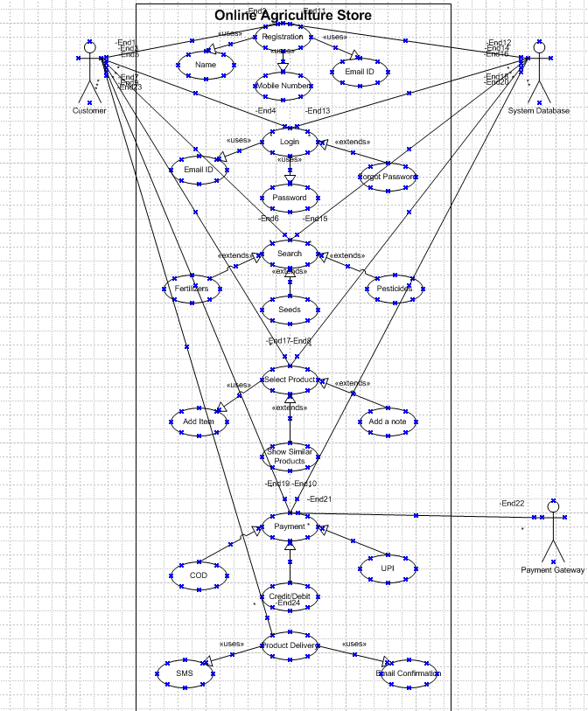

1. **Prepare Use case specs for all use cases**

Use case 1: Product Catalog management

Use case ID: UC-001

Actors:

* Manufacturer
* System (Online Store)

Preconditions:

* Internet connectivity is available.
* Manufacturer has an active account on the platform

Postconditions:

* Product details (fertilizers, seeds, pesticides) are available in the catalog for farmers to view.

Main Flow:

* Manufacturer logs into the application.
* Manufacturer selects "Add Product" from the dashboard.
* Manufacturer enters the product details (name, type, description, price, quantity available, etc.).
* Manufacturer uploads product images (optional).
* Manufacturer submits the product for approval.
* System validates and approves the product entry (manual or automated approval).
* Product is listed in the product catalog.

Alternate Flow:

* If validation fails, the system displays errors, and the manufacturer corrects and resubmits.

Exceptions:

* Internet connectivity issues may prevent submission.
* Product approval delays may result in listing delays.

Use Case 2: Product Browsing and Search

Use Case ID: UC-002

Actors:

* Farmer

Preconditions:

* Farmer has an active account.
* At least one product is listed in the catalog.

Post Conditions:

* Farmer views details of products and adds items to the cart.

Main Flow:

* Farmer logs into the application.
* Farmer navigates to the "Product Catalog" section.
* Farmer uses filters (e.g., product type, price range) or search functionality to find products.
* Farmer selects a product to view details (e.g., description, price, reviews).
* Farmer adds desired products to the cart.

Alternate Flow:

* If no products match the filters, the system displays a "No Results Found" message.

Exceptions:

* Network issues prevent loading the catalog.

Use Case 3: Product Purchase and Delivery

Use Case ID: UC-003

Actors:

* Farmers
* System

Preconditions:

* Farmer has items in their cart.
* Delivery addresses are predefined or provided at checkout.

Post Conditions:

* Order is placed successfully, and delivery details are sent to the farmer.

Main Flow:

* Farmer reviews the cart and proceeds to checkout.
* Farmer confirms the delivery address and selects a payment method.
* Farmer completes the payment process.
* System generates an order confirmation with details.
* System notifies the manufacturer of the new order.
* Manufacturer ships the product, and the system updates the delivery status.

Alternate Flow:

* Farmer opts for Cash on Delivery instead of online payment.

Exceptions:

* Payment gateway failure results in an unsuccessful order.

Use Case 4: User Registration

Use Case ID: UC-004

Actors:

* Farmers
* Manufacturer

Preconditions:

* Internet access is available.

Post Conditions:

* User account is created and activated.

Main Flow:

* User selects the "Register" option.
* User provides required details (name, email, phone number, role: Farmer/Manufacturer, etc.).
* System validates the details and sends an OTP/email for verification.
* User enters the OTP or verifies through email.
* System activates the account and notifies the user.

Alternate Flow:

* If verification fails, the system prompts the user to retry.

Exceptions:

* Missing or invalid information leads to unsuccessful registration.

Use Case 5: Feedback and Support

Use Case ID: UC-005

Actors:

* Farmer
* Manufacturer
* System

Pre Conditions:

* User has an active account.

Post Condition:

* Feedback or support request is logged successfully.

Main Flow:

* User navigates to the "Feedback and Support" section.
* User selects the feedback type (e.g., query, complaint, suggestion).
* User enters the details of their feedback or request.
* System acknowledges the submission and generates a ticket/reference ID.
* Support team addresses the feedback/request within a stipulated time.

Alternate Flow:

* User opts to call the support center directly instead of filling out the form.

Exception:

* Internet connectivity issues prevent submission of feedback.

1. **Activity Diagrams**

1. User Login:

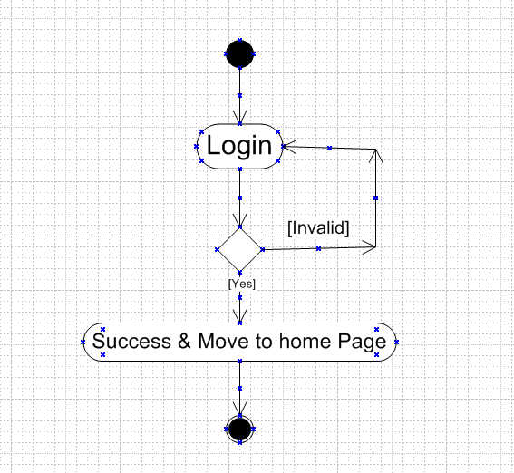

1. Making a Payment

