# CAPSTONE PROJECT 3 PART 1

**Case Study 1 (Q1-Q6 → 24 Marks)**

**A customer can make a payment either by Card or by Wallet or by Cash or by Net banking. Q1. Draw a Use Case Diagram - 4 Marks  
  
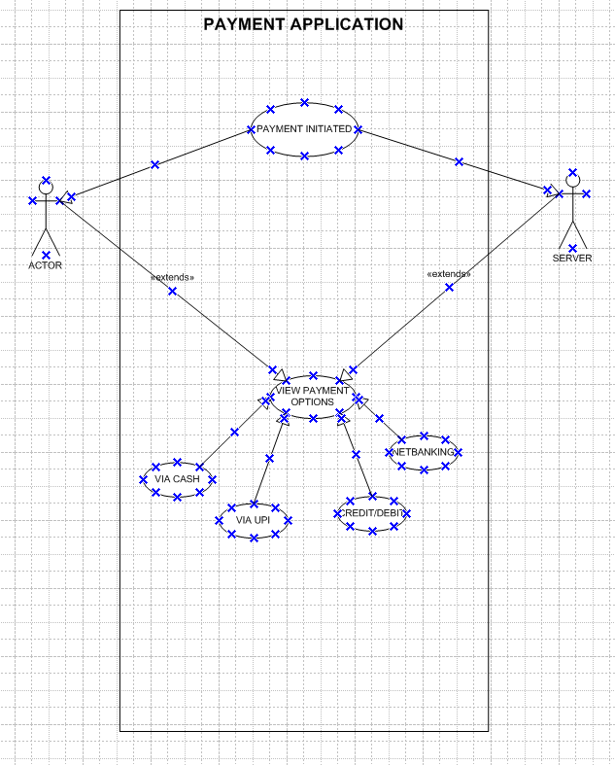**

**Q2.** **Derive Boundary Classes, Controller classes , Entity Classes. - 4 Marks**

**Boundary Classes**: Boundary Class used to handle interactions between the system and external actors

**Ex:** Payment option Boundary

Card Payment Boundary

Wallet Payment Boundary

Cash Payment Boundary.

NetBanking Payment Boundary  
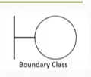

**Controller classes**: Controller Class-act as intermediaries between boundary and entity classes.

**Ex:** Payment initiated Controller

Card Payment Controller

Wallet Payment Controller

Cash Payment Controller

NetBanking Payment Controller  
  
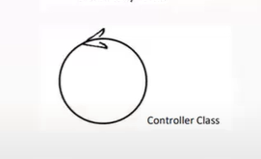

**Entity Classes**: Entity Class-represent the core data and business logic of the application.

**Ex:** Customer

Payment

Card

Wallet

Server

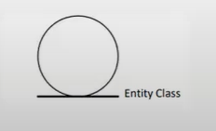  
  
Q3. Place these classes on a three tier Architecture. - 4 Marks  
**Presentation Layer (UI Layer): Boundary Classes**:

Payment Option Boundary

Card Payment Boundary

Wallet Payment Boundary

Cash Payment Boundary

NetBanking Payment Boundary

**2. Business Logic Layer (Application Layer):Controller Classes:**

Payment Initiated Controller

Card Payment Controller

Wallet Payment Controller

Cash Payment Controller

NetBanking Payment Controller

**3. Data Layer (Persistence Layer):Entity Classes:**

Customer

Payment

Card

Wallet

Server

**Q4. Explain Domain Model for Customer making payment through Net Banking - 4 Marks  
A Domain Model is a conceptual representation that defines the structure, relationships, and behaviours of entities within a specific problem domain  
