**75ew + 43Question 1 – Functional Requirements - 15 Marks**

**Functional Requirements**

|  |  |  |  |
| --- | --- | --- | --- |
| **Req ID** | **Req Name** | **Req Description** | **Priority** |
| FR001 | User Registration & Login | Farmers and manufacturers must be able to register and log in using email and password. | 9 |
| FR002 | Product Catalog Management | Manufacturers should be able to list fertilizers, seeds, and pesticides with details such as price, description, and stock availability. | 8 |
| FR003 | Product Browsing & Search | Farmers should be able to browse and search for products by name, category, or manufacturer. | 8 |
| FR004 | Add to Cart & Wishlist | Farmers should be able to add products to their cart for purchase or save them in a "buy-later" list. | 8 |
| FR005 | Order Placement | Farmers should be able to select products, enter delivery details, and place an order. | 10 |
| FR006 | Payment Gateway Integration | Support for multiple payment methods, including COD, Credit/Debit Cards, and UPI. | 10 |
| FR007 | Order Confirmation | Send email and SMS confirmation for successful orders. | 10 |
| FR008 | Delivery Tracking | Farmers should be able to track their order status. | 9 |
| FR009 | Vendor Registration & Product Management | Manufacturers should be able to register, add, update, and remove products. | 8 |
| FR010 | Stock Management | System should notify manufacturers when stock is low. | 7 |
| FR011 | Reviews & Rating | Farmers should be able to rate and review products. | 6 |
| FR012 | Customer Support | A helpdesk or chatbot for queries and complaints. | 5 |
| FR013 | Multi-Language Support | Provide language options for better accessibility. | 5 |
| FR014 | Discount & Offers | Manufacturers should be able to offer discounts on products. | 8 |
| FR015 | Order History | Farmers should be able to view past purchases. | 9 |
| FR016 | Return & Refund System | Implement a process for returning products and initiating refunds. | 8 |
| FR017 | Dilevery Scheduling | Allow farmers to choose a preferred delivery date and time. | 9 |
| FR018 | Invoice Generation | Automatically generate invoices for purchases. | 9 |
| FR019 | Notification & Alerts | Notify users about new products, offers and order updates via email/SMS. | 9 |
| FR020 | Admin Dashboard | Admin should have a dashboard to manage users, products, payments and reports. | 8 |
|  |  |  |  |
|  | **Non-Functional Requirements** |  |  |
|  |  |  |  |
| NFR001 | Scalability | The system should handle increasing numbers of users and transactions | 9 |
| NFR002 | Security | Secure login, encrypted data, and safe payment transactions. | 10 |
| NFR003 | Performance | Pages should load within 3 seconds, even during peak times. | 9 |
| NFR004 | Usability | The UI should be intuitive and mobile-friendly. | 8 |
| NFR005 | Reliability | The system should have 999.9% uptime. | 9 |
| NFR006 | Data Backup | Regular data backups to prevent loss. | 10 |
| NFR007 | Compliance | Adhere to data protection laws and e-commerce regulations. | 10 |
| NFR008 | Availibility | The platform should be available 24/7. | 8 |
| NFR009 | Maintainability | Easy updates and maintainance for future upgrades. | 9 |
| NFR010 | Compatibility | The system should work on all modern browsers and mobile devices. | 8 |

**Question 2–Minimum 5 page designs - 15 Marks Make wireframe and prototypes**

1. **Homepage**

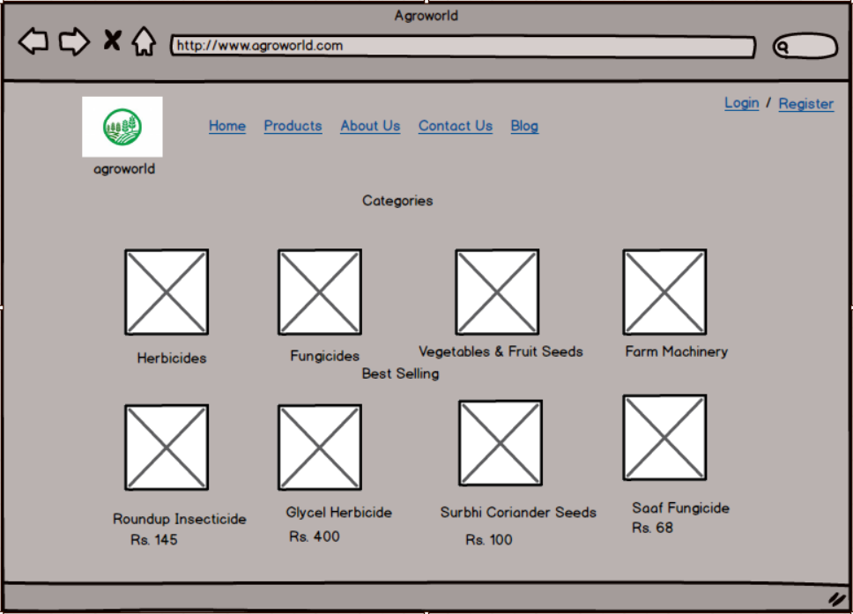

**2. Login**

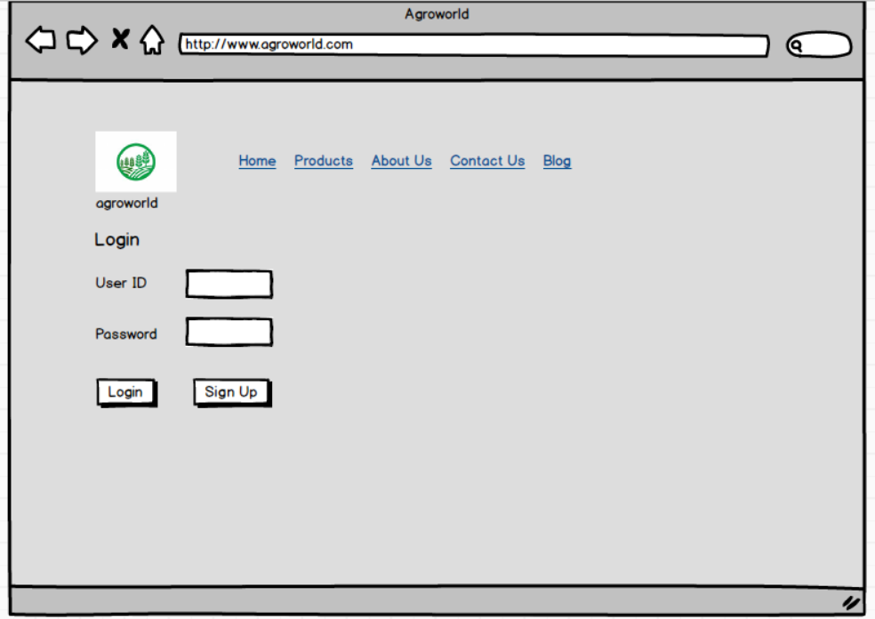

**3. Search for Product**

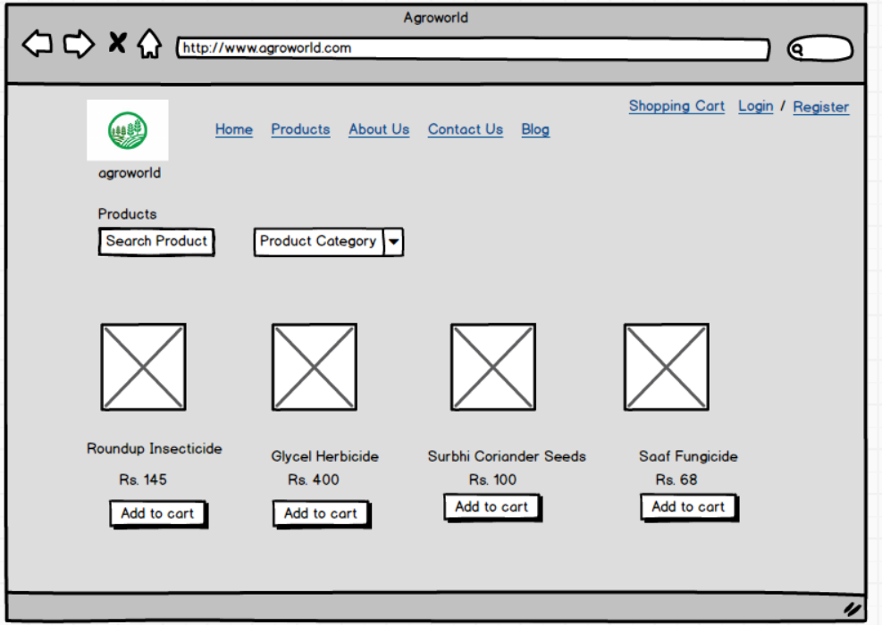

**4. Registration**

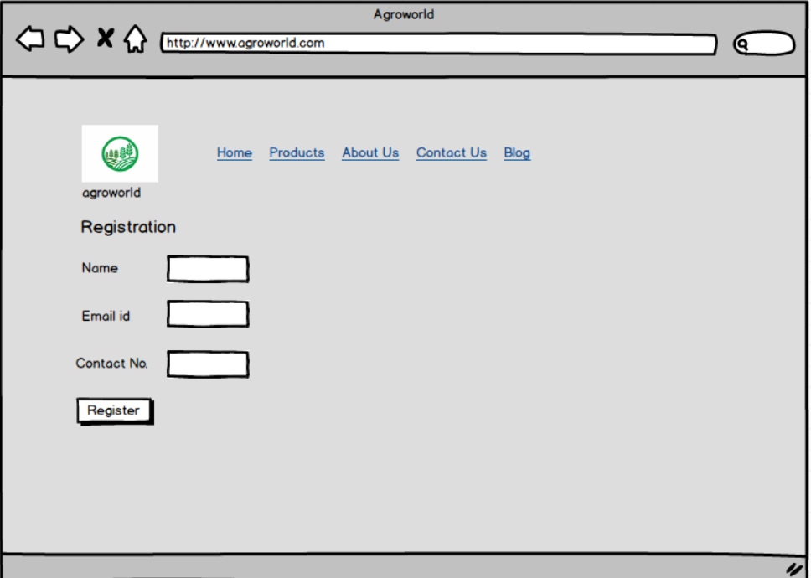

**5. Shopping Cart**

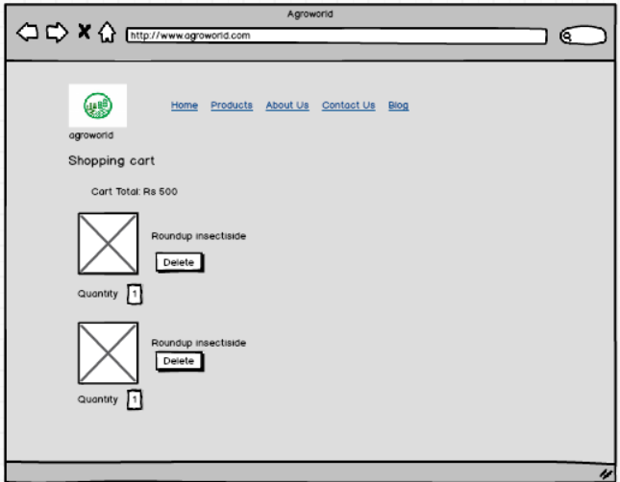

**Question 3 – Tools (Visio, Balsamiq) - 15 Marks Make a note of the Tools, which you are using for above concepts.**

**Microsoft Visio:** Microsoft Visio is a diagramming tool used for creating flowcharts, organizational charts, network diagrams, and more. It provides a wide range of templates and shapes, enabling users to visualize complex data and processes efficiently.

**Balsamiq:** Balsamiq is a tool for making simple wireframes and mockups. It helps designers and developers plan apps and websites by creating quick sketches of layouts. The drag-and-drop features make it easy to use. Balsamiq focuses on fast brainstorming, so teams can design ideas before building real products.

**Axure** is a tool for making website and app prototypes. It helps designers create interactive mockups without coding. Users can add buttons, links, and animations to show how a product will work. Axure is great for testing ideas, improving designs, and sharing projects with teams before real development starts.

**Question 4 – RTM - 6 Marks**

**Requirements Traceability Matrix (RTM)**

**s**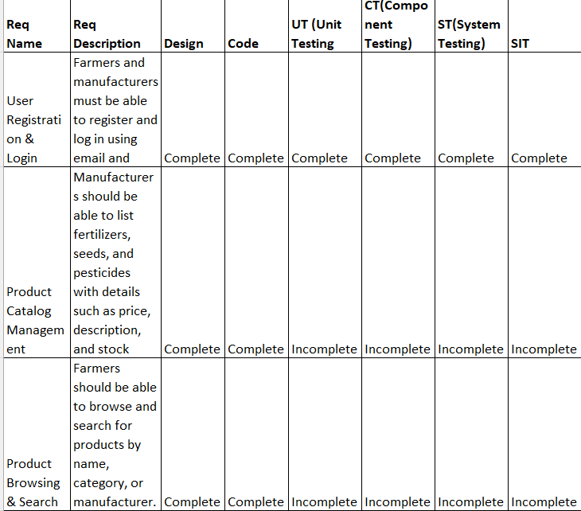

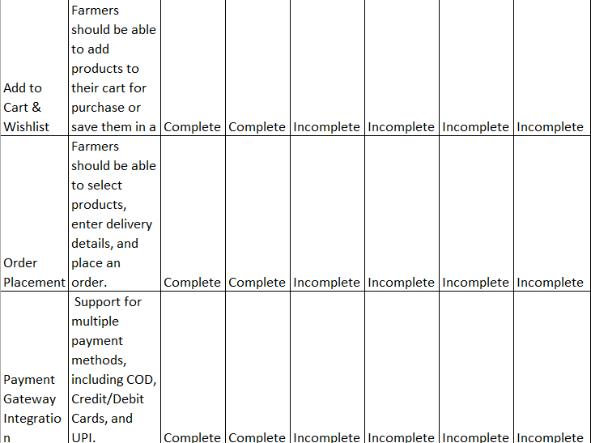

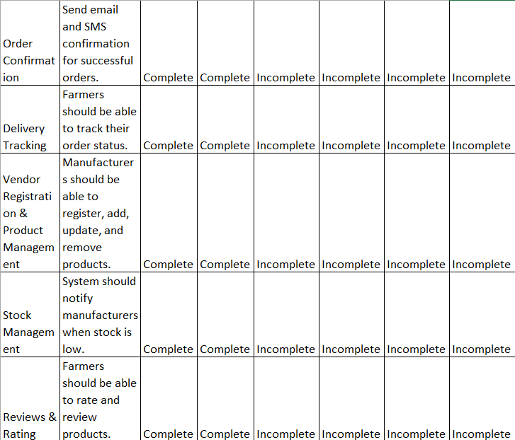

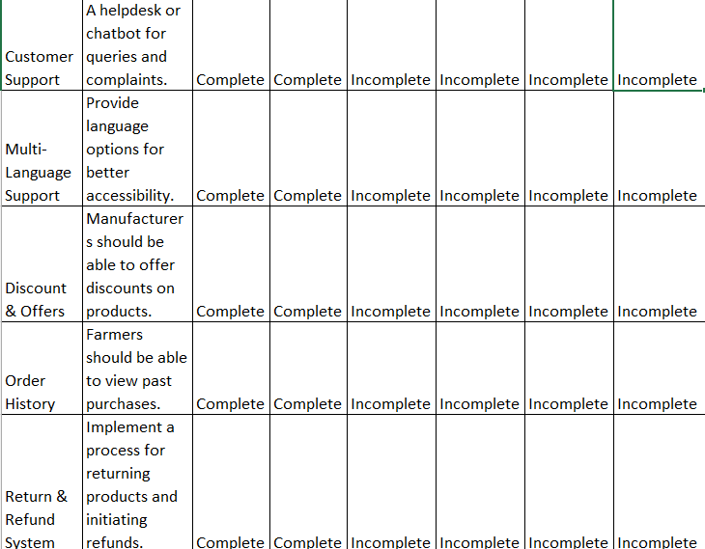

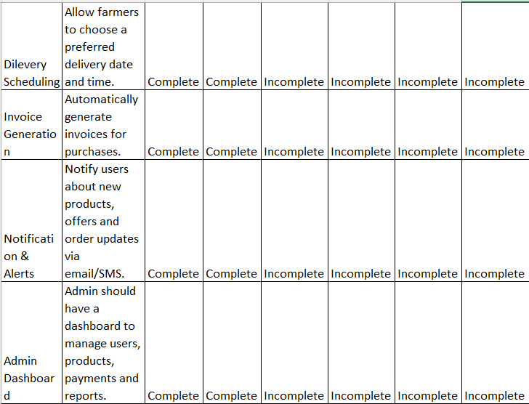

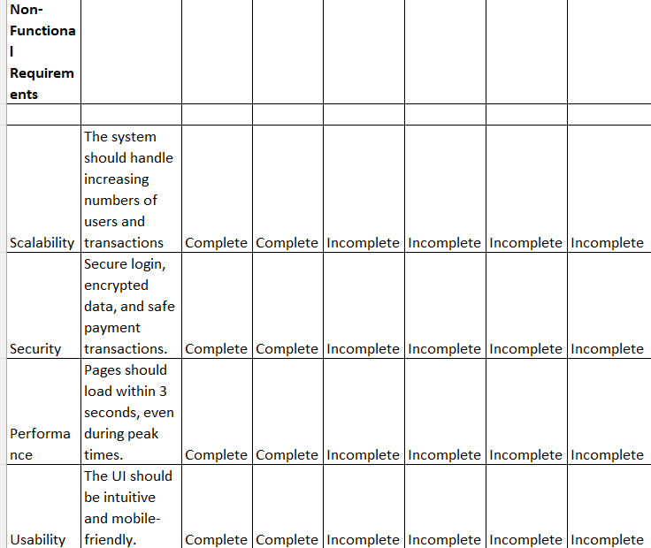

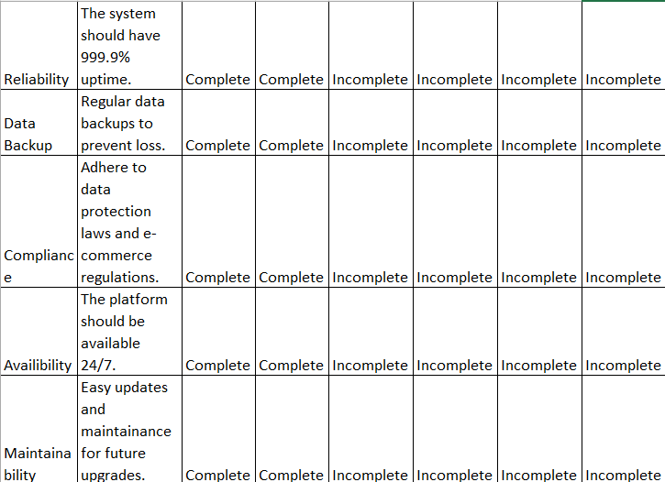

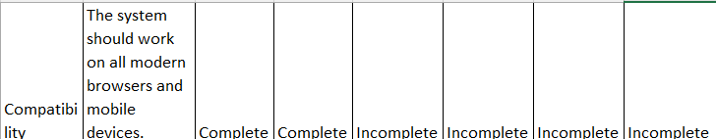

**Question 5 – 10 Test Case Documents - 10 Marks**

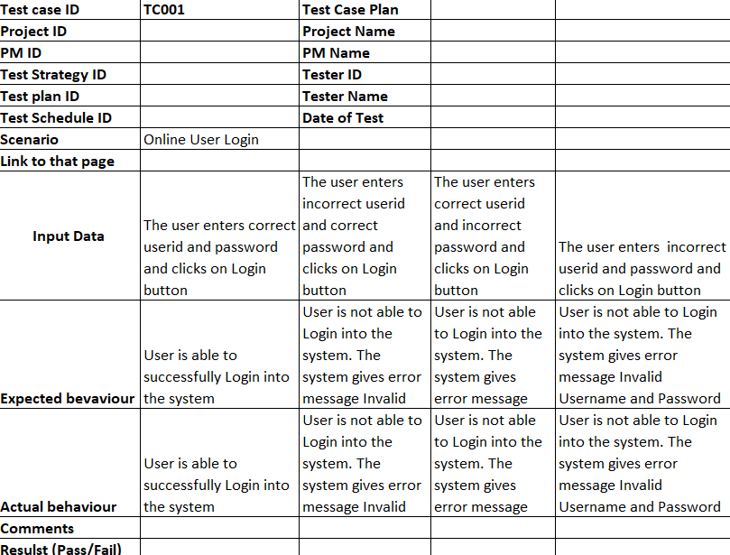

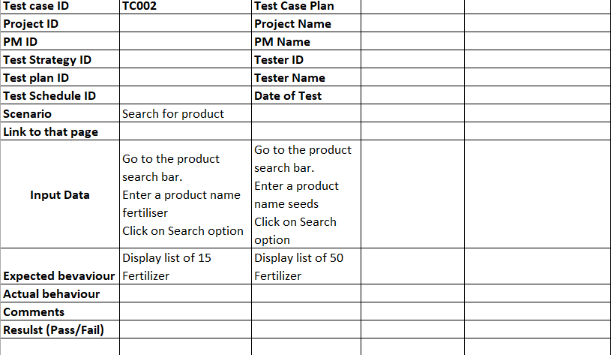

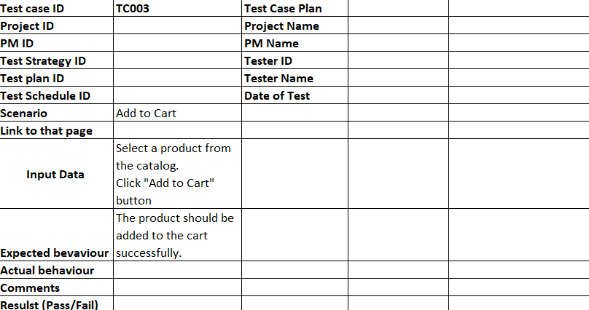

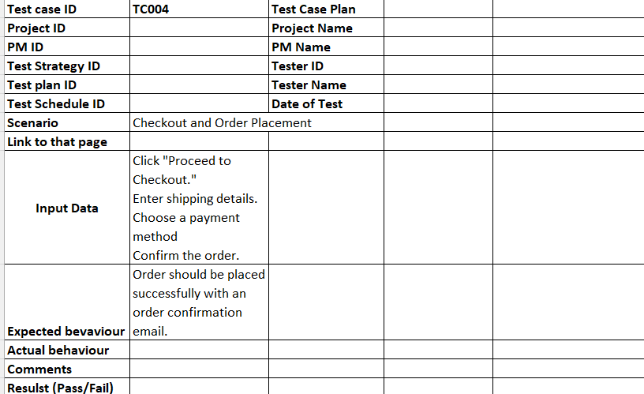

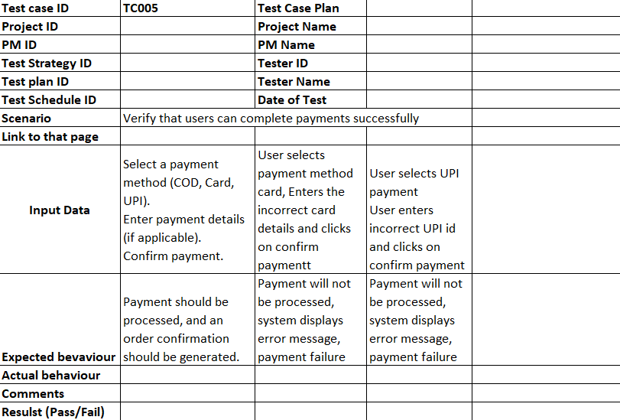

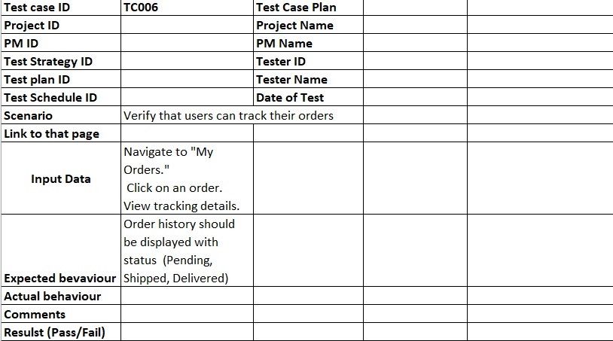

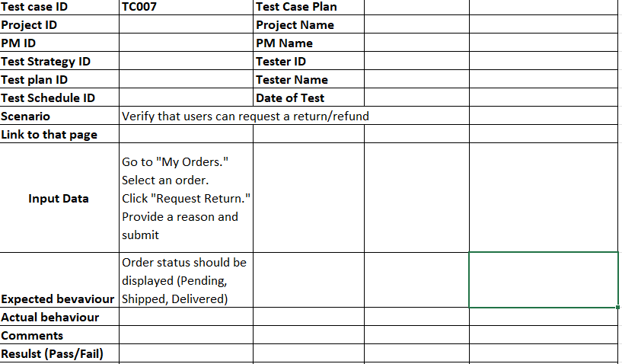

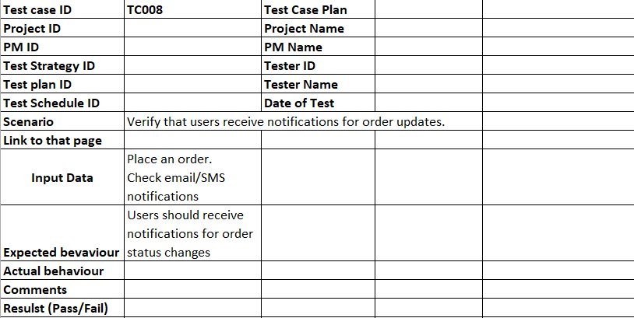

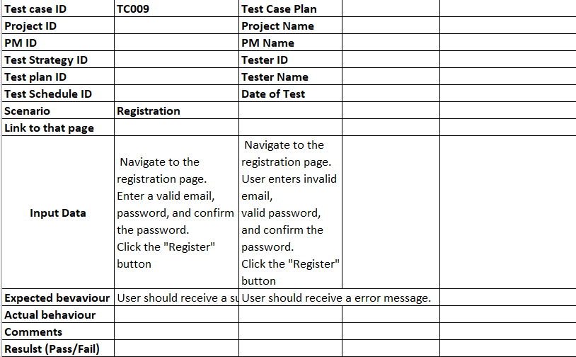

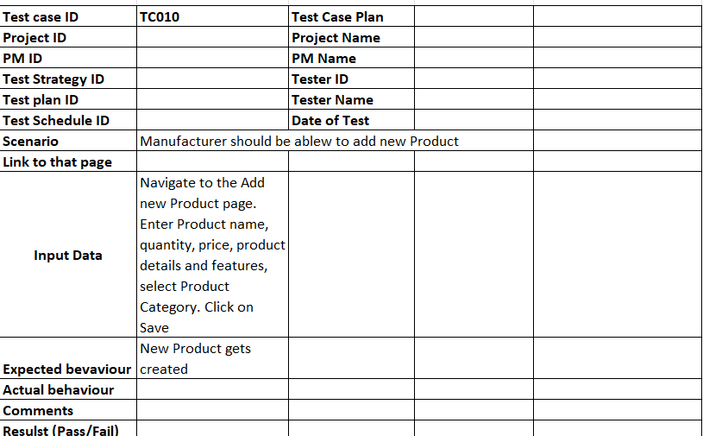

**Question 6 – DB Design – 8 Marks**

**Database Schema (Tables & Relationships)**

**ER Diagram Components**

|  |
| --- |
| **Product Category** |
| category_Id int |
| name varchar |
| description varchar |
| created_On datetime |
| modified_On datetime |

|  |
| --- |
| **Product** |
| product_Id int |
| name varchar |
| description varchar |
| category_Id int |
| price decimal |
| created_On datetime |
| modified_On datetime |

|  |
| --- |
| **User** |
| user_Id int |
| username varchar |
| password varchar |
| first_name varchar |
| last_name varchar |
| contact_no varchar |
| created_On datetime |
| modified_On datetime |

1

|  |
| --- |
| **Product Inventory** |
| inventory_Id int |
| product_Id int |
| quantity int |
| created_On datetime |
| modified_On datetime |

|  |
| --- |
| **User Address** |
| address_Id int |
| user_Id int |
| address1 int |
| address2 varchar |
| address3 varchar |
| postal_code varchar |
| created_On datetime |
| modified_On datetime |

1 * *

1

1 1 1

|  |
| --- |
| **User Payment** |
| User_payment_Id int |
| user_id int |
| payment_type varchar |
| account_no varchar |
| created_On datetime |
| modified_On datetime |

1

|  |
| --- |
| **Cart** |
| cart_Id int |
| user_Id int |
| created_On datetime |
| modified_On datetime |

*

|  |
| --- |
| **Cart Item** |
| cart_item_id int |
| cart_Id int |
| user_Id int |
| product_id int |
| quantity int |
| created_on datetime |
| modified_on datetime |

|  |
| --- |
| **Order** |
| order_Id int |
| user_Id int |
| total decimal |
| payment_id int |
| created_on datetime |
| modified_on datetime |

1

*

1 1

|  |
| --- |
| **Payment Details** |
| payment_id int |
| order_Id int |
| amount decimal |
| provider varchar |
| quantity int |
| created_on datetime |
| modified_on datetime |

*

1

1

|  |
| --- |
| **Order Details** |
| order_Id int |
| product_Id int |
| quantity int |
| payment_id int |
| created_on datetime |
| modified_on datetime |

*

**Question 7 – Data Flow Diagram - 3 Marks What is a data flow diagram? Draw a data flow diagram to represent the in-flow and out-flow of data when a Farmer is placing an order for the product**

**What is a Data Flow Diagram (DFD)?**

A **Data Flow Diagram (DFD)** is a graphical representation of the **flow of data** through a system. It shows how information is **input, processed, stored, and output** within a system. DFDs are used to understand, analyze, and optimize processes in a system.

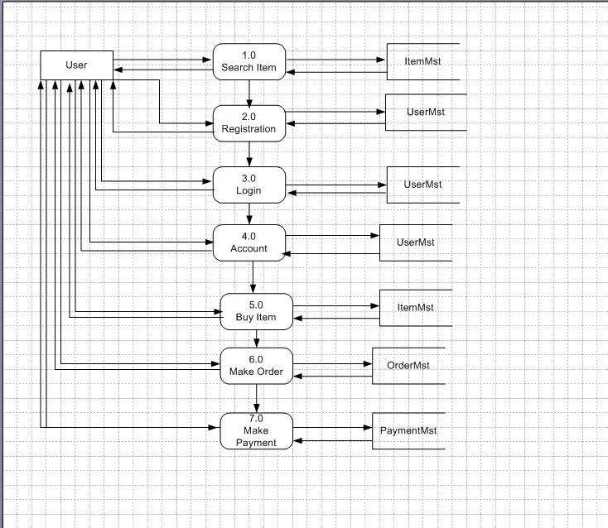

**Question 8 – Change Request - 10 Marks Due to change in the Government Taxation structure . we should change the Tax structure How do you handle change requests in a project?**

**Ans:** Understand the scope of change request and document the change request.

Do the impact analysis- project scope, schedule, budget, resources, and risks.

Prioritize change requests based on its urgency, importance, impact on project

Seek approval from the project sponsor for the change request.

Communication the change request and its potential impact to all relevant stakeholders, including the project team.

**Question 9 – Change Request Vs an Enhancement - 5 Marks As the project is in process, Ben and Kevin have contacted you. The reason is to inform you that they want the Farmers to sell their crop yields through this application i.e. Farmers should be able to add their crop yields or products and display to general public and should be able to sell them. They also want to introduce Auction system for their Crop yields. As a BA, what will be your response? Is this a change request or an enhancement???**

**Change Request vs. Enhancement**

* A **Change Request (CR)** is a modification to an existing requirement due to external factors (e.g., policy change, bug fixes).
* An **Enhancement** is an **addition** of a **new feature** that was **not part of the original scope** but improves functionality.

**Analysis of Ben & Kevin’s Request**

**New Functionality:**

* Originally, the application was designed for **Farmers to buy fertilizers, seeds, and pesticides** from manufacturers.
* Now, Farmers want to **sell their crop yields** to the general public.
* They also want an **Auction System** for better pricing.

**Impact on the System:**

* **New Seller Module:** Farmers will become **sellers** instead of just buyers.
* **New Auction Feature:** Requires **bidding, time-based pricing, and notifications**.
* **Database Changes:** Need to store **crop yield details, bidding history, and buyer information**.
* **Payment Processing Adjustments:** Farmers will receive **payments**, not just make them.

**Is this a Change Request or an Enhancement?**

**This is an Enhancement.**

**Why?**

* It is **not modifying an existing feature** but **introducing a new module**.
* It **expands the project scope** beyond the initial vision.
* It adds **business value** by allowing **Farmers to sell products**.

**Question 10 – Estimations - 6 Marks Come up with estimations – How many Manhours required**

**Project Estimation – Man-Hours Calculation**

To estimate the total **man-hours required**, we need to break the project into **phases** and estimate effort based on the **tasks and roles involved**.

**Assumptions & Project Scope**

* **Project Duration:** 18 Months (≈ 78 weeks)
* **Team Members:** 12 Core Team Members (BA, Developers, Testers, DB Admin, Network Admin, PM)
* **Key Features:**
  + **User Registration & Login**
  + **Product Listing & Search**
  + **Order Placement & Payment Integration**
  + **Delivery Tracking System**
  + **Admin & Manufacturer Panel**

**Effort Breakdown by Project Phase**

| **Phase** | **Task Description** | **Man-Hours** |
| --- | --- | --- |
| **1. Requirements Analysis** | Business requirement gathering, stakeholder meetings, documentation | 320 hrs (BA, PM) |
| **2. System Design** | Database design, UI/UX wireframes, architecture setup | 400 hrs (BA, DB Admin, Designers) |
| **3. Development** | Frontend & Backend Development (Java, APIs, Database) | 3,600 hrs (Developers) |
| **4. Testing & QA** | Unit Testing, Integration Testing, UAT, Bug Fixing | 1,200 hrs (Testers) |
| **5. Deployment & Security** | Server setup, cloud hosting, data encryption, API security | 480 hrs (Network Admin, DB Admin) |
| **6. Training & Documentation** | User manual, training sessions for farmers & manufacturers | 240 hrs (BA, Support) |
| **7. Post-Launch Support** | Bug fixes, maintenance, enhancements | 600 hrs (Developers, Testers) |

**Total Estimated Effort**

**6,840 Man-Hours**

**Resource Allocation (Per Role):**

* **Business Analyst (BA):** 560 hrs
* **Project Manager (PM):** 400 hrs
* **Developers (5 Devs):** 3,600 hrs
* **DB Admin:** 320 hrs
* **Network Admin:** 160 hrs
* **Testers (2 Testers):** 1,200 hrs
* **UI/UX Designers:** 400 hrs
* **Support Team:** 200 hrs

**Conclusion**

The project will require approximately **6,840 man-hours** over **18 months**.

**Question 11 – UAT – 6 Marks Project has finally completed all the stages i.e., design, development, testing etc. Now, it is the role of a business analyst to contact the client for testing of the final product and have to successfully complete it. How are you going to handle this situation? And once it is done, what will be the process to close the project? Explain UAT Acceptance process**

Once the project is **fully developed and tested**, the **Business Analyst (BA)** is responsible for conducting **User Acceptance Testing (UAT)** with the client and ensuring a smooth **project closure**.

**Steps to Handle UAT (User Acceptance Testing)**

**1. Plan UAT with Client**

* **Schedule a meeting** with key stakeholders (Mr. Henry, Mr. Pandu, Mr. Dooku, Farmers, and Manufacturers).
* **Define UAT objectives** – Ensure that the system meets business requirements.
* **Prepare UAT Test Cases** – Cover key scenarios like:
  + User registration & login
  + Product search & order placement
  + Payment processing
  + Delivery tracking
  + Manufacturer dashboard
* **Set up a UAT environment** – A staging server similar to production.

**2. Execute UAT with the Client**

* **Demonstrate the system** to the client.
* **Clients perform testing** based on real-world scenarios.
* **Record client feedback** (bugs, usability issues, improvement suggestions).
* **Track issues** in a UAT defect log.

**3. Fix Bugs & Get Final Approval**

* **Development team fixes** critical UAT issues.
* **Retest the fixed issues** with client approval.
* **Get formal UAT Sign-off** from Mr. Henry & stakeholders.

**Question 12 – Project Closure Document - 6 Marks Explain Project closure document**

**What is a Project Closure Document?**

A **Project Closure Document** is an official report that confirms the **completion of a project** and summarizes key details such as objectives achieved, deliverables, approvals, and post-deployment support. It acts as the **final handover** and ensures **all project activities are formally closed**.

**Key Sections of a Project Closure Document**

**1. Project Overview**

* **Project Name:** Online Agriculture Product Store
* **Client:** SOONY Company
* **Project Sponsor:** Mr. Henry
* **Project Duration:** 18 months
* **Project Budget:** 2 Crores INR
* **Project Manager:** Mr. Vandanam
* **Delivery Head:** Mr. Karthik

**2. Project Objectives & Success Criteria**

Provide an **online platform** for farmers to buy seeds, fertilizers, and pesticides.

Enable **direct communication** between farmers and manufacturers.

Implement a **secure payment system** with multiple options (COD, UPI, Credit/Debit cards).

Deliver an easy-to-use **product search, order, and delivery tracking system**.

Ensure **compliance with new taxation policies**.

**3. Deliverables & Milestones Achieved**

| **Milestone** | **Completion Date** | **Status** |
| --- | --- | --- |
| Requirements Gathering | Month 2 | Completed |
| System Design & Database Setup | Month 4 | Completed |
| Development Phase 1 (Core Features) | Month 8 | Completed |
| Development Phase 2 (Payment, Order Tracking) | Month 12 | Completed |
| UAT & Bug Fixing | Month 16 | Approved |
| Final Deployment | Month 18 | Live |

**4. UAT & Client Approval**

* **UAT Performed By:** Mr. Henry & Key Stakeholders (Peter, Kevin, Ben)
* **Feedback & Fixes:** Minor UI enhancements, tax adjustments
* **Final UAT Sign-off Date:** Approved

**5. Outstanding Issues (If Any)**

* No critical issues pending.
* Minor enhancements (e.g., additional farmer dashboard features) are **planned for future updates**.

**6. Transition Plan & Support Agreement**

* **Support Team Assigned:** APT IT Solutions
* **Post-Go-Live Support:** 6 months of free support
* **SLA (Service Level Agreement):**
  + **Critical Bugs:** Fixed within **24 hours**
  + **Minor Issues:** Fixed within **5 business days**
  + **Enhancements:** Reviewed quarterly

**7. Financial Summary**

* **Initial Budget:** 2 Crores INR
* **Actual Spend:** 1.95 Crores INR
* **Cost Savings:** 5 Lakhs INR

**8. Client Sign-Off & Project Closure Approval**

**Approved By:**  
**Mr. Henry** (Project Sponsor)  
**Mr. Pandu** (Financial Head)  
**Mr. Dooku** (Project Coordinator)

**Final Project Status:** **Successfully Completed & Delivered**