Vaishnavi Rathod

Abstract

use case diagram, activity diagram and a use case specification  
document, - Screens and pages, Tools-Visio and Axure, BA experience

Lead Management System

### **Document 6- Please prepare a use case diagram, activity diagram and a use case specification document. 1. Use Case Diagram**

The Use Case Diagram will depict the interactions between actors and the system's functionality for the Lead Management System. Below is a description of how it can be structured:

**Use Case Diagram Description:**

* **Actors:**
  + Sales Representative
  + Manager
  + Administrator
  + System (CRM Integration)
* **Use Cases:**
  + Login
  + Add Lead
  + Assign Lead
  + Track Lead Status
  + Generate Reports
  + Manage User Roles
  + Integrate with CRM



### **Activity Diagram**

The Activity Diagram will illustrate the workflow of key processes like **Lead Assignment** or **Lead Status Tracking** in the system.

#### Example: Lead Assignment Process

1. **Start**: Sales Representative or Manager logs in.
2. **Activity**: Add a new lead or fetch leads from integrated CRM.
3. **Decision**: Manager decides to assign a lead.
   * **Yes**: Lead is assigned to a Sales Representative.
   * **No**: Lead remains unassigned.
4. **Activity**: Notification sent to Sales Representative.
5. **End**: Sales Representative follows up on the assigned lead.

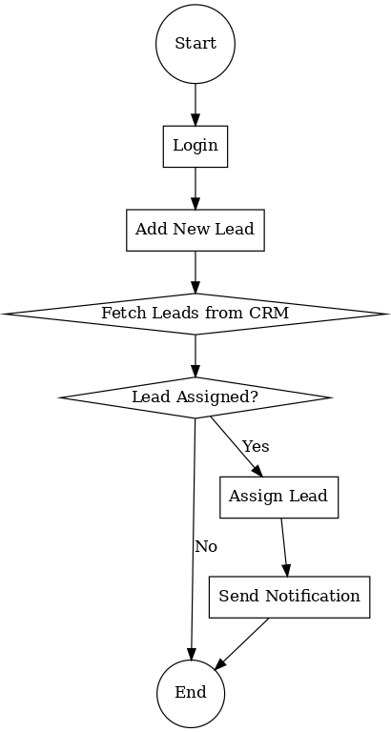

### **Use Case Specification Document**

A structured **Use Case Specification** for the primary use cases:

#### Template:

### **Use Case 1: Login**

|  |  |
| --- | --- |
| **Use Case ID:** | UC001 |
| **Use Case Name:** | Login |
| **Actor:** | Sales Representative, Manager, Administrator |
| **Description:** | The actor logs into the system to access functionalities based on their roles. |
| **Preconditions**: | Actor has valid credentials.  **The system is online and accessible.** |
| **Postconditions**: | Successful login provides access to the dashboard.  Unsuccessful login shows an error message. |
| **Main Flow**: | Actor enters username and password.System validates credentials. If valid, the actor is redirected to the dashboard. |
| **Alternate Flow**: | Invalid credentials: Display error and allow retry. |
| **Exceptions**: | System downtime: Notify the actor. |
| **Priority**: | High |

### **Use Case 2: Add lead**

**Use Case ID:** UC-001  
**Actors**: Salesperson  
**Description**: The system allows the salesperson to add new leads with details like name, contact, source, and interest level.  
**Preconditions**: The salesperson must be logged into the system.  
**Postconditions**: A new lead is successfully added to the system and assigned a unique ID.  
**Flow** **of** **Events**:

1. The salesperson navigates to the "Add Lead" section.
2. Enters lead details (Name, Email, Phone, Company, Source, etc.).
3. Clicks "Save Lead."
4. The system validates and stores the lead.
5. A confirmation message is displayed.

### **Use Case 3: Qualify Lead**

**Use Case ID:** UC-002  
**Actors:** Salesperson  
**Description:** The salesperson qualifies a lead by assessing interest level and lead potential.  
**Preconditions:** A lead must exist in the system.  
**Postconditions:** The lead is marked as Qualified or Unqualified.  
**Flow of Events:**

1. Salesperson opens the lead profile.
2. Selects "Qualify Lead."
3. Updates lead status (Hot, Warm, Cold).
4. Adds remarks and submits.
5. The system updates lead status and logs the action.

### **Use Case 4: Assign Lead**

**Use Case ID:** UC-003  
**Actors:** Manager  
**Description:** The manager assigns a lead to a salesperson for follow-up.  
**Preconditions:** The lead must be in the system.  
**Postconditions:** The lead is assigned to a salesperson.  
**Flow of Events:**

1. The manager opens the list of unassigned leads.
2. Selects a lead and clicks "Assign."
3. Chooses a salesperson from the dropdown.
4. Clicks "Confirm Assignment."
5. The system updates lead ownership and notifies the salesperson.

**Use Case 5: Follow Up**

**Use Case ID:** UC-004  
**Actors:** Salesperson  
**Description:** The salesperson follows up with assigned leads.  
**Preconditions:** Lead must be assigned to the salesperson.  
**Postconditions:** The follow-up details are logged in the system.  
**Flow of Events:**

1. The salesperson opens the assigned lead list.
2. Selects a lead and views contact history.
3. Updates the follow-up action (Call, Email, Meeting).
4. Adds follow-up notes and next steps.
5. The system logs the activity.

**Use Case 6: Close Lead**

**Use Case ID:** UC-005  
**Actors:** Salesperson  
**Description:** The system allows salespeople to mark a lead as "Won" or "Lost."  
**Preconditions:** The lead must be followed up at least once.  
**Postconditions:** The lead is marked as Won or Lost.  
**Flow of Events:**

1. The salesperson selects a lead.
2. Clicks "Close Lead."
3. Chooses "Won" or "Lost."
4. Provides reasons and submits.
5. The system updates lead status and records it.

**Use Case 7: Generate Report**

**Use Case ID:** UC-006  
**Actors:** Manager, Admin  
**Description:** The system generates lead reports based on filters like status, date, or salesperson.  
**Preconditions:** The system must have lead data.  
**Postconditions:** A report is generated and downloadable.  
**Flow of Events:**

1. The manager/admin accesses the Reports section.
2. Selects filters (Timeframe, Status, Assigned Salesperson).
3. Clicks "Generate Report."
4. The system compiles data and displays the report.
5. The user downloads or prints the report.

**Document 7- Screens and pages**

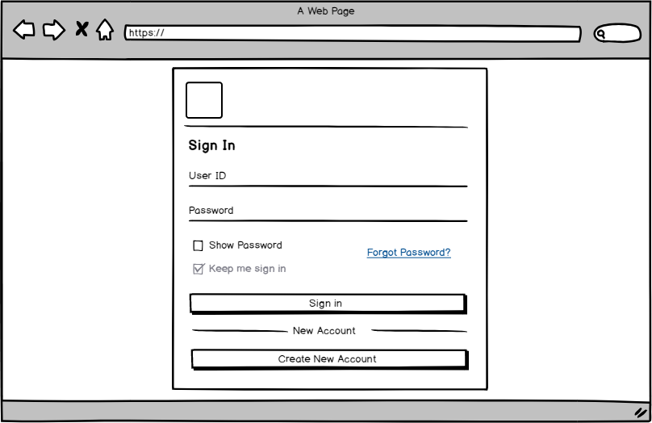

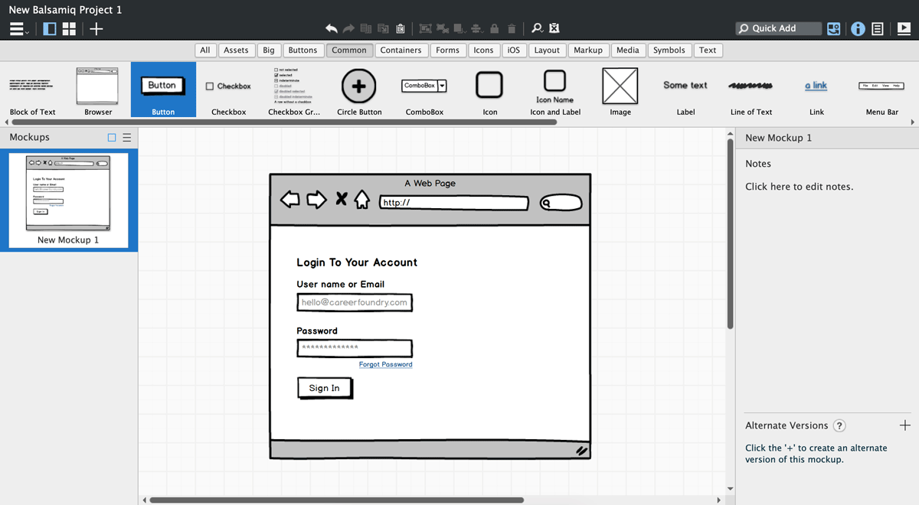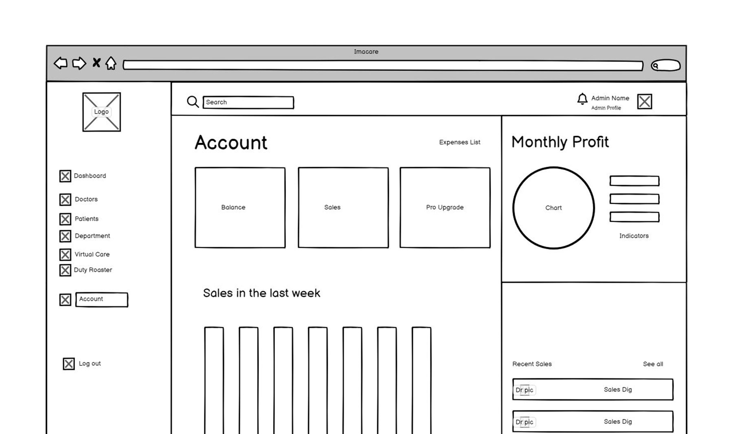

**Document 8- Tools-Visio and Axure   
Write a paragraph on your experience using Visio and Axure for the project**

For the **Lead Management System** project, we used **Microsoft Visio** and **Axure RP** to create various diagrams and UI mockups. **Visio** was instrumental in designing structured diagrams such as **Use Case Diagrams, Activity Diagrams, and Process Flows**. Its intuitive drag-and-drop interface, along with a vast collection of shapes and templates, allowed us to efficiently map out the system’s workflows and interactions. The ability to link data sources and customize diagrams made it easier to represent system functionalities and dependencies effectively.

On the other hand, **Axure RP** played a crucial role in creating **interactive wireframes and realistic UI mockups** for the system's screens and pages. The tool's dynamic panel feature and interactive elements allowed us to simulate user interactions, making it easier to visualize the end-user experience. With Axure’s ability to create high-fidelity prototypes, stakeholders were able to review and provide feedback before development, ensuring a user-centric design.

Both tools significantly enhanced the project by streamlining **requirement visualization, stakeholder communication, and design validation**, ultimately leading to a well-structured and user-friendly **Lead Management System**.

**Document 9- BA experience**

**1. Requirement Gathering:**

As a **Business Analyst (BA)**, my primary responsibility during this phase was to engage with stakeholders, including **sales teams, marketing managers, and customer service representatives**, to understand their pain points and expectations from the **Lead Management System**. I conducted **stakeholder interviews, brainstorming sessions, and surveys** to gather comprehensive business needs. Additionally, I used **elicitation techniques** such as **workshops, document analysis, and competitor analysis** to ensure all functional and non-functional requirements were well-defined.

**2. Requirement Analysis:**

After gathering the requirements, I categorized and prioritized them based on **business impact, feasibility, and urgency**. I created **use case models, process flow diagrams, and requirement traceability matrices (RTM)** to ensure that all business needs were mapped correctly. Collaborating with **technical teams**, I validated the requirements to check for any potential conflicts or dependencies. During this phase, I also worked closely with stakeholders to resolve ambiguities and ensured that the documented requirements aligned with business objectives.

**3. Design:**

In this phase, I actively participated in the **UI/UX discussions**, working alongside designers to create **wireframes and prototypes** using **Axure RP and Balsamiq**. I also assisted in developing **system architecture diagrams and data flow diagrams** using **Visio** to visualize how different system components interact. I ensured that the design was user-friendly, scalable, and aligned with the client’s expectations.

**4. Development:**

During the development phase, I served as a **liaison between the business and development teams**, ensuring that the implementation adhered to the documented requirements. I conducted **requirement walkthroughs and sprint reviews** to clarify doubts and make necessary adjustments. I also worked on **change request management**, handling modifications efficiently while minimizing scope creep.

**5. Testing:**

I worked closely with the **Quality Assurance (QA) team** to define **test cases and scenarios** based on the requirements. I reviewed **User Acceptance Testing (UAT) test plans**, ensuring that all business processes were covered. I participated in **UAT sessions with end-users**, gathering feedback and working on necessary refinements. Any defects or gaps were documented and tracked for resolution in collaboration with the development team.

**6. Deployment:**

Before deployment, I conducted **training sessions** for end-users and prepared **user manuals, SOPs, and FAQs**. I supported the **go-live process**, ensuring smooth adoption by providing post-implementation support. I also gathered **post-deployment feedback** and worked on **continuous improvement suggestions** for future system enhancements.

**Conclusion:**

Through my experience as a **BA in the Lead Management System project**, I have developed expertise in **stakeholder management, requirement engineering, process modeling, and system validation**. My ability to **bridge the gap between business and technology** ensured successful project execution and user satisfaction.