**Agile Project**

Part 2/2

**Agile Documents –**

**Document 1: Definition of Done**

**Definition of Done for T&S Compliance Dashboard -**

The Definition of Done is a crucial element in project management, particularly in Agile methodologies, as it outlines the criteria that must be met for a project or a specific task to be considered complete.

Key Components of the Definition of Done:

**Functional Requirements:**

Automated Processes: All manual workflows are successfully automated, ensuring efficiency and accuracy.

Real-Time Data Refresh: The dashboard provides live updates, ensuring that all data is current and accessible.

Centralized Data Storage: All relevant data is stored in one place, enhancing visibility and access control.

Access Control: Only authorized personnel have access to sensitive data, ensuring security and compliance.

**Quality and Accuracy:**

100% Data Accuracy: The dashboard ensures that all data is accurate and reliable, eliminating errors.

Zero Errors in Agent Work: Agents can perform tasks with zero errors due to the automated and streamlined workflow.

Performance Metrics:

Turnaround Time (TAT) Reduction: The implementation results in a significant reduction in TAT, improving productivity.

Auto-Generated Reports: Performance reports are automatically generated, facilitating real-time decision-making.

Real-Time Decision Making: Stakeholders can make informed decisions based on live data.

**Integration and Compatibility:**

Seamless Integration: The dashboard integrates smoothly with existing systems and other relevant dashboards.

Data Migration: All historical data from Google Sheets is successfully migrated to the new dashboard.

**User Acceptance and Training:**

User Acceptance Testing (UAT): SMEs and stakeholders have conducted thorough UAT, confirming that the dashboard meets all requirements.

User Training: Comprehensive training has been provided to all users, ensuring they are proficient in using the dashboard.

**Security and Compliance:**

Security Measures: All necessary security measures are in place to prevent data leaks or unauthorized access.

Compliance Standards: The dashboard adheres to all relevant compliance standards and regulations.

**Maintenance:**

Maintenance Plan: A plan for ongoing maintenance, updates, and future enhancements is established.

**Document 2- Product Vision**

|  |  |  |  |
| --- | --- | --- | --- |
| **Scrum Project Name:** | T&S Compliance Dashboard | | |
| **Venue:** Board Room |  |  |  |
| **Date:** 05-March-2025 | **Start time:** 11:00 AM | **End time:** 01:00 PM | **Duration:** 3 Hrs. |
| **Client:** | T&S Department | | |
| **Stakeholder list:** |  |  |  |
| **VP T&S** | Susshil Singh |  |  |
| **SME** | Clementina Kinny |  |  |
| **BA** | Tejas Yadav |  |  |
| **Scrum Team** | | | |
| **Scrum Master:** | Abhishek Srivastav |  |  |
| **Product Owner:** | Kunal Shroff |  |  |
| **Scrum Developer:** | Omkar K. |  |  |
| **Scrum Developer:** | Abhijeet Singh |  |  |
| **Scrum Developer:** | Kiran Mishra |  |  |
| **Tester:** | Krisha Jain |  |  |
| **Vision**: A fully functional, user-friendly, and secure dashboard that significantly improves the efficiency and accuracy of compliance operations. | | | |
| **Target Group** It’s internal product of organization, T&S agents are targeted users. | **Needs** The T&S Compliance Dashboard solves the problem of manual, error-prone workflows by automating data handling, task assignments, and reporting. It provides real-time visibility, improves accuracy, boosts agent productivity, and ensures secure, centralized access to critical operational data. | **Product** The product is a real-time, automated dashboard designed for the T&S team to manage data, track productivity, and generate reports efficiently. It’s desirable because it replaces manual work with automation, enhances accuracy, and offers secure, centralized access. | **Value** The product will benefit the company by improving operational efficiency, reducing manual workload, and enabling faster, data-driven decisions. The business goals are to increase agent productivity, ensure data accuracy, and streamline reporting across teams. The business model focuses on internal optimization, using in-house resources to build a scalable tool that supports long-term workflow automation. |

**Document 3: User stories**

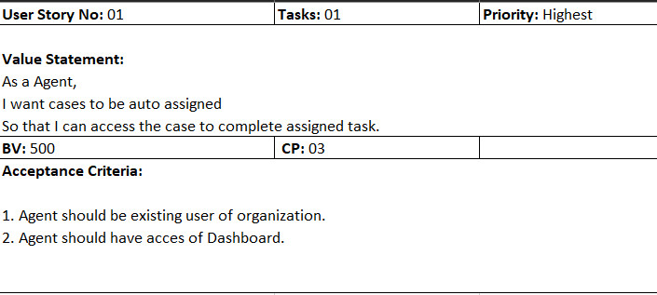

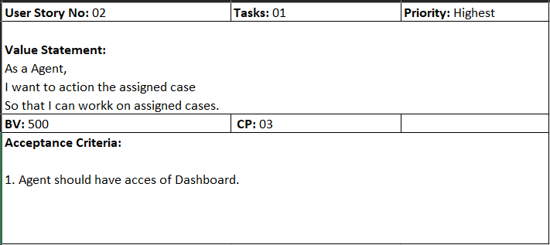

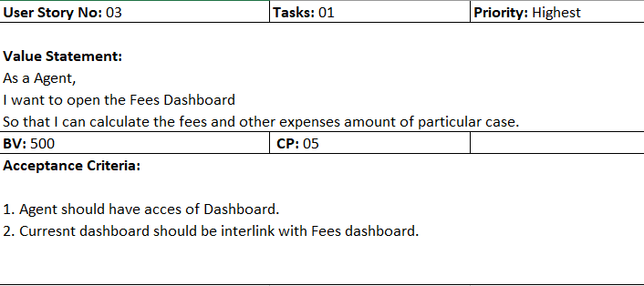

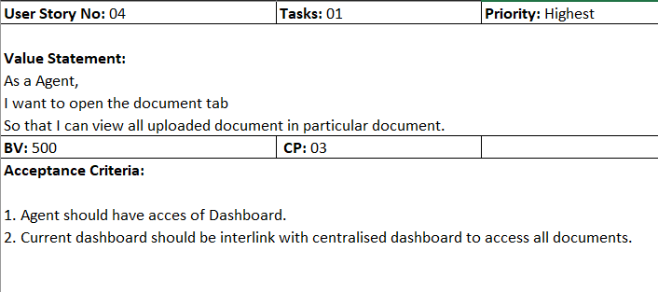

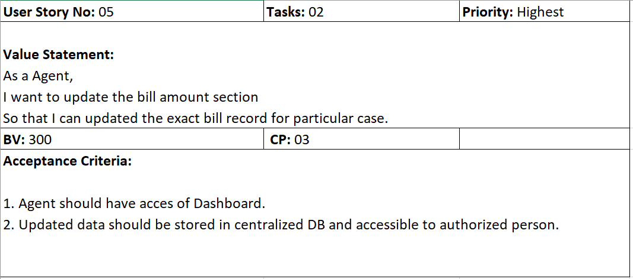

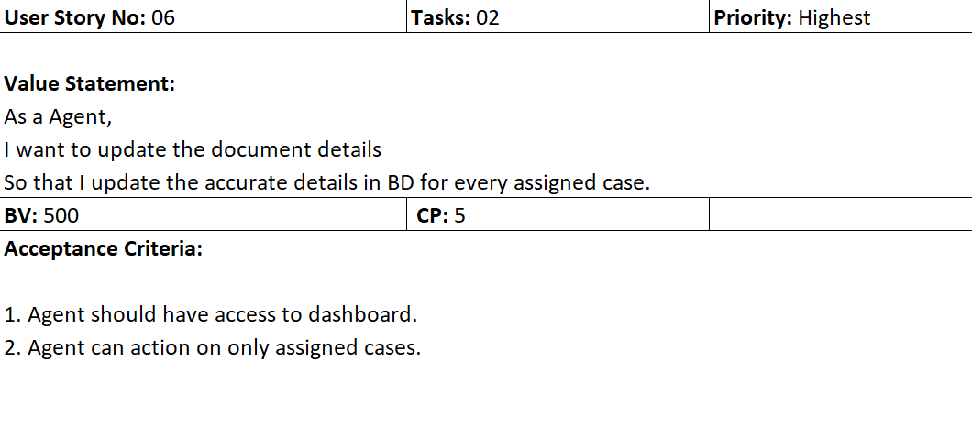

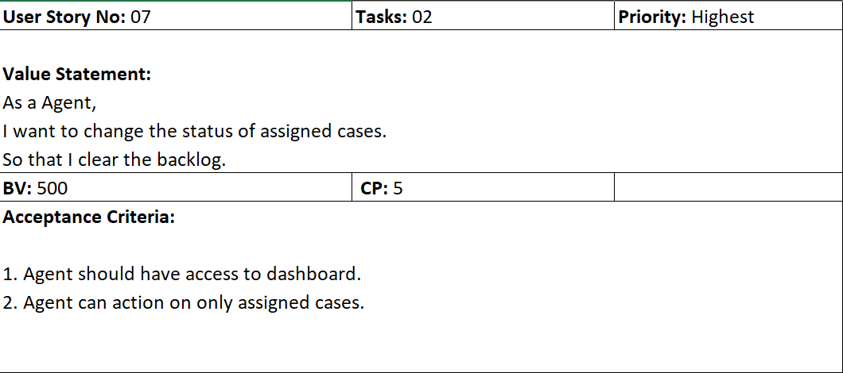

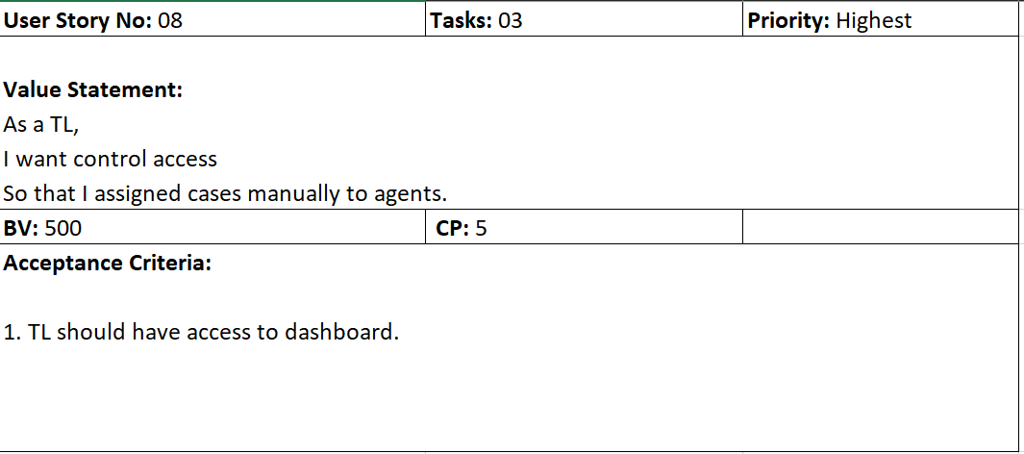

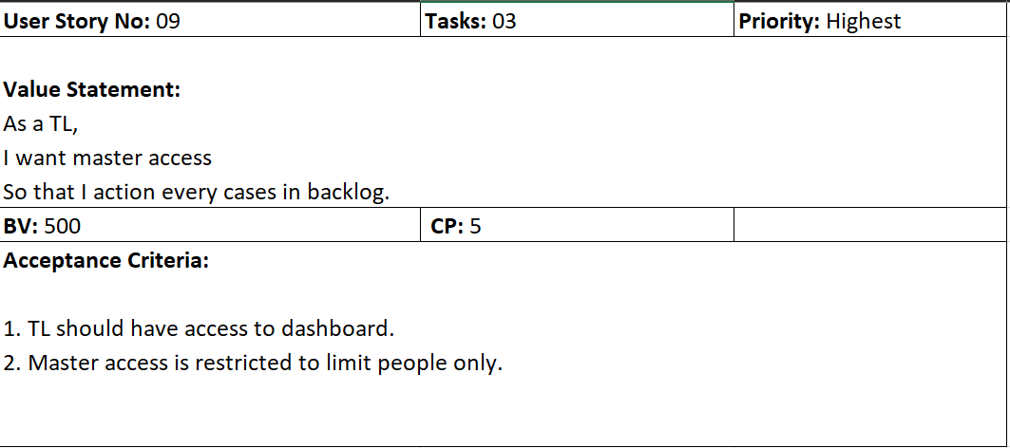

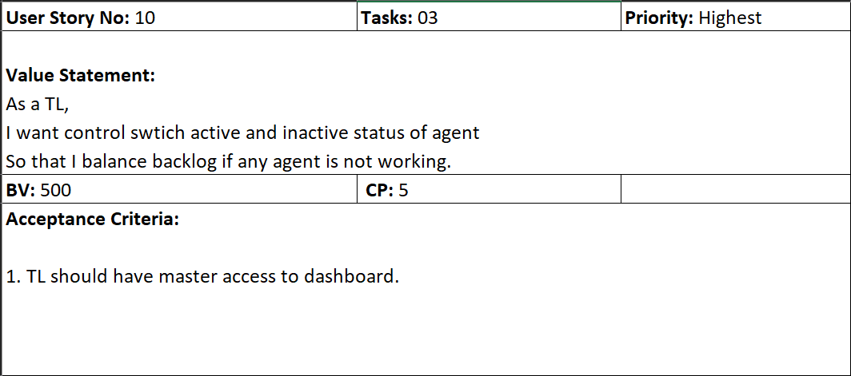

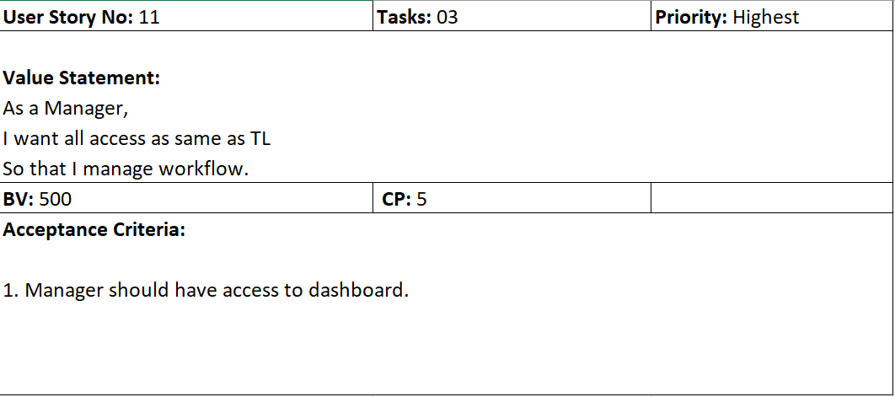

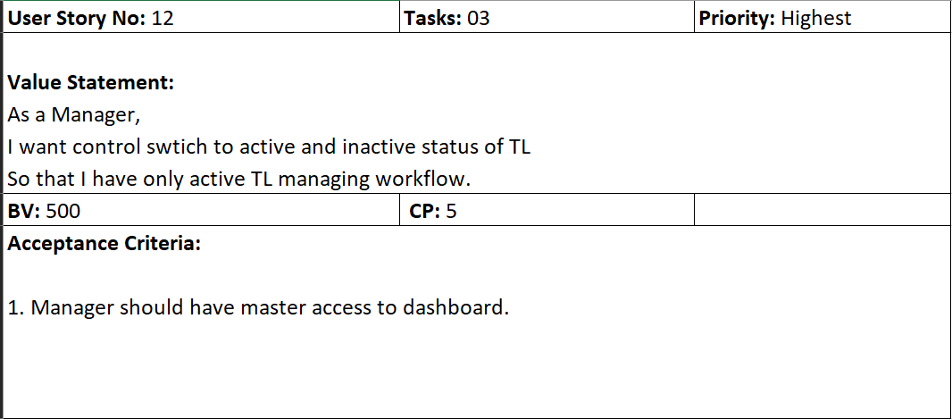

**Document 4: Agile PO Experience**The Product Owner has a vision of the product keeping the domain/industry experience and the market need.

Following are the responsibilities of PO in a project-

Defining Product Vision:

* Set a clear, compelling product vision aligned with business goals. Communicate the vision to the development team and stakeholders.

Stakeholder Collaboration:

* I have Gather requirements, feedback, and validate ideas with stakeholders. Also Updating Stakeholder with project improvement.

Defining User Stories and Acceptance Criteria:

* I have converted business needs into user stories with clear acceptance criteria.
* Ensured stories are “Ready” for development and meet the Definition of Done.

Prioritization and Road mapping:

* I have prioritize user stories based on business value, complexity Points, and stakeholder input.

Enterprise Research:

* As current project is an internal project no need of Market Research. Need to analyze the Stakeholders needs and feedback on project.

Managing the Product Backlog:

* I have created, refined, prioritized, and maintained the product backlog.
* Ensured backlog items are clearly defined, estimated and well understood.

Sprint Planning and Execution Support:

* I have handle sprint planning, daily stand-ups, sprint reviews, and retrospectives.
* I have been available to answer questions and provide clarifications to the team.

Validating Work Delivered:

* I have reviewed and accepted / rejected completed work based on acceptance criteria.
* I have ensured delivered work meets quality standards and business goals.

Managing Budget and ROI:

* Current Project is internal project no need any budget.
* As it’s a due diligence process which part of fraud detection no ROI but we can increase the Goodwill in market.

Continuous Improvement:

* Learn from metrics, user feedback and team retrospectives to improve product and processes.

**Document 5: Product and sprint backlog and product and sprint burndown charts.**

Product Backlog:

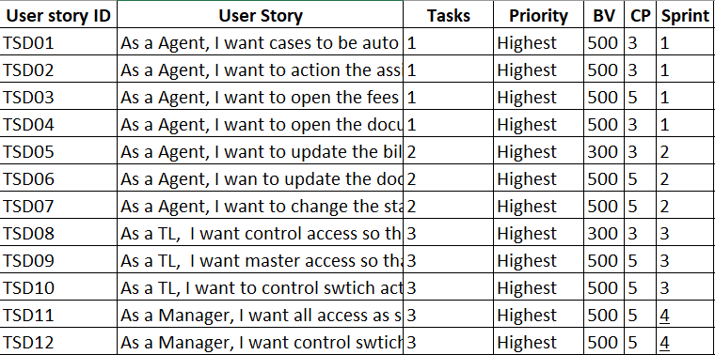

Sprint Backlog:

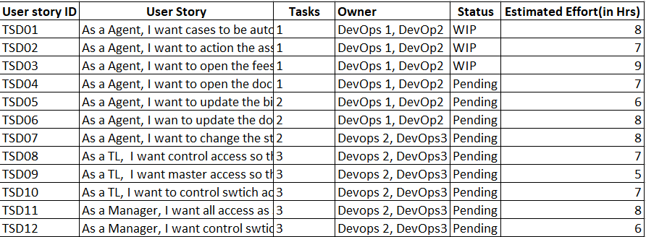

Product burndown Chart:

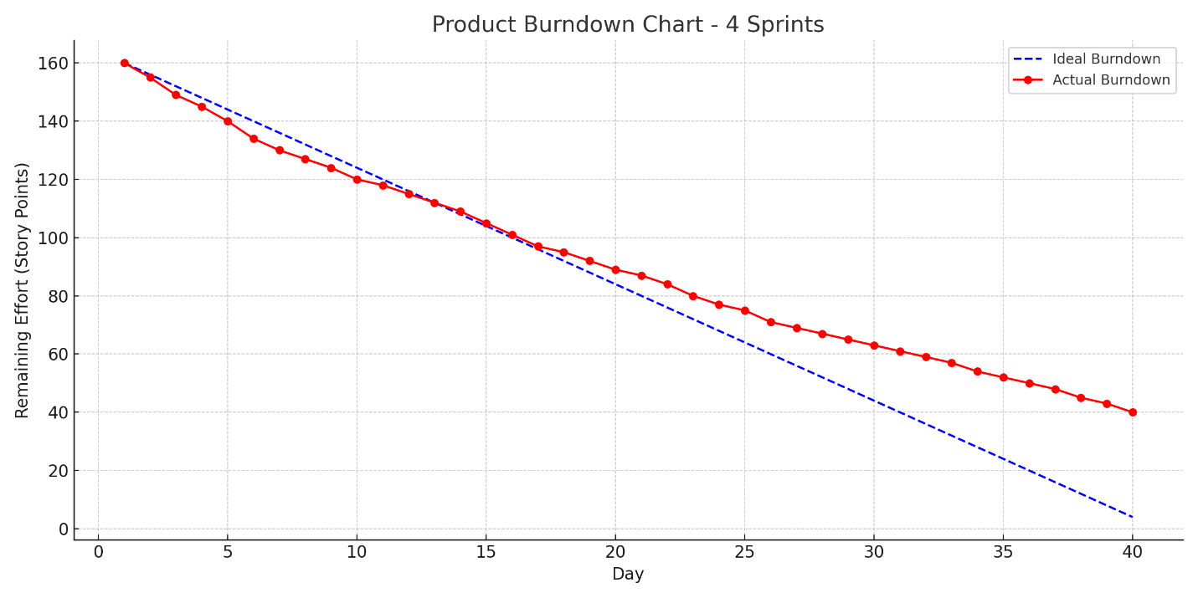

Sprint Burndown Chart:

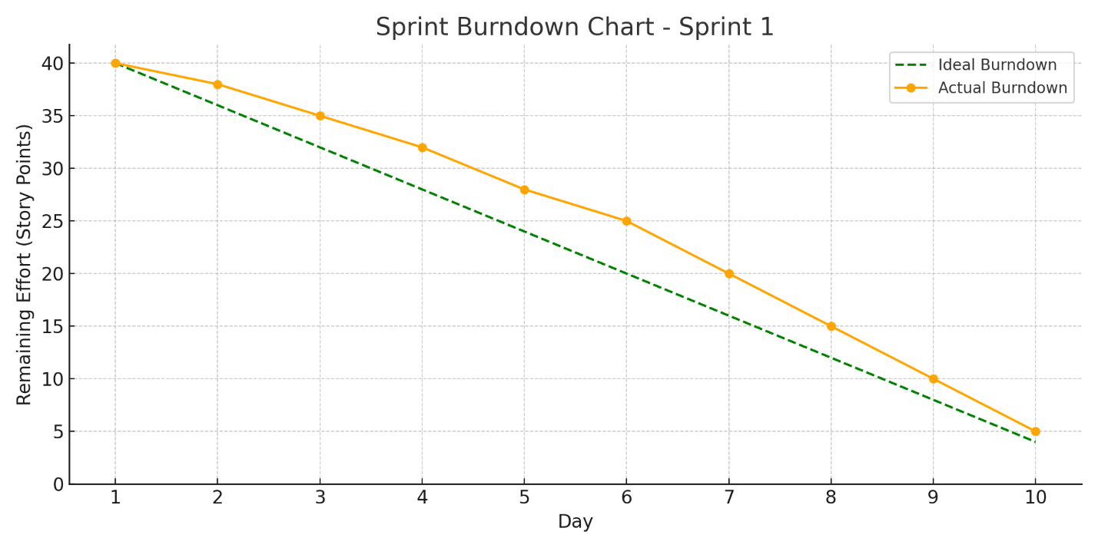

**Document 6: Sprint meetings**

**Meeting Type 1: Sprint Planning meeting**

|  |  |
| --- | --- |
| **Date** | 14-March-2025 |
| **Time** | 11:00 AM |
| **Location** | Board Meeting Room |
| **Prepared by** | BA Tejas Yadav |
| **Attendees** | Scrum Master, Scrum Developers. |

**Agenda Topics**

|  |  |  |
| --- | --- | --- |
| **Topic** | **Presenter** | **Time Allotted** |
| Sprint 1 Meeting | BA Tejas Yadav | 30 Mins |
| Sprint 1 Daily Stand-Up | BA Tejas Yadav | 20 Mins |

**Other Information**

|  |  |
| --- | --- |
| **Observers** | Product Owner |
| **Resources** | BRD |
| **Special Notes** | Interlink of dashboards |

**Meeting Type 2: Sprint review meeting**

|  |  |
| --- | --- |
| **Date** | 14-March-2025 |
| **Time** | 06:15 PM |
| **Location** | Meeting Cabin 02 |
| **Prepared by** | BA Tejas Yadav |
| **Attendees** | Scrum Master, Scrum Developers. |

|  |  |  |  |
| --- | --- | --- | --- |
| **Sprint Status** | **Things to demo** | **Quick Updates** | **What’s Next** |
| **WIP** | **User Access to Dashboard** | **Database created for Dashboard** | **TL Access control** |

**Meeting Type 3: Sprint retrospective meeting**

|  |  |
| --- | --- |
| **Date** | 20-March-2025 |
| **Time** | 06:00 PM |
| **Location** | Meeting Cabin 01 |
| **Prepared by** | BA Tejas Yadav |
| **Attendees** | Scrum Master, Scrum Developers. |

|  |  |  |  |  |
| --- | --- | --- | --- | --- |
| **Agenda** | **What went well** | **What didn’t go well** | **Questions** | **Reference** |
| Sprint 1 Review | Sprint 1 all user stories points completed | Data from Google cannot be linked. | How can data be updated from Google sheet. | Sprint 1 and Sprint 2. |

**Meeting Type 4: Daily Stand-up meeting**

