**COEPD – Prep Exam 3**

Case Study 1 (Q1-Q6 → 12 Marks) A customer can make a payment either by Card or by Wallet or by Cash or by Net banking.

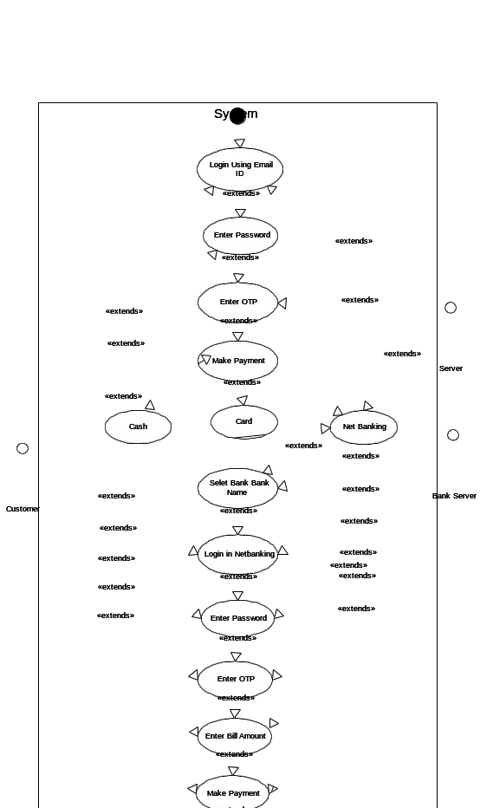

Q2. Derive Boundary Classes, Controller classes, Entity Classes. - 2 Marks Answer:

Boundary Classes:

The Boundary class is a class that is the boundary of the system and other system or user (which is actor in the use case diagram).

The followings are the feature of the Boundary class.

1. This class is easier to be changed than the Entity and Control class.
2. The attribute of this class and screen layout are defined at the basic design.
3. In a class diagram, there are cases that the stereotype (<<boundary>>) is added.
4. In a class diagram, there are cases that is shown by the following icon.



Controller classes:

The followings are the feature of the Control class.

1. This class has a few attributes.
2. In a class diagram, there are cases that the stereotype (<<control>>) is added.
3. This class is a class to achieves use cases in the Use case diagram.
4. In a class diagram, there are cases that is shown by the following icon.



Entity Classes:

The Entity class is a class that has data.

The "E" of the ER diagram means "Entity" too, if you know the ER diagram, you easily understand.

The followings are the feature of the Entity class.

1. There are many cases that these objects of this class are perpetuated 1 in the DB.
2. The extraction of the class is like ER diagram 2.
3. This class is related to the DOA (Data-oriented approach) 2.
4. The module cohesion of this class is high 3, and is not easy to be changed.
5. In a class diagram, there are cases that the stereotype (<<entity>>) is added.
6. In a class diagram, there are cases that is shown by the following icon.



Q3. Place these classes on a three tier Architecture. - 2 Marks

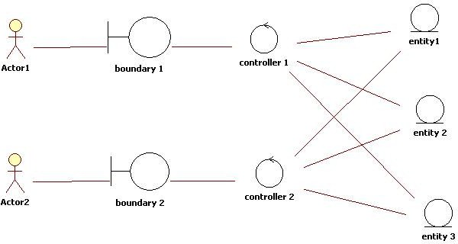

Q4. Explain Domain Model for Customer making payment through Net Banking - 2 Marks

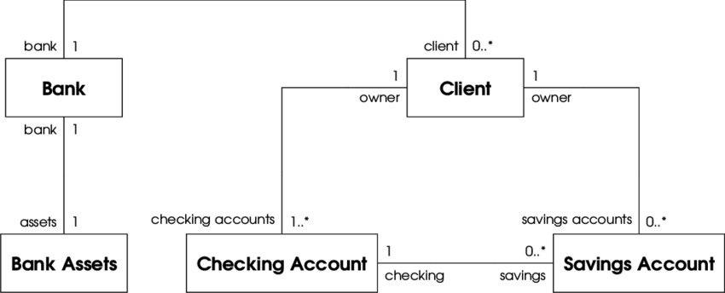

Q5. Draw a sequence diagram for payment done by Customer Net Banking - 2 Marks

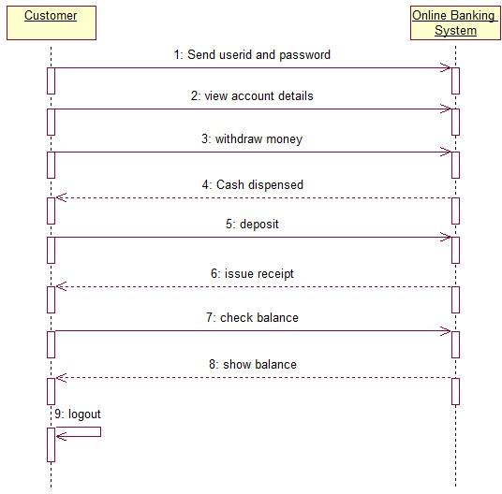

Q6. Explain Conceptual Model for this Case - 2 Marks

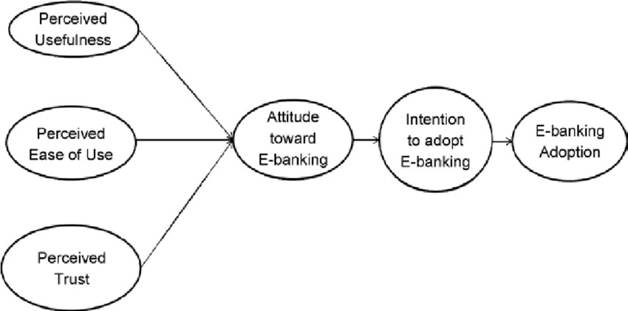

Q7. What is MVC architecture? Explain MVC rules to derive classes from use case diagram and guidelines to place classes in 3-tier architecture - 4 Marks

Ans:

The Model-View-Controller (MVC) is a well-known [design pattern](https://www.javatpoint.com/design-patterns-in-java) in the web development field. It is way to organize our code. It specifies that a program or application shall consist of data model, presentation information and control information. The MVC pattern needs all these components to be separated as different objects.

* **Model:** It represents the business layer of application. It is an object to carry the data that can also contain the logic to update controller if data is changed.
* **View:** It represents the presentation layer of application. It is used to visualize the data that the model contains.
* **Controller:** It works on both the model and view. It is used to manage the flow of application, i.e. data flow in the model object and to update the view whenever data is changed.

Advantages of MVC Architecture

The advantages of MVC architecture are as follows:

* MVC has the feature of scalability that in turn helps the growth of application.
* The components are easy to maintain because there is less dependency.
* A model can be reused by multiple views that provides reusability of code.
* The developers can work with the three layers (Model, View, and Controller) simultaneously.
* Using MVC, the application becomes more understandable.
* Using MVC, each layer is maintained separately therefore we do not require to deal with massive code.
* The extending and testing of application are easier.

Three-tier architecture, which separates applications into three logical and physical computing tiers, is the predominant software architecture for traditional client-server applications.

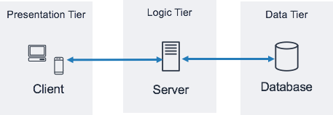

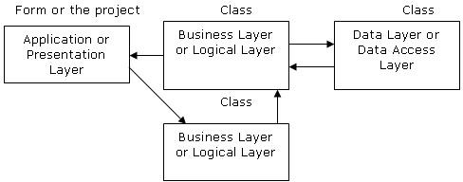

Q8. Explain BA contributions in project (Waterfall Model – all Stages) – 4marks

Ans:

A waterfall model is very old and traditional model in IT industries. It is a progressive implementation of the projects which is divided into different phrases of SDLC.

The business analyst will **verify the product is delivered as per the requirements and it is meeting the business need**. Maintenance: Once the implementation is done the team has to give support by installing patches, handling change requests, etc.

Stages in Waterfall Model.

1. Requirement Gathering and Analysis
2. Designing
3. Coding
4. Testing
5. Deployment
6. Maintenance

## Requirement Gathering and Analysis:

This is the initial stage of the project where is an involvement of the BA. BA is responsible for preparing BRD document (Business Requirement Document)

**Artifacts**: Functional Specification document. Business Requirement Document.

## Designing:

In this phase the architect will start designing the system based on the business analyst inputs and requirement documents. The BA helps him to clear the doubts about the requirements.

**Artifacts**: Design Documents and UML diagrams get ready in this phase.

## Coding:

This phase is quite lengthy as the core development starts in this phase. Developer start product development based on the requirement document prepared by the BA. Developer may ask questions to BA regarding the requirement and he needs to answer the questions as and when required.

**Artifacts:** Code

## Testing:

After coding, the testing phase will start, in this phase BA helps the testing team to understand the requirements so that they will build proper functional test cases. BA has to review whether the test cases covering the whole functionality.

**Artifacts:** Test Cases and test results.

## Deployment:

Once the code is developed and tested, it is ready to deploy in the production environment. The BA will verify the product is delivered as per the requirements and it is meeting the business needs.

**Artifacts:** Implementation Review document.

## Maintenance:

Once the implementation is done the team has to give support by installing patches, Handling changes requests, Etc.

A BA is the person who knows every nook and corner of the project. So, every change request has to be reviewed by him and based on his inputs and reports the team will respond.

**Artifacts:** User Satisfaction review and change request review.

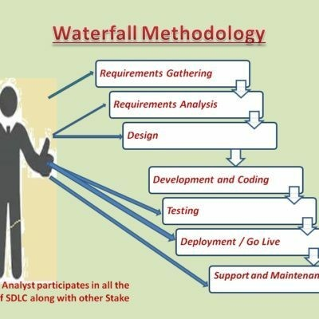

Q9. What is conflict management? Explain using Thomas – Kilmann technique – 3Marks

Ans:

In the 1970s, researchers Kenneth Thomas and Ralph Kilmann developed a model for conflict resolution. It was called the Thomas-Kilmann model after them. Under this model, the term ‘conflict’ is described as the condition in which people’s concerns can’t be compared with the others. If two or more people or groups care about things that are contradictory to each other, then the outcome is conflict.

This model describes the two core dimensions while choosing a code of conduct in a situation of conflict: ‘assertiveness’ and ‘cooperativeness’.

Assertiveness is the extent to which you try to solve and resolve for your preferred outcomes. Think of this as the factor on the Y-Axis of a graph. On the other hand, Cooperativeness is the level to which you try to resolve the other party’s problems. This is the factor on the X-Axis of the graph.

Thomas-Kilmann’s Five Modes for Handling Conflicts

From the correlation of these two and the scale of implementation, Thomas-Kilmann gave us the following five modes for handling the presented conflicts:

* **Competing**

Competing, the first Thomas-Kilmann conflict mode is [assertive](https://harappa.education/harappa-diaries/interpersonal-skills-examples-and-how-to-improve-them) and non- cooperative. It refers to addressing only one’s own concerns at the cost of the concerns of the other. It is a power-oriented mode—one uses whatever power dynamic seems appropriate to get a favorable outcome for oneself. An individual’s ability to debate, their position in the hierarchy, or their financial power matters the most. Competing is defensive—it strictly means standing up for your individual beliefs and simply trying to win.

* **Accommodating**

According to the Thomas-Kilmann model, the Accommodating mode is both accepting and cooperative. It is the opposite of competing. While accommodating, the individual in question neglects their own problems or beliefs to address the problems of the other party. The element of self- sacrifice is highlighted in this mode. Accommodating typically involves selfless understanding, generosity, or charity. At times, accommodating

would require you to follow the other person’s orders when you would not like to do so, or submit to the other’s perspective or decisions.

* **Avoiding**

In the Thomas-Kilmann model, avoiding is both unassertive and uncooperative. The individual wants to neither address their own problems nor the problems of others. This ultimately means that they do not want to engage in the conflict at all. Avoiding might be seen at times as a diplomatic move involving bypassing or ignoring the issue. It could also involve putting off the issue until the time is favorable, or simply stepping back from an uncomfortable or hazardous situation.

* **Collaborating**

Collaborating, the most beneficial outcome in the Thomas-Kilmann conflict model. is both assertive and cooperative. This mode is the complete opposite of avoiding. Collaborating includes a voluntary effort to work alongside the opposition to find a perfect solution that wholly addresses the collective problem. Collaborating involves deep-diving into an issue to locate the critical demands of the concerned individuals or parties.

Collaborating between two or more people might take the form of a quest to understand the ‘why’ of the disagreement. It involves striving to look for creative answers to interpersonal issues and enriching yourself from the other person’s insights.

* **Compromising**

The last outcome in the Thomas-Kilmann conflict model falls on the average point on both the assertiveness and cooperativeness scales. The goal here is to find a mutually acceptable and robust solution that, in some ways, satisfies both the individuals. It comes midway between competing and accommodating. It addresses an issue more directly than avoiding but falls short of investigating it with as much depth and rigor as collaborating. In certain situations, compromising might involve seeking middle-ground solutions, providing concessions, or looking for a quick solution that provides some way forward from the impasse.

The Thomas-Kilmann Model is based on two dimensions: assertiveness and empathy. There are 5 conflict resolution strategies: **Compete, Avoid, Accommodate, Collaborate and Compromise**. Each strategy has its benefits and disadvantages. Choose the appropriate one according to the situation.

Q10. List down the reasons for project failure – 3 Marks Ans:

## Poor planning

Although sometimes overlooked in importance, lack of planning can make a project fail.

Having a successful project depends on properly defining in detail the scope, the time frame, and each member’s role. This way, you’ll have a route laid out to follow.

## Inconsistently defined resources

Let’s be clear: planning shouldn’t be limited to agendas, meetings, and responsibilities. It should also include human, intellectual, financial, or structural resources. If these are not consistently determined, deadlines can’t be met, which can jeopardize the project’s conclusion.

## Unclear objectives

objectives should be clearly defined, so as time goes by, you’ll know if you’re doing what’s right or not. Remember that choosing measurable goals helps you better visualize your progress and helps you see how close you are to achieving your results.

## Lack of detail control

Monitoring is essential for successful projects, even knowing the details of many projects simultaneously can be very challenging.

As a result, it’s important to know how your project is going, if it is on schedule and if the budget is under control. This way, if there are any divergences from the initial plan, you can still correct them.

## Lack of transparency

It’s essential that everyone involved in the projects have complete project visibility so that it doesn’t fail – not only the project manager, but other team members too.

This includes clear communication, good document management, and transparency about tasks’ status, all of which can be achieved with centralized, all-digital files.

## Lack of communication

Communication is the key to good project management. Without the right tools and processes to allow interaction among team members and the

project manager from the beginning, efficient communication can seldom be achieved.

## Change of direction

Among the ways projects fail, a very common one is scope creep. This concept refers to changes requested when the project has already started which had not been planned before. This is very common when projects are not appropriately documented and defined beforehand.

## Unrealistic expectations

When you want to do something fast, with a limited budget, and a reduced team, it can really make your project fail. You should be realistic when it comes to your teams’ capabilities, deadlines, and the resources available – only then can you obtain the results you want.

## Lack of monitoring

Providing a schedule to the team is not enough for a project to be successful.

You should also make sure everything goes as planned. This means

having frequent progress checks or meetings, as well as making adaptations, when necessary, is essential.

## Unrealistic due dates

Planning co **Unrealistic due dates** plex tasks for short due dates is definitely one of the causes for project failure. It is vitally important to carefully consider how long each project phase will take, in addition to extra time for unexpected events. This is the only way to develop a quality project.

## Poorly assigned roles

When each team member receives their responsibilities clearly, they will know what, when, and how to perform their activities without someone needing to constantly ask for it.

Q11. List the Challenges faced in projects for BA – 3 Marks Ans.

A [BA is responsible for multiple tasks](https://techcanvass.com/blogs/business-analyst-role-and-responsibilities.aspx?utm_source=Blogs&utm_medium=Link&utm_campaign=BusinessAnalysisBlogs) at the same time. From handling the projects, maintaining client relationships, interacting with stakeholders, and managing project deadlines, Business Analysts got a lot on their plate. Read below to find out the challenges faced by business analysts and a possible solution to them

## Lack Of Domain Knowledge

A Business Analyst needs to collaborate with the business users to understand the requirements. Domain knowledge plays a vital role in having a clear and complete [understanding of the requirements.](https://www.youtube.com/watch?v=j3MnELjNFJU)

It is challenging for **Business Analysts** to be assigned to a wide variety of projects as learning new domains needs time and energy.

**Possible solution**: Whenever you are assigned a new project, sit with the responsible person and understand the project requirements. Take notes whenever necessary and understand them thoroughly. It is challenging to learn new domains sometimes, but you must make mistakes.

Hence, go on a loop until you make a very bit of your knowledge count on your fingertips. It will help you while implementing and processing the outcome of the project.

# Lack of Up-to-Date Process

The success of a project does not happen overnight. First, much effort and mental exhaustion are poured in to bring results.

Following this, the lion’s share is the up-to-date process of maintaining and evolving the project. The biggest challenge is the lack of up-to-date techniques and documentation. In most cases, the [Project Documentation](https://businessanalyst.techcanvass.com/which-are-the-documents-prepared-by-a-business-analyst/) is incomplete, which hampers productivity.

**Possible solution:** Testing a system is the most remarkable technique to learn about an existing project. It may seem odd, but it has been used for a long time. To further understand the flow, request a demo from a staff member or SME. Afterward, conduct extensive testing.

# Changing Business Needs or Requirements

Business stakeholders frequently request revisions to requirements even after they have been finalized and approved, as experienced by **Business Analysts.**

It might happen more once, even for the exact requirement, making it one of the most frequent issues. These adjustments could have an impact on the **Business Analysis** effort as well as the total project effort, cost, and schedule.

**Possible solution:** A change in the implementation cycle might impact the delivery process even if there are approaches that, like Agile, accept change. **Business Analysts** and other essential stakeholders must therefore determine how the difference may be

implemented in the best way.

# Inadequate Stakeholder Involvement

One of the essential success criteria for every project is [stakeholder](https://www.youtube.com/watch?v=hXeCEU1qMgs)  [involvement.](https://www.youtube.com/watch?v=hXeCEU1qMgs) You might encounter any of the following as a Business Analyst:

**Lack of crucial stakeholders:** If this occurs, there will be multiple problems since they will not be up to date on discussions about the most recent requirements. Either they won’t be able to express their ideas, or they will subsequently propose revisions.

**Stakeholders’ Lack of Cooperation:** Occasionally, you may encounter one or more stakeholders who are unwilling to cooperate. It could cause delays, sign-off problems, and even approval problems.

**Possible solution: Business analysts** may record the requirement discussions, particularly significant decisions made, and distribute them to all stakeholders in the meeting minutes. Before the scheduled requirements sessions, they may ask everyone who wasn’t present to review the points. This will reduce the likelihood of miscommunication and reopening requirements items that have already been closed.

# Unrealistic Timelines

As a Business Analyst, you may find yourself in a problematic situation where timelines might be the concern. In that case, pressure is created, which might hamper your work. In that case, understand how to tackle such a situation while maintaining the quality of the work.

**Possible solution:** Sales Team may be forced to accept a difficult situation for tactical reasons. As a Business Analyst, you cannot change the terms of the agreement, but you can evaluate its effects and inform management of the probable costs and losses. You have the option of starting over. [Unrealistic Expectations from](https://www.youtube.com/watch?v=wUPMBH8W5Rs)  [stakeholders are widespread.](https://www.youtube.com/watch?v=wUPMBH8W5Rs) It’s crucial to manage these

expectations balanced without permanently damaging the relationships.

# Technical Skills

When it comes to Business Analysts, it’s a myth that they don’t require technical skills. On the contrary, most of them are champions in coding, know how to maintain business processes, and have a knack for technically undertaking the requirements.

Moreover, Business Analysts are involved in every step of the product development cycle; hence, they must understand the technical and functional side of the business as well.

**Possible solution:** Working with multiple clients, customers, and stakeholders is not easy. It [requires a lot of skills](https://businessanalyst.techcanvass.com/business-analyst-skills-soft-skills/) to put in to bring the best results. Therefore, develop your skills over time. Whenever you are available, read, take courses and understand the technicality of the Project and the business. This will help you in developing better Project documents and will help in multiple ways.

# Professionalism

Business analysts are one of the most underappreciated, underpaid, and ignored members of the IT world. They frequently serve as the binding agent between a project’s technical and business aspects.

They are the one who contributes to the development of the project plan and who supports the project from beginning to end. They will collaborate with developers to ensure the project is constructed following the most current standards and satisfies the business’ expectations.

# Managing Communication

When you [communicate effectively,](https://www.youtube.com/watch?v=toWlmWa-Cqc) you aid developers in understanding the needs, limits, and requirements of the business. You contribute to the development of solutions that benefit the client as well as the company. You guarantee the work is completed on schedule and to the required standards. But communicating the point is difficult. It involves a variety of abilities and trade secrets.

**Possible solution:** Soft skills are part of better work opportunities and personality. Try to communicate your views clearly and confidently to your team so they can understand them easily. It will help incur the communication gap between the team. While

intersecting with the stakeholders, try to break the idea into pointers and explain the leads to them.

# Conflict with Users

Sometimes, you might find yourself in a situation where you cannot understand the user’s complaint. It happens during the product release stage and might come as rude feedback. Even [conflict](https://businessanalyst.techcanvass.com/how-to-handle-challenging-stakeholders/)  [between stakeholders and business analysts may arise](https://businessanalyst.techcanvass.com/how-to-handle-challenging-stakeholders/) when a team suggests a new strategy pertinent to the existing business process.

# Mindset

Business analysts must be prepared to deal with various difficulties throughout their work, from limitations of the technologies they employ to push back from [stakeholders](https://www.youtube.com/watch?v=HhheNIfry10) and other team members. But how one approaches their task can significantly alter if they are ready for the most typical obstacles.

Q12. Write about Document Naming Standards – 2 Marks Ans:

## Keep file names short, but meaningful.

Correct - /…/Orientation/20181105SchdlVlntrs.pdf Incorrect - The_schedule_and_volunteers_for_Orientation_Nov_18.pdf

## Avoid unnecessary repetition and redundancy in file names and folder names/file paths.

Correct - /…/Doe/Events/Kids Sibs/20181105BnceHsRsrvtn.pdf Incorrect - /

…/Doe/Events/Kids Sibs/20181105KidsNSibsBounceHouseReservati on.pdf

* 1. **The most preferred is title case (Filename).** Less preferable are, no separation (filename), underscores (filename), dashes (file- name), or spaces (File Name).

Correct/Preferred – PSYCSyllabus.docx

Incorrect/Not Preferred – PSYC_syllabus.docx, psych syllabus.docx

## When including a number, use leading zeros to ensure files sort properly, i.e., “001, 002…101” instead of “1, 2… 101”.

Correct – (In alphanumeric sort order)) Image01.jpg, Image02.jpg, Image03.jpg, Image10.jpg, Image11.jpg, Image20.jpg

Incorrect – (In alphanumeric sort order) image1.jpg, image10.jpg, image11.jpg,

## Date format should be YYYYMMDD (or YYMMDD) so years of files sort in chronological order.

Correct - 2018FAPSYC100SmithTest01V02.docx, 2018FAPSYC100SmithSyllabusV03.docx

Incorrect - test psychology smith Fall 18.docx, smith psych 100 syllabus Fall 2018.docx

## When including a personal name in a file name give the family name first followed by the initials.

Correct - DoeJL20180421.jpg Incorrect -John-L-Doe20180421.jpg

## Avoid using common words such as “draft” or “letter” at the start of file names. Avoid using common words such as “draft” or “letter” at the start of file names.

Correct – SyllabusV02Draft.docx, SyllabusV03Final.docx, TestV01Draft.docx, TestV04Final.docx

Incorrect - DraftSyllabusV02.docx, DraftTestV01.docx, FinalSyllabusV03.docx, FinalTestV04.docx

## Order the elements in a file name in the most appropriate way to retrieve the record.

Correct -

/…/Planning Cttee/ 20040630Agenda.rtf 20040630Minutes.rtf 20050120Agenda.rtf 20050120Minutes.rtf

/…/Events/ GardenParty20040630.rtf ProcurementAward20040905.rtf WeddingDinner20030304.rtf

Incorrect -

/…/Sausage Cttee/ Agenda1Feb2005.rtf Agenda20Jan2005.rtf Minutes1Feb2005.rtf Minutes20Jan2005.rtf

/…/Events/ 20030304WeddingDinner.rtf 20040630GardenParty.rtf 20040905ProcurementAward.rtf

## The file names of records relating to recurring events should include the date and a description of the event, except where the inclusion of either of these elements would be incompatible with rule 2.

Correct - KidsNSibs20181012.docx, KidsNSibs20191016.pdf, Orientation20180810.pptx

Incorrect – SibsWeekend.docx, WeekendWithTheKids.docx, 20180810.pptx

* 1. The file names of correspondence should include the name of the correspondent, an indication of the subject, the date of the correspondence and whether it is incoming or outgoing correspondence, except where the inclusion of any of these elements would be incompatible with rule 2.

Correct – /…/Returns/DoeJL20180815rcvd.txt Incorrect – LetterFromJohnDoeReReturnAug18.txt

* 1. The version number of a record should be indicated in its file name by the inclusion of ‘V’ followed by the version number and, where applicable, ‘Draft’.

Correct – SyllabusV02Draft.docx, SyllabusV03Final.docx, TestV01Draft.docx, TestV04Final.docx

Incorrect - DraftSyllabusV02.docx, DraftTestV01.docx, FinalSyllabusV03.docx, FinalTestV04.docx

* 1. Avoid using special characters, i.e., ~! @ # $ % ^ & * ( ) ` ; < >

? , [ ] { } ‘ “

Correct - GardenParty20040630.rtf

Incorrect – “Picnic & Garden Party, June 30, 2004”.pdf

## Q13. What are the Do’s and Don’ts of a Business analyst – 3 Marks

Ans.

1. Every problem of Client has uniqueness, so talk to the client with a plain mind with no assumptions from your previous experience.
2. Never come to any conclusion before listening or understanding all the aspect of requirement from client, if you have a slight amount of doubt about any demand or change it’s always preferable to clear it with the client, subject matter expert, or with your team member.
3. You can take inputs from experienced people about any requirement and for that conducting meeting with them is not the only way, you can have coffee with them, have a walk, meet them sometime in between or end of the day; you can use your own creative ideas to interact with them.
4. Listen very carefully and completely to the client as well as to the end user and then ask question, don’t interrupt them in between, sometimes the solution is itself hidden in the problem.
5. Always remember to use best of your time, it’s not always compulsory or beneficial to attend the entire meeting, try to priorities them, and always have a prior discussion with your project manager and sponsor before conducting a meeting.
6. Maximum try to extract solution from client itself.
7. Don’t be washed away by add on functionalities; just make sure to prioritize them.
8. Always try to build a repo with your senior, colleague and your team, take care not to break confidentiality, earn their trust.
9. Make sure that you have gathered all the requirements from the stakeholder for your project, missing out any information can result to unwanted redo the work as well as delay projects and increase cost.
10. It’s better to ensure the activities of your analysis plans are synchronizing with the project manager schedule time to avoid any delay in project deliverables.
11. Sometimes nonfunctional requirements of client are not feasible because of budget or time constraint, so it’s always better to liaison with your PM to find out what is out of scope so that all will be in the same page and avoid misunderstanding.
12. In a project, PM aim is to minimize new requirement to add in project scope, so as a BA we need to understand this and help to minimize the scope creep.
13. As a BA understand the root cause of the problem, to facilitate the solution don’t jump into the conclusion.
14. Prepare your mind to work through challenging situation to negotiate and facilitate the project to complete on time.

## Q14. Write the difference between packages and sub- systems – 2Marks

Ans:

## Packages

A **Packages** is a grouping and organizing element in which other elements reside, which must be uniquely named. In the UML, packages are used in a manner similar to the way directories and folders in an operating system group and organize files. For example, the project management system may be decomposed into a collection of classes organized into packages as follows:

## Sub-Systems:

Recall that a system is an organized collection of elements that may be recursively decomposed into smaller subsystems and eventually into non decomposable primitive elements. For example, the project management system may be decomposed into the following:

A user interface subsystem responsible for providing a user interface through which users may interact with the system

A business processing subsystem responsible for implementing business functionality

A data subsystem responsible for implementing data storage functionality.

While a package simply groups elements, a subsystem groups elements that together provide services such that other elements may access only those services and none of the elements themselves. A subsystem is shown as a package marked with the subsystem keyword.

## Q15. What is camel-casing and explain where it will be used- 2 Marks

Ans.

CamelCase is a naming convention for writing file or object names using compounded or joined words with at least of those words beginning in a capital letter.

CamelCase is used in programming language to name different files and functions without violating the naming laws of the underlying language.

CamelCase is also known as medial capitals and Pascal case.

The term camelCase is derived from its appearance, which can resemble a camel's back. It is used in many programming languages that doesn't allow spaces in file names. CamelCase enables the creation of names that are more unique and have more meaning for the developer.

For example, file names big ball, Big Ball and big Ball can be read much more easily than big ball

CamelCase is a way to separate the words in a phrase by making the first letter of each word capitalized and not using spaces. It is commonly used in web URLs, programming and computer naming conventions.

## Q16. Illustrate Development server and what are the accesses does business analyst has? -3 Marks

Ans:

A development server is a type of server that is designed to facilitate the development and testing of programs, websites, software or applications for software programmers. It provides a run-time environment, as well as all hardware/software utilities that are essential to program debugging and development.

A development server is the core tier in a software development environment, where software developers test code directly. It is comprised of the essential hardware, software and other components used to deploy and test the software under development, including bulk storage, development platform tools and utilities, network access and a high-end processor. Upon testing completion, the application is moved either to a staging server or production/live server.

Business Analyst has the visualizing access in development server. BA has the access to all the functional servers and not to the technical servers.

## Q17. What is Data Mapping 2 Marks

**Ans:**

Data mapping is the process of matching fields from one database to another. It's the first step to facilitate data migration, data integration, and other data management tasks.

Data mapping bridges the differences between two systems, or [data](https://www.talend.com/resources/what-is-data-modeling/) [models](https://www.talend.com/resources/what-is-data-modeling/), so that when data is moved from a source, it is accurate and usable at the destination.

Data mapping has been a common business function for some time, but as the amount of data and sources increase, the process of data mapping has become more complex, requiring automated tools to make it feasible for large data sets.

Data mapping is an essential part of many data management processes. If not properly mapped, data may become corrupted as it moves to its destination. Quality in data mapping is key in getting the most out of your data in data migrations, integrations, transformations, and in populating a data warehouse.

Data mapping is an essential part of ensuring that in the process of moving data from a source to a destination, data accuracy is maintained. Good data mapping ensures good data quality in the data warehouse.

## Q18. What is API. Explain how you would use API integration in the case of your application Date format is dd-mm-yyyy and it is accepting some data from Other Application from US whose Date Format is mm-dd-yyyy 3 Marks

**Ans:**

An API, is Application Programming Interface, is a software-to- software interface. APIs provide a secure and standardized way for applications to work with each other and deliver the information or functionality requested without user intervention.

An API, or application programming interface, is a set of defined rules that enable different applications to communicate with each other. It acts as an intermediary layer that processes data transfers between systems, letting companies open their application data and functionality to external third-party developers, business partners, and internal departments within their companies.

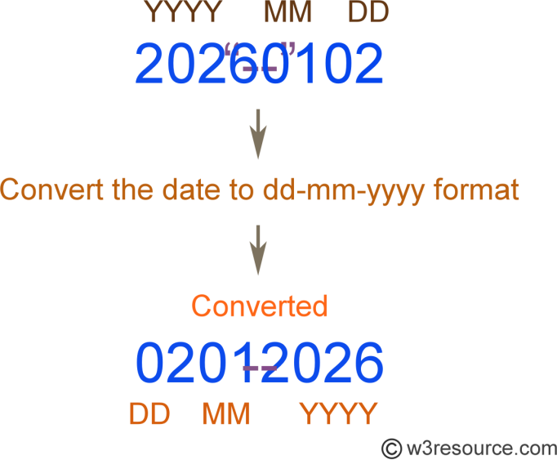

## Q19. What is the difference between Brainstorming and JAD Sessions? 2 Marks

**Ans:**

* Brain storming: brain storming technique contain group of stake holders to give deep thought about particular topic. This technique basically useful in developing new ideas.
* JAD: JAD is conducted by bringing Stake holder and developer together at same place. JAD provide high accurate level of

requirement. Though JAD are conducted for different types purpose in SDLC JAD is Mostly conducted in two Ways, one is as eliciting technique and second is to clarify development teams doubts.

* Brainstorming: group discussion among stakeholders to collect ideas to include the relevant requirements.
* JAD session: the session conduct among selected stakeholders (business client system developer) to get more refined requirements.
* Brainstorming: Brainstorming can be done either individually or in groups. The ideas collected can then be reviewed/analyzed and where relevant included within the system requirements.
* JAD technique is an extended, facilitated workshop. It involves collaboration between stakeholders and systems analysts to

identify needs or requirements in a concentrated and focused effort.

* Brain Storming techniques last for about 2-3 hours
* JAD Sessions last for about 2-3 days
* Brain Storming covers all of the mentioned subjects.
* JAD covers technology used for the development.

## Q 20. Why Document Analysis is one of the compulsory techniques we use in a Project? Justify – 2 Marks

**Ans:**

Document Analysis is one of the compulsory elicitation techniques for any project.

Documentation of the system could provide lot of information which may include interface details, user manuals and software vendor manuals. It would be easy to transfer lot of information to a new system requirement document.

we have documentation about the current system which could provide some of the input for the new system requirements. Such documentation could include interface details, user manuals and software vendor manuals

You may have documentation about your current system which could provide some of the input for the new system requirements. Such documentation (if it exists) could include interface details, user manuals, and software vendor manuals.

Could be a lot of information and easy to transfer to a new system requirements document.

Document Analysis is an important gathering technique. Evaluating the documentation of a present system can assist when making AS

-ARE process documents and also when driving the gap analysis for scoping of the migration projects.

## Q21. In Which Context we will use Reverse Engineering? - 2 Marks

**Ans:**

[Reverse engineering](https://www.interaction-design.org/literature/topics/reverse-engineering) is a process that is designed to extract enough data from a product and then to be able to reproduce that product. It may involve moving to creating a product from scratch or from pre-developed components. It can be applied to any product (such as computer technology, manufactured products, biological products, chemical products, etc.) to determine how the components are put together and how it works.

Reverse engineering is a useful design and development technique with many potential applications. However, it is always important to get legal advice prior to conducting reverse engineering exercises and doubly so if you intend the outputs of your reverse engineering to become commercially available. There is no single process across industries for reverse engineering it is simply a process by which you take an end product and deduce how it is made and works.

## Q22. What is the difference between Brainstorming and Focus Groups? - 2 Marks

**Ans:**

Here are the main differences between the two techniques:

|  |  |  |
| --- | --- | --- |
|  | Brainstorming | Focus Group |
| Purpose | Generate ideas | Improve existing ideas |
| Trigger | A need to solve a problem | A need to study an existing ide solution or process |
| Condition | Problem exists | Idea, solution or process exist |
| Setup |  |  |
| Number of participants | 6 - 8 | 6 - 12 |
| Participant types | Heterogeneous | Can be homogeneous or heterogeneous |
| Person running the show | Facilitator | Skilled moderator |
| Knowledge of topic of discussion | Not necessary | In depth knowledge of topic of discussion |
| Guide | Develop criteria for evaluating and rating ideas | Create a discussion guide and moderator scripts |
| Game Time |  |  |
| Ground rules | Must have | Nice to have |
| Duration | Restrict time to produce ideas  1 – 2 hrs. | 1 – 2 hrs. and sometimes over several days |
| Type of questions to ask | Progressive closed- ended to generate and build on ideas | Can be open-ended to genera qualitative data or closed-end to generate quantitative data |
| Observers | No | Yes |
| Result | List of ideas combined to form themes | Report of findings Could be   * bullet list of information learns * comparative analysis between to solutions |

|  |  |  |
| --- | --- | --- |
|  |  | - summary of response collected for each question |

## Q23. Observation Technique – Explain both Active and Passive approaches - 2 Marks

**Ans:**

Business analysts use observation techniques to gather information by watching and understanding workplace activities.

It is used to identify needs and opportunities, understand business processes, create performance standards, assess solution performance, and facilitate training and development.

Observation of activities or job shadowing, is the act of studying a work activity as it is being performed. It can be performed in either the user’s work environment or in a recreated test environment.

There are two approaches for observation and they are:

* **Active/noticeable**: while observing an activity the observer can ask any questions as they occur. Despite this interruption to the workflow, the observer can quickly understand the reasoning

and any undocumented processes within the activity.

* **Passive/unnoticeable**: in this approach, the observer does not interrupt the work while the user is performing the work activity. Any questions would be asked once the observation is over. This

allows a natural flow of events to be observed without interference by the observer, as well as the measurement of the time and quality of work.

## Q24. How do you conduct the Requirements Workshop- 2 Marks

Ans:

* This is a structured meeting with the specific goal of capturing requirements. It is used to define, prioritize and hopefully finalize

requirements for the new initiative that you’re working on. Requirements workshops typically last between one and a few days. They should also be a highly focused event that is let by a seasoned facilitator. Some benefits and disadvantages of the requirements workshop are identified in the following table:

|  |  |
| --- | --- |
| Benefits | Disadvantages |
| * Get to a set of meaningful   stated requirements in a  short,  intensive session. Having the | * There can be a lot of time,   coordination  and finances required.   * Getting the right resources in |

|  |  |
| --- | --- |
| right stakeholders involved that will allow for a much easier buy-in.   * Requirements are considered, discussed, and understood before going to   final approvals | the same room, at the same time with the proper authority to speak on the subject matter.   * You may have to run several workshops |

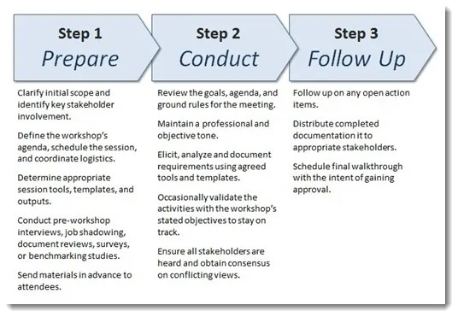

## Q25. In which context, Interview Technique can be conducted by a BA? How may approaches are there in conducting Interviews? (Structured – Unstructured) Explain them. Explain the difference between Open Ended Questions and Closed ended Questions – 4 Marks

**Ans:**

Interview Technique can be used to verify the facts, clarify ambiguity, trigger enthusiasm, engage end users, identify requirements, and the opinions and ideas. It is used to get more information from the people in a formal or informal setting by asking questions and documenting the responses.

It involves direct communication with the individuals or a group of people who are part of an initiative. There are two basic types of interviews. They are,

* **Structured Interview** - in which the interviewer has the predefined set of questions. It is a structured way of interview.
* **Unstructured Interview** - in which the interviewer does not have the predetermined set of questions and it may vary based on the stakeholder responses and interactions.
* **Open Ended Questions** - Open-ended questions are those that provide respondents with a question prompt and provide them a space in which to construct their own response
* ***Closed-ended questions*** Often the answer is a single word (e.g. Yes or No) or less commonly a short phrase. You are not looking

for an explanation or an elaboration to the question in the answer given to the question.

## Q26. Questionnaire Technique – Where we will use? Give one example - 3 Marks

**Ans:**

A questionnaire is a research instrument that consists of a set of questions or other types of prompts that aims to collect information from a respondent. A research questionnaire is typically a mix

of close-ended questions and open-ended questions.

Open-ended, long-form questions offer the respondent the ability to elaborate on their thoughts. The data collected from a data collection questionnaire can be both [qualitative](https://www.questionpro.com/blog/qualitative-market-research/) as well

as [quantitative](https://www.questionpro.com/blog/quantitative-market-research/) in nature. A questionnaire may or may not be delivered in the form of a [survey](https://www.questionpro.com/blog/surveys/), but a survey always consists of a questionnaire.

A survey or questionnaire is used to elicit business analysis information including information about the customers, products, work practices, and attitudes from a group of people in a structured way and in relatively short period of time.

Surveys are the preferred elicitation technique when faced with a large number of stakeholders or when stakeholders are geographically dispersed and you need to gather the same information from them.

## Examples:

1. How many times have you visited [website] in the past month? None

Once

More than once

1. What is the primary reason for your visit to [website]? To make a purchase

To find more information before making a purchase in-store to contact customer service

1. Who did you purchase these products for?

* Self
* Family member
* Friend
* Colleague
* On behalf of a business
* Other

## Q27. How to Sort the Requirements – Where we will use? Give one example - 3 Mark

Ans

When all the requirements are gathered there are chances of redundancy in those requirements so basically all the scattered requirements are put together and the repetition of requirements are removed which is known as sorting of requirements. The process for sorting is:

1. Identification of requirements.
2. Dividing the identified requirements into functional and nonfunctional requirements
3. If identified requirements are similar then they are put together and removed.

We will sort the requirements in two ways such as functional requirements and Non-Functional requirements.

* + Functional requirements define a function that a system or system element must be qualified to perform and must be documented in different forms. The functional requirements

describe the behavior of the system as it correlates to the system's functionality.

Examples of functional requirements are authentication, business rules, audit tracking, certification requirements, transaction corrections, etc.

* + Non-functional requirements are not related to the software's functional aspect. They can be the necessities that specify the criteria that can be used to decide the operation instead of

specific behaviors of the system.

* + Examples - usability, reliability, security, storage, cost, flexibility, configuration, performance, legal or regulatory requirements, etc.

## Q28. Priorities the Requirements – –Where we will use? Give one example - 3 Marks

**Ans:**

Large software systems have a few hundred to thousands of requirements. Neither are all requirements equal nor do the implementation teams have resources to implement all the documented requirements. There are several constraints such as limited resources, budgetary constraints, time crunch, feasibility, etc., which brings in the need to prioritize requirements.

Most customers on their part have a reasonable idea of what they need and what they want. But during requirements elicitation the customer provides the Business Analyst (BA) with all the requirements that he feels will make his work easier. The customer is not wrong on his part; the BA needs to understand the needs of the business to prioritize the requirements

Most requirements are interdependent and you will hardly find any requirement that exists independently. To understand why we need a dependency map – let us take a scenario where you have 8 requirements X,Y,Z,P,Q,R,M,O and N with priorities, on a 5- level scale where 1 is most critical and 5 least critical, as 1,2,1,4,5,1,2,2,3. So, with these priorities it would be logical to begin with requirements X, Z and R

1. MoSCoW – This prioritization technique was developed by Dai Clegg of Oracle UK Consulting. it is one of the more widely used techniques for its simplicity and ease of use. The letters of the word MoSCoW stand for Must, Should, Could and Won’t.
   * Must have (or Minimum Usable Subset) – These are features that must be included before the product can be launched.
   * Should haves be features that are not critical for the launch, but are considered to be important and of a high value to the user.
   * Could haves be features that are nice to have and could potentially be included without incurring too much effort or cost
   * Won’t have - are features that have been requested but are explicitly excluded from scope for the planned duration and may be included in a future phase of development.

MoSCoW method works better than the numeric rating system as it is much easier for the stakeholders to rate the requirements as Must, Should, Could or Would.

## MUST (M)

Defines a requirement that has to be satisfied for the final solution to be acceptable **e.g**. The HR system “must” store employee leave history.

## SHOULD (S)

This is a high-priority requirement that should be included, if possible, within the delivery time frame. Workarounds may be available for such requirements and they are not usually considered as time-critical or must-haves. **e.g**. The HR system “should” allow printing of leave letters.

## COULD (C)

This is a desirable or nice-to-have requirement (time and resources permitting) but the solution will still be accepted if the functionality is not included **e.g.** The HR system “could” send out notifications on pending leave dates.

## WON’T or WOULD (W)

This represents a requirement that stakeholders want to have, but have agreed will not be implemented in the current version of the system. That is, they have decided it will be postponed till the next round of developments **e.g**. The HR system “won’t” support remote access but may do so in the next release.

## Q29. Weekly status reporting – How we will drive? 2 Mark Ans:

A weekly status report, also known as a weekly check-in, is a communication tool that project managers use to keep tabs on their employees' work experiences. While a team lead can do a weekly status report in person, it's easier to do it online.

A weekly status report is a complete overview of your week at work, covering projects you've completed, ones that are still in progress and upcoming plans for the future.

A weekly report is a review of your workweek and provides a summary of what you completed, what projects are in progress and plans that outline your workflow for the next week. Typically, weekly reports are brief and concise and only one page long. Most professionals send weekly reports on Friday afternoons to establish consistent communication with team members and supervisors.

Additionally, a weekly report can benefit both you and your employer by providing insight into important aspects of the work you complete.

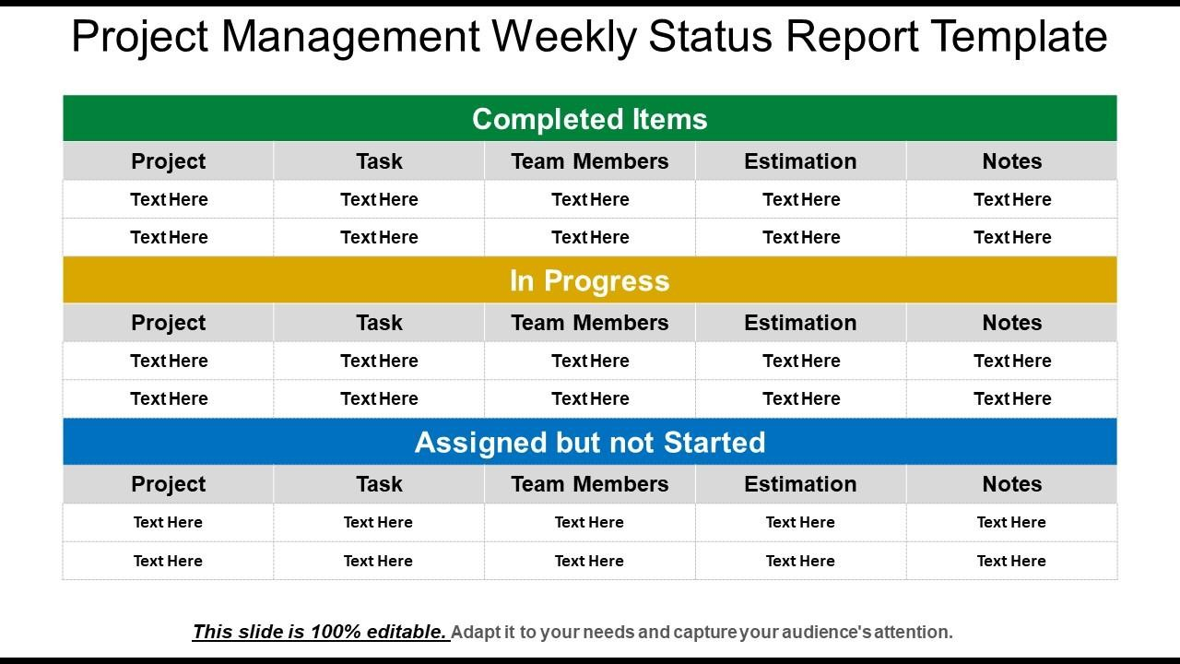

## Q30. Meeting Minutes Document – prepare one Sample -2 Mark

**Ans:**

Minutes is to create an official record of the actions taken at a Meeting. Minutes serve to both memorialize the actions taken for those attending the Meeting as well as for those who were unable to attend the Meeting.

Meeting minutes are notes that are recorded during a meeting. They highlight the key issues that are discussed, motions proposed or voted on, and activities to be undertaken.

**MEETING AGENDA**

|  |  |  |  |
| --- | --- | --- | --- |
| **Meeting/Project t Name:** | **Sprint Review Meeting** | | |
| **Date of Meeting: (MM/DD/YYYY)** | **23.01.2023** | **Time:** | **09:30** |
| **Meeting Facilitator:** | **Business Analyst** | **Location:** | **Pune** |

**1. Meeting Objective**

1. Discuss status of sprints
2. Discuss progress report of project
3. Discuss about impediments if any.
4. Suggest Solutions

|  |  |  |  |
| --- | --- | --- | --- |
| **2. Attendees** | | | |
| **Name Department/Divisi E-mail Phone on** | | | |
| Harshad Karate | Development Team | [Harshad.kharate@yahoo.com](mailto:Harshad.kharate@yahoo.com) | xxxxxxxxxx |
| Rajendra Kharate | Technical Team | XXXXXXXXXXX | XXXXXXXX |
| Rakesh | Business Analyst | XXXXXXXXXXX | XXXXXXXX |
|  |  |  |  |

|  |  |  |
| --- | --- | --- |
| **3. Meeting Agenda** | | |
| **Topic** | **Owner** | **Time** |
| Decision about the actions n sprints | Development Team |  |
| Decision on WIP items | Development Team |  |
|  |  |  |
|  |  |  |

## Q31. Change Tracker – Document - – prepare one Sample -2 Mark

**Ans:**

The role of BA in change request is very important as the change requests differ in number and complexity across business projects and may come in before, during or after implementation of a solution.

Below are the steps to follow

-->Understand the reason for the change

-->Understand the impact of the change

-->Understand the effort required to implement the change

-->Ensure that the change request follows the predetermined approval process

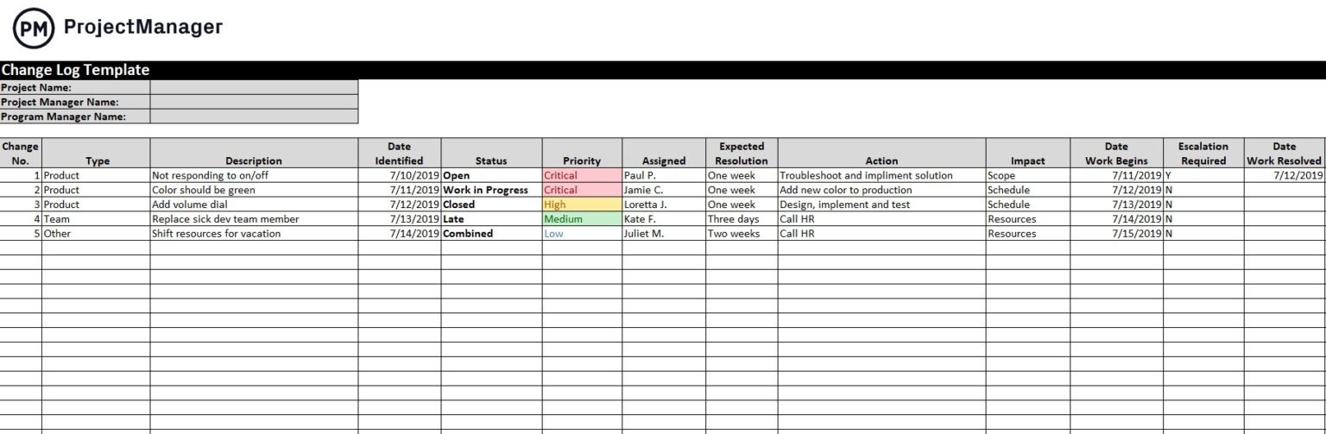

**Q32. Difference between Traditional Development Model and Agile Development Models – 5 Marks**

**Ans:**

**Traditional model:**

* Used to develop Simple Software
* In this testing is done once the development phase is totally completed
* It provides less security
* It provides less functionality in the software
* It supports fixed development model
* Development cost is less
* It consists of five phases
* Expectation is favored in the traditional model
* product delivered at the end of the project
* It is rigid to accept the change
* Models based on traditional software development- spiral, waterfall, V model, incremental model.

Traditional project management focuses on the linear approach. In the agile world, this project management approach is often known as the? waterfall approach.? In the traditional method, all the project phases are completed in sequential order. This rigid, top-down approach contains some fixed stages, such as plan, design, build, testing, user acceptance, deployment, release, etc. Unlike agile, traditional project management plans everything beforehand and not empirically.

In this approach, requirements are fixed, and budget and time get agreed on earlier. For this reason, teams often face budget and timeline problems with this approach. You can’t use traditional project management to develop complex products, as this approach leaves no room for changing the requirements. However, studies suggested that the waterfall or traditional approaches failure rate is nearly 21% while the agile failure rate is 8%.

## Agile model:

* It is used to develop complicated software
* In this testing and development process are performed concurrently
* it provides less high security
* It provides all functionality needed by the users
* It is used by professionals
* It supports changeable development model
* Development cost is higher
* It consists only three phases
* Adaptability is favored in the agile methodology
* Product delivered frequently within couple of weeks to couple of moths
* Change accepted even in late development stage
* Model based on agile software development - Scrum, XP, Crystal, Dynamic systems development method (DSDM), feature driven development (FDD), Adaptive software development (ASD)

Agile Project Management:

In agile project management, projects are time-boxed in short iterations. The iteration lasts for a maximum of a calendar month. And after each iteration, you’ll get a new releasable product increment. Agile project management focuses more on implementing the clients feedback and reviewing the product periodically. Customer collaboration is a vital factor in agile. It doesn’t follow a plan blindly and responses to changes quickly.

Today, agile methodology comes with different methods and frameworks for project management. For example, Scrum, Kanban, Less, Safe, and Scrumban are great examples of popular agile project management methods. These methods are the perfect choices for preventing time consumption, increasing customer satisfaction, and encouraging decision-making at every product development step. Initially, agile project management was considered for the software development industry and, in recent times, successfully implemented in other sectors like architecture, financial services, marketing, etc.

## Q33. Explain Brainstorming Technique – Where to use? 2 Marks

**Ans:**

The basic idea behind brainstorming is to find a conclusion for a specific problem by gathering a list of

ideas spontaneously contributed by its member(s).

In other words, brainstorming is a situation where a group of people meet to

generate new ideas and solutions around a specific domain of interest by removing inhibitions

These meetings are used for solving a process problem, inventing new products or product innovation, solving inter-group communication problems, improving customer service, budgeting exercises, project scheduling, etc.

1. Nominal group technique: In this technique Participants are asked to write their ideas anonymously. Then the facilitator collects the ideas and the group votes on each idea. The vote can be as simple as a show of hands in favor of a given idea. This process is called distillation.
2. Group passing technique: In this technique Each person in a circular group writes down one idea, and then passes the piece of paper to the next person, who adds some thoughts. This continues until everybody gets his or her original piece of paper back. By this time, it is likely that the group will have extensively elaborated on each idea.
3. Team idea mapping method: This method of brainstorming works by the method of association. It may improve collaboration and increase the quantity of ideas, and is designed so that all attendees participate and no ideas are rejected.
4. Directed brainstorming: Directed brainstorming is a variation of electronic brainstorming (described below). It can be done manually or with computers. Directed brainstorming works when the solution space (that is, the set of criteria for evaluating a good idea) is known prior to the session.

There are many other techniques as well. Most important thing is you have to decide which technique is most suitable for your team

You can use brainstorming throughout any design or work process, of course, to generate ideas for design solutions, but also any time you are trying to generate ideas, such as planning where to do empathy work, or thinking about product and services related to your project.

Brain storming: It is a creative technique to find a solution or to understand the need or requirement by a group of people. As a BA, by using brainstorming, we can gather the ideas and can creative solutions for problems in short time.

The steps involved in brainstorming

1. Prepare for brainstorming: start a clear and concise objective for the session. Generate as many ideas as possible and don’t limit the creative ideas instead limit the time for session. Decide who all are going to include in session and their role like participant or facilitator.
2. Conduct brainstorming session: Share new ideas without any discussion, criticism or evaluation. Record or note down all ideas.
3. Wrap up the brainstorming: once the time limit is reached create a list of ideas and eliminate the duplicates. Rate the ideas and prioritize the ideas using voting and distribute the final list of ideas.

**Q34. What reports Accounts Departments will generate (minimum 5 reports) – 5 Marks**