**QUESTION- 1 FUNCTIONAL REQUIRMENTS:-**

**Functional Requirements:** Functional Requirement describes capabilities the system will be able to perform in terms of behavior or operations.

Functional Requirements are those the system needs to perform all those actions which come in the development of the application are considered as functional requirement.

|  |  |  |  |
| --- | --- | --- | --- |
| S.NO | Req ID | Req Name | Req Description |
| 1. | FR0001 | User Registration | Users should able to register with the application |
| 2. | FR0002 | Login | Users should able to login |
| 3. | FR0003 | Search of products | Users able to search the available products |
| 4. | FR0004 | Selection of products | Users able to select the searched products |
| 5. | FR0005 | Adding product to wish list | Users able to add the product to wishlist |
| 6. | FR0006 | Adding product to cart | Users able to add the product to cart |
| 7. | FR0007 | Adding Address | Users able to add the address for product delivery with valid pincode |
| 8. | FR0008 | Mode of Payment | Users able to make the payment with different modes |
| 9. | FR0009 | Select Payment Method | Users able to select the payment for payment confirmation |
| 10. | FR0010 | Confirmation order | User able to check the order status |
| 11. | FR0011 | Tracking of order | Users able to track the order with the help of tracking id |

**Non – Functional Requirements:**

Non- Functional Requirement don’t directly relate to the behavior or functionality of the solution, but rather describes environmental conditions under which the solution must remain effective like capacity, speed, security etc.

Define in terms of Performance, scalability, portability ,compatibility , reliability ,availability , maintainability, security, localization and usability.

|  |  |  |  |
| --- | --- | --- | --- |
| **S.NO** | **Req ID** | **Req Name** | **Req Description** |
| 1. | NFR001 | Performance | System should handle at least 500concentrent users |
| 2. | NFR002 | scalability | The platform should support future growth, without performance loss |
| 3. | NFR003 | security | Implement two factor authentication(2FA) for seller and admin |
| -  0084. | NFR004 | Usability | The website should be simple with accessibility features like screen reader and high contrast modes. |
| 5. | NFR005 | Availability | System should have 99.9% uptime ensure minimal downtime. |
| 6. | NFR006 | Maintainability | Allowing for easy updates and bug fixes |
| 7. | NFR007 | Backup & Recovery | Data backup should be automatically taken every 24 hours and stored securely for disaster recovery |
| 8. | NFR008 | Compatibility | System should be compatible with All major web browsers and mobile devices |
| 9. | NFR009 | Response time | Website should load with 2 seconds for 90% of users even during peak hours. |

**QUESTION-2 MINIMUM 5 PAGES DESINGS:**

**Wireframes:** A **wireframe** is a low-fidelity, simplified visual representation of a web page, app, or product interface. It outlines the structure, layout, and key elements without including detailed design elements like colors, images.

**Prototypes :** A **prototype** is a sample or early version of a product used to test how it works. It’s like a rough draft that helps improve the final version before it’s fully made. It can range from a clickable wireframe to a fully interactive model .

**Make wireframes and prototypes**

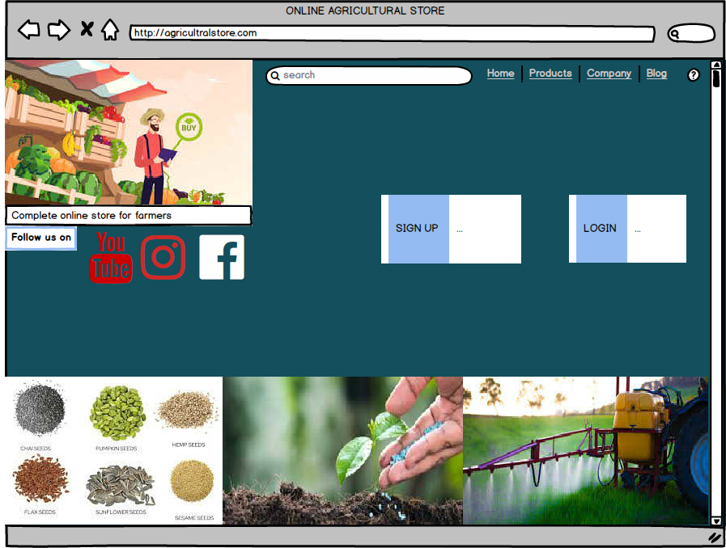

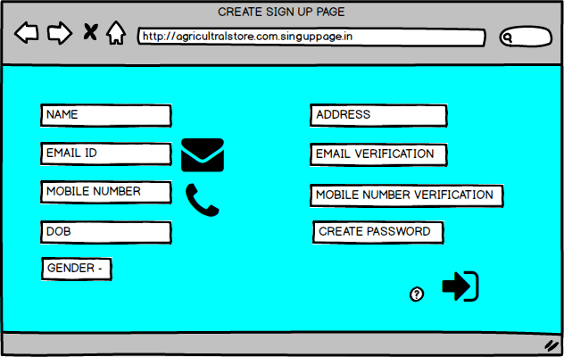

**[\**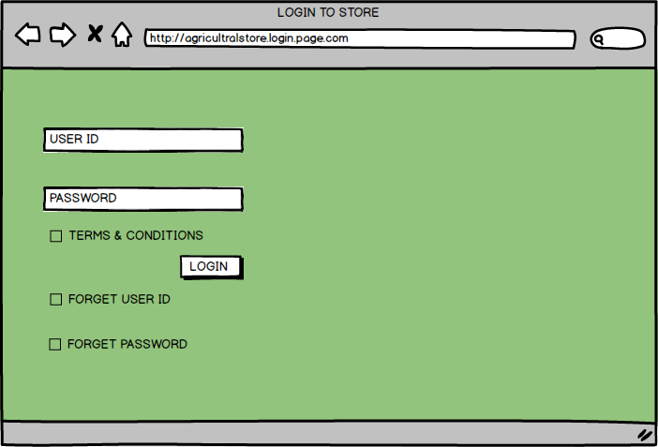

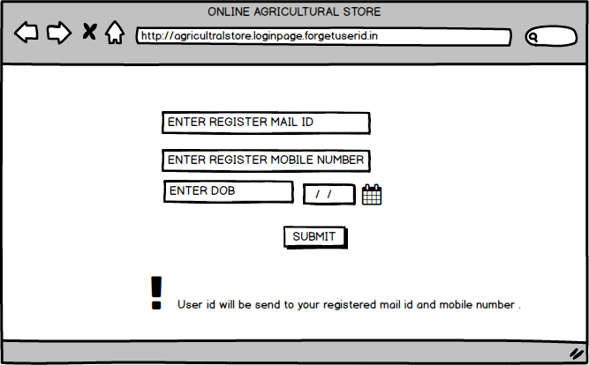

**op**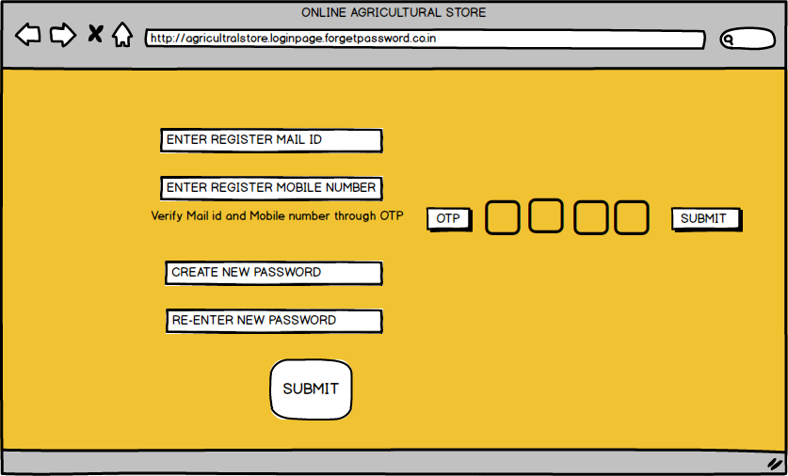

**]**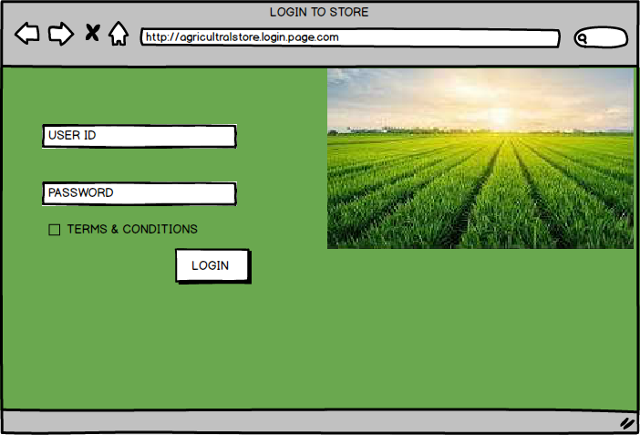

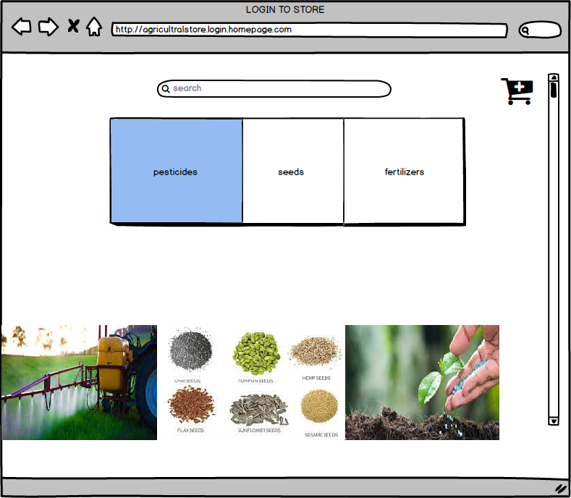

**‘-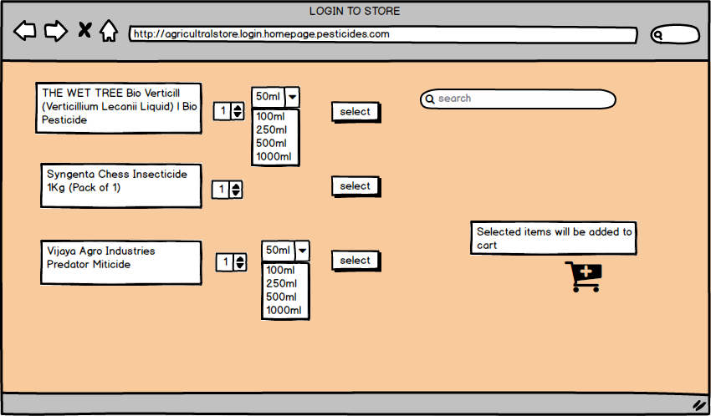\**

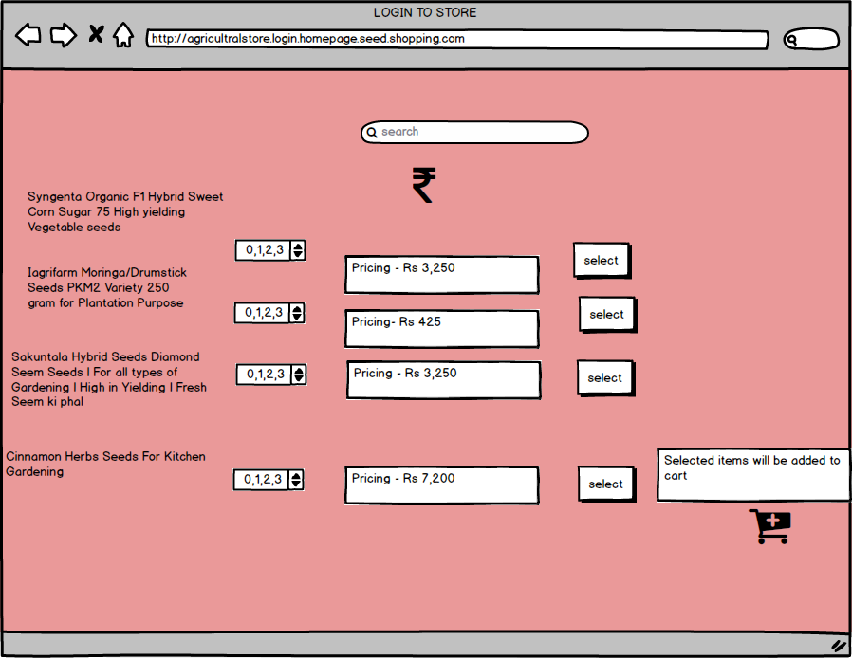

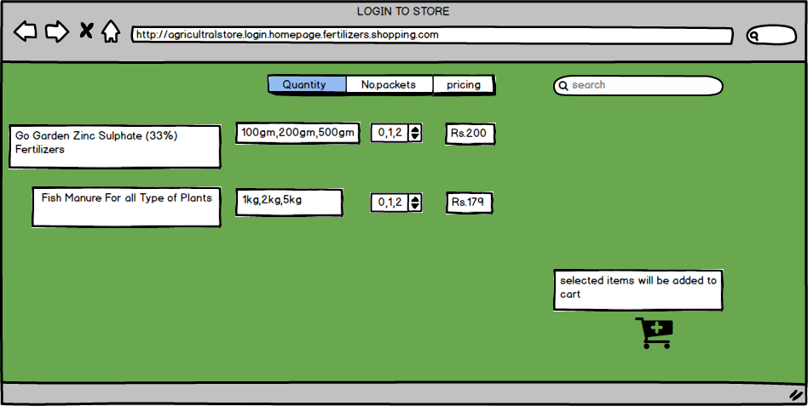

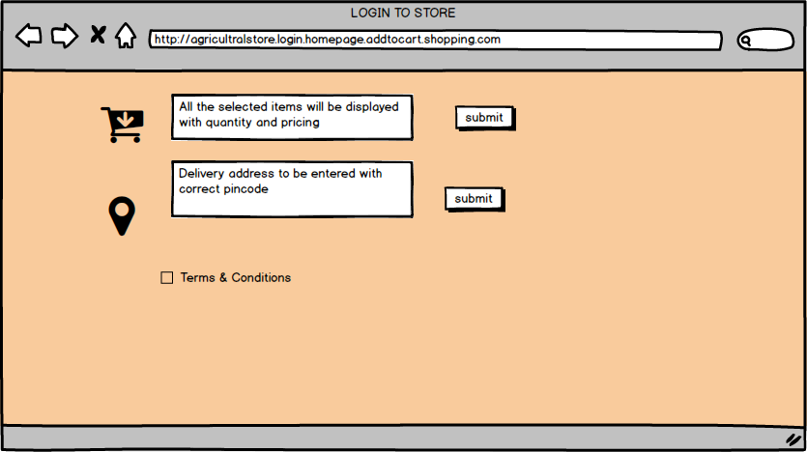

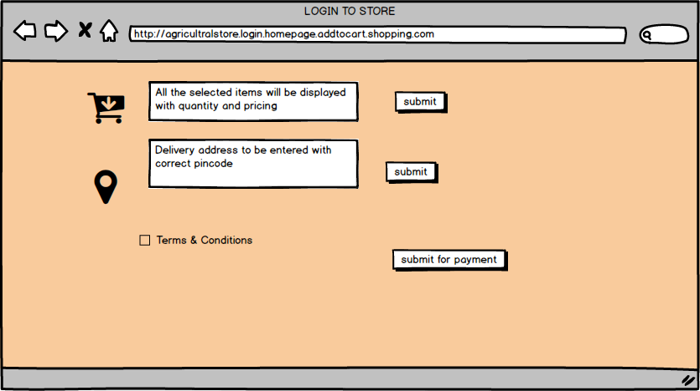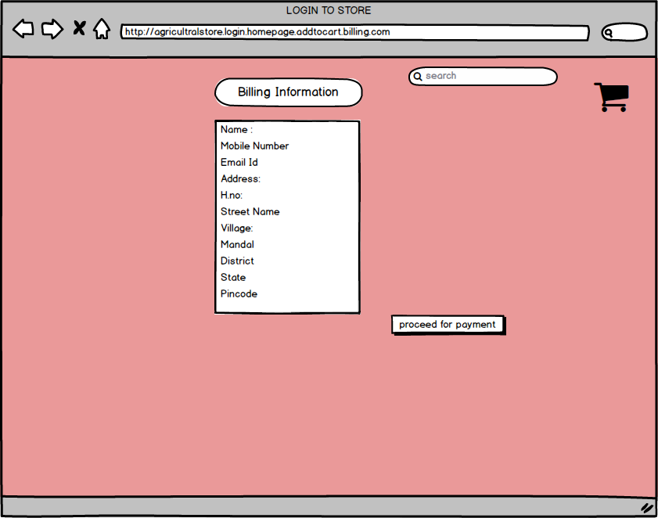

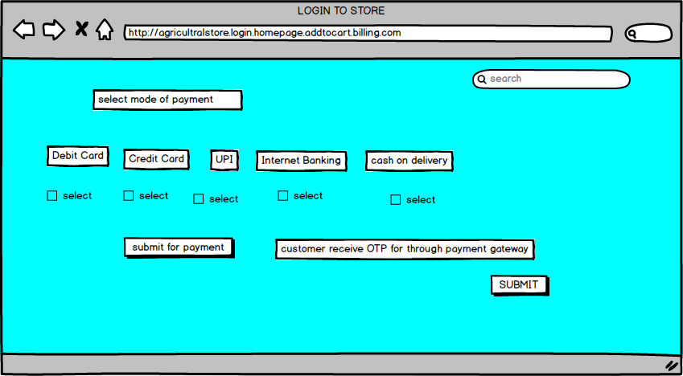

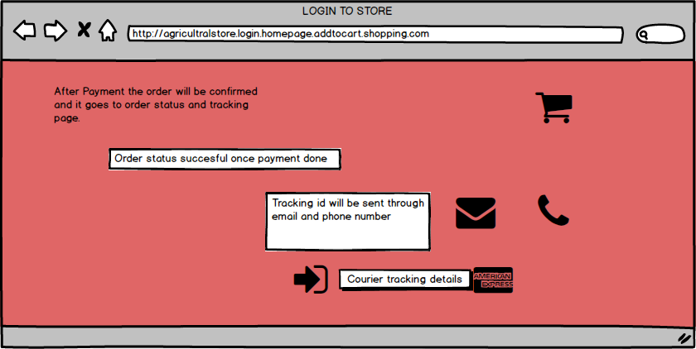

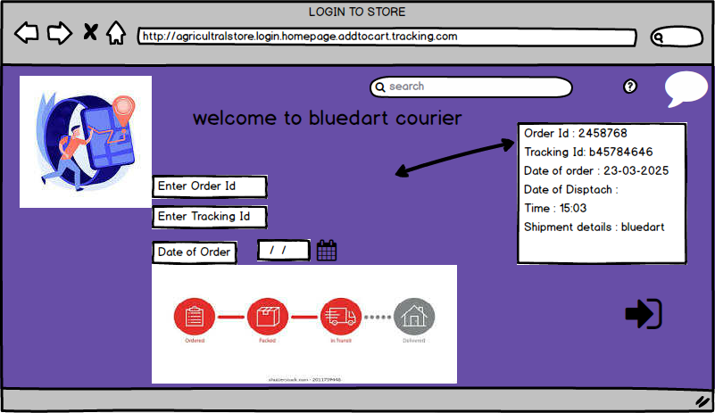

**QUESTION-3 TOOLS (VISIO, BALSAMIQ):**

**Balsamiq :**

Balsamiq is basically a design tool that is created by one of the ex-employee of adobe.

The main purpose of this tool to create wireframes /mockups. Wireframes/mockups means showing the application or the front end of the application in a very simple manner.

**Example :** A client approaches and explain about the project thoughts and their products which they want. We will gather the requirements and we create the dummy models / dummy representation of the pages. They look like real or end of the product or end of the application.

**MS VISIO :**

Microsoft Visio is a powerful diagramming tool used for creating various types of visual representations, such as flowcharts, organizational charts, network diagrams, and floor plans.

It consists of Shapes, connectors, text tools, grid , layers, formatting tools, templates, data linking, collaboration & sharing, export and save options.

**QUESTION-4 RTM:**

Requirement Traceability Matrix is a kind of tool which provide traceability from a requirement towards solutioning .

* It is a matrix used to trace requirements.
* The main usage of RTM are to ensure that all the business requirements are developed, tested and delivered.
* It helps faster impact analysis and reliable assessment.

|  |  |  |  |  |  |  |  |  |  |  |  |
| --- | --- | --- | --- | --- | --- | --- | --- | --- | --- | --- | --- |
|  | |  | | --- | |  | |  |  | Functional Requirements |  | Design |  | code |  | test case |
| Business Requirements |  | Stake Holder Requirements |  |  |  |  |  |  |  |  |
|  |  |  |  | Non-Functional Requirements |  |  |  |  |  |  |
|  |  |  |  |  |  |  |  |  |  |  |

|  |  |  |  |  |  |  |  |  |  |
| --- | --- | --- | --- | --- | --- | --- | --- | --- | --- |
| **Req Id** | **Req Name** | **Req Description** | **Design** | **Code** | **Unit Testing** | **Component Testing** | **System Testing** | **SIT** | **UAT** |
| FR0001 | User Registration | Users should able to register with the application | completed | completed | completed | completed | completed | completed | completed |
| FR0002 | Login | Users should able to login | completed | completed | completed | completed | completed | completed | completed |
| FR0003 | Search of products | Users able to search the available products | completed | completed | completed | completed | completed | completed | completed |
| FR0004 | Selection of products | Users able to select the searched products | completed | completed | completed | completed | completed | completed | completed |
| FR0005 | Adding product to wish list | Users able to add the product to wishlist | completed | completed | completed | completed | completed | completed | completed |
| FR0006 | Adding product to cart | Users able to add the product to cart | completed | completed | completed | completed | completed | completed | completed |
| FR0007 | Adding Address | Users able to add the address for product delivery with valid pincode | completed | completed | completed | completed | completed | completed | completed |
| FR0008 | Mode of Payment | Users able to make the payment with different modes | completed | completed | completed | completed | completed | completed | completed |
| FR0009 | Select Payment Method | Users able to select the payment for payment confirmation | completed | completed | completed | completed | completed | completed | completed |
| FR0010 | Confirmation order | User able to check the order status | completed | completed | completed | completed | completed | completed | completed |
| FR0011 | Tracking of order | Users able to track the order with the help of tracking id | completed | completed | completed | incomplete | completed | completed | completed |

**QUESTION-5 10 TEST CASE DOCUMENTS:**

**Test Case Document:** A Test Case Document is a detailed outline used by the testers to ensure that a software application or system is working as expected.

Who will prepare the Test Case Document?

Test Managers and Senior Test Managers will prepare Test Case Document.

In Test Case Document we have 3 sections –

* **CONTROL INFORMATION**
* **THE SCENARIO**
* **THE TEST DATA**

**TEST CASE DOCUMENT -1**

|  |  |  |  |
| --- | --- | --- | --- |
| Test Case Id | PQ1234TS001 | Test Case Name | **User Registration** |
| Project ID | PQ03062023 | Project Name | Online Agriculture Product Store |
| PM ID | 388190 | PM Name | Mr. Vandanam |
| Test Strategy ID | PQ110724 | Tester Id |  |
| Test plan ID | PQ110724 | Tester Name |  |
| Test Schedule ID | PQ110724 | Date of Test |  |

|  |
| --- |
| **Scenario:** Before browsing on online agriculture product store user has to register with the site using their Name, valid email id, mobile number and addresses. |

|  |  |  |  |
| --- | --- | --- | --- |
|  | Set-1 | Set-2 | Set-3 |
| Input Data | 1.Enter name of the customer  2.Enter Valid mobile number  3. Enter valid mail id | 1.Enter name of the customer  2.Enter Invalid mobile number  3. Enter valid mail id | 1.Enter name of the customer  2.Enter Valid mobile number  3. Enter Invalid mail id. |
| Expected Behavior | User has to register with site by verifying email id and mobile number | User mobile number was not verified with the site | User mail id was not verified with the site |
| Actual Behavior | Successfully Registration | Unsuccessful Registration | Unsuccessful Registration |
| Comments | Mobile number and email id should be verified | Mobile number and email id should be verified | Mobile number and email id should be verified |
| Results Pass/ Fail | Pass | Fail | Fail |

**TEST CASE DOCUMENT -2**

|  |  |  |  |
| --- | --- | --- | --- |
| Test Case Id | PQ1234TS001 | Test Case Name | **User Registration login to portal.** |
| Project ID | PQ03062023 | Project Name | Online Agriculture Product Store |
| PM ID | 388190 | PM Name | Mr. Vandanam |
| Test Strategy ID | PQ110724 | Tester Id |  |
| Test plan ID | PQ110724 | Tester Name |  |
| Test Schedule ID | PQ110724 | Date of Test |  |

|  |
| --- |
| **Scenario:** To validate the User by using their registration id like mobile number and mail id like login to the site with the help of their id’s. |

|  |  |  |  |
| --- | --- | --- | --- |
|  | Set-1 | Set-2 | Set-3 |
| Input Data | 1.Enter valid login id- [merugxxxxxxxx@gmail.com](mailto:merugxxxxxxxx@gmail.com)  2.Enter valid Password- Naxxxxxxxx  3. Click on login | Enter valid login id- [merugxxxxxxxx@gmail.com](mailto:merugxxxxxxxx@gmail.com)  2.Enter Invalid Password- Baxxxxxxxx  3. Click on login | Enter Invalid login id- [merugxxxxxxxx@gmail.com](mailto:merugxxxxxxxx@gmail.com)  2.Enter valid Password- Naxxxxxxxx  3. Click on login |
| Expected Behavior | User will check internal like valid user id and password and it proceed for login | User will check internal like valid user id and password and it proceed for login , it was password error it shows the pop up of incorrect password | User will check internal like valid user id and password and it proceed for login , it was user id error it shows the pop up of incorrect user id |
| Actual Behavior | Successful login | Login failed | Login Failed |
| Comments | Valid user id and password | Invalid Password | Invalid Userid |
| Results Pass/ Fail | PASS | FAIL | FAIL |

**TEST CASE DOCUMENT -3**

|  |  |  |  |
| --- | --- | --- | --- |
| Test Case Id | PQ1234TS001 | Test Case Name | **Search of product** |
| Project ID | PQ03062023 | Project Name | Online Agriculture Product Store |
| PM ID | 388190 | PM Name | Mr. Vandanam |
| Test Strategy ID | PQ110724 | Tester Id |  |
| Test plan ID | PQ110724 | Tester Name |  |
| Test Schedule ID | PQ110724 | Date of Test |  |

|  |
| --- |
| **Scenario:** To validate the user with the search of product. |

|  |  |  |  |
| --- | --- | --- | --- |
| **Description** | **Set-1** | **Set-2** | **Set-3** |
| Input Data | Enter valid product name | Invalid product name | Empty search query |
| Expected Behavior | Display a list of matching products | Display “ no products found” message | Display an error page |
| Actual Behavior | Successful search | Error in search | Error in search |
| Comments | Valid search | Invalid search | No search found |
| Results Pass/ Fail | Pass | Fail | Fail |

**TEST CASE DOCUMENT -4**

|  |  |  |  |
| --- | --- | --- | --- |
| Test Case Id | PQ1234TS001 | Test Case Name | **Add Product to cart** |
| Project ID | PQ03062023 | Project Name | Online Agriculture Product Store |
| PM ID | 388190 | PM Name | Mr. Vandanam |
| Test Strategy ID | PQ110724 | Tester Id |  |
| Test plan ID | PQ110724 | Tester Name |  |
| Test Schedule ID | PQ110724 | Date of Test |  |

|  |
| --- |
| **Scenario:** To validate the user with the search of product and to add the product to cart . |

|  |  |  |  |
| --- | --- | --- | --- |
| **Description** | **Set-1** | **Set-2** | **Set-3** |
| Input Data | Valid Payment Details | Expired Card | Empty Payment Fields |
| Expected Behavior | Payment Successful | Show 'Card Expired' message | Prompt to enter payment details |
| Actual Behavior | Product added to cart successfully | 'Out of stock' message displayed | 'Invalid quantity' error displayed |
| Comments | na | na | na |
| Results Pass/ Fail | pass | pass | pass |

**TEST CASE DOCUMENT -5**

|  |  |  |  |
| --- | --- | --- | --- |
| Test Case Id | PQ1234TS001 | Test Case Name | **Apply Discount Coupon** |
| Project ID | PQ03062023 | Project Name | Online Agriculture Product Store |
| PM ID | 388190 | PM Name | Mr. Vandanam |
| Test Strategy ID | PQ110724 | Tester Id |  |
| Test plan ID | PQ110724 | Tester Name |  |
| Test Schedule ID | PQ110724 | Date of Test |  |

|  |
| --- |
| **Scenario:** To validate the user with add to cart and applying discount coupon on billing amount |

|  |  |  |  |
| --- | --- | --- | --- |
| **Description** | **Set-1** | **Set-2** | **Set-3** |
| Input Data | Valid Coupon Code | Expired Coupon | Invalid Coupon Code |
| Expected Behavior | Apply discount successfully | Show 'Coupon Expired' message | Show 'Invalid Coupon' message |
| Actual Behavior | Discount applied successfully | 'Coupon Expired' message displayed | 'Invalid Coupon' message displayed |
| Comments | na | na | na |
| Results Pass/ Fail | pass | pass | pass |

**TEST CASE DOCUMENT -6**

|  |  |  |  |
| --- | --- | --- | --- |
| Test Case Id | PQ1234TS001 | Test Case Name | **Checkout process** |
| Project ID | PQ03062023 | Project Name | Online Agriculture Product Store |
| PM ID | 388190 | PM Name | Mr. Vandanam |
| Test Strategy ID | PQ110724 | Tester Id |  |
| Test plan ID | PQ110724 | Tester Name |  |
| Test Schedule ID | PQ110724 | Date of Test |  |

|  |
| --- |
| **Scenario:**  To Validate the Checkout process by ensuring a smooth order placement, payment processing and confirmation. |

|  |  |  |  |
| --- | --- | --- | --- |
| **Description** | **Set-1** | **Set-2** | **Set-3** |
| Input Data | Valid payment details | Expired card | Empty payment fields |
| Expected Behavior | Payment should be successful and order confirmation should be displayed | System shows error as expired card | System should prompt user to enter payment details |
| Actual Behavior | Payment successful and order confirmed | System displayed card expired error | System should prompt user to enter payment details |
| Comments | Payment gateway working fine | Handled correctly | No payment details found |
| Results Pass/ Fail | pass | pass | pass |

**TEST CASE DOCUMENT -7**

|  |  |  |  |
| --- | --- | --- | --- |
| Test Case Id | PQ1234TS001 | Test Case Name | **Order Tracking** |
| Project ID | PQ03062023 | Project Name | Online Agriculture Product Store |
| PM ID | 388190 | PM Name | Mr. Vandanam |
| Test Strategy ID | PQ110724 | Tester Id |  |
| Test plan ID | PQ110724 | Tester Name |  |
| Test Schedule ID | PQ110724 | Date of Test |  |

|  |
| --- |
| **Scenario:**  To verify that users can view their **order history** |

|  |  |  |  |
| --- | --- | --- | --- |
| **Description** | **Set-1** | **Set-2** | **Set-3** |
| **Input Data** | Registered user with past orders | Registered user with no orders | Unregistered user |
| **Expected Behavior** | Display list of past orders with details. | Show a message: "No orders found". | Show a login prompt. |
| **Actual Behavior** | Past orders displayed correctly. | "No orders found" message appeared. | System prompted the user to log in. |
| **Comments** | Order history retrieval working fine. | No orders case handled properly. | Non-logged-in user validation works. |
| **Results (Pass/Fail)** | Pass | Pass | Pass |

**TEST CASE DOCUMENT -8**

|  |  |  |  |
| --- | --- | --- | --- |
| Test Case Id | PQ1234TS001 | Test Case Name | Product Review & Rating |
| Project ID | PQ03062023 | Project Name | Online Agriculture Product Store |
| PM ID | 388190 | PM Name | Mr. Vandanam |
| Test Strategy ID | PQ110724 | Tester Id |  |
| Test plan ID | PQ110724 | Tester Name |  |
| Test Schedule ID | PQ110724 | Date of Test |  |

|  |
| --- |
| **Scenario:** To validate that users can **submit, edit, and view product reviews and ratings**. |

|  |  |  |  |
| --- | --- | --- | --- |
| **Description** | **Set-1** | **Set-2** | **Set-3** |
| Input Data | Registered user submit reviews and rating. | Unregistered user tries to submit review | User tried to submit a review without rating |
| Expected Behavior | It should posted successfully | System should prompt the user to log in. | System should show an error message: "Rating is required". |
| Actual Behavior | Review posted successfully | |  | | --- | | ogin prompt appeared. | | |  | | --- | | Error message displayed correctly. | |
| Comments | Works fine | |  | | --- | | Non-logged-in users are restricted. | | |  | | --- | | Validation for missing rating is working. | |
| Results Pass/ Fail | pass | pass | pass |

**QUESTION -6 DB DESIGN:**

**Draw Database schema and ER diagram:**

Database is collection of Tables.

Generally Table will have” Table Name, Entities and Data Record”.

|  |  |  |  |
| --- | --- | --- | --- |
| **1.USERS TABLE ( Customer Registration process)** | | | |
| **S.NO** | **Data Type** | **Verification** | **Remarks** |
| 1 | USER ID CREATION | YES | Check with system for different user id |
| 2 | NAME | NA | NA |
| 3 | MOBILE NUMBER | YES | OTP Generates |
| 4 | EMAIL ID | YES | OTP Generates |
| 5 | ADDRESS | NA | valid pincode |
| 6 | PASSWORD | YES | special charters, numbers and upper alphabets |

|  |  |  |  |
| --- | --- | --- | --- |
| **2.LOGIN TABLE** | | | |
| **S.NO** | **Data Type** | **Verification** | **Remarks** |
| 1 | login with user id | YES | verify the correct path |
| 2 | password | yes | correct password |
| 3 | terms and conditions | na | acceptance needed |

|  |  |  |  |  |  |  |
| --- | --- | --- | --- | --- | --- | --- |
| **3.PRODUCT TABLE** | | | | | | |
| **S.NO** | **TYPE OF PRODUCT** | **DESCRIPTION** | **DOE** | **STOCK QUANTITY** | **PRICE** | **SUPLLIERS ID** |
| 1 | Fertilizer | Organic compost for soil enrichment | 10-05-2026 | 100 | 1200 | SUP001 |
| 2 | Pesticide | Insect killer for crops | 20-12-2025 | 200 | 2000 | SUP002 |
| 3 | Seeds | Hybrid wheat seeds | 15-03-2027 | 500 | 800 | SUP003 |
| 4 | Farming Tools | Hand plows and diggers | N/A | 50 | 2400 | SUP004 |
| 5 | Irrigation Pump | Water-saving drip irrigation system | N/A | 20 | 1600 | SUP005 |
| 6 | Herbicide | Weed control solution | 08-10-2025 | 150 | 450 | SUP006 |
| 7 | Animal Feed | Nutrient-rich cattle feed | 12-08-2026 | 300 | 960 | SUP007 |
| 8 | Greenhouse Kit | Mini greenhouse for home gardens | N/A | 10 | 40000 | SUP008 |

|  |  |  |  |  |  |  |
| --- | --- | --- | --- | --- | --- | --- |
| **4.ORDER TABLE** | | | | | | |
| **S.NO** | **ORDER ID** | **ORDER NAME** | **USER ID** | **ORDER DATE** | **TOTAL AMOUNT** | **STATUS** |
| 1 | 201 | Fertilizer Order | 1 | 25-03-2025 | 500 | Pending |
| 2 | 202 | Seeds Order | 2 | 26-03-2025 | 1200 | Shipped |
| 3 | 203 | Organic Products | 1 | 26-03-2025 | 750 | Delivered |
| 4 | 204 | Farming Tools | 3 | 27-03-2025 | 300 | Cancelled |
| 5 | 205 | Pesticides Order | 2 | 27-03-2025 | 900 | Pending |

|  |  |  |  |  |  |
| --- | --- | --- | --- | --- | --- |
| **5.ORDER ITEMS TABLE** | | | | | |
| **S.NO** | **ORDER ITEM ID** | **ORDER NAME** | **PRODUCT ID** | **QUANTITY** | **SUBTOTAL** |
| 1 | 1001 | Fertilizer Order | 501 | 2 | 1000 |
| 2 | 1002 | Seeds Order | 502 | 5 | 2500 |
| 3 | 1003 | Organic Products | 503 | 3 | 1800 |
| 5 | 1005 | Pesticides Order | 505 | 4 | 2000 |

|  |  |  |  |  |  |
| --- | --- | --- | --- | --- | --- |
| **6. CART TABLE ( FOR CUSTOMER ADDING ITEMS TO CART)** | | | | | |
| **S.NO** | **CART ID** | **USER ID** | **PRODUCT NAME** | **PRODUCT ID** | **QUANTITY** |
| 1 | 201 | 101 | Organic Seeds | 5001 | 2 |
| 2 | 202 | 102 | Pesticide A | 5002 | 1 |
| 3 | 203 | 103 | Fertilizer B | 5003 | 3 |
| 4 | 204 | 104 | Gardening Kit | 5004 | 1 |

|  |  |  |  |  |  |
| --- | --- | --- | --- | --- | --- |
| **7.PAYMENT TABLE** | | | | | |
| **S.NO** | **PAYMENT ID** | **ORDER ID** | **PAYMENT METHOD** | **PAYMENT STATUS** | **TRANSCATION DATE** |
| 1 | 2001 | 1001 | Credit Card | Completed | 26-03-2025 14:30 |
| 2 | 2002 | 1002 | PayPal | Pending | 26-03-2025 15:00 |
| 3 | 2003 | 1003 | UPI | Completed | 26-03-2025 16:10 |
| 4 | 2004 | 1004 | Net Banking | Failed | 26-03-2025 17:20 |
| 5 | 2005 | 1005 | Debit Card | Completed | 26-03-2025 18:05 |

|  |  |  |  |  |  |  |
| --- | --- | --- | --- | --- | --- | --- |
| **8.REVIEWS TABLE( PRODUCT REVIEW & RATING)** | | | | | | |
| **S.NO** | **USER ID** | **PRODUCT ID** | **PRODUCT NAME** | **REVIEW ID** | **RATING** | **COMMENT** |
| 1 | 101 | 5001 | Organic Seeds | 3001 | 5 | Excellent quality seeds |
| 2 | 102 | 5002 | Pesticide A | 3002 | 4 | Works well, but expensive |
| 3 | 103 | 5003 | Fertilizer B | 3003 | 3 | Average results |
| 4 | 104 | 5004 | Gardening Kit | 3004 | 5 | Very useful and affordable |

**Relations between Tables:**

1.Users – Orders : One user can place multiple orders

2.Orders – order items : Each order contains multiple products

3. products – suppliers : Each product has supplier

4. Order – payments : Each order has one payment

5. User – Reviews – Products : User review products what they purchase

6. Users- cart- Products: Users add products to their cart before ordering

**ER DIAGRAM:**



**QUESTION -7 DATA FLOW DIAGRAM:**  A Data Flow Diagram is visual representation of how data moves within a system. It shows the flow of data between different entities , processes and data stores .

For the below

**Entities-** Customer , Supplier

**Processes -** Browse Product, place order, payment processing, order shipment

**Data Store -** Product Data Base and Order Data Base

Here I will explain the flow

* Farmer → Browse Products
* Browse Products → Product Database
* Farmer → Place Order
* Place Order → Order Database
* Place Order → Payment Processing
* Payment Processing → Supplier
* Supplier → Order Shipment
* Order Shipment → Farmer



**QUESTION -8 CHANGE REQEUST:**

**Due to change in the Government Taxation structure . we should change the Tax structure How do you handle change requests in a project?**

* BA’s Always will be prepared for change requests and their management.
* Whenever change request comes from clients the BA will analyze the request.
* Initially BA will perform “Feasibility **Study** “to accept the change.

**Feasibility Study:** Possibility of doing a project within some constraints like technology, budget and time.

* Then Impact Analysis is used to measure change to project, estimation & Implementation the change in project.

**Change Request Document**

Project Name: Online Agriculture Product Store  
Change Request Number: CR-2024-001  
Date: 25-03-2025  
Requested By: Havana

Department: Business Analysis

**1. Change Description**

Due to a change in the Government Taxation structure, the tax calculations and implementation in the online agriculture product store need to be updated to comply with new regulatory requirements. This change will impact the pricing structure, billing, and financial reporting aspects of the system.

**2. Reason for Change**

* Compliance with the new Government Taxation structure.
* Avoiding penalties and regulatory issues for non-compliance.

**3. Impact Analysis**

**Impact on Scope:**

* Modification of tax calculation formulas in the application.
* Updates to invoices and receipts reflecting the revised taxation policy.
* Changes to the financial reporting module.
* Work on payment gateways.

**Impact on Schedule:**

* Estimated implementation time: 18 weeks
* Development and testing of tax structure changes: 12 weeks
* Deployment and stabilization phase: 6 weeks

**Impact on Budget:**

* Additional cost for development and testing: Rs.50,000/-
* Legal consultation expenses for tax compliance: Rs.50,000/-

**Impact on Resources:**

* + Financial and Legal Teams: To ensure compliance
  + Farmers and Manufacturers: Affected by price changes

**Impact on Stakeholders:**

* Farmers and Manufacturers: Adjustments in pricing and tax deductions.
* Finance Department: Compliance with new tax regulations.
* Development Team: Additional workload for updating tax rules and financial modules.
* Testing Team: Ensuring accuracy in tax calculations and invoices.
* Project Timeline: Slight delay due to regulatory updates.

4. Approval

|  |  |  |  |
| --- | --- | --- | --- |
| Name | Role | Approval (Yes/No) | Date |
| Mr. Henry | Project Sponsor | yes | 25-03-2025 |
| Mr. Pandu | Financial Head | yes | 25-03-2025 |
| Mr. Dooku | Project Coordinator | yes | 25-03-2025 |
| Mr. Vandanam | Project Manager | yes | 25-03-2025 |

5. Change Status

* Approved / Rejected
* Implementation Status: Pending/In Progress/Completed

**QUESTION -9 CHANGE REQUEST VS ENHANCEMENT:**

**Change Request :** Change request refers to modifications required due to external factors such as regulatory changes . ( Ex : Government tax).

**Enhancement :**  Enhancement is an additional feature or improvement that was not original plan in the project but can provide extra value to the users.

In this case the project is already in progress, adding a farmer selling feature and auction system is a scope expansion. Hence this request consider as a enhancement.

**QUESTION-10 ESTIMATIONS:**

Estimation is the process of predicting the time, effort, cost , resources required to complete the project or a task. It is used for managing stakeholder expectations.

Project Duration : 18 Months

Budget : 2 crores

Team size : 15 Members

Estimation

|  |  |  |
| --- | --- | --- |
| S.NO | DESCRIPTION | MONTHS |
| 1. | Requirement gathering | 2 months |
| 2. | Design | 1.5months |
| 3. | development | 8months |
| 4. | implementation | 2 months |
| 5. | Testing | 3 months |
| 6. | Deployment | 1 months |
| 7. | Support and maintenance | 0.5 months |

**QUESTION-11 UAT:**

**Planning :**  In this step , we have identified the functional requirements from the stakeholder .

**Designing :** involves creating test scenarios and scripts based on business requirements to validate system functionality.

**UAT Tester :** who validate the system's functionality, usability, and performance against business requirements . They ensure the application meets real-world needs before final deployment.

**UAT Sign-Off :** UAT sign –off is the final approval from the client or business stakeholders confirming that the application meets all business requirements and is ready for production deployment. It includes a formal sign-off document that outlines test results, defects resolved, and final acceptance from end users.

|  |  |  |
| --- | --- | --- |
| **Category** | **Acceptance criteria** | **status** |
| User Registration | Farmers & manufacturers can register/login | Passed |
| Product Browsing & Search | Users can search fertilizers, seeds, pesticides | Passed |
| Order Placement | Farmers can place orders | Passed |
| Payment Processing | COD, UPI, and card payments work | Passed |
| Delivery Tracking | Farmers receive live updates | Passed |

**QUESTION-12 PROJECT CLOSURE DOCUMENT:**

A project closure document is a formal report that marks the completion of a project . It provides the summary of the whole project. This document ensures that all deliverables have been met, resources are released and the project is formally closed with approval from the stakeholders.

Project closure document consists of

* **Project Overview:** To create an online platform that enables farmers in remote areas to buy agricultural products (fertilizers, seeds, pesticides) directly from manufacturers through a web/mobile application.
* **Achievements:** Successfully developed web and mobile application . Implemented secure login system . created product catalog, search functionality , order system , payment gateway, email / mobile confirmation , order tracking and delivery tracking.
* **Lessons Learned :** Early engament with farmers for designing user friendly interface. Vendor communication for on time supply.
* **Quality Assurance :** Performed UAT with stakeholders , maintained proper documentation for further reference.
* **Resources Utilization :** Efficiently managed by assigned roles and responsibilities, stayed within budget , cloud based hosting for seamless access.
* **Risk Management :**  In this project involved to identify the potential risks such as technical challenges, security concerns, logistic issues.
* **Challenges:**  Hesitation from farmers due to lack of technical knowledge, real time stock updates from suppliers, coordinating with multiple stakeholder to ensure project alignment.
* **Final sign off and Approvals:**  This section confirms that the key stakeholders, including project sponsors , Financial Head, Project coordinator, delivery head and project manager have reviews and approved the completion. Their signatures validate the final submission or execution of the project within scope, budget and timeline.