Capstone project prep 1 part 2:

Q1.

Every company will have audits happening on regular basis. In this project we will be checking audits on quarterly basis.How well a company maintains operational efficiency and manage accounting processes while complying with its standard rules and regulations.

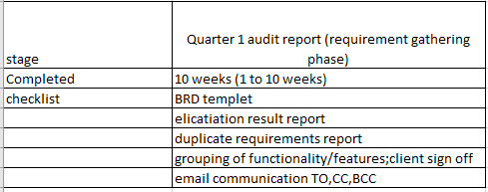

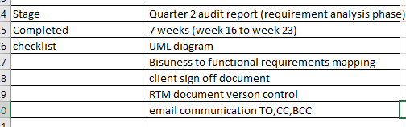

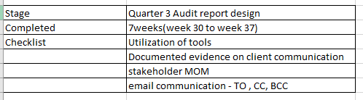

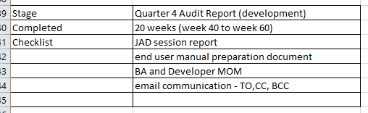

* To check if the project is progressing with the company’s objective or not.
* Weather various risks are being managed effectively by BA
* Are the process are being followed properly by BA.
* What all process can be improved are being suggested.

Q2 BA approach strategy:

* What elicitation techniques to apply: there are many elicitation techniques to apply used to gather requirements some of them are Brainstorming, document analysis, reverse engineering, focus groups, observation, workshops, interviews, surveys and questioner, mind mapping, prototyping, use cases, user stories, business process modelling, requirements workshops, JAD (joint application development)
* How to do stakeholder analysis RACI: Is a project management tool that defines and clarifies roles and responsibilities with in a project.
* BA role is to identifying roles and responsibilities, create the RACI matrix, RACI roles.
* Business stakeholder- project managers, Business owner, operations team, SME, End users

R- Responsible, A- accountable, C- Consulted, I- informed.

* Requirements gathering - stakeholders are consulted and BA is responsible
* Requirement Analysis – project manager is informed and BA is responsible
* Development – Java Developers are accountable and BA is consulted
* Testing - BA, project manager and java developers are informed, Testers are responsible
* What document to write: BRD, FRD, use case documentation, and test case documentation etc…,

What process to follow to sign off document:

* **What sign off documents to follow:** sign off to be taken on SRS as this is the primary and important document. Sign off can be taken by using e mail confirmation from client.
* **How to take approvals from the client:** Established a formal meeting with the clients to keep them informed and get continuous feedback.
* **What communication channel to establish and implement:** Regular meetings – weekly status meetings, bi-weekly sprints reviews, and monthly stakeholder’s updates.
* **How to handle change requests:** change requests from, do impact analysis. Approvals process, Documentation.
* How to update the progress of the project to the stakeholders, weekly status reports, monthly review meetings.
* How to take signoff on the UAT – Client Acceptance from: UAT preparation, conduct UAT, FIX issues, Acceptance form, Final Review Meeting, obtain sign off.

Q3 3 -Tier Architecture:

This divides the application into 3 logical layers-

1 **Application layer** - top most layer of the architecture –also known as ‘’Presentation layer-it handles user interface(UI) components such as screens, pages. User interface that allows user to interact with system.

2 **Business logic layer**- The middle tier that handles the application logics, business rules and calculation.

3 **Database layer**- The bottom most-layer of the architecture-responsible for storing and retrieving data

Q4

1.5W1H

The 5W1H framework is a useful tool for gathering information and understanding a situation by answering questions about who, what, when, where, why and how.

For gathering information from the stakeholder we should use 5W1H.

2. The SMART technique is also used in creating questions in requirement gathering.

SMART – specific, measurable, Achievable, Relevant, timeframe.

Specific: The requirement is clear and explains the project team what is expected.

Measurable: The requirements are been measured to be determine whether it is met.

Achievable: The requirement is attainable.

Relevant: The requirement should be relevant to business needs.

Time frame: The requirement has clearly-defined time frame for when it will be achieved.

3.RACI: RACI - Who is responsible, accountable, consulted and informed for each task.

4.UML: Unified Modelling Language, is a standardized way of diagramming and modelling software systems to aid and design, development and communication between team members.

5Q

1. JAD (joint application development). Application development through JAD has higher customer satisfaction and less number of errors as user is directly involved in the development process.
2. Document analysis: Review existing documents such as business plans and understanding product, process and project.
3. Interview- One on one or group discussions to gather information and clarify requirements.
4. Survey/ Questionnaire- Structured and unstructured questionnaire to collect data from a large number of stakeholders.
5. Brainstorming- Group sessions to generate a large number of ideas and solutions.
6. Reverse Engineering: is also called back engineering, is the process of analysing the existing system or process to understand its components and functionality.
7. Focus Group: Group discussions with a modulator to gather feedback and options.
8. Observations: watching user interact with the current system or process to identify pain points and areas of improvement.
9. Workshop: A collaborative session with stakeholders to discuss requirements, identify solutions and build consensus.
10. Prototyping- Creating a mock up or prototype to visualise the solution and gather feedback.
11. Use Case specs: Use case specification is a detailed document that outlines the interaction between a user and a system to achieve a specific goal.

Q6

Brainstorming: This is one of the valuable technique to gather requirements to generate ideas and solutions. We can have multiple ideas coming from other side would also add helping hand to the project. A group problem- solving method that involves the spontaneous contribution of creative ideas and solutions.

7Q. Business requirements:

BR001- Farmers should be able to search of available products in fertilizers, seeds, and pesticides.

BR002-Manufactures should be able to upload and display their products in the application

BR003-A farmer should be able to browse through the products catalogue once they visit the website.

BROO4-The website should have search option so that they can search for any product they need.

BR005- everyone should be able to log in website as the users

BR006-A product catalogue of fertilizers, seeds, pesticides and a search option to search for products. Payment process and delivery tracking should be there.

BR007-Any farmer wants to buy a product or add them to buy later list, they need to do the login first using their email id and password.

BR008-The new user should be able to create a new account submitting their email id and creating a secure password.

BR009-If a farmer wants to purchase, they should have an easy to use payment gateway which should be include cash on delivery (COD), credit/debit card and UPI.

BR0010-The user should get an email confirmation regarding their order status. A delivery tracker to track the whereabouts of their orders.

Q8

The assumptions for the project are:

In project management, assumptions are factors that are believed to be true or certain, though their certainty cannot be fully confirmed.

1.Quick delivery of orders to farmers.

2.The application can also be run without internet

4.The website would require very less maintenance.

Q9

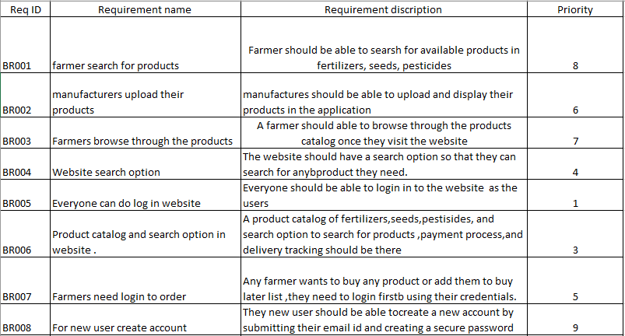

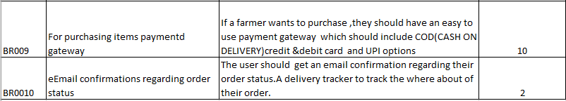

Q10.

Use Case Diagram: Use case Diagram is a visual representation of the interactions between actors and system to achieve a specific goal.

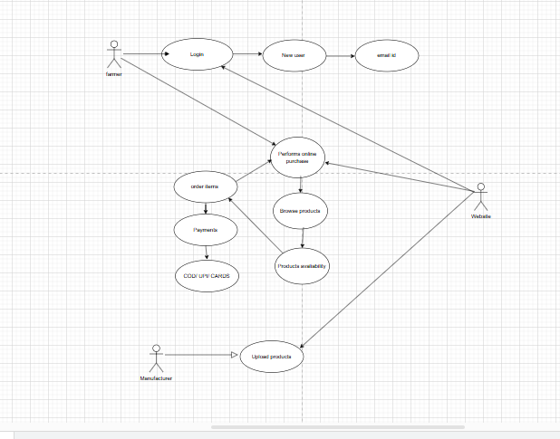

Q11.

**1.Use case spec for login**

Description-username, password.

Actors- Farmers, website

Preconditions-Active internet condition and Browser compatible

Post condition –home post should be displayed.

Basic flows: username and password is correct.

Alternate flow; password is wrong

Username is wrong, user name and password is wrong.

Exceptional flow: forgot password, forgot username.

Assumptions: users have basic computer knowledge English

Constraints: username cannot be special character

Dependents: user should exist – registration done

Inputs; username and password

Output; status flag or error code.

Business rules –username should use valid mail id password should have at least one special character.

**2.Use case spec- order items**

Description: add to cart, purchase

Actor- farmer and website

Preconditions; Active internet connection, browse for different products

Post condition: allow to add items to cart and direct to payment page

Basic flow: items selected are correctly captured while adding to cart.

Exceptional flow: while adding to cart different pages’ pops out not directing to payment pages

Assumptions: user should know how to add product to cart.

Constraint: at least 2 products to be added to cart

Dependences: the product should be available with the company.

Input: the selected product.

Output: the order gets through to the payment site.

Business rules- visa card and maestro card for payment

Miss communication - payment page with no errors.

3.**New user: use case spec**

Decriptions: registration and email verification

Actor- farmer and website

Precondition - active internet and have a valid Gmail account.

Post condition- able to register and login to website

Basic flow –

otp verification and gmail verification code done

Alternate flow –

otp is not going to number

Verification mail is not going to the mail

otp and verification mail mot going to mail

Exceptional flow – Gmail account not there, number out of reach/service.

Assumption- user have basic knowledge, have Gmail account.

Constraint –both mobile and Gmail need to verified to the registration

Dependents- user should have Gmail and number to be linked

Input-otp and gmail.

Output: registration done and able to login the website

Business rules –username should use valid mail id password should use special character.

MIS information – interactive design and browser compatible.

4.**use case spec-upload products**

Description: track item, refill stock

Actor manufacturer and website

Precondition: stock replacement data to be generated, easy controlling of website.

Post condition: stock are available all the time for demanded products

Basic flow- stock information is provided correctly.

Alternate flow – stock information is not provided correctly.

Exceptional flow- takes more time show stock data, no control on data.

Assumptions- manufacturer gets notified about stock of products.

Constraint- stock cannot be refilled for just one product

Dependents- if order is there the stock are being met.

Input-refill goes to manufacturer.

Output- product available or not available.

Business rules once all old stock is finished then only new stock will be come.

MIS information - interactive design and browser compatible.

**5.Use case spec – payment option**

Actors- farmer, website.

Precondition – the item to be in cart

Post condition- the farmer to able to make payment through upi card or cod

Basic flow- able to make payment

Alternate flow –not able to male payment

Exceptional flow – card blocked, upi not registered,

Assumption- have basic knowledge about using cards, know how to make upi payments.

Constraints- from gpay cannot make payment

Dependents- orders need to be in cart.

Inputs-card details

Output- payment gateway or error page

Business rule – card should be either visa or maestro

MIS information – interactive design and browser compatible.

12Q. Activity Diagram: An activity diagram is a visual representation of the steps involved in a business process system. It is a type of UML diagram that shows the flow of activities and actions with in a system.

Registered customer login:

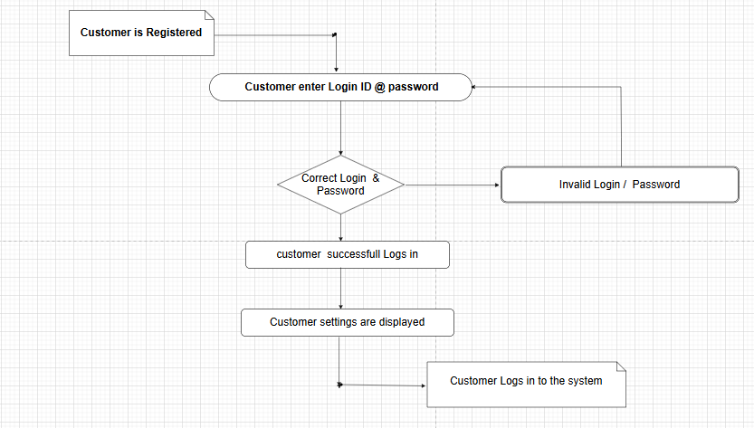

Add to Cart

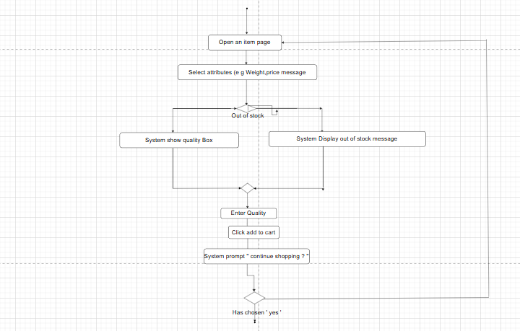

Making Payment: using branch:

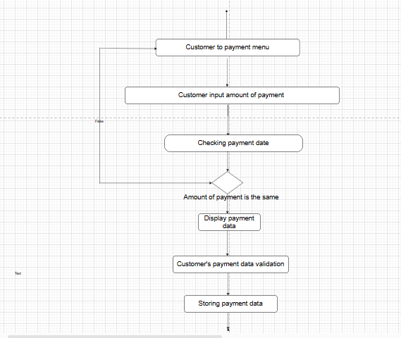

Order Deliver:

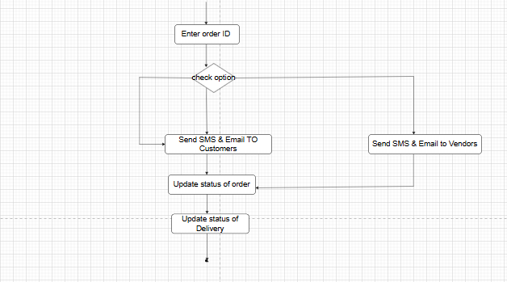

Search for products:

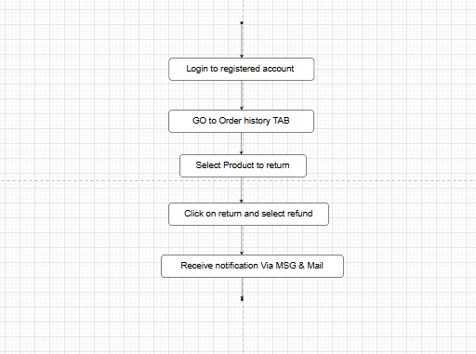

.

Buying fertilizer

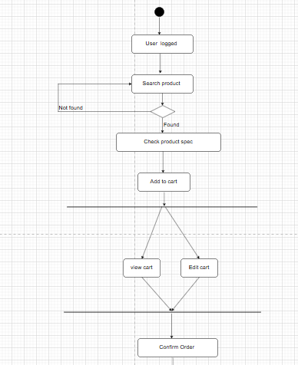

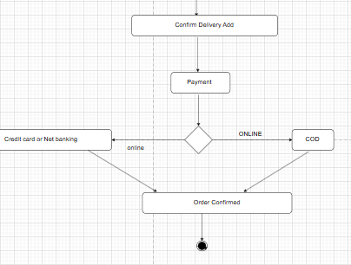

Order cancellation:

