Capstone Project 1
  - Part 1/3

  - Author: Ameya Mahajan (ameya_mahajan@yahoo.com)
  - Version: 0.1
Date: 02/04/2025

Contents
1. BPM 3
2. SWOT 3
3. Feasibility Study 4
4. GAP Analysis 5
5. Risk Analysis 6
6. Stakeholder Analysis (RACI Matrix) 7
7. Business Case Document 9
8. Four SDLC Methodologies 10
9. Waterfall RUP Spiral and Scrum Models 11
10. Waterfall vs V-Model 12
11. Justify your choice 12
12. Gantt Chart 13
13. Fixed Bid Vs Billing 13
14. Prepare timesheets of a BA in various stages of SDLC 14

BPM
ANS:
- Goal: To facilitate farmers in remote area to buy agricultural products through an online agricultural product store
- Inputs: Customer data, agriculture product manufacturers and their product data
- Resources: software, warehouses, trained employees, office space, internet
- Outputs: Revenue through the online agriculture store for both the online store operator and agriculture product manufacturers
- Activities: Partner with leading agriculture product manufacturers, provide product information on the online store, customer orders after checking the information, deliver the product to the provided customer address
- Value: Availibility of wide range of agriculture products, ease of ordering, and quick delivery

SWOT
ANS:
- Strengths:
  - Accessibility: The application would provide access to numerous agricultural products, including pesticides, seeds, and fertilizers, to farmers living in the remote areas, benefitting both agriculture businesses by providing more customers and to farmers by providing products.
  - Competitive Pricing: Considering many number of manufacturers would be providing their products on the application, they are likely to offer competitive pricing and discounts to farmers to stay ahead of the competition, benefitting farmers with cheaper rates and availibility of a wide range of products.
- Weaknesses:
  - Logistics: Considering the farmers are in remote areas, delivering the products on time might pose challenge if the road networks, especially in developing countries, are under developed.
  - Inexperience: Mr. Henry doesn’t seem to have any mentioned experience in building a shopping application, which may be a weakness in strategizing the marketing and operational strategies.
- Opportunity:
  - Improving Technology Infrastructure: The growing internet and smartphone penetration across the world, including rural areas, is likley to give more farmers the access to the application, creating significant growth opportunities.
  - Growth in Agriculture Output: The application can provide farmers with the required products on time, improving their crop yield and thereby improving the national economy.
- Threats:
  - Growth in Online Shopping Applications: The rapid growth in the emergence of online shopping applications across categories, such as clothing and electronics, also make the agriculture product online shopping application vulnerable to the entry on nee market entrants.
  - Irregular Weather Patterns: Natural calamities and irregular weather patterns could pose a threat to the demand of agriculture products on the application.

Feasibility Study
ANS:
Budget: Rs 2 crore
Timeline: 18 months
Technology:
Domain Name: ₹ 2,000/-
Hosting: ₹ 35,000/-
Plugins & Apps: ₹ 25,000/-
Logo Designing: ₹ 25,000/-
SSL Certificate: ₹ 7,500/-
Hardware:
Servers: ₹ 5,00,000/-
Network Infrastructure: ₹ 50,000/-
Software:
Content Management System (CMS): ₹ 5,00,000/-
Payment Gateway: 3% of per transaction
Resources:
Project Manager: ₹ 14L * 1.5 = ₹ 21L
Business Analyst: ₹ 8L * 1.5 = ₹ 12L
Senior Java Developer: ₹ 9L * 1.5 = ₹ 13.5L
4 Java Developers: ₹ 7L * 1.5 * 4 = ₹ 42L
Network Administrator: ₹ 5L * 1.5 = ₹ 7.5L
DB Administrator: ₹ 7L * 1.5 = ₹ 10.5L
2 Testers: ₹ 5L * 1.5 * 2 = ₹ 15L
Total Cost Estimated (for development - 18 months) - ~ ₹ 130 L

GAP Analysis
ANS:
Current State:
- Farmers in remote villages are facing challenges in procuring necessary products, for example:
    - Peter is facing challenge in procuring fertilizers
    - Kevin is facing problem in buying seeds
    - Ben is not having many pesticide buying option
    - Many other farmers in remote areas are facing the issue
- This is probably hampering the operations of the farmers and their crop yield and revenue.
Desired State:
- Farmers get access to a wide range of agriculture products through a user friendly application and internet connectivity.
- The product information is shared on the application with the farmers and get delivered right to their doorstep in a timely manner.
- Agriculture product manufacturers increase their customer base by serving these farmers.
- The farmers and agriculture product manufacturers witness an increase in revenue.

Risk Analysis
ANS:
Internal Risks:
- Dependence on agriculture product manufacturers for product supply and inventory management.
- Dependence on logistics companies to deliver the products to farmers doorstep.
- Since the users would be new the application should be user friendly, system downtime and sluggish responsiveness could impact the customer experience.
External Risks:
- Bad internet connectivity in remote rural areas could affect the performance of the application
- Changes in government regulations and policies regarding the manufacture and sale of agriculture products could affect the adoption of the application
BA Risks:
- Incomplete/vague requirements
- Scope creep/frequent changes in requirements
Project/process based risks:
- Budget overruns
- Technical challenges
- Unclear objectives

Stakeholder Analysis (RACI Matrix)
ANS.
Application Development
R/A/C/I | Name | Designation | Details
Responsible | Ms Juhi | Senior Java Developer | Emailid: juhi@123.com  Ph no: 000 000 0000  Reachout: 9 AM to 2 PM IST
 | Mr Teyson | Java Developer | Emailid: teyson@123.com  Ph no: 000 001 0000  Reachout: 9 AM to 2 PM IST
 | Ms Lucie | Java Developer | Emailid: lucie@123.com  Ph no: 000 100 0000  Reachout: 9 AM to 2 PM IST
 | Mr Tucker | Java Developer | Emailid: tucker@123.com  Ph no: 000 000 1000  Reachout: 9 AM to 2 PM IST
 | Mr Bravo | Java Developer | Emailid: bravo@123.com  Ph no: 010 000 0000  Reachout: 9 AM to 2 PM IST
 | Mr Mike | Network Admin | Emailid: mike@123.com  Ph no: 000 000 0100  Reachout: 9 AM to 2 PM IST
 | Mr John | DB Admin | Emailid: john@123.com  Ph no: 000 000 0010  Reachout: 9 AM to 2 PM IST
 | Mr Jason | Tester | Emailid: jason@123.com  Ph no: 000 000 0110  Reachout: 9 AM to 2 PM IST
 | Ms Alekya | Tester | Emailid: alekya@123.com  Ph no: 000 100 0000  Reachout: 9 AM to 2 PM IST
Accountable | Mr Karthik | Delivery Head | Emailid: karthik@123.com  Ph no: 000 100 0200  Reachout: 9 AM to 2 PM IST
 | Mr Vandanam | Project Manager | Emailid: vandanam@123.com  Ph no: 002 100 0000  Reachout: 9 AM to 2 PM IST
 | Mr Jacob | Business Analyst | Emailid: jacob@123.com  Ph no: 000 100 0300  Reachout: 9 AM to 2 PM IST
Consulted | Mr Peter | Farmer (End User) | Emailid: peter@123.com  Ph no: 100 100 0300  Reachout: 9 AM to 2 PM IST
 | Mr Kevin | Farmer (End User) | Emailid: kevin@123.com  Ph no: 000 150 0300  Reachout: 9 AM to 2 PM IST
 | Mr Ben | Farmer (End User) | Emailid: ben@123.com  Ph no: 060 100 0300  Reachout: 9 AM to 2 PM IST
Informed | Mr. Henry | Sponsor | Emailid: henry@123.com  Ph no: 060 100 0300  Reachout: 9 AM to 2 PM IST
 | Mr Pandu | Financial Head | Emailid: pandu@123.com  Ph no: 070 100 0300  Reachout: 9 AM to 2 PM IST
 | Mr Dooku | Project Coordinator | Emailid: dooku@123.com  Ph no: 080 100 0300  Reachout: 9 AM to 2 PM IST

Business Case Document
ANS.
Why is the project initiated?
The project is initiated as there is a gap between the current state and future state. The project aims to address the problem faced by farmers in remote areas of not having access to agriculture products.
What are the current problems?
Mr. Henry’s friends, Peter, Kevin, and Ben, among other farmers don’t have easy and timely access to agricultural products such as pesticides, fertilizers, and seeds, which is probably hampering their agricultural operations.
With this project, how many problems could be solved?
The project would facilitate ease of access and buying of agricultural products for farmers by providing information of agricultural products on the application and enable their buying and delivery at their doorstep. It would help in enhancing their agricultural operations and improving crop yield and revenue.
What are the resources required?
Overall 12 people are required to successfully execute the project over 18 months. The approximate cost is ₹ 1.3 crore.
How much organizational change is required to adopt this technology?
Considering APT IT SOLUTIONS will have to adopt waterfall/V Model SDLC methodology for this project from their usual agile methodology, about 30%-40% organizational change is required in terms of mindset change and operations change for executing this project.
What is the time frame to recover ROI?
Average e-commerce business revenue in the first 2 years – USD 930k (~ ₹ 8 cr)
Average Gross profit Margin (30-35%) = 32.5%*8 = ₹ 2.6 cr (first 2 years)
So 1 year is the approximate time frame to recover ROI (since cost of development is about ₹ 1.3 cr).
How to identify stakeholders?
Stakeholders would be identified through RACI matrix based on functionalities.

Four SDLC Methodologies

ANS.
Sequential: The sequential methodology follows a linear and structured approach. Each phase, such as requirements gathering, design, implementation, testing, deployment, and maintenance, is completed to move into the next. This model emphasizes thorough planning and documentation, making it suitable for projects with well-defined requirements and scope.
Iterative: The iterative methodology involves developing a system through repeated cycles (iterations), allowing for incremental improvements with each cycle. Unlike the sequential approach, this model enables team to revisit and refine aspects of the project, incorporating feedback and evolving requirements throughout the development process.
Evolutionary: The evolutionary methodology focuses in developing an initial, simplified version of the software and progressively enhancing it through multiple iterations. Each iteration builds upon the previous one, adding new features and refinements based on the user feedback and changing requirements. This approach is particularly useful when the final system requirements are not fully understood from the outset.
Agile: Agile is flexible, collaborative approach that emphasizes iterative development, customer feedback, and rapid delivery of functional components. Projects are divided into small manageable units called sprints, typically lasting a few weeks, allowing teams to adapt to changing requirements and deliver value incrementally. Agile promotes close collaboration among cross-functional teams and stakeholders to ensure alignment with business objectives.

Waterfall RUP Spiral and Scrum Models
ANS.
Waterfall: This is the most common and classic life cycle models. Also referred to as linear-sequential life cycle model. It is very simple to use and understand. In a waterfall model, each phase must be completed in its entirety before the next phase can begin. At the end of each phase, a review takes place to determine if the project is on the right path and whether or not to continue or discard the project.
V Model: The V-model, also known as the Verification and Validation model, emphasizes a systematic and disciplined approach. It extends the traditional waterfall model by integrating corresponding testing phases for each development stage, forming a V-shaped diagram. On the left side of the ‘V’, the model outlines stages such as requirement analysis, system design, and architectural design. Each of these stages has a corresponding testing phase on the right side of the ‘V’.
RUP: The Rational Unified Process (RUP) is an iterative software development process framework created by the Rational Software Corporation, which was acquired by IBM in February 2003. RUP is based on a set of building blocks, or content elements, describing what is to be produced, the necessary skills required and the step-by-step explanation describing how specific development goals are to be achieved.
Spiral: The spiral model gives more emphasis on risk analysis. The spiral model has four phases: planning, risk analysis, engineering, and evaluation. A software project repeatedly passes through these phases in iterations (called spirals in this model).
Scrum: Scrum is an iterative development methodology used to manage software projects. In scrum-based projects, there isn’t a specific project manager directing project team tasks; the team is self-directed, with co-located team members relying on communication over documentation for effective project delivery.

Waterfall vs V-Model
ANS.
Sr. No. | Waterfall | V-Model
1 | Generally low initial costs due to straightforward planning. | May involve higher initial costs due to extensive testing.
2 | Testing is conducted after the development phase is fully completed. | Testing activities are planned in parallel with corresponding development phases, allowing for early validation.
3 | Linear and sequential; each phase must be completed before the next begins. | Extends the waterfall model by integrating corresponding testing phases for each development stage, forming a V-shape.
4 | Limited customer involvement after the initial requirement gathering until the final delivery. | Encourages customer feedback during the validation phases, enhancing alignment with user expectations.

Justify your choice
ANS.
The waterfall model is a more suitable choice due to:
- Simplicity and Ease of Use: The waterfall model’s straightforward, linear progression makes it easy to understand and implement. Each phase has defined deliverables and a review process, facilitating clear project management and documentation.
- Well Suited for Well Defined Projects: Since the online agriculture store development technologies are relatively known (not many unknows technology wise), the model’s structured approach allows for efficient planning and execution without the need for extensive testing phases associated with the V-model.

Gantt Chart
ANS.
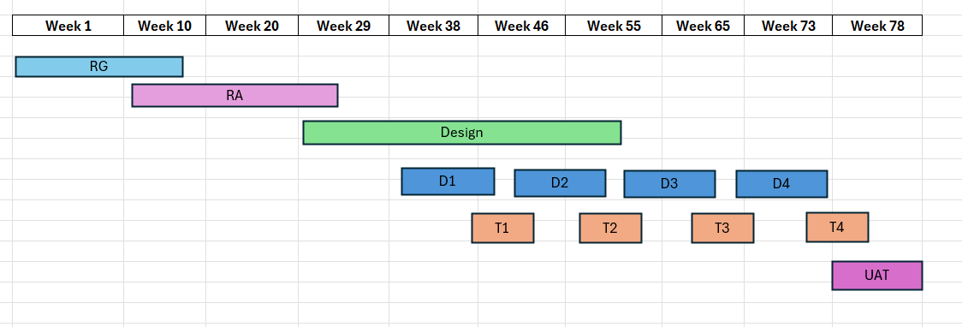
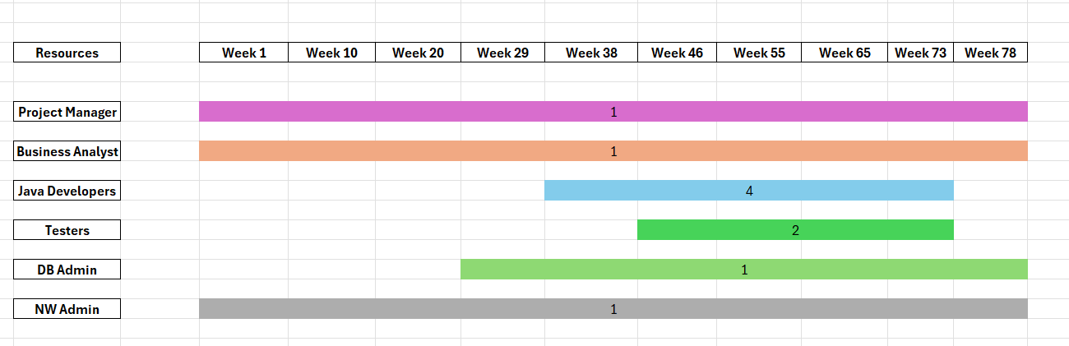

Fixed Bid Vs Billing
ANS.
Fixed Bid Projects: In a fixed bid agreement, the service provider and client agree upon a predetermined price for the entire project before the work begins. This fixed price remains constant regardless of the actual timeline or resources expended during the project’s execution.
Billing Projects: The resources working in the project will be billed to the client on hourly basis. Example: PM $120/hr and Programmers $50/hr, and so on. This approach offers greater flexibility to accommodate changes in project scope or unforeseen complexities.

Prepare timesheets of a BA in various stages of SDLC
ANS.
