Question 1 – Functional Requirements

Identify minimum 20 functional requirements

|  |  |  |  |
| --- | --- | --- | --- |
| **Req ID** | **Req Name** | **Req Description** | **Priority** |
| FR0001 | Farmer Registration | Farmers should be able to register with their email ID and create a secure password. | 8 |
| FR0002 | User Login | Farmers should be able to log in using their email ID and password. | 10 |
| FR0003 | Forgot Password | Farmers should be able to reset their password via email if they forget it. | 9 |
| FR0004 | Product Catalog | The system should display a catalog of fertilizers, seeds, and pesticides. | 10 |
| FR0005 | Search Functionality | Farmers should be able to search for products by name, category, or manufacturer. | 8 |
| FR0006 | Add to Cart | Farmers should be able to add selected products to their shopping cart. | 10 |
| FR0007 | Buy Later List | Farmers should be able to add products to a "Buy Later" list for future purchase. | 8 |
| FR0008 | Product Details | The system should display detailed information about each product (description, price, etc.). | 8 |
| FR0009 | Order Placement | Farmers should be able to place an order for the products they’ve selected. | 10 |
| FR0010 | Payment Gateway | The system should provide payment options such as COD, Credit/Debit Card, and UPI. | 10 |
| FR0011 | Email Confirmation | The system should send an email confirmation regarding order status after placing an order. | 9 |
| FR0012 | Order Tracking | Farmers should be able to track the location and status of their orders. | 9 |
| FR0013 | Delivery Information | Farmers should be able to enter and update their delivery address during checkout. | 8 |
| FR0014 | Secure Payment | The system should ensure that all payment transactions are secure (SSL/TLS encryption). | 9 |
| FR0015 | Product Availability Notification | The system should notify farmers if a product is out of stock. | 7 |
| FR0016 | User Profile Management | Farmers should be able to update their email, password, and delivery address in their profile. | 8 |
| FR0017 | Order History | Farmers should be able to view their past orders and statuses. | 7 |
| FR0018 | Product Review and Rating | Farmers should be able to leave reviews and ratings for products they’ve purchased. | 7 |
| FR0019 | Admin Management | Admins should be able to manage product listings, including adding, updating, and deleting products. | 7 |
| FR0020 | Inventory Management | Manufacturers should be able to manage and update product stock levels. | 6 |

|  |  |  |  |
| --- | --- | --- | --- |
| **Req ID** | **Req Name** | **Req Description** | **Priority** |
| NFR0101 | Page Loading Time | Each page should load within 2 seconds to ensure quick user access and responsiveness. | 10 |
| NFR0102 | WCAG 2.1 Compliance | The system must meet Web Content Accessibility Guidelines (WCAG 2.1) for accessibility. | 9 |
| NFR0103 | Security | All data transactions should be encrypted using SSL/TLS to ensure secure communication. | 10 |
| NFR0104 | Availability | The system shall be available 99.9% of the time, ensuring minimal downtime. | 10 |
| NFR0105 | Backup and Recovery | The system shall perform daily backups and ensure quick recovery in case of data loss. | 9 |
| NFR0106 | Performance | The system should handle up to 10,000 concurrent users without performance degradation. | 10 |
| NFR0107 | Disaster Recovery | The system shall have a disaster recovery plan, ensuring restoration within 4 hours in case of catastrophic failure. | 9 |
| NFR0108 | Scalability | The system shall be able to scale horizontally to handle increased load as the user base grows. | 8 |
| NFR0109 | Cross-Platform Support | The application must work seamlessly on different platforms (iOS, Android, Web). | 9 |
| NFR0110 | Response Time | The system should process requests within 5 seconds for any transaction or query. | 10 |
| NFR0111 | Load Balancing | The system should distribute user traffic across multiple servers to optimize performance during peak times. | 9 |
| NFR0112 | User Session Management | User sessions should be terminated after 15 minutes of inactivity for security purposes. | 8 |
| NFR0113 | Compliance | The system must comply with relevant data protection and privacy laws, such as GDPR. | 8 |
| NFR0114 | Usability | The application should have a user-friendly interface that requires minimal training to use. | 9 |
| NFR0115 | Accessibility Support | The system must support screen readers and keyboard navigation for visually impaired users. | 8 |
| NFR0116 | Mobile Responsiveness | The application should be responsive and optimized for mobile devices (phones and tablets). | 8 |
| NFR0117 | Error Handling | The system shall provide clear, user-friendly error messages for failed actions. | 7 |
| NFR0118 | Logging and Monitoring | The system must maintain detailed logs of critical actions (e.g., logins, order placements) for monitoring and debugging. | 7 |
| NFR0119 | Maintainability | The system should be easy to maintain, with modular components and well-documented code. | 7 |
| NFR0120 | Integration Capability | The system should support integration with third-party services like payment gateways, email services, and delivery tracking systems. | 8 |

**Functional requirements** define the core functionalities and features that a system must perform to meet user and business needs. These requirements describe **what the system should do**, including inputs, processes, and expected outputs.

**Non-functional requirements (NFRs)** define the **quality attributes, performance, and operational constraints** of a system. They describe **how well** a system should function rather than what it should do. These requirements ensure that the system meets **performance, security, usability, scalability, and reliability** expectations.

Question 2–Minimum 5 page designs - 15 Marks

Make wireframe and prototypes

1.Login page

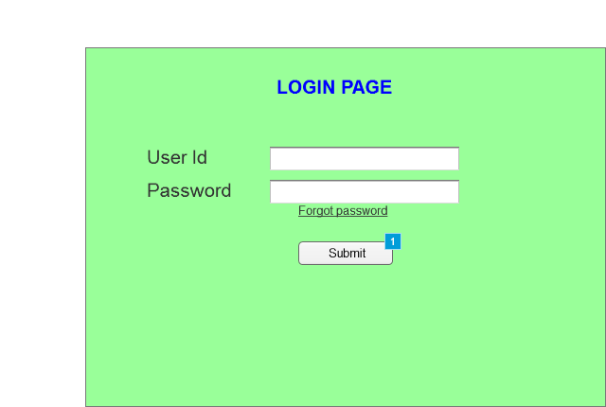

2.Home page

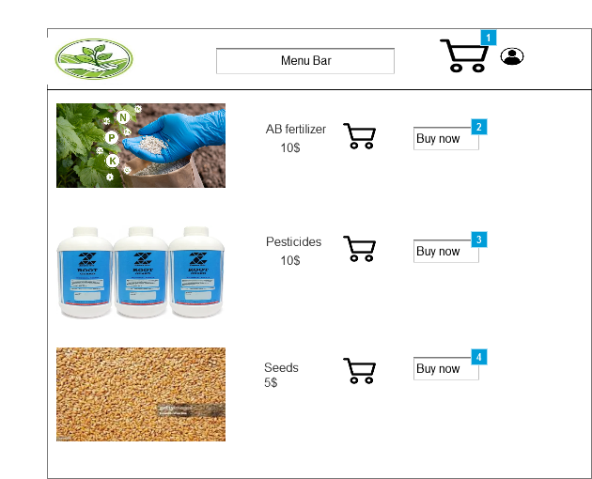

3.Cart Page

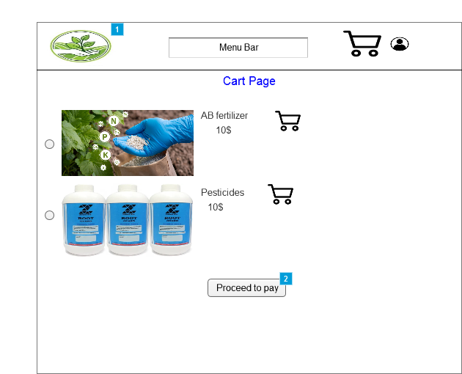

4.Payment page

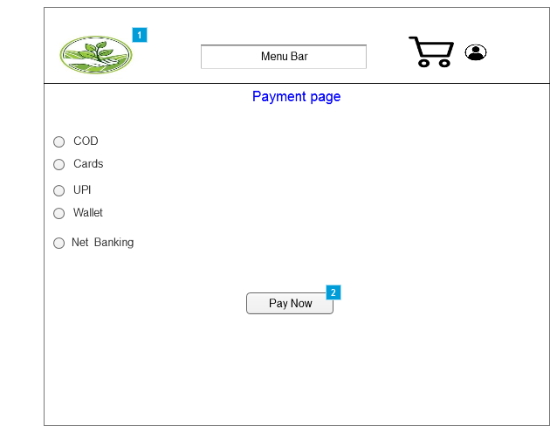

5.Payment completion page.

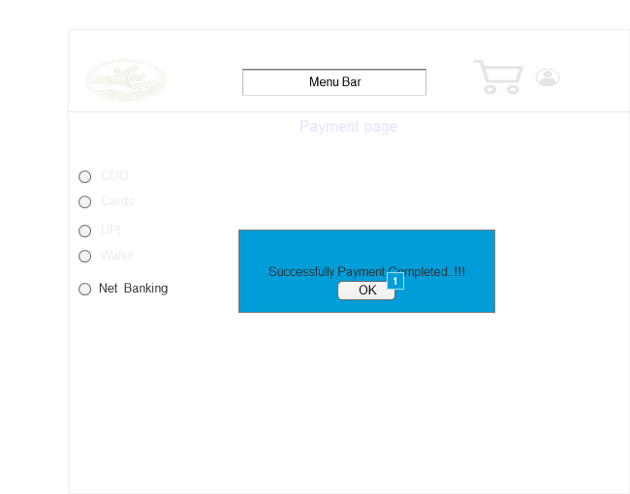

Wireframe for Home page

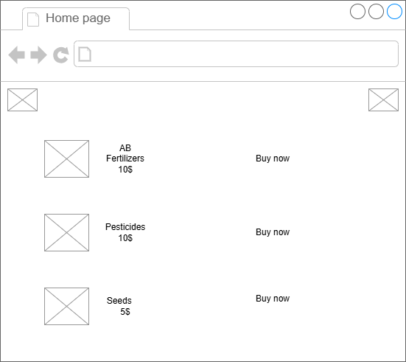

Question 3 – Tools (Visio, Balsamiq) - 15 Marks

Make a note of the Tools, which you are using for above concepts.

**MS Visio** is a powerful diagramming tool that allows users to create detailed charts, flowcharts, network diagrams, and organizational structures. It offers a variety of templates and shapes to visualize complex processes, making it useful for business, engineering, and IT professionals to communicate ideas and data clearly and efficiently. In **Software Development it is**  Used to map out application architectures, UML diagrams, and wireframes.

**Balsamiq** is a wireframing tool designed to help users quickly create low-fidelity prototypes for websites and apps. **Its drag-and-drop interface allows designers to sketch layouts and user interfaces with** ease, enabling teams to visualize concepts early in the design process and streamline communication between stakeholders. Facilitates communication among design teams, stakeholders, and clients by visualizing ideas. Focuses on simplicity and clarity, with hand-drawn, low-fidelity designs that prioritize layout over aesthetics.

**Axure** is a powerful prototyping tool used for creating interactive wireframes, prototypes, and specifications. It allows designers to build dynamic, high-fidelity prototypes with advanced interactions, animations, and conditional logic. Axure is popular among UX/UI designers for its ability to simulate complex user experiences and collaborate with teams effectively. Supports high-fidelity design elements, making it possible to simulate more polished, production-ready user interfaces.

Question 4 – RTM - 6 Marks

A business analyst’s key responsibilities are to keep track of the requirements and make sure that no requirement is missed.

|  |  |  |  |  |  |  |  |  |  |
| --- | --- | --- | --- | --- | --- | --- | --- | --- | --- |
| Req id | Req name | Req Description | Design | Code | UT( Unit Testing) | CT (component testing) | ST(System testing) | SIT | UAT |
| FR0001 | Farmer Registration | Farmers should be able to register with their email ID and create a secure password. | Complete | Complete | Complete | Complete | Complete | Complete | Incomplete |
| FR0002 | User Login | Farmers should be able to log in using their email ID and password. | Complete | Complete | Complete | Complete | Incomplete | Incomplete | Incomplete |
| FR0003 | Forgot Password | Farmers should be able to reset their password via email if they forget it. | Complete | Complete | Complete | Complete | Incomplete | Incomplete | Incomplete |
| FR0004 | Product Catalog | The system should display a catalog of fertilizers, seeds, and pesticides. | Complete | Complete | Complete | Complete | Incomplete | Incomplete | Incomplete |
| FR0005 | Search Functionality | Farmers should be able to search for products by name, category, or manufacturer. | Complete | Complete | Complete | Complete | Incomplete | Incomplete | Incomplete |
| FR0006 | Add to Cart | Farmers should be able to add selected products to their shopping cart. | Complete | Complete | Complete | Complete | Incomplete | Incomplete | Incomplete |
| FR0007 | Buy Later List | Farmers should be able to add products to a "Buy Later" list for future purchase. | Complete | Complete | Complete | Complete | Incomplete | Incomplete | Incomplete |
| FR0008 | Product Details | The system should display detailed information about each product (description, price, etc.). | Complete | Complete | Complete | Complete | Incomplete | Incomplete | Incomplete |
| FR0009 | Order Placement | Farmers should be able to place an order for the products they’ve selected. | Complete | Complete | Complete | Complete | Incomplete | Incomplete | Incomplete |
| FR0010 | Payment Gateway | The system should provide payment options such as COD, Credit/Debit Card, and UPI. | Complete | Complete | Complete | Complete | Incomplete | Incomplete | Incomplete |
| FR0011 | Email Confirmation | The system should send an email confirmation regarding order status after placing an order. | Complete | Complete | Complete | Complete | Incomplete | Incomplete | Incomplete |
| FR0012 | Order Tracking | Farmers should be able to track the location and status of their orders. | Complete | Complete | Complete | Complete | Incomplete | Incomplete | Incomplete |
| FR0013 | Delivery Information | Farmers should be able to enter and update their delivery address during checkout. | Complete | Complete | Complete | Complete | Incomplete | Incomplete | Incomplete |
| FR0014 | Secure Payment | The system should ensure that all payment transactions are secure (SSL/TLS encryption). | Complete | Complete | Complete | Complete | Incomplete | Incomplete | Incomplete |
| FR0015 | Product Availability Notification | The system should notify farmers if a product is out of stock. | Complete | Complete | Complete | Complete | Incomplete | Incomplete | Incomplete |
| FR0016 | User Profile Management | Farmers should be able to update their email, password, and delivery address in their profile. | Complete | Complete | Complete | Complete | Incomplete | Incomplete | Incomplete |
| FR0017 | Order History | Farmers should be able to view their past orders and statuses. | Complete | Complete | Complete | Complete | Incomplete | Incomplete | Incomplete |
| FR0018 | Product Review and Rating | Farmers should be able to leave reviews and ratings for products they’ve purchased. | Complete | Complete | Complete | Complete | Incomplete | Incomplete | Incomplete |
| FR0019 | Admin Management | Admins should be able to manage product listings, including adding, updating, and deleting products. | Complete | Complete | Complete | Complete | Incomplete | Incomplete | Incomplete |
| FR0020 | Inventory Management | Manufacturers should be able to manage and update product stock levels. | Complete | Complete | Complete | Complete | Incomplete | Incomplete | Incomplete |

Non- Functional Requirements

|  |  |  |  |  |  |  |  |  |  |
| --- | --- | --- | --- | --- | --- | --- | --- | --- | --- |
| Req id | Req name | Req Description | Design | Code | UT( Unit Testing) | CT (component testing) | ST(System testing) | SIT | UAT |
| NFR0101 | Page Loading Time | Each page should load within 2 seconds to ensure quick user access and responsiveness. | Complete | Complete | Complete | Complete | Complete | Complete | Incomplete |
| NFR0102 | WCAG 2.1 Compliance | The system must meet Web Content Accessibility Guidelines (WCAG 2.1) for accessibility. | Complete | Complete | Complete | Complete | Incomplete | Incomplete | Incomplete |
| NFR0103 | Security | All data transactions should be encrypted using SSL/TLS to ensure secure communication. | Complete | Complete | Complete | Complete | Incomplete | Incomplete | Incomplete |
| NFR0104 | Availability | The system shall be available 99.9% of the time, ensuring minimal downtime. | Complete | Complete | Complete | Complete | Incomplete | Incomplete | Incomplete |
| NFR0105 | Backup and Recovery | The system shall perform daily backups and ensure quick recovery in case of data loss. | Complete | Complete | Complete | Complete | Incomplete | Incomplete | Incomplete |
| NFR0106 | Performance | The system should handle up to 10,000 concurrent users without performance degradation. | Complete | Complete | Complete | Complete | Incomplete | Incomplete | Incomplete |
| NFR0107 | Disaster Recovery | The system shall have a disaster recovery plan, ensuring restoration within 4 hours in case of catastrophic failure. | Complete | Complete | Complete | Complete | Incomplete | Incomplete | Incomplete |
| NFR0108 | Scalability | The system shall be able to scale horizontally to handle increased load as the user base grows. | Complete | Complete | Complete | Complete | Incomplete | Incomplete | Incomplete |
| NFR0109 | Cross-Platform Support | The application must work seamlessly on different platforms (iOS, Android, Web). | Complete | Complete | Complete | Complete | Incomplete | Incomplete | Incomplete |
| NFR0110 | Response Time | The system should process requests within 5 seconds for any transaction or query. | Complete | Complete | Complete | Complete | Incomplete | Incomplete | Incomplete |
| NFR0111 | Load Balancing | The system should distribute user traffic across multiple servers to optimize performance during peak times. | Complete | Complete | Complete | Complete | Incomplete | Incomplete | Incomplete |
| NFR0112 | User Session Management | User sessions should be terminated after 15 minutes of inactivity for security purposes. | Complete | Complete | Complete | Complete | Incomplete | Incomplete | Incomplete |
| NFR0113 | Compliance | The system must comply with relevant data protection and privacy laws, such as GDPR. | Complete | Complete | Complete | Complete | Incomplete | Incomplete | Incomplete |
| NFR0114 | Usability | The application should have a user-friendly interface that requires minimal training to use. | Complete | Complete | Complete | Complete | Incomplete | Incomplete | Incomplete |
| NFR0115 | Accessibility Support | The system must support screen readers and keyboard navigation for visually impaired users. | Complete | Complete | Complete | Complete | Incomplete | Incomplete | Incomplete |
| NFR0116 | Mobile Responsiveness | The application should be responsive and optimized for mobile devices (phones and tablets). | Complete | Complete | Complete | Complete | Incomplete | Incomplete | Incomplete |
| NFR0117 | Error Handling | The system shall provide clear, user-friendly error messages for failed actions. | Complete | Complete | Complete | Complete | Incomplete | Incomplete | Incomplete |
| NFR0118 | Logging and Monitoring | The system must maintain detailed logs of critical actions (e.g., logins, order placements) for monitoring and debugging. | Complete | Complete | Complete | Complete | Incomplete | Incomplete | Incomplete |
| NFR0119 | Maintainability | The system should be easy to maintain, with modular components and well-documented code. | Complete | Complete | Complete | Complete | Incomplete | Incomplete | Incomplete |
| NFR0120 | Integration Capability | The system should support integration with third-party services like payment gateways, email services, and delivery tracking systems. | Complete | Complete | Complete | Complete | Incomplete | Incomplete | Incomplete |

**How to Tackle the Situation with the Current Status:**

1. **Review the Status of Completed Requirements (FR0001):**
   * For **FR0001** (Farmer Registration), everything is complete except for UAT. This is a critical requirement, so I would prioritize completing UAT for this feature and involve testers to perform the final checks.
   * I would confirm with the QA team if they need any additional details or clarifications to complete UAT.
2. **Track the Pending Requirements :**
   * For all other requirements, since they are currently in a pending state, I will reach out to the design and development teams to determine the expected timelines for these tasks. It's essential to have a clear schedule for when each requirement will enter the respective stages (design, code, testing).
   * If there are any blockers preventing progress (e.g., resource limitations, design challenges), I would work with the team to resolve those issues.
3. **Conduct Regular Status Meetings:**
   * I would set up a regular cadence for checking on the status of each requirement across different testing phases. This would involve daily stand-up meetings or weekly reviews with the development, testing, and project management teams to ensure progress is on track.
   * I would communicate with Mr. Henry and Peter on the current status and potential timeline for UAT completion. I would also provide updates on the other features' statuses to manage expectations.
4. **Escalate Critical Issues:**
   * If any requirements are delayed or at risk, I would escalate the issues to the project manager (Mr. Vandanam) and highlight any impact on the overall timeline or project scope.
   * I would work with stakeholders to adjust priorities, if necessary, to keep the project on track.
5. **Ensure Feedback Incorporation:**
   * Once UAT is completed for **FR0001**, I would gather feedback from the stakeholders (farmers and the committee) and ensure all identified issues are resolved promptly. Similarly, I would do the same for the other requirements when they are in the UAT phase.

**Final Thought:**

By actively managing the RTM, coordinating with all stakeholders, and addressing any blockers or delays early on, I can ensure that the project stays on track and meets the expectations of Mr. Henry, Peter, and all other involved parties.

Question 5 – 10 Test Case Documents - 10 Marks

1. **Search product**

|  |  |  |  |  |  |
| --- | --- | --- | --- | --- | --- |
| Test case Id | PQ786TS001 | Test case name | **Search product** |  |  |
| Project ID | PQ786 | project name | Online agricultural store |  |  |
| PM ID | 4869 | PM name | Mr. Vandanam |  |  |
| Test Strategy ID | PQ786TS001 | Tester Id | TST001 |  |  |
| Test plan ID | PQ786TP001 | Tester name | Mr. Jason |  |  |
| Test Schedule Id | PQ786TS001 | Date of text |  |  |  |
| Scenario | **Search for product** |  |  |  |  |
| Link to that page |  |  |  |  |  |
| Input data | Set 1Fertilizers with varities | Set2 Crop seeds like jowar,maze, wheat | Set 3 maze price down with delivery free | Set 4 monsoon crops from within Rs.500 | Set 5 Fertilizer of karif crops |
| Expected behaviour | 10 Searches for the product | 10 Searches for the product | 3 Searches for the product | 10 Searches for the product | 5 Searches for the product |
| Actual behaviour | 10 Searches for the product | 10 Searches for the product | 3 Searches for the product | Searches for the product | Searches for the product |
| comments |  |  |  |  |  |
| Results(pass/fail) | Pass | Pass | Pass | Pass | Pass |
|  |  |  |  |  |  |

2. **Login page**

|  |  |  |  |  |  |
| --- | --- | --- | --- | --- | --- |
| Test case Id | PQ786TS002 | Test case name | **Login page** |  |  |
| Project ID | PQ786 | project name | Online agricultural store |  |  |
| PM ID | 4869 | PM name | Mr. Vandanam |  |  |
| Test Strategy ID | PQ786TS002 | Tester Id | TST001 |  |  |
| Test plan ID | PQ786TP002 | Tester name | Mr. Jason |  |  |
| Test Schedule Id | PQ786TS002 | Date of text |  |  |  |
| Scenario | Login page |  |  |  |  |
| Link to that page |  |  |  |  |  |
| Input data | Set 1- login with valid user name and password . | Set 2 -Login with invalid credentials may be incorrect password | Set 3 –Login with invalid user name | Set- 4 Forgot user name | Set -5  Forgot password |
| Expected behaviour | Login successful and view homepage | Error message "Incorrect username or password." should be displayed. | Error message "User does not exist." should be displayed. | User should be redirected to the User name recovery page. | User should be redirected to the password recovery page. |
| Actual behaviour | Login successful and view homepage | Error message "Incorrect username or password." should be displayed. | Error message "User does not exist." should be displayed. | User should be redirected to the user name recovery page. | User should be redirected to the password recovery page. |
| comments |  |  |  |  |  |
| Results(pass/fail) | pass | Pass | Pass | Pass | Pass |
|  |  |  |  |  |  |

3. **Shopping cart and check out**

|  |  |  |  |  |  |
| --- | --- | --- | --- | --- | --- |
| Test case Id | PQ786TS003 | Test case name | **Shopping cart and check out** |  |  |
| Project ID | PQ786 | project name | Online agricultural store |  |  |
| PM ID | 4869 | PM name | Mr. Vandanam |  |  |
| Test Strategy ID | PQ786TS003 | Tester Id | TST001 |  |  |
| Test plan ID | PQ786TP003 | Tester name | Mr. Jason |  |  |
| Test Schedule Id | PQ786TS003 | Date of text |  |  |  |
| Scenario | Adding, remove ,update product to the shopping cart |  |  |  |  |
| Link to that page |  |  |  |  |  |
| Input data | Set 1- Select "Fertilizer A" and click "Add to Cart" | Set 2 - Change quantity of "Fertilizer A" from 1 to 3 | Set 3 – Apply a valid discount coupon during checkout Enter coupon code "DISCOUNT10" | Set- 4 Click on "Proceed to Checkout" | Set -5  Change quantity of "Fertilizer A" from 1 to 3 |
| Expected behaviour | Product "Fertilizer A" should be added to the shopping cart. | Product "Fertilizer A" should be removed from the shopping cart. | A 10% discount should be applied to the total amount. | User should be redirected to the checkout page. | Quantity to be changed |
| Actual behaviour | Product "Fertilizer A" should be added to the shopping cart. | Product "Fertilizer A" should be removed from the shopping cart. | A 10% discount should be applied to the total amount. | User should be redirected to the checkout page. | Quantity to be changed |
| comments |  |  |  |  |  |
| Results(pass/fail) | Pass | Pass | Pass | Pass | pass |
|  |  |  |  |  |  |

4. **Inventory Management**

|  |  |  |  |  |  |  |
| --- | --- | --- | --- | --- | --- | --- |
| Test case Id | PQ786TS004 | Test case name | **Inventory Management** |  |  | |
| Project ID | PQ786 | project name | Online agricultural store |  |  | |
| PM ID | 4869 | PM name | Mr. Vandanam |  |  | |
| Test Strategy ID | PQ786TS004 | Tester Id | TST001 |  |  | |
| Test plan ID | PQ786TP004 | Tester name | Mr. Jason |  |  | |
| Test Schedule Id | PQ786TS004 | Date of text |  |  |  | |
| Scenario | Manufacturers add new product,make addition to existing product,deletion, stock alert, reports. |  |  |  |  | |
| Link to that page |  |  |  |  |  | |
| Input data | Set 1- Product Name: Fertilizer BCategory: FertilizersStock Quantity: 100Price: Rs. 500 | Set 2 - Product Name: Fertilizer B  New Stock Quantity: 150 | Set 3 – Select "Fertilizer B" and click "Delete" | Set- 4 Reduce stock of "Fertilizer B" to 5 (threshold is 10) | Set -5  Click on "Generate Report" and select "Download as PDF") | |
| Expected behaviour | The new product "Organic Fertilizer" should be added to the inventory list with correct details | Stock quantity for "Organic Fertilizer" should be updated to 150. | Product "Organic Fertilizer" should be removed from the inventory list. | A low stock alert should be displayed for "Organic Fertilizer". | | Inventory report should be generated and downloaded successfully. |
| Actual behaviour | Organic Fertilizer" added to the inventory list | Stock was updated to 150 | Fertilizer B got deleted form the list | Displayed as low stock alert | | Report generated |
| comments |  |  |  |  | |  |
| Results(pass/fail) | Pass | Pass | Pass | Pass | | Pass |
|  |  |  |  |  | |  |

5. **Payment Gateway**

|  |  |  |  |  |  |
| --- | --- | --- | --- | --- | --- |
| Test case Id | PQ786TS005 | Test case name | **Payment Gateway** |  |  |
| Project ID | PQ786 | project name | Online agricultural store |  |  |
| PM ID | 4869 | PM name | Mr. Vandanam |  |  |
| Test Strategy ID | PQ786TS005 | Tester Id | TST001 |  |  |
| Test plan ID | PQ786TP005 | Tester name | Mr. Jason |  |  |
| Test Schedule Id | PQ786TS005 | Date of text |  |  |  |
| Scenario | Successful payment, payment failure,timed out |  |  |  |  |
| Link to that page |  |  |  |  |  |
| Input data | Set 1- Card Number: 4111 1111 1111 1111Expiry Date: 12/25CVV: 123Cardholder Name: John Doe | Set 2 - Card Number: 1234 5678 9012 3456Expiry Date: 12/25CVV: 000Cardholder Name: Invalid User | Set 3 – Leave the payment page idle for more than 10 minutes. | Set- 4 Select Net Banking -> Choose Bank -> Enter valid credentials -> Complete Payment" | Set -5  Simulate a failed transaction (e.g., network error during payment) |
| Expected behaviour | Payment should be processed successfully, and the user should be redirected to the order confirmation page. | An error message "Invalid card details. Please try again." should be displayed, and payment should not be processed. | session should time out, and an error message "Session expired. Please try again." should be displayed. | Payment should be processed successfully, and the user should be redirected to the order confirmation page. | Transaction should fail, and a refund should be initiated automatically. |
| Actual behaviour | Payment processed order confirmed page viewed | Displayed the status as "Invalid card details. Please try again."and could not process | "Session expired. Please try again." Got displayed | Payment processed and order confirmed viewed. | Refund got initiated for the failed transaction. |
| comments |  |  |  |  |  |
| Results(pass/fail) | Pass | Pass | Pass | Pass | Pass |
|  |  |  |  |  |  |

6. **User Profile Management**

|  |  |  |  |  |  |
| --- | --- | --- | --- | --- | --- |
| Test case Id | PQ786TS006 | Test case name | **User Profile Management** |  |  |
| Project ID | PQ786 | project name | Online agricultural store |  |  |
| PM ID | 4869 | PM name | Mr. Vandanam |  |  |
| Test Strategy ID | PQ786TS006 | Tester Id | TST001 |  |  |
| Test plan ID | PQ786TP006 | Tester name | Mr. Jason |  |  |
| Test Schedule Id | PQ786TS006 | Date of text |  |  |  |
| Scenario | Edit and update user profile information, user password change,Delete account. |  |  |  |  |
| Link to that page |  |  |  |  |  |
| Input data | Set 1- Change "Phone Number" to "9876543210" and "Address" to "123 Green Street, Farmville". | Set 2 - Current Password: oldpassword123  New Password: newpassword456  Confirm New Password: newpassword456 | Set 3 Select and upload "profile_pic.jpg" | Set- 4 Click on "Delete Account" and confirm the deletion. | Set -5  Navigate to "My Profile" |
| Expected behaviour | User profile information should be updated successfully with the new phone number and address. | Password should be changed successfully, and the user should receive a confirmation message. | The new profile picture should be uploaded and displayed correctly on the profile page. | The user account should be deleted, and the user should be logged out and redirected to the homepage. | All user profile information should be displayed correctly. |
| Actual behaviour | Phone number and address was updated successfully | Password changed successfully, and the user should receive a confirmation message. | The new profile picture uploaded and displayed correctly on the profile page. | Account deleted and redirected to the home page | User Name ,phone number,emailid was displayed |
| comments |  |  |  |  |  |
| Results(pass/fail) | Pass | Pass | Pass | Pass | Pass |
|  |  |  |  |  |  |

7. **Shipping and Delivery**

|  |  |  |  |  |  |
| --- | --- | --- | --- | --- | --- |
| Test case Id | PQ786TS007 | Test case name | **Shipping and Delivery** |  |  |
| Project ID | PQ786 | project name | Online agricultural store |  |  |
| PM ID | 4869 | PM name | Mr. Vandanam |  |  |
| Test Strategy ID | PQ786TS007 | Tester Id | TST001 |  |  |
| Test plan ID | PQ786TP007 | Tester name | Mr. Jason |  |  |
| Test Schedule Id | PQ786TS007 | Date of text |  |  |  |
| Scenario | preferred shipping method,time, status,check if free shipping,validate address. |  |  |  |  |
| Link to that page |  |  |  |  |  |
| Input data | Set 1- Choose "Express Shipping" | Set 2 - Select "Standard Shipping" | Set 3- Order total: Rs. 1500 (Free shipping threshold: Rs. 1000) | Set- 4 Enter incomplete address: "123 Green Street" | Set -5  Enter Order ID "ORD123456" |
| Expected behaviour | "Express Shipping" should be selected, and the shipping cost should update accordingly. | Estimated delivery time should be displayed as "5-7 business days". | Free shipping option should be available for selection. | An error message should be displayed prompting the user to complete the address. | Order status should be displayed as "Shipped/In Transit/Delivered" based on the current status. |
| Actual behaviour | Shipping cost updated | Estimated delivery time displayed as "5-7 business days". | Free shipping option got displayed for Order total: Rs. 1500 (Free shipping threshold: Rs. 1000) | Enter incomplete address was displayed | Order status displayed as "Shipped/In Transit/Delivered" |
| comments |  |  |  |  |  |
| Results(pass/fail) | Pass | Pass | Pass | Pass | Pass |
|  |  |  |  |  |  |

8. **Product Management**

|  |  |  |  |  |  |
| --- | --- | --- | --- | --- | --- |
| Test case Id | PQ786TS008 | Test case name | **Product Management** |  |  |
| Project ID | PQ786 | project name | Online agricultural store |  |  |
| PM ID | 4869 | PM name | Mr. Vandanam |  |  |
| Test Strategy ID | PQ786TS008 | Tester Id | TST001 |  |  |
| Test plan ID | PQ786TP008 | Tester name | Mr. Jason |  |  |
| Test Schedule Id | PQ786TS008 | Date of text |  |  |  |
| Scenario | Add new product,Edit details,delete,search,filters. |  |  |  |  |
| Link to that page |  |  |  |  |  |
| Input data | Set 1- Product Name: Organic FertilizerCategory: FertilizersPrice: Rs. 500Stock: 100 | Set 2 - Product Name: Organic Fertilizer  Change Price: Rs. 450 | Set 3- Select "Organic Fertilizer" and click "Delete" | Set- 4 Enter "Organic Fertilizer" in the search bar | Set -5  Select "Fertilizers" from the category filter |
| Expected behaviour | The new product "Organic Fertilizer" should be added to the product catalog and displayed on the storefront. | The price of "Organic Fertilizer" should be updated to Rs. 450 in the product catalog. | The product "Organic Fertilizer" should be removed from the product catalog | The product "Organic Fertilizer" should appear in the search results. | Only products under the "Fertilizers" category should be displayed. |
| Actual behaviour | Product Name: Organic FertilizerCategory: FertilizersPrice: Rs. 500Stock: 100 displayed . | Product Name: Organic Fertilizer  Change Price: Rs. 450 | Organic Fertilizer was not displayed as it was deleted from the product catalog | The organic fertilizer was not seen in search bar for the user | Fertilizer category displayed |
| comments |  |  |  |  |  |
| Results(pass/fail) | Pass | Pass | Pass | Pass | Pass |
|  |  |  |  |  |  |

9. **Customer support**

|  |  |  |  |  |  |
| --- | --- | --- | --- | --- | --- |
| Test case Id | PQ786TS009 | Test case name | **Customer support** |  |  |
| Project ID | PQ786 | project name | Online agricultural store |  |  |
| PM ID | 4869 | PM name | Mr. Vandanam |  |  |
| Test Strategy ID | PQ786TS009 | Tester Id | TST001 |  |  |
| Test plan ID | PQ786TP009 | Tester name | Mr. Jason |  |  |
| Test Schedule Id | PQ786TS009 | Date of text |  |  |  |
| Scenario | "Contact Us", live chat support , Response Time for Email Queries, FAQs,feedback. |  |  |  |  |
| Link to that page |  |  |  |  |  |
| Input data | Set 1- Name: John Doe  Email: [johndoe@example.com](mailto:johndoe@example.com)  Message: "I have an issue with my recent order." | Set 2 - Click on "Live Chat" during business hours (9 AM - 6 PM) | Set 3- Send an email query to support@example.com | Set- 4 Click on "FAQs" link | Set -5  Enter feedback: "Great service, fast delivery!" |
| Expected behaviour | The query should be submitted successfully, and a confirmation message "Your query has been submitted." should be displayed. | Live chat window should open, and a support agent should be available for assistance. | A response should be received within 24 hours. | The FAQs page should load, displaying common questions and answers. | Feedback should be submitted successfully, and a confirmation message should be displayed. |
| Actual behaviour | Contact Us accepted the input and displayed submitted | Live chat window was open during business hours (9 AM - 6 PM) | After sending email id response expected with in 24 hours | "FAQs" link got displayed | Feedback input displayed |
| comments |  |  |  |  |  |
| Results(pass/fail) | Pass | Pass | Pass | Pass | Pass |
|  |  |  |  |  |  |

10. **Order Management**

|  |  |  |  |  |  |
| --- | --- | --- | --- | --- | --- |
| Test case Id | PQ786TS010 | Test case name | **Order Management** |  |  |
| Project ID | PQ786 | project name | Online agricultural store |  |  |
| PM ID | 4869 | PM name | Mr. Vandanam |  |  |
| Test Strategy ID | PQ786TS010 | Tester Id | TST001 |  |  |
| Test plan ID | PQ786TP010 | Tester name | Mr. Jason |  |  |
| Test Schedule Id | PQ786TS010 | Date of text |  |  |  |
| Scenario | order successfully, Track the status of an order using the order ID,cancel order, Initiate a return for a delivered order, view history. |  |  |  |  |
| Link to that page |  |  |  |  |  |
| Input data | Set 1- Name: Add "Organic Fertilizer" to cart and proceed to checkout with valid payment details. | Set 2 Enter Order ID "ORD123456" | Set 3- Select Order ID "ORD123456" and click "Cancel Order" | Set- 4 Select Order ID "ORD123456" and click "Return Order" | Set -5  Navigate to "My Orders" |
| Expected behaviour | Order should be placed successfully, and an order confirmation message with order ID should be displayed. | The current status of the order (e.g., Processing, Shipped, Delivered) should be displayed. | Order should be canceled successfully, and a confirmation message should be displayed. | The return process should be initiated, and a return confirmation message should be displayed. | A list of all past orders with their statuses should be displayed |
| Actual behaviour | Order was processed for valid payment | Displayed the order with the status when entered order id. | "ORD123456" got cancelled . | "ORD123456” order returned. | List got displayed |
| comments |  |  |  |  |  |
| Results(pass/fail) | Pass | Pass | Pass | Pass | Pass |
|  |  |  |  |  |  |

Q6. DB Design – 8 Marks

After the requirements are thoroughly explained to the entire project team by business analyst, the Database architects have decided to do the database design and also to represent the in-flow and out-flow of data. Draw database schema and ER diagram

A database schema is the logical structure of a database that defines how data is organized, stored, and related within a database system. It consists of tables, fields, relationships, constraints, indexes, views, and stored procedures.

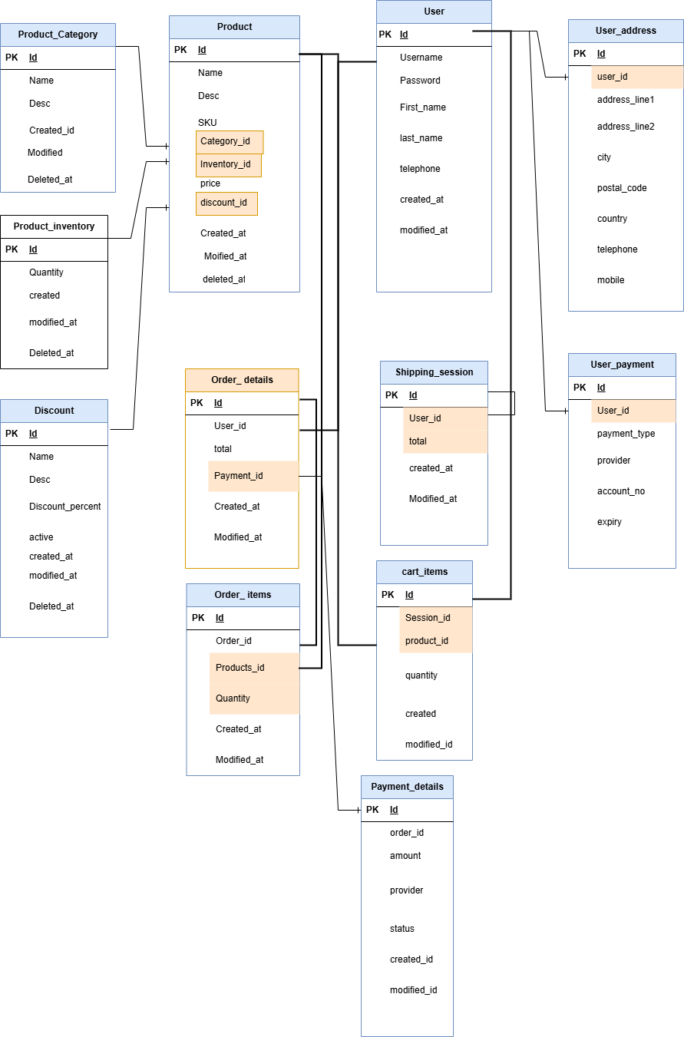

Q7. What is a data flow diagram? Draw a data flow diagram to represent the in-flow and out-flow of data when a Farmer is placing an order for the product

A Data Flow Diagram (DFD) is a visual representation of how data moves within a system. **It illustrates how data enters, is processed, stored, and exits a system, making it useful for understanding system** workflows and improving efficiency.

Key Components of a DFD:

External Entities – Sources or destinations of data (e.g., users, systems).

Processes – Transformations that manipulate data (e.g., calculations, business rules).

Data Stores – Places where data is stored (e.g., databases, files).

Data Flows – Arrows showing how data moves between entities, processes, and stores.

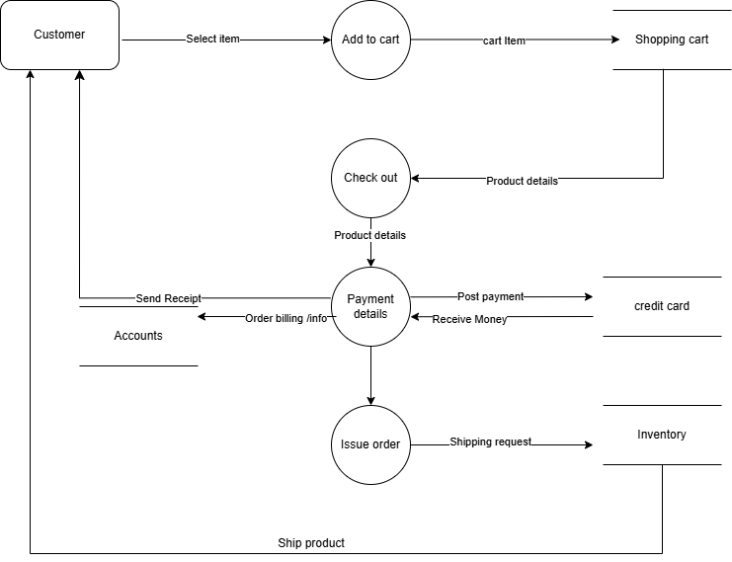

Q8. Due to change in the Government Taxation structure . we should change the Tax structure How do you handle change requests in a project?

1. Identify the Change .

* Receive the change request from stakeholders, government regulations, or internal teams.
* In this case, the request is due to a change in the government taxation structure, making it mandatory.

2. Document the Change .

* Clearly define the nature of the change, including the reason, **scope**, and impact.
* Record it in a Change Request Document (CRD) or a project management tool.

3. Analyze the Impact .

Conduct an Impact Analysis to determine:

* Effect on existing tax calculations and system modules.
* Any changes required in databases, APIs, reports, or UI.
* Cost, timeline, and resource implications.
* Compliance and legal considerations.

4. Seek Stakeholder Approval .

* Present the findings to key stakeholders, including the project sponsor, finance, and development teams.
* Gain approval before proceeding with implementation.

5. Plan and Prioritize .

* If the change is critical (such as tax compliance), prioritize it in the development cycle.
* Update the project roadmap and timelines accordingly.

6. Implement the Change .

* Update system configurations, tax calculation modules, and relevant components.
* Conduct thorough testing (Unit, Integration, and UAT) to ensure accuracy.

7. Communicate Updates .

* Notify all relevant teams (finance, development, QA, end-users) about the change.
* Provide necessary training or documentation if required.

8. Monitor and Validate .

* Post-implementation, monitor the system to ensure smooth functioning.
* Validate with stakeholders that the change meets compliance and business needs

Question 9 – Change Request Vs an Enhancement –

As the project is in process, Ben and Kevin have contacted you. The reason is to inform you that they want the Farmers to sell their crop yields through this application i.e. Farmers should be able to add their crop yields or products and display to general public and should be able to sell them. They also want to introduce Auction system for their Crop yields. As a BA, what will be your response? Is this a change request or an enhancement???

As a Business Analyst, my role is to evaluate the nature of the request and classify it appropriately to ensure proper handling.

#### ****Understanding the Request:****

* **Ben and Kevin’s Request:**
  + Farmers should be able to **add and display crop yields** for sale.
  + Farmers should be able to **sell crops through the application**.
  + An **auction system** should be introduced for crop yields.

#### ****Is This a Change Request or an Enhancement?****

**Enhancement**  
This request qualifies as an **enhancement** rather than a change request because:

1. **New Functionality:** These features were not part of the original project scope but are being introduced as additional functionalities.
2. **Not a Correction or Compliance Change:** Unlike a change request (which typically involves fixing an issue, aligning with compliance, or modifying an existing feature), this introduces **new capabilities** to the system.
3. **Strategic Business Expansion:** The request is focused on improving the application by adding new business opportunities rather than modifying an existing feature.

#### ****BA's Next Steps:****

1. **Gather Detailed Requirements:**
   * Understand the workflow for farmers adding products.
   * Define the auction process and bidding system.
2. **Conduct Feasibility Analysis:**
   * Assess system, database, and UI modifications.
   * Estimate cost, time, and resource impact.
3. **Stakeholder Discussion & Approval:**
   * Present impact analysis to decision-makers.
   * Prioritize based on business value.
4. **Plan Implementation:**
   * Include enhancements in future releases or as a separate project phase.

#### ****Final Answer:****

Since this request introduces **new features**, it is classified as an **Enhancement** rather than a Change Request.

Question 10 – Estimations

Come up with estimations – How many Manhours required

**1. Requirement Gathering & Analysis**

* **Role Involved:** Business Analyst (BA)
* **Tasks:**
  + Gathering stakeholder requirements
  + Creating BRD (Business Requirement Document)
  + Reviewing & finalizing requirements with stakeholders
  + Preparing wireframes/mockups
  + Conducting requirement review meetings

**Estimation:**

* **1 BA** working **6 hours/day** for **approx. 3 months (60 working days)**
* **Total Manhours = 1 × 6 × 60 = 360 hours**
* Adding buffer for revisions, approvals, and documentation updates: **+140 hours**
* **Final Estimation: 500 hours**

**2. UI/UX Design**

* **Role Involved:** UI/UX Designer
* **Tasks:**
  + Designing wireframes & prototypes
  + Creating UI components
  + Reviewing designs with stakeholders
  + Updating designs based on feedback

**Estimation:**

* **1 UI/UX Designer** working **5 hours/day** for **80 working days (~4 months)**
* **Total Manhours = 1 × 5 × 80 = 400 hours**
* **Final Estimation: 400 hours**

**3. Development (Frontend, Backend, Database)**

* **Roles Involved:**
  + Senior Java Developer (1)
  + Java Developers (4)
  + DB Admin (1)
* **Tasks:**
  + Frontend Development (UI, User Authentication, Product Listings, Cart, Payment Gateway)
  + Backend Development (APIs, Business Logic, Security, Integration)
  + Database Design & Optimization

**Estimation:**

* **5 Developers (1 Senior + 4 Developers)** working **7 hours/day** for **120 working days (~6 months)**
* **Total Manhours = 5 × 7 × 120 = 4200 hours**
* Adding **DB Admin efforts** (working **6 hours/day** for 50 days): **300 hours**
* **Final Estimation: 4500 hours**

**4. Testing (QA/UAT)**

* **Roles Involved:** Testers (2)
* **Tasks:**
  + Test case preparation
  + Functional testing
  + Bug fixing & retesting
  + Performance & security testing

**Estimation:**

* **2 Testers** working **6 hours/day** for **67 working days (~3.5 months)**
* **Total Manhours = 2 × 6 × 67 = 804 hours**
* **Final Estimation: 800 hours** (Rounded)

**5. Deployment & Go-Live Support**

* **Roles Involved:** Network Admin + DB Admin + Developers
* **Tasks:**
  + Server setup
  + Security configurations
  + Deployment & troubleshooting
  + Post-go-live monitoring

**Estimation:**

* **3 Resources (Network Admin + DB Admin + 1 Developer)** working **5 hours/day** for **20 working days (~1 month)**
* **Total Manhours = 3 × 5 × 20 = 300 hours**
* **Final Estimation: 300 hours**

**6. Project Management & Coordination**

* **Role Involved:** Project Manager
* **Tasks:**
  + Project planning & tracking
  + Risk management
  + Team coordination
  + Client communication

**Estimation:**

* **1 Project Manager** working **5 hours/day** for **100 working days (~5 months)**
* **Total Manhours = 1 × 5 × 100 = 500 hours**
* **Final Estimation: 500 hours**

**Final Calculation Summary**

| **Phase** | **Estimated Hours** |
| --- | --- |
| **Requirement Gathering & Analysis** | 500 hours |
| **UI/UX Design** | 400 hours |
| **Development (Frontend, Backend, DB)** | 4500 hours |
| **Testing (QA/UAT)** | 800 hours |
| **Deployment & Go-Live Support** | 300 hours |
| **Project Management & Coordination** | 500 hours |
| **Total Estimated Manhours** | **7000 hours** |

**Final Conclusion**

Total Estimated Effort: ~7000 Manhours  
Project Duration: 18 Months

Resources Involved: 10-12 team members

Question 11 – UAT – 6 Marks

Project has finally completed all the stages i.e., design, development, testing etc. Now, it is the role of a business analyst to contact the client for testing of the final product and have to successfully complete it. How are you going to handle this situation? And once it is done, what will be the process to close the project? Explain UAT Acceptance process

UAT is the final testing phase where real users (clients or business stakeholders) test the system to make sure it works **exactly as expected** before going live.

### ****Step-by-Step UAT Process****

### ****1.Planning & Preparation****

Before testing starts, we:

* Select the people who will test (farmers, manufacturers, stakeholders)
* Decide what needs to be tested (login, product catalog, payments, order tracking, etc.)
* Set up a test environment with real-like data
* Prepare test cases (scenarios to check if everything works)

**Example:** A farmer should be able to log in, search for seeds, add them to the cart, and place an order.

### ****2.Executing UAT****

Users **start testing** the system by performing real tasks.

* They follow the test cases and check if everything is working as expected
* If something is broken, they report the issue
* The development team fixes the issues
* Users re-test after fixes

**Example:** A farmer tries to pay using UPI, but it fails. The issue is reported and fixed by developers.

### ****3.UAT Sign-Off****

* After all issues are fixed, users confirm that everything is working
* A **UAT Sign-Off Document** is prepared and signed by the client
* The system is now **approved for go-live**

**Example:** The client signs the document saying, “The platform is working as expected.”

### ****4.Go-Live & Support****

* The system is **launched** for real use
* Training is given to users if needed
* The team monitors for any issues after going live

**Example:** Farmers and manufacturers start using the platform to buy and sell products.

### ****Simple Summary****

1. **Plan** (Decide what to test)  
**2.Test** (Users check the system)

3. **Fix** (Developers solve issues)  
**4.Approve** (Client gives final confirmation)  
**5.Go Live** (System is launched for real use)

Question 12 – Project Closure Document - 6 Marks Explain Project closure document

A **Project Closure Document** is a final report that confirms the successful completion of a project. It ensures that all objectives have been met, stakeholders are satisfied, and no pending issues remain.

1.**Complete All Work** – Ensure all tasks and deliverables are finished.

2.**Get Approvals** – Obtain sign-off from stakeholders confirming project completion.

3.**Review the Project** – Check if goals were met and evaluate success.

4.**Document Lessons Learned** – Identify what went well and what can be improved.

5.**Handover Deliverables** – Transfer final products, documents, or services to the client or relevant team.

6.**Release Resources** – Free up team members, close contracts, and return unused funds.

7.**Officially Close the Project** – Archive documents, finalize reports, and formally announce project closure.

8.**Celebrate Success** – Recognize team efforts and achievements!

Project closure document

|  |  |  |  |  |
| --- | --- | --- | --- | --- |
| Sl no. | Points to include | Details | Reference Link |  |
| 1 | Did the client sign of on the UAT testing |  |  |  |
|  | Date of sign off : | 01.02.2025 | Business_Scope.docx |  |
|  | Name of the resource | Mr. Jason |  |  |
| 2 | Objective of the project |  |  |  |
|  | User friendliness | Achieved |  |  |
|  | Customer Satisfaction | Return on Investemt(ROI) in 6 months |  |  |
|  | More categories | Achieved |  |  |
| 3 | Functionalities worked on |  |  |  |
|  | Secure payment processing | Achieved | FRD.docx |  |
|  | Categoires | Achieved |  |  |
| 4 | Infrastructure |  |  |  |
|  | Softwares installed | Achieved | Procurement.docx |  |
|  | Laptops purchased | Achieved |  |  |
| 5 | Funding |  |  |  |
|  | Amount approved | Rs.2 crore | Financialdetails.xlsx |  |
|  | Amount used | Rs.1.8 crore |  |  |
| 6 | Overall project information |  |  |  |
|  | Escalations | 30 |  |  |
|  | Customer Satisfaction | High |  |  |
| 7 | Value to the company |  |  |  |
|  | Positive/Negative | Company has gained sucessful integration process,increased turnover by 20% and efficiency by 20%. |  |  |