Assignment 1

Q1. Please make a BRD which can be presented to the client along with complete development and resource plan

Ans.

BRD for Ice-Cream & Milk Products Company

Business Requirements Document (BRD)
Project Name: Inventory and Delivery Management System
Project ID: IMD-001
Version ID: 1.0
Author: Aman (Business Analyst, APT IT Solutions)

1. Document Revisions
Date | Version | Document Changes
09/10/2025 | 1.0 | Initial Draft Submitted for Client Review

2. Approvals
Role | Name | Title | Signature | Date
Project Sponsor | Mr. Henry | Client Representative
Business Owner | Mr. Pandu | Director, APT IT Solutions
Project Manager | Mr. Vandanam | Project Manager
System Architect | Ms. Juhi | Senior Java Developer
Development Lead | Mr. Karthik | Delivery Head
QA Lead | Ms. Shreya | QA Analyst

3. RACI Chart for This Document
Name | Position | R | A | S | C | I
Aman | Business Analyst | R | A
Mr. Pandu | Business Owner |  |  |  | C | I
Mr. Vandanam | Project Manager |  | A | S
Ms. Juhi | System Architect |  |  | S
Mr. Henry | Client Representative |  |  |  | C | I

4. Introduction

4.1 Business Goals
To design and implement a centralized digital platform for managing inventory across all manufacturing plants and warehouses, and to optimize logistics for faster product delivery to customers.
Organizational Need:
Currently, the company lacks an integrated system to monitor inventory levels and manage dispatches, resulting in delays, overstocking, and wastage.

4.2 Business Objectives
To provide an IT solution for:
- Automated inventory tracking across multiple plants and warehouses.
- Real-time stock level visibility.
- Route optimization for quickest product delivery.
- Integration with delivery partners for live order tracking.
- Data analytics for production and supply chain efficiency.

4.3 Business Rules
- Each product batch must be tagged with a unique Batch ID.
- Expiry-based products must follow FEFO (First Expiry First Out) principle.
- Delivery must be completed within SLA timelines based on region.
- Stock threshold alerts to be auto-triggered.
- Only authorized warehouse managers can update stock levels.

4.4 Background
The company manufactures ice-cream and milk products distributed via multiple warehouses nationwide. Manual tracking and paper-based dispatch logs have caused inconsistencies in inventory records and late deliveries. To address this, management proposed developing a digital solution to streamline operations.

4.5 Project Objective
To build a web and mobile-based application that provides:
- Centralized control of stock availability.
- Efficient supply chain coordination.
- Quickest route and delivery management.
- Integration with existing ERP and POS systems.

4.6 Project Scope

4.6.1 In-Scope Functionality
- Inventory management across plants and warehouses.
- Stock transfer requests and approvals.
- Delivery scheduling and route optimization.
- Real-time order and dispatch tracking.
- Notifications and alerts for low stock and delivery updates.
- Reporting dashboard for management.

4.6.2 Out-of-Scope Functionality
- Direct customer ordering (handled by existing retail partners).
- Payroll and HR-related modules.
- Supplier invoicing and accounting.

5. Assumptions
- Stable internet connectivity at all warehouse and delivery points.
- Employees trained to use the new system.
- Integration APIs available from ERP for product data synchronization.

6. Constraints
- Budget capped at INR 2 Crores.
- Project duration limited to 18 months.
- Dependency on third-party logistics APIs.
- Seasonal production cycles may impact rollout schedule.

7. Risks
Risk Type | Description | Mitigation Strategy
Technological | Integration issues with legacy systems. | Conduct API compatibility testing early.
Skills Risk | Shortage of skilled logistics analysts. | Cross-train internal resources.
Political Risk | Inter-state compliance for food transport. | Ensure legal review of distribution routes.
Business Risk | Delay in implementation may impact seasonal sales. | Adopt phased rollout by region.
Requirements Risk | Unclear warehouse process variations. | Conduct detailed stakeholder workshops.

8. Business Process Overview

8.1 Legacy System (AS-IS)
- Manual stock entries in spreadsheets.
- No centralized monitoring of warehouse inventory.
- Delivery scheduling handled by phone and email.
- Frequent delivery delays due to lack of route coordination.
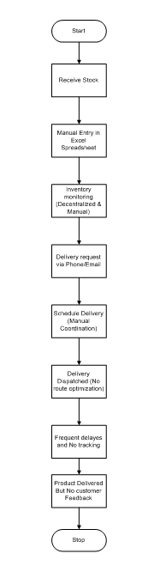

8.2 Proposed Recommendations (TO-BE)
- Centralized digital inventory dashboard.
- Automated stock update after each dispatch.
- Smart route optimization for deliveries.
- Real-time tracking of vehicles and delivery status.
- Performance analytics on delivery timelines and wastage.
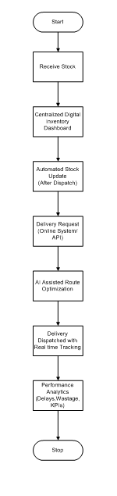

9. Business Requirements
Req ID | Requirement Name | Description | Priority
BR001 | Centralized Inventory | Track stock levels across all warehouses in real-time. | High
BR002 | Stock Transfer Management | Initiate and approve inter-warehouse transfers. | High
BR003 | Delivery Management | Plan, assign, and monitor deliveries for each order. | High
BR004 | Route Optimization | Suggest shortest routes to minimize delivery time. | Medium
BR005 | Notification Alerts | Trigger alerts for low stock or delayed delivery. | Medium
BR006 | Reporting Dashboard | Generate reports on inventory turnover and delivery performance. | High

10. Appendices

10.1 List of Acronyms
Acronym | Description
ERP | Enterprise Resource Planning
SLA | Service Level Agreement
FEFO | First Expiry First Out
API | Application Programming Interface

10.2 Glossary of Terms
Term | Definition
Inventory | The stock of ice-cream and milk products stored in warehouses.
Dispatch | The process of sending products from warehouses to customers or dealers.
Route Optimization | The process of finding the fastest and most cost-efficient delivery route.

10.3 Related Documents
- Business Case Document
- Functional Specification Document
- Requirement Traceability Matrix

Q2. Prepare process flow diagram using your imagination.

Ans. Process Flow Diagram (Inventory & Delivery System)
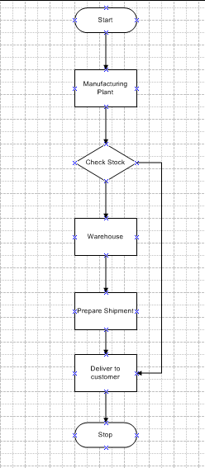

Assignment 2

Q1. Write an introduction letter to a client introducing yourself as a business analyst in charge of working with the client and his team to start the business understanding process.

Ans.

Introduction Letter
Subject: Introduction – Business Analyst for Your Project
Dear Vijaya Dairy,
I am Amandeep Singh, the assigned Business Analyst from APT IT Solutions, and I will be working with you and your team to initiate the business understanding process for your upcoming project. My primary role will be to gather requirements, document business needs, and ensure the development team delivers a solution aligned with your goals.
I look forward to collaborating closely and ensuring that your vision is successfully transformed into a working system.
Best Regards,
Amandeep Singh
Business Analyst – APT IT Solutions

Q2. Prepare a brief BRD and SRS for a project- Horoscope or Ticketing system or online store.

Ans.

Business Requirement Document (BRD) – Support Ticketing system
Project Name: Support Ticketing System
Project ID: STS-001
Version ID: 1.0
Author: Aman (Business Analyst, APT IT Solutions)

1. Document Revisions
Date | Version | Document Changes
09/10/2025 | 1.0 | Initial Draft for Client Review

2. Approvals
Role | Name | Title | Signature | Date
Project Sponsor | Mr. Henry | Client Representative
Business Owner | Mr. Pandu | Director, APT IT Solutions
Project Manager | Mr. Vandanam | Project Manager
System Architect | Ms. Juhi | Senior Developer
Development Lead | Mr. Karthik | Delivery Head
QA Lead | Ms. Shreya | Quality Analyst

3. RACI Chart for This Document
Name | Position | R | A | S | C | I
Aman | Business Analyst | R | A
Mr. Vandanam | Project Manager |  | A | S
Mr. Karthik | Delivery Head |  |  | S | C | I
Mr. Henry | Client Sponsor |  |  |  | C | I
Ms. Juhi | Developer |  |  | S

4. Introduction

4.1 Business Goals
To develop an integrated Support Ticketing System that enables customers to raise, track, and resolve issues efficiently, ensuring faster turnaround times and improved customer satisfaction.

4.2 Business Objectives
To provide an IT solution for:
- Centralized issue reporting and tracking.
- Automated ticket assignment to support agents.
- SLA-based ticket escalation and notifications.
- Reporting and analytics for management review.
- Web and mobile accessibility for users and agents.

4.3 Business Rules
- Each ticket must have a unique Ticket ID.
- Tickets are assigned automatically based on category and priority.
- High-priority tickets must be resolved within the SLA timeframe.
- Only authorized users can modify or close tickets.
- Email and SMS notifications must be sent for status updates.

4.4 Background
Currently, support requests are handled through emails and phone calls, leading to delays and lack of accountability.
The management team decided to implement a digital solution to streamline the support process, monitor agent performance, and improve transparency in issue resolution.

4.5 Project Objective
To build a web-based Support Ticketing System that allows:
- Customers to submit and track tickets.
- Support agents to manage, resolve, and update tickets.
- Managers to monitor SLAs and generate performance reports.

4.6 Project Scope

4.6.1 In-Scope Functionality
- Ticket creation, categorization, and prioritization.
- Role-based access (Admin, Agent, Customer).
- Email/SMS notifications.
- SLA management and escalation.
- Dashboard and reporting features.

4.6.2 Out-of-Scope Functionality
- Chatbot support integration (future phase).
- Integration with third-party CRMs.
- Voice call support module.

5. Assumptions
- All users have access to the internet.
- Admins will define categories and SLAs before go-live.
- System will be hosted on a secure cloud platform.

6. Constraints
- Project budget limited to ₹80 Lakhs.
- Delivery timeline of 6 months.
- Data security must comply with ISO 27001.

7. Risks
Risk Type | Description | Mitigation
Technological | Integration challenges with existing ERP | Conduct early API compatibility testing
Skills Risk | Untrained support staff | Provide onboarding and training
Requirements Risk | Ambiguity in SLA definitions | Conduct workshops with stakeholders
Business Risk | Delayed adoption | Conduct phased rollout and user training

8. Business Process Overview

8.1 Legacy System (AS-IS)
- Customers contact via phone/email.
- No centralized record of issues.
- Difficult to measure response and resolution times.
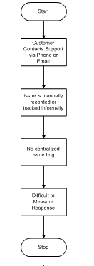

8.2 Proposed Recommendations (TO-BE)
- Web portal for customer ticket submission.
- Automatic assignment and tracking of tickets.
- Escalation alerts for SLA breaches.
- Analytical dashboard for performance review.
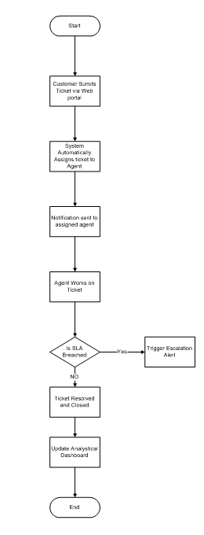

9. Business Requirements
Req ID | Requirement Name | Description | Priority
BR001 | Ticket Creation | Customers can create new tickets with attachments. | High
BR002 | Ticket Assignment | System automatically assigns tickets to agents. | High
BR003 | SLA Tracking | System tracks and escalates based on SLA timers. | High
BR004 | Notifications | Send email/SMS updates for status changes. | Medium
BR005 | Reports | Admin can view ticket analytics and SLA reports. | Medium

10. Appendices

10.1 List of Acronyms
Acronym | Description
SLA | Service Level Agreement
ERP | Enterprise Resource Planning
API | Application Programming Interface

10.2 Glossary of Terms
Term | Definition
Ticket | Record of a customer issue or request.
SLA | Agreed time frame for resolution.

10.3 Related Documents
- Business Case Document
- SRS Document
- RTM Document

SOFTWARE REQUIREMENT SPECIFICATION (SRS)
Project Name: Support Ticketing System
Version: 1.0
Prepared By: Aman (Business Analyst)

1. Introduction
The Support Ticketing System aims to automate customer support operations by digitizing the process of logging, tracking, and resolving service requests.

2. Functional Requirements
Req ID | Functionality | Description
FR001 | User Authentication | Users can register, log in, and access dashboards.
FR002 | Create Ticket | Customers can raise tickets with description and category.
FR003 | Assign Ticket | System auto-assigns tickets based on category or load.
FR004 | Update Status | Agents can change ticket status (Open, In Progress, Resolved, Closed).
FR005 | Notification System | Email/SMS notifications on ticket updates.
FR006 | SLA Monitoring | Timer tracks resolution deadlines with escalation alerts.
FR007 | Reports and Dashboard | Admins can view analytics on open, closed, and overdue tickets.

3. Non-Functional Requirements Work on this:
- Performance:
- 1. System should handle up to 1000 concurrent users.
- 2. Automatic ticket assignment should happen within 2 seconds after submission
- 3. The system must handle up to 10,000 concurrent users without performance degradation
- Reliability
  - 99.5% uptime expected.
  - All ticket data should be backed up daily and retrievable within 1 hour.
  - System should recover from failure within 5 minutes.
- Security:
  - Role-based access and encrypted data storage.
  - Sensitive data (passwords, communication) must be encrypted
  - System must maintain logs of ticket creation, updates, and deletions
- Scalability:
  - Must support multi-department ticket management.
  - New modules (e.g., Chat Support, AI Ticket Classification) should be easily integrable.
- Usability:
  - Intuitive UI for customers and agents.
  - Users should access their tickets within 3 clicks from the homepage

4. System Architecture
- Frontend: Angular or ReactJS
- Backend: Java Spring Boot / Node.js
- Database: MySQL / PostgreSQL
- Hosting: AWS Cloud
- APIs: REST-based integration for notifications and authentication.

5. User Roles
- Customer: Raise and track tickets.
- Support Agent: Manage assigned tickets.
- Admin: Configure categories, SLAs, and view analytics.

6. Future Enhancements
- Integration with chatbots for instant support.
- AI-based ticket categorization.
- Mobile app for field agents.

Q3. Make an ERD of creating a support ticket/Ticketing life cycle.

ERD – Ticketing System (Support Ticket Life Cycle)

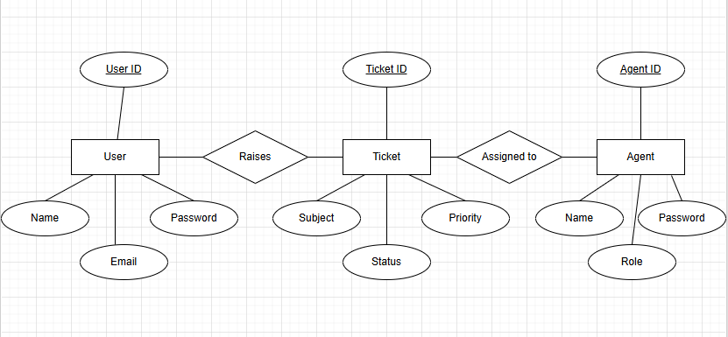

Q4. User Story of Shopping from E-commerce?

Ans. Following are the User Stories:

User Story No: 01 Tasks: 2 Priority: HIGH
AS A CUSTOMER
I WANT TO BROWSE AND SEARCH PRODUCTS BY CATEGORY, BRAND, AND PRICE
SO THAT I CAN EASILY FIND THE ITEMS I WANT TO PURCHASE
BV: 500 CP: 3
ACCEPTANCE CRITERIA:
1. Users can search using keywords.
2. Filters (price range, brand, category) are available.
3. Results display product name, price, and stock availability.

User Story No: 02 Tasks: 2 Priority: HIGH
AS A CUSTOMER
I WANT TO VIEW DETAILED PRODUCT INFORMATION
SO THAT I CAN MAKE AN INFORMED PURCHASE DECISION
BV: 100 CP: 3
ACCEPTANCE CRITERIA:
1. Product page shows name, description, price, and stock status.
2. High-quality product images are available.
3. Customer ratings and reviews are visible.

User Story No: 03 Tasks: 2 Priority: HIGH
AS A CUSTOMER
I WANT TO ADD PRODUCTS TO MY SHOPPING CART
SO THAT I CAN PURCHASE MULTIPLE ITEMS IN A SINGLE CHECKOUT
BV: 500 CP: 5
ACCEPTANCE CRITERIA:
1. Cart allows adding/removing items.
2. Quantity can be increased/decreased.
3. Cart updates total price dynamically.

User Story No: 04 Tasks: 3 Priority: HIGHEST
AS A CUSTOMER
I WANT TO CHECKOUT AND PAY SECURELY
SO THAT I CAN COMPLETE MY PURCHASE
BV: 1000 CP: 13
ACCEPTANCE CRITERIA:
1. Multiple payment options (Credit Card, UPI, Net Banking, Wallets).
2. Billing and shipping details are required.
3. Order confirmation message is displayed after payment.

User Story No: 05 Tasks: 2 Priority: HIGH
AS A CUSTOMER
I WANT TO RECEIVE AN ORDER CONFIRMATION EMAIL/SMS
SO THAT I HAVE PROOF AND DETAILS OF MY PURCHASE
BV: 100 CP: 2
ACCEPTANCE CRITERIA:
1. Confirmation includes order ID, item details, price, and delivery date.
2. Email/SMS sent within 1 minute of order placement.

User Story No: 06 Tasks: 2 Priority: HIGH
AS A CUSTOMER
I WANT TO TRACK MY ORDER STATUS ONLINE
SO THAT I KNOW WHEN TO EXPECT DELIVERY
BV: 50 CP: 5
ACCEPTANCE CRITERIA:
1. Order status updates: Processing → Shipped → Out for Delivery → Delivered.
2. Tracking link provided via email/SMS.
3. Real-time updates visible in user’s account.

User Story No: 07 Tasks: 2 Priority: HIGH
AS A CUSTOMER
I WANT MY ORDER DELIVERED TO MY SELECTED ADDRESS
SO THAT I RECEIVE MY PRODUCTS CONVENIENTLY
BV: 100 CP: 8
ACCEPTANCE CRITERIA:
1. Delivery person contact details shared.
2. Estimated delivery time displayed.
3. Proof of delivery captured (OTP or signature).

User Story No: 08 Tasks: 2 Priority: MEDIUM
AS A CUSTOMER
I WANT TO RETURN OR REPLACE DEFECTIVE PRODUCTS
SO THAT I AM ASSURED OF PRODUCT QUALITY
BV: 20 CP: 1
ACCEPTANCE CRITERIA:
1. Return request can be raised within X days.
2. Refund/Replacement option provided.
3. Notifications sent for return status.

