**Question 1 – Functional Requirements. Identify minimum 20 functional requirements.**

**Functional Requirements**

Functional requirements define the specific behaviors, functions or operations of a system. They describe what the system should do, outlining the necessary tasks, actions or activities is must perform to achieve its objectives

According to case study below example of functional requirements.

|  |  |  |  |
| --- | --- | --- | --- |
| **Req ID** | **Req Name** | **Req Description** | **Priority** |
| FR001 | User Registration & Log in | Users should be able to do sign up, log in & log out. | 10 |
| FR002 | Search for the products | Users should be able to search for the available products | 8 |
| FR003 | Adding products to the Cart | Users should be able to add the products to the cart | 8 |
| FR004 | Adding product to the Wishlist | Users should be able to add the products to the Wishlist | 8 |
| FR005 | Payment with different modes | Users should be able to make payment with different modes | 9 |
| FR006 | Product details | Users should be able to view detail information about the project | 8 |
| FR007 | Order Tracking | Users should be able to track the status of their orders | 8 |
| FR008 | Refill stock | Manufacturing companies should be able refill stock | 8 |
| FR009 | Customer review | Users should be able to reviews or rating for purchased product | 8 |
| FR010 | View Past purchase | User should be able to view past purchase | 8 |

**Non-Functional Requirements**

Non functional requirements will describe the qualities and attributes of a system, focusing on how the system performs rather than specific behaviors or functions.

According to case study below example of Non functional requirements.

|  |  |  |  |
| --- | --- | --- | --- |
| **Req ID** | **Req Name** | **Req Description** | **Priority** |
| NFR001 | Usability | The application should be user friendly and easy to navigate | 9 |
| NFR002 | Performance | The application must load pages within 3 second | 10 |
| NFR003 | Security | The application must ensure secure user authentication | 10 |
| NFR004 | Compatibility | The application must work for all devices, including desktop, tablet and smartphone | 10 |
| NFR005 | Response Time | The application should respond to user inputs within 2 second, it should not exceed 2 seconds. | 9 |
| NFR006 | Availability | The application should be available 100 % | 10 |
| NFR007 | Localization | The application should be supporting multiple language | 8 |
| NFR008 | Maintainability | The application should allow easy update | 9 |
| NFR009 | Scalability | The application must handle up to 10,000 users simultaneously | 10 |
| NFR010 | Backup &Recovery | The application must do back up & recovery regularly to prevent loss | 9 |

**Question 2–Minimum 5-page designs -Make wireframe and prototypes**

Wireframe is a basic blueprint or outline of a design. It shows the layout, structure and arrangement of elements like button, image and text. Wireframe are usually simple and lack colors, detailed graphics or interactive features. Think it like a skeleton or sketch of a website or app.

Prototype is a working model of the design, it looks and functions closer to the final product, often including colors, and clickable elements to show how user would interact with it, its like a demo version can test out.

Here I have used Axure tool for creating screen and pages, as per below.

1. Login Page
2. Home Page
3. Cart Page
4. Payment Page
5. Payment successful Page

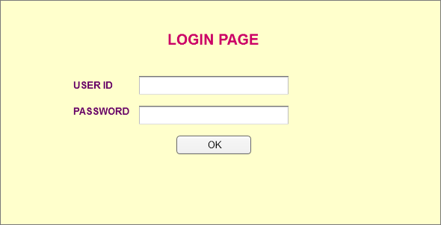

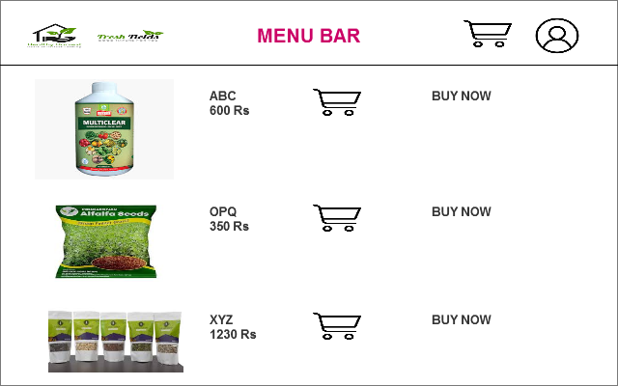

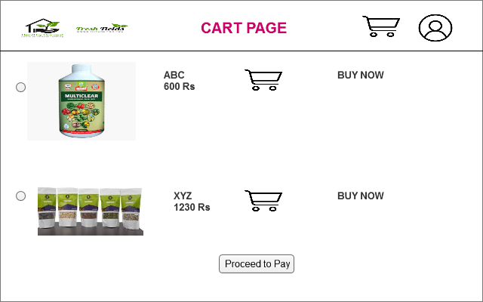

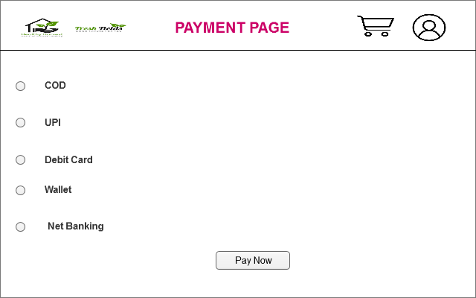

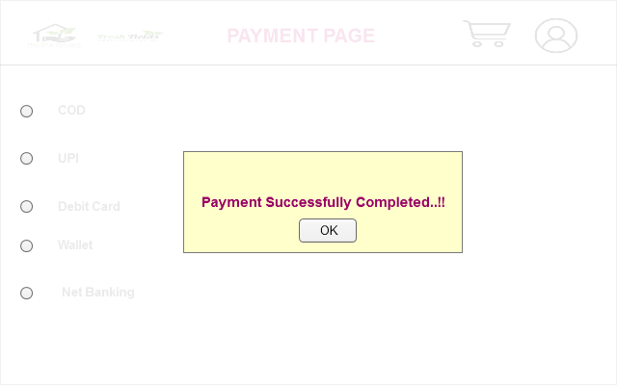

**Question 3 – Tools (Visio, Balsamiq) Make a note of the Tools, which you are using for above concepts**

During a project Business Analyst play multiple role. Such as gather requirements, document the requirements and model the requirements. One of the very important responsibilities of BA is modelling requirements and modelling the requirements means changing the requirements in visual representation and for this BA use different tool such as , Balsamiq, Axure, MS Visio

**Balsamiq-** Balsamiq is basically design tool which is created by the one of ex-employee of Adobe. The main purpose to create the wireframe or mock-ups. Wireframe means showing frontend in very simple manner. We use Balsamiq tool to create a dummy model which will look front page of end application. In brief Balsamiq is rapid wireframing tool used to create makeups and prototypes of user interface.

**Axure-** Under the waterfall model we have multiple phases, and the third phase is design phase we would model requirement based on the need of the client. To create wireframe and mock-up we use Axure tool as well. Axure is more advanced prototyping tool used to create high fidelity, interactive wireframe and prototypes for web and mobile application.

**MS Visio-** Microsoft Visio is a diagramming and vector graphic application that is part of the Microsoft Office family. Ms Visio is used to create diagrams such as flowchart, Use case diagram, Activity diagram, organisational chart, floor plan and more. It allows users to add connect shapes, text to show relationship in their data and create visual representation of process and system.

MS Office Visio is a tool is the process of making complex diagram, especially for business purpose. It can help in the making presentation. Listed below are some uses of Visio.

Flowchart is helps to show the steps in sequential order. These are steps that need to be taken to complete a certain process. It is effective in conveying information. Thus, it can be used in various another field too.

Business process modelling notation BPMN is a flowchart method of displaying all the process in a business that is to be taken. In other words, it is helps in give a clear understanding of the process in a particular business through visual representation.

Organisation chart, an organisation chart displays the roles and reporting relationships in business organisation, it can be used in also any other organisation. It despite the names and position of employees in a company. In short, we can say it shows structure of an organisation. Architectures used this tool for floor plan.

**Question 4 – RTM –** Mr. Henry and peter have approached you regarding the current status of the project. How will you tackle this situation.

RTM stands for Requirements Traceability Matrix. It helps to ensure that all the requirements have been addressed in the way they wanted. It is a document to track the requirements throughout the project lifecycle, ensuring that they are met and not requirements are overlooked. A business analyst’s key responsibilities are to keep track of the requirements and make sure that no requirement is missed.

According to case study RTM is prepared is give below

|  |  |  |  |  |  |  |  |  |  |  |  |  |
| --- | --- | --- | --- | --- | --- | --- | --- | --- | --- | --- | --- | --- |
| **Req ID** | **Req Name** | **Req Description** | **Design** | **D1** | **T1** | **D2** | **T2** | **D3** | **T3** | **D4** | **T4** | **UAT** |
| FR001 | User Registration & Log in | Users should be able to do sign up, log in & log out. | Comp | Comp | Comp | Comp | Comp | Comp | Comp | Comp | Comp | Comp |
| FR002 | Search for the products | Users should be able to search for the available products | Comp | Comp | Comp | Comp | Comp | Comp | Comp | Comp | Comp | Comp |
| FR003 | Adding products to the Cart | Users should be able to add the products to the cart | Comp | Comp | Comp | Comp | Comp | Comp | Comp | Comp | Comp | Comp |
| FR004 | Adding product to the Wishlist | Users should be able to add the products to the Wishlist | Comp | Comp | Comp | Comp | Comp | Comp | Comp | Comp | Comp | Comp |
| FR005 | Payment with different modes | Users should be able to make payment with different modes | Comp | Comp | Comp | Comp | Comp | Comp | Comp | Comp | Comp | Comp |
| FR006 | Product details | Users should be able to view detail information about the project | Comp | Comp | Comp | Comp | Comp | Comp | Comp | Comp | Comp | Comp |
| FR007 | Order Tracking | Users should be able to track the status of their orders | Comp | Comp | Comp | Comp | Comp | Comp | Comp | Comp | Comp | Comp |
| FR008 | Refill stock | Manufacturing companies should be able refill stock | Comp | Comp | Comp | Comp | Comp | Comp | Comp | Comp | Comp | Comp |
| FR009 | Customer review | Users should be able to reviews or rating for purchased product | Comp | Comp | Comp | Comp | Comp | Comp | Comp | Comp | Comp | Incomp |
| FR010 | View Past purchase | Admin should be able to view past purchase | Comp | Comp | Comp | Comp | Comp | Comp | Comp | Comp | Comp | Incomp |
| NFR001 | Usability | The application should be user friendly and easy to navigate | Comp | Comp | Comp | Comp | Comp | Comp | Comp | Comp | Comp | Incomp |
| NFR002 | Performance | The application must load pages within 3 second | Comp | Comp | Comp | Comp | Comp | Comp | Comp | Comp | Incomp | Incomp |
| NFR003 | Security | The application must ensure secure user authentication | Comp | Comp | Comp | Comp | Comp | Comp | Comp | Comp | Incomp | Incomp |
| NFR004 | Compatibility | The application must work for all devices, including desktop, tablet and smartphone | Comp | Comp | Comp | Comp | Comp | Comp | Comp | Comp | Incomp | Incomp |
| NFR005 | Response Time | The application should respond to user inputs within 2 second, it should not exceed 2 seconds. | Comp | Comp | Comp | Comp | Comp | Comp | Comp | Incomp | Incomp | Incomp |
| NFR006 | Availability | The application should be available 100 % | Comp | Comp | Comp | Comp | Comp | Comp | Comp | Incomp | Incomp | Incomp |
| NFR007 | Localization | The application should be support multiple language | Comp | Comp | Comp | Comp | Comp | Incomp | Incomp | Incomp | Incomp | Incomp |
| NFR008 | Maintainability | The application should allow easy update | Comp | Comp | Comp | Comp | Comp | Incomp | Incomp | Incomp | Incomp | Incomp |
| NFR009 | Scalability | The application must handle upto 10,000 users simultaneously | Comp | Comp | Comp | Comp | Incomp | Incomp | Incomp | Incomp | Incomp | Incomp |
| NFR010 | Backup & Recovery | The application must do back up & recovery regularly to prevent loss | Comp | Comp | Incomp | Incomp | Incomp | Incomp | Incomp | Incomp | Incomp | Incomp |

**Question 5 – 10 Test Case Documents -** **Prepare 10 Test Case Documents**

Test case document It’s a kind of document is detailed outline used by tester to ensure that a software application or system is working as expected. According to case study sample of 10 Test Case documents as per below.

|  |  |  |  |
| --- | --- | --- | --- |
| **Test Case ID** | **TC001** | **Test Case Name** | **Search Query** |
| **Project ID** | PRJ001 | **Project Name** | Online Agriculture Application |
| **PM ID** | PM001 | **PM Name** | Mr. XYZ |
| **Test Strategy ID** | TS001 | **Tester ID** | APT00023 |
| **Test Plan ID** | TP001 | **Tester Name** | Ms. OPQ |
| **Test Schedule ID** | TSCH001 | **Date of Test** | 30-12-2024 |
| **Scenario :** Mandatory details need to field new Users registration | | | |
| **Link to that page:** | | | |
| **Input Data** | **Set 1** | | |
| First Name | | |
| Last Name | | |
| Mobile Number | | |
| Password | | |
| **Expected Behavior** | Mandatory field are marked with * against the field. | | |
| **Actual Behavior** |  | | |
| **Comments** |  | | |
| **Result Pass/Fail** |  | | |
|  |  | | |

|  |  |  |  |
| --- | --- | --- | --- |
| **Test Case ID** | TC002 | **Test Case Name** | **Search Query** |
| **Project ID** | PRJ001 | Project Name | Online Agriculture Application |
| **PM ID** | PM001 | PM Name | Mr. XYZ |
| **Test Strategy ID** | TS001 | Tester ID | APT00023 |
| **Test Plan ID** | TP001 | Tester Name | Ms. OPQ |
| **Test Schedule ID** | TSCH001 | Date of Test | 30-12-2024 |
| **Scenario :** Verify User Log In functionality | | | |
| **Link to that page:** | | | |
| **Input Data** | **Set 1** | | |
| Open the application | | |
| Entre Valid credential | | |
| Click Log in | | |
| **Expected Behavior** | User Log In and redirected to the Dashboard | | |
| **Actual Behavior** |  | | |
| **Comments** |  | | |
| **Result Pass/Fail** |  | | |

|  |  |  |  |
| --- | --- | --- | --- |
| **Test Case ID** | TC003 | **Test Case Name** | **Search Query** |
| **Project ID** | PRJ001 | Project Name | Online Agriculture Application |
| **PM ID** | PM001 | PM Name | Mr. XYZ |
| **Test Strategy ID** | TS001 | Tester ID | APT00023 |
| **Test Plan ID** | TP001 | Tester Name | Ms. OPQ |
| **Test Schedule ID** | TSCH001 | Date of Test | 30-12-2024 |
| **Scenario:** Search for a product “Soyabean Seeds” | | | |
| **Link to that page:** | | | |
| **Input Data** | **Set 1** | | |
| Customer click on Search product “Soyabean” | | |
| Soyabean | | |
| 1 Kg | | |
| 500 Rs/Kg | | |
| **Expected Behavior** | Application shows more than 10 types of Soyabean Seeds products from various companies. | | |
| **Actual Behavior** |  | | |
| **Comments** |  | | |
| **Result Pass/Fail** |  | | |

|  |  |  |  |
| --- | --- | --- | --- |
| **Test Case ID** | TC004 | **Test Case Name** | **Search Query** |
| **Project ID** | PRJ001 | Project Name | Online Agriculture Application |
| **PM ID** | PM001 | PM Name | Mr. XYZ |
| **Test Strategy ID** | TS001 | Tester ID | APT00023 |
| **Test Plan ID** | TP001 | Tester Name | Ms. OPQ |
| **Test Schedule ID** | TSCH001 | Date of Test | 30-12-2024 |
| **Scenario :** Verify Wishlist functionality | | | |
| **Link to that page:** | | | |
| **Input Data** | **Set 1** | | |
| Customer Select a product | | |
| Add to Wishlist | | |
| Select product quantity | | |
| **Expected Behavior** | Product and its quantity added to the Wishlist and displayed correctly | | |
| **Actual Behavior** |  | | |
| **Comments** |  | | |
| **Result Pass/Fail** |  | | |

|  |  |  |  |
| --- | --- | --- | --- |
| **Test Case ID** | TC005 | **Test Case Name** | **Search Query** |
| **Project ID** | PRJ001 | Project Name | Online Agriculture Application |
| **PM ID** | PM001 | PM Name | Mr. XYZ |
| **Test Strategy ID** | TS001 | Tester ID | APT00023 |
| **Test Plan ID** | TP001 | Tester Name | Ms. OPQ |
| **Test Schedule ID** | TSCH001 | Date of Test | 30-12-2024 |
| **Scenario :** Verify order placement | | | |
| **Link to that page:** | | | |
| **Input Data** | **Set 1** | | |
| Proceed to checkout | | |
| Entre shipping details | | |
| Choose payment method | | |
| Place order | | |
| **Expected Behavior** | Order is placed successfully and confirmation message is displayed | | |
| **Actual Behavior** |  | | |
| **Comments** |  | | |
| **Result Pass/Fail** |  | | |

|  |  |  |  |
| --- | --- | --- | --- |
| **Test Cse ID** | TC006 | **Test Case Name** | **Search Query** |
| **Project ID** | PRJ001 | Project Name | Online Agriculture Application |
| **PM ID** | PM001 | PM Name | Mr. XYZ |
| **Test Strategy ID** | TS001 | Tester ID | APT00023 |
| **Test Plan ID** | TP001 | Tester Name | Ms. OPQ |
| **Test Schedule ID** | TSCH001 | Date of Test | 30-12-2024 |
| **Scenario :** Verify debit card payment functionality on application | | | |
| **Link to that page:** | | | |
| **Input Data** | **Set 1** | | |
| Check different payment option | | |
| Entre Card details | | |
| Entre Payment details | | |
| **Expected Behavior** | Text confirmation with order number generated | | |
| **Actual Behavior** |  | | |
| **Comments** |  | | |
| **Result Pass/Fail** |  | | |

|  |  |  |  |
| --- | --- | --- | --- |
| **Test Case ID** | TC007 | **Test Case Name** | **Search Query** |
| **Project ID** | PRJ001 | Project Name | Online Agriculture Application |
| **PM ID** | PM001 | PM Name | Mr. XYZ |
| **Test Strategy ID** | TS001 | Tester ID | APT00023 |
| **Test Plan ID** | TP001 | Tester Name | Ms. OPQ |
| **Test Schedule ID** | TSCH001 | Date of Test | 30-12-2024 |
| **Scenario :** Verify order status tracking | | | |
| **Link to that page:** | | | |
| **Input Data** | **Set 1** | | |
| Customer - Login | | |
| Click on -Go to my orders | | |
| Check status of a recent order | | |
| **Expected Behavior** | Order status is displayed correctly " Processing / Shipped" | | |
| **Actual Behavior** |  | | |
| **Comments** |  | | |
| **Result Pass/Fail** |  | | |

|  |  |  |  |
| --- | --- | --- | --- |
| **Test Cse ID** | TC008 | **Test Case Name** | **Search Query** |
| **Project ID** | PRJ001 | Project Name | Online Agriculture Application |
| **PM ID** | PM001 | PM Name | Mr. XYZ |
| **Test Strategy ID** | TS001 | Tester ID | APT00023 |
| **Test Plan ID** | TP001 | Tester Name | Ms. OPQ |
| **Test Schedule ID** | TSCH001 | Date of Test | 30-12-2024 |
| **Scenario :** Verify delivery boy Login functionality | | | |
| **Link to that page:** | | | |
| **Input Data** | **Set 1** | | |
| Delivery boy click on application | | |
| Login into the app | | |
| Checks assigned order | | |
| **Expected Behavior** | Delivery boy sees assigned order and statuses | | |
| **Actual Behavior** |  | | |
| **Comments** |  | | |
| **Result Pass/Fail** |  | | |

|  |  |  |  |
| --- | --- | --- | --- |
| **Test Case ID** | TC009 | **Test Case Name** | **Search Query** |
| **Project ID** | PRJ001 | Project Name | Online Agriculture Application |
| **PM ID** | PM001 | PM Name | Mr. XYZ |
| **Test Strategy ID** | TS001 | Tester ID | APT00023 |
| **Test Plan ID** | TP001 | Tester Name | Ms. OPQ |
| **Test Schedule ID** | TSCH001 | Date of Test | 30-12-2024 |
| **Scenario :** Verify order review and rating submission | | | |
| **Link to that page:** | | | |
| **Input Data** | **Set 1** | | |
| Got to "My Orders" | | |
| Select delivered orders | | |
| Submit review and rating | | |
| **Expected Behavior** | Review and ratings are successfully submitted and displayed | | |
| **Actual Behavior** |  | | |
| **Comments** |  | | |
| **Result Pass/Fail** |  | | |

|  |  |  |  |
| --- | --- | --- | --- |
| **Test Case ID** | TC0010 | **Test Case Name** | **Search Query** |
| **Project ID** | PRJ001 | Project Name | Online Agriculture Application |
| **PM ID** | PM001 | PM Name | Mr. XYZ |
| **Test Strategy ID** | TS001 | Tester ID | APT00023 |
| **Test Plan ID** | TP001 | Tester Name | Ms. OPQ |
| **Test Schedule ID** | TSCH001 | Date of Test | 30-12-2024 |
| **Scenario :** Verify manufacturing order notification | | | |
| **Link to that page:** | | | |
| **Input Data** | **Set 1** | | |
| Customer select desired order | | |
| Customer placed a bulk order | | |
| Notification is set to the manufacturing company | | |
| **Expected Behavior** | Manufacturing company receives order details | | |
| **Actual Behavior** |  | | |
| **Comments** |  | | |
| **Result Pass/Fail** |  | | |

**Question 6 – DB Design.**

**After the requirements are thoroughly explained to the entire project team by business analyst, the Database architects have decided to do the database design and also to represent the in-flow and out-flow of data.**

**Draw database schema and ER diagram.**

In an IT application data save in data base, later on this data can be use for reporting or retrieval purposes.

Data base is collection of tables. Generally, table will have table names, entities and table record. All

tables + Entities = Data Base Schema (DB Schema) . A data base schema is a logical structure of data base, it defines how data organise and how relationship between data are structured.

DB Schema + ER Diagram = Data Base design (DB Design)

In table, entities are related with each other, that is represented through ER diagram which is known as entity relationship diagram (ER Diagram). ER diagram is visual representation of the data base schema.

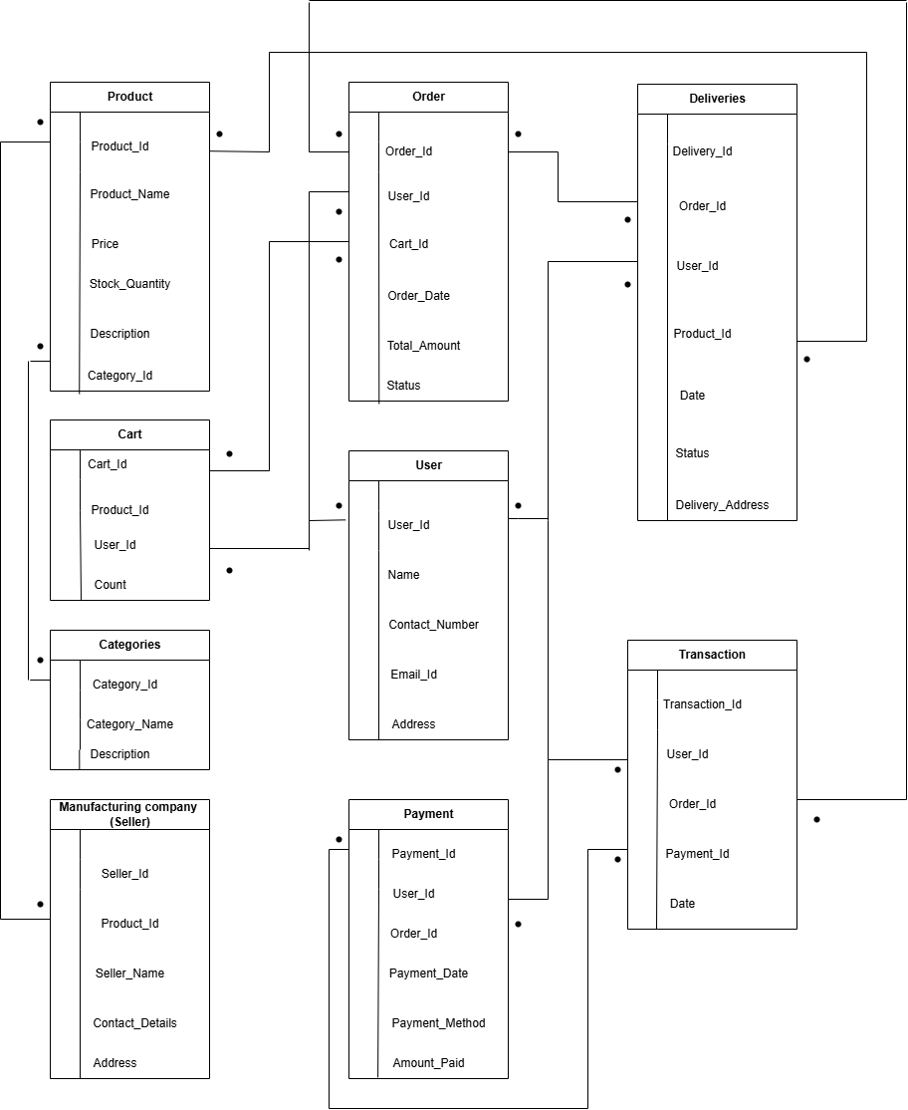

**Question 7 – Data Flow Diagram**

**What is a data flow diagram? Draw a data flow diagram to represent the in-flow and out-flow of data when a Farmer is placing an order for the product**

Data flow diagram is provides information about the input and output of each entity and the process itself. A data flow diagram is a way of representing a flow data through a process or a system usually an information system. It providers clear overview of the system functions and data handling.

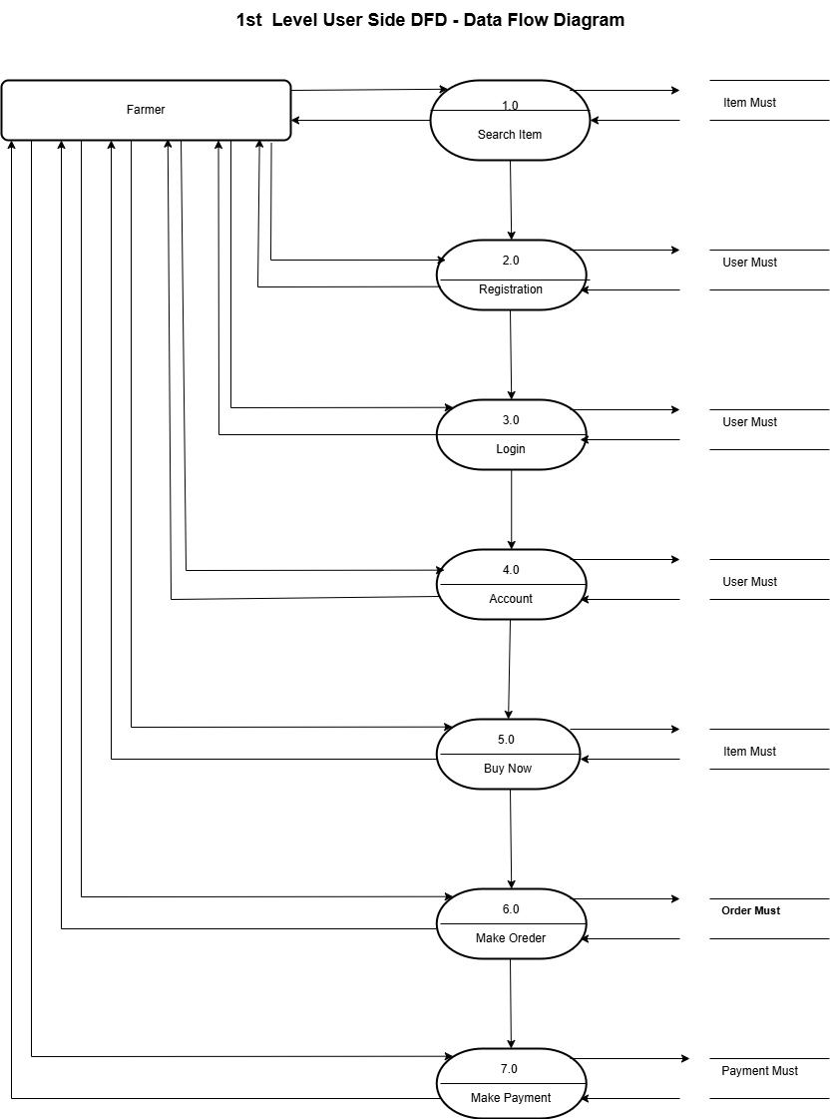

**Question 8 – Change Request**

**Due to change in the Government Taxation structure. we should change the Tax structure How do you handle change requests in a project?**

Handling change request in a project involves a systematic process to ensure that changes are effectively manages while minimizing disruption to the projects scope, timeline and resources.

As a Business Analyst Initially I will document the change request. Then analyse the change request. Then I shall take approval from the manager. Here is the change request is in the government taxation, after that I will inform to the stakeholder and discuss, that we have done changes in own taxation structure so that our budget to complete this project will be changed.

As a business analyst I will handle below steps to handle change request and explanation as per below.

**Change request identification**- Identify and document the change request, including the specific details of the requested change, reason for the change, understand the scope of change and document the change request.

**Do the impact analysis**- Asess the impact of the change on various aspects of the project such as Project scope, schedule, budget, resources & risk. Evaluate the feasibility and implication of implementing the change.

**Change Prioritization**- Prioritize change request based on its urgency, importance, impact on project. Here we will have to determine whether the change is critical and must be implemented immediately or can be scheduled for a future phase or release.

**Change Approval**- Seek approval from the project sponsor for the change request. Obtain formal approval from the appropriate stakeholder, such as project sponsor.

**Change Communication** - Communicate the change request and its potential impacts to all relevant stakeholder, including project team, client, other stakeholder. Here we have to clearly explain reason for a change, impact on the project.

By following these steps, a project can effectively manage change request, ensuring that changes are evaluated, approved and can be implemented in a controlled manner, while minimizing disruption and maintaining project success

**Question 9 – Change Request Vs an Enhancement**

**As the project is in process, Ben and Kevin have contacted you. The reason is to inform you that they want the Farmers to sell their crop yields through this application i.e. Farmers should be able to add their crop yields or products and display to general public and should be able to sell them. They also want to introduce Auction system for their Crop yields. As a BA, what will be your response? Is this a change request or an enhancement???**

In this case study as a project is in progress, Farmers came up with the additional requirement which is they want the Framers to sell their crop yield through this application, farmers should be able to add their product / crop and display to the general public and should be able to sell them.

Enhancement means adding more value to the application without disturbing existing functionality adding more values and change request means alteration or modification in given requirements. As per the case study, as a business analyst, my response to Ben and Keni’s request would be classify as an enhancement rather than change request, as it is involved adding new feature to the systems that were not initially specified. In this case, the request to allow farmers to add their crop yield, through this application, farmers should be able to add their product / crop and display to the general public and should be able to sell them. The introduction of an auction system for crop yield adds another layer of functionality to the application.

As business analyst I will document the requirements and work with development team to determine the feasibility and impact of the new features, considering potential benefits, risk and cost associated with the encashment before making any recommendation to the client.

By treating this request as an encashment, the project can effectively manage the additional requirements and deliver desired functionality while considering the impact on the ongoing project.

**Question 10 – Estimations. Come up with estimations – How many Manhours required?**

Estimating the number of man hours required for a project is a crucial task for business analyst. The number of man hours required depends on various factors such as project scope, complexity and team experience.

Man, hours are the required effort the resources to complete a project. 12% to 16 % of team size should be BA’s (2 BA’s in 12, 13 members team, 4 BA’s in 24,25 members team) There are 3 types of projects.

Small: Upto 500 hours

Medium: Upto 1000 hours

Large: Upto 1500 hours

Analysis

As per the case study, the duration of the project is 18 months and the current team size is around 11. This will come under medium project. As the trained resources are available, trainers are not required, as the structure of the project is available, new and enhanced infrastructure is not required.

1. Requirement gathering and analysis- 10–20-man hours. This includes meetings with stakeholders, gathering detailed requirements, analysing the impact and documenting the encashment.
2. Design – 20–40-man hours. This involves designing and system components, database structure and user interface for the new features. It also includes identifying the necessary changes to accommodate the encashment.
3. Development and coding- 20–40-man hours. The actual development of new features, including backend and frontend coding.
4. Testing and quality assurance- 20–40-man hours. This phase involves performing unit testing, integration testing and ensure the proper functioning and stability of the added features.
5. User Acceptance Testing UAT- 10–20-man hours. This involves conducting user acceptance testing and resolving any issues identified during UAT.
6. Documentation and training- 10-20 man hours. This involves documenting the new features, updating user manuals and providing training or support materials for farmers and users.

**Question 11 – UAT**

**Project has finally completed all the stages i.e., design, development, testing etc. Now, it is the role of a business analyst to contact the client for testing of the final product and have to successfully complete it. How are you going to handle this situation? And once it is done, what will be the process to close the project? Explain UAT Acceptance process**

UAT means User Acceptance Testing. The UAT acceptance process ensures that final product meets the client’s expectations and ready for deployment, it serves as a final validation before the project is considered complete and ready for closure. It has steps and explanation is given below, first stage will be planning,

**Planning-** In this step, Blue prints are made to implement UAT testing for every features that needs to test and minimum standards for accepting the test. The team decides what parts of the software to test how to do it, They set clear goals, create timelines and allocated resources. This helps ensure the testing process runs smoothly and covers everything needed.

**Designing-** Here the Test Cases are designed to hide all the possibilities of software packages in a real-world environment. Test cases are created to simulate how users will interact with the software in real life. These scenarios are kept simple and focused on what users care about most.

**UAT Testers-** A testing team consists of a end users that meet the criteria for implementing, testing, They should know the test cases to run and understand the functionalities. Here End User are chosen to test the software, they use in it ways they normally would and check if it is work properly. Their feedback helps identify problems and improves the software’s usability.

**Bug Fixing-** Whatever Bugs are found in the UAT Testing, the development team will work on them and make it software error free and the testers check again ensure the fixes work and this cycle continuous until the software is error free.

**Sign Off-** After removing all bugs, the testing team indicates acceptance of the completion of the bugs. In this phase all the stakeholder come to a conclusion that software is ready to GO LIVE and sign it off.

**Question 12 – Project Closure Document. Explain Project closure document**

A project Clouser document, also known as a project closure report, its formal document that summarizes the key outcome, lesson learned and final details of a completed project. It serves as a comprehensive record of the project’s accomplishment, challenges and overall performance, providing valuable insights for stakeholder and future projects.

It is a crucial document that helps to ensure that all project stakeholders are aware of the project’s completion and that all necessary steps have been taken to close the project

**Points to be include in the Project closure documents are:**

Project closure document serves as a final report that capture the projects journey, outcomes and key learning. It provides a reference for future projects, helps in evaluating projects success and facilitates knowledge transfer to stakeholder involved in the project. It serves various steps and explanation as per below.

**Project Overview-** This section provided an overview of the project, including its objectives, scope and stakeholder involved. It summarises the project’s purpose, why project was started and what problems it aimed to solve.

**Achievement-** Here document highlights the key achievements and deliverable of the project. It outlines the successful completion of milestone, tasks and any significant accomplishments that were achieved. It included the completion of objectives, meeting declined and delivering high quality output. Any additional achievements, such as exceeding client expectations.

**Lessons Learned –** The lesson learned section reflects highlights what the team learned during the projects, in includes both positive and negative experience. The aim is to document insights that can help improves future projects.

**Quality Assurance-** This part focuses on how the projects quality was ensured. It includes details about testing, reviews and validation to meet the required standards. It is also notes if the final deliverables met the expectations of the stakeholder.

**Resource Utilization-** This section explains how resources like time, money and manpower were used in the project. It highlights efficient use of resources and addresses any areas where resources could have been manages better. This helps in planning better in future project.

**Risk Management-** This part discusses the risks identified during the project and how they were handled. It includes details on mitigation strategies contingency plans, and how effectively risks were managed to prevent delays or failure.

**Challenges-** This section outlines the difficulties faced during the project. It explains how these challenges were addresses or overcome. This can include issues like technical, difficulties, resource constraints or changes in project requirements.