**Assignment 1.2: Process Flow Diagram**

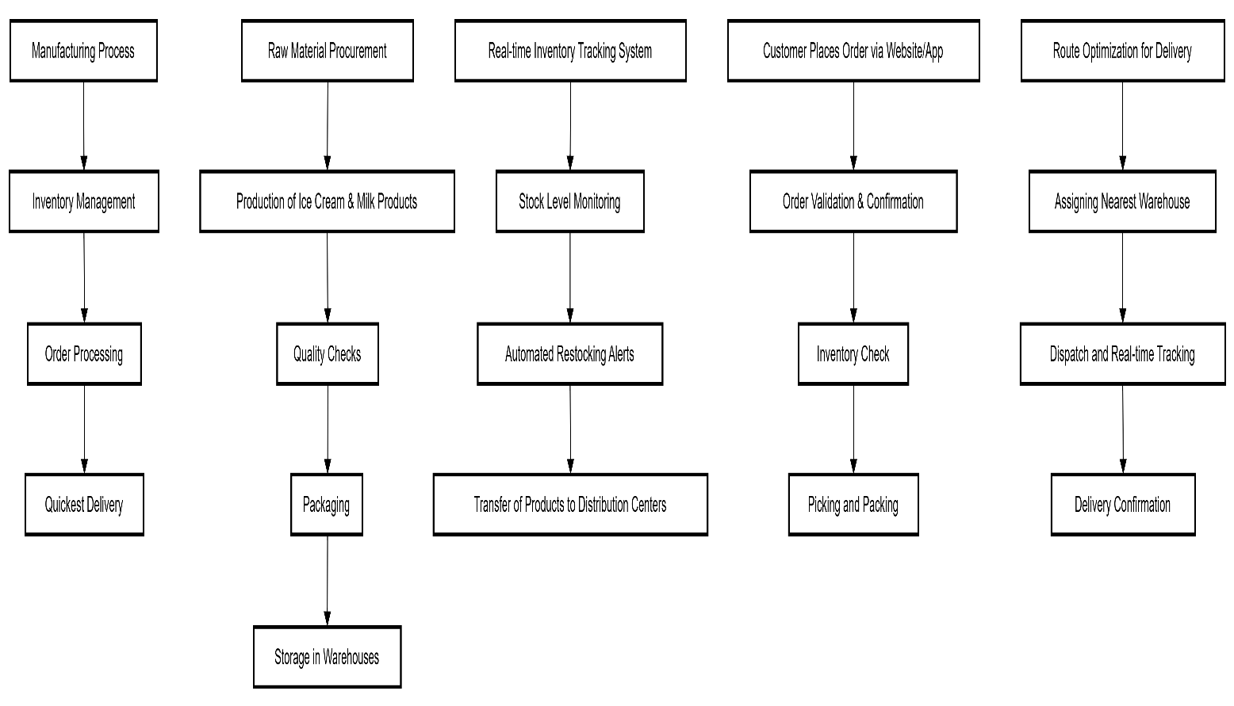

**Assignment 2: Business Analyst Introduction Letter**

**Introduction Letter to the Client**

This section provides a formal introduction of the Business Analyst (BA) to the client. The letter highlights the BA's role in requirement gathering and collaboration with the client to ensure a smooth project implementation.

**Nikhil Sharma**  
Business Analyst  
7222949115  
04/02/2025

**To:** [Client Name]  
[Client Company Name]

**Subject:** Introduction as Business Analyst for Project Initiation

Dear Sir/Mam,

I hope this letter finds you well. My name is Nikhil, and I am pleased to introduce myself as the Business Analyst assigned to your project. My primary role is to work closely with you and your team to gather requirements, understand your business objectives, and translate them into actionable solutions.

I look forward to collaborating with you to ensure a seamless and efficient implementation of the project. Please let me know a convenient time to discuss your requirements in detail.

Best regards,  
Nikhil Sharma  
Business Analyst

**Assignment 3: Business Requirement Document (BRD) for an Online Store**

**1. Introduction:**

This section provides an overview of the online store project, outlining the main objectives and business goals.

* **Project Name:** Online Store
* **Objective:** Develop an e-commerce platform for seamless online shopping.

**2. Business Goals:**

Defines the key business objectives that the online store aims to achieve.

* **Enhance user experience:** Ensure smooth navigation and user-friendly interface.
* **Secure payment integration:** Implement reliable and encrypted payment gateways.
* **Streamlined order management:** Automate order processing and inventory tracking.

**3. Functional Requirements:**

Lists the core features required in the system.

* **User Registration and Login:** Secure user authentication and account management.
* **Product Browsing and Search:** Intuitive search and filter options for easy navigation.
* **Shopping Cart and Checkout:** Smooth checkout process with multiple payment options.
* **Order Management:** Order tracking and status updates for customers.
* **Payment Gateway Integration:** Secure and multiple payment options.
* **Order Tracking:** Live updates and delivery notifications for customers.

**4. Non-Functional Requirements:**

Details the performance and security expectations.

* **Security measures:** Data encryption and secure transactions.
* **Scalability and performance optimization:** Ability to handle high traffic and product expansion.

**5. Assumptions & Constraints:**

Identifies the external dependencies and project constraints.

* **Availability of required technologies:** Ensuring compatibility with existing systems.
* **Compliance with legal regulations:** Adhering to data protection and e-commerce laws.

**Software Requirements Specification (SRS) for an Online Store**

**1.0 Introduction**

Provides a structured overview of the SRS document.

* **Overview:** Project summary and purpose.
* **Acronyms and definitions:** Technical terminology explained.
* **Operational Requirements:** Technical and business constraints.

**2.0 System Overview**

Explains the system’s current state and proposed improvements.

* **Current System:** Analysis of existing processes.
* **Proposed System:** Overview of the new solution.
* **Benefits of the Proposed System:** Expected improvements in efficiency and user experience.

**3.0 UI Requirements**

Specifies the user interface elements.

* **Project contents:** Breakdown of functionalities and modules.

**4.0 Other Parameters**

Outlines project deliverables and acceptance criteria.

* **Acceptance criteria:** Criteria for client approval.

**ERD for Ticketing System**

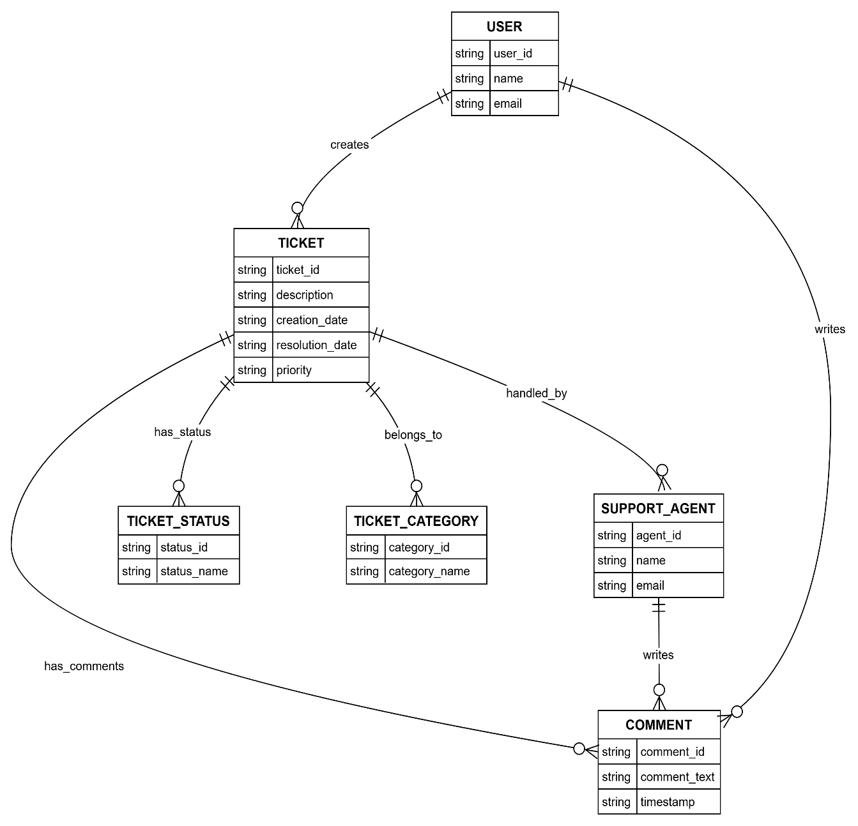

**User Story for E-Commerce Shopping**

**User Story for Online Shopping Experience**

**As a customer**, I want to browse products, add them to the cart, and complete a secure checkout so that I can purchase items conveniently online.

**Acceptance Criteria:**

1. Customers can search and filter products.
2. Customers can add products to the cart.
3. Customers can complete the purchase using a payment gateway.
4. Customers receive an order confirmation.