**AGILE DOCUMENTS**

**Document 1: Definition Of Done**

The Definition of done means the criteria that must be met for a User Story, Feature, or Sprint to be considered "Done" (complete) for the core banking system enhancements project. All team members agreed on below criteria.

**Code & Functionality:**

* **Produced Code:** The code for the functionalities is complete and documented in to the appropriate branch in version control.
* **Assumptions Met:** Assumptions are done to make user story complete. It highlights the dependency a user story may require to function properly. All assumptions should be documented for the User Story till it has been addressed and validated. Any change from assumptions should be documented and agreed upon with the Product Owner.
* **Clean Build:** The project builds software successfully without any errors or warnings on the designated build server (Buildbot, Azure Devops & Gitlab). In simple language these servers compile, integrate and test the code as a part of build and provides catches bugs if any so the developer does not have to do it manually.
* **Unit Tests:** Unit tests means testing a small code or coding of a single feature/functionality and testing it. These can be tested automatically by build servers.

**Environment & Testing:**

* **Deployment:** The User Story's functionality has been deployed to the test environment, which is identical to the production platform in terms of hardware, software, and configuration.
* **Device/Browser Testing:** Tests have been successfully executed on all devices (mobiles and chrome) and browsers listed in the project assumptions document.
* **UX Sign-off:** UX designer has reviewed and approved the user interface elements related to the User Story and formal sign-off is documented in email confirmation.
* **QA Testing:** QA testing has been performed, and all identified bugs or issues have been resolved and retested. QA sign-off has been taken and is documented.
* **Acceptance Criteria:** The feature has been thoroughly tested against all defined acceptance criteria, and all criteria have been met.
* **Product Owner Approval:** The Product Owner has reviewed and formally accepted the completed User Story. This acceptance is documented (e.g., Jira ticket update).

**Code Quality & Documentation:**

* **Refactoring:** Any necessary code refactoring related to the User Story has been completed and tested.
* **Configuration or Build Changes:** Any configuration change or build process updates for the User Story have been documented.
* **Documentation Updates:** All relevant documentation (e.g., user manuals, API documentation, technical specifications) has been updated to reflect the changes introduced by the User Story.
* **Peer Code Review:** A peer code review has been performed by at least one other developer, and all feedback has been addressed. The code review is also documented

**EXAMPLE:**

**User Story 1:** As a banking staff, I want to process customer transactions (deposits, withdrawals) so that I can improve customer satisfaction and reduce waiting times.

The banking staff want to be able to handle deposits and withdrawals efficiently to serve customers better. The DoD ensures that this functionality is built to a high standard.

Based on checklist below is the explanation of example…

**Produced Code:**

The developers must write the code that implements the deposit and withdrawal features. This code must be complete, meaning it handles all expected scenarios (valid amounts, insufficient funds, etc.).

**Assumptions Met:**

There might be assumptions about transaction limits, how customer data is accessed, error handling, etc. These assumptions were clearly documented within the User Story details (e.g., in the Jira). For example, an assumption might be "Transactions are limited to ₹50000 amount." These assumptions was validated. If an assumption changes during development (e.g., the limit is changed to ₹40000), this change was documented and approved by the Product Owner.

**Clean Build:**

* The entire project, including the new code for deposits and withdrawals, was build successfully on the designated build server. This means the code compiles without errors and was integrated correctly with other parts of the system.

**Unit Tests:**

* Developers has written unit tests to verify that the deposit and withdrawal functions work correctly. These tests covered various scenarios (valid inputs, invalid inputs). All unit tests must pass successfully. For example, a unit test checked that a withdrawal from an account with sufficient funds reduced the balance correctly.

**Environment & Testing:**

**Deployment:**

* The new code was deployed to the test environment which was close to the production environment.

**Device/Browser Testing:**

* The deposit and withdrawal features was tested on all the target devices and browsers specified in the project assumptions document. This ensures that the functionality works correctly on different platforms. For example, tests were run on Chrome and the bank's mobile app on both iOS and Android.

**UX Sign-off:**

* The UX designer reviewed and approved the user interface for the deposit and withdrawal features. This ensured that the interface was user-friendly and consistent with the overall design and approval were formally documented.

**QA Testing:**

* The QA team perform testing of the deposit and withdrawal features which includes testing various scenarios, looking for bugs, and ensuring that the functionality meets the requirements. All bugs (if any) were fixed and tested again. QA team sign off was also taken.

**Acceptance Criteria:**

* The User Story has specific acceptance criteria. For example:
  + "A user can successfully deposit funds into their account."
  + "A user can successfully withdraw funds from their account (if sufficient funds are available)."
  + "The system displays appropriate error messages for invalid inputs."
* These features were tested against above criteria, and all criteria was met.

**Code Quality & Documentation:**

**Refactoring:**

* If any code refactoring (improving the code structure without changing its functionality) was necessary during the development of this User Story, it was completed and tested.

**Configuration or Build Changes:**

* No changes were required however, any changes to the system's configuration or build process required by this User Story was documented.

**Documentation Updates:**

* Any user manuals, technical documentation, or API documentation that needs to be updated to reflect the new functionality was updated.

**Peer Code Review:**

* Another developer must review the code written for this User Story. This helps to catch potential errors and ensure code quality. Any feedback from the code review were addressed.

**Document 2: Product Vision**

**Answer:**

**Product Vision Table**

|  |  |  |  |
| --- | --- | --- | --- |
| **Project Name** | Bancs Application Enhancement |  |  |
| **Venue:** | Pune | **Date:** | 20/01/2025 |
| **Start Time:** | 10am | **End Time:** | 11pm |
| **Client:** | Diligenta |  |  |
| **Stakeholders:** | PO | Developers | Client |
|  | IT Operation | Customer support | Customer |
|  | End user | Regulatory Bodies | Partners |
|  |  |  |  |
| **Scrum Team** | Rajat |  |  |
| **Developer 1** | Kashmira | **Developer 2** | Sonali |
| **Developer 3** | Ankita | **Developer 4** | Frank |
| **Developer 5** | Pushpa |  |  |

**What is your vision, your overarching goal for creating the product?**

**Vision**

My Vision is to work on enhancement of the BaNCS system and provide a product which delivers solution effectively and addresses both current and future business needs and at the same time add value to end user and all the stake holder.

To develop BaNCS application into a more user friendly, scalable, and adaptable as per the business environment particularly for banking sector.

The enhanced system should help improve customer experience and ensure compliance with regulatory standards. In addition to this the application should easily get integrated with evolving technologies.

**Goal**

Overarching Goal is to create efficient, scalable, and flexible banking system which enables the following…

* **Enhance efficiency** by improving automation and workflows and thus leading to faster banking process.
* **Enhance user experience** by designing intuitive user interface that reduces user learning curve and user satisfaction.
* **Enhance scalability and flexibility** which makes the system adaptable to changing requirements, easy to integrate with new product, service, and other application.
* **Supports regulatory compliance** ensuringapplication supports evolving regulations.
* **Enhance performance** by optimizing and minimizing system outage.

**O Target Group**

It is specifically focused on core banking systems such as TCS BaNCS for Universal Banking, Retail Banking, and Insurance/Wealth Management systems.

**Which market segment does the product address?**

* Banks (retail, commercial, and digital banks)
* Insurance and Wealth Management Companies
* Small financial institutions
* Regulatory Bodies (for compliance-related needs)

**Who are the target users and customers?**

**Banking Users/Staff:** The primary users are employees who interact with the core banking system by handling transactions and customer service.

**Back-End Users:** Data entry operators, financial analysts, auditors, and compliance officers for managing financial records, transactions, and customer data.

**IT and System Administrators:** Responsible for the maintenance and support of the system.

**Traders, Analysts, and Wealth Managers:** In wealth management or insurance sectors using the system to manage customer portfolios.

**Additional** customers are the banks, financial institutions, and other financial services organizations looking to improve their operational capabilities, enhance their customer-facing services, or optimize their processes for cost efficiency, compliance, and performance.

**O Needs**

**What Problem Does the Product Solve?**

**The product addresses several critical problems:**

**Slow Adoption and Training:** Core banking systems can be hard to understand and require extensive training and user adoption.

**Integration:** Difficulty integrating new features or third-party systems with the core banking platform.

**High Configuration and Maintenance Costs:** High time taken for configuring or enhancing the system results in delay and rising operational costs.

**Data Migration:** Challenges with migrating and managing large customer database securely across multiple product lines.

**What benefit does it provide?**

**Better User Experience** with streamlined and enhanced functionality that make the system more intuitive thus reducing training time and increasing adoption rates.

**A more flexible and adaptable** system that allows quicker configuration, customization and integration to new services or channels (like., mobile banking, UPI & wallets).

**Automation and optimization** reduce the need for manual intervention thus increases processing speed increase operational efficiency.

**Making the system regulatory compliant** ensures that the system is robust and is providing security measures to protect sensitive customer data.

**Product**

**What product is it?**

The product is an enhanced version of the TCS BaNCS Banking System, integrating enhanced functionalities, new user interfaces, and improved integration capabilities with third-party applications, digital banking, and data sources.

This product (we) aims to offer inclusive banking services with better scalability, flexibility, and user-friendliness.

**What makes it desirable and special?**

**It is customizable and flexible** system that can be easily adapted to different banks’ needs, providing workflows, reporting, and integrations.

**Intuitive UI/UX** design that reduces training time and improves user productivity.

**Its modular design** allows the financial institution to adopt the specific features as per there need, reducing complexity and cost.

**It has** **built-in compatibility** with third-party systems, payment gateways, mobile apps and flexibility for future upgrades.

**Its strong** **focus** on security to protect sensitive financial data, with built-in encryption and secure authentication protocols.

**It is designed** to enable the rapid adoption as per new digital environment such as mobile banking, and cloud-based solutions.

**Is It Feasible to Develop the Product?**

**Feasibility:** Yes, the product is feasible to develop with existing core banking frameworks and adding enhancements using modern technologies such as cloud computing, API management, and AI/ML (Artificial Intelligence/Machine Learning) for automation and insights.

**Development Feasibility:** The development team has the necessary technical expertise of banking, and the product can be developed using Agile methodologies, ensuring constant feedback from stakeholders and early releases of functional modules.

**Cost Feasibility:** With adequate and right resource allocation, with right technology the product can be developed within the assigned budget and timeline.

**Value**

**How is the product going to benefit the company?**

**Revenue increase:** By offering new and improved features to financial institutions, the company can capture a larger market share within the banking sector and attract customers from other banking providers.

**Customer Retention:** Existing customers will benefit from enhanced functionality, leading to higher customer satisfaction.

By providing an advanced and customizable banking system, the company will stand out from other competition in the market.

**What Are the Business Goals?**

**Offer enhance product**/platform with new features, and user-centric enhancements that drive adoption.

**Increase market share** and Capture more clients in the financial services market by addressing the challenges faced by existing clients and providing scalable, flexible, and modular product.

**Generate Continuous Revenue** leverage subscription models, licensing, and service agreements to establish long-term business relationships and generate recurring revenue.

**What Is the Business Model?**

**Subscription based licensing:** Here we will allow financial institutions to pay annually or monthly for access to the software, along with ongoing support and updates.

**Professional services:** Revenue from consulting, training, and implementation services to help customer set up, configure, and integrate the system according to their specific requirements.

**Cloud-Enabled Models:** Offer both in-premise and cloud-based service options, where cloud services can be charged.

**Maintenance and Upgrades:** Recurring revenue from maintenance contracts and periodic upgrades ensures the system stays up to date with new features, security patches, and regulatory changes.

**Document 3: User stories**

User Stories: Core Banking System Enhancements

|  |  |  |  |
| --- | --- | --- | --- |
| User Story 01 | Task 1 | | Priority – High |
| AS A BANKING STAFF I WANT TO PROCESS CUSTOMER TRANSACTIONS (DEPOSITS, WITHDRAWALS) | | | |
| SO THAT I CAN IMPROVE CUSTOMER SATISFACTION AND REDUCE WAITING TIMES. | | | |
| BV – 1000 | | CP – 50 | |
| Acceptance Criteria – Click on deposite/withdrawals. Enter the amount. Hit submit. Show notification of successful/Unsuccessful Deposit/Withdrawals. | | | |

|  |  |  |  |
| --- | --- | --- | --- |
| User Story 02 | Task 1 | | Priority – High |
| AS A BANKING STAFF I WANT TO VIEW CUSTOMER BALANCES | | | |
| SO THAT I CAN PROVIDE DETAILS TO CUSTOMER WHEN REQUESTED. | | | |
| BV – 1000 | | CP – 50 | |
| Acceptance Criteria – Click on show balance. System should show real time balance. | | | |

|  |  |  |  |
| --- | --- | --- | --- |
| User Story 03 | Task 1 | | Priority – High |
| AS A CUSTOMER WANT TO ACCESS A/C ONLINE VIA MOBILE APP | | | |
| SO THAT I CAN PERFORM TRANSACTION AND MANAGE MY FINANCES. | | | |
| BV – 1000 | | CP – 50 | |
| Acceptance Criteria – Customer can login to mobile app, view balances, transfer fund and see history. | | | |

|  |  |  |  |
| --- | --- | --- | --- |
| User Story 04 | Task 1 | | Priority – High |
| AS A STAFF WANT TO VIEW LOAN ELIGIBILITY BASED ON CREDIT SCORE AND HISTORY | | | |
| SO THAT I CAN LOAN PRODUCT CAN BE OFFERED ACCORDINGLY. | | | |
| BV – 1000 | | CP – 50 | |
| Acceptance Criteria – Need access to customer credit score and history. System show Eligibility criteria, loan limits, interest rates, and products. | | | |

|  |  |  |  |
| --- | --- | --- | --- |
| User Story 05 | Task 1 | | Priority – High |
| AS A CUSTOMER WANT TO RECEIVE NOTIFICATION FOR MY ACCOUNT | | | |
| SO THAT I STAY INFORMED ABOUT ACTIVITIES OF MY ACCOUNT. | | | |
| BV – 1000 | | CP – 50 | |
| Acceptance Criteria – System should send email/SMS notifications for deposits, withdrawals, and transfers in real time. | | | |

|  |  |  |  |
| --- | --- | --- | --- |
| User Story 06 | Task 1 | | Priority – High |
|  |  | |  |
| AS AN ADMIN WANT TO MONITOR SYSTEM PERFORMANCE AND UPTIME. | | | |
| SO THAT I CAN ENSURE SYSTEM AVAILABILITY ALL TIME. | | | |
| BV – 1000 | | CP – 50 | |
| Acceptance Criteria – Real time access to system dashboard and alert for any issue or downtime. | | | |

|  |  |  |  |
| --- | --- | --- | --- |
| User Story 07 | Task 1 | | Priority – High |
|  |  | |  |
| AS A STAFF WANT TO UPDATE CUSTOMER DETAILS. | | | |
| SO THAT I CAN ENSURE CUSTOMER RECORD IS UP TO DATE. | | | |
| BV – 1000 | | CP – 50 | |
| Acceptance Criteria – System should show fields related to customer name, phone number, account number, address. | | | |

|  |  |  |  |
| --- | --- | --- | --- |
| User Story 08 | Task 1 | | Priority – High |
| AS A STAFF WANT TO UPDATE CUSTOMER DETAILS. | | | |
| SO THAT I CAN ENSURE CUSTOMER RECORD IS UP TO DATE. | | | |
| BV – 1000 | | CP – 50 | |
| Acceptance Criteria – System should show fields related to customer name, phone number, account number, address. | | | |

|  |  |  |  |
| --- | --- | --- | --- |
| User Story 09 | Task 1 | | Priority – High |
| AS A STAFF I WANT TO UPDATE SERVICE FEES TO CERTAIN TRANSACTION (INTERNATIONAL PAYMENT etc..). | | | |
| SO THAT I CAN COLLECT ACCURATE FEE. | | | |
| BV – 1000 | | CP – 50 | |
| Acceptance Criteria – System should calculate fees bases on transaction type. The fees should be shown before completing transaction. | | | |

|  |  |  |  |
| --- | --- | --- | --- |
| User Story 10 | Task 1 | | Priority – High |
| AS A CUSTOMER I WANT TO SETUP AUTO BILLPAYMENT (UTILITIES & LOAN). | | | |
| SO THAT I DON’T MISS MY DUES. | | | |
| BV – 1000 | | CP – 50 | |
| Acceptance Criteria – System should allow customer to schedule and manage recurring payments. System should send notification for the transaction processed. | | | |

|  |  |  |  |
| --- | --- | --- | --- |
| User Story 11 | Task 1 | | Priority – High |
| AS A MANAGER I WANT TO GENERATE REPORT FOR TRANSACTION VOLUME CUSTOMER FEEDBACK. | | | |
| SO THAT I CAN ASSESS STAFF PERFORMANCE. | | | |
| BV – 1000 | | CP – 50 | |
| Acceptance Criteria – System should generate report on daily, weekly, and monthly based on transaction, customer satisfaction. | | | |

|  |  |  |  |
| --- | --- | --- | --- |
| User Story 12 | Task 1 | | Priority – High |
| AS A CUSTOMER I WANT TO APPLY FOR LOAN VIA BANKING APP. | | | |
| SO THAT I CAN APPLY FROM MY MOBILE WITHOUT VISITING BANK. | | | |
| BV – 1000 | | CP – 50 | |
| Acceptance Criteria – Customer should have access to app login, App should have apply for loan option, with eligibility & upload documents option. | | | |

|  |  |  |  |
| --- | --- | --- | --- |
| User Story 13 | Task 1 | | Priority – High |
| AS A CUSTOMER I WANT TO DOWNLOAD BANK STATEMENT IN pdf FORMAT FROM MOBILE APP. | | | |
| SO THAT I CAN TRACK MY INCOMES AND EXPENDITURE | | | |
| BV – 1000 | | CP – 50 | |
| Acceptance Criteria – Customer should have access to app login. He should have option to download monthly statements for any selected time period in PDF format. | | | |

|  |  |  |  |
| --- | --- | --- | --- |
| User Story 14 | Task 1 | | Priority – High |
| AS A DEVELOPER I WANT TO INTEGRATE THIRD PARTY GATEWAYS FOR EASE OF BANKING. | | | |
| SO THAT I CAN MAKE PAYMENT ACROSS VARIOUS PAYMENT METHODS | | | |
| BV – 1000 | | CP – 50 | |
| Acceptance Criteria – System should be integrated and made compatible with external payment system (e.g. Paypal, Phonepe etc). System should provide various payment option. | | | |

|  |  |  |  |
| --- | --- | --- | --- |
| User Story 15 | Task 1 | | Priority – High |
| AS A DEVELOPER I WANT TO INTEGRATE THIRD PARTY GATEWAYS FOR EASE OF BANKING. | | | |
| SO THAT I CAN MAKE PAYMENT ACROSS VARIOUS PAYMENT METHODS | | | |
| BV – 1000 | | CP – 50 | |
| Acceptance Criteria – System should be integrated and made compatible with external payment system (e.g. Paypal, Phonepe etc). System should provide various payment option. | | | |

|  |  |  |  |
| --- | --- | --- | --- |
| User Story 16 | Task 1 | | Priority – High |
| AS AN ADMIN I WANT TO SET UP CUSTOMER NOTIFICATION PREFERENCES. | | | |
| SO THAT CUSTOMER CAN RECEIVE ALERTS THROUGH VARIOUS CHANNELS (EMAIL, SMS, WHATSAPP, PUSH NOTIFICATION) | | | |
| BV – 1000 | | CP – 50 | |
| Acceptance Criteria – Add option for notification preferences for customer (email, SMS, Whatsapp, Push notification). The customer should have option to opting in for preferences. | | | |

|  |  |  |  |
| --- | --- | --- | --- |
| User Story 17 | Task 1 | | Priority – High |
| AS AN CUSTOMER I WANT TO BLOCK MY DEBIT/CREDIT CARD VIS MOBILE APP. | | | |
| SO THAT I CAN PROTECT MY ACCOUNT FROM UNAUTHORIZED USE/ACCESS | | | |
| BV – 1000 | | CP – 50 | |
| Acceptance Criteria – Add option under Profile option for block/unblock the card, after confirming customer identity, select card and then block the card, a pop up should appear stating to confirm the block. | | | |

|  |  |  |  |
| --- | --- | --- | --- |
| User Story 18 | Task 1 | | Priority – High |
| AS AN CUSTOMER I WANT TO TRACK STATUS OF MY LOAN APPLICATION. | | | |
| SO THAT I CAN STAY UPDATED ON MY LOAN APPROVAL OR REJECTION. | | | |
| BV – 1000 | | CP – 50 | |
| Acceptance Criteria – In mobile app add Track status feature, by clicking on which it should ask for loan account number. Later should provide detailed status of the application and expected timeline of approval. | | | |

|  |  |  |  |
| --- | --- | --- | --- |
| User Story 19 | Task 1 | | Priority – High |
| AS AN CUSTOMER I WANT TO ADD BENEFICIARIES TO MY ACCOUNT. | | | |
| SO THAT I CAN TRANSFER FUND SEAMLESSLY TO VARIOUS ACCOUNTS IN MY CONTACTS. | | | |
| BV – 1000 | | CP – 50 | |
| Acceptance Criteria – Provide Add beneficiaries details feature under profile with details (name, account number, relationship) | | | |

|  |  |  |  |
| --- | --- | --- | --- |
| User Story 20 | Task 1 | | Priority – High |
| AS AN ADMIN WANT TO AUDIT TRANSACTION LOG. | | | |
| SO THAT I CAN AUDIT TRANSACTION LOGS AND IDENTIFY ANY SUSPICIOUN. | | | |
| BV – 1000 | | CP – 50 | |
| Acceptance Criteria – Provide ACCESS TO LOF TRANSACTION WITH DATE AND TIME OF USER AND TRANSACTION DETAILS | | | |

|  |  |  |  |
| --- | --- | --- | --- |
| User Story 21 | Task 1 | | Priority – High |
| AS AN STAFF WANT TO TRACK AND RESOLVE CUSTOMER COMPLAINTS. | | | |
| SO THAT I CAN PROVIDE TIMELY ASSISTANCE. | | | |
| BV – 1000 | | CP – 50 | |
| Acceptance Criteria – Provide access to complaint log, complaints should be categorized based on type of complaint. | | | |

|  |  |  |  |
| --- | --- | --- | --- |
| User Story 22 | Task 1 | | Priority – High |
| AS AN STAFF WANT TO SEE REAL TIME PERFORMANCE MATRICS (TRANSACTION VOLUME, CUSTOMER SERVICE QUALITY). | | | |
| SO THAT I CAN TAKE ACTIONS TO IMPROVE THE PERFORMANCE. | | | |
| BV – 1000 | | CP – 50 | |
| Acceptance Criteria – Branch manager should have access to metrics on real time dashboard. Metrics should include AHT and customer satisfaction score. | | | |

|  |  |  |  |
| --- | --- | --- | --- |
| User Story 24 | Task 1 | | Priority – High |
| AS AN CUSTOMER WANT TO ADD MULTIPLE BANK ACCOUNT TO VIA MOBILE APP. | | | |
| SO THAT I CAN MANGE MULTIPLE ACCOUNT VIA ONE PLATFORM. | | | |
| BV – 1000 | | CP – 50 | |
| Acceptance Criteria – Authorised customer with valid login can link multiple accounts. | | | |

|  |  |  |  |
| --- | --- | --- | --- |
| User Story 25 | Task 1 | | Priority – High |
| AS AN IT AMIN WANT AUTO SYSTEM BACKUPS. | | | |
| SO THAT DATA IS PROTECTED ALWAYS. | | | |
| BV – 1000 | | CP – 50 | |
| Acceptance Criteria – Schedule auto backup every day on time and store. Should be restored if necessary... | | | |

|  |  |  |  |
| --- | --- | --- | --- |
| User Story 26 | Task 1 | | Priority – High |
| AS AN STAFF (LOAN OFFICER) WANT LOAN REPAYMENT SCHEDULE. | | | |
| SO THAT I CAN PROVIDE LOAN MANAGEMENT SUPPORT. | | | |
| BV – 1000 | | CP – 50 | |
| Acceptance Criteria – System should display detailed loan repayment schedule. Officer can adjust terms or issue reminder to customer. | | | |

|  |  |  |  |
| --- | --- | --- | --- |
| User Story 27 | Task 1 | | Priority – High |
| AS AN CUSTOMER WANT TO WITHDRAW FROM ATM VIA MOBILE. | | | |
| SO THAT I THERE IS NO NEED TO CARRY DEBIT CARD. | | | |
| BV – 1000 | | CP – 50 | |
| Acceptance Criteria – System should provide customer with QR code and mobile app should generate OTP verification. | | | |

|  |  |  |  |
| --- | --- | --- | --- |
| User Story 28 | Task 1 | | Priority – High |
| AS AN ADMIN WANT TO SET PERMISSION FOR LOAN APPLICATION S. | | | |
| SO THAT ONLY AUTHORIZED USERS CAN APPROVE OR REJECT. | | | |
| BV – 1000 | | CP – 50 | |
| Acceptance Criteria – System should check the restriction placed on operators ID based on role and should provide access to approvals. | | | |

|  |  |  |  |
| --- | --- | --- | --- |
| User Story 29 | Task 1 | | Priority – High |
| AS A CUSTOMER WANT TO UPDATE MY PERSONAL IDENTIFICATION DETAILS IN SYSTEM. | | | |
| SO THAT MY RECORDS ARE UP-TO-DATE. | | | |
| BV – 1000 | | CP – 50 | |
| Acceptance Criteria – System should provide access to authorized customer via mobile app. System should validate the changes provided the required documents are uploaded in system. | | | |

|  |  |  |  |
| --- | --- | --- | --- |
| User Story 30 | Task 1 | | Priority – High |
| AS A IT ADMIN WANT TO APPLY SECURITY PATCHES. | | | |
| SO THAT VULMERABILITES ARE MITIGATED AND SYSTEM REMAINS SECURE. | | | |
| BV – 1000 | | CP – 50 | |
| Acceptance Criteria – System should be compatible for upgradation. Security should be able to applied during non-peak hours. System should alert if patches fail. | | | |

|  |  |  |  |
| --- | --- | --- | --- |
| User Story 31 | Task 1 | | Priority – High |
| AS A BA WANT TO CONDUCT USER FEEDBACK SURVEYS. | | | |
| SO THAT I CAN IDENTIFY AREAS FOR IMPROVEMENT. | | | |
| BV – 1000 | | CP – 50 | |
| Acceptance Criteria – To collect the survey in regular interval and analyze it for the future system updates. | | | |

|  |  |  |  |
| --- | --- | --- | --- |
| User Story 32 | Task 1 | | Priority – High |
| AS A CUSTOMER WANT TO LINK EXTERNAL BANK ACCOUNT. | | | |
| SO THAT TRANSFER OF FUNDS CAN BE DONE BETWEEN ACCOUNTS. | | | |
| BV – 1000 | | CP – 50 | |
| Acceptance Criteria – System should allow linking with authorized external bank accounts. Cross bank transfer should be processed securely. | | | |

|  |  |  |  |
| --- | --- | --- | --- |
| User Story 33 | Task 1 | | Priority – High |
| AS A DEVELOPER WANT TO CREATE API ENDPOINTS FOR INTEGRATION WITH THRID PARTY SERVICES. | | | |
| SO THAT I CAN EXPAND THE PLATFORM CAPABILITIES | | | |
| BV – 1000 | | CP – 50 | |
| Acceptance Criteria – System should have secure API for third party integration. Documentation and guidelines should be available for the developers. | | | |

|  |  |  |  |
| --- | --- | --- | --- |
| User Story 34 | Task 1 | | Priority – High |
| AS A CUSTOMER WANT TO SET LIMITS ON MY DEBIT/CREDIT CARD. | | | |
| SO THAT I CAN CONTROL OVER MY SPENDINGS. | | | |
| BV – 1000 | | CP – 50 | |
| Acceptance Criteria – System should set transaction/withdrawal limit option, with field to enter figures manually. Notification should be send to customer when limit is about to reach. | | | |

|  |  |  |  |
| --- | --- | --- | --- |
| User Story 35 | Task 1 | | Priority – High |
| AS A CUSTOMER WANT TO LINK ACCOUNT TO SOCIAL MEDIA ACCOUNT OF BANK. | | | |
| SO THAT I CAN GET PERSONALIZED OFFER AND NOTIFICATION. | | | |
| BV – 1000 | | CP – 50 | |
| Acceptance Criteria – System should provide option to link to social media and should provide option to On/Off the notification for the same. | | | |
| User Story 36 | Task 1 | | Priority – High |
| AS A ADMIN WANT MULTI FACTOR AUTHENTICATION (MFA) FOR ACCESSING SENSITIVE CUSTOMER DATA. | | | |
| SO THAT CUSTOMER GET ENHANCED SECURITY. | | | |
| BV – 1000 | | CP – 50 | |
| Acceptance Criteria – System to provide MFA access to users using sensitive data. System to support various authentication methods (SMS, email, OTP) | | | |

|  |  |  |  |
| --- | --- | --- | --- |
| User Story 37 | Task 1 | | Priority – High |
| AS A ADMIN WANT TO SET AUTO PASSWORD EXPIRATION FOR USER. | | | |
| SO THAT SECURITY STANDARD CAN BE MAINTAINED | | | |
| BV – 1000 | | CP – 50 | |
| Acceptance Criteria – System should auto prompt change password after specific period and send notification too. | | | |

|  |  |  |  |
| --- | --- | --- | --- |
| User Story 38 | Task 1 | | Priority – High |
| AS A DEVELOPER WANT TO CREATE AUTOMATED DEPLOYMENT PIPELINES FOR BANKIND SYSTEM. | | | |
| SO THAT NEW FEATURE AND UPDATES CAN BE ROLLED OUT QUICKLY AND SAFELY. | | | |
| BV – 1000 | | CP – 50 | |
| Acceptance Criteria – System should support automated deployments with rollback caauto prompt change password after specific period and send notification too. | | | |

|  |  |  |  |
| --- | --- | --- | --- |
| User Story 39 | Task 1 | | Priority – High |
| AS A ADMIN WANT TO SET DAILY TRANSACTION LIMIT FOR CUSTOMER. | | | |
| SO THAT CUSTOMER CAN BE SAFE FROM FRAUD AND RISK | | | |
| BV – 1000 | | CP – 50 | |
| Acceptance Criteria – System to provide option to admin to set limit on transaction. Alert to be triggered if limit exceeded. | | | |

|  |  |  |  |
| --- | --- | --- | --- |
| User Story 40 | Task 1 | | Priority – High |
| AS A EVELOPER WANT TO INTEGRATE AI TOOLS | | | |
| SO THAT FRAUD CAN BE DETECTED AND HELP PREVENT UNAUTHORISED TRANSACTION | | | |
| BV – 1000 | | CP – 50 | |
| Acceptance Criteria – System to installed with AI algorithms that analyze transaction patterns for anomalies. System to flag/trigger alert if anomalies found. | | | |

**Document 4**

Agile Product Owner (PO) Experience Summary

In my experience as a Product Owner (PO), I have been deeply involved in development and delivery of the product in collaboration with all stakeholders and Scrum team members.

The key learnings I have gained in the process are as below…

**Market Analysis & Market Demand:** For this I did research to understand the market demand by interacting with stakeholders and customers, which gave me insights of customer problem issues and their needs.

Being PO I assessed the strength and weaknesses of product like ours which gave me visibility to better position our product and improve the areas where competitors are lacking.

This helped me in learning ability to evaluate market and understand how to differentiate our product and deliver value and remain competitive.

**Due Diligence on Market Opportunity:** Due diligence being a thorough study about company, product or service which later helps in taking financial and legal decision helped me evaluate the feasibility and potential of the product. This was done by analyzing potential customer segments, identifying trends, and thus forecasting future growth in the market.

This helped me learn the ability to assess the financial and strategic impact of product development.

**Product Vision and Roadmap:**

I worked closely with stakeholders to define and communicate a clear product vision which aligns with our business objectives. This provided me with the guiding principles for the product's design and functionality.

Based on the market analysis and needs, I developed a roadmap that outlined the key features, and timelines for the product’s development.

This helped me learn how to balance long-term and short-term goals which aligns business needs by roadmap which is adaptable yet focused.

Doing market analysis, due diligence and preparing roadmap helped me in understanding the product and thus we came up with precise product features.

**Managing Product Features and Managing Stakeholder Expectations and Prioritizing Needs:**

I was in constant touch with stakeholders to understand their needs and concerns. This helped in managing expectations, ensuring that stakeholders had realistic views of the product’s its capabilities and timelines. Thus, features/requirements were gathered, prioritized and finalized in communication with stakeholders.

Prioritization of Epics, Stories, and Features (poker, CP/SP, Moscow, Jira) were done based on business value, its complexity, customer impact. This involved collaboration with the team to break down features into manageable tasks. Reprioritization was also done based on evolving business needs and customer feedback.

This helped me refined my skills in negotiation and communication, ensuring that all stakeholders were on the same page. Prioritization was most important in maximizing ROI and at the same time alignment with business goals.

Through constant backlog refinement in interaction with stakeholders helped me adjust priorities quickly in response to shifting business needs

**Sprint:** I regularly reviewed the progress of each sprint, working closely with the Scrum Master and team members to identify obstacles and ensure that the development was on track to meet sprint goals.

After each sprint, I participated in sprint review, retrospectives to check what went well, what didn’t, and how we could improve the moving forward. This feedback was key to continuous improvement.

Also, every **User Story** I learned how to effectively define the scope for the sprint and help the team set realistic goals while managing stakeholder expectations.

**User Stories Creation:** I was responsible for creating user stories that helped me prepare the product backlog. Each user story was prepared using below…

*Story Number:* A unique identifier for each user story.

*Tasks:* Clear and actionable tasks required to complete the user story.

*Priority:* Based on business value and impact.

*Acceptance Criteria:* Conditions that must be met for the user story to be considered complete.

*BV & CP* (Business Value & Customer Priority): Clear assessment of the business value and customer priority for the feature.

Role as Liaison Between Multiple Stakeholders:

So as a Product Owner, I was the key liaison between different departments, ensuring that the needs of the business were met while maintaining alignment with the development team.

I communicated regularly with business stakeholders to gather requirements and feedback, ensuring that the Scrum team was building a product which is as per expectation.

**Document 5**

**Product and sprint backlog and product and sprint burndown charts**

**Sprint Burnup**

**Backlog**

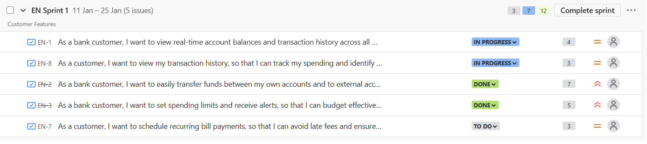

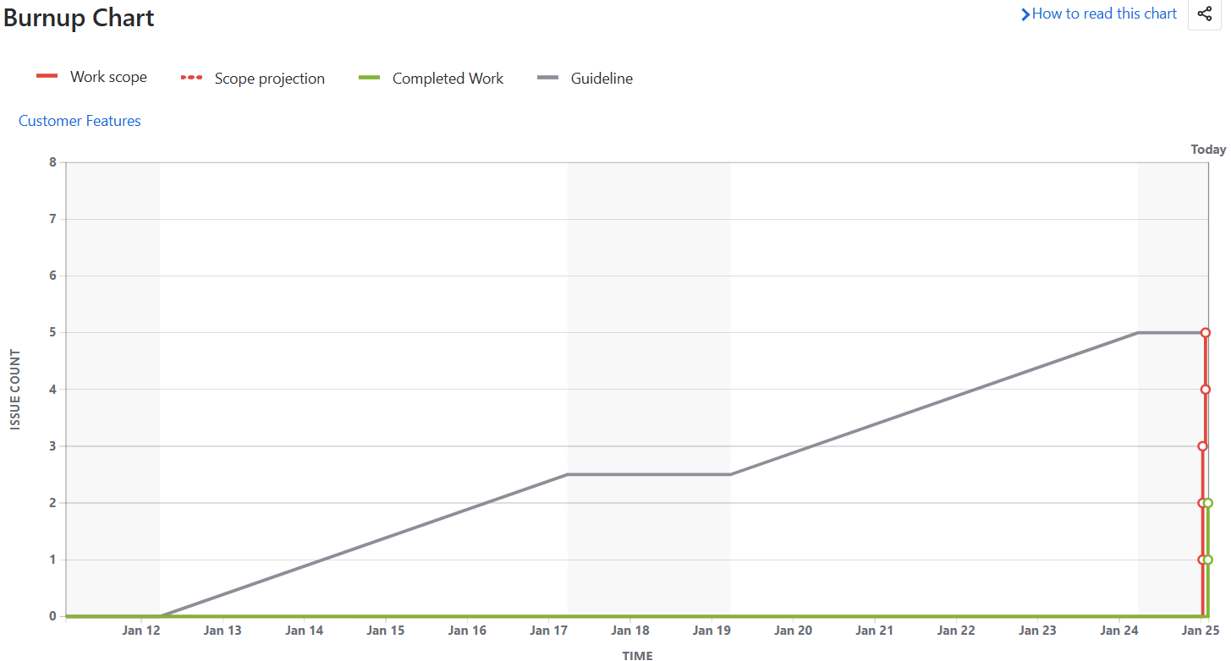

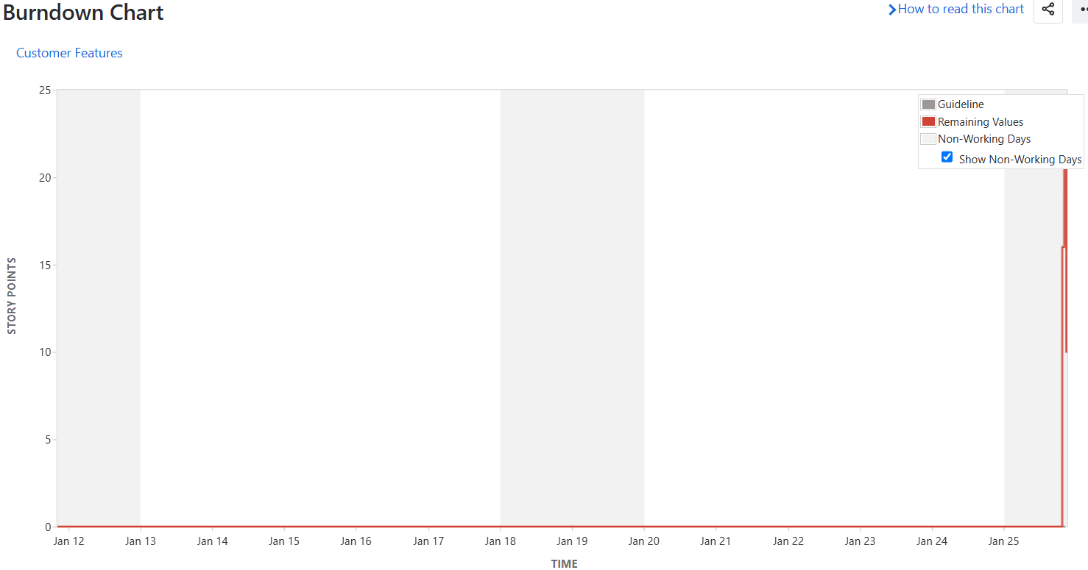

**Security**

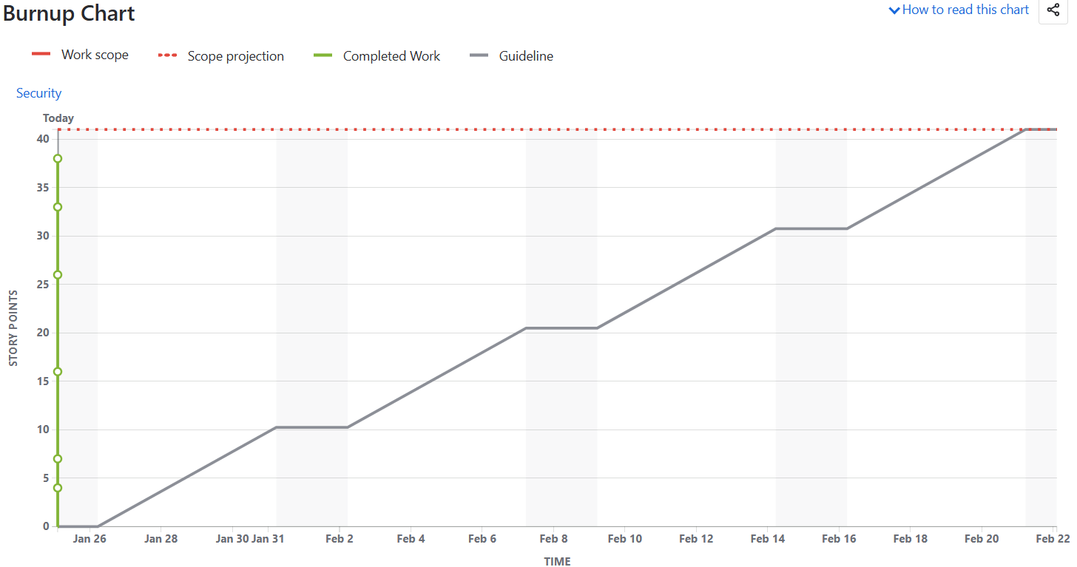

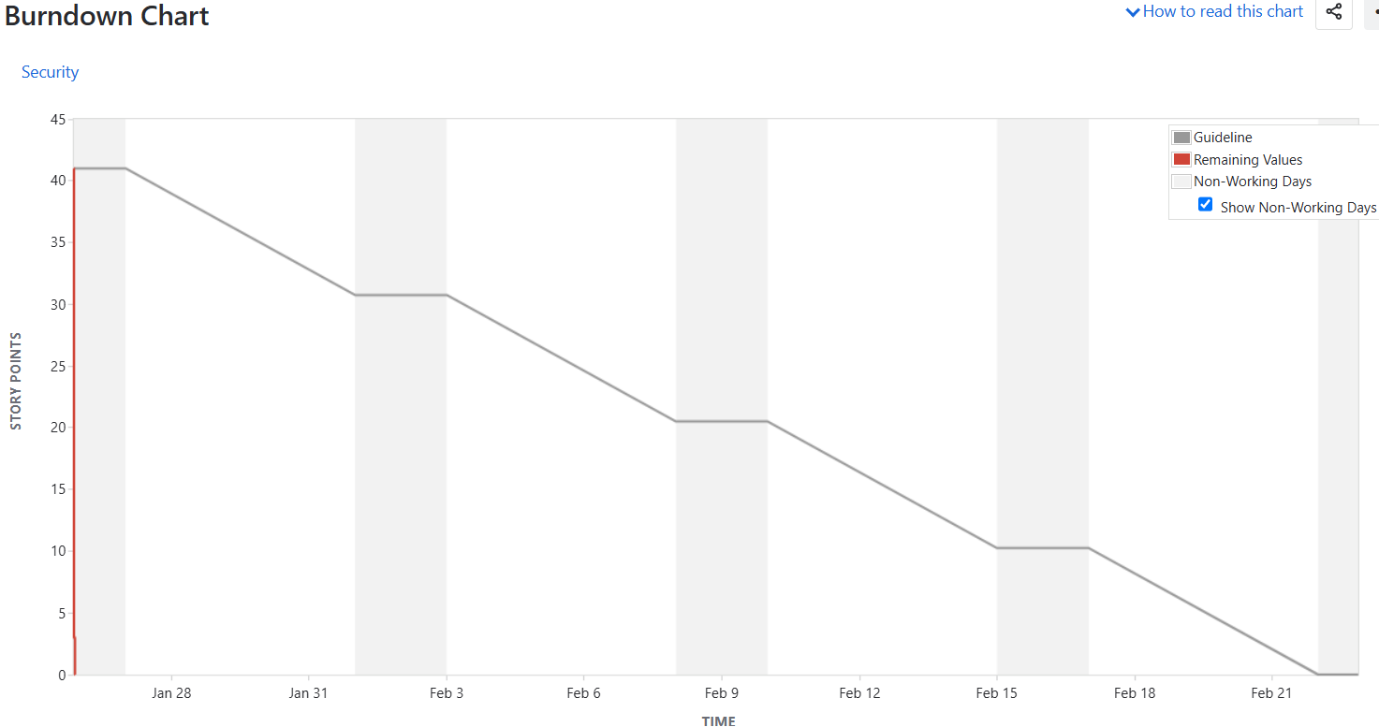

**Document 6**

**Sprint Meeting**

|  |  |
| --- | --- |
| **Date** | **25th Jan 2024** |
| **Time** | **3 pm** |
| **Location** | **MR 1** |
| **Prepared By** | **Alex** |
| **Attendees** | **Alex (PO), John (Scrum Master) Pratham, Arjun (Developer)** |

**Agenda Topic**

|  |  |  |  |
| --- | --- | --- | --- |
| **Topic** | **Presenter** | **Time Alloted** | **Details** |
| **Sprint Goal Review & Clarification** | Product Owner | 15 mins | Review and clarify the Sprint Goal for the upcoming Sprint |
| **Product Backlog Review & Refinement** | Product Owner, Development team | 35 mins | Discuss and refine Product Backlog items (User Stories, Epics) for the upcoming Sprint. |
| **Sprint Backlog Creation** | Development team | 25 mins | Create the Sprint Backlog by selecting User Stories and tasks to be completed within the Sprint |
| **Sprint Planning Poker** | Development team | 30 mins | Conduct Sprint Planning Poker to estimate the effort for selected User Stories |

**Other Information**

|  |  |
| --- | --- |
| **Observers** | **N/A** |
| **Resources** | Whiteboard/Projector, Sticky Notes, Estimation Cards, Project Management Tool - Jira |
| **Special Notes** | Document every action, Ensure clear communication. |

**Meeting Type 2: Sprint review meeting**

|  |  |
| --- | --- |
| **Date** | 14th Jan 2025 |
| **Time** | 3.30pm |
| **Location** | MR1 room |
| **Prepared By** | Name of the Scrum Master or designated individual |
| **Attendees** | Product Owner, Scrum Master, Development Team (Developers, Testers) |

|  |  |  |  |
| --- | --- | --- | --- |
| **Sprint Status** | **Things to demo** | **Quick Updates** | **What’s Next** |
| **Sprint 1** - Feature like ‘Transfer of fund’ & setting the ‘Spending limit’ completed In Sprint 1.  **Development** of feature like ‘Checking the real time account balance’ and ‘Viewing the transaction history’ was on going.  **While** we were yet to start with ‘Scheduling recurring or Auto payment’ feature.  Few of the team member were on emergency leave which acted as impediment in completing the Sprint. However, member was asked to WFH and complete the bare minimum task.  **Sprint 2 –** Features like Biometric Authentication, Data Privacy, Alerts, Fund transfer and pending features from Sprint 1 was also completed. | Testing was done of all the completed features/user stories post which live demonstrations was provided using PPT, screen sharing and live coding to showcase the work.  Feedback was requested from stakeholders on the completed work. | As 2 small sprints were completed each team member were asked to provide the feedback/update on their individual contributions and any challenges faced.  However, there was also a delay in receiving testing environment and issue related to a bit tight schedule. | Issue related leaves which ended up with tight schedule has been addressed and team has been asked to plan their leaves. In case of emergency team should work from home for at least 6 hours.  Upcoming sprints were discussed and backlog was prioritized |

**Meeting Type 3: Sprint retrospective meeting**

|  |  |
| --- | --- |
| **Date** |  |
| **Time** |  |
| **Location** |  |
| **Prepared By** | **Name of the Scrum Master or designated individual** |
| **Attendees** | **Product Owner, Scrum Master, Development Team (Developers, Testers)** |

|  |  |  |  |  |
| --- | --- | --- | --- | --- |
| **Agenda** | **What went well** | **What didn’t go well** | **Questions** | **References** |
|  | Successfully completed User Story: "View Real-time Account Balances", Transfer of fund’ & setting the ‘Spending limit’  There was Effective communication and collaboration within the team.  High-quality code delivered with minimal defects.  Effective use of daily stand-up meetings for quick updates | Emergency/Unexpected leave taken by team which resulted in incomplete Sprint and the features like ‘Scheduling recurring payment’ were added to upcoming Sprint.  Some challenges in clarifying the Acceptance Criteria for User Story 2. Minor communication gap regarding the design of the user interface for  Testing environment delay - We experienced delays in getting the testing environment set up, which impacted our testing timeline. This led to some time stretch at end on Sprint  Unclear Acceptance criteria of user story 3 were not clear which led to some rework. | How can we improve backup plan when people are on leave?  What can be done to ensure the testing environment is available at the start of the sprint?  What strategies can we implement to prevent similar delays in the future.  How can we better clarify and document Acceptance Criteria to avoid misunderstandings? | -Sprint Burndown Chart  -Daily Scrum notes  -User Story completion data  -Impediment log  -Team feedback from surveys |

**Meeting Type 4: Daily Stand-up meeting**

**20th Jan 2025 to 24th Jan 2025**

|  |  |  |  |  |  |  |
| --- | --- | --- | --- | --- | --- | --- |
| **Question** | **Name Role** | **Mon** | **Tue** | **Wed** | **Thur** | **Fri** |
| What did you do yesterday? | Pratham | Worked on the backend logic for the "View Balance" feature. | Integrated the "View Balance" API with the mobile app frontend. | Refactored the "Fund Transfer" code to improve performance. | Started working on the UI for the "Recurring Payments" | Completed the initial UI for "Recurring Payments" |
|  | Arjun | Focused on the frontend development for the "Fund Transfer" feature and implemented the transaction input form and validation. | Tested the "Fund Transfer" feature end-to-end. Fixed a few minor UI bugs. | Worked on the database schema changes required for the "Recurring Payments" | Collaborated with Developer 1 on the backend integration for "Recurring Payments" | Implemented the payment gateway integration for "Recurring Payments." |
| What will you do today? | Pratham | Continue working on the backend logic for "Recurring Payments." | Integrate the payment gateway API with the backend for "Recurring Payments." | Complete the backend logic for "Recurring Payments" and write unit tests. | Work with Developer 2 to integrate the backend with the frontend for "Recurring Payments." | Review and test the complete "Recurring Payments" feature. |
|  | Arjun | Work on the frontend validation for the "Recurring Payments" feature. | Implement the UI for viewing scheduled payments. | Work with Developer 1 on the backend integration for "Recurring Payments." | Complete the frontend development for "Recurring Payments." | Help with testing the "Recurring Payments" feature. |
| What (if any) is blocking your progress? | Pratham | Need clarification from the PO on the exact requirements for handling failed recurring transactions. | None | None | None | None |
|  | Arjun | Waiting for the payment gateway API documentation to be updated. | None | None | None | None |