Document 1: Definition of Done

### 1. Enhance Data Retrieval Performance

* **Objective**: Improve query performance and data retrieval speed.
* **DoD Criteria**:

|  |  |
| --- | --- |
| All performance benchmarks for data retrieval are met. |  |
| Query execution time for critical use cases is reduced by X% (based on baseline data). |  |
| Performance metrics are documented and validated through load testing. |  |
| Any identified bottlenecks are addressed and resolved. |  |
| Load testing results are reviewed and signed off by stakeholders. |  |

**2. Streamline System Integration**

* **Objective**: Simplify and optimize the integration with external systems.
* **DoD Criteria**:

|  |  |
| --- | --- |
| All system interfaces and integrations are documented. |  |
| Integration endpoints have been tested with both positive and negative scenarios. |  |
| Error handling and retries for failed integrations are implemented and tested. |  |
| Data flow between systems is validated to ensure smooth operation. |  |
| Integration setup can be automated where possible (e.g., using CI/CD pipelines). |  |
| System integrations meet functional and non-functional requirements (e.g., latency, error rates). |  |

**3. Facilitate Cloud Transition**

* **Objective**: Transition the system to the cloud or optimize existing cloud resources.
* **DoD Criteria**:

|  |  |
| --- | --- |
| The system is fully deployed and tested in the cloud environment. |  |
| All data storage and compute resources are properly configured for the cloud. |  |
| Cloud infrastructure scaling is verified and tested under load. |  |
| Cloud-related security, compliance, and cost optimization requirements are addressed. |  |
| All stakeholders are trained or provided with documentation for the new cloud-based system. |  |

**4. Improve User Experience**

* **Objective**: Enhance the system's usability and accessibility.
* **DoD Criteria**:

|  |  |
| --- | --- |
| UI/UX changes are user-tested and feedback is incorporated. |  |
| Key user flows are streamlined, and usability issues are resolved. |  |
| Accessibility standards (e.g., WCAG) are met. |  |
| Performance improvements (e.g., load time) are validated. |  |
| User satisfaction is measured and improved (e.g., through surveys or metrics). |  |

**5. Ensure Data Consistency and Accuracy**

* **Objective**: Guarantee that data remains accurate, consistent, and synchronized across systems.
* **DoD Criteria**:

|  |  |
| --- | --- |
| Data integrity checks are implemented and automated. |  |
| Consistency models are applied (e.g., eventual consistency, strong consistency). |  |
| Data validation rules are defined, automated, and executed. |  |
| Syncing mechanisms between systems are tested for reliability. |  |
| Error handling for data anomalies is robust (e.g., logs, alerts). |  |

Document 2- Product Vision

|  |  |  |  |
| --- | --- | --- | --- |
| **Scrum Project Name:** | QAD Application Enhancement and Optimization Project | | |
| **Venue:** | Virtual / On-site (Pune Office Medline Industries ltd.) | | |
| **Date: 20/01/2025** | **Start time: 9.00 AM** | **End time: 6.00 PM** | **Duration: 24 Months** |
| **Client:** | QAD | | |
| **Stakeholder list:** | MR ABC, CEO QAD | Mr XYZ, Project Lead QAD | Mr. EFG, BA, QAD |
|  | Ms Marion, Project Lead Medline | | Mr Matthieu, VP Medline |
| **Scrum Team** | | | |
| **Scrum Master:** | Devendra Chaudhari |  |  |
| **Product owner:** | Rashmi Garse |  |  |
| **Scrum Developer 1:** | Rudransh |  |  |
| **Scrum Developer 2:** | Moksh |  |  |
| **Scrum Developer 3:** | Tweesha |  |  |
| **Scrum Developer 4:** | Ishika |  |  |
| **Scrum Developer 5:** | Ishani |  |  |
| **Scrum Developer 1:** | Laksh |  |  |

### ****Product Vision:****

Our vision is to transform the **QAD ERP system** into a more efficient, scalable, and user-friendly platform that supports the evolving needs of the business. By enhancing data retrieval performance, streamlining system integrations, and improving user experience, we aim to create a seamless and powerful tool that empowers users, reduces operational friction, and enables faster decision-making. This project will also ensure data consistency, facilitate cloud migration for greater flexibility, and simplify customization and maintenance processes, ultimately positioning QAD as a more reliable, adaptive, and future-proof solution for the organization.

|  |  |  |  |
| --- | --- | --- | --- |
| **Target group** | **Needs** | **Product** | **Value** |
| Which market segment does the product address? | What problem does the product solve? | What product is it? | How is the product going to benefit the company? |
| **Manufacturing Industry**: Mid to large-sized manufacturers needing efficient supply chain, inventory, and production management.  **ERP Solutions Market**: Businesses looking for integrated software to manage core functions like finance, HR, and operations.  **Supply Chain & Logistics**: Companies needing seamless integration for real-time data and order management.  **Cloud Adoption**: Organizations transitioning to cloud-based systems for scalability and flexibility.  **IT & Operations Teams**: Internal teams seeking easier system maintenance and improved performance for business operations. | Slow data retrieval  Complex system integration  Limited scalability  Cumbersome user interface  Data inconsistencies  Difficult customization  Support and maintenance challenges | The product is the **QAD ERP System**, an enterprise resource planning (ERP) software designed for manufacturing businesses to manage and streamline core processes like production, inventory, supply chain, financials, and human resources.  The **enhancement project** focuses on improving its **performance, integration, user interface, scalability, and support**, making it a more efficient, user-friendly, and future-proof solution for businesses. | The product will benefit the company by:  **Improving Efficiency**: Faster data retrieval and streamlined processes reduce operational delays.  **Supporting Growth**: Scalable performance supports expanding business needs.  **Enhancing Decision-Making**: Accurate and consistent data enables better, faster decisions.  **Reducing Costs**: Cloud transition and improved integration lower maintenance and infrastructure costs.  **Boosting User Productivity**: A more intuitive interface and easier customization improve user efficiency.  **Future-Proofing**: The system is more adaptable to future needs, ensuring long-term value. |
| Who are the target users and customers? | Which benefit does it provide? | What makes it desirable and special? | What are the business goals? |
| **Manufacturers**: Production managers and supply chain teams needing real-time data for operations and inventory.  **IT Teams**: System administrators and business analysts managing and maintaining the ERP system.  **Business Leaders**: CEOs, CFOs, and Operations Directors needing accurate, real-time insights for decision-making.  **Supply Chain & Logistics**: Managers needing better data for inventory and order management.  **Cloud Transition Teams**: CTOs and cloud architects leading the move to cloud solutions. | The QAD ERP enhancement project provides the following benefits:  Faster data retrieval  Seamless system integration  Scalable performance for business growth  Improved user experience with an intuitive interface  Accurate and consistent data  Easier and faster customization  Simplified maintenance and better support | Industry-specific for manufacturing  Scalable to support business growth  Cloud-ready for flexibility and cost efficiency  Enhanced, intuitive user interface  Ensures data accuracy and consistency  Easy system customization  Seamless integration with other business systems | The business goals for the QAD ERP enhancement project are:  **Improve Operational Efficiency:** Streamline processes and reduce delays in data retrieval and system integration.  **Support Scalability:** Ensure the system can handle growing business demands without performance bottlenecks.  **Enhance Decision-Making:** Provide accurate, real-time data for faster, more informed business decisions.  **Reduce IT Costs:** Lower infrastructure and maintenance costs through cloud adoption and better system integration.  **Improve User Experience:** Create an intuitive, efficient interface to increase user productivity.  **Future-Proof the System:** Ensure the system can easily adapt to future technological and business changes. |
|  |  | Is it feasible to develop the product? | What is the business model? |
|  |  | Yes, the product is feasible to develop because:  The required technologies (cloud, integration tools, UI/UX) are available.  The team has the necessary expertise.  QAD ERP supports performance improvements and cloud transition.  Sufficient budget and resources are allocated.  Stakeholder support aligns with project goals.  With proper planning, it's achievable. | **Subscription-Based Licensing**: QAD may operate under a subscription model, where businesses pay for access to the ERP system based on usage, number of users, or specific modules.  **Cloud Services**: Transitioning to cloud-based solutions offers a recurring revenue stream through cloud hosting and maintenance services.  **Customization and Consulting**: Additional revenue from providing tailored solutions, implementation services, and ongoing consulting to ensure the system meets specific business needs.  **Maintenance & Support**: Offering long-term support, updates, and maintenance packages for continued customer engagement.  **Integration Services**: Charging for custom integrations with other business systems to ensure seamless data flow and process synchronization. |

Document 3: User stories

|  |  |  |
| --- | --- | --- |
| **User Story No:** 1 | **Tasks:** Optimize data retrieval from remote locations. | **Priority:** High |
| **Value Statement:**  As a user,  I want to access data faster,  So that I can make quicker decisions and improve productivity. | | |
| **BV (Business Value):** High, 100 | **CP (Customer Pain):** 5 | |
| **Acceptance Criteria:**  Data retrieval time is reduced by 50%.  Performance tests show improved access from remote locations. | | |

|  |  |  |
| --- | --- | --- |
| **User Story No:** 2 | **Tasks:** Simplify system integrations with third-party applications. | **Priority:** High |
| **Value Statement:**  As a user,  I want the system to integrate easily with third-party applications,  So that I can avoid manual data entry and ensure accurate data across systems. | | |
| **BV:** High, (80) | **CP:** 10 | |
| **Acceptance Criteria:**  Integration with external systems works without errors.  Data syncs automatically between systems. | | |

|  |  |  |
| --- | --- | --- |
| **User Story No:** 3 | **Tasks:** Migrate QAD system to the cloud. | **Priority:** Medium |
| **Value Statement:**  As a user,  I want the system to be cloud-based,  so that I can access it from anywhere and scale as needed. | | |
| **BV:** High, 70 | **CP:** 20 | |
| **Acceptance Criteria:**  QAD is fully operational in a cloud environment.  No downtime during the transition. | | |

|  |  |  |
| --- | --- | --- |
| **User Story 4:** | **Tasks:** Improve user interface for better navigation. | **Priority:** High |
| **Value Statement:**  As a user,  I want a more intuitive user interface,  so that I can navigate the system faster and more efficiently. | | |
| **BV:** Medium, 30 | **CP:** 50 | |
| **Acceptance Criteria:**  UX design changes are implemented.  Positive user feedback on ease of use. | | |

|  |  |  |
| --- | --- | --- |
| **User Story No:** 5 | **Tasks:** Implement role-based access control. | **Priority:** High |
| **Value Statement:**  As a user,  I want role-based access,  So that I can ensure that only authorized individuals can view or modify sensitive data. | | |
| **BV:** High, 60 | **CP:** 20 | |
| **Acceptance Criteria:**  Users are assigned appropriate roles and permissions.  Unauthorized access is blocked. | | |

|  |  |  |
| --- | --- | --- |
| **User Story No:** 6 | **Tasks:** Improve data consistency across systems. | **Priority:** High |
| **Value Statement:**  As a user,  I want accurate and consistent data across all platforms,  So that I can trust the data for reporting and decision-making. | | |
| **BV:** High, 50 | **CP:** 50 | |
| **Acceptance Criteria:**  Data is consistent across all systems.  Sync errors are minimized. | | |

|  |  |  |
| --- | --- | --- |
| **User Story No:** 7 | **Tasks:** Automate report generation. | **Priority:** Medium |
| **Value Statement:**  As a user,  I want reports to be automatically generated,  So that I can save time and avoid manual errors in reporting. | | |
| **BV:** Medium, 30 | **CP:** 70 | |
| **Acceptance Criteria:**  Reports are generated automatically on schedule.  Reports include accurate and relevant data. | | |

|  |  |  |
| --- | --- | --- |
| **User Story No:** 8 | **Tasks:** Improve system scalability for increased data volume. | **Priority:** High |
| **Value Statement:**  As a user,  I want the system to scale with business growth,  So that I can handle increased data volume without performance issues. | | |
| **BV:** High, 90 | **CP:** 20 | |
| **Acceptance Criteria:**  System handles higher volumes of data without performance degradation.  Stress tests confirm scalability. | | |

|  |  |  |
| --- | --- | --- |
| **User Story No:** 9 | **Tasks:** Enhance mobile access for remote users. | **Priority:** Medium |
| **Value Statement:**  As a user,  I want to access QAD from my mobile device,  So that I can manage tasks on the go. | | |
| **BV:** Medium, 20 | **CP:** 70 | |
| **Acceptance Criteria:**  Mobile app or mobile-optimized site is functional.  Users can perform core functions via mobile. | | |

|  |  |  |
| --- | --- | --- |
| **User Story No:** 10 | **Tasks:** Improve data backup and disaster recovery. | **Priority:** High |
| **Value Statement:**  As a user,  I want reliable data backup and disaster recovery,  so that I can ensure business continuity in case of data loss. | | |
| **BV:** High, 40 | **CP:** 10 | |
| **Acceptance Criteria:**  Backup system is automated and reliable.  Disaster recovery plan is tested and effective. | | |

Document 4: Agile PO Experience

### ****Agile Product Owner Experience – QAD ERP Enhancement****

#### ****Key Responsibilities with Examples:****

1. **Market Analysis**
   * **Example**: I analyzed the market need for improved **data retrieval speeds** and **cloud migration** in ERP systems. Through competitor research, I identified that many ERP solutions were failing to provide efficient cloud-based solutions or real-time data access for large manufacturing enterprises.
   * **Action**: Identified the opportunity to enhance QAD's capabilities in **cloud transition** and **remote data access**, addressing a key pain point for global manufacturing companies.
2. **Enterprise Analysis**
   * **Example**: Conducted an in-depth **due diligence** on the market opportunity by evaluating QAD’s current standing in the industry and assessing client feedback, particularly around **integration** and **user interface (UI) issues**.
   * **Action**: Discovered that many QAD users were struggling with **complex system integrations** and **a non-intuitive UI**, opening the opportunity for focused improvements in those areas.
3. **Product Vision and Roadmap**
   * **Example**: Developed a product vision centered around improving **performance** and **usability**, focusing on **faster data retrieval**, **seamless integration** with other systems, and **enhanced user interface** for better user experience.
   * **Action**: Created a roadmap with features such as **cloud-based architecture**, **faster data processing**, **improved system UI**, and **integration capabilities** planned for the next 6-12 months.
4. **Managing Product Features**
   * **Example**: Managed stakeholder expectations by prioritizing key features, such as **cloud migration** for scalability and **enhanced data consistency**, while ensuring a balance between performance, security, and usability.
   * **Action**: Worked closely with the development team to prioritize **data consistency improvements** and **cloud integration** as the first features for the QAD system to address major client pain points.
5. **Managing Product Backlog**
   * **Example**: Continuously refined the **product backlog** by adding and reprioritizing user stories based on feedback from internal stakeholders, such as **data retrieval performance**, **real-time data analytics**, and **customization ease** for users.
   * **Action**: Worked with the team to ensure that the most critical features were at the top of the backlog, such as **faster data retrieval** and **integration with third-party logistics systems**.
6. **Managing Overall Iteration Progress**
   * **Example**: During each sprint, I reviewed the progress on the development of the **cloud migration** feature and **data performance optimization**. When we hit delays, I **re-prioritized** to ensure the most impactful features (like **data consistency**) were delivered first.
   * **Action**: Regularly communicated with stakeholders on sprint progress and adjusted priorities based on feedback or unforeseen challenges (e.g., migration delays due to third-party integrations).

#### ****Agile Methodology & Scrum Practices with Examples:****

* **Sprint Meetings**
  + **Sprint Planning**:
    - **Example**: In sprint planning meetings, we prioritized **cloud migration** tasks to ensure the system would be scalable and accessible remotely. We also planned tasks to improve **data retrieval speed** for global users.
    - **Action**: Broke down these features into smaller stories like **optimizing database queries** for faster retrieval or **setting up cloud infrastructure**.
  + **Daily Scrum**:
    - **Example**: Every day, I facilitated the stand-up by tracking the status of critical tasks like **integration with third-party systems** and addressing any blockers related to **data consistency**.
    - **Action**: I ensured that all team members communicated issues like delays in integration and worked with them to solve the problems efficiently.
  + **Sprint Review**:
    - **Example**: At the end of the sprint, I reviewed the work completed, such as the **cloud migration** feature and its impact on **scalability**. We demonstrated the improved **data retrieval speed** and **seamless integration** with external systems to the stakeholders.
    - **Action**: Gathered feedback from users and stakeholders to fine-tune the next features in the roadmap, such as refining **user interface design** for better usability.
  + **Sprint Retrospective**:
    - **Example**: During retrospectives, we discussed what went well and areas for improvement. For instance, we identified that **testing integrations** with third-party systems could have been started earlier to avoid delays.
    - **Action**: Implemented changes in the next sprint to start integration testing earlier and allocate resources for better coordination between internal and external teams.
  + **Backlog Refinement**:
    - **Example**: I regularly refined the **product backlog**, ensuring user stories like **integration with supply chain systems** and **improvements to the UI** were well-defined and prioritized.
    - **Action**: Ensured that each backlog item had **clear acceptance criteria** and that the highest-priority items were always ready for the next sprint.

#### ****User Story Creation with Examples:****

* **User Story No**: 1
  + **Tasks**: Implement faster data retrieval from remote locations.
  + **Priority**: High
  + **Value Statement**:
    - **As a user**, I want faster data retrieval,
    - **so that I can** make quicker decisions from any location.
  + **BV**: High, improves global operations.
  + **CP**: Slow access to data for remote workers.
  + **Acceptance Criteria**:
    - Data retrieval time reduced by 50% for remote users.
    - Performance tests show improved access from remote locations.
* **User Story No**: 2
  + **Tasks**: Improve integration with third-party supply chain systems.
  + **Priority**: High
  + **Value Statement**:
    - **As a user**, I want to seamlessly integrate QAD with my supply chain systems,
    - **so that I can** eliminate manual data entry and improve data accuracy.
  + **BV**: High, reduces errors and manual work.
  + **CP**: Manual data entry and sync issues.
  + **Acceptance Criteria**:
    - Successful integration with third-party supply chain systems.
    - Data is synced automatically across systems.
* **User Story No**: 3
  + **Tasks**: Migrate QAD to cloud infrastructure for scalability.
  + **Priority**: Medium
  + **Value Statement**:
    - **As a user**, I want QAD to be cloud-based,
    - **so that I can** scale the system as needed and access it remotely.
  + **BV**: Medium, supports business growth and remote work.
  + **CP**: Limited scalability and access issues.
  + **Acceptance Criteria**:
    - QAD fully operational in the cloud.
    - No downtime during the migration process.

#### ****Liaison Role with Examples:****

* As a **Product Owner**, I served as the primary **liaison** between:
  + **Business stakeholders** (e.g., department heads, supply chain managers) and **Scrum teams** (e.g., developers, QA testers).
  + I ensured that **business requirements** for features like **cloud migration**, **data performance**, and **custom reporting** were clearly communicated and aligned with the team’s **technical deliverables**.
  + I facilitated **weekly stakeholder meetings** to keep everyone informed of progress and issues.

#### ****Learnings & Key Takeaways with Examples:****

1. **Sprint Meeting Management**:  
   I learned how to effectively manage and lead **Sprint meetings**, including prioritizing key features like **data retrieval optimization** and **system integrations**.
2. **User Story Creation & Refinement**:  
   Gained hands-on experience creating **user stories** for features like **real-time data synchronization** and **cloud deployment**, ensuring they included proper acceptance criteria and were aligned with business objectives.
3. **Stakeholder Communication**:  
   Improved my communication with stakeholders by continuously updating them on progress, including when **user interface improvements** and **system integrations** were completed.
4. **Backlog Management**:  
   Learned how to manage a **backlog** effectively, ensuring that critical features like **cloud scalability** and **faster data retrieval** were prioritized and delivered on time.

Document 5: Product and sprint backlog and product and sprint burndown charts

**Sprint 1:**

| **User Story ID** | **User Story** | **Tasks** | **Priority** | **BV** | **CP** | **Sprint** |
| --- | --- | --- | --- | --- | --- | --- |
| US-001 | **Enhance data retrieval speed** | 1. Identify performance bottlenecks in data queries 2. Optimize database indexing  3. Test data retrieval speed post-optimization | High | High, reduces decision-making delays | Slow access to data | Sprint 1 |
| US-002 | **Cloud migration for scalability** | 1. Set up cloud infrastructure  2. Migrate database to cloud 3. Test system functionality in cloud environment | Medium | Medium, future-proofs system | Limited scalability | Sprint 1 |
| US-003 | **Improve integration with third-party supply chain systems** | 1. Assess current integration points  2. Design integration APIs 3. Implement and test third-party system integration | High | High, reduces manual work and errors | Manual data entry | Sprint 1 |

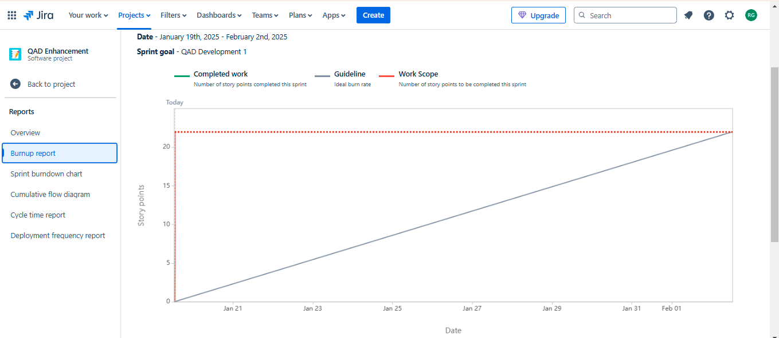

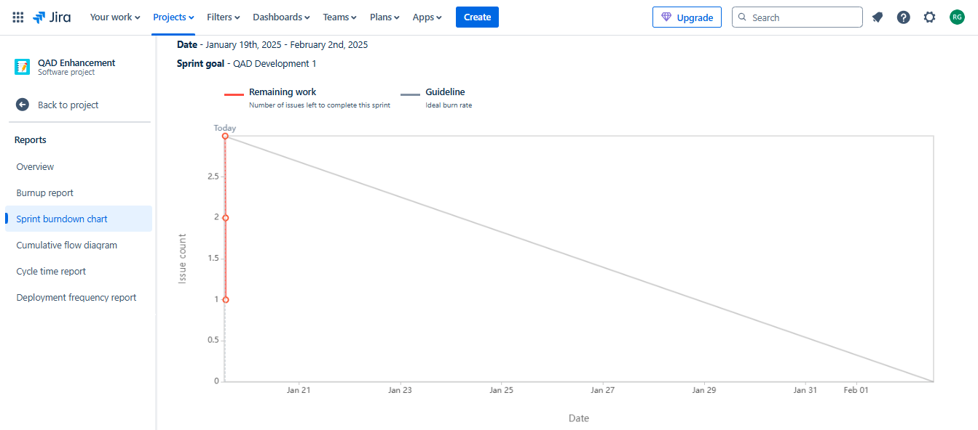

**Sprint 2:**

| **User Story ID** | **User Story** | **Tasks** | **Priority** | **BV** | **CP** | **Sprint** |
| --- | --- | --- | --- | --- | --- | --- |
| US-004 | **Optimize system UI for ease of use** | 1. Review current UI pain points with stakeholders  2. Redesign UI components for better navigation  3. Implement design changes | High | Medium, increases user efficiency | Difficult-to-navigate UI | Sprint 2 |
| US-005 | **Enhance data consistency across systems** | 1. Identify data sync issues  2. Implement data validation rules  3. Test data synchronization between systems | High | High, ensures reliable reporting | Inconsistent data across systems | Sprint 2 |
| US-006 | **Improve reporting capabilities (Custom reports)** | 1. Review business reporting needs 2. Create custom report templates 3. Test report generation for accuracy | Medium | Medium, improves flexibility for users | Lack of flexible reporting | Sprint 2 |

