**Question 1 – Audits**

4 Quarterly Audits are planned Q1, Q2, Q3, Q4 for this Project what is your

Knowledge on how these Audits will happen for a BA?



|  |  |  |  |
| --- | --- | --- | --- |
|  |  | document sign-off obtained |  |
| Q4 | Development | Development aligns with approved requirements | 3 weeks |
|  |  | Mid-phase review conducted for progress tracking | 2 weeks |
|  |  | Issues and requirement clarifications handled | 2 weeks |
|  |  | Business rules integrated correctly | 2 weeks |
|  |  | Initial unit testing and validation completed | 2 weeks |
| Q5 | Testing | User Acceptance Testing (UAT) criteria defined | 1 week |
|  |  | Test cases prepared and reviewed | 2 weeks |
|  |  | Test execution completed with defects logged | 3 weeks |
|  |  | BA validates requirement coverage in testing | 2 weeks |
|  |  | Sign-off obtained for go-live approval | 1 week |

**Question 2: B A Approach Strategy**

A **Business Analysis Approach Strategy** defines how a Business Analyst (BA) plans, conducts, and manages business analysis activities throughout a project. It ensures that the right **elicitation techniques**, **stakeholder engagements**, **documentation processes**, and **change management strategies** are in place for successful project completion.

**What Elicitation Techniques to apply?**  
1. **Workshops** – Discuss business goals with stakeholders.  
2. **Interviews** – With farmers, buyers, logistics team.  
3. **Surveys & Questionnaires** – Gather user preferences.  
4. **Document Analysis** – Study existing e-commerce models.  
5. **Prototyping** – Create wireframes/mockups for validation.

**How to do Stakeholder Analysis & RACI Matrix?**

Identify key stakeholders:  
 **Business Owners** (Client) – Project Sponsor  
 **Farmers & Suppliers** – Product Providers  
 **Customers (Buyers)** – End Users  
 **Tech Team** – Developers, UI/UX Designers  
 **Marketing Team** – Handles Promotions & Branding  
 **Logistics & Operations** – Manages Inventory & Delivery

* **RACI Matrix (Roles & Responsibilities)**

|  |  |  |  |  |
| --- | --- | --- | --- | --- |
| Activity | Responsible | Accountable | Consulted | Informed |
| Requirement Gathering | BA | Client | Tech Team, Marketing | Stakeholders |
| Design | UI/UX Team | Client | BA, Tech team | Users |
| Development | Dev Team | Tech lead | BA, Client | Marketing |
| Testing & UAT | QA Team | Client | BA, Dev team | Users |
| Deployment | DevOps | Client | BA, Operations | Users |

**What documents to write?**

Requirement Phase:

* Business Requirements Document (BRD)
* Functional & Non-Functional Requirements (FRD/NFRD)
* Use Case Document

Design Phase:

* Process Flow Diagrams (BPMN, UML)
* Wireframes & Prototypes

Development & Testing Phase:

* User Stories & Acceptance Criteria
* Test Cases & Test Scenarios
* Requirement Traceability Matrix (RTM)

Deployment & Post-Implementation:

* User Training Manual
* Client Project Acceptance Form (UAT Sign-off)

**What process to follow to sign off on the document?**

**Sign off to be taken on SRS as this is the primary and important document. Sign off can be taken by using E-mail confirmation from the client.**

**How to take approvals from the client?**

Establish a formal meeting with the clients to keep them informed and get continuous feedback.

**What communication channels to establish and implement?**

* **Meetings & Stand-ups** – Weekly progress updates,bi-weekly status meetings
* **Emails & Reports** – Status updates to stakeholders.

**How to handle change requests?**

**Change Management Process:**  
1. Client submits a **Change Request Form**.  
2. BA conducts **impact analysis**.  
3. Discuss with stakeholders on feasibility.  
4. Update **FRD & RTM** to include changes.  
5. Get **Client Approval** before development.

**How to update the progress of the project to the stakeholders?**

Weekly status reports, monthly review meetings

**How to sign off on the UAT (Client project acceptance form)**

* Prepare **UAT test cases** based on user stories.
* Conduct **UAT sessions** with the client.
* Log defects, fix issues, re-test.
* Once approved, obtain **Client Project Acceptance Form** sign-off.

**Question 3. Explain and illustrate the 3 tier architecture?**

**Explanation:**

The **3-tier architecture** is a **client-server software architecture** that divides an application into **three logical layers**, each responsible for specific functionalities.

It enhances **scalability, security, and maintainability** by separating **presentation, business logic, and data layers**.

## ****1.Application Layer (Presentation Layer)****

* **What it does?**  
  Acts as the **user interface (UI)**.  
  Handles user inputs and displays processed data.  
   Sends requests to the **business logic layer** for processing.
* **Examples:**  
  Web Apps (React, Angular, HTML, CSS)  
  Mobile Apps (Android, iOS)
* **Example in Online Agriculture Store:**  
  A customer browses available crops and places an order.

## ****2. Business Logic Layer (Application Layer)****

* **What it does?**  
   Processes business **rules and validations**.  
  Handles communication between the **UI and Database**.  
   Ensures **data accuracy and integrity**.
* **Examples:**  
   Backend Technologies (Node.js, Python, Java, .NET)  
   APIs & Web Services (REST)
* **Example in Online Agriculture Store:**  
   When a customer places an order, this layer checks **stock availability**, applies **discounts**, and processes the request.

## ****3. Data Layer (Database Layer)****

* **What it does?**  
  Stores and manages **all data securely**.  
  Ensures **data consistency, security, and backup**.  
  Fetches and updates data when requested by the business logic layer.
* **Examples:**  
  SQL Databases (MySQL, PostgreSQL, Oracle)  
  NoSQL Databases (MongoDB, Firebase)
* **Example in Online Agriculture Store:**  
  Stores farmer details, crop listings, and customer orders.

### ****How They Work Together?****

1. The **Application Layer** (UI) sends a request (e.g., "Get available crops").  
2. The **Business Logic Layer** processes the request and retrieves data.  
3. The **Data Layer** fetches the required data and sends it back.  
4. The **Application Layer** displays the results to the user.

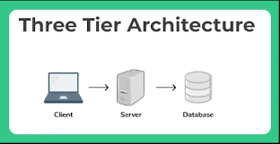

**Question 4.Business Analyst (BA) Approach Strategy for Framing Questions**

When a **Business Analyst (BA)** frames questions for stakeholders, they must ensure the questions are **clear, relevant, and structured** to gather accurate requirements.

**1 5W 1H Approach (Fundamental Questions)**

Before framing any question, a BA should consider:

**Who** – Who will use the system or process? (End users, customers, employees, etc.)  
 **What** – What features or functionalities are required? (Business rules, constraints, etc.)  
**Where** – Where will the system be used? (Geographical or departmental considerations)  
**When** – When should the process or system be available? (Deadlines, time constraints)  
 **Why** – Why is this feature or process needed? (Business objectives, pain points)  
**How** – How will it work? (Process flow, integrations, and dependencies)

**Example Question:**  
✅ *What are the main challenges you face in managing farm produce sales?*

**2 SMART Approach (To Make Questions Goal-Oriented)**

BA questions should align with **SMART** criteria:

**S**pecific – Clearly define the objective of the question.  
**M**easurable – Ensure responses can be quantified.  
**A**chievable – Ask within realistic expectations.  
 **R**elevant – Ensure relevance to the project goals.  
**T**ime-bound – Consider time constraints and deadlines.

**Example Question:**  
✅ *What specific KPIs do you track to measure online agriculture store performance?*

**3 RACI Approach (Role-Based Questions)**

A BA should know **who is responsible for what** before asking stakeholders.

**R**esponsible – Who will perform the task?  
**A**ccountable – Who will approve decisions?  
**C**onsulted – Who should be consulted for input?  
 **I**nformed – Who needs to be updated?

**Example Question:**  
✅ *Who is responsible for managing product listings on the online store?*

**4 .3-Tier Architecture Questions (Technical Understanding)**

When gathering requirements, the BA should ensure the questions align with the **three layers** of system architecture:

🔹 **Application Layer (UI/UX)** – *How should the interface look?*  
🔹 **Business Logic Layer** – *What business rules should be applied?*  
🔹 **Data Layer (Database)** – *What data needs to be stored and retrieved?*

**Example Question:**  
✅ *What fields should be mandatory when a farmer adds a new crop listing?*

**5 Use Cases, Use Case Specifications & Activity Diagrams**

🔹 **Use Cases** – Define how the system will interact with users.  
🔹 **Use Case Specs** – Detail user actions, system responses, preconditions, and postconditions.  
🔹 **Activity Diagrams** – Visual representation of workflows and interactions.

**Example Question:**  
✅ *Can you describe a typical process of a customer purchasing crops online?*

**6 Page Designs & UI Considerations**

BAs must frame questions considering **UI/UX design** to improve usability.

**Example Question:**  
✅ *What details should be displayed on the product listing page?*

**Question 5 – Elicitation Techniques**

**As a Business Analyst, What Elicitation Techniques you are aware of? ( BDRFOWJIPQU)**

* Brain storming
* Document analysis
* Reverse engineering
* Focus groups
* Observation
* Workshops
* JAD
* Interview
* Prototype
* Questionnaire
* Use case specs

**Question 6 – This project Elicitation Techniques - 5 Marks**

**Which Elicitation Techniques can be used in this Project and Justify your selection of Elicitation Techniques?**

A **Business Analyst (BA)** must choose the right elicitation techniques to gather accurate **business requirements**.

**1️⃣ Prototyping (For UI & Customer Experience)**

✅ **Why Use It?**

* **Stakeholders may struggle** to visualize the final product.
* Helps in **gathering feedback early** on the UI/UX design.
* Ensures **farmers and customers** get a user-friendly platform.

✅ **Justification:**  
A **low-fidelity prototype (wireframe)** of the website/app can be shown to farmers, vendors, and customers to **validate the user journey** before actual development.

✅ **Example:**  
A **mockup of the product listing page** can be created, and stakeholders can **suggest changes** before development starts.

**2 Use Case Specifications (For Defining User Interactions)**

✅ **Why Use It?**

* Clearly defines **how users (farmers, buyers, and admins)** interact with the system.
* Helps **developers and testers** understand workflows.
* Avoids **miscommunication** in requirement interpretation.

✅ **Justification:**  
Since this system involves **multiple actors** (e.g., farmers listing products, customers placing orders, admins managing transactions), detailed **use case specifications** are required to ensure every scenario is documented.

✅ **Example:**

* **Use Case: "Place an Order"**
  + **Actor:** Customer
  + **Steps:** Browse products → Add to cart → Make payment → Order confirmation

**3️⃣ Document Analysis (For Understanding Existing Processes)**

✅ **Why Use It?**

* Helps in understanding **existing agriculture business workflows** (if any).
* Identifies **business rules, regulations, and constraints** related to online selling.
* Saves time by avoiding repetitive stakeholder meetings.

✅ **Justification:**  
If the business already has **contracts, policies, or operational guidelines**, analyzing them will help define system requirements accurately.

✅ **Example:**

* Reviewing **government regulations** on online agricultural sales and **taxation policies** before system implementation.

**4️⃣ Brainstorming (For Generating Ideas & Identifying Risks)**

✅ **Why Use It?**

* Helps in **gathering creative ideas** from stakeholders.
* Identifies **possible risks, constraints, and improvements**.
* Useful for defining **new features & enhancements**.

✅ **Justification:**  
Since an **online agriculture store is a new concept** for many farmers, brainstorming sessions with **farmers, supply chain managers, and business owners** will help discover **new pain points and features**.

✅ **Example:**

* **Brainstorming Session Topic:** "How can we improve farmer-customer engagement?"
  + Solution 1: **Live chat between farmers and buyers**
  + Solution 2: **Product rating and review system**

**Question 7 – 10 Business Requirements- 10 Marks**

**Make suitable Assumptions and identify at least 10 Business Requirements.**

Business Requirements (BRs)

|  |  |  |
| --- | --- | --- |
| Requirement ID | Business Requirement (BR) | Description |
| BR-01 | User Registration & Authentication | Farmers and customers must be able to register and log in securely using email, phone, or social media. |
| BR-02 | Product Listing & Management | Farmers should be able to add, edit, and remove product listings with images, descriptions, and pricing. |
| BR-03 | Order Placement & Tracking | Customers should be able to add products to a cart, place orders, and track their delivery status. |
| BR-04 | Payment Gateway Integration | The system must support secure online payments via UPI, credit/debit cards, and net banking. |
| BR-05 | Rating & Review System | Customers should be able to review and rate products to help others make informed decisions. |
| BR-06 | Inventory Management | Farmers should receive notifications when their stock is low to prevent overselling. |
| BR-07 | Chat & Query Support | A chat feature should allow direct communication between farmers and buyers for product-related queries. |
| BR-08 | Multi-Language Support | The platform should be available in multiple languages to cater to different regions. |
| BR-09 | Delivery & Logistics Management | The system should integrate with logistics providers for seamless delivery tracking. |
| BR-10 | Reports & Analytics | Admins and sellers should be able to generate reports on sales, customer behavior, and product performance. |

### ****Assumptions Made****

* The platform will serve both **farmers (sellers) and customers (buyers)**.
* Payment transactions will be handled securely via **third-party gateways**.
* The system will support **multi-language accessibility** for rural farmers.
* The online store will integrate with **logistics services** for order fulfillment.

**Question 8 –Assumptions-**

**List your assumptions**

**1. Users can log in using Face book and Google** for quick access.  
2 **Farmers can list, update, and delete their products** from the platform.  
3 **Customers can track their orders in real time** through the system.  
4 The **platform supports multiple languages** for better accessibility.  
5 Secure **payment methods** like UPI, credit/debit cards, and net banking are integrated.  
6 Customers **can leave ratings and reviews** for purchased products.  
7 The **system will notify farmers** when inventory is low.  
8 The **platform will follow e-commerce tax regulations** and automatically calculate GST/VAT.  
**Delivery tracking is integrated** with third-party logistics providers.

**Question 9 – This project Requirements Priority**

Give Priority 1 to 10 numbers (1 being low priority – 10 being high priority) to these Requirements

After discussions with the stakeholders

|  |  |  |  |
| --- | --- | --- | --- |
| Requirement ID | Requirement Name | Requirement Description | Priority (1-10) |
| BR-01 | User Registration & Authentication | Users (farmers and customers) must be able to register and log in using email, phone, or social media. | 10 |
| BR-02 | Product Listing & Management | Farmers should be able to add, edit, and remove product listings with images, descriptions, and pricing. | 9 |
| BR-03 | Order Placement & Tracking | Customers should be able to add products to a cart, place orders, and track their delivery status. | 10 |
| BR-04 | Payment Gateway Integration | The system must support secure online payments via UPI, credit/debit cards, and net banking. | 10 |
| BR-05 | Rating & Review System | Customers should be able to review and rate products to help others make informed decisions. | 6 |
| BR-06 | Inventory Management | Farmers should receive notifications when their stock is low to prevent overselling. | 7 |
| BR-07 | Chat & Query Support | A chat feature should allow direct communication between farmers and buyers for product-related queries. | 5 |
| BR-08 | Multi-Language Support | The platform should be available in multiple languages to cater to different regions. | 4 |
| BR-09 | Delivery & Logistics Management | The system should integrate with logistics providers for seamless delivery tracking. | 8 |
| BR-10 | Reports & Analytics | Admins and sellers should be able to generate reports on sales, customer behavior, and product performance. | 3 |

Question 10 – Use Case Diagram

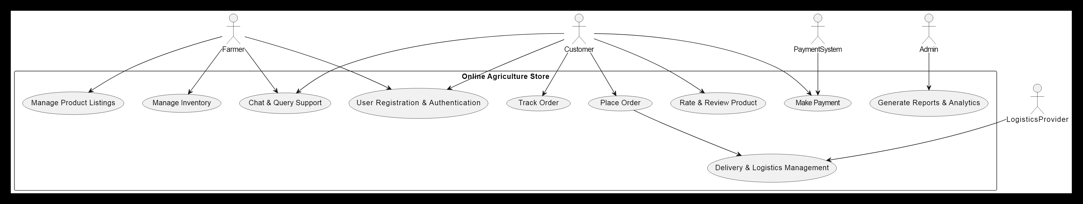

### **Explanation of the Use Case Diagram**

* **Actors:**
  + **Farmer** → Registers, manages products, handles inventory, and responds to customer queries.
  + **Customer** → Registers, places orders, makes payments, tracks orders, and rates products.
  + **Admin** → Manages platform reports and analytics.
  + **Payment System** → Handles secure online transactions.
  + **Logistics Provider** → Manages delivery and tracking.
* **Use Cases:**
  + **User Registration & Authentication** → Required for platform access.
  + **Manage Product Listings** → Farmers can add/edit/delete products.
  + **Place Order** → Customers can buy products.
  + **Track Order** → Customers check order status.
  + **Make Payment** → Customers pay via online payment gateway.
  + **Manage Inventory** → Farmers get stock notifications.
  + **Rate & Review Product** → Customers can review products.
  + **Chat & Query Support** → Customers and farmers communicate.
  + **Generate Reports & Analytics** → Admins view sales and user activity.
  + **Delivery & Logistics Management** → Orders are processed and shipped.

**Question 11 – (minimum 5) Use Case Specs**

Prepare use case specs for all use cases

A **Use Case Specification (Use Case Document)** is a **detailed description** of how a user interacts with a system to achieve a specific goal. It provides a structured way to define the **flow of events, actors, conditions** in a system.

Use Case 1: User Registration & Authentication

|  |  |
| --- | --- |
| Use Case ID | UC1 |
| Use Case Name | User Registration & Authentication |
| Actors | Farmer, Customer |
| Description | Allows users to register and log in using email, phone, or social media (Google/Facebook). |
| Preconditions | User must have valid credentials and internet access. |
| Postconditions | The user is successfully registered and can access the platform. |
| Flow of Events | **1.** User enters details (email, phone, password). **2.** System validates inputs. **3.** If valid, account is created; if invalid, an error is shown. **4.** User logs in with credentials. **5.** System verifies authentication and grants access. |
| Alternate Flow | **A1:** If the user forgets the password, they can reset it via email/OTP verification. |
| Exceptions | **E1:** Invalid credentials → Show error message. **E2:** Account already exists → Prompt user to log in. |

Use Case 2: Manage Product Listings

Use Case 2: Manage Product Listings

|  |  |
| --- | --- |
| Use case ID | UC2 |
| Use Case Name | Manage Product Listings |
| Actors | Farmer |
| Descriptions | Allows farmers to add, edit, or delete their product listings. |
| Preconditions | User must be logged in as a Farmer. |
| Postconditions | The product listing is updated successfully. |
| Flow of events | **1.** Farmer navigates to product management. **2.** Adds new product details (name, price, image, stock). **3.** System validates and saves the data. **4.** Farmer can edit or delete existing listings. |
| Alternate flow | **A1:** If product data is incomplete, show an error message. |
| Exceptions | **E1:** Invalid image format → Prompt for correct format. **E2:** Insufficient stock → Show warning. |

Use Case 3: Place Order

|  |  |
| --- | --- |
| Use Case ID | UC3 |
| Use case name | Place Order |
| Actors | Customer |
| Description | Allows customers to select products and place an order. |
| Preconditions | Customer must be logged in and have items in the cart. |
| Postconditions | Order is successfully placed and saved in the system. |
| Flow of events | **1.** Customer selects products and adds them to the cart. **2.** Proceeds to checkout. **3.** Enters delivery details. **4.** Selects payment method. **5.** Confirms and places the order. **6.** System generates an order ID and sends confirmation. |
| Alternate flow | **A1:** Customer modifies cart before finalizing the order. |
| Exceptions | **E1:** Payment failure → Order is not placed, prompt for retry. **E2:** Out-of-stock item → Notify customer and update cart. |

Use Case 4: Make Payment

|  |  |
| --- | --- |
| Use case ID | UC4 |
| Use case name | Make Payment |
| Actors | Customer, Payment System |
| Description | Customers complete payment through secure gateways. |
| Preconditions | Customer has an active order in the cart. |
| Postconditions | Payment is processed, and order is confirmed. |
| Flow of events | **1.** Customer selects payment method (UPI, card, net banking). **2.** System redirects to the payment gateway. **3.** Customer enters payment details. **4.** Payment gateway verifies and approves transaction. **5.** System confirms order and sends receipt. |
| Alternate flow | **A1:** If payment fails, the user can retry or select another method. |
| Exceptions | **E1:** Card declined → Show error message. **E2:** Session timeout → Prompt to restart the process. |

Use Case 5: Track Order

|  |  |
| --- | --- |
| Use Case ID | UC5 |
|  | Track Order |
|  | Customer, Logistics Provider |
|  | Customers can track their order delivery status in real-time. |
|  | Customer must have placed an order. |
|  | Customer receives real-time updates about order status. |
|  | **1.** Customer navigates to "My Orders". **2.** Selects an order to view tracking details. **3.** System fetches tracking updates from the logistics provider. **4.** Order status (Processing, Shipped, Delivered) is displayed. |
|  | **A1:** If no tracking updates are available, the system prompts the user to check back later. |
|  | **E1:** Order ID not found → Show error message. **E2:** Delay in delivery → Notify customer with a revised date. |

**Question 12 – (minimum 5) Activity Diagrams**

1.User Registration & Login Activity Diagram

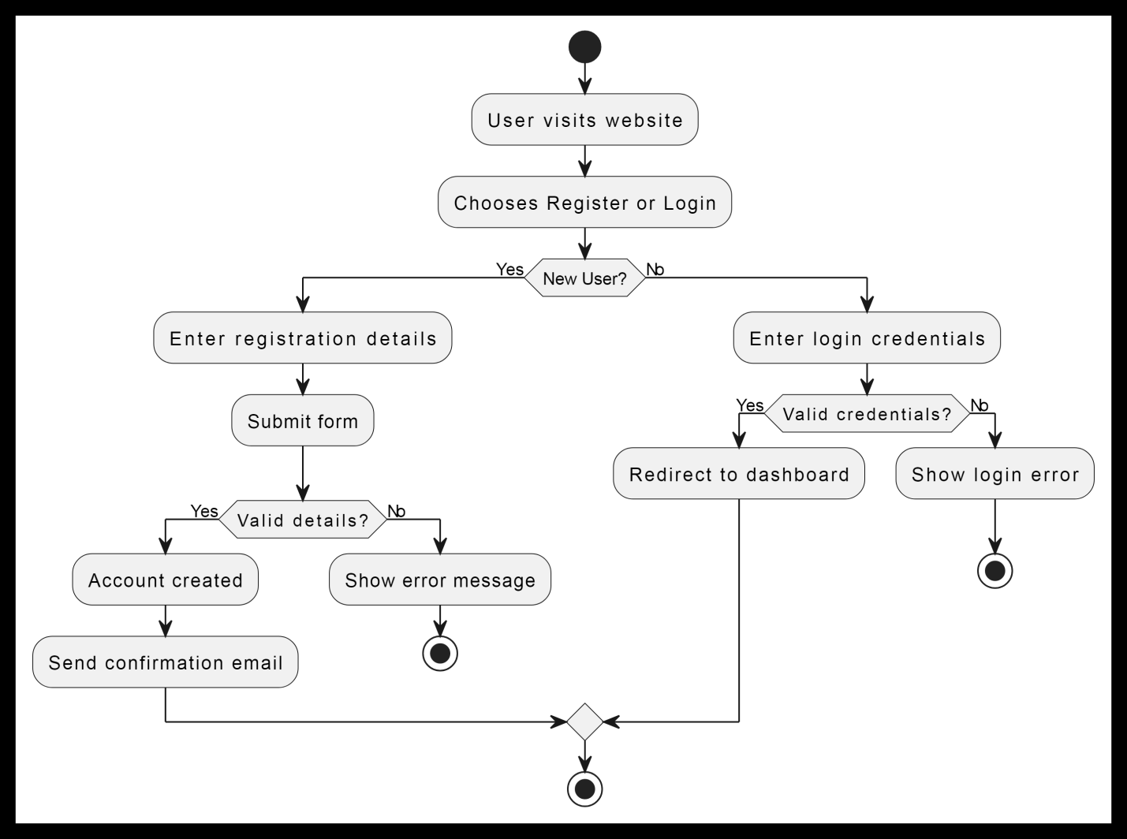

2.Product Listing by Farmers Activity Diagram

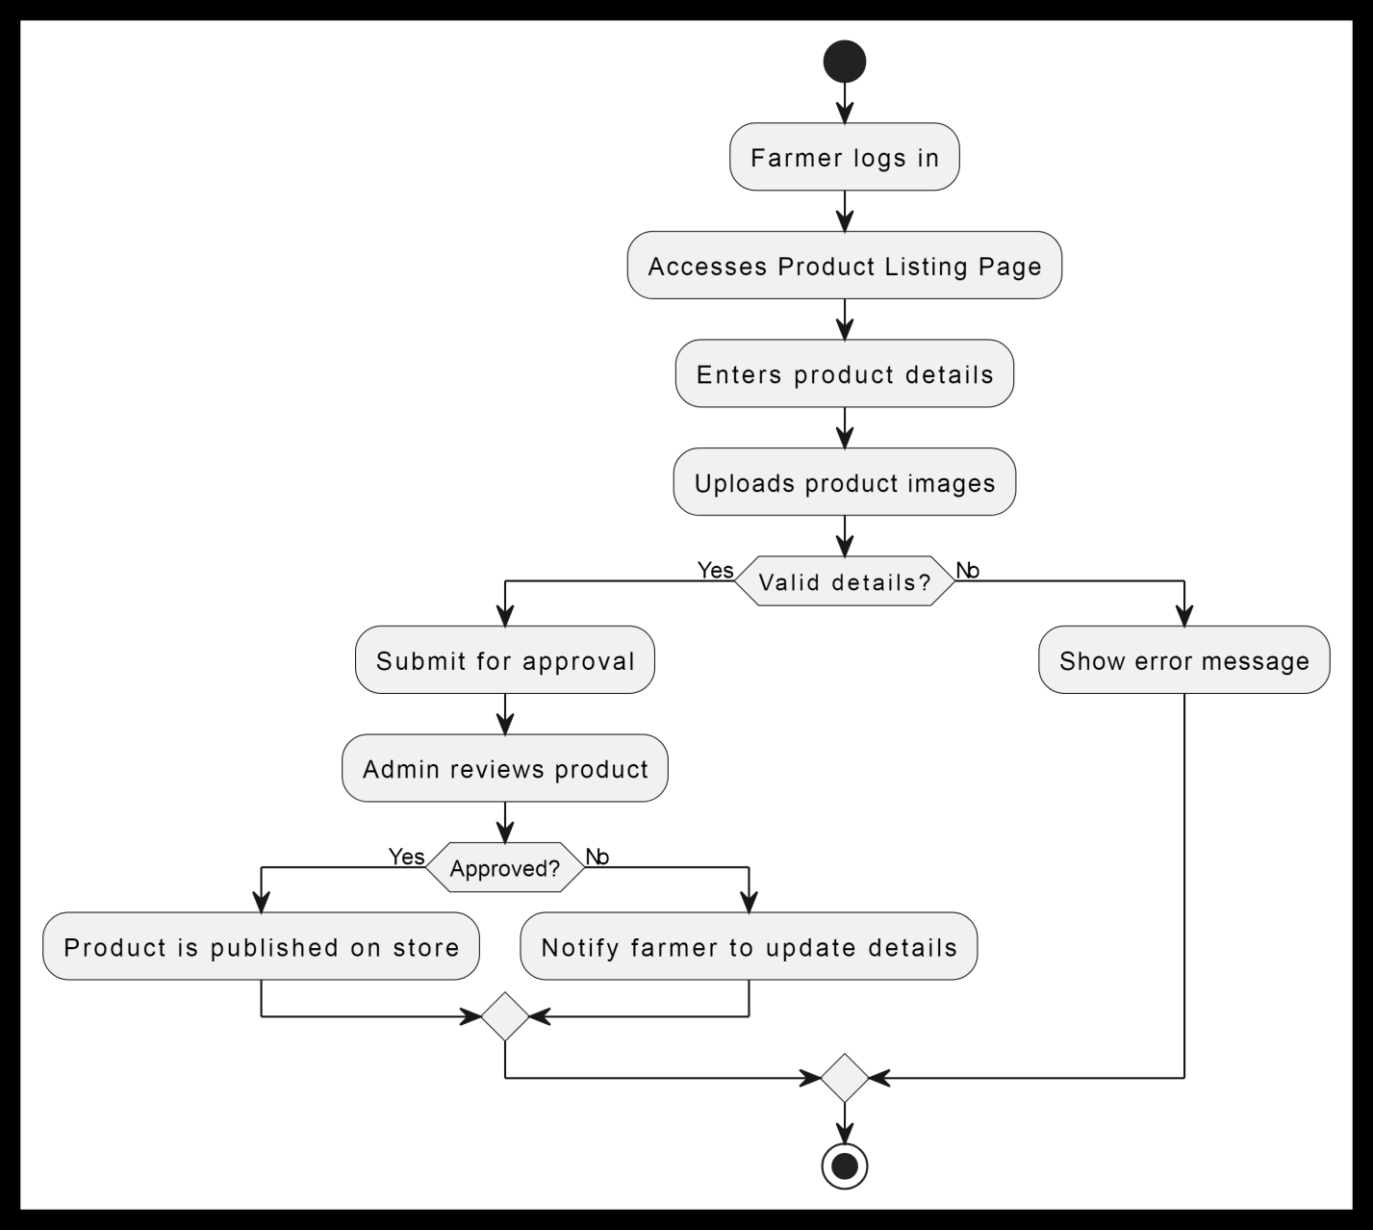

3. Placing an Order Activity Diagram

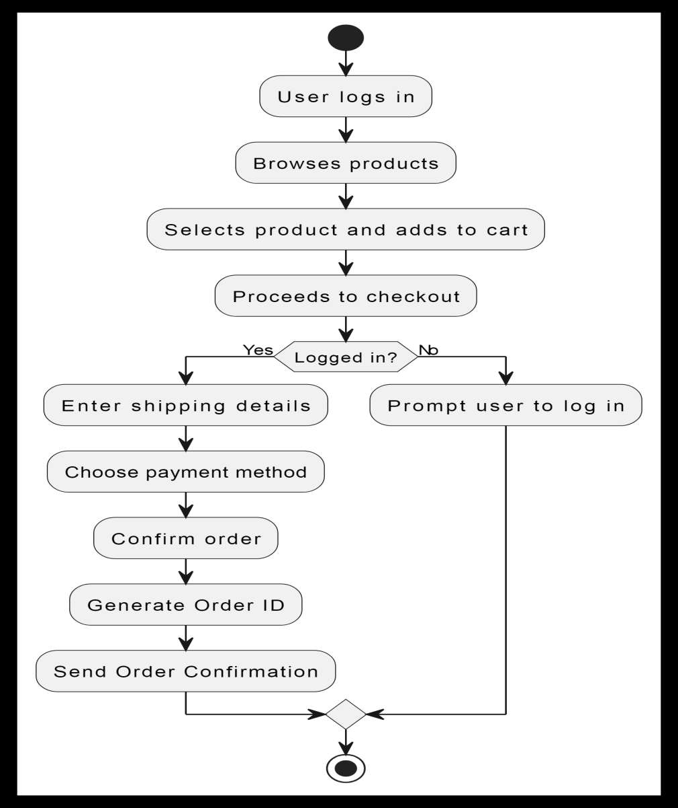

4.Payment Processing Activity Diagram

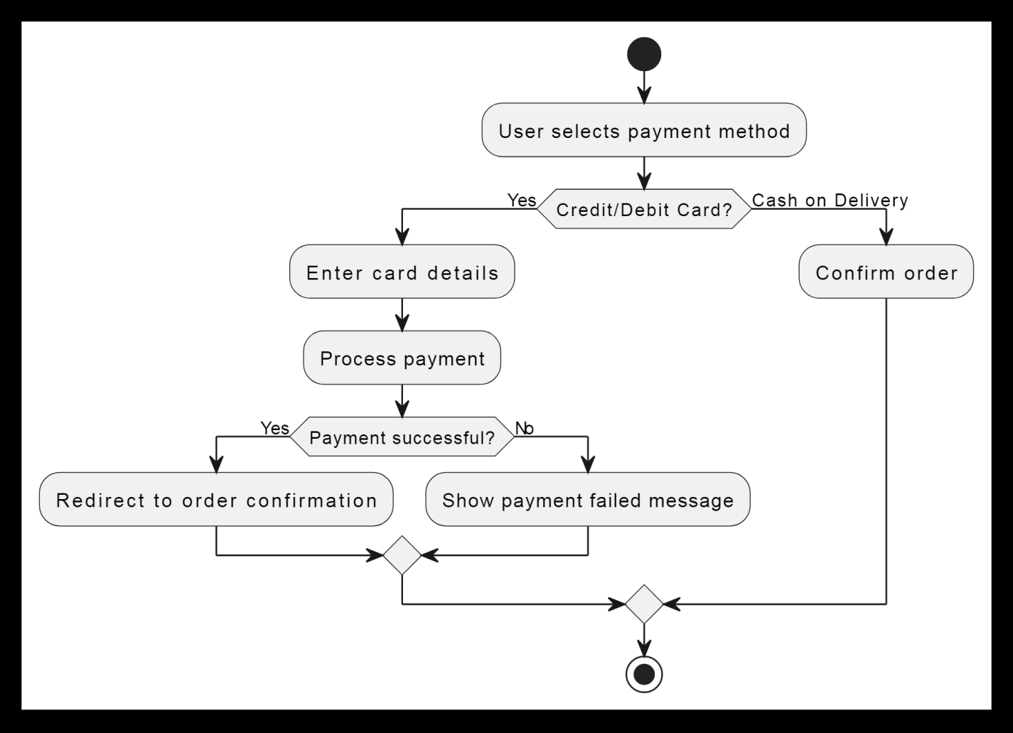

5.Order Tracking & Delivery Activity Diagram

