**Capstone Project 1**

**Question 1 – BPM**

Identify Business Process Model for Online Agriculture Store – (Goal, Inputs, Resources, Outputs, Activities, Value created to the end Customer)

**Answer 1 –** BPM

Definition: Business process modeling (BPM) is a method of visually representing and documenting the workflows within a business to help understand, analyze, and improve those processes. It involves creating diagrams that show the sequence of tasks, the actors involved, and the flow of information within a process.

As a BA our role involves understanding stakeholder requirements and acting as a bridge between the technical team and the stakeholders ensuring project objective and maximum efficiency for customer satisfaction.

Business process model for online agriculture store

**Goal**

Facilitate remote area farmers in purchasing agriculture products such as fertilizer, seeds, and pesticides through an online platform, ensuring accessibility, convenience, and a direct communication channel between farmers and product manufacturers.

**Inputs**

* Product Details (fertilizers, seeds, pesticides) provided by the manufacturing companies.
* User Requirements and feedback from stakeholders (Peter, Kevin, Ben, and other farmers)

**Resources**

* Financial Resources – 2 Crores INR
* Human Resources – The whole team of APT IT Solutions (project manager, developers, testers, network admin, DB admin and BA)

**Outputs**

* Online platform/website/mobile application developed by APT IT Solutions
* User-friendly interface for farmers to browse select and purchase agricultural products
* Direct channel communication between manufacturer and farmers
* Delivery of products to farmers' locations.

**Activities**

* Requirement Gathering
* System Development – Design Online platform/ mobile application
* Product Listing and display
* User-friendly interaction and ordering
* Order processing and delivery
* Quality Assurance – Through Testing
* Deployment and Maintenance

**Value created for the end Customer**

Farmers can purchase products remotely, which saves their time, they have access to a wide range of products, and direct communication with the manufacturer that will help them to enhance their productivity.

Question 2 – SWOT

**Answer 2 –** SWOT Analysis

A SWOT analysis is a strategic planning tool used to identify and analyze an organization's Strengths, Weaknesses, Opportunities, and Threats, helping in making informed decisions and developing effective strategies.

The primary goal of SWOT analysis is to increase awareness of the factors that go into making a business decision or establishing a business strategy.

It's a simple but powerful framework for understanding a company's competitive position and making informed decisions.

Businesses commonly use SWOT analysis, but it is also used by nonprofit organizations and, to a lesser degree, individuals for personal assessment. SWOT is also used to assess initiatives, products or projects.

**Strengths** – Direct connectivity between farmer and manufacturer, Strong Financial support, Skilled team (APT IT Solutions)

**Weaknesses**- Connectivity issues (Internet issues from the farmer side), Developing user-friendly web/mobile apps for users

**Opportunity** – Market expansion to remote areas to reach farmers, and diversify vast offerings of products.

**Threats** – Fluctuating market prices, Security risks (Data breaches)

Question 3 – Feasibility study

**Answer 3 –**

A feasibility study is an assessment that determines the likelihood of a proposed project being successful, such as a new product line or technical system. The study analyzes the project's relevant factors, such as technical, economic and legal considerations, to assess whether the project is worth an investment. The study can also identify potential issues and problems that could arise from pursuing the project.

**Hardware –** Check server requirements, storage needs, and networking infrastructure.

**Software –** Evaluate JAVA frameworks and tools for software development.

**Trained Resources –** Assess the expertise and availability of Java developers and testers.

**Budget Analysis –** Assessment covering development costs, maintenance, and hardware procurement.

**Timeframe –** Evaluate time duration including development, testing, and deployment.

Question 4 – Gap Analysis

**Answer 4 –**

A gap analysis is the process that is use to compare their current performance with their desired, expected performance. This analysis is used to determine whether a company is meeting expectations and using its resources effectively.

To effectively address "gaps" identified in a gap analysis, we need to clearly define the current and desired states, analyze the gap, develop a plan to bridge it, and then implement and monitor the plan.

|  |  |  |  |
| --- | --- | --- | --- |
| **Aspect** | **AS-IS (Current Process)** | **TO-BE (Proposed Future Process)** | **Gap/Issue Addressed** |
| **Data Capture** | Manual data entry using physical forms and spreadsheets | Digital data capture through an online platform | Reduces human error and data entry delays |
| **Data Availability** | Fragmented and siloed data stored in multiple formats and locations | Centralized database accessible in real-time | Improves accessibility and decision-making |
| **Reporting** | Time-consuming and inconsistent manual reports | Automated, standardized, and real-time dashboards and analytics | Enhances reporting accuracy and efficiency |
| **Process Visibility** | Limited visibility on project progress, delays, or bottlenecks | Real-time tracking and process transparency | Supports better monitoring and control |
| **Communication** | Reliant on email and verbal communication, often resulting in miscommunication | Integrated communication channels within the platform | Streamlines collaboration and reduces information loss |
| **Approvals & Workflows** | Manual approvals causing delays and paperwork errors | Automated workflows with digital approvals | Speeds up processes and ensures accountability |
| **Customer Interaction** | Inconsistent customer updates and service experiences | Systematic customer notifications and feedback mechanisms | Improves customer satisfaction |
| **Data Security & Auditability** | Vulnerable to loss and lacks a proper audit trail | Secure digital records with traceable activity logs | Enhances compliance and security |
| **Scalability** | Difficult to manage increased data and processes with growth | Scalable architecture that supports organizational expansion | Future-proofs operations |
| **Resource Utilization** | Over-reliance on manual labor for routine tasks | Automation frees up staff for higher-value tasks | Increases productivity and resource optimization |

Question 5 – Risk Analysis

**Answer 5 –**

Risk analysis is a process of identifying, assessing, and evaluating potential risks that could impact a project, business, or organization. It involves determining the likelihood of risks occurring and their potential impact, ultimately helping to prioritize and manage them effectively. Risk analysis is used to develop strategies for avoiding, mitigating, or transferring risks.

**Internal/External Risks**

* Dependence on external vendors on product supply.
* Change in government policies.

**BA Risks**

* Requirement Ambiguity-Changing requirements may lead to misunderstanding between stakeholders and the team.
* Stakeholder Involvement – Insufficient involvement of key stakeholders might result in missing critical needs.
* Scope – Uncontrolled expansions may delay projects and increase costs.

**Process/Project Risks**

* Technical Issues – Compatibility problems can lead to system functionality
* Security Threats- Cybersecurity threats, and data breaches could compromise user information.
* Resources Issues – Resources and Budget limitations can affect project timelines.

Question 6 – Stakeholder Analysis (RACI Matrix)

Stakeholder analysis, when combined with a RACI matrix, provides a structured approach to understanding and managing the roles and responsibilities of individuals involved in a project or activity. The RACI matrix, which stands for Responsible, Accountable, Consulted, and Informed, helps clarify who is responsible for performing a task, who has final authority over it, who needs to be consulted for input, and who needs to be kept informed.

**Answer 6**

1. **Mr Henry –** Who initiates the project and makes the final project decisions,
2. **Mr. Pandu and Mr. Dooku (SOONY Company) –** Will provide financial and project coordination support.
3. **Peter, Kevin, and Ben (Farmers) –** Share requirements and provide farming needs, they should be informed on project development.
4. **Mr Karthik(APT IT Solutions) –** He is the delivery head and needs to ensure delivery on time within budget and timeframe.
5. **Mr.Vandanam , Ms. Juhi, and team (APT IT Solutions) –** Develop the online store and ensure its functionality, they need to update stakeholders on the project's progress. They will get inputs from stakeholders.
6. **Mr Mike and DB Admin John. Mr Jason and Ms Alekya Tech Team –** Manage the technical infrastructure and testing.

|  |  |  |  |  |
| --- | --- | --- | --- | --- |
| **Stakeholders** | **Responsible** | **Accountable** | **Consulted** | **Informed** |
| Mr. Henry |  | A | C | I |
| Peter | R |  | C | I |
| Kevin | R |  | C | I |
| Ben | R |  | C | I |
| Mr. Pandu |  | A | C | I |
| Mr. Dooku |  | A | C | I |
| Mr. Karthik | R | A |  | I |
| Mr. Vandanam | R | A |  | I |
| Ms. Juhi | R | A |  | I |
| Mr. Teyson | R | A |  | I |
| Ms. Lucie | R | A |  | I |
| Mr. Tucker | R | A |  | I |
| Mr. Bravo | R | A |  | I |
| Mr. Mike | R | A |  | I |
| Mr. John | R | A |  | I |
| Mr. Jason | R | A |  | I |
| Ms. Alekya | R | A |  | I |

Question 7 – Business Case Document

**Answer 7**

**Business Case Document -** A Business Case Document is a comprehensive report to provide stakeholders, investors, or decision-makers with a clear understanding of why a particular project is worthwhile and how it aligns with the organization's goals and strategies. In context to the current project below can be considered as a basic outline of the business case document.

* Project Initiation Reason - To address the challenges faced by farmers in procuring agricultural products efficiently. The objective is to enable farmers to easily access and purchase fertilizers, seeds, and pesticides through an online platform.
* Current Problems Addressed – Currently farmers are facing problems in procuring agricultural supplies such as fertilizers, seeds, and pesticides, which are affecting their yield. Remote area farmers face problems in acquiring supplies, also they are unable to connect to the manufacturer directly.
* Problem Resolution - The project aims to resolve procurement challenges by offering an online platform for farmers. Establishing direct communication channels between farmers and manufacturers.
* Required Resources - Budgetary requirements include infrastructure development, platform maintenance, and marketing strategies. Technical Expertise in software development, database management, networking, and design.
* Organizational Change - To adapt to the new technological platform minor organizational changes are required. Training and Support will help smooth adoption among farmers and internal staff. Change can happen in business policies and goals as per the project
* ROI Recovery Timeframe – The period for this project is around 18 months so I suppose projections for ROI recovery could range from 12 to 24 months based on user acquisition and revenue generation.
* Stakeholder Identification - Key Stakeholders: The project involves various stakeholders including Mr. Henry, Peter, Kevin, Ben, APT IT SOLUTIONS, farmers, suppliers, and regulatory bodies. Each plays a crucial role in the project. There are various techniques (for example RACI matrix) from which we identify the stakeholders for our project.

Question 8 – Four SDLC Methodologies

**Answer 8**

**Overview of the four SDLC methodologies.**

1. Sequential - Waterfall Model: The Waterfall model follows a linear, systematic approach. Each phase of development (requirements, design, implementation, testing, deployment, and maintenance) flows in a structured sequence, and progress moves downwards like a waterfall. It emphasizes thorough planning and documentation before proceeding to the next phase.
2. Iterative - RUP (Rational Unified Process): RUP is an iterative approach that focuses on managing changes effectively, refining the product through iterations, and addressing risks. RUP involves continuous development and validation cycles, allowing for incremental enhancements and improved user involvement throughout the development process.
3. Evolutionary - Spiral Model: The Spiral model integrates iterative development with elements of the Waterfall model. It emphasizes risk analysis and mitigation, involving cycles or 'spirals' of planning, risk assessment, engineering, and evaluation. Each loop represents a phase in the development process, enabling iterative improvements and accommodating changing requirements.
4. Agile - Scrum: Scrum is an agile framework promoting iterative and incremental development. It divides work into small iterations called sprints, usually lasting a few weeks. It allows teams to respond quickly to changes and deliver high-value features regularly

SDLC models are specific implementations or representations of SDLC methodologies.

* Waterfall Model: The Waterfall model follows a linear and sequential approach. It progresses through defined phases like requirements, design, implementation, testing, deployment, and maintenance. Each phase must be completed before moving to the next, resembling a waterfall flowing in one direction.
* V Model: The V Model, a variant of the Waterfall, emphasizes testing at each stage's corresponding phase. It ensures early testing, providing a clearer traceability between requirements and tests.
* Spiral Model: The Spiral model integrates iterative development with elements of the Waterfall model. It involves a series of cycles (spirals). Each cycle results in a prototype, refining the product with each iteration while addressing risks progressively.
* Scrum: Scrum is an Agile methodology focusing on iterative and incremental development. It divides work into sprints, typically two to four weeks long. Scrum emphasizes adaptability and frequent inspections.
* Rational Unified Process (RUP): RUP is an iterative software development process framework; RUP emphasizes iterative development, risk management, and approaches to ensure high-quality software delivery.

Question 9 – Waterfall RUP Spiral and Scrum Models

**Answer 9**

The Waterfall, Rational Unified Process (RUP), and Spiral models are distinct software development methodologies. Waterfall is a sequential, linear approach, RUP is an iterative, risk-managed process, and Spiral is an iterative, risk-driven model.

Scrum is an agile framework for managing projects, particularly in software development, that emphasizes teamwork, accountability, and iterative progress towards a goal. It's a lightweight framework that focuses on enabling teams to self-organize, learn through experience, and adapt to change. Scrum uses time-boxed iterations called sprints, where teams work on a goal, and then review the progress and adapt as needed.

As a BA, I would be choosing the Waterfall methodology because the Waterfall model is an easy-to-understand and simple model.

The complete process is divided into several phases. One phase should be completed to reach the next phase. The first phase is requirement gathering and analysis. The requirements are then documented. The next is the system design phase. It is to design the entire software architecture. The next phase is the implementation phase. It is to start coding the small units. These units are combined to form the complete system and tested in the integration and testing phase. After the testing is completed, the software is distributed to the market. The activities such as maintenance of the software and adding new features come under deployment and maintenance

Question 10 – Waterfall Vs V-Model

**Answer 10**

**V Model**

* Emphasizes verification and validation at each stage.
* Integrates testing early in the development phases.
* Clear documentation and traceability between requirements and tests.
* Well suited for projects with well-defined and stable requirements

**Waterfall Model**

* Sequential approach
* High documentation is needed upfront
* Testing comes after the development phase is complete.
* Progression is downward, non-iterative, and rigid.

Question 11 – Justify your choice

**Answer 11**

As a BA I would be choosing the Waterfall methodology because the Waterfall model is an easy-to-understand and simple model.

The waterfall model breaks the project into stages: understanding what is needed, designing how it will work, making it, checking if it works well, and then launching it. This model ensures every step is completed before moving to the next, which is great for a project where things need to be clear from the start.

Secondly, the structured nature of the Waterfall model emphasizes thorough documentation and planning in each phase. For an e-commerce platform like the Online Agriculture Products Store, this approach ensures an understanding of functionalities. Moreover, the Waterfall model systematic approach enables better risk management by completing each phase before moving to the next. This can be advantageous for an online store

Question 12 – Gantt chart

**Answer 12**

Creating a Gantt chart based on the V Model for this project includes scheduling activities across all the stages(RG, RA, Design, D1, T1, D2, T2, D3, T3, D4, T4, and UAT) within the timeframe of 18 months.

Example of Gantt chart

* Requirement Gathering (RG) and Requirement Analysis (RA) – Months 1-2
* Design phase – Months 3-4
* Development Phase (D1,D2,D3,D4) – Months 5-12
* Testing Phase (T1,T2,T3,T4)- Months 9-16
* User Acceptance Testing (UAT)- Months 17-18

Resource Allocation

* Project Manager – Mr.Vandanam – Throughout the project
* Business Analyst – Myself - Throughout the project
* Senior Java Developer – Ms Juhi Mr Teyson, Ms Lucie, Mr Tucker, Mr Bravo –week 5-12
* Network Admin – Mr Mike – As required
* DB Admin – John- As required
* Testers – Mr Jason, Ms Alekya – Throughout the testing phase

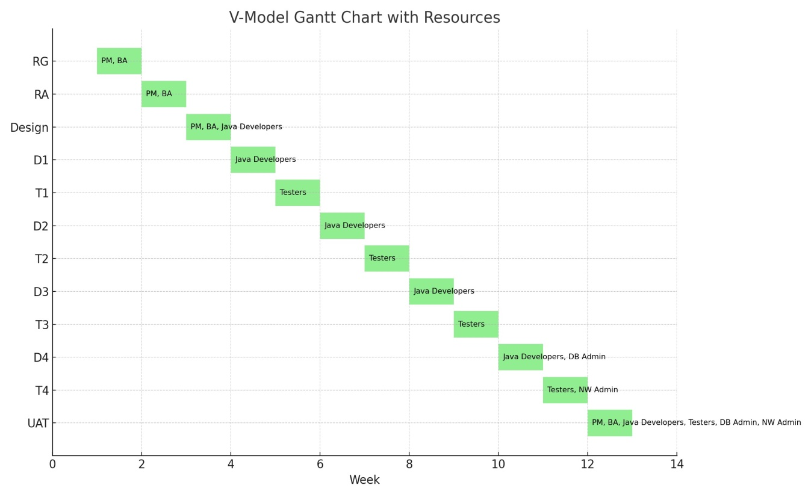

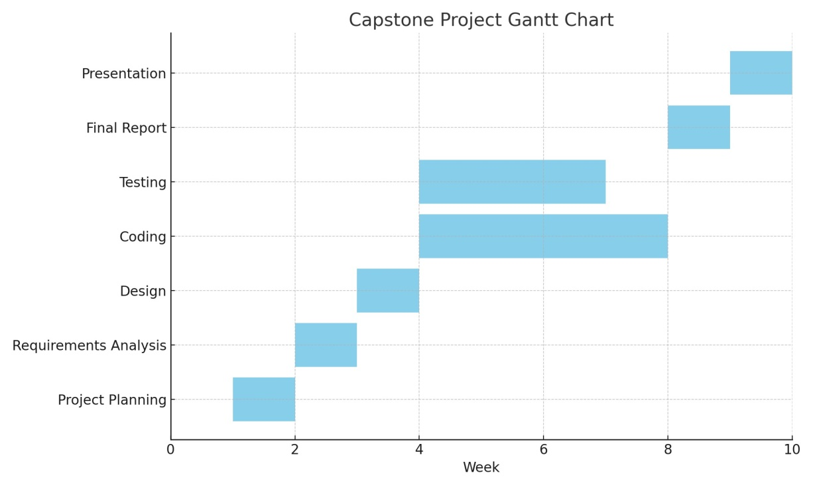

Question 13 – Fixed Bid Vs Billing

**Answer 13**

**Fixed Bid Model**

Under this, the project scope, timeline, and cost are already decided before the project starts

**Pros** – we will have a clear idea of the project cost from the beginning because of that our project scope will be cleared which will reduce confusion.

**Cons**- Less flexibility and sudden change will cost more and lead to financial loss for the vendor

**Billing Model**

This model is payment based on actual efforts either hourly or timesheet-driven, the team will release funds against timesheets submitted.

**Pros** – Payment will be according to the actual work completed it will be transparent.

**Cons** – without a fixed budget, it might exceed the costs, and Continuous tracking might be difficult.

Question 14,15,16,17,18,19,20 – Timesheets

**Answer 14,15,16,17,18,19,20 – Timesheets**

**The calculation of hours in a Timesheet depends upon the project's complexity.**

Requirement Gathering (RG) Timesheet of a BA

|  |  |  |  |  |  |
| --- | --- | --- | --- | --- | --- |
| **S.no.** | **Task** | **Actionable Items** | **Start Time** | **End Time** | **Duration (hours)** |
| 1 | Stakeholder Interviews | Interviewed Peter, Kevin, Ben for farming challenges | 9:00 AM | 11:00 AM | 2 |
| 2 | Requirements Documentation | Documented fertilizer, seed, pesticide needs | 11:30 AM | 1:00 PM | 1.5 |
| 3 | Meeting with Team | Discussion on technical requirements | 2:00 PM | 3:30 PM | 1.5 |
| 4 | Analysis and Summary | Compiled findings and prepared summary report | 4:00 PM | 5:00 PM | 1 |
| 5 | Requirements sorting | Emails, documentation, and planning, Various template | 5:30 PM | 6:00 PM | 0.5 |
|  | Total |  |  |  | 6.5 |

Requirement Analysis (RA) Timesheet of a BA

|  |  |  |  |  |  |
| --- | --- | --- | --- | --- | --- |
| **S.no.** | **Task** | **Actionable Items** | **Start Time** | **End Time** | **Duration (hours)** |
| 1 | Review User Feedback | Analyzed feedback from farmers and companies | 9:00 AM | 10:30 AM | 1.5 |
| 2 | Consolidate Requirements | Compiled a list of required features and functionalities | 11:00 AM | 12:30 PM | 1.5 |
| 3 | Requirements Prioritization | Assessed and prioritized essential features | 1:30 PM | 3:00 PM | 1.5 |
| 4 | Stakeholder Meeting | Discussed requirements with the project team | 3:30 PM | 5:00 PM | 1.5 |
| 5 | Documentation and Reporting | Summarized RA findings in a detailed report | 5:30 PM | 6:30 PM | 1 |
|  | Total |  |  |  | 6 |

Design Timesheet of a BA

|  |  |  |  |  |  |
| --- | --- | --- | --- | --- | --- |
| **S.no.** | **Task** | **Actionable Items** | **Start Time** | **End Time** | **Duration (hours)** |
| 1 | Review System Architecture | Analyzed system architecture and design documents | 9:00 AM | 10:30 AM | 1.5 |
| 2 | UI/UX Design Collaboration | Worked with UI/UX team on design considerations | 11:00 AM | 12:30 PM | 1.5 |
| 3 | Data Flow Diagram Creation | Drafted data flow diagrams for system components | 1:30 PM | 3:00 PM | 1.5 |
| 4 | Documentation and Reporting | Summarized design decisions in a detailed report | 3:30 PM | 5:00 PM | 1.5 |
| 5 | Team Meeting for Design Review | Presented design concepts to the project team | 5:30 PM | 6:30 PM | 1 |
|  | Total |  |  |  | 7 |

Development Timesheet of a BA

|  |  |  |  |  |  |
| --- | --- | --- | --- | --- | --- |
| **S.no.** | **Task** | **Actionable Items** | **Start Time** | **End Time** | **Duration (hours)** |
| 1 | Requirement Clarification | Gathered further details on specific module needs | 9:00 AM | 10:00 AM | 1 |
| 2 | User Story Review | Revised user stories based on stakeholder feedback | 10:30 AM | 12:00 PM | 1.5 |
| 3 | Code Review | Inspected code for adherence to project requirements | 1:00 PM | 3:00 PM | 2 |
| 4 | Team Meeting for Development | Presented findings and suggestions to the development team | 3:30 PM | 4:30 PM | 1 |
|  | Total |  |  |  | 5.5 |

Testing Timesheet of a BA

|  |  |  |  |  |  |
| --- | --- | --- | --- | --- | --- |
| **S.no.** | **Task** | **Actionable Items** | **Start Time** | **End Time** | **Duration (hours)** |
| 1 | Test Case Review | Analyzed and verified test cases for new functionalities | 9:00 AM | 10:30 AM | 1.5 |
| 2 | Defect Analysis | Investigated reported defects for root cause analysis | 11:00 AM | 12:30 PM | 1.5 |
| 3 | Regression Testing | Conducted regression testing on the updated features | 1:30 PM | 3:30 PM | 2 |
| 4 | Test Result Documentation | Compiled and documented test results for reporting | 4:00 PM | 5:00 PM | 1 |
|  | Total |  |  |  | 6 |

UAT Timesheet of a BA

|  |  |  |  |  |  |
| --- | --- | --- | --- | --- | --- |
| **S.no.** | **Task** | **Actionable Items** | **Start Time** | **End Time** | **Duration (hours)** |
| 1 | UAT Test Planning | Prepared test scenarios and UAT plans for new features | 9:00 AM | 10:30 AM | 1.5 |
| 2 | User Feedback Collection | Gathered feedback from stakeholders on application use | 11:00 AM | 12:30 PM | 1.5 |
| 3 | UAT Execution | Actively participated in executing UAT test cases | 1:30 PM | 4:00 PM | 2.5 |
| 4 | Defect Reporting & Documentation | Documented and reported identified defects | 4:30 PM | 5:30 PM | 1 |
|  | Total |  |  |  | 6.5 |

Deployment and Implementation Timesheet of a BA

|  |  |  |  |  |  |
| --- | --- | --- | --- | --- | --- |
| **S.no.** | **Task** | **Actionable Items** | **Start Time** | **End Time** | **Duration (hours)** |
| 1 | Final Review of Deployment Plan | Reviewing the finalized deployment plan | 9:00 AM | 10:00 AM | 1 |
| 2 | Coordination with Development Team | Facilitating discussions regarding deployment schedule | 10:30 AM | 12:00 PM | 1.5 |
| 3 | Communication Plan Development | Drafting emails and communication materials for stakeholders | 1:00 PM | 2:30 PM | 1.5 |
| 4 | User Training Coordination | Arranging and organizing training sessions for end-users | 3:00 PM | 5:00 PM | 2 |
|  | Total |  |  |  | 6 |